MÉDIA: | Autoszektor.hu | MEDIA SPECIFICS
DATE | 2017.09.29. | TYPE: | Online
PAGE | - | REACH: | N/A
EAV (EUR) | 580 | FREQUENCY:
TITLE: | Bridgestone Budaörs Half Marathon kicks off
SUMMARY | More than 400 people will race on the 1 October, 2017 in one of the country's most recent long-running races, the Bridgestone Budaörs Half Marathon. The popular event moves the city and its surroundings for the fourth time. Runners will be able to prove in three different distances, and in addition to the adult age, children can test their abilities too. At this year's event a real Olympic team will race: Imre Pulai, Mihály Kótai and Attila Vozár will also run. Regular runners are also expected, as well as those who are spending more time behind the wheel or at the office, because about 50% of the Hungarian population spend up to 10 hours a day sitting. This weekend offers mobility for those who live a less active lifestyle.

http://www.autoszektor.hu/hu/content/indul-bridgestone-budaors-felmaraton

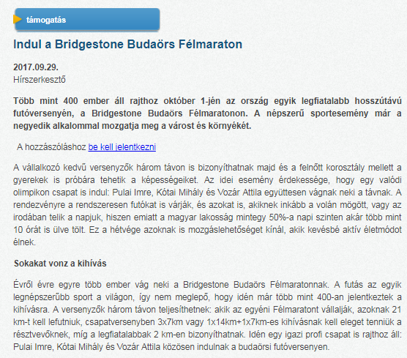

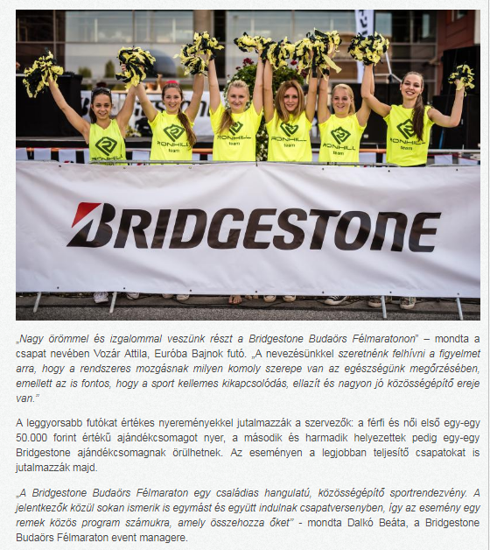
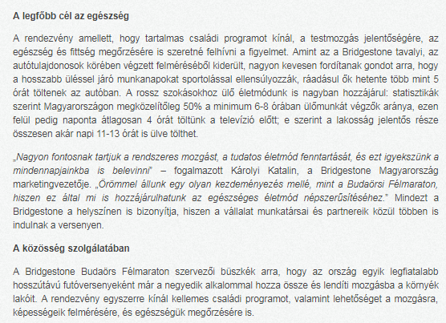

MÉDIA: | Blikk.hu | MEDIA SPECIFICS
DATE | 2017.09.29. | TYPE: | Online
PAGE | - | REACH: | 359 301
EAV (EUR) | 1 612 | FREQUENCY:
TITLE: | Let's run, Bridgestone Budaörs Half Marathon kicks off 1st October!
SUMMARY | More than 400 people will race on the 1 October, 2017 in one of the country's most recent long-running races, the Bridgestone Budaörs Half Marathon. The popular event moves the city and its surroundings for the fourth time. Runners will be able to prove in three different distances, and in addition to the adult age, children can test their abilities too. At this year's event a real Olympic team will race: Imre Pulai, Mihály Kótai and Attila Vozár will also run. Regular runners are also expected, as well as those who are spending more time behind the wheel or at the office, because about 50% of the Hungarian population spend up to 10 hours a day sitting. This weekend offers mobility for those who live a less active lifestyle.

http://www.blikk.hu/aktualis/belfold/futasra-fel-oktober-1-jen-indul-a-bridgestone-budaors-felmaraton/bjgyg6f

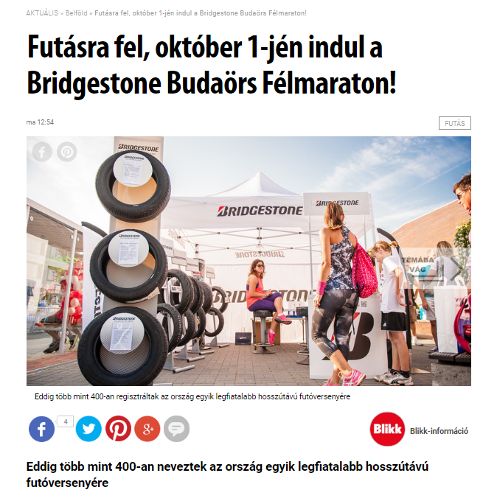

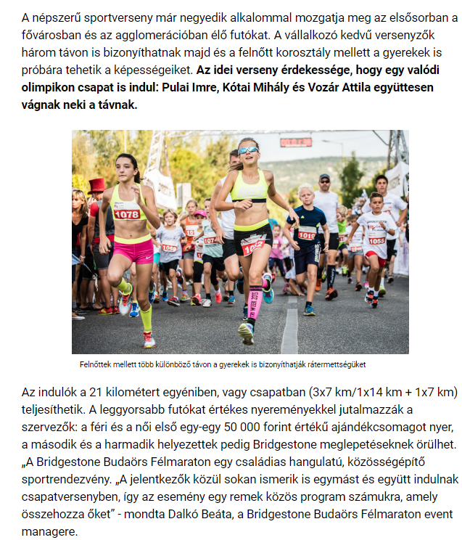

MÉDIA: | Sportmenu.hu | MEDIA SPECIFICS
DATE | 2017.09.29. | TYPE: | Online
PAGE | - | REACH: | N/A
EAV (EUR) | N/A | FREQUENCY:
TITLE: | Bridgestone Budaörs Half Marathon kicks off 1st October!
SUMMARY | More than 400 people will race on the 1 October, 2017 in one of the country's most recent long-running races, the Bridgestone Budaörs Half Marathon. The popular event moves the city and its surroundings for the fourth time. Runners will be able to prove in three different distances, and in addition to the adult age, children can test their abilities too. At this year's event a real Olympic team will race: Imre Pulai, Mihály Kótai and Attila Vozár will also run. Regular runners are also expected, as well as those who are spending more time behind the wheel or at the office, because about 50% of the Hungarian population spend up to 10 hours a day sitting. This weekend offers mobility for those who live a less active lifestyle.

http://sportmenu.hu/oktober-1-en-rajtol-a-bridgestone-budaors-felmaraton/

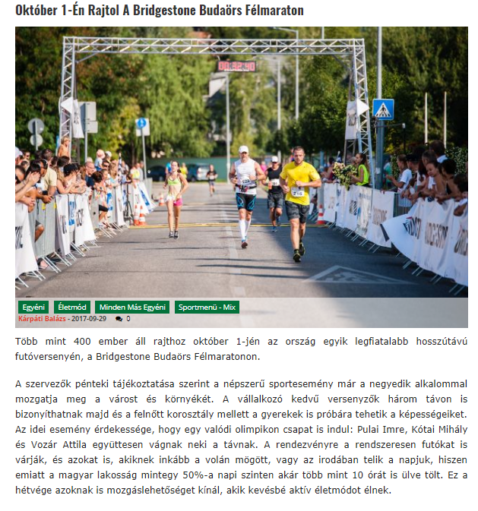

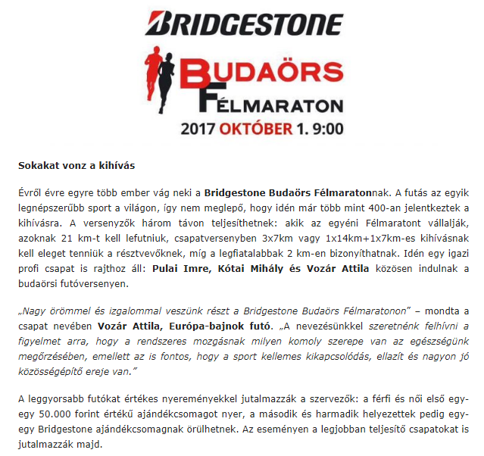
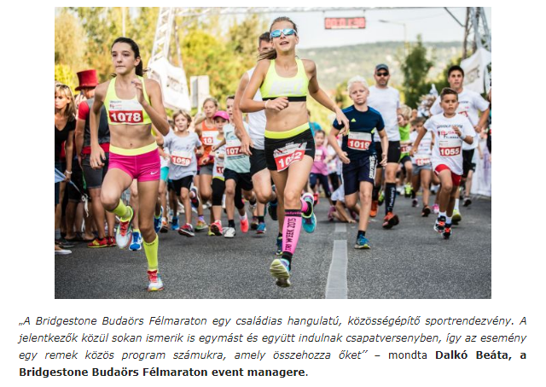

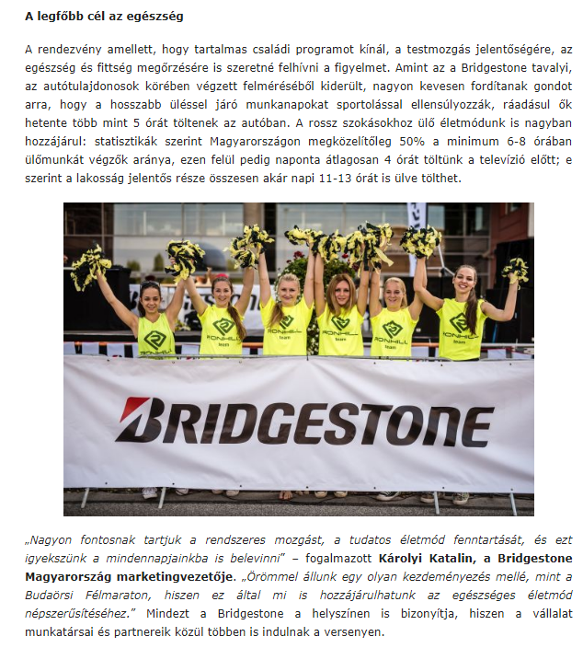
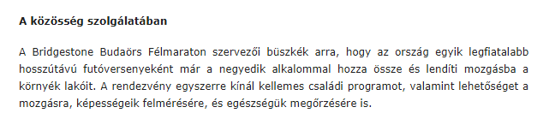

MÉDIA: | Starthirek.hu | MEDIA SPECIFICS
DATE | 2017.09.29. | TYPE: | Online
PAGE | - | REACH: | N/A
EAV (EUR) | N/A | FREQUENCY:
TITLE: | Bridgestone Budaörs Half Marathon kicks off 1st October
SUMMARY | More than 400 people will race on the 1 October, 2017 in one of the country's most recent long-running races, the Bridgestone Budaörs Half Marathon. The popular event moves the city and its surroundings for the fourth time. Runners will be able to prove in three different distances, and in addition to the adult age, children can test their abilities too. At this year's event a real Olympic team will race: Imre Pulai, Mihály Kótai and Attila Vozár will also run. Regular runners are also expected, as well as those who are spending more time behind the wheel or at the office, because about 50% of the Hungarian population spend up to 10 hours a day sitting. This weekend offers mobility for those who live a less active lifestyle.

https://starthirek.hu/2017/09/29/indul-a-bridgestone-budaors-felmaraton/

