MÉDIA: | Mediapiac.com | MEDIA SPECIFICS
DATE | 2017.09.05. | TYPE: | Online
PAGE | - | REACH: | N/A
EAV (EUR) | N/A | FREQUENCY:
TITLE: | Bridgestone supports emergency blood transport by donating tyres
SUMMARY | Bridgestone supports the assurance of almost 10.000 emergency transports and the same number of round deliveries every year by donating tyres for the continuous operation of the 5-car blood transport fleet of Semmelweis University. The blood transport units of the university transport the crucial blood products in Budapest between the blood supply center and the important hospitals and clinics. During this activity, the cars can run up to 150-200 kms daily and up to 80.000 kms annually.

http://www.mediapiac.com/marketing/Gumiabroncsokkal-segiti-a-verszallitast-a-Bridgestone/23878/

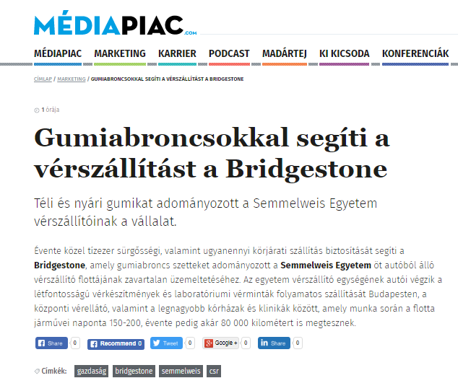

MÉDIA: | Formula.hu | MEDIA SPECIFICS
DATE | 2017.09.05. | TYPE: | Online
PAGE | - | REACH: | 4 177
EAV (EUR) | 54 | FREQUENCY:
TITLE: | Tyres in the pay of emergency blood transport
SUMMARY | Bridgestone supports the assurance of almost 10.000 emergency transports and the same number of round deliveries every year by donating tyres for the continuous operation of the 5-car blood transport fleet of Semmelweis University. The blood transport units of the university transport the crucial blood products in Budapest between the blood supply center and the important hospitals and clinics. During this activity, the cars can run up to 150-200 kms daily and up to 80.000 kms annually.

http://formula.hu/auto/2017/09/05/gumiabroncsok-a-verszallitas-szolgalataban

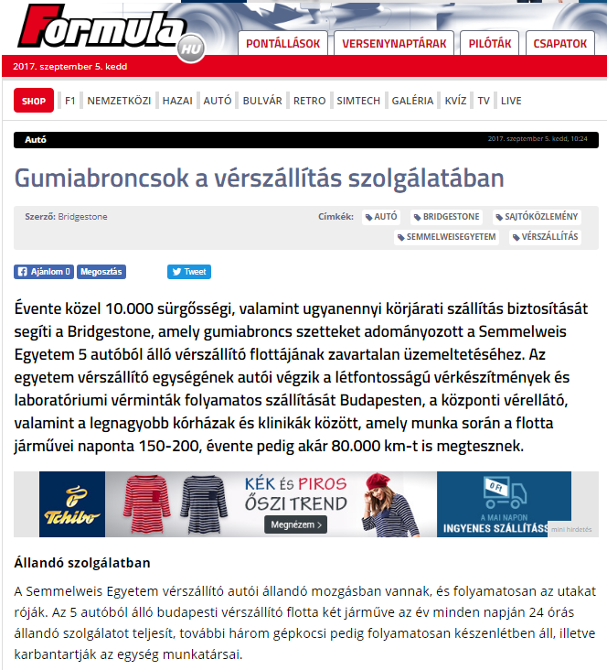

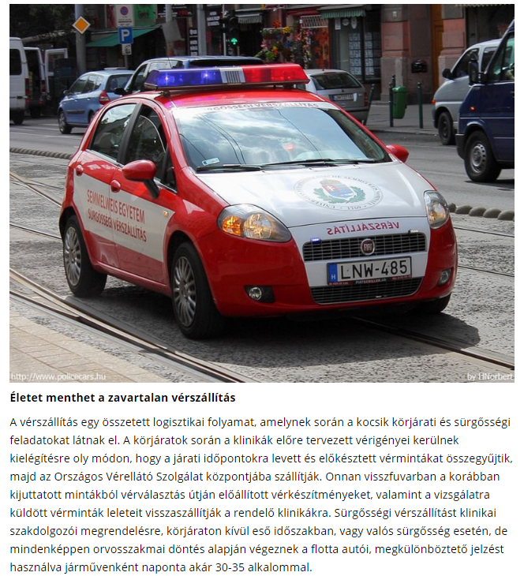
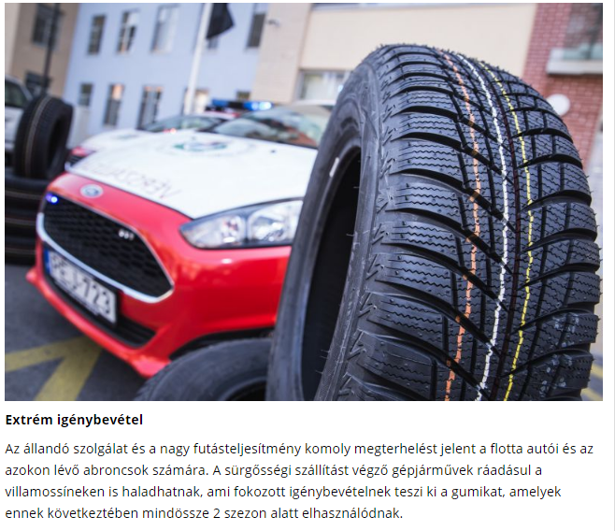
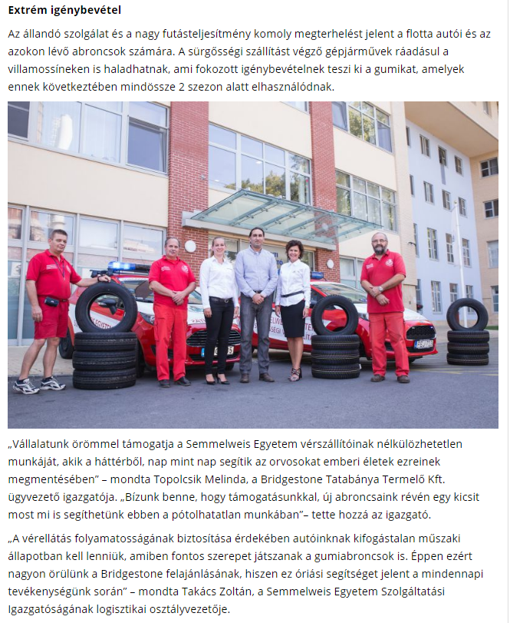
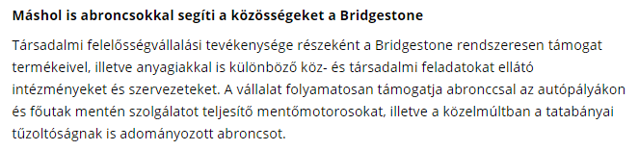

MÉDIA: | Vezess.hu | MEDIA SPECIFICS
DATE | 2017.09.05. | TYPE: | Online
PAGE | - | REACH: | 100 000
EAV (EUR) | 69 | FREQUENCY:
TITLE: | Bridgestone supports emergency blood transport by donating tyres
SUMMARY | Bridgestone supports the assurance of almost 10.000 emergency transports and the same number of round deliveries every year by donating tyres for the continuous operation of the 5-car blood transport fleet of Semmelweis University. The blood transport units of the university transport the crucial blood products in Budapest between the blood supply center and the important hospitals and clinics. During this activity, the cars can run up to 150-200 kms daily and up to 80.000 kms annually.

http://www.vezess.hu/hirek/2017/09/05/gumiabroncsokkal-segiti-a-verszallitast-a-bridgestone/

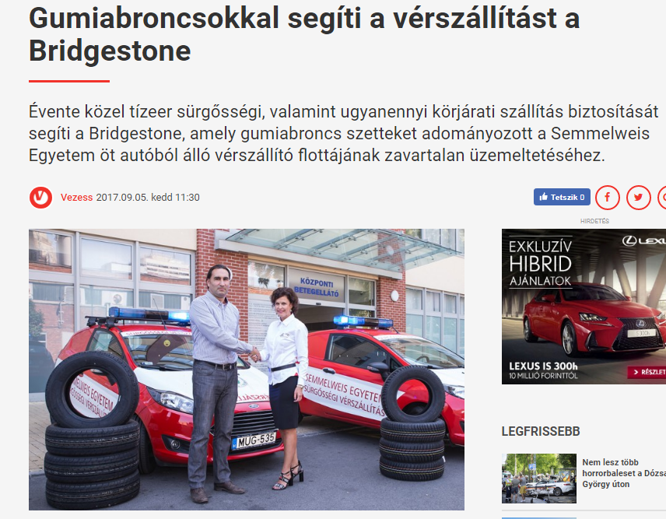
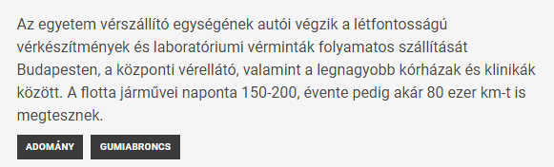

MÉDIA: | Panoramanet.hu | MEDIA SPECIFICS
DATE | 2017.09.05. | TYPE: | Online
PAGE | - | REACH: | N/A
EAV (EUR) | N/A | FREQUENCY:
TITLE: | Bridgestone supports emergency blood transport by donating tyres
SUMMARY | Bridgestone supports the assurance of almost 10.000 emergency transports and the same number of round deliveries every year by donating tyres for the continuous operation of the 5-car blood transport fleet of Semmelweis University. The blood transport units of the university transport the crucial blood products in Budapest between the blood supply center and the important hospitals and clinics. During this activity, the cars can run up to 150-200 kms daily and up to 80.000 kms annually.

http://panoramanet.hu/gumiabroncsokkal-segiti-a-verszallitast-a-bridgestone/

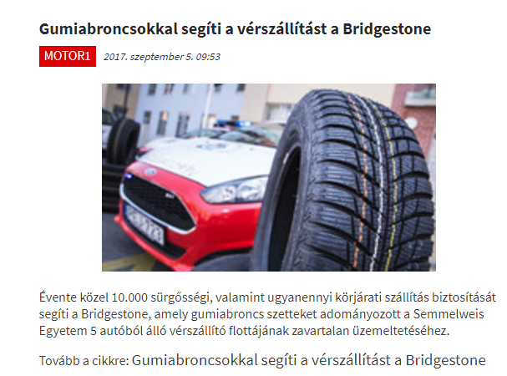

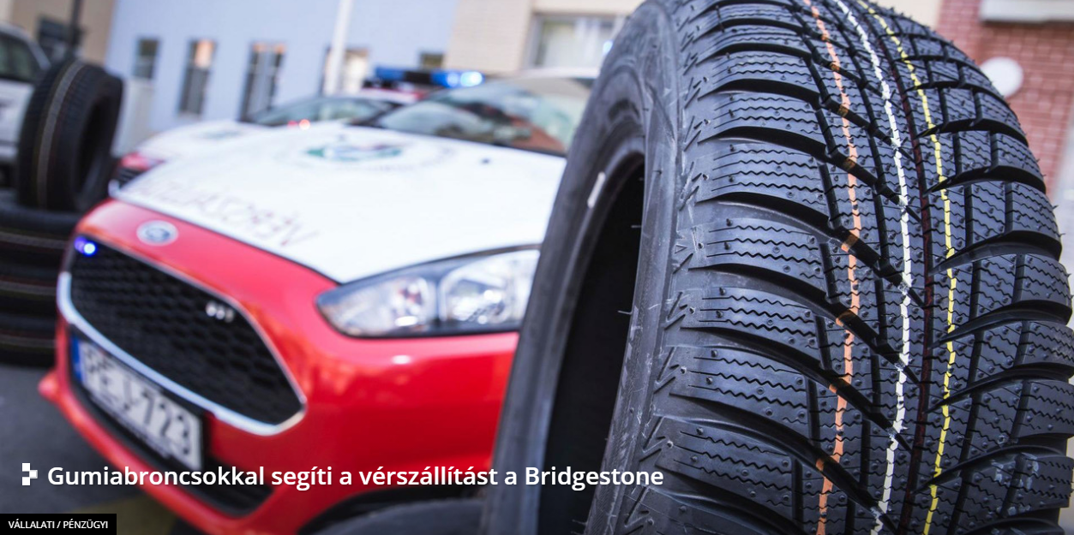
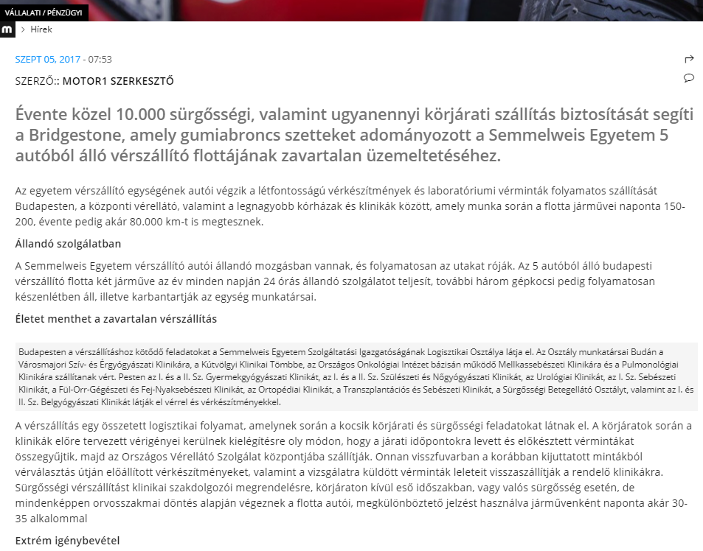
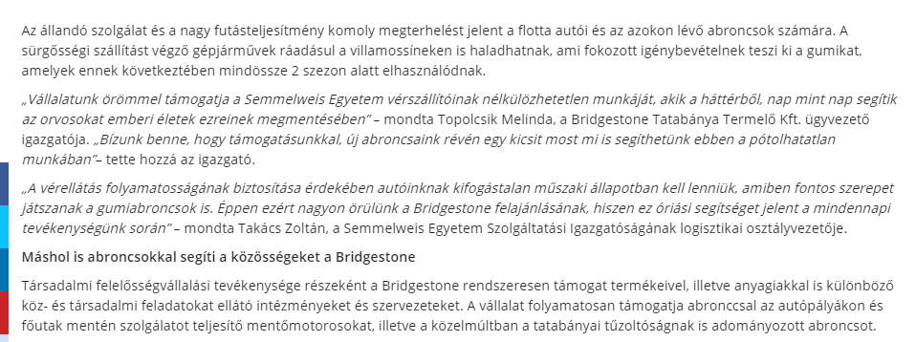

MÉDIA: | Weborvos.hu | MEDIA SPECIFICS
DATE | 2017.09.05. | TYPE: | Online
PAGE | - | REACH: | 3 912
EAV (EUR) | 138 | FREQUENCY:
TITLE: | Always on duty, with extreme impressment
SUMMARY | Bridgestone supports the assurance of almost 10.000 emergency transports and the same number of round deliveries every year by donating tyres for the continuous operation of the 5-car blood transport fleet of Semmelweis University. The blood transport units of the university transport the crucial blood products in Budapest between the blood supply center and the important hospitals and clinics. During this activity, the cars can run up to 150-200 kms daily and up to 80.000 kms annually.

http://www.weborvos.hu/regionalis_hirek/allando_szolgalatban_extrem_igenybevetellel/241030/

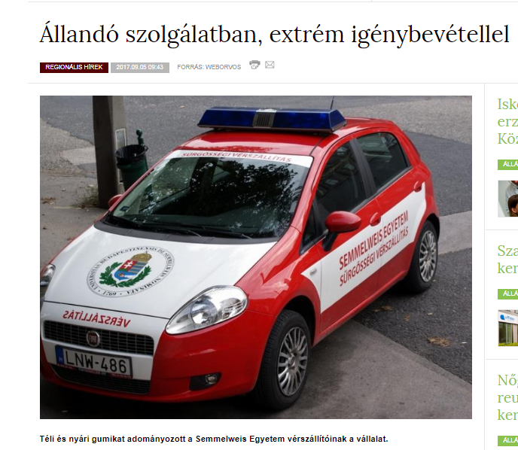

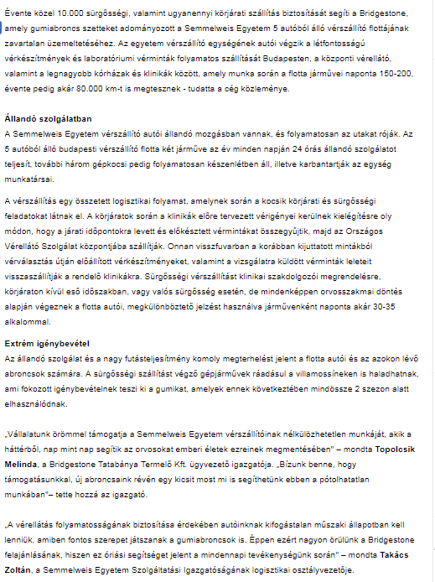

MÉDIA: | Civilhetes.net | MEDIA SPECIFICS
DATE | 2017.09.05. | TYPE: | Online
PAGE | - | REACH: | N/A
EAV (EUR) | N/A | FREQUENCY:
TITLE: | Emergency blood transport fleet of Semmelweis University gets tyres from donation, not from government
SUMMARY | Bridgestone supports the assurance of almost 10.000 emergency transports and the same number of round deliveries every year by donating tyres for the continuous operation of the 5-car blood transport fleet of Semmelweis University. The blood transport units of the university transport the crucial blood products in Budapest between the blood supply center and the important hospitals and clinics. During this activity, the cars can run up to 150-200 kms daily and up to 80.000 kms annually.
http://civilhetes.net/a-kormany-helyett-adomanyokbol-van-gumi-a-semmelweis-egyetem-verszallito-autoin
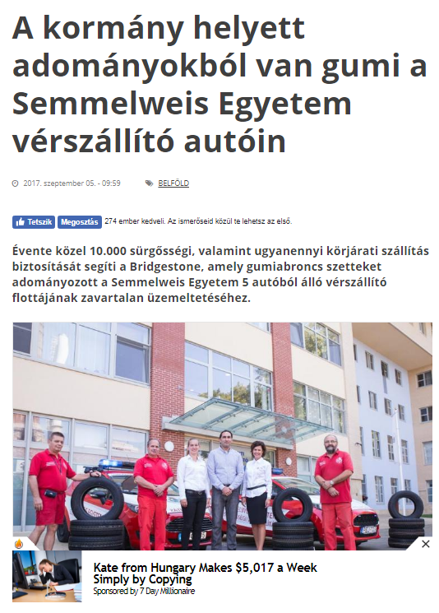

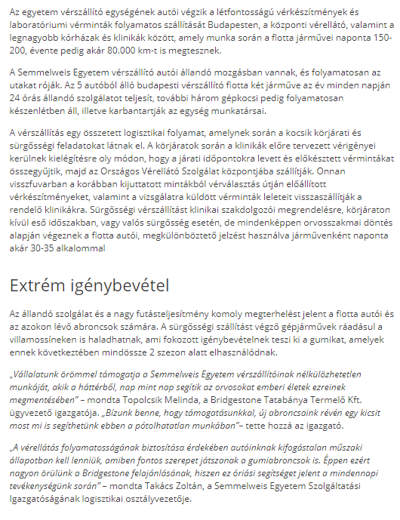
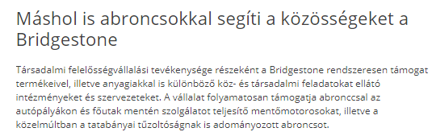

MÉDIA: | Hirado.hu | MEDIA SPECIFICS
DATE | 2017.09.05. | TYPE: | Online
PAGE | - | REACH: | 150 000
EAV (EUR) | 1 935 | FREQUENCY:
TITLE: | Some donate blood, donate give tyre
SUMMARY | Bridgestone supports the assurance of almost 10.000 emergency transports and the same number of round deliveries every year by donating tyres for the continuous operation of the 5-car blood transport fleet of Semmelweis University. The blood transport units of the university transport the crucial blood products in Budapest between the blood supply center and the important hospitals and clinics. During this activity, the cars can run up to 150-200 kms daily and up to 80.000 kms annually.

http://www.hirado.hu/2017/09/05/egyesek-vert-masok-gumit-adnak/

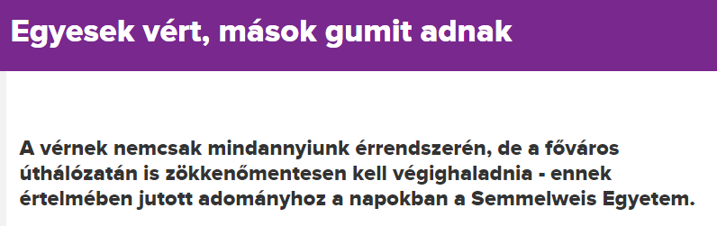

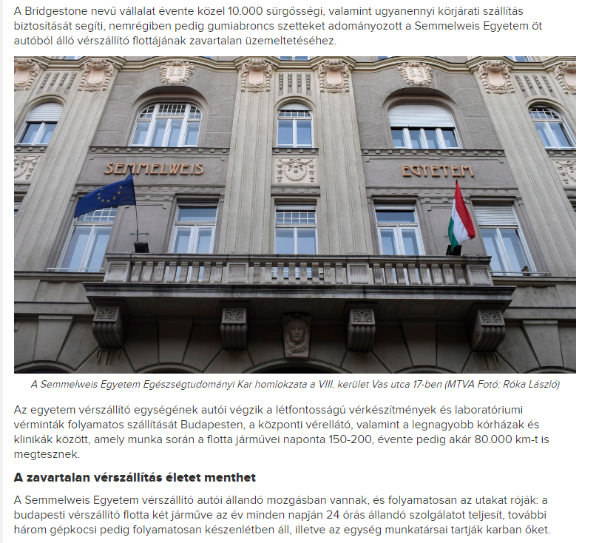

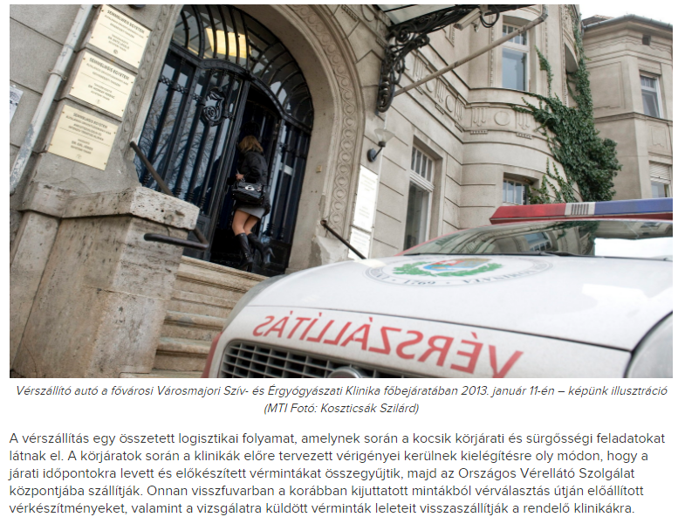
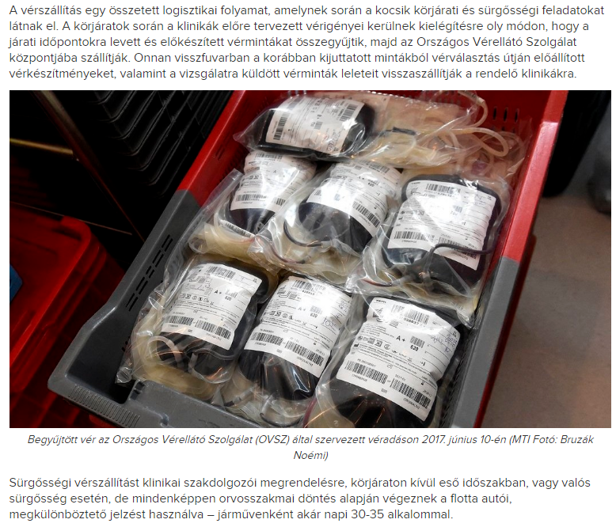
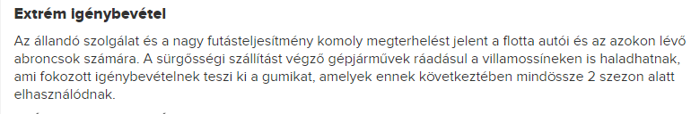
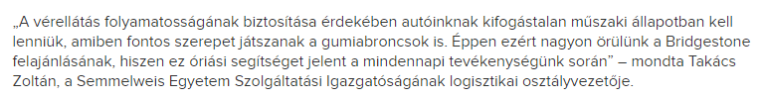

MÉDIA: | Logisztika.com | MEDIA SPECIFICS
DATE | 2017.09.05. | TYPE: | Online
PAGE | - | REACH: | N/A
EAV (EUR) | N/A | FREQUENCY:
TITLE: | Bridgestone supports emergency blood transport by donatng tyres
SUMMARY | Bridgestone supports the assurance of almost 10.000 emergency transports and the same number of round deliveries every year by donating tyres for the continuous operation of the 5-car blood transport fleet of Semmelweis University. The blood transport units of the university transport the crucial blood products in Budapest between the blood supply center and the important hospitals and clinics. During this activity, the cars can run up to 150-200 kms daily and up to 80.000 kms annually.

http://logisztika.com/gumiabroncsokkal-segiti-a-verszallitast-a-bridgestone/

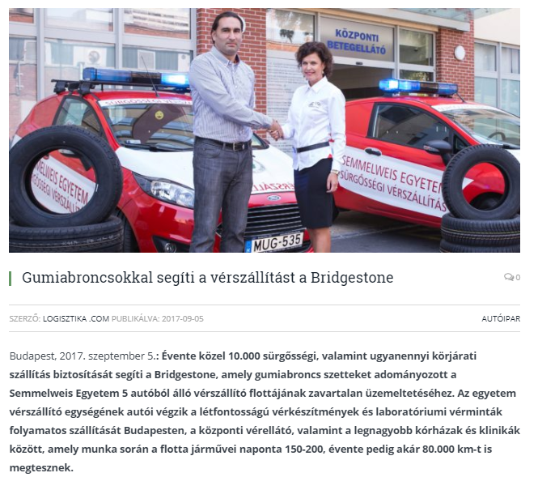

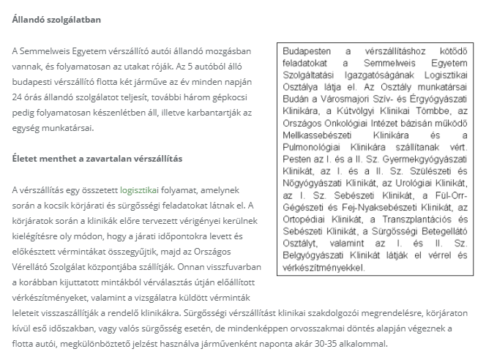
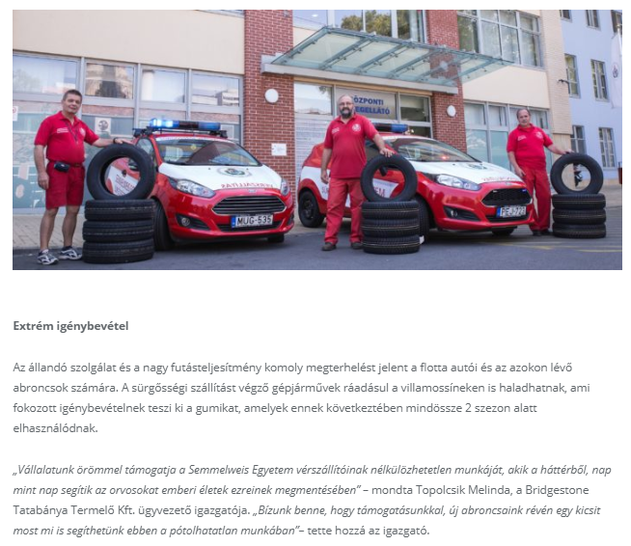
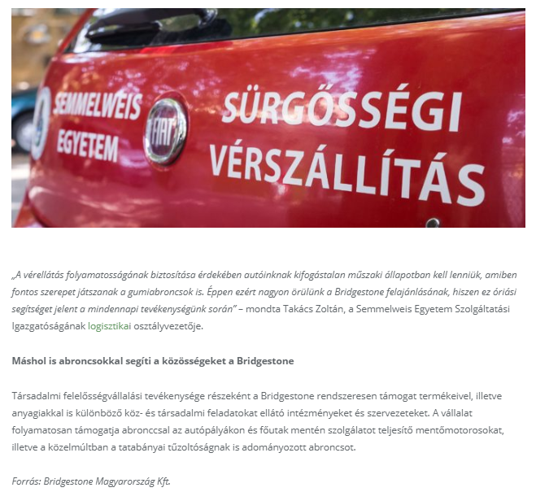

MÉDIA: | Weborvospro.hu | MEDIA SPECIFICS
DATE | 2017.09.05. | TYPE: | Online
PAGE | - | REACH: | N/A
EAV (EUR) | N/A | FREQUENCY:
TITLE: | Always on duty, with extreme impressment
SUMMARY | Bridgestone supports the assurance of almost 10.000 emergency transports and the same number of round deliveries every year by donating tyres for the continuous operation of the 5-car blood transport fleet of Semmelweis University. The blood transport units of the university transport the crucial blood products in Budapest between the blood supply center and the important hospitals and clinics. During this activity, the cars can run up to 150-200 kms daily and up to 80.000 kms annually.

http://www.weborvospro.hu/cikkek/gyorshir/allandoszolgalatbanextremigenybevetellel.html

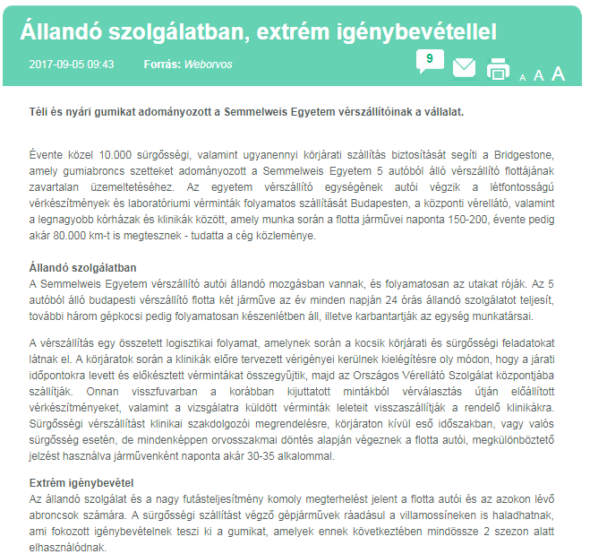
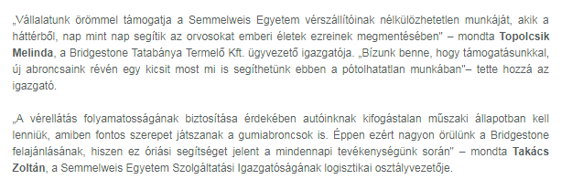

MÉDIA: | Noizz.hu | MEDIA SPECIFICS
DATE | 2017.09.05. | TYPE: | Online
PAGE | - | REACH: | N/A
EAV (EUR) | N/A | FREQUENCY:
TITLE: | Bridgestone donates winter and summer tyres to the emergency blood transport cars of Semmelweis University
SUMMARY | Bridgestone supports the assurance of almost 10.000 emergency transports and the same number of round deliveries every year by donating tyres for the continuous operation of the 5-car blood transport fleet of Semmelweis University. The blood transport units of the university transport the crucial blood products in Budapest between the blood supply center and the important hospitals and clinics. During this activity, the cars can run up to 150-200 kms daily and up to 80.000 kms annually.

http://noizz.hu/most/teli-es-nyari-gumikat-adomanyozott-a-semmelweis-egyetem-verszallitoinak-a-bridgestone/gbwk8br

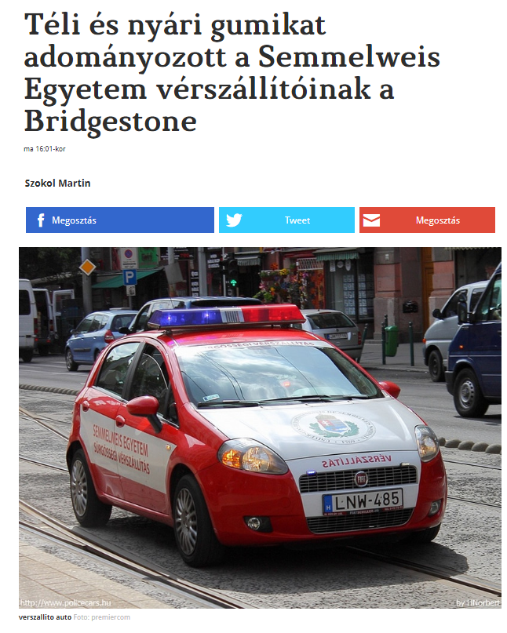

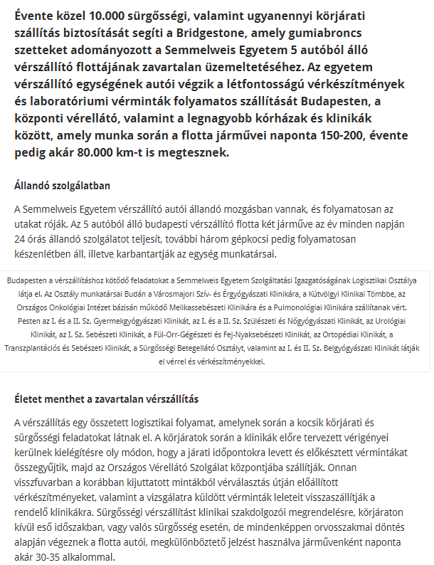
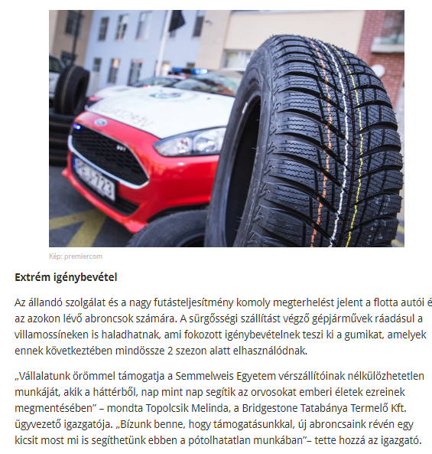

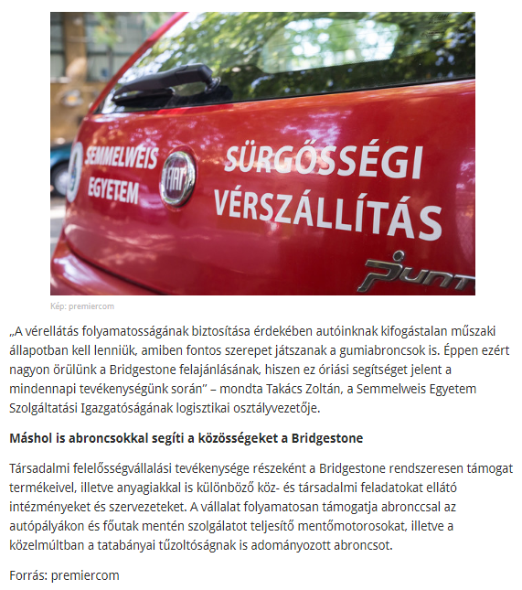

MÉDIA: | Carlinx.hu | MEDIA SPECIFICS
DATE | 2017.09.05. | TYPE: | Online
PAGE | - | REACH: | 100 000
EAV (EUR) | 69 | FREQUENCY:
TITLE: | Bridgestone supports emergency blood transport by donating tyres
SUMMARY | Bridgestone supports the assurance of almost 10.000 emergency transports and the same number of round deliveries every year by donating tyres for the continuous operation of the 5-car blood transport fleet of Semmelweis University. The blood transport units of the university transport the crucial blood products in Budapest between the blood supply center and the important hospitals and clinics. During this activity, the cars can run up to 150-200 kms daily and up to 80.000 kms annually.

https://www.carlinx.hu/post/gumiabroncsokkal-segiti-a-verszallitast-a-bridgestone

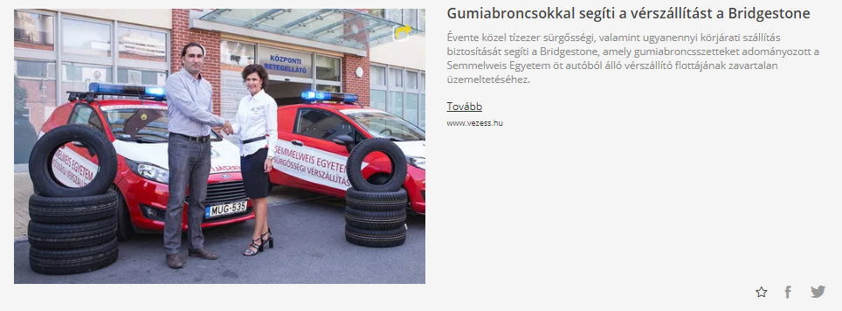

MÉDIA: | Autoszektor.hu | MEDIA SPECIFICS
DATE | 2017.09.05. | TYPE: | Online
PAGE | - | REACH: | 5 990
EAV (EUR) | 345 | FREQUENCY:
TITLE: | Bridgestone supports emergency blood transport by donating tyres
SUMMARY | Bridgestone supports the assurance of almost 10.000 emergency transports and the same number of round deliveries every year by donating tyres for the continuous operation of the 5-car blood transport fleet of Semmelweis University. The blood transport units of the university transport the crucial blood products in Budapest between the blood supply center and the important hospitals and clinics. During this activity, the cars can run up to 150-200 kms daily and up to 80.000 kms annually.

http://www.autoszektor.hu/hu/content/abroncsokkal-segiti-verszallitast-bridgestone

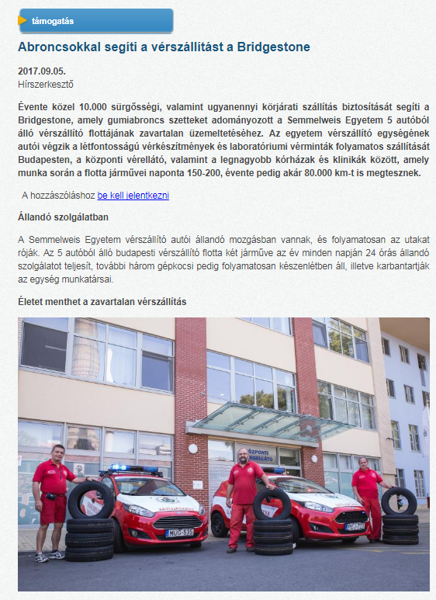

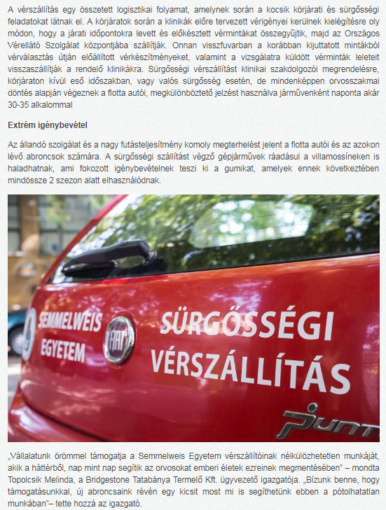
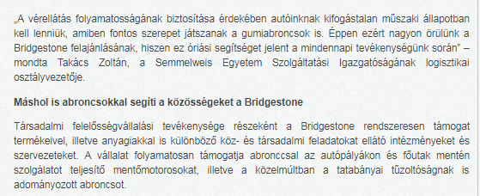

MÉDIA: | Kemma.hu | MEDIA SPECIFICS
DATE | 2017.09.05. | TYPE: | Online
PAGE | - | REACH: | 4 214
EAV (EUR) | 143 | FREQUENCY:
TITLE: | Bridgestone donates winter and summer tyres to the emergency blood transport cars of Semmelweis University
SUMMARY | Bridgestone supports the assurance of almost 10.000 emergency transports and the same number of round deliveries every year by donating tyres for the continuous operation of the 5-car blood transport fleet of Semmelweis University. The blood transport units of the university transport the crucial blood products in Budapest between the blood supply center and the important hospitals and clinics. During this activity, the cars can run up to 150-200 kms daily and up to 80.000 kms annually.

https://www.kemma.hu/hirek/helyi-hirek/831125-831125/

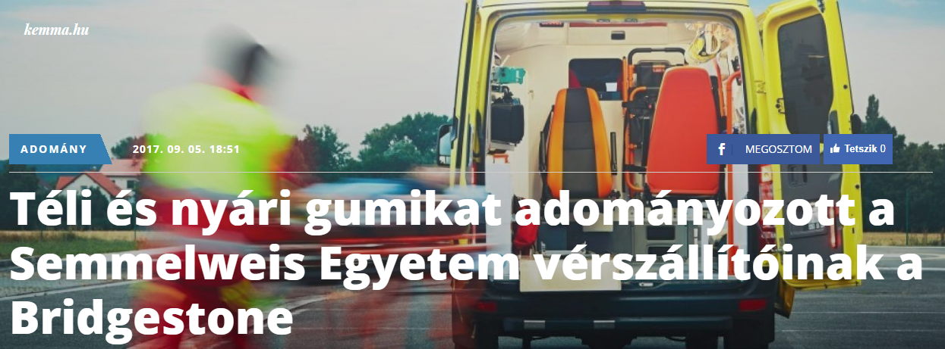

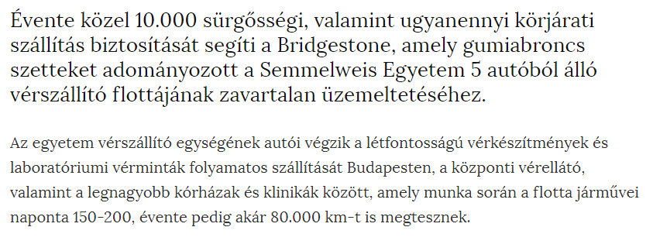

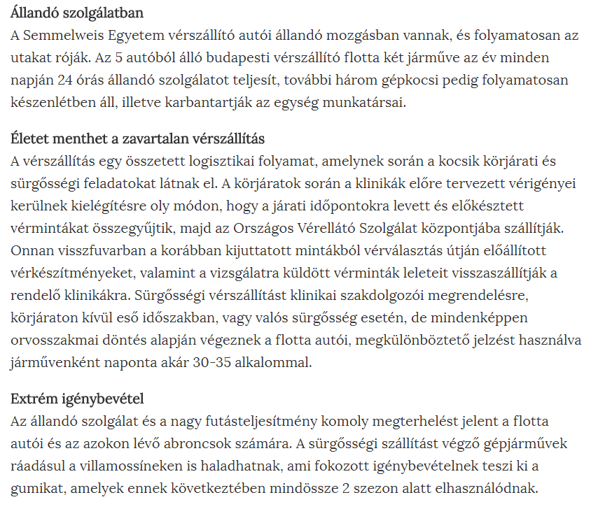
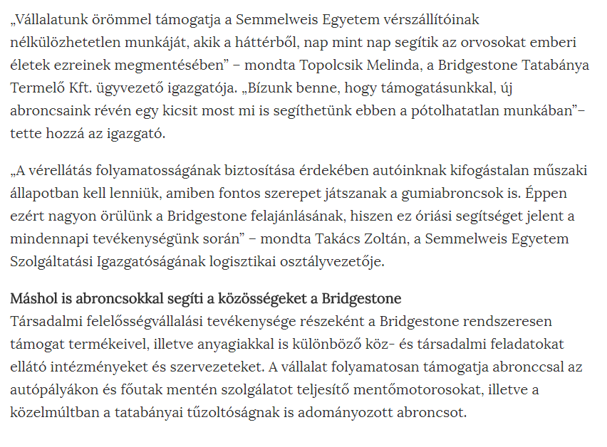

MÉDIA: | Autosvilag.com | MEDIA SPECIFICS
DATE | 2017.09.05. | TYPE: | Online
PAGE | - | REACH: | N/A
EAV (EUR) | N/A | FREQUENCY:
TITLE: | Bridgestone - they help in transportring blood
SUMMARY | Bridgestone supports the assurance of almost 10.000 emergency transports and the same number of round deliveries every year by donating tyres for the continuous operation of the 5-car blood transport fleet of Semmelweis University. The blood transport units of the university transport the crucial blood products in Budapest between the blood supply center and the important hospitals and clinics. During this activity, the cars can run up to 150-200 kms daily and up to 80.000 kms annually.

https://autosvilag.com/h%C3%ADrek/1146-bridgestone-%E2%80%93-beseg%C3%ADtenek-a-v%C3%A9rsz%C3%A1ll%C3%ADt%C3%A1sba.html

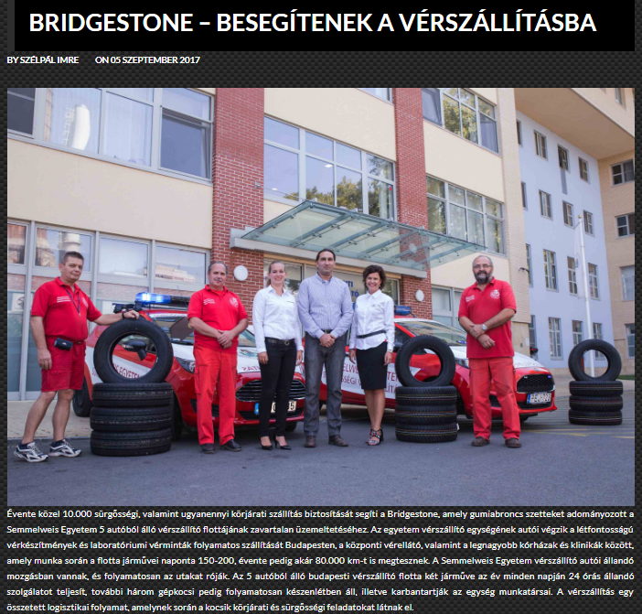

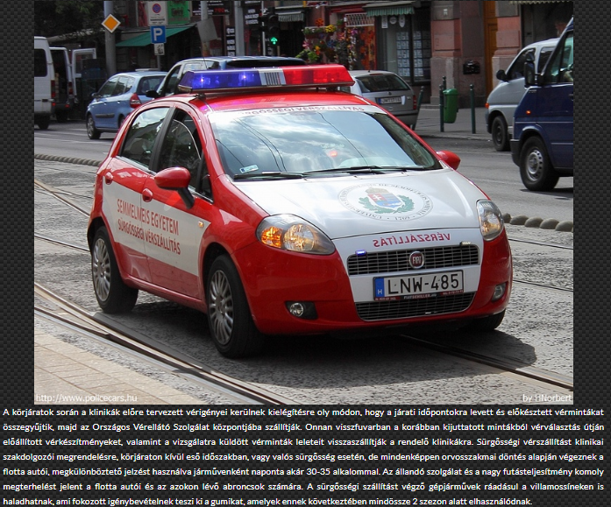
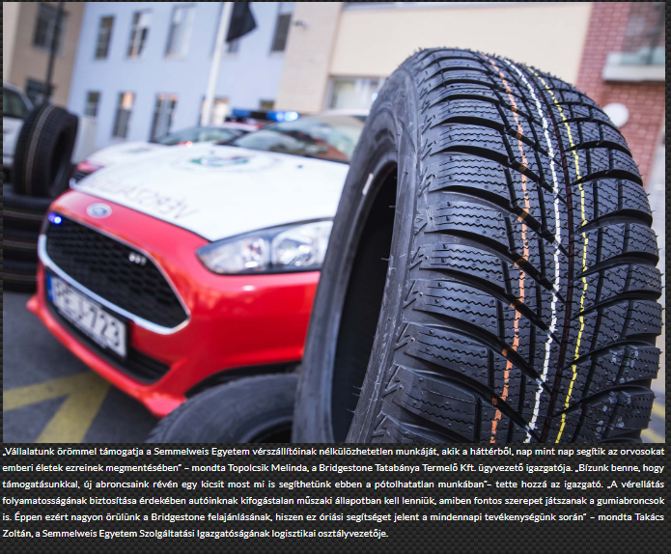

MÉDIA: | Itthon.myhunet.com | MEDIA SPECIFICS
DATE | 2017.09.05. | TYPE: | Online
PAGE | - | REACH: | N/A
EAV (EUR) | N/A | FREQUENCY:
TITLE: | Tyres in the pay of emergency blood transport
SUMMARY | Bridgestone supports the assurance of almost 10.000 emergency transports and the same number of round deliveries every year by donating tyres for the continuous operation of the 5-car blood transport fleet of Semmelweis University. The blood transport units of the university transport the crucial blood products in Budapest between the blood supply center and the important hospitals and clinics. During this activity, the cars can run up to 150-200 kms daily and up to 80.000 kms annually.

http://itthon.myhunet.com/friss-cikk/gumiabroncsok-a-verszallitas-szolgalataban-u13705105.html

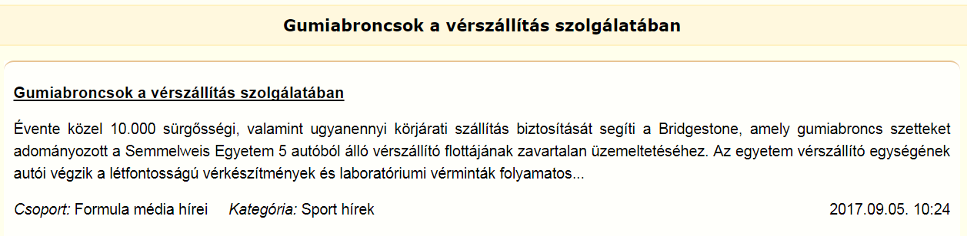

MÉDIA: | Starthirek.hu | MEDIA SPECIFICS
DATE | 2017.09.05. | TYPE: | Online
PAGE | - | REACH: | N/A
EAV (EUR) | N/A | FREQUENCY:
TITLE: | Bridgestone supports emergency blood transport by donatng tyres
SUMMARY | Bridgestone supports the assurance of almost 10.000 emergency transports and the same number of round deliveries every year by donating tyres for the continuous operation of the 5-car blood transport fleet of Semmelweis University. The blood transport units of the university transport the crucial blood products in Budapest between the blood supply center and the important hospitals and clinics. During this activity, the cars can run up to 150-200 kms daily and up to 80.000 kms annually.

https://starthirek.hu/2017/09/05/abroncsokkal-segiti-a-verszallitast-a-bridgestone/

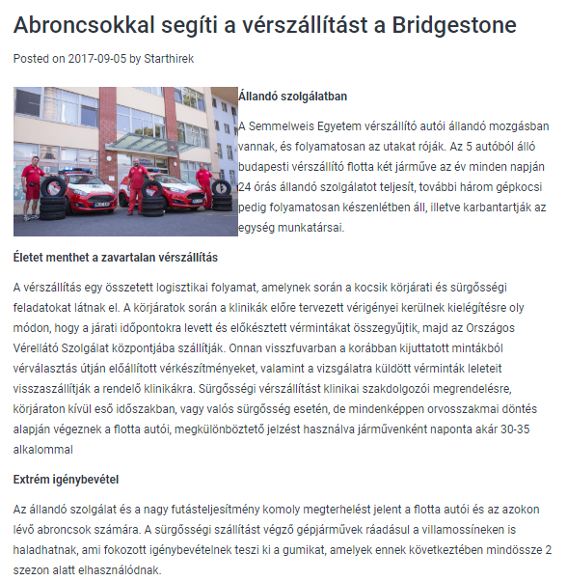

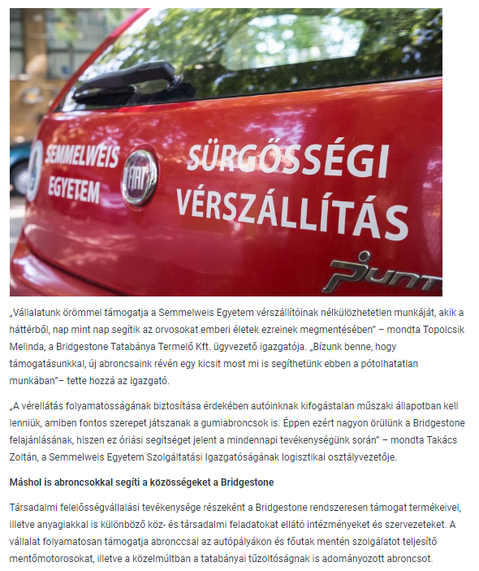

MÉDIA: | Motor1.com | MEDIA SPECIFICS
DATE | 2017.09.05. | TYPE: | Online
PAGE | - | REACH: | N/A
EAV (EUR) | N/A | FREQUENCY:
TITLE: | Bridgestone supports emergency blood transport by donatng tyres
SUMMARY | Bridgestone supports the assurance of almost 10.000 emergency transports and the same number of round deliveries every year by donating tyres for the continuous operation of the 5-car blood transport fleet of Semmelweis University. The blood transport units of the university transport the crucial blood products in Budapest between the blood supply center and the important hospitals and clinics. During this activity, the cars can run up to 150-200 kms daily and up to 80.000 kms annually.

https://hu.motor1.com/news/179125/gumiabroncsokkal-segiti-a-verszallitast-a-bridgestone/?utm_source=RSS&utm_medium=referral&utm_campaign=RSS-all-

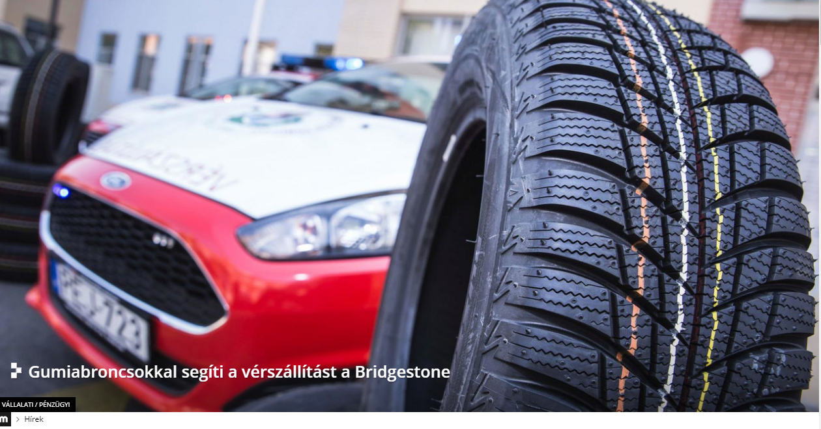
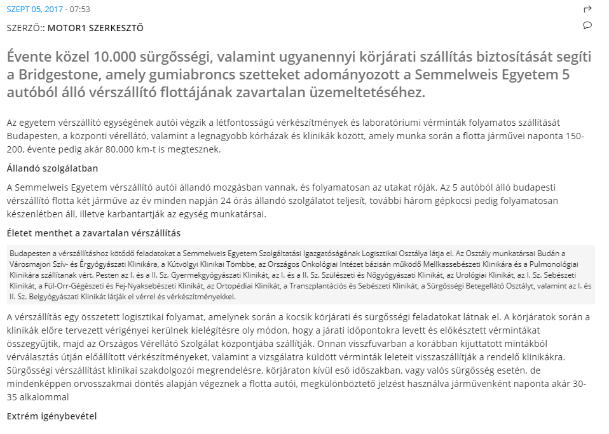

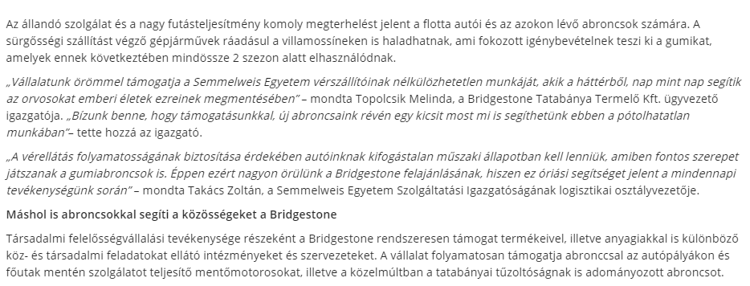

MÉDIA: | Gazmegfek.hu | MEDIA SPECIFICS
DATE | 2017.09.07. | TYPE: | Online
PAGE | - | REACH: | N/A
EAV (EUR) | N/A | FREQUENCY:
TITLE: | Bridgestone supports emergency blood transport by donatng tyres
SUMMARY | Bridgestone supports the assurance of almost 10.000 emergency transports and the same number of round deliveries every year by donating tyres for the continuous operation of the 5-car blood transport fleet of Semmelweis University. The blood transport units of the university transport the crucial blood products in Budapest between the blood supply center and the important hospitals and clinics. During this activity, the cars can run up to 150-200 kms daily and up to 80.000 kms annually.

http://www.gazmegfek.hu/2017/09/07/gumiabroncsokkal-segiti-verszallitast-bridgestone/

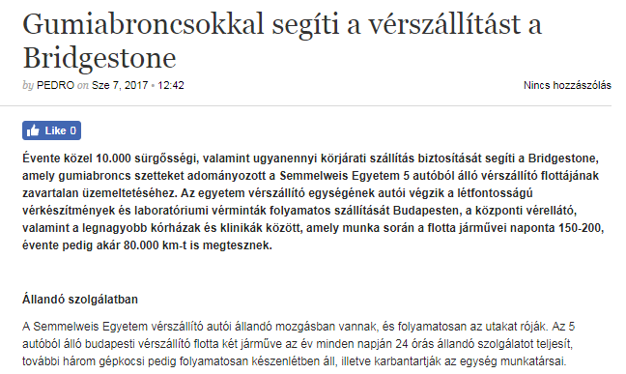
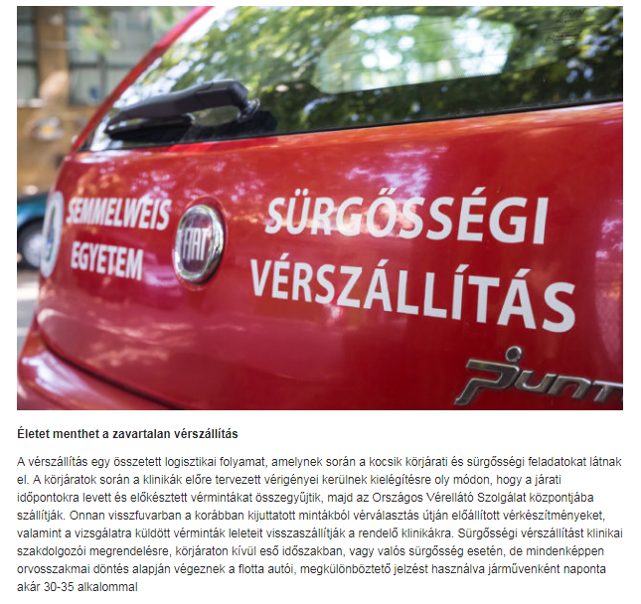

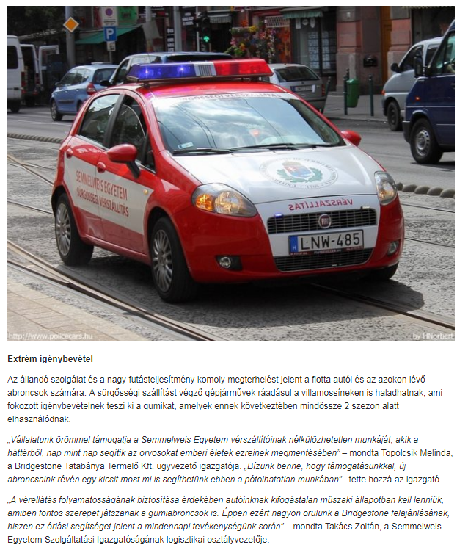
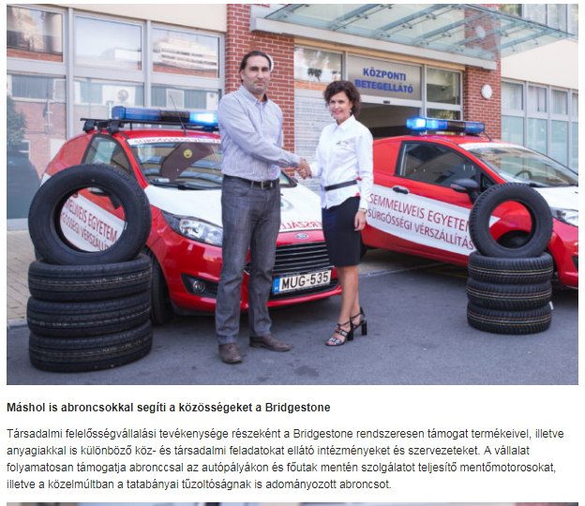
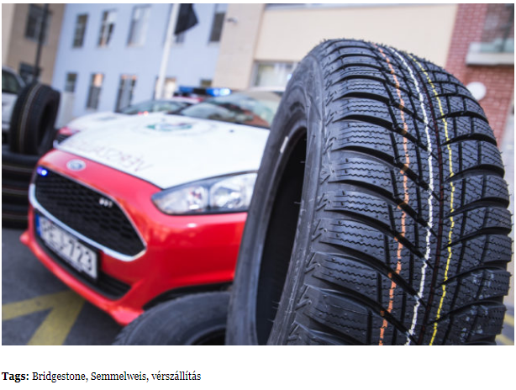

MÉDIA: | Biztonsagpiac.hu | MEDIA SPECIFICS
DATE | 2017.09.10. | TYPE: | Online
PAGE | - | REACH: | N/A
EAV (EUR) | N/A | FREQUENCY:
TITLE: | Bridgestone is kind: it supports emergency blood transporting by donating tyres
SUMMARY | Bridgestone supports the assurance of almost 10.000 emergency transports and the same number of round deliveries every year by donating tyres for the continuous operation of the 5-car blood transport fleet of Semmelweis University. The blood transport units of the university transport the crucial blood products in Budapest between the blood supply center and the important hospitals and clinics. During this activity, the cars can run up to 150-200 kms daily and up to 80.000 kms annually.

http://biztonsagpiac.hu/a-bridgestone-rendes-gumiabroncsokkal-segiti-a-verszallitast

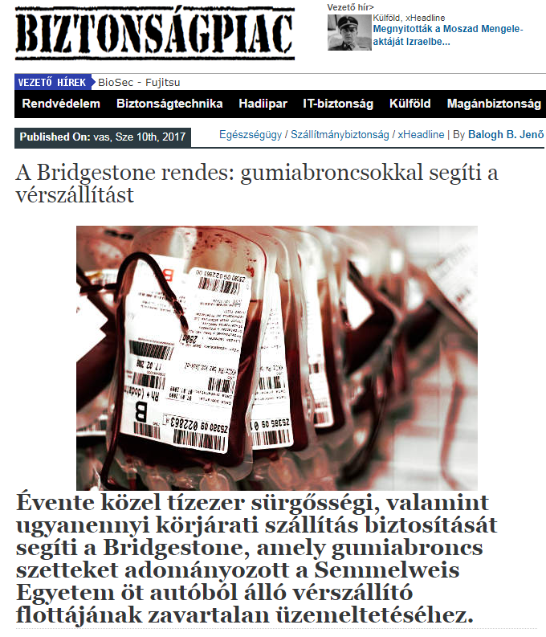
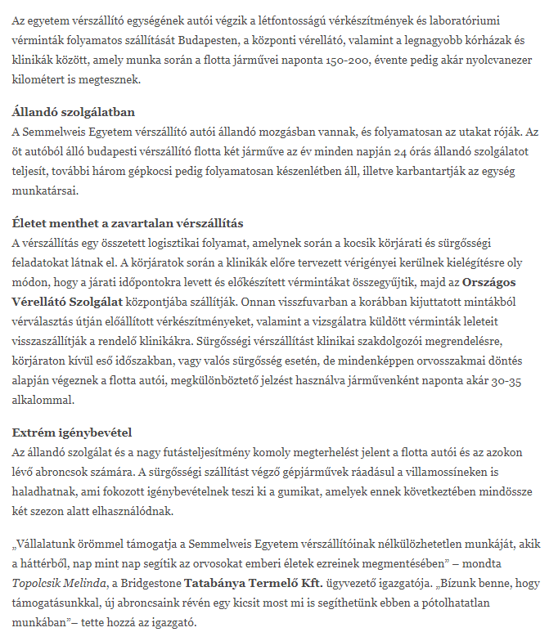
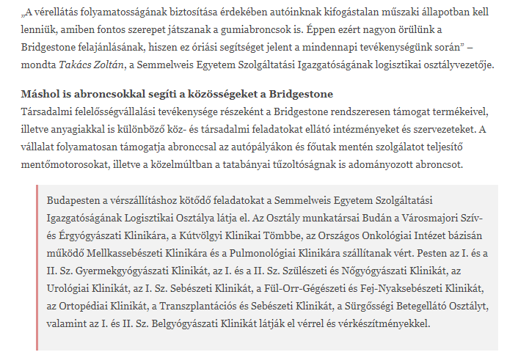

MÉDIA: | Semmelweis.hu | MEDIA SPECIFICS
DATE | 2017.09.08. | TYPE: | Online
PAGE | - | REACH: | N/A
EAV (EUR) | N/A | FREQUENCY:
TITLE: | Emergency blood transport cars are supported by tyres
SUMMARY | Bridgestone supports the assurance of almost 10.000 emergency transports and the same number of round deliveries every year by donating tyres for the continuous operation of the 5-car blood transport fleet of Semmelweis University. The blood transport units of the university transport the crucial blood products in Budapest between the blood supply center and the important hospitals and clinics. During this activity, the cars can run up to 150-200 kms daily and up to 80.000 kms annually.

http://semmelweis.hu/hirek/2017/09/08/gumiabroncsokkal-segitik-a-verszallito-autokat/

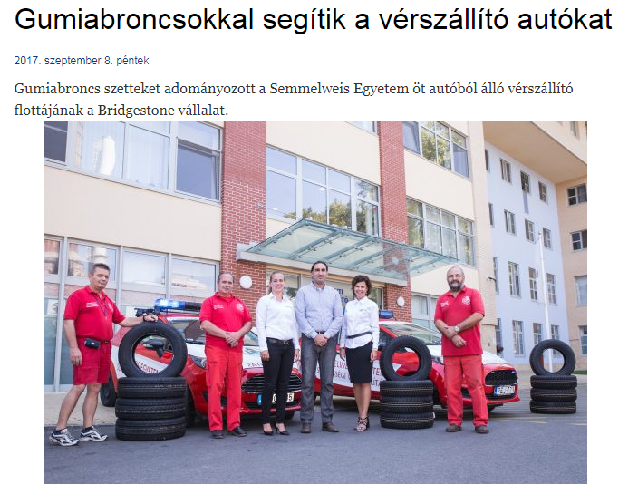
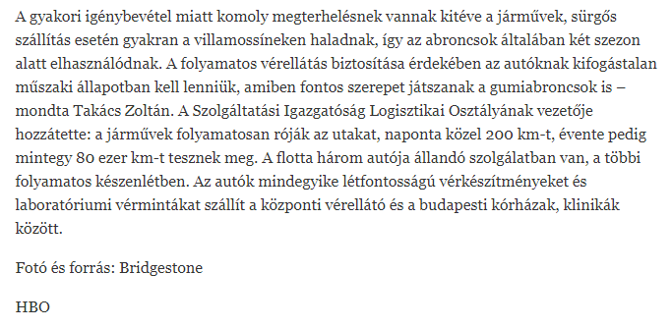

MÉDIA: | Gepjarmuszektor.hu | MEDIA SPECIFICS
DATE | 2017.09.07. | TYPE: | Online
PAGE | - | REACH: | N/A
EAV (EUR) | N/A | FREQUENCY:
TITLE: | Bridgestone supports emergency blood transport by donatng tyres
SUMMARY | Bridgestone supports the assurance of almost 10.000 emergency transports and the same number of round deliveries every year by donating tyres for the continuous operation of the 5-car blood transport fleet of Semmelweis University. The blood transport units of the university transport the crucial blood products in Budapest between the blood supply center and the important hospitals and clinics. During this activity, the cars can run up to 150-200 kms daily and up to 80.000 kms annually.

http://gepjarmuszektor.hu/cikk/id/gumiabroncsokkal_segiti_a_verszallitast_a_bridgestone_070917

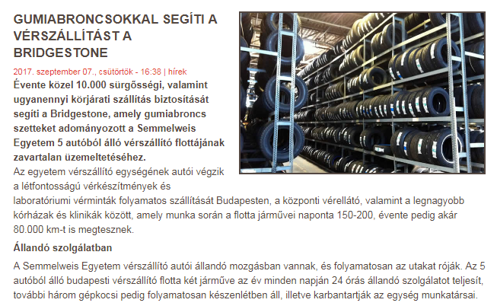

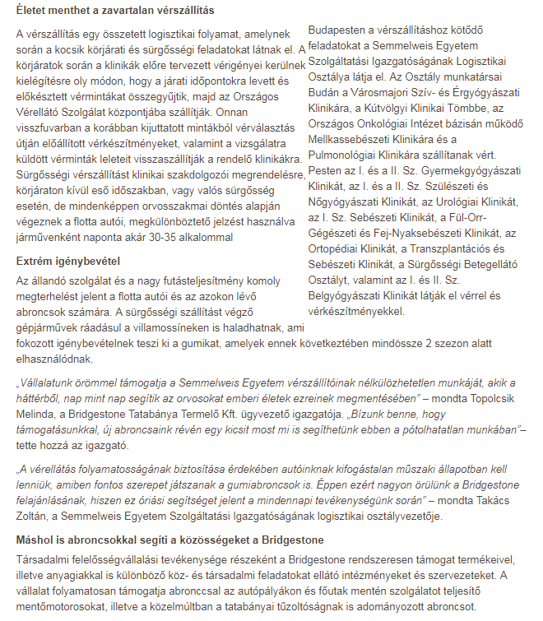

MÉDIA: | Regioregia.hu | MEDIA SPECIFICS
DATE | 2017.09.07. | TYPE: | Online
PAGE | - | REACH: | N/A
EAV (EUR) | N/A | FREQUENCY:
TITLE: | Bridgestone helps with tyres
SUMMARY | Bridgestone supports the assurance of almost 10.000 emergency transports and the same number of round deliveries every year by donating tyres for the continuous operation of the 5-car blood transport fleet of Semmelweis University. The blood transport units of the university transport the crucial blood products in Budapest between the blood supply center and the important hospitals and clinics. During this activity, the cars can run up to 150-200 kms daily and up to 80.000 kms annually.

http://www.regioregia.hu/index.php?hir_id=7341

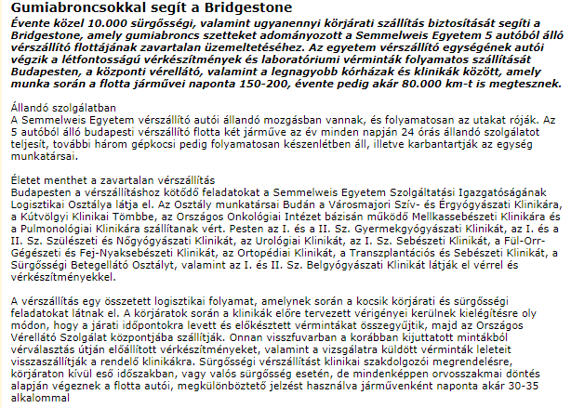

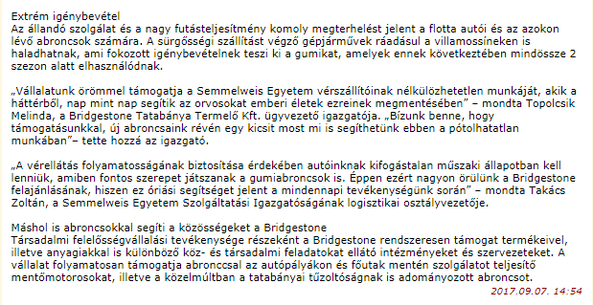

MÉDIA: | Bellacafe.hu | MEDIA SPECIFICS
DATE | 2017.09.12. | TYPE: | Online
PAGE | - | REACH: | 4 400
EAV (EUR) | 69 | FREQUENCY:
TITLE: | Bridgestone supports emergency blood transport by donatng tyres
SUMMARY | Bridgestone supports the assurance of almost 10.000 emergency transports and the same number of round deliveries every year by donating tyres for the continuous operation of the 5-car blood transport fleet of Semmelweis University. The blood transport units of the university transport the crucial blood products in Budapest between the blood supply center and the important hospitals and clinics. During this activity, the cars can run up to 150-200 kms daily and up to 80.000 kms annually.

http://www.bellacafe.hu/2017/09/12/gumiabroncsokkal-segiti-verszallitast-bridgestone/

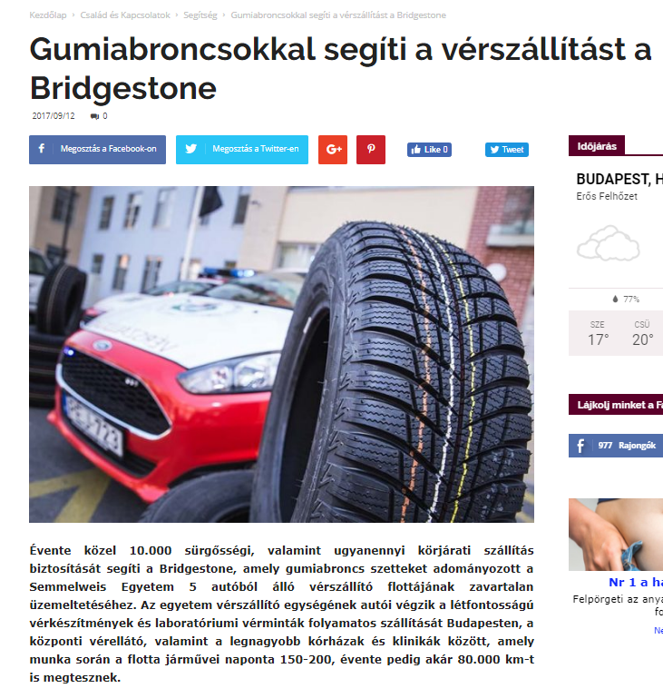
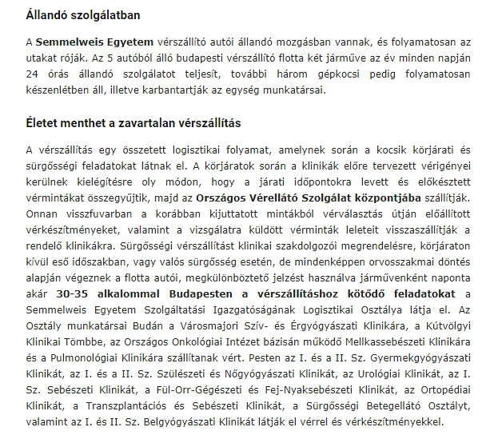
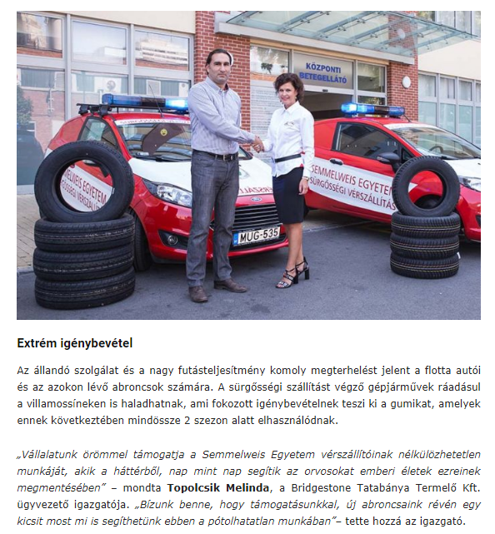

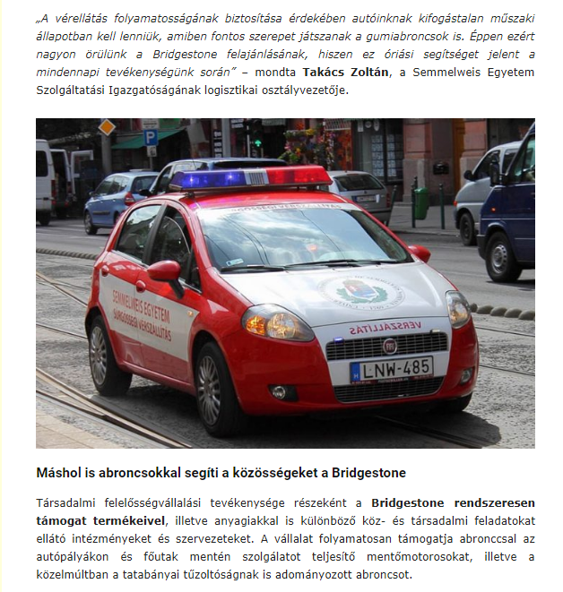

MÉDIA: | Gumipiacmagazin.hu | MEDIA SPECIFICS
DATE | 2017.09.13. | TYPE: | Online
PAGE | - | REACH: | 100
EAV (EUR) | 13 | FREQUENCY:
TITLE: | Bridgestone supports emergency blood transport
SUMMARY | Bridgestone supports the assurance of almost 10.000 emergency transports and the same number of round deliveries every year by donating tyres for the continuous operation of the 5-car blood transport fleet of Semmelweis University. The blood transport units of the university transport the crucial blood products in Budapest between the blood supply center and the important hospitals and clinics. During this activity, the cars can run up to 150-200 kms daily and up to 80.000 kms annually.

https://gumipiacmagazin.hu/2017/09/13/verszallitast-segit-bridgestone/

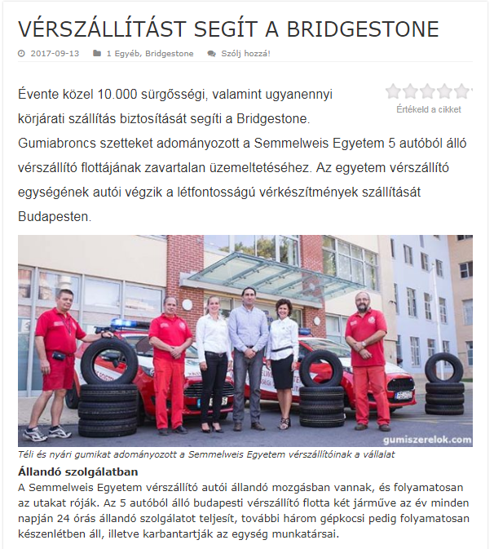

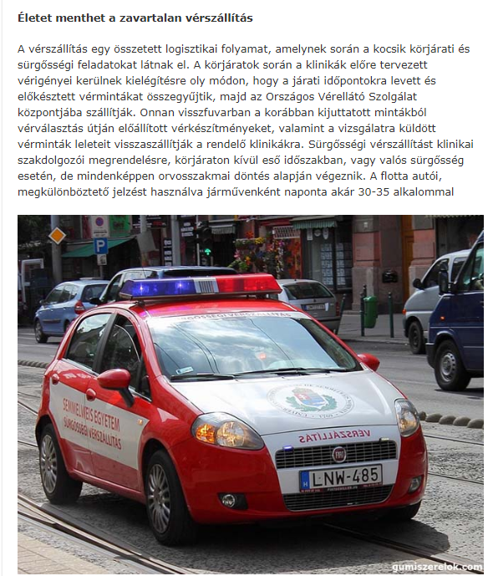
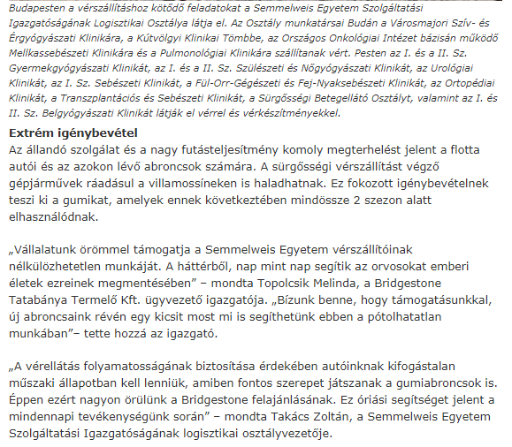
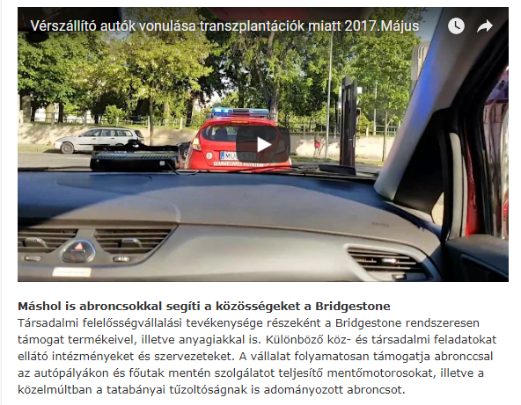

MÉDIA: | Magyar Idők | MEDIA SPECIFICS
DATE | 2017.09.13. | TYPE: | Print
PAGE | - | REACH: | 60 000
EAV (EUR) | 1 290 | FREQUENCY:
TITLE: | Emergency blood transport is supported with tyres
SUMMARY | Bridgestone supports the assurance of almost 10.000 emergency transports and the same number of round deliveries every year by donating tyres for the continuous operation of the 5-car blood transport fleet of Semmelweis University. The blood transport units of the university transport the crucial blood products in Budapest between the blood supply center and the important hospitals and clinics. During this activity, the cars can run up to 150-200 kms daily and up to 80.000 kms annually.

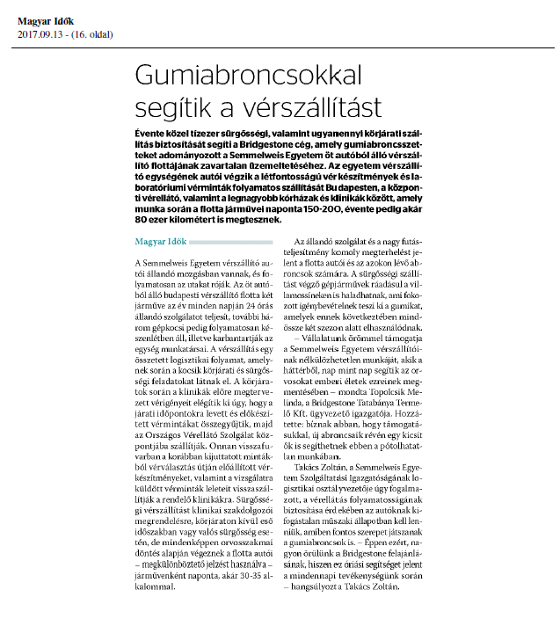

MÉDIA: | Népszava | MEDIA SPECIFICS
DATE | 2017.09.14. | TYPE: | Print
PAGE | - | REACH: | 92 547
EAV (EUR) | 1 000 | FREQUENCY:
TITLE: | Emergency blood transport is supported with tyres
SUMMARY | Bridgestone supports the assurance of almost 10.000 emergency transports and the same number of round deliveries every year by donating tyres for the continuous operation of the 5-car blood transport fleet of Semmelweis University. The blood transport units of the university transport the crucial blood products in Budapest between the blood supply center and the important hospitals and clinics. During this activity, the cars can run up to 150-200 kms daily and up to 80.000 kms annually.

MÉDIA: | Magyaridok.hu | MEDIA SPECIFICS
DATE | 2017.09.13. | TYPE: | Online
PAGE | - | REACH: | 20 000
EAV (EUR) | 276 | FREQUENCY:
TITLE: | Emergency blood transport is supported with tyres
SUMMARY | Bridgestone supports the assurance of almost 10.000 emergency transports and the same number of round deliveries every year by donating tyres for the continuous operation of the 5-car blood transport fleet of Semmelweis University. The blood transport units of the university transport the crucial blood products in Budapest between the blood supply center and the important hospitals and clinics. During this activity, the cars can run up to 150-200 kms daily and up to 80.000 kms annually.

http://magyaridok.hu/gazdasag/gumiabroncsokkal-segitik-verszallitast-2203996/

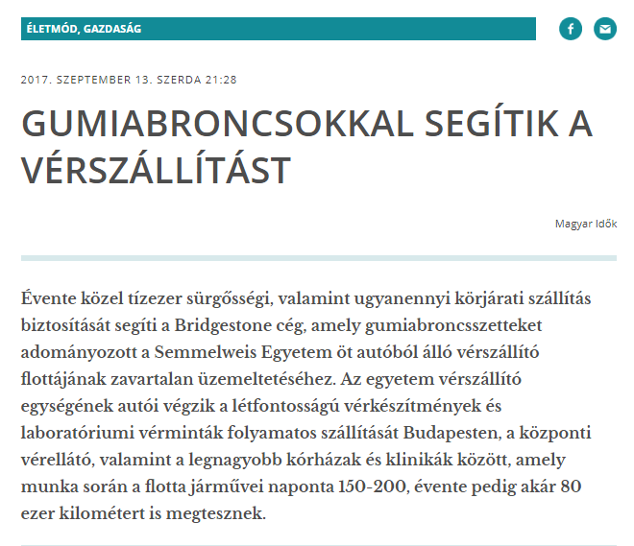
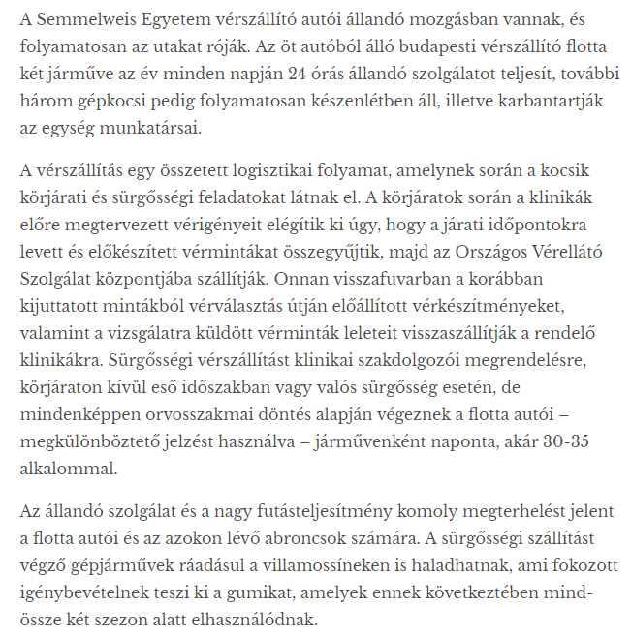
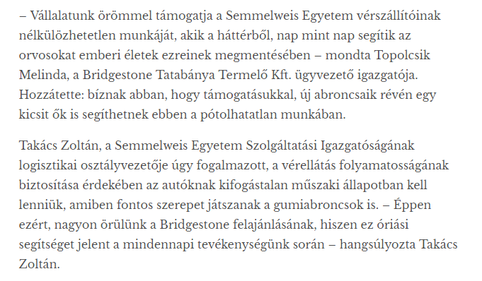

MÉDIA: | Hirekma.hu | MEDIA SPECIFICS
DATE | 2017.09.12. | TYPE: | Online
PAGE | - | REACH: | N/A
EAV (EUR) | N/A | FREQUENCY:
TITLE: | Bridgestone supports emergency blood transport by donatng tyres
SUMMARY | Bridgestone supports the assurance of almost 10.000 emergency transports and the same number of round deliveries every year by donating tyres for the continuous operation of the 5-car blood transport fleet of Semmelweis University. The blood transport units of the university transport the crucial blood products in Budapest between the blood supply center and the important hospitals and clinics. During this activity, the cars can run up to 150-200 kms daily and up to 80.000 kms annually.

http://hirekma.hu/hir/2264552/gumiabroncsokkal-segiti-a-verszallitast-a-bridgestone.html

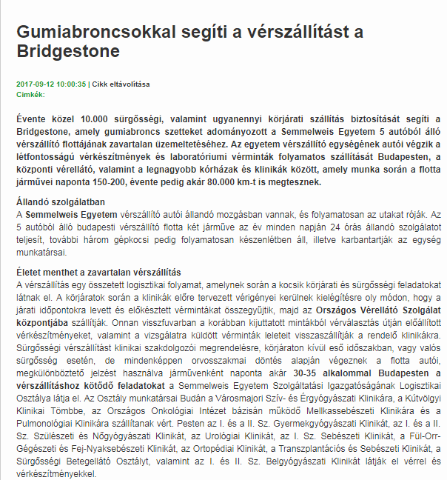

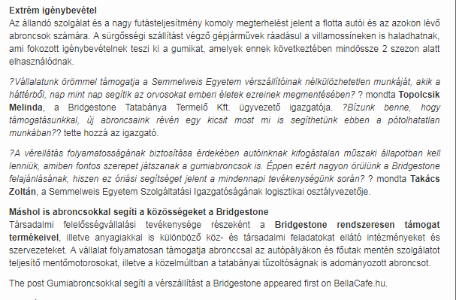

MÉDIA: | Egyszermarlattamautot.hu | MEDIA SPECIFICS
DATE | 2017.09.05. | TYPE: | Online
PAGE | - | REACH: | N/A
EAV (EUR) | N/A | FREQUENCY:
TITLE: | Bridgestone donates winter and summer tyres to the emergency blood transport cars of Semmelweis University
SUMMARY | Bridgestone supports the assurance of almost 10.000 emergency transports and the same number of round deliveries every year by donating tyres for the continuous operation of the 5-car blood transport fleet of Semmelweis University. The blood transport units of the university transport the crucial blood products in Budapest between the blood supply center and the important hospitals and clinics. During this activity, the cars can run up to 150-200 kms daily and up to 80.000 kms annually.

http://egyszermarlattamautot.hu/2017/09/05/teli-es-nyari-gumikat-adomanyozott-a-semmelweis-egyetem-verszallitoinak-a-bridgestone/

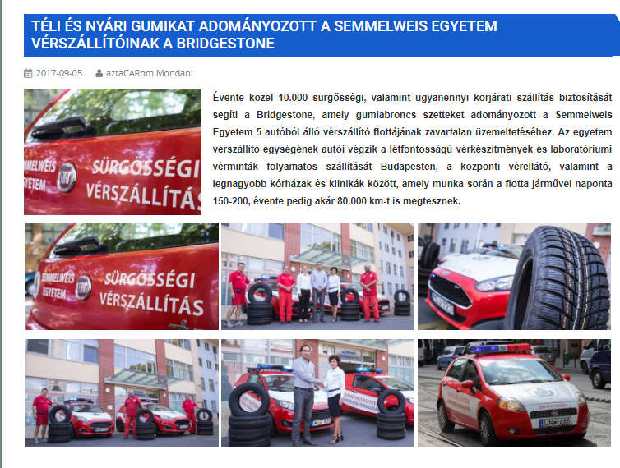

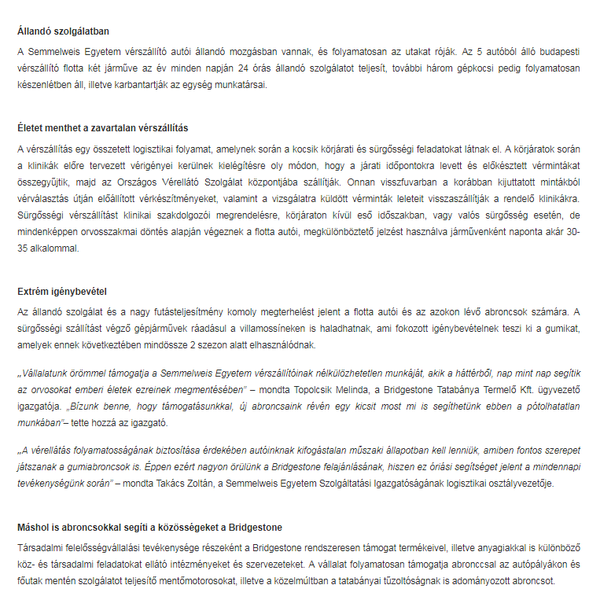

MÉDIA: | Magnolia-magazin.hu | MEDIA SPECIFICS
DATE | 2017.09.06. | TYPE: | Online
PAGE | - | REACH: | N/A
EAV (EUR) | N/A | FREQUENCY:
TITLE: | Bridgestone supports emergency blood transport by donatng tyres
SUMMARY | Bridgestone supports the assurance of almost 10.000 emergency transports and the same number of round deliveries every year by donating tyres for the continuous operation of the 5-car blood transport fleet of Semmelweis University. The blood transport units of the university transport the crucial blood products in Budapest between the blood supply center and the important hospitals and clinics. During this activity, the cars can run up to 150-200 kms daily and up to 80.000 kms annually.

http://www.magnolia-magazin.hu/aktualis/gumiabroncsokkal-segiti-a-verszallitast-a-bridgestone/

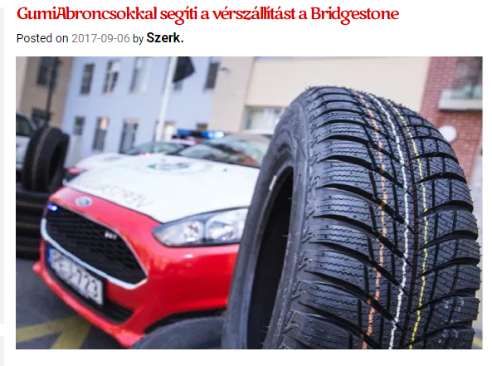

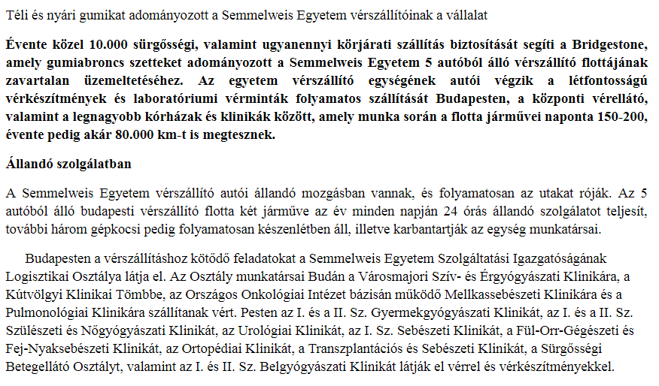
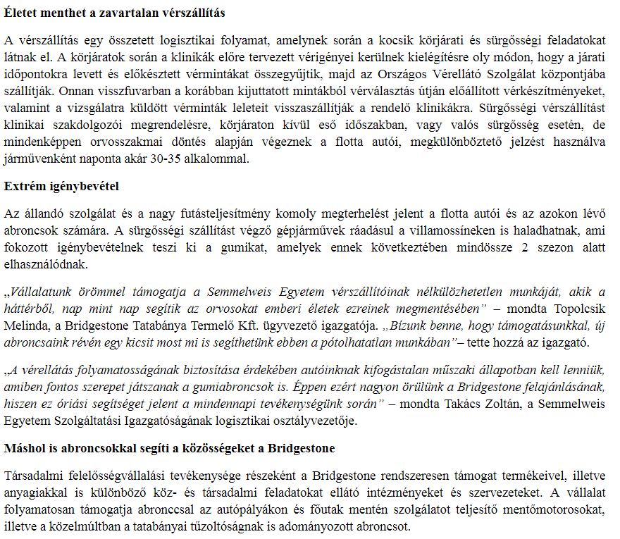

MÉDIA: | Lokál | MEDIA SPECIFICS
DATE | 2017.09.13. | TYPE: | Print
PAGE | - | REACH: | 450 000
EAV (EUR) | 1 190 | FREQUENCY:
TITLE: | Donation for emergency blood transporters
SUMMARY | Bridgestone supports the assurance of almost 10.000 emergency transports and the same number of round deliveries every year by donating tyres for the continuous operation of the 5-car blood transport fleet of Semmelweis University. The blood transport units of the university transport the crucial blood products in Budapest between the blood supply center and the important hospitals and clinics. During this activity, the cars can run up to 150-200 kms daily and up to 80.000 kms annually.

MÉDIA: | Flagmagazin.hu | MEDIA SPECIFICS
DATE | 2017.09.13. | TYPE: | Online
PAGE | - | REACH: | 450 000
EAV (EUR) | 1 190 | FREQUENCY:
TITLE: | Emergency blood transport is supported with tyres
SUMMARY | Bridgestone supports the assurance of almost 10.000 emergency transports and the same number of round deliveries every year by donating tyres for the continuous operation of the 5-car blood transport fleet of Semmelweis University. The blood transport units of the university transport the crucial blood products in Budapest between the blood supply center and the important hospitals and clinics. During this activity, the cars can run up to 150-200 kms daily and up to 80.000 kms annually.

https://www.flagmagazin.hu/aktualis/gumiabroncsokkal-segitik-a-verszallitast

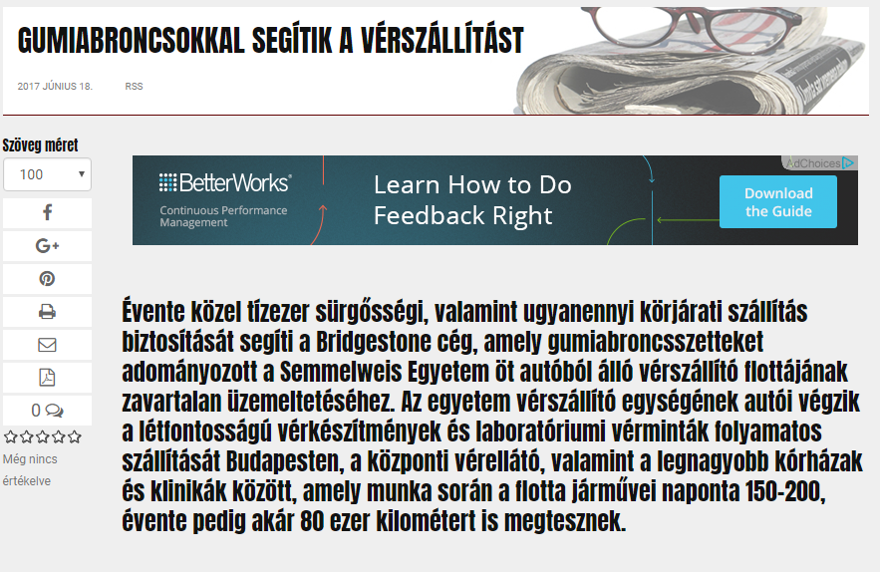

MÉDIA: | Lánchíd Rádió | MEDIA SPECIFICS
DATE | 2017.09.13. | TYPE: | Electronic
PAGE | - | REACH: | 21 000
EAV (EUR) | 400 | FREQUENCY:
TITLE: | Tyres in the pay of emergency blood transport
SUMMARY | Bridgestone supports the assurance of almost 10.000 emergency transports and the same number of round deliveries every year by donating tyres for the continuous operation of the 5-car blood transport fleet of Semmelweis University. The blood transport units of the university transport the crucial blood products in Budapest between the blood supply center and the important hospitals and clinics. During this activity, the cars can run up to 150-200 kms daily and up to 80.000 kms annually.

http://www.premiercom.hu/download/private/Bridgestone/Lanchid--20170918--1144.mp3

Username: Bridgestone
Password: 5665

MÉDIA: | Bonum TV | MEDIA SPECIFICS
DATE | 2017.09.13. | TYPE: | Electronic
PAGE | - | REACH: | N/A
EAV (EUR) | N/A | FREQUENCY:
TITLE: | Interview with Zoltán Takács
SUMMARY | Bridgestone supports the assurance of almost 10.000 emergency transports and the same number of round deliveries every year by donating tyres for the continuous operation of the 5-car blood transport fleet of Semmelweis University. The blood transport units of the university transport the crucial blood products in Budapest between the blood supply center and the important hospitals and clinics. During this activity, the cars can run up to 150-200 kms daily and up to 80.000 kms annually.

http://bonumtv.hu/verszallitok-budapesten-takacs-zoltan/

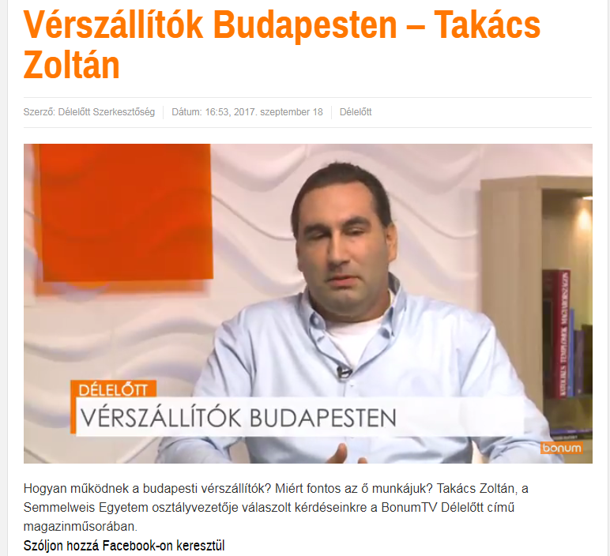

MÉDIA: | Auto-Motor | MEDIA SPECIFICS
DATE | 2017.09.20. | TYPE: | Print
PAGE | - | REACH: | 645
EAV (EUR) | 91 671 | FREQUENCY:
TITLE: | Blood Line
SUMMARY | Bridgestone supports the assurance of almost 10.000 emergency transports and the same number of round deliveries every year by donating tyres for the continuous operation of the 5-car blood transport fleet of Semmelweis University. The blood transport units of the university transport the crucial blood products in Budapest between the blood supply center and the important hospitals and clinics. During this activity, the cars can run up to 150-200 kms daily and up to 80.000 kms annually.

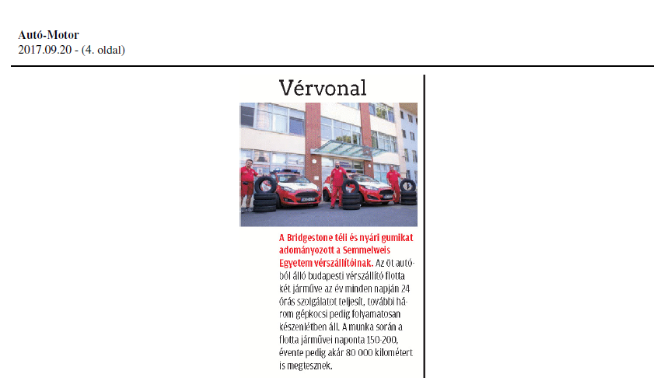

MÉDIA: | MTV | MEDIA SPECIFICS
DATE | 2017.09.20. | TYPE: | Electronic
PAGE | - | REACH: | 250 000
EAV (EUR) | 1 000 | FREQUENCY:
TITLE: | The emergency blood transport cars of Semmelweis University winter and summer tyres
SUMMARY | Bridgestone supports the assurance of almost 10.000 emergency transports and the same number of round deliveries every year by donating tyres for the continuous operation of the 5-car blood transport fleet of Semmelweis University. The blood transport units of the university transport the crucial blood products in Budapest between the blood supply center and the important hospitals and clinics. During this activity, the cars can run up to 150-200 kms daily and up to 80.000 kms annually.

http://www.mediaklikk.hu/video/ma-delelott-2017-09-23-i-adas/

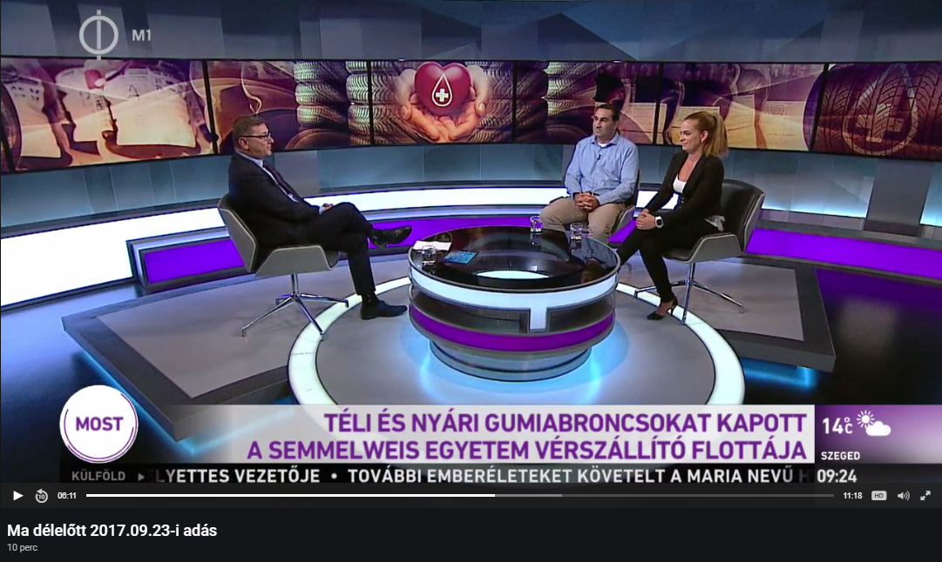

MÉDIA: | Napidoktor.hu | MEDIA SPECIFICS
DATE | 2017.09.12. | TYPE: | Online
PAGE | - | REACH: | 250 000
EAV (EUR) | 1 000 | FREQUENCY:
TITLE: | The emergency blood transport cars of Semmelweis University winter and summer tyres
SUMMARY | Bridgestone supports the assurance of almost 10.000 emergency transports and the same number of round deliveries every year by donating tyres for the continuous operation of the 5-car blood transport fleet of Semmelweis University. The blood transport units of the university transport the crucial blood products in Budapest between the blood supply center and the important hospitals and clinics. During this activity, the cars can run up to 150-200 kms daily and up to 80.000 kms annually.

http://napidoktor.hu/napi-hirek/gumiabroncsokkal-segitik-verszallitast/

