MEDIA: | Blikk.hu | MEDIA SPECIFICS
DATE: | 27.11.2018. | TYPE: | Online
PAGE: | - | Reach: | 400 000
Ad value (€) | 240 | FREQUENCY: | 2 alkalommal
HEADLINE: | Arctic cold: the tire changing peak
SUMMARY: | During these week almost 1.5 million drivers change their summer tires to more adhesive winter tires with more lamellae. In this period 300,000 owner buys new winter tire set, and is necessary when the tires' profile depth falls below 4 mm or has been running for 3-4 seasons and its material is aging. Tire manufacturers are also prepared for the season. For example, Bridgestone offers its most popular winter and four season tires with defect-resistant technology, because one of the major road safety risks is the snow-covered defect.

http://www.blikk.hu/eletmod/tippek/csucson-az-abroncscsere-szezon/dhw3nx5

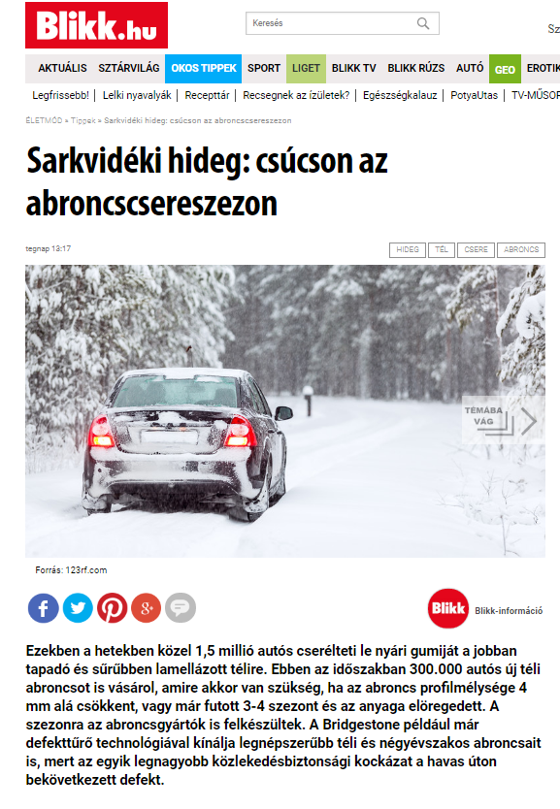

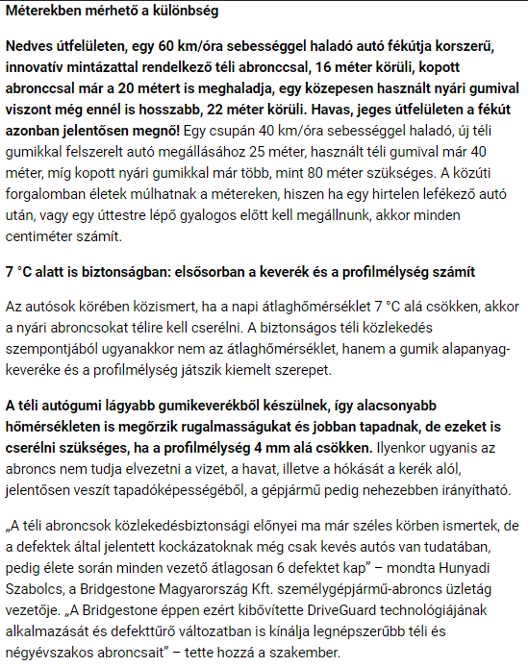

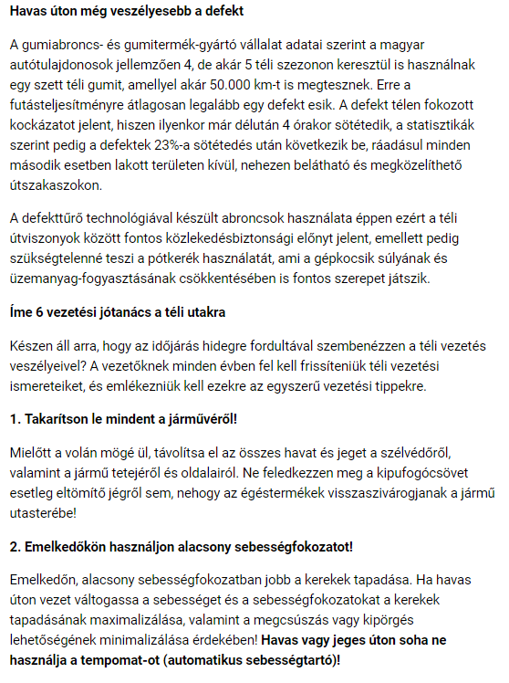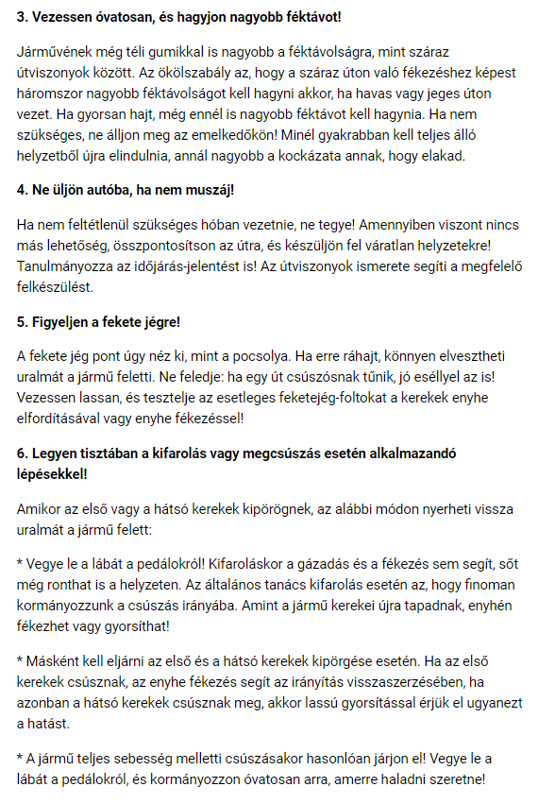

MEDIA: | Civilhetes.net | MEDIA SPECIFICS
DATE: | 27.11.2018. | TYPE: | Online
PAGE: | - | Reach: | N/A
Ad value (€) | N/A | FREQUENCY:
HEADLINE: | Arctic cold: the tire changing peak
SUMMARY: | During these week almost 1.5 million drivers change their summer tires to more adhesive winter tires with more lamellae. In this period 300,000 owner buys new winter tire set, and is necessary when the tires' profile depth falls below 4 mm or has been running for 3-4 seasons and its material is aging. Tire manufacturers are also prepared for the season. For example, Bridgestone offers its most popular winter and four season tires with defect-resistant technology, because one of the major road safety risks is the snow-covered defect.

https://civilhetes.net/sarkvideki-hideg-csucson-az-abroncscsere-szezon

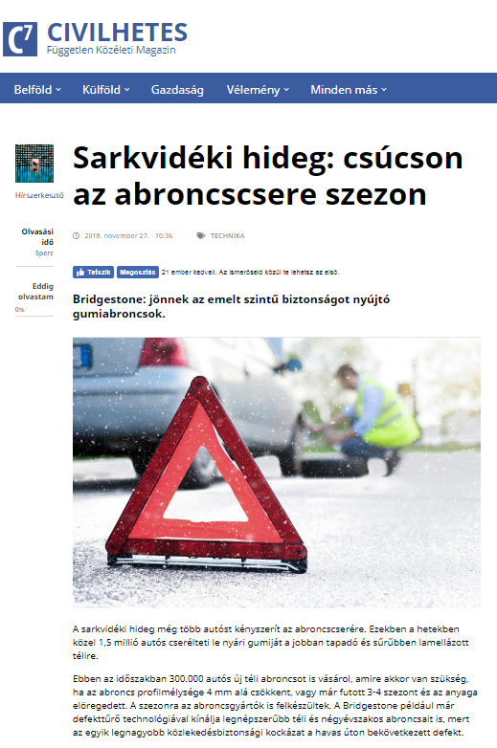

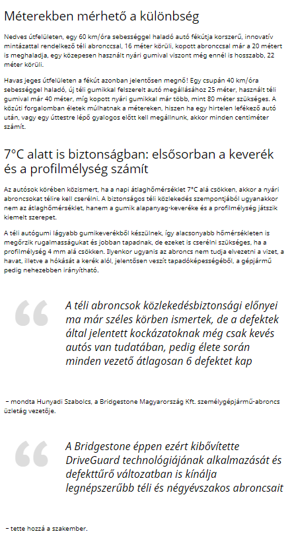

MEDIA: | Gazdasagportal.hu | MEDIA SPECIFICS
DATE: | 27.11.2018. | TYPE: | Online
PAGE: | - | Reach: | N/A
Ad value (€) | N/A | FREQUENCY:
HEADLINE: | Arctic cold: the tire changing peak
SUMMARY: | During these week almost 1.5 million drivers change their summer tires to more adhesive winter tires with more lamellae. In this period 300,000 owner buys new winter tire set, and is necessary when the tires' profile depth falls below 4 mm or has been running for 3-4 seasons and its material is aging. Tire manufacturers are also prepared for the season. For example, Bridgestone offers its most popular winter and four season tires with defect-resistant technology, because one of the major road safety risks is the snow-covered defect.

http://gazdasagportal.hu/index.php/sarkvideki-hideg-csucson-az-abroncscsere-szezon/

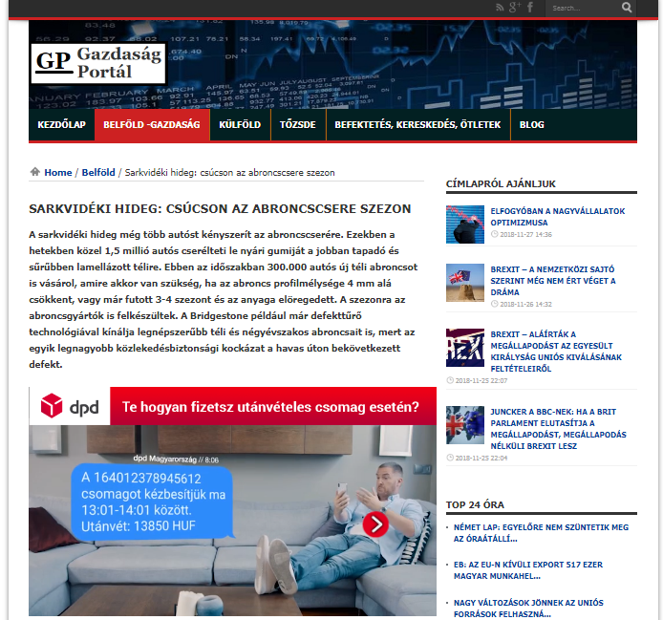

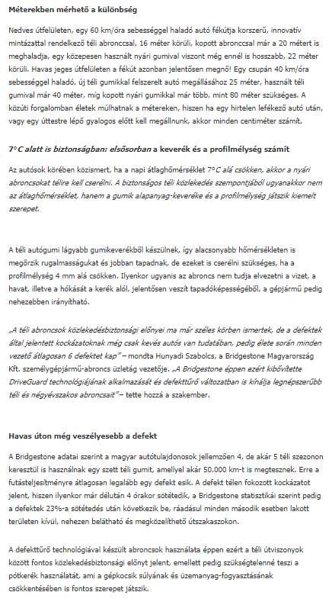

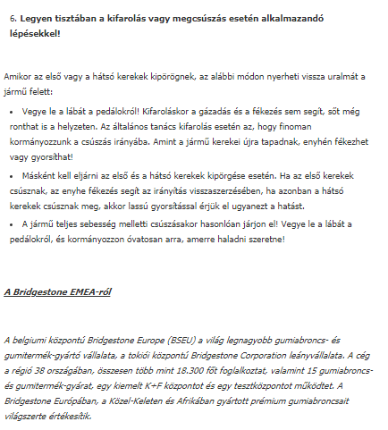

MEDIA: | Hrglobe.hu | MEDIA SPECIFICS
DATE: | 27.11.2018. | TYPE: | Online
PAGE: | - | Reach: | N/A
Ad value (€) | N/A | FREQUENCY:
HEADLINE: | Arctic cold: the tire changing peak
SUMMARY: | During these week almost 1.5 million drivers change their summer tires to more adhesive winter tires with more lamellae. In this period 300,000 owner buys new winter tire set, and is necessary when the tires' profile depth falls below 4 mm or has been running for 3-4 seasons and its material is aging. Tire manufacturers are also prepared for the season. For example, Bridgestone offers its most popular winter and four season tires with defect-resistant technology, because one of the major road safety risks is the snow-covered defect.

https://hrglobe.hu/1perc/itt-az-ideje-az-abroncscserenek/

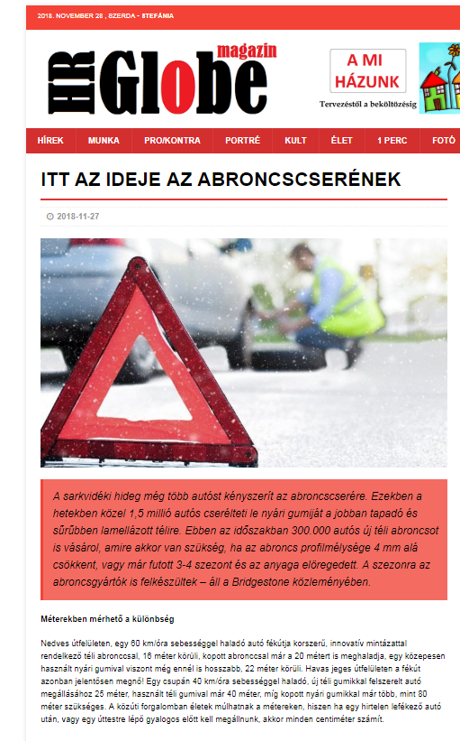

MEDIA: | Kadarka.net | MEDIA SPECIFICS
DATE: | 27.11.2018. | TYPE: | Online
PAGE: | - | Reach: | N/A
Ad value (€) | N/A | FREQUENCY:
HEADLINE: | Tire changing peak
SUMMARY: | During these week almost 1.5 million drivers change their summer tires to more adhesive winter tires with more lamellae. In this period 300,000 owner buys new winter tire set, and is necessary when the tires' profile depth falls below 4 mm or has been running for 3-4 seasons and its material is aging. Tire manufacturers are also prepared for the season. For example, Bridgestone offers its most popular winter and four season tires with defect-resistant technology, because one of the major road safety risks is the snow-covered defect.

https://kadarka.net/cikkek-kat/csucson-az-abroncscsere-szezon

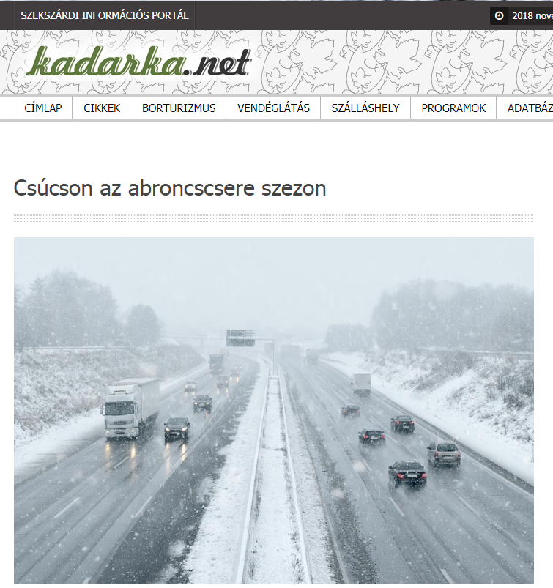

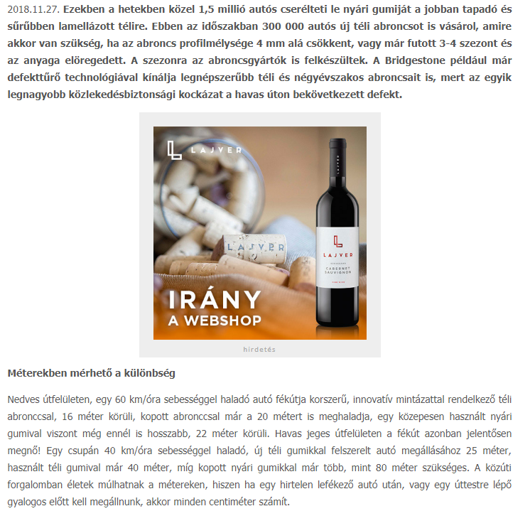

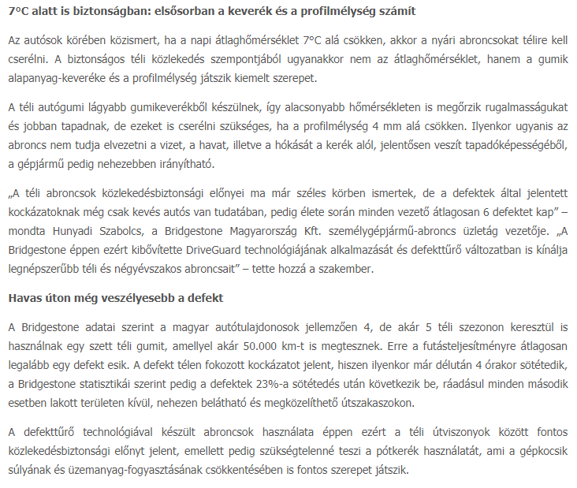

MEDIA: | Pecsinapilap.hu | MEDIA SPECIFICS
DATE: | 27.11.2018. | TYPE: | Online
PAGE: | - | Reach: | 28 333
Ad value (€) | 266 | FREQUENCY: | 28 alkalommal
HEADLINE: | Tire changing peak
SUMMARY: | During these week almost 1.5 million drivers change their summer tires to more adhesive winter tires with more lamellae. In this period 300,000 owner buys new winter tire set, and is necessary when the tires' profile depth falls below 4 mm or has been running for 3-4 seasons and its material is aging. Tire manufacturers are also prepared for the season. For example, Bridgestone offers its most popular winter and four season tires with defect-resistant technology, because one of the major road safety risks is the snow-covered defect.

http://www.pecsinapilap.hu/cikk/Sarkvideki_hideg__csucson_az_abroncscsere_szezon/218937/

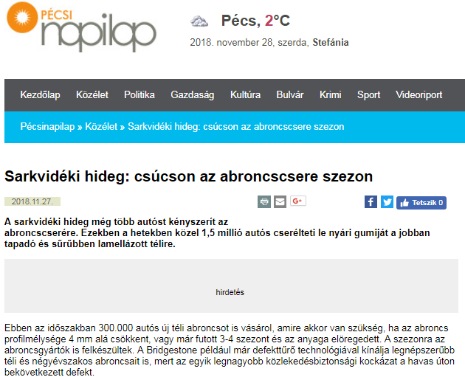

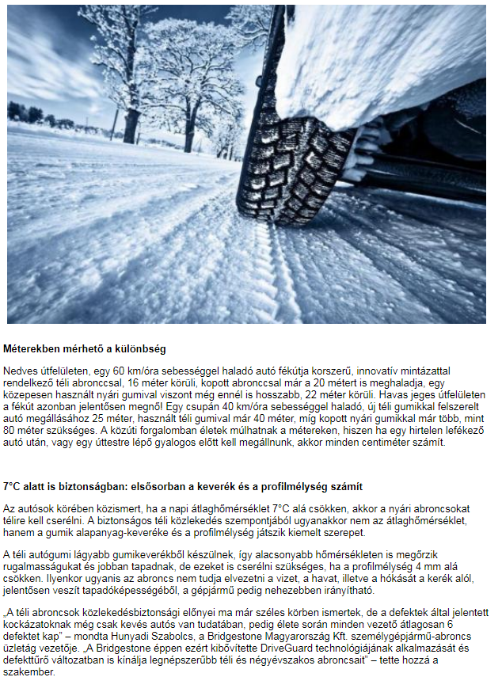

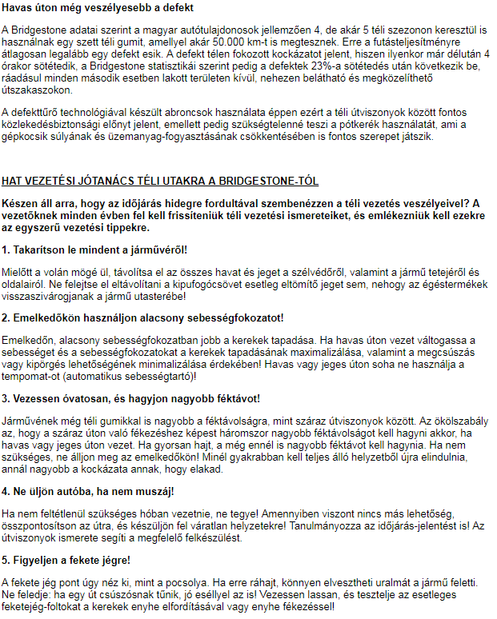

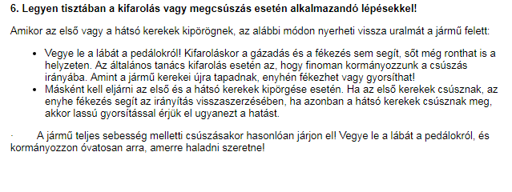

MEDIA: | Erdon.ro | MEDIA SPECIFICS
DATE: | 27.11.2018. | TYPE: | Online
PAGE: | - | Reach: | 168 000
Ad value (€) | 120 | FREQUENCY:
HEADLINE: | Spectacular tire change
SUMMARY: | During these week almost 1.5 million drivers change their summer tires to more adhesive winter tires with more lamellae. In this period 300,000 owner buys new winter tire set, and is necessary when the tires' profile depth falls below 4 mm or has been running for 3-4 seasons and its material is aging. Tire manufacturers are also prepared for the season. For example, Bridgestone offers its most popular winter and four season tires with defect-resistant technology, because one of the major road safety risks is the snow-covered defect.

http://www.erdon.ro/latvanyosan-kereket-oldo-gumisok/4063794
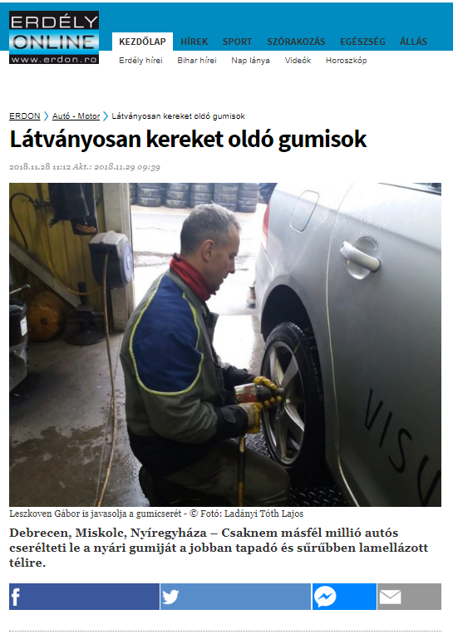

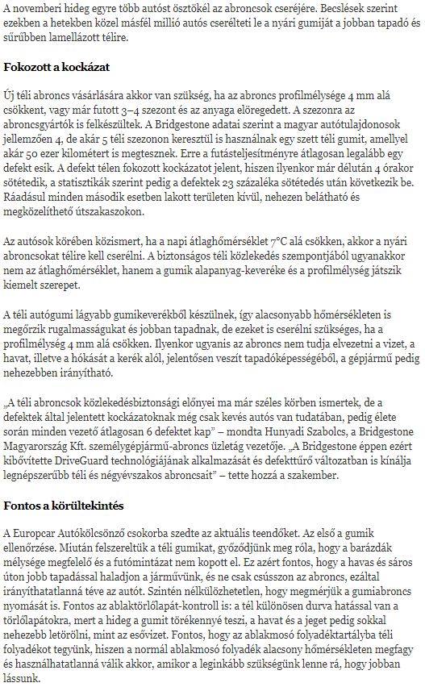

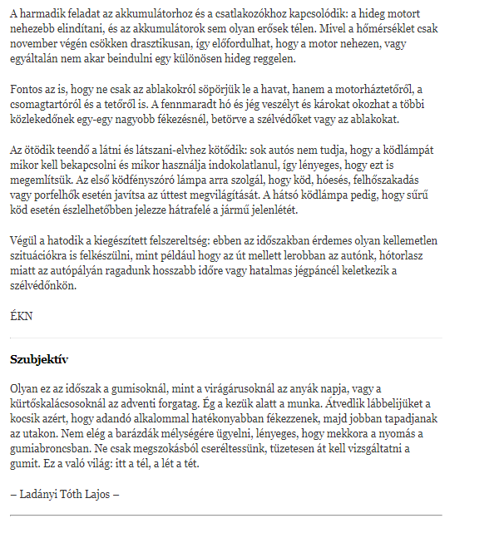

MEDIA: | Haon.hu | MEDIA SPECIFICS
DATE: | 27.11.2018. | TYPE: | Online
PAGE: | - | Reach: | 36 232
Ad value (€) | 545 | FREQUENCY:
HEADLINE: | Spectacular tire change
SUMMARY: | During these week almost 1.5 million drivers change their summer tires to more adhesive winter tires with more lamellae. In this period 300,000 owner buys new winter tire set, and is necessary when the tires' profile depth falls below 4 mm or has been running for 3-4 seasons and its material is aging. Tire manufacturers are also prepared for the season. For example, Bridgestone offers its most popular winter and four season tires with defect-resistant technology, because one of the major road safety risks is the snow-covered defect.

http://www.haon.hu/latvanyosan-kereket-oldo-gumisok/4063794
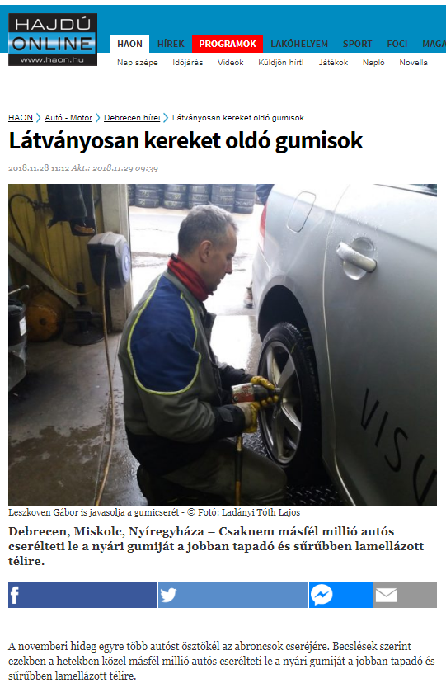
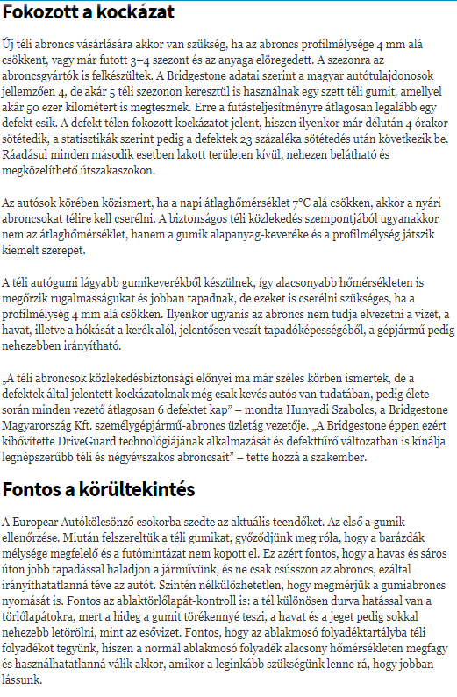

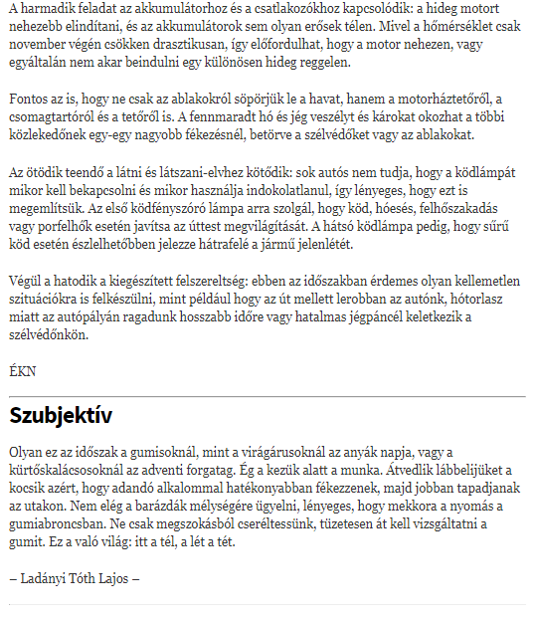

MEDIA: | Szon.hu | MEDIA SPECIFICS
DATE: | 27.11.2018. | TYPE: | Online
PAGE: | - | Reach: | 44 362
Ad value (€) | 545 | FREQUENCY:
HEADLINE: | Spectacular tire change
SUMMARY: | During these week almost 1.5 million drivers change their summer tires to more adhesive winter tires with more lamellae. In this period 300,000 owner buys new winter tire set, and is necessary when the tires' profile depth falls below 4 mm or has been running for 3-4 seasons and its material is aging. Tire manufacturers are also prepared for the season. For example, Bridgestone offers its most popular winter and four season tires with defect-resistant technology, because one of the major road safety risks is the snow-covered defect.

http://www.szon.hu/latvanyosan-kereket-oldo-gumisok/4063794

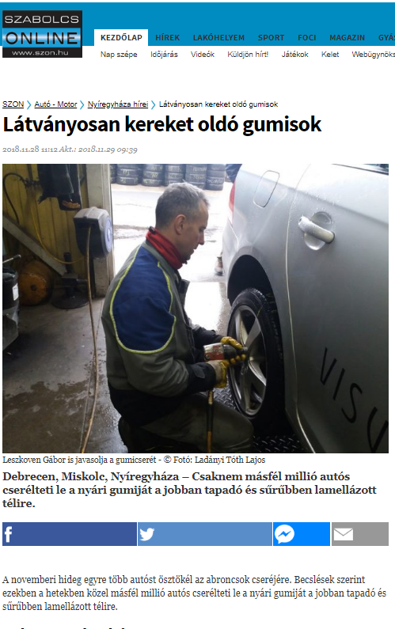

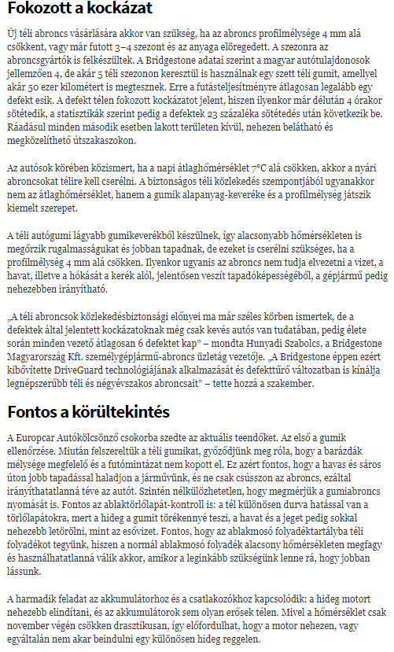

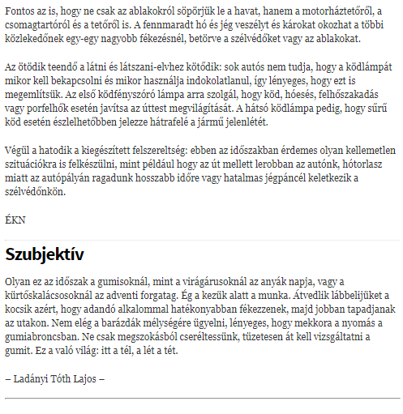

MEDIA: | Boon.hu | MEDIA SPECIFICS
DATE: | 27.11.2018. | TYPE: | Online
PAGE: | - | Reach: | 21 160
Ad value (€) | 545 | FREQUENCY:
HEADLINE: | Spectacular tire change
SUMMARY: | During these week almost 1.5 million drivers change their summer tires to more adhesive winter tires with more lamellae. In this period 300,000 owner buys new winter tire set, and is necessary when the tires' profile depth falls below 4 mm or has been running for 3-4 seasons and its material is aging. Tire manufacturers are also prepared for the season. For example, Bridgestone offers its most popular winter and four season tires with defect-resistant technology, because one of the major road safety risks is the snow-covered defect.

http://www.boon.hu/latvanyosan-kereket-oldo-gumisok/4063794

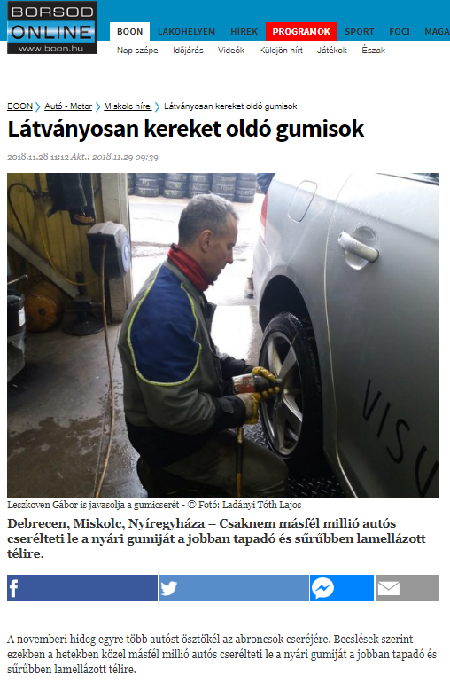

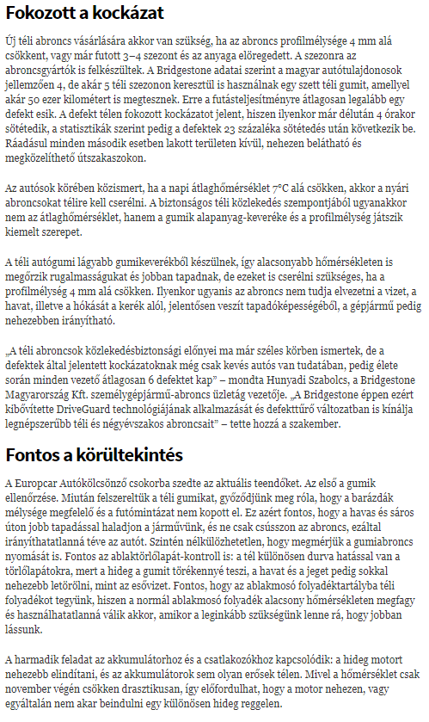

MEDIA: | Kelet-Magyarország | MEDIA SPECIFICS
DATE: | 28.11.2018. | TYPE: | Print
PAGE: | - | Reach: | 117 000
Ad value (€) | 2 064 | FREQUENCY:
HEADLINE: | Spectacular tire change
SUMMARY: | During these week almost 1.5 million drivers change their summer tires to more adhesive winter tires with more lamellae. In this period 300,000 owner buys new winter tire set, and is necessary when the tires' profile depth falls below 4 mm or has been running for 3-4 seasons and its material is aging. Tire manufacturers are also prepared for the season. For example, Bridgestone offers its most popular winter and four season tires with defect-resistant technology, because one of the major road safety risks is the snow-covered defect.

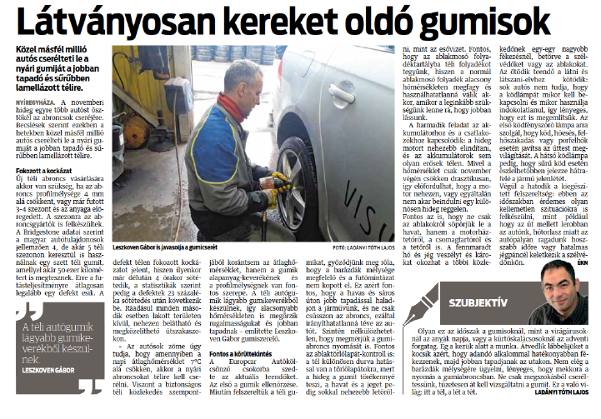

MEDIA: | Észak-Magyarország | MEDIA SPECIFICS
DATE: | 28.11.2018. | TYPE: | Print
PAGE: | - | Reach: | 403 000
Ad value (€) | 2 250 | FREQUENCY:
HEADLINE: | Spectacular tire change
SUMMARY: | During these week almost 1.5 million drivers change their summer tires to more adhesive winter tires with more lamellae. In this period 300,000 owner buys new winter tire set, and is necessary when the tires' profile depth falls below 4 mm or has been running for 3-4 seasons and its material is aging. Tire manufacturers are also prepared for the season. For example, Bridgestone offers its most popular winter and four season tires with defect-resistant technology, because one of the major road safety risks is the snow-covered defect.

MEDIA: | Hajdú-Bihari Napló | MEDIA SPECIFICS
DATE: | 28.11.2018. | TYPE: | Print
PAGE: | - | Reach: | 403 000
Ad value (€) | 2 064 | FREQUENCY:
HEADLINE: | Spectacular tire change
SUMMARY: | During these week almost 1.5 million drivers change their summer tires to more adhesive winter tires with more lamellae. In this period 300,000 owner buys new winter tire set, and is necessary when the tires' profile depth falls below 4 mm or has been running for 3-4 seasons and its material is aging. Tire manufacturers are also prepared for the season. For example, Bridgestone offers its most popular winter and four season tires with defect-resistant technology, because one of the major road safety risks is the snow-covered defect.

MEDIA: | Autosvilag.hu | MEDIA SPECIFICS
DATE: | 28.11.2018. | TYPE: | Online
PAGE: | - | Reach: | N/A
Ad value (€) | N/A | FREQUENCY:
HEADLINE: | Arctic cold: the tire changing peak
SUMMARY: | During these week almost 1.5 million drivers change their summer tires to more adhesive winter tires with more lamellae. In this period 300,000 owner buys new winter tire set, and is necessary when the tires' profile depth falls below 4 mm or has been running for 3-4 seasons and its material is aging. Tire manufacturers are also prepared for the season. For example, Bridgestone offers its most popular winter and four season tires with defect-resistant technology, because one of the major road safety risks is the snow-covered defect.

https://www.autosvilag.com/hírek/3143-sarkvidéki-hideg-csúcson-az-abroncscsere-szezon.html

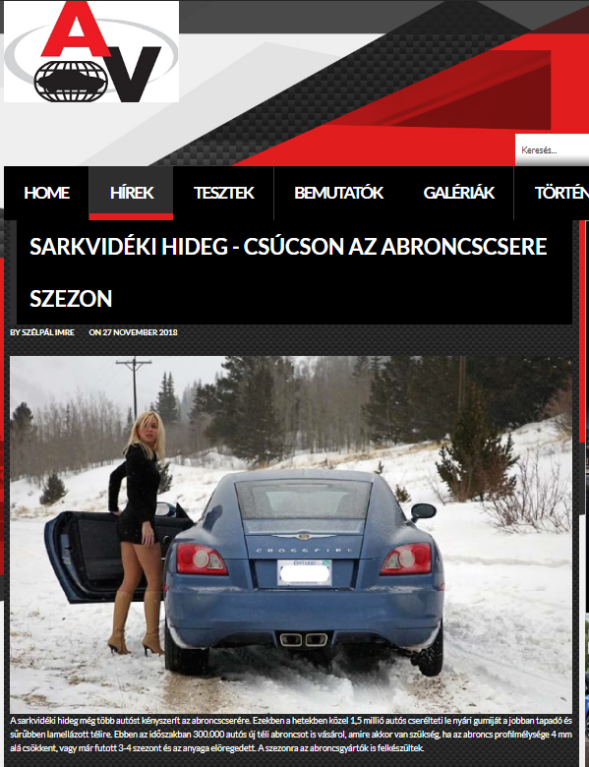

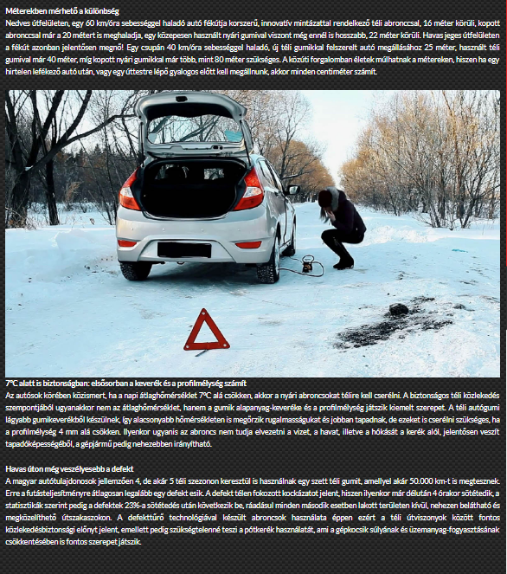

MEDIA: | Formula.hu | MEDIA SPECIFICS
DATE: | 28.11.2018. | TYPE: | Online
PAGE: | - | Reach: | N/A
Ad value (€) | 54 | FREQUENCY:
HEADLINE: | Arctic cold: the tire changing peak
SUMMARY: | During these week almost 1.5 million drivers change their summer tires to more adhesive winter tires with more lamellae. In this period 300,000 owner buys new winter tire set, and is necessary when the tires' profile depth falls below 4 mm or has been running for 3-4 seasons and its material is aging. Tire manufacturers are also prepared for the season. For example, Bridgestone offers its most popular winter and four season tires with defect-resistant technology, because one of the major road safety risks is the snow-covered defect.

http://formula.hu/auto/2018/11/27/sarkvideki-hideg-csucson-az-abroncscsere-szezon

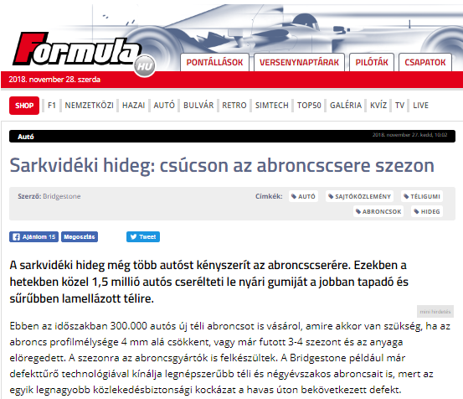

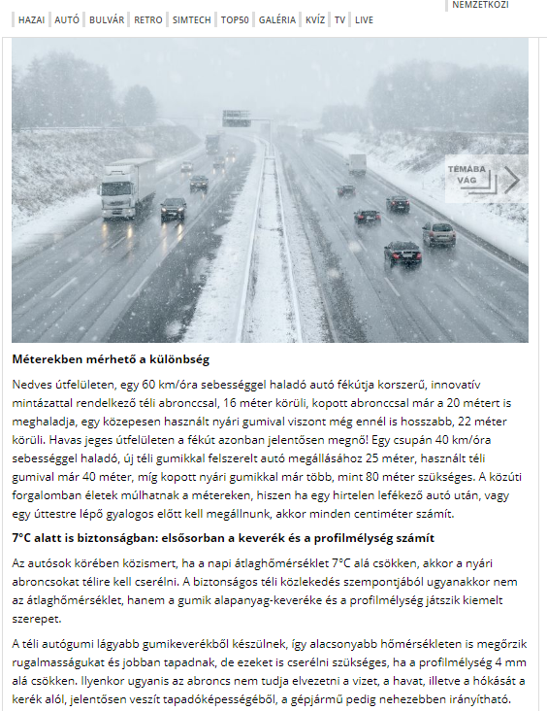

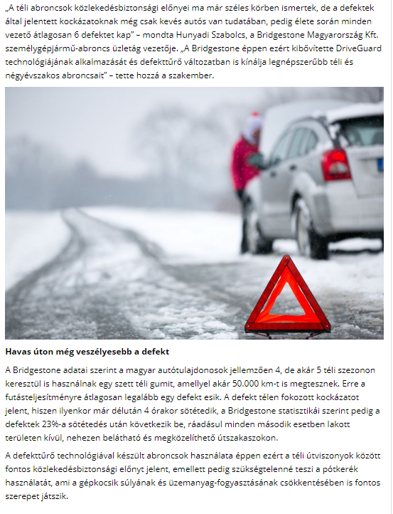

MEDIA: | Autotechnika.hu | MEDIA SPECIFICS
DATE: | 27.11.2018. | TYPE: | Online
PAGE: | - | Reach: | N/A
Ad value (€) | N/A | FREQUENCY:
HEADLINE: | Arctic cold: the tire changing peak
SUMMARY: | During these week almost 1.5 million drivers change their summer tires to more adhesive winter tires with more lamellae. In this period 300,000 owner buys new winter tire set, and is necessary when the tires' profile depth falls below 4 mm or has been running for 3-4 seasons and its material is aging. Tire manufacturers are also prepared for the season. For example, Bridgestone offers its most popular winter and four season tires with defect-resistant technology, because one of the major road safety risks is the snow-covered defect.

https://autotechnika.hu/cikkek/friss-hir/12438/sarkvideki-hideg-csucson-az-abroncscsere-szezon

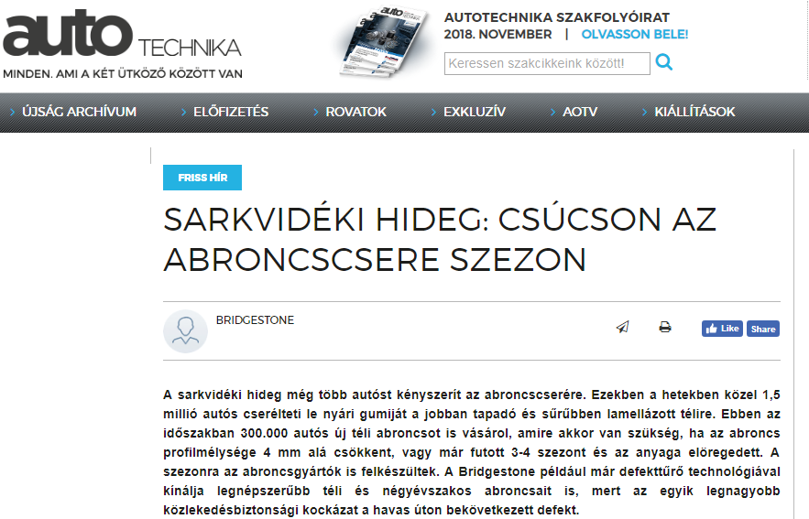

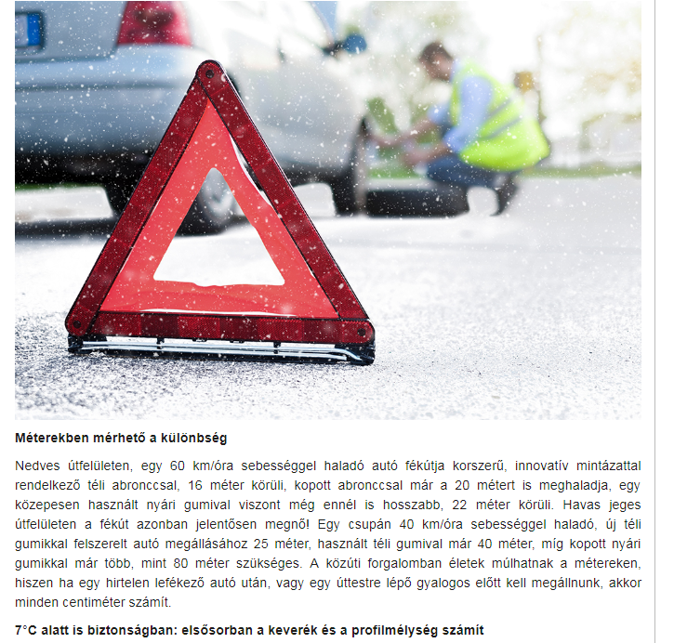
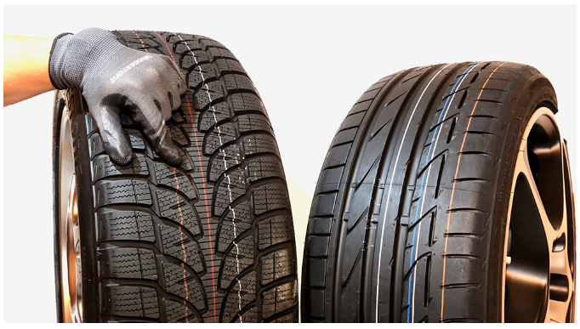

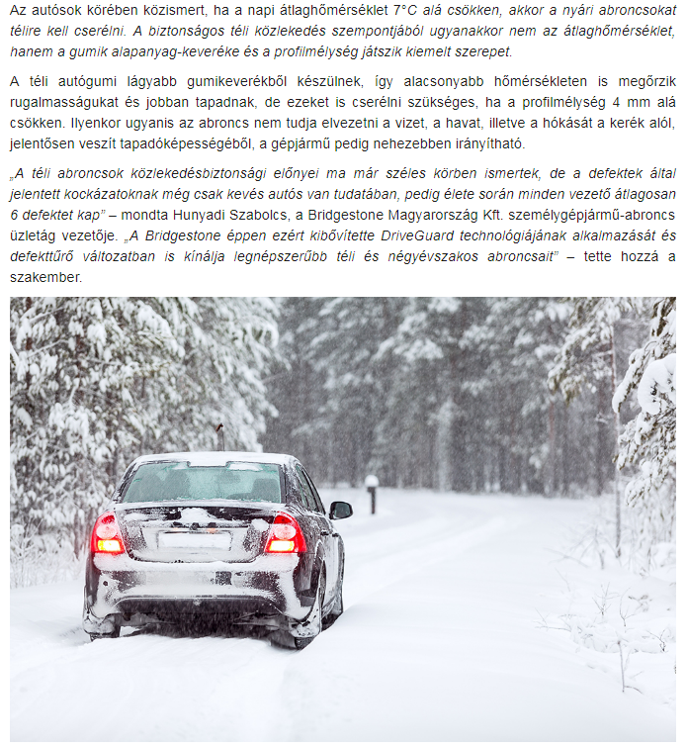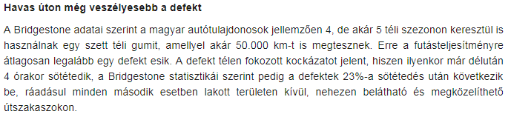

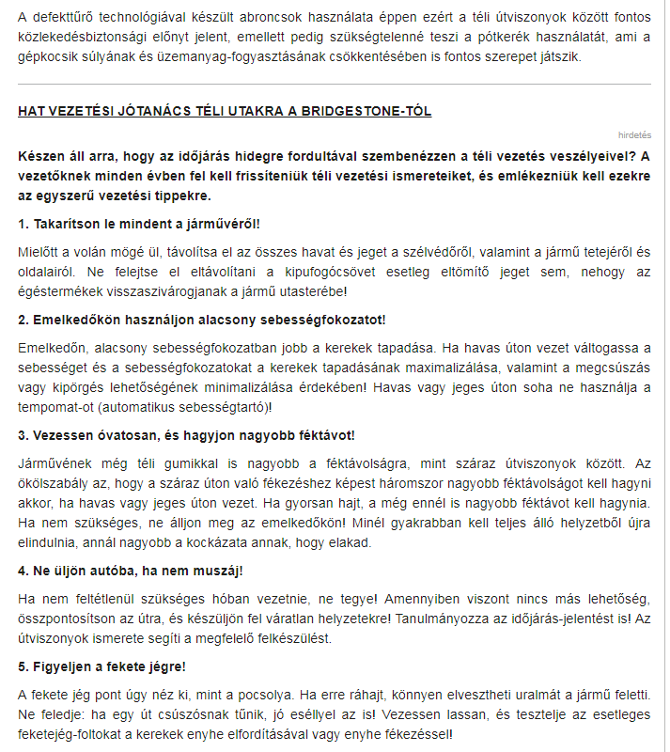

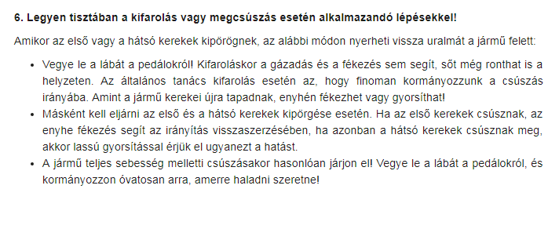

MEDIA: | Logisztika.hu | MEDIA SPECIFICS
DATE: | 27.11.2018. | TYPE: | Online
PAGE: | - | Reach: | N/A
Ad value (€) | N/A | FREQUENCY:
HEADLINE: | Arctic cold: the tire changing peak
SUMMARY: | During these week almost 1.5 million drivers change their summer tires to more adhesive winter tires with more lamellae. In this period 300,000 owner buys new winter tire set, and is necessary when the tires' profile depth falls below 4 mm or has been running for 3-4 seasons and its material is aging. Tire manufacturers are also prepared for the season. For example, Bridgestone offers its most popular winter and four season tires with defect-resistant technology, because one of the major road safety risks is the snow-covered defect.

http://logisztika.com/sarkvideki-hideg-csucson-az-abroncscsere-szezon/

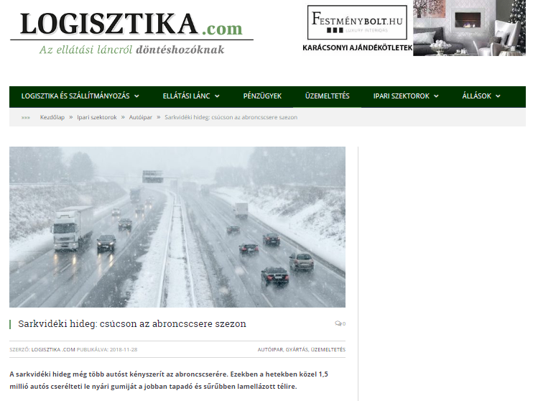

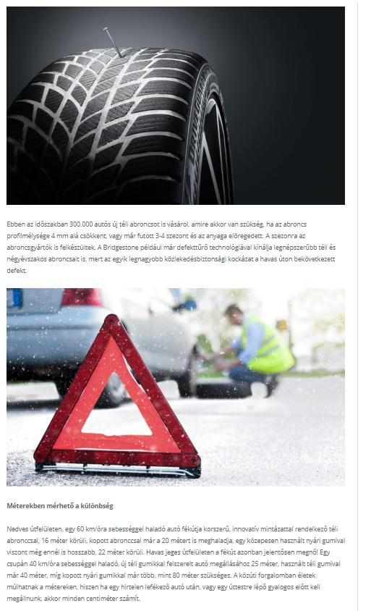

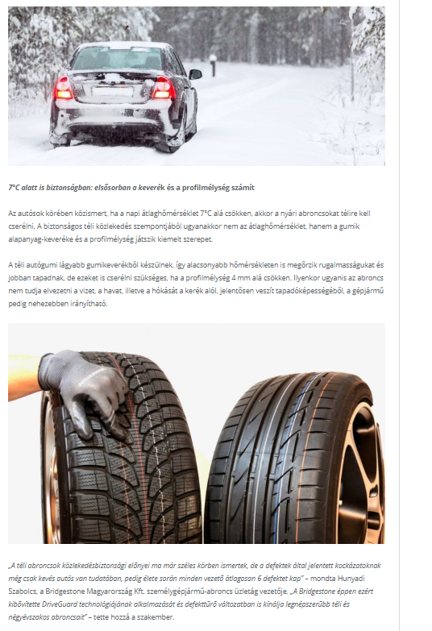

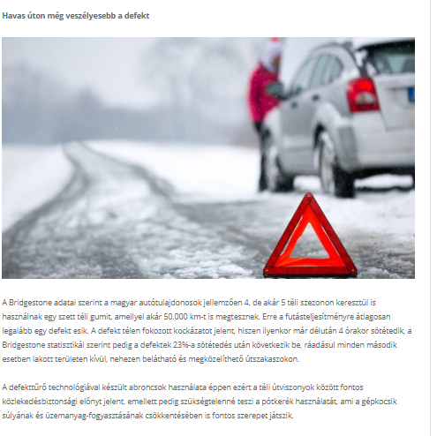

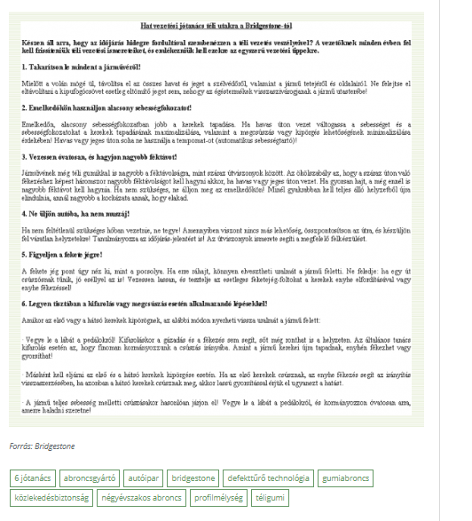

MEDIA: | Gumipiacmagazin.hu | MEDIA SPECIFICS
DATE: | 27.11.2018. | TYPE: | Online
PAGE: | - | Reach: | 100
Ad value (€) | 2 | FREQUENCY:
HEADLINE: | Arctic cold: the tire changing peak
SUMMARY: | During these week almost 1.5 million drivers change their summer tires to more adhesive winter tires with more lamellae. In this period 300,000 owner buys new winter tire set, and is necessary when the tires' profile depth falls below 4 mm or has been running for 3-4 seasons and its material is aging. Tire manufacturers are also prepared for the season. For example, Bridgestone offers its most popular winter and four season tires with defect-resistant technology, because one of the major road safety risks is the snow-covered defect.

https://gumipiacmagazin.hu/2018/11/27/bridgestone-sarkvideki-hideg-csucson-az-abroncscsere-szezon/

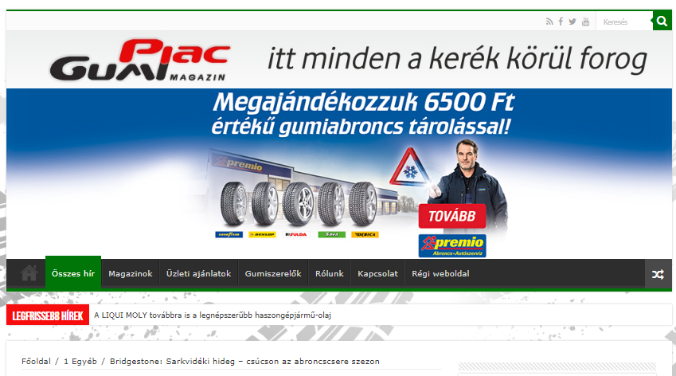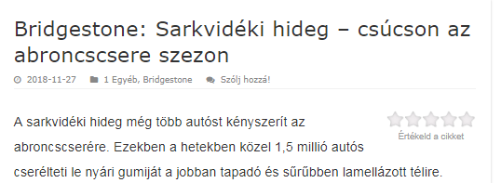

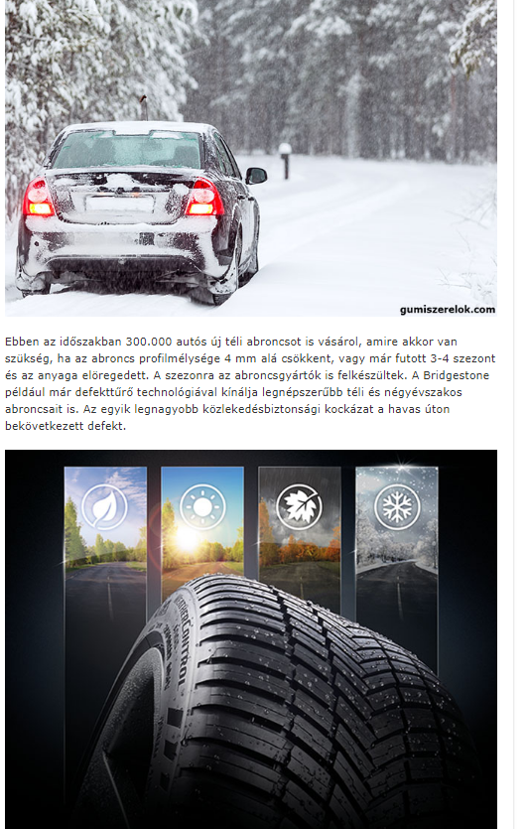

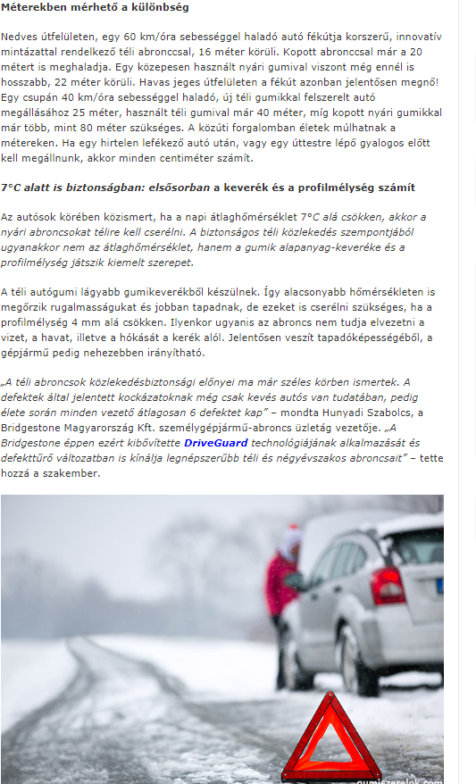

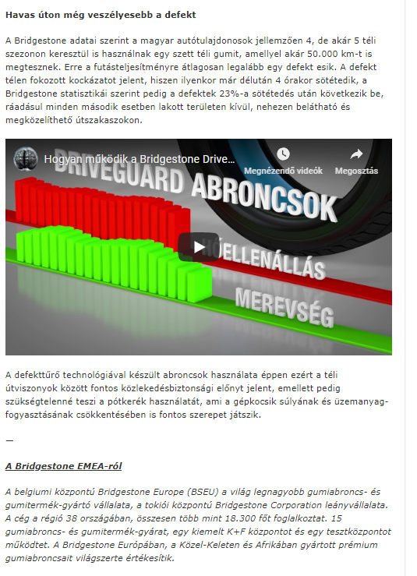

MEDIA: | Autoszektor.hu | MEDIA SPECIFICS
DATE: | 29.11.2018. | TYPE: | Online
PAGE: | - | Reach: | 9 616
Ad value (€) | 690 | FREQUENCY: | 2 alkalommal
HEADLINE: | Arctic cold: the tire changing peak
SUMMARY: | During these week almost 1.5 million drivers change their summer tires to more adhesive winter tires with more lamellae. In this period 300,000 owner buys new winter tire set, and is necessary when the tires' profile depth falls below 4 mm or has been running for 3-4 seasons and its material is aging. Tire manufacturers are also prepared for the season. For example, Bridgestone offers its most popular winter and four season tires with defect-resistant technology, because one of the major road safety risks is the snow-covered defect.

http://www.autoszektor.hu/hu/content/sarkvideki-hideg-csucson-az-abroncscsere-szezon-0

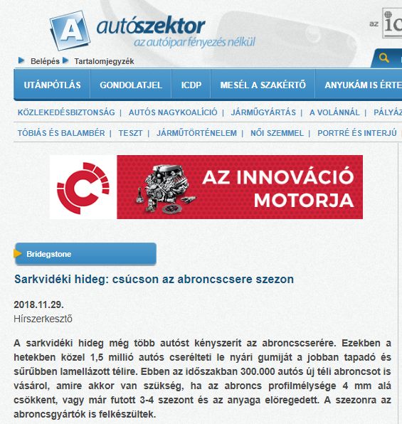

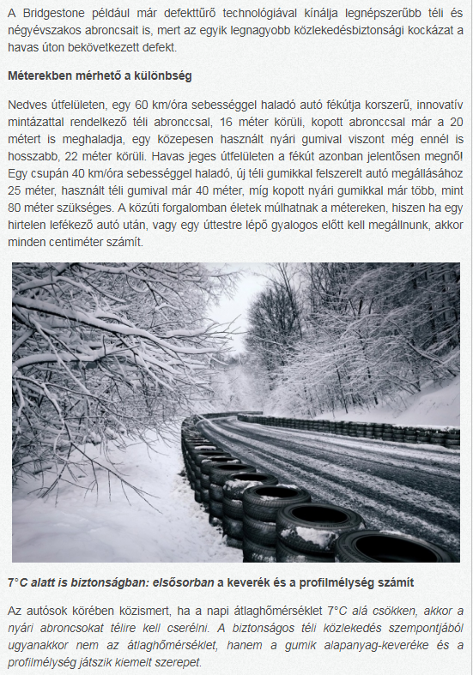

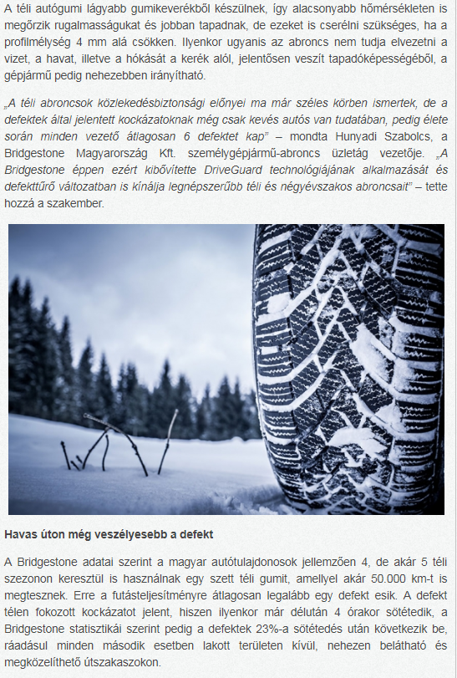

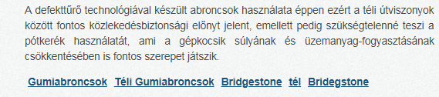

MEDIA: | Egyszermarlattamautot.hu | MEDIA SPECIFICS
DATE: | 29.11.2018. | TYPE: | Online
PAGE: | - | Reach: | N/A
Ad value (€) | N/A | FREQUENCY:
HEADLINE: | Arctic cold: the tire changing peak
SUMMARY: | During these week almost 1.5 million drivers change their summer tires to more adhesive winter tires with more lamellae. In this period 300,000 owner buys new winter tire set, and is necessary when the tires' profile depth falls below 4 mm or has been running for 3-4 seasons and its material is aging. Tire manufacturers are also prepared for the season. For example, Bridgestone offers its most popular winter and four season tires with defect-resistant technology, because one of the major road safety risks is the snow-covered defect.

http://egyszermarlattamautot.hu/2018/11/29/csucson-az-abroncscsere-szezon/

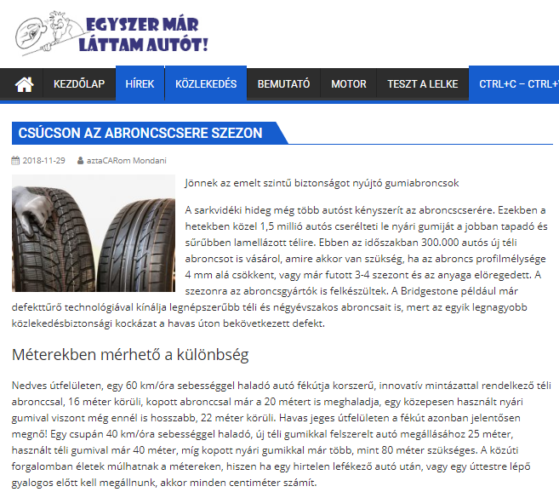

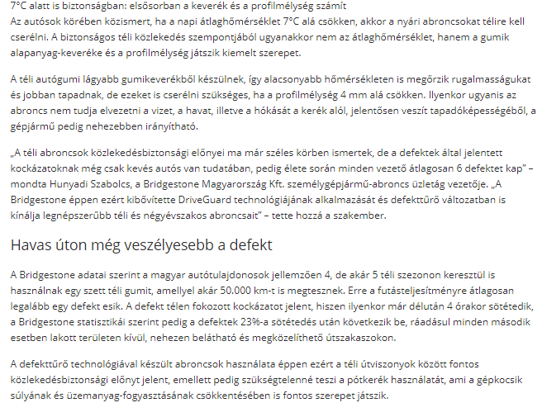

MEDIA: | Hajdú-Bihari Napló | MEDIA SPECIFICS
DATE: | 06.12.2018. | TYPE: | Print
PAGE: | - | Reach: | 403 000
Ad value (€) | 2 064 | FREQUENCY:
HEADLINE: | They are changing tires: being runflat is a viewpoint
SUMMARY: | During these week almost 1.5 million drivers change their summer tires to more adhesive winter tires with more lamellae. In this period 300,000 owner buys new winter tire set, and is necessary when the tires' profile depth falls below 4 mm or has been running for 3-4 seasons and its material is aging. Tire manufacturers are also prepared for the season. For example, Bridgestone offers its most popular winter and four season tires with defect-resistant technology, because one of the major road safety risks is the snow-covered defect.

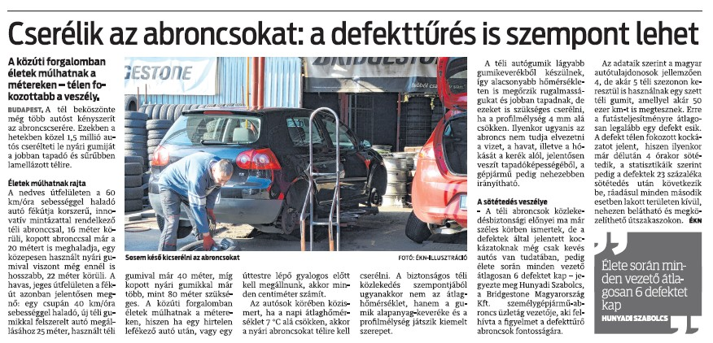

MEDIA: | Észak-Magyarország | MEDIA SPECIFICS
DATE: | 06.12.2018. | TYPE: | Print
PAGE: | - | Reach: | 403 000
Ad value (€) | 2 250 | FREQUENCY:
HEADLINE: | They are changing tires: being runflat is a viewpoint
SUMMARY: | During these week almost 1.5 million drivers change their summer tires to more adhesive winter tires with more lamellae. In this period 300,000 owner buys new winter tire set, and is necessary when the tires' profile depth falls below 4 mm or has been running for 3-4 seasons and its material is aging. Tire manufacturers are also prepared for the season. For example, Bridgestone offers its most popular winter and four season tires with defect-resistant technology, because one of the major road safety risks is the snow-covered defect.

MEDIA: | Kelet-Magyarország | MEDIA SPECIFICS
DATE: | 06.12.2018. | TYPE: | Print
PAGE: | - | Reach: | 117 000
Ad value (€) | 2 064 | FREQUENCY:
HEADLINE: | They are changing tires: being runflat is a viewpoint
SUMMARY: | During these week almost 1.5 million drivers change their summer tires to more adhesive winter tires with more lamellae. In this period 300,000 owner buys new winter tire set, and is necessary when the tires' profile depth falls below 4 mm or has been running for 3-4 seasons and its material is aging. Tire manufacturers are also prepared for the season. For example, Bridgestone offers its most popular winter and four season tires with defect-resistant technology, because one of the major road safety risks is the snow-covered defect.

MEDIA: | Euroastra.blog.hu | MEDIA SPECIFICS
DATE: | 04.12.2018. | TYPE: | Online
PAGE: | - | Reach: | 2 339
Ad value (€) | 30 | FREQUENCY:
HEADLINE: | Arctic cold: the tire changing peak
SUMMARY: | During these week almost 1.5 million drivers change their summer tires to more adhesive winter tires with more lamellae. In this period 300,000 owner buys new winter tire set, and is necessary when the tires' profile depth falls below 4 mm or has been running for 3-4 seasons and its material is aging. Tire manufacturers are also prepared for the season. For example, Bridgestone offers its most popular winter and four season tires with defect-resistant technology, because one of the major road safety risks is the snow-covered defect.

https://euroastra.blog.hu/2018/12/04/sarkvideki_hideg_csucson_az_abroncscsere_szezon_670

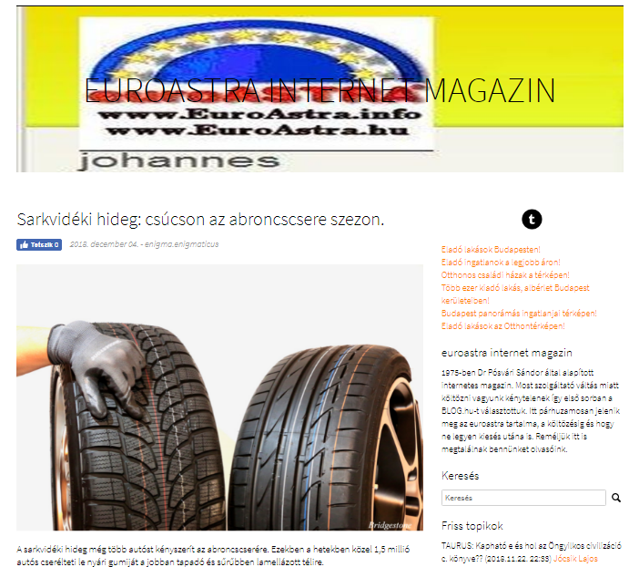

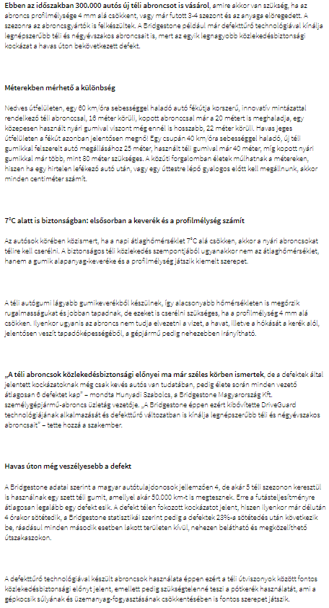

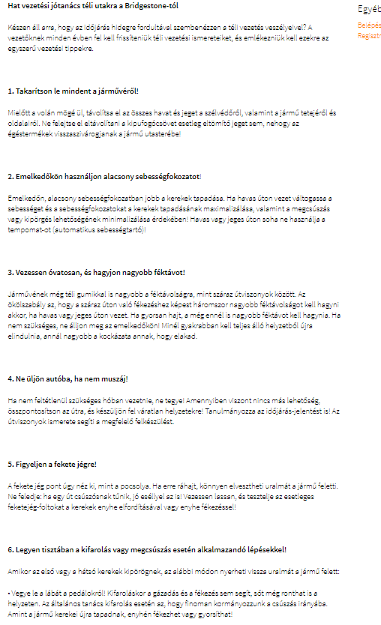

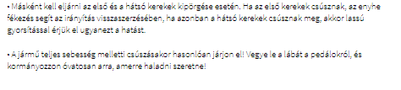

MEDIA: | Caranten.blog.hu | MEDIA SPECIFICS
DATE: | 02.12.2018. | TYPE: | Online
PAGE: | - | Reach: | N/A
Ad value (€) | N/A | FREQUENCY:
HEADLINE: | Arctic cold: the tire changing peak
SUMMARY: | During these week almost 1.5 million drivers change their summer tires to more adhesive winter tires with more lamellae. In this period 300,000 owner buys new winter tire set, and is necessary when the tires' profile depth falls below 4 mm or has been running for 3-4 seasons and its material is aging. Tire manufacturers are also prepared for the season. For example, Bridgestone offers its most popular winter and four season tires with defect-resistant technology, because one of the major road safety risks is the snow-covered defect.

https://caranten.blog.hu/2018/12/02/sarkvideki_hideg_csucson_az_abroncscsere_szezon

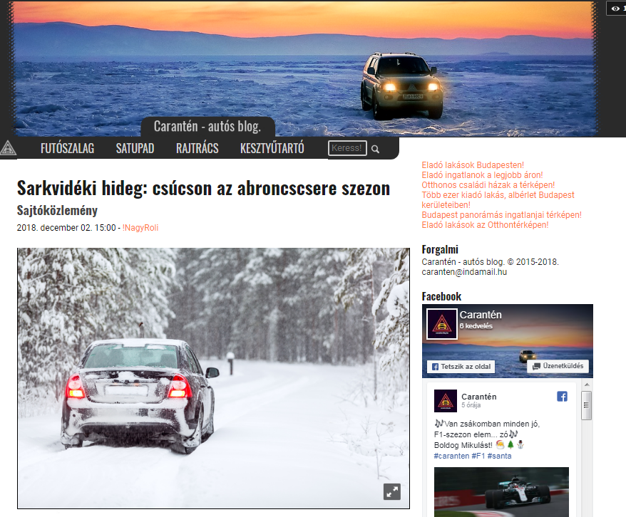

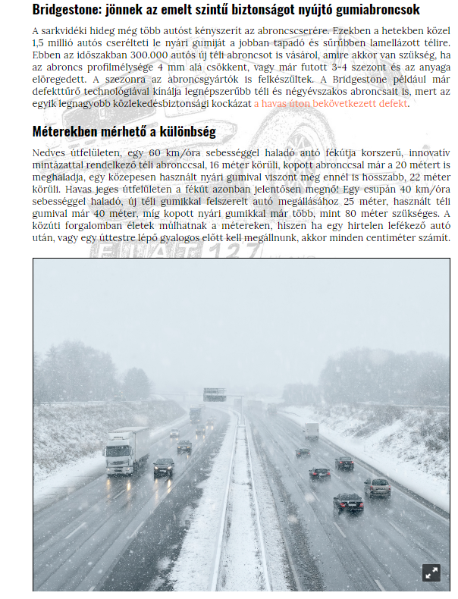

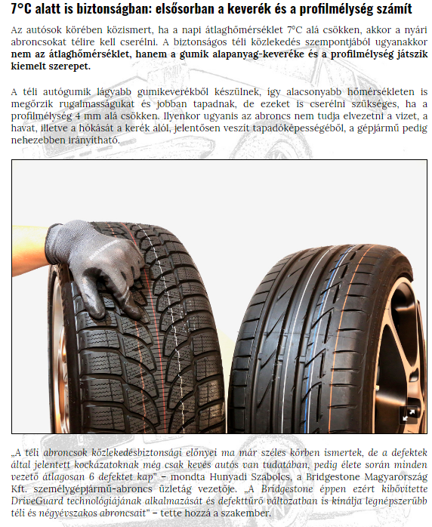

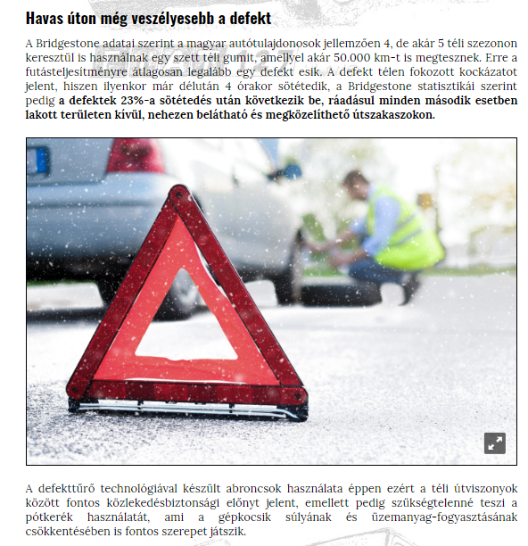

MEDIA: | Szon.hu | MEDIA SPECIFICS
DATE: | 05.12.2018. | TYPE: | Online
PAGE: | - | Reach: | 44 362
Ad value (€) | 545 | FREQUENCY:
HEADLINE: | They are changing tires: being runflat is a viewpoint
SUMMARY: | During these week almost 1.5 million drivers change their summer tires to more adhesive winter tires with more lamellae. In this period 300,000 owner buys new winter tire set, and is necessary when the tires' profile depth falls below 4 mm or has been running for 3-4 seasons and its material is aging. Tire manufacturers are also prepared for the season. For example, Bridgestone offers its most popular winter and four season tires with defect-resistant technology, because one of the major road safety risks is the snow-covered defect.

http://www.szon.hu/cserelik-az-abroncsokat-a-defekttures-is-szempont-lehet/4071703?utm_source=feedburner&utm_medium=feed&utm_campaign=Feed%3A+szon%2Fmegye+%28Szabolcs+Online+Megyei+hírek%29

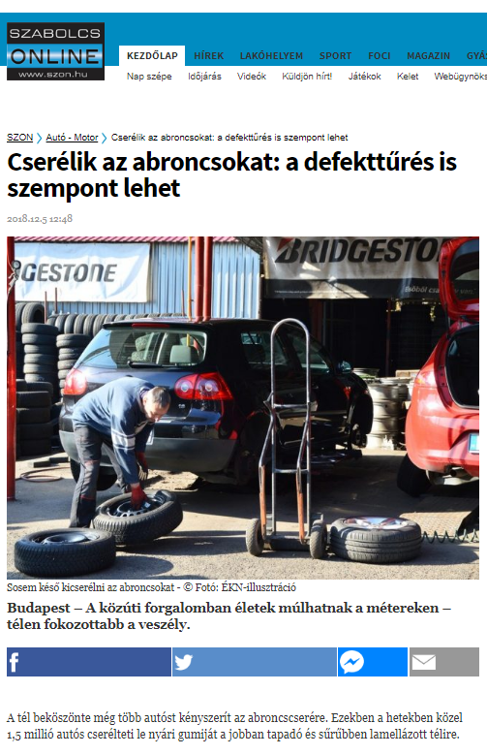

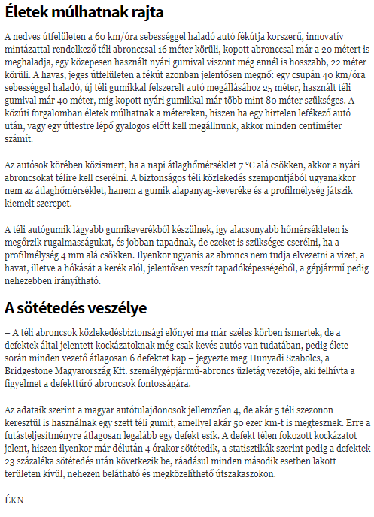

MEDIA: | Haon.hu | MEDIA SPECIFICS
DATE: | 05.12.2018. | TYPE: | Online
PAGE: | - | Reach: | 44 362
Ad value (€) | 545 | FREQUENCY:
HEADLINE: | They are changing tires: being runflat is a viewpoint
SUMMARY: | During these week almost 1.5 million drivers change their summer tires to more adhesive winter tires with more lamellae. In this period 300,000 owner buys new winter tire set, and is necessary when the tires' profile depth falls below 4 mm or has been running for 3-4 seasons and its material is aging. Tire manufacturers are also prepared for the season. For example, Bridgestone offers its most popular winter and four season tires with defect-resistant technology, because one of the major road safety risks is the snow-covered defect.

http://www.haon.hu/cserelik-az-abroncsokat-a-defekttures-is-szempont-lehet/4071703?utm_source=feedburner&utm_medium=feed&utm_campaign=Feed%3A+haon%2Fmegye+%28Hajdú+Online+Megyei+hírek%29

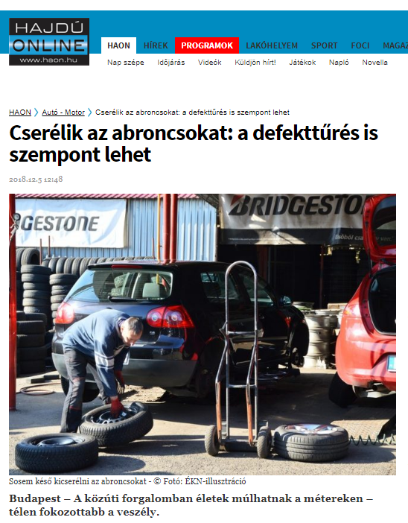

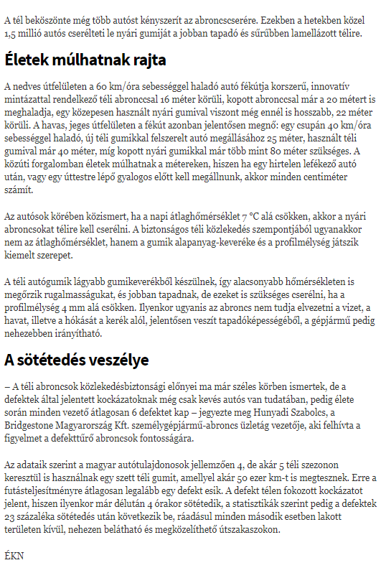

MEDIA: | Erdon.ro | MEDIA SPECIFICS
DATE: | 05.12.2018. | TYPE: | Online
PAGE: | - | Reach: | 168 000
Ad value (€) | 120 | FREQUENCY:
HEADLINE: | They are changing tires: being runflat is a viewpoint
SUMMARY: | During these week almost 1.5 million drivers change their summer tires to more adhesive winter tires with more lamellae. In this period 300,000 owner buys new winter tire set, and is necessary when the tires' profile depth falls below 4 mm or has been running for 3-4 seasons and its material is aging. Tire manufacturers are also prepared for the season. For example, Bridgestone offers its most popular winter and four season tires with defect-resistant technology, because one of the major road safety risks is the snow-covered defect.

http://www.erdon.ro/cserelik-az-abroncsokat-a-defekttures-is-szempont-lehet/4071703

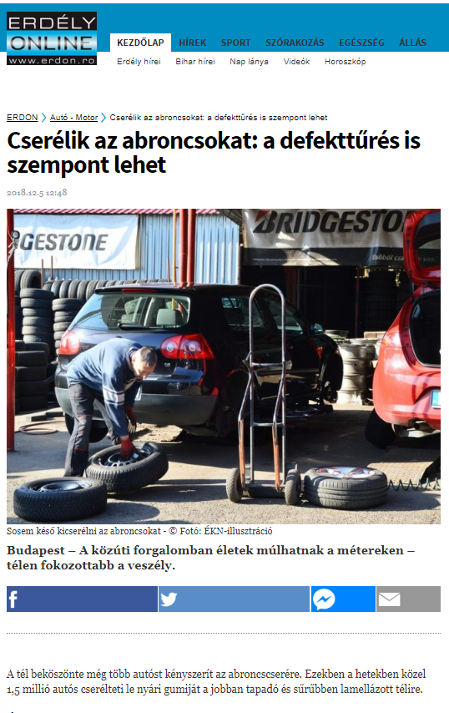

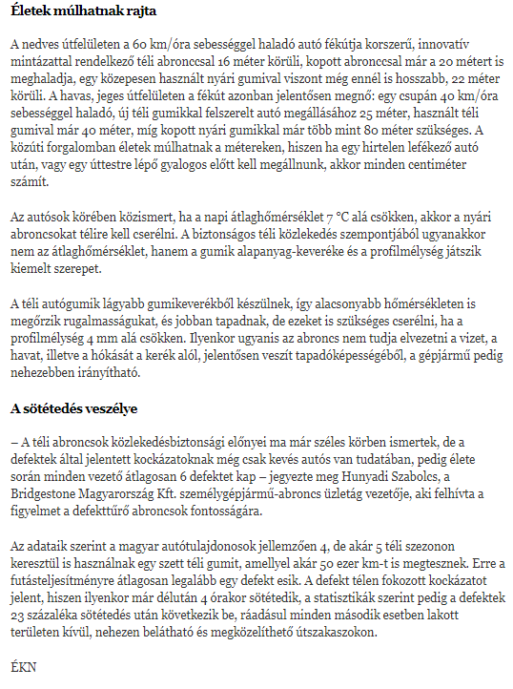

MEDIA: | Boon.hu | MEDIA SPECIFICS
DATE: | 05.12.2018. | TYPE: | Online
PAGE: | - | Reach: | 21 160
Ad value (€) | 545 | FREQUENCY:
HEADLINE: | They are changing tires: being runflat is a viewpoint
SUMMARY: | During these week almost 1.5 million drivers change their summer tires to more adhesive winter tires with more lamellae. In this period 300,000 owner buys new winter tire set, and is necessary when the tires' profile depth falls below 4 mm or has been running for 3-4 seasons and its material is aging. Tire manufacturers are also prepared for the season. For example, Bridgestone offers its most popular winter and four season tires with defect-resistant technology, because one of the major road safety risks is the snow-covered defect.

http://www.boon.hu/cserelik-az-abroncsokat-a-defekttures-is-szempont-lehet/4071703?utm_source=feedburner&utm_medium=feed&utm_campaign=Feed%3A+boon%2Fborsod+%28Borsod+Online+B.-A.-Z.+megye+hírei%29

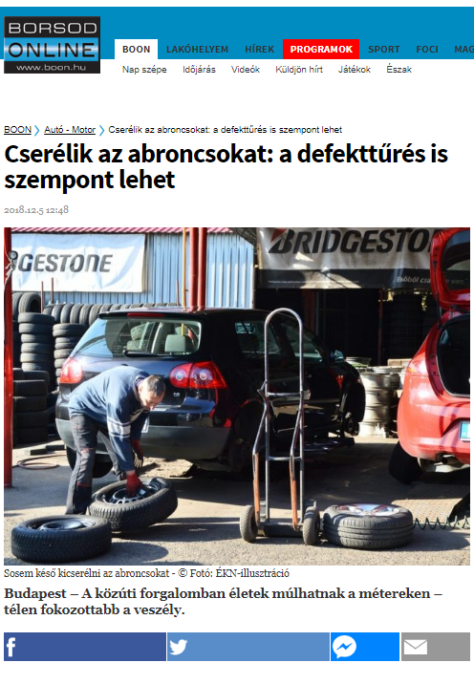

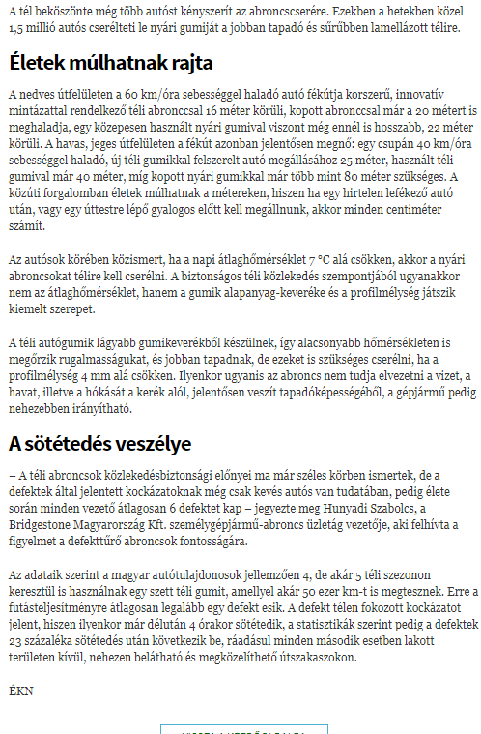

MEDIA: | Duna TV | MEDIA SPECIFICS
DATE: | 03.12.2018. | TYPE: | Electronic
PAGE: | - | Reach: | 100 000
Ad value (€) | 2 580 | FREQUENCY:
HEADLINE: | Interview with Gergely Németh
SUMMARY: | During these week almost 1.5 million drivers change their summer tires to more adhesive winter tires with more lamellae. In this period 300,000 owner buys new winter tire set, and is necessary when the tires' profile depth falls below 4 mm or has been running for 3-4 seasons and its material is aging. Tire manufacturers are also prepared for the season. For example, Bridgestone offers its most popular winter and four season tires with defect-resistant technology, because one of the major road safety risks is the snow-covered defect.

Felvétel bekérve

MEDIA: | M1 Ma reggel | MEDIA SPECIFICS
DATE: | 03.12.2018. | TYPE: | Electronic
PAGE: | - | Reach: | 1 550 000
Ad value (€) | 5 000 | FREQUENCY: | 2 alkalommal
HEADLINE: | Interview with Gergely Németh
SUMMARY: | During these week almost 1.5 million drivers change their summer tires to more adhesive winter tires with more lamellae. In this period 300,000 owner buys new winter tire set, and is necessary when the tires' profile depth falls below 4 mm or has been running for 3-4 seasons and its material is aging. Tire manufacturers are also prepared for the season. For example, Bridgestone offers its most popular winter and four season tires with defect-resistant technology, because one of the major road safety risks is the snow-covered defect.

https://www.mediaklikk.hu/video/hirado-2018-12-03-i-adas-4/

MEDIA: | Bellacafe.hu | MEDIA SPECIFICS
DATE: | 06.12.2018. | TYPE: | Online
PAGE: | - | Reach: | 4 400
Ad value (€) | 10 | FREQUENCY: | -
HEADLINE: | Arctic cold: the tire changing peak
SUMMARY: | During these week almost 1.5 million drivers change their summer tires to more adhesive winter tires with more lamellae. In this period 300,000 owner buys new winter tire set, and is necessary when the tires' profile depth falls below 4 mm or has been running for 3-4 seasons and its material is aging. Tire manufacturers are also prepared for the season. For example, Bridgestone offers its most popular winter and four season tires with defect-resistant technology, because one of the major road safety risks is the snow-covered defect.

https://www.bellacafe.hu/2018/12/06/sarkvideki-hideg-csucson-az-abroncscsere-szezon/

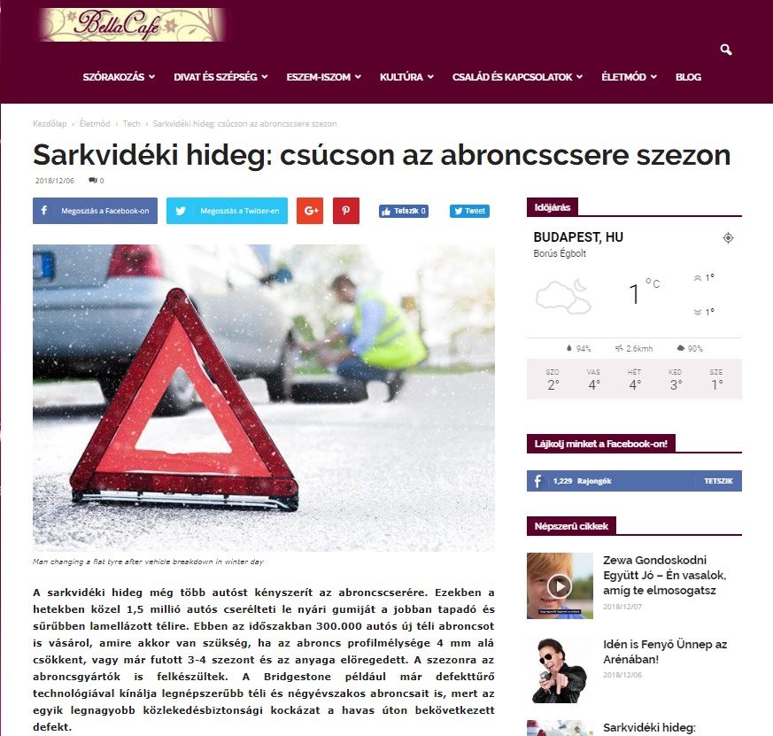

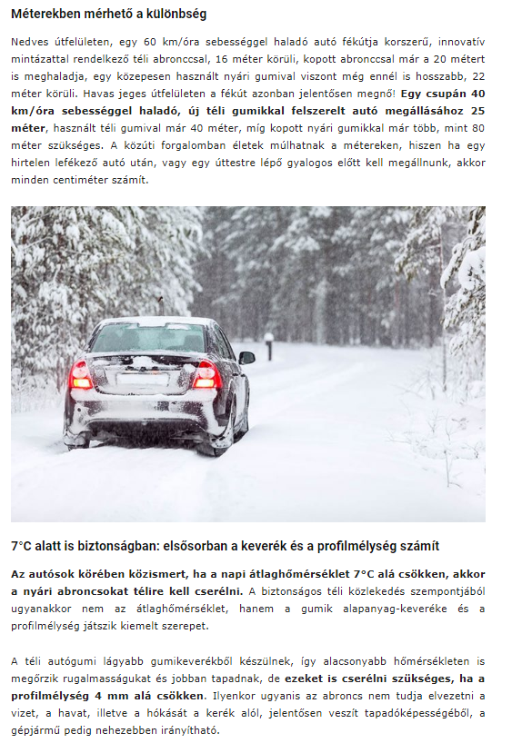

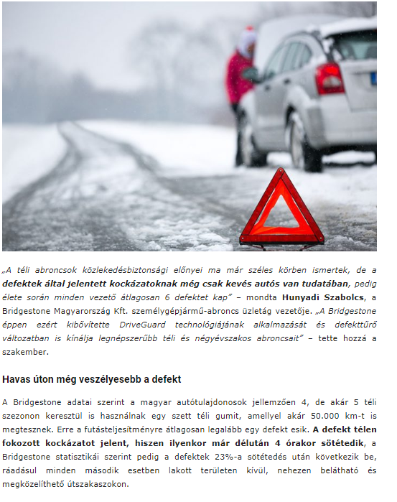

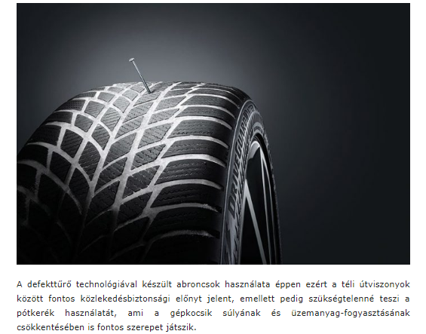

MEDIA: | Jazzy Rádió | MEDIA SPECIFICS
DATE: | 28.10.2018. | TYPE: | Electronic
PAGE: | - | Reach: | 32 000
Ad value (€) | 216 | FREQUENCY: | -
HEADLINE: | Interview with Gergely Németh
SUMMARY: | During these week almost 1.5 million drivers change their summer tires to more adhesive winter tires with more lamellae. In this period 300,000 owner buys new winter tire set, and is necessary when the tires' profile depth falls below 4 mm or has been running for 3-4 seasons and its material is aging. Tire manufacturers are also prepared for the season. For example, Bridgestone offers its most popular winter and four season tires with defect-resistant technology, because one of the major road safety risks is the snow-covered defect.

http://www.premiercom.hu/download/private/Bridgestone/N%C3%A9meth_Gergely_interj%C3%BA_Jazzy_R%C3%A1di%C3%B3_Winter_tyre.wav

