MEDIA: | Civilhetes.hu | MEDIA SPECIFICS
DATE: | 01.02.2017 | TYPE: | Online
PAGE: | - | Reach: | N/A
Ad value (€) | N/A | FREQUENCY:
HEADLINE: | Bridgestone Celebrates Final Countdown to Olympic Winter Games PyeongChang 2018
SUMMARY: | As part of its Games-time program, Bridgestone is supplying winter tires for the International Olympic Committee (IOC) vehicles within the Olympic fleet, and is supporting Team Bridgestone -- a global roster of Olympic and Paralympic hopefuls aiming to compete in PyeongChang. Additionally, the company is proud to support the official PyeongChang 2018 Education Program to help the Games leave a lasting, positive impact in the host country, and it plans to share its core Olympic message, “Chase Your Dream,” with visitors and fans through marketing efforts in the host country.

https://civilhetes.net/megkezdte-a-vegso-visszaszamlalast-a-2018-as-phjongcshangi-teli-olimpiai-jatekokig-a-bridgestone

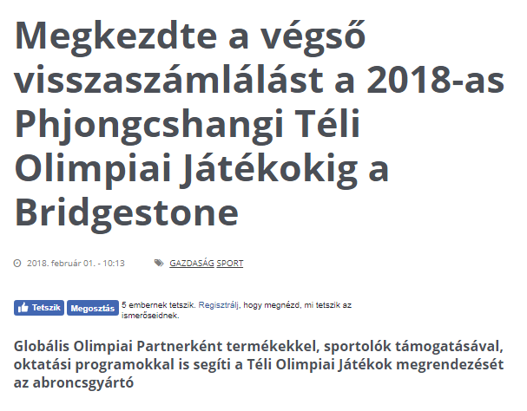

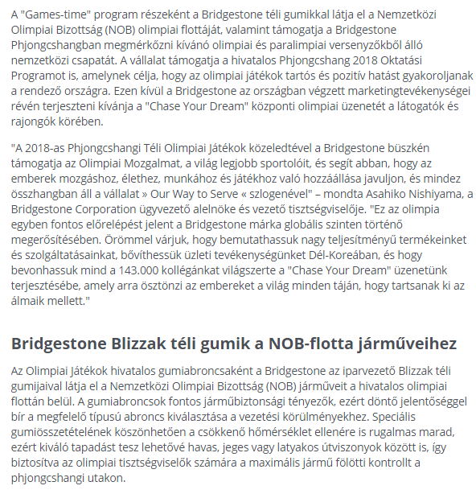
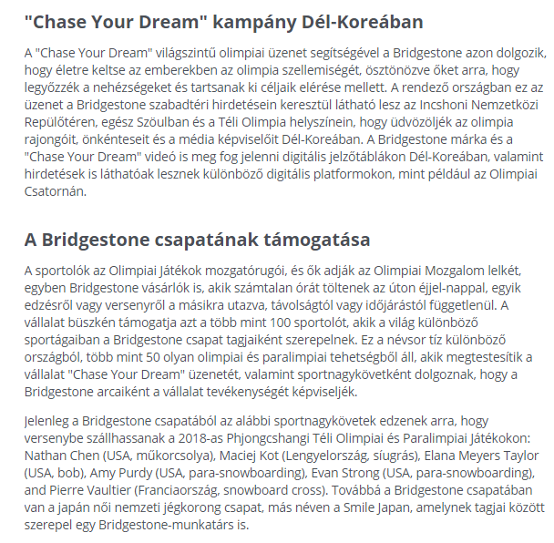
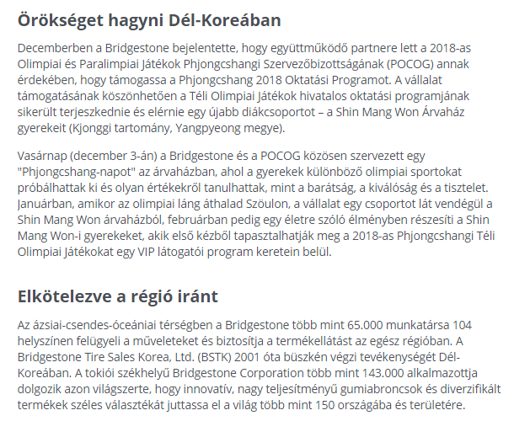
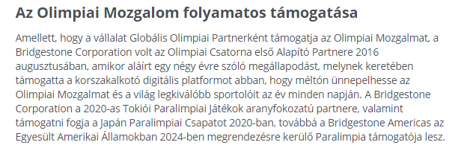

MEDIA: | Bdpst24.hu | MEDIA SPECIFICS
DATE: | 01.02.2017 | TYPE: | Online
PAGE: | - | Reach: | 3 500
Ad value (€) | 56 | FREQUENCY:
HEADLINE: | Bridgestone Celebrates Final Countdown to Olympic Winter Games PyeongChang 2018
SUMMARY: | As part of its Games-time program, Bridgestone is supplying winter tires for the International Olympic Committee (IOC) vehicles within the Olympic fleet, and is supporting Team Bridgestone -- a global roster of Olympic and Paralympic hopefuls aiming to compete in PyeongChang. Additionally, the company is proud to support the official PyeongChang 2018 Education Program to help the Games leave a lasting, positive impact in the host country, and it plans to share its core Olympic message, “Chase Your Dream,” with visitors and fans through marketing efforts in the host country.

http://bdpst24.hu/2018/02/01/megkezdte-a-vegso-visszaszamlalast-a-2018-as-phjongcshangi-teli-olimpiai-jatekokig-a-bridgestone/

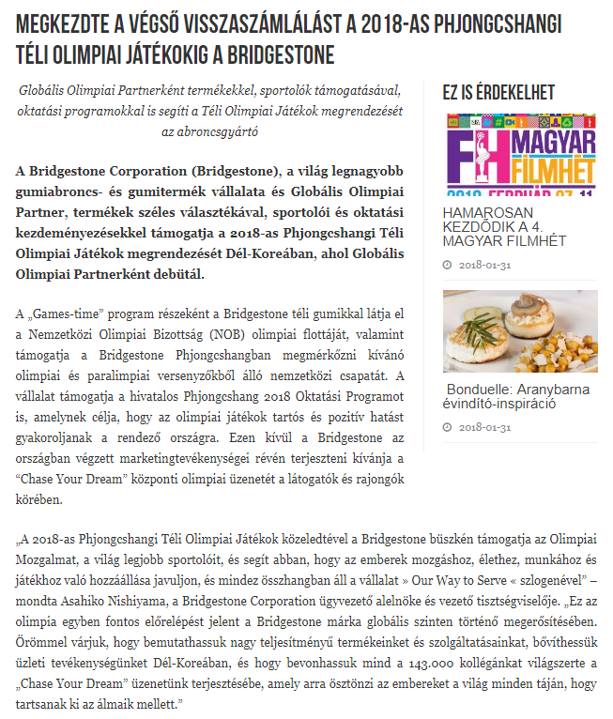

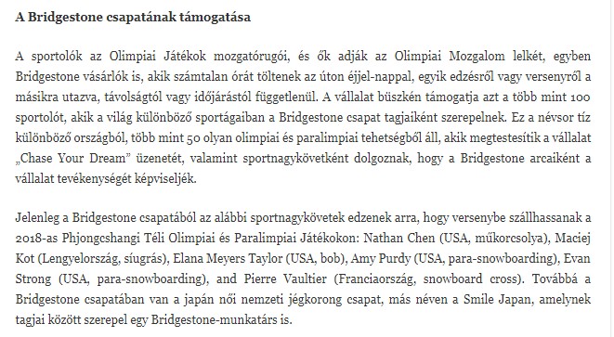

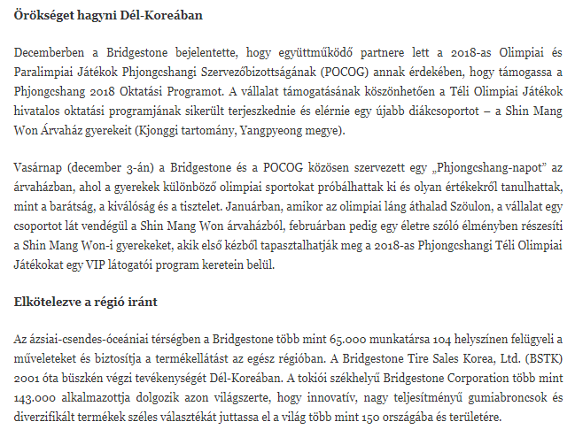
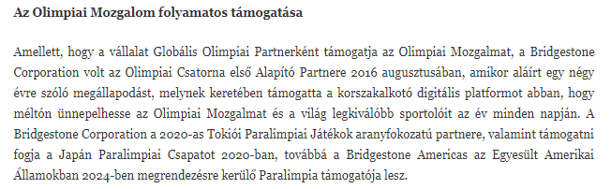

MEDIA: | Mediapiac.com | MEDIA SPECIFICS
DATE: | 01.02.2017 | TYPE: | Online
PAGE: | - | Reach: | N/A
Ad value (€) | 166 | FREQUENCY:
HEADLINE: | Bridgestone Celebrates Final Countdown to Olympic Winter Games PyeongChang 2018
SUMMARY: | As part of its Games-time program, Bridgestone is supplying winter tires for the International Olympic Committee (IOC) vehicles within the Olympic fleet, and is supporting Team Bridgestone -- a global roster of Olympic and Paralympic hopefuls aiming to compete in PyeongChang. Additionally, the company is proud to support the official PyeongChang 2018 Education Program to help the Games leave a lasting, positive impact in the host country, and it plans to share its core Olympic message, “Chase Your Dream,” with visitors and fans through marketing efforts in the host country.

http://www.mediapiac.com/marketing/Megkezdte-a-vegso-visszaszamlalast-a-Bridgestone/25036/

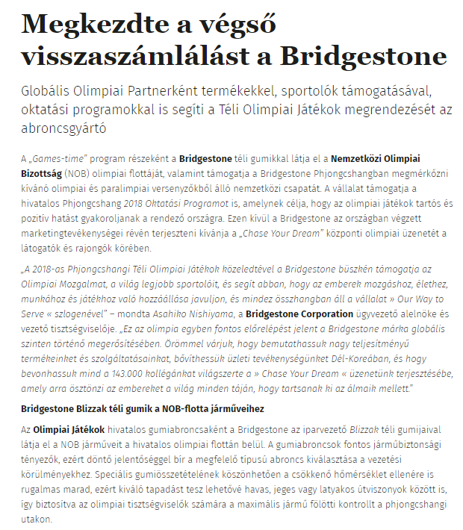

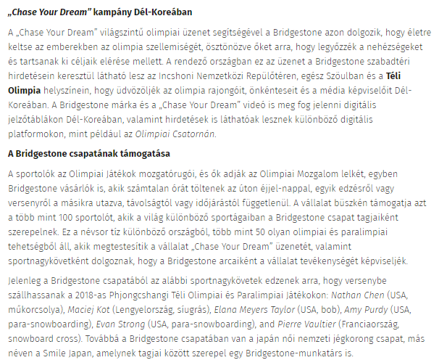
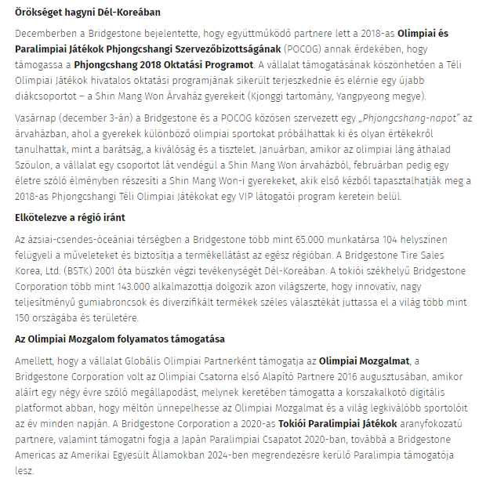

MEDIA: | Autosvilag.com | MEDIA SPECIFICS
DATE: | 01.02.2017 | TYPE: | Online
PAGE: | - | Reach: | N/A
Ad value (€) | N/A | FREQUENCY:
HEADLINE: | Let's go to the Olympics!
SUMMARY: | As part of its Games-time program, Bridgestone is supplying winter tires for the International Olympic Committee (IOC) vehicles within the Olympic fleet, and is supporting Team Bridgestone -- a global roster of Olympic and Paralympic hopefuls aiming to compete in PyeongChang. Additionally, the company is proud to support the official PyeongChang 2018 Education Program to help the Games leave a lasting, positive impact in the host country, and it plans to share its core Olympic message, “Chase Your Dream,” with visitors and fans through marketing efforts in the host country.

https://autosvilag.com/h%C3%ADrek/1767-bridgestone-%E2%80%93-ir%C3%A1ny-az-olimpia.html

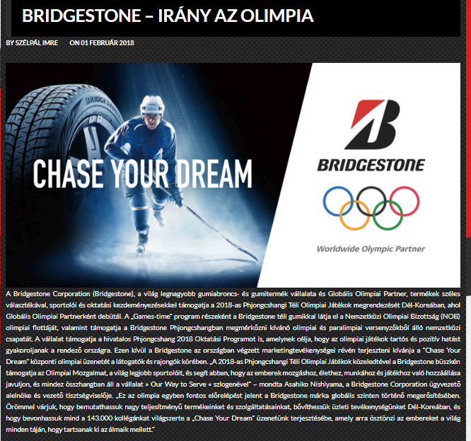

MEDIA: | Hirek.sztradaradio.hu | MEDIA SPECIFICS
DATE: | 01.02.2017 | TYPE: | Online
PAGE: | - | Reach: | N/A
Ad value (€) | N/A | FREQUENCY:
HEADLINE: | Bridgestone Celebrates Final Countdown to Olympic Winter Games PyeongChang 2019
SUMMARY: | As part of its Games-time program, Bridgestone is supplying winter tires for the International Olympic Committee (IOC) vehicles within the Olympic fleet, and is supporting Team Bridgestone -- a global roster of Olympic and Paralympic hopefuls aiming to compete in PyeongChang. Additionally, the company is proud to support the official PyeongChang 2018 Education Program to help the Games leave a lasting, positive impact in the host country, and it plans to share its core Olympic message, “Chase Your Dream,” with visitors and fans through marketing efforts in the host country.

http://hirek.sztradaradio.hu/2018/02/01/megkezdte-a-vegso-visszaszamlalast-a-2018-as-phjongcshangi-teli-olimpiai-jatekokig-a-bridgestone/

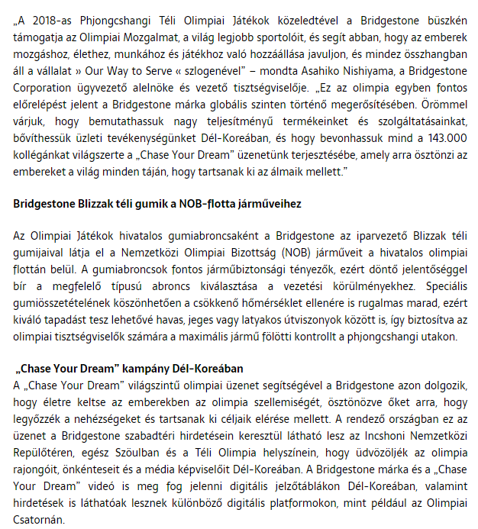

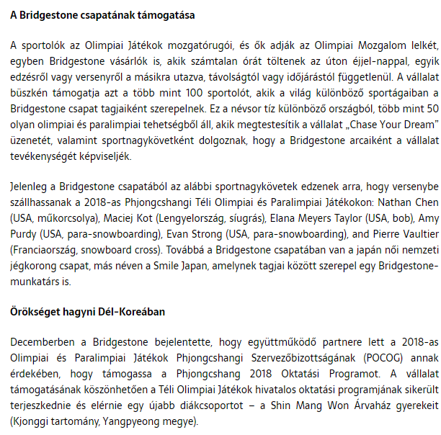
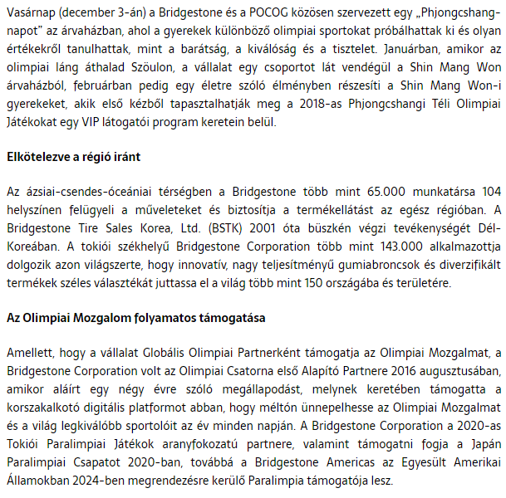

MEDIA: | SztádaRádió Facebook | MEDIA SPECIFICS
DATE: | 01.02.2017 | TYPE: | Online
PAGE: | - | Reach: | N/A
Ad value (€) | N/A | FREQUENCY:
HEADLINE: | Bridgestone Celebrates Final Countdown to Olympic Winter Games PyeongChang 2019
SUMMARY: | As part of its Games-time program, Bridgestone is supplying winter tires for the International Olympic Committee (IOC) vehicles within the Olympic fleet, and is supporting Team Bridgestone -- a global roster of Olympic and Paralympic hopefuls aiming to compete in PyeongChang. Additionally, the company is proud to support the official PyeongChang 2018 Education Program to help the Games leave a lasting, positive impact in the host country, and it plans to share its core Olympic message, “Chase Your Dream,” with visitors and fans through marketing efforts in the host country.

https://www.facebook.com/sztradaradio/

