MEDIA: | Gumipiac Magazin Youtube csatorna | MEDIA SPECIFICS
DATE: | 09.10.2018. | TYPE: | Online
PAGE: |  | Reach: | N/A
Ad value (€) | N/A | FREQUENCY:
HEADLINE: | Drivers don’t want to struggle with tire change
SUMMARY: | More than 15,000 consumers across Europe where involved in the development of the new Bridgestone Weather Control A005. Multiple research strategies were used to define the customer journey, evaluate expectations and identify the most common challenges of daily driving in a variety of situations and locations.

https://www.youtube.com/watch?v=wV3g23-ckUA

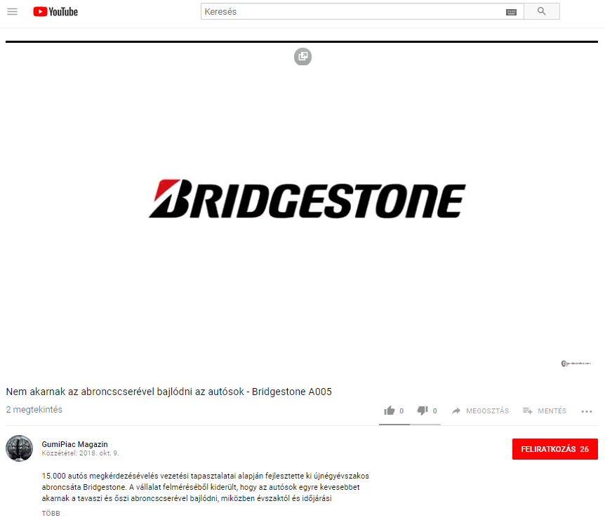

MEDIA: | Holvezessek,hu | MEDIA SPECIFICS
DATE: | 10.10.2018. | TYPE: | Online
PAGE: |  | Reach: | N/A
Ad value (€) | N/A | FREQUENCY:
HEADLINE: | Bridgestone launches S/A tire
SUMMARY: | More than 15,000 consumers across Europe where involved in the development of the new Bridgestone Weather Control A005. Multiple research strategies were used to define the customer journey, evaluate expectations and identify the most common challenges of daily driving in a variety of situations and locations.

http://www.holvezessek.hu/hirek.html?azonosito=15845

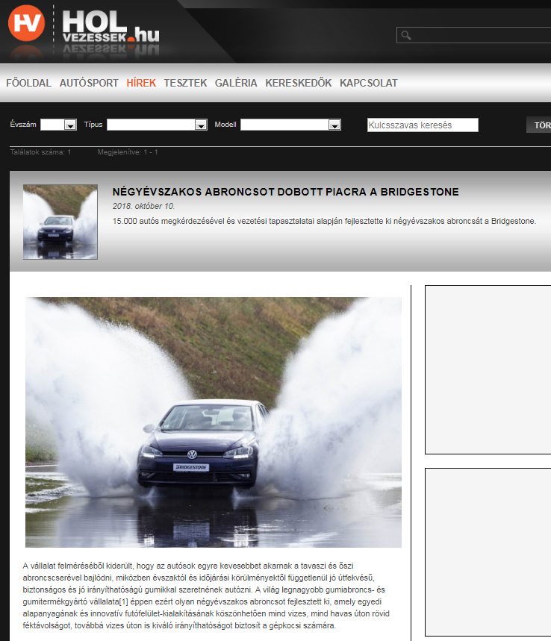

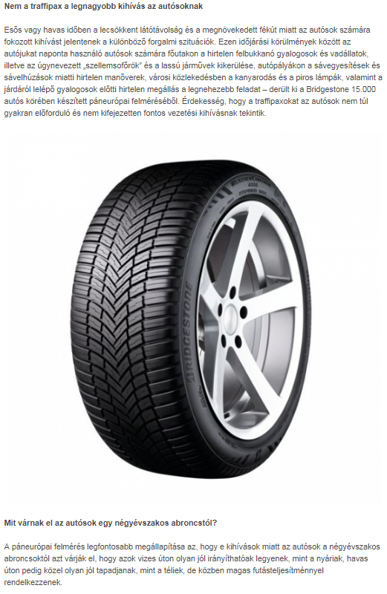

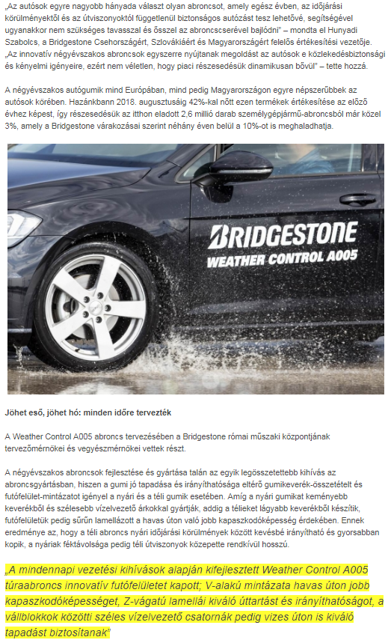

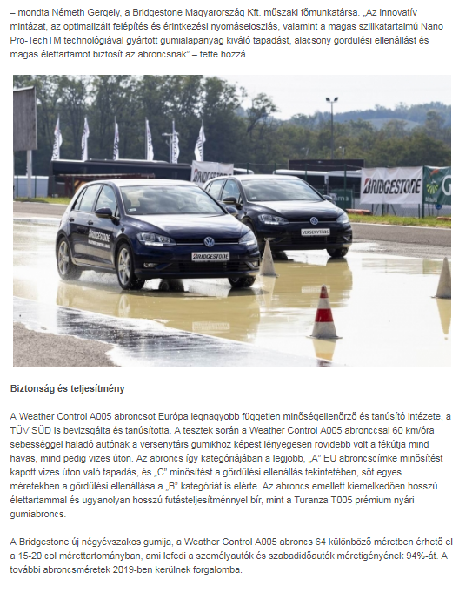

MEDIA: | Blikk.hu | MEDIA SPECIFICS
DATE: | 09.10.2018. | TYPE: | Online
PAGE: |  | Reach: | 800 000
Ad value (€) | 460 | FREQUENCY: | 2 alkalommal
HEADLINE: | Drivers don’t want to struggle with tire change
SUMMARY: | More than 15,000 consumers across Europe where involved in the development of the new Bridgestone Weather Control A005. Multiple research strategies were used to define the customer journey, evaluate expectations and identify the most common challenges of daily driving in a variety of situations and locations.

http://www.blikk.hu/auto/garazs/nem-akarnak-az-abroncscserevel-bajlodni-az-autosok/g7eqtf0

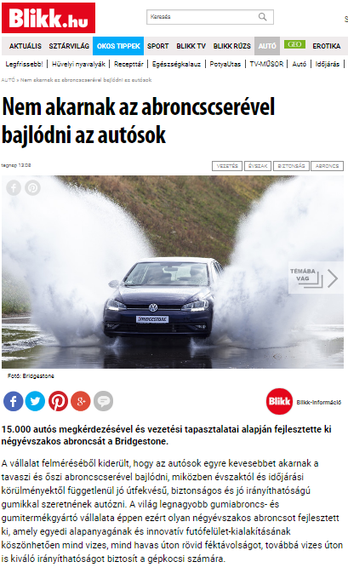

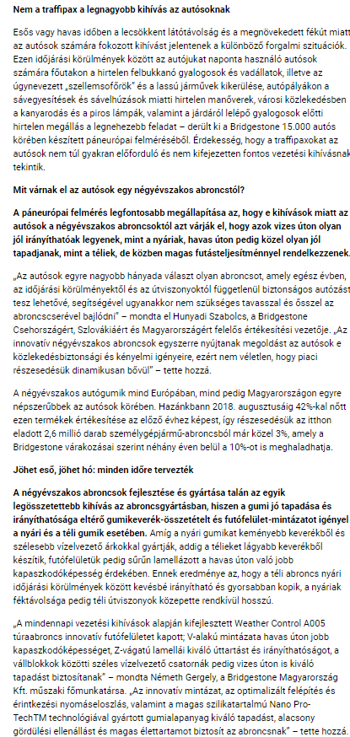

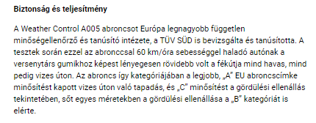

MEDIA: | Vezess.hu | MEDIA SPECIFICS
DATE: | 09.10.2018. | TYPE: | Online
PAGE: |  | Reach: | 100 000
Ad value (€) | 69 | FREQUENCY:
HEADLINE: | These are the biggest fear of drivers while driving
SUMMARY: | More than 15,000 consumers across Europe where involved in the development of the new Bridgestone Weather Control A005. Multiple research strategies were used to define the customer journey, evaluate expectations and identify the most common challenges of daily driving in a variety of situations and locations.

https://www.vezess.hu/hirek/2018/10/09/ezek-az-autosok-legnagyobb-felelmei-vezetes-kozben/

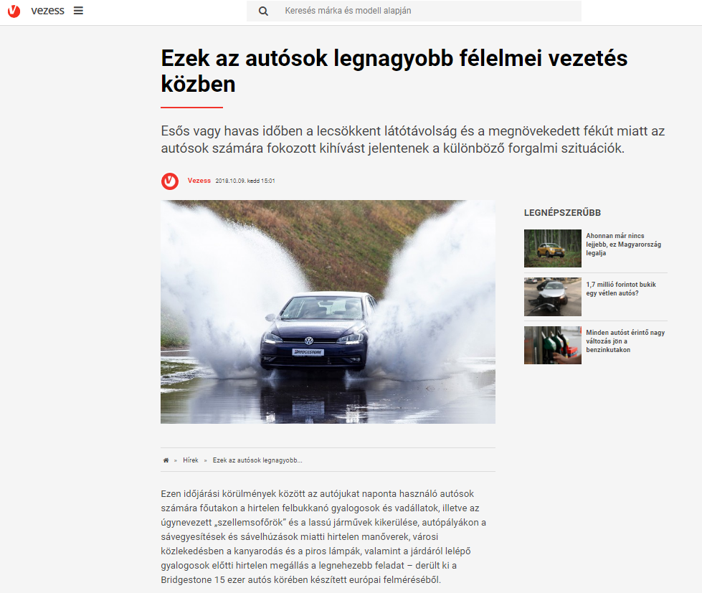

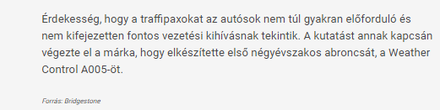

MEDIA: | Márkamonitor.hu | MEDIA SPECIFICS
DATE: | 10.10.2018. | TYPE: | Online
PAGE: |  | Reach: | N/A
Ad value (€) | N/A | FREQUENCY: | 2 alkalommal
HEADLINE: | Bridgestone launches S/A tire
SUMMARY: | More than 15,000 consumers across Europe where involved in the development of the new Bridgestone Weather Control A005. Multiple research strategies were used to define the customer journey, evaluate expectations and identify the most common challenges of daily driving in a variety of situations and locations.

https://markamonitor.hu/2018/10/10/negy-evszakos-abroncsot-dobott-piacra-a-bridgestone/

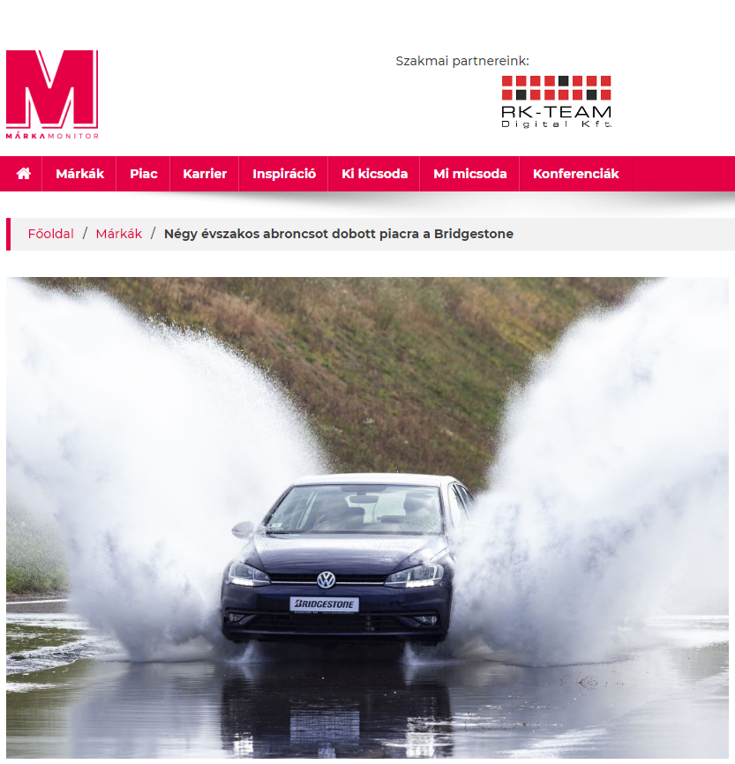
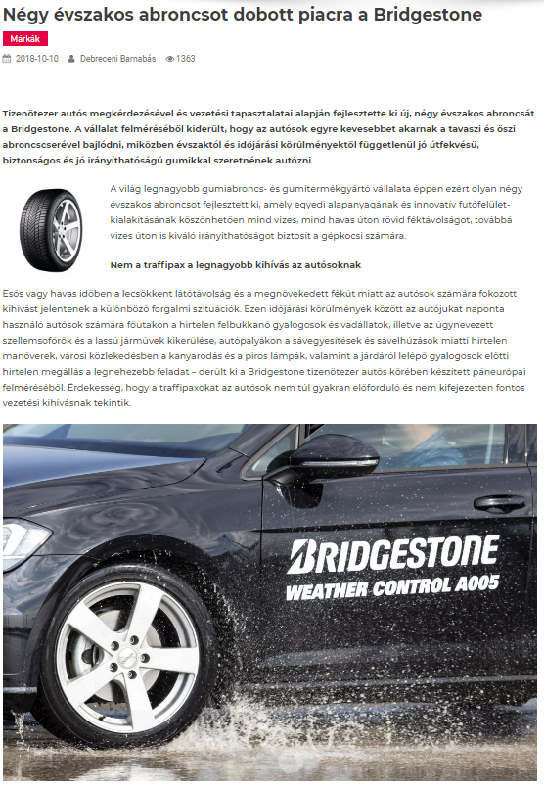

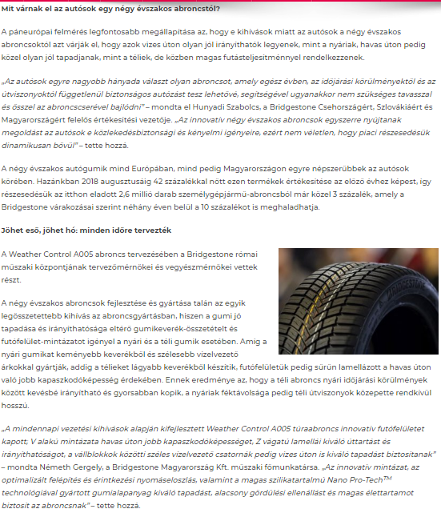

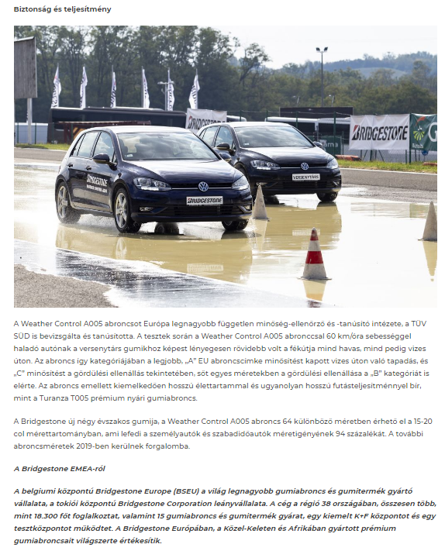

MEDIA: | Alapjarat.hu | MEDIA SPECIFICS
DATE: | 10.10.2018. | TYPE: | Online
PAGE: |  | Reach: | 26 242
Ad value (€) | 335 | FREQUENCY: | -
HEADLINE: | Bridgestone launches S/A tire
SUMMARY: | More than 15,000 consumers across Europe where involved in the development of the new Bridgestone Weather Control A005. Multiple research strategies were used to define the customer journey, evaluate expectations and identify the most common challenges of daily driving in a variety of situations and locations.

https://alapjarat.hu/hasznos-infok/negyevszakos-abronccsal-ujit-bridgestone

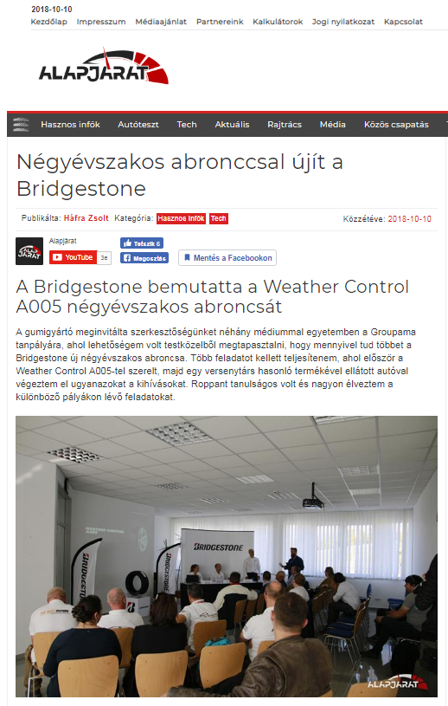

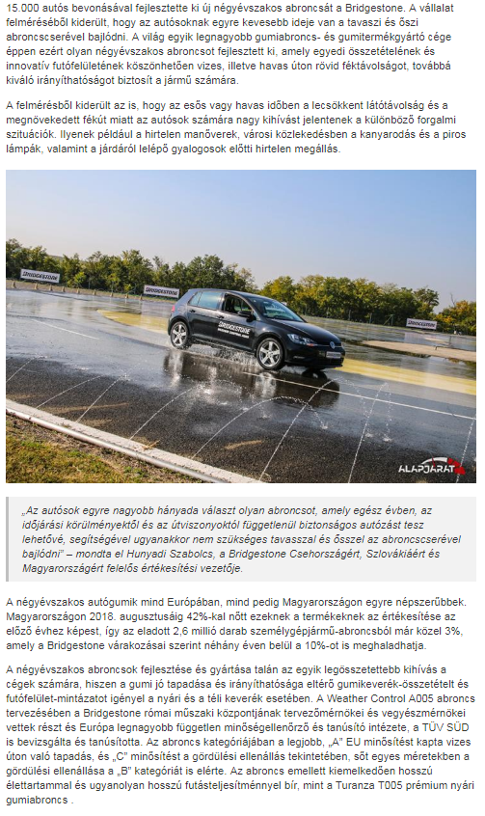

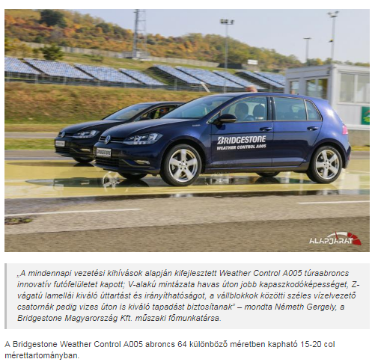

MEDIA: | Formula.hu | MEDIA SPECIFICS
DATE: | 10.10.2018. | TYPE: | Online
PAGE: |  | Reach: | N/A
Ad value (€) | 54 | FREQUENCY: | -
HEADLINE: | Drivers don’t want to struggle with tire change
SUMMARY: | More than 15,000 consumers across Europe where involved in the development of the new Bridgestone Weather Control A005. Multiple research strategies were used to define the customer journey, evaluate expectations and identify the most common challenges of daily driving in a variety of situations and locations.

http://formula.hu/auto/2018/10/09/nem-akarnak-az-abroncscserevel-bajlodni-az-autosok

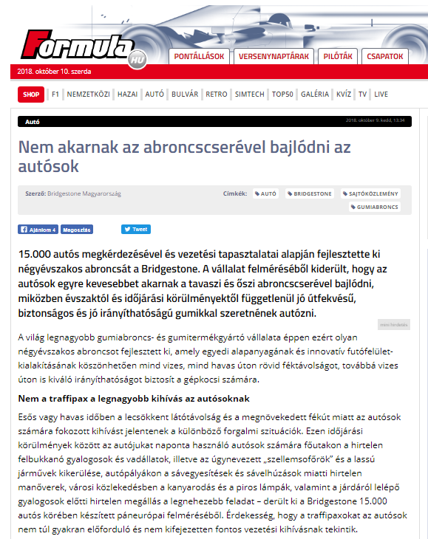

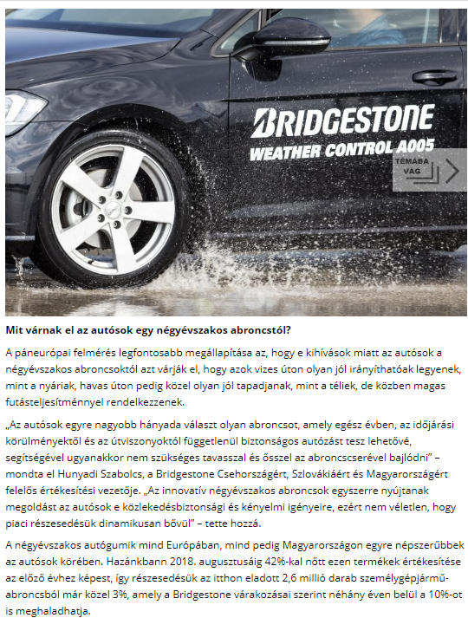

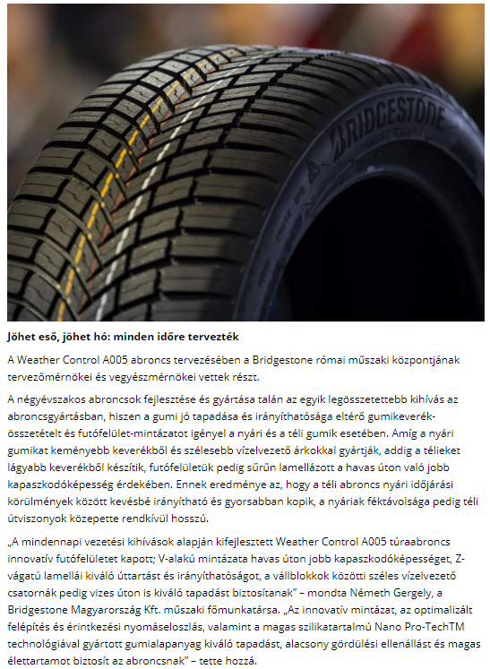

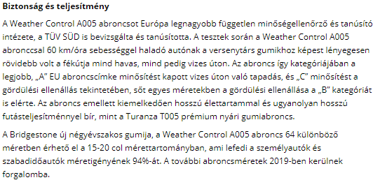

MEDIA: | Origo.hu | MEDIA SPECIFICS
DATE: | 11.10.2018. | TYPE: | Online
PAGE: |  | Reach: | 450 000
Ad value (€) | 3 500 | FREQUENCY: | -
HEADLINE: | Speedcams? Though: here are the things that scare drivers the most
SUMMARY: | More than 15,000 consumers across Europe where involved in the development of the new Bridgestone Weather Control A005. Multiple research strategies were used to define the customer journey, evaluate expectations and identify the most common challenges of daily driving in a variety of situations and locations.

http://www.origo.hu/auto/20181011-traffipax-ugyan-ime-a-meglepo-dolgok-amiktol-valoban-felnek-az-autosok.html

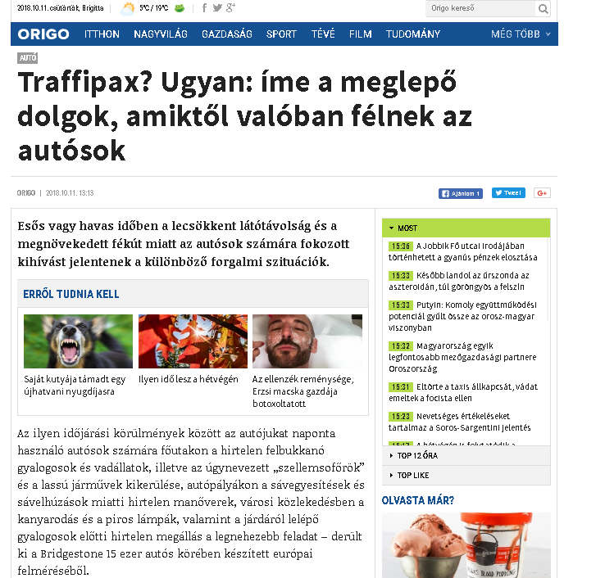

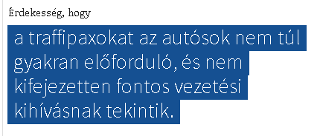

MEDIA: | Jogumi.blog.hu | MEDIA SPECIFICS
DATE: | 17.10.2018. | TYPE: | Online
PAGE: |  | Reach: | n/a
Ad value (€) | n/a | FREQUENCY: | -
HEADLINE: | Speedcams? Though: here are the things that scare drivers the most
SUMMARY: | More than 15,000 consumers across Europe where involved in the development of the new Bridgestone Weather Control A005. Multiple research strategies were used to define the customer journey, evaluate expectations and identify the most common challenges of daily driving in a variety of situations and locations.

https://jogumi.blog.hu/2018/10/17/bridgestone_weather_control_a005#more14306177

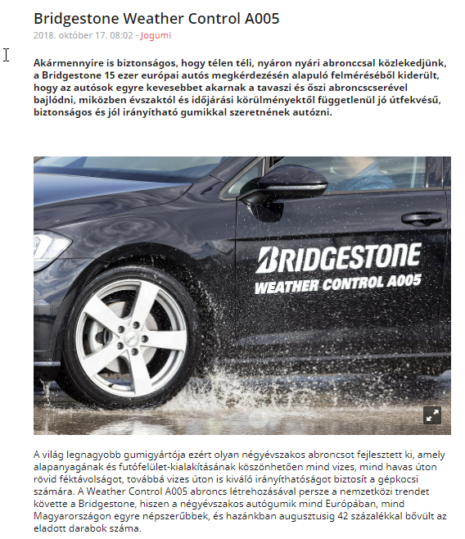
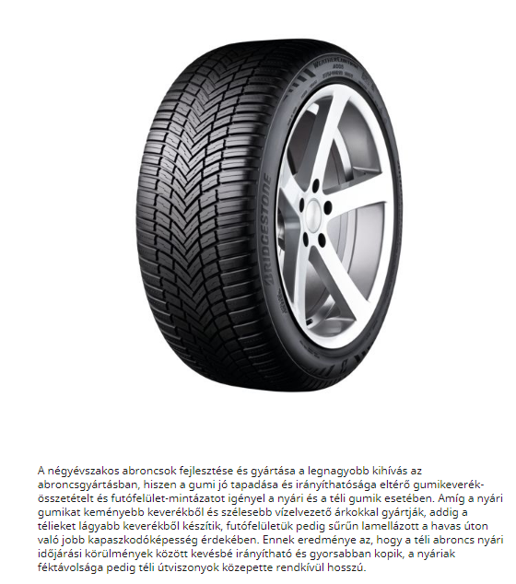
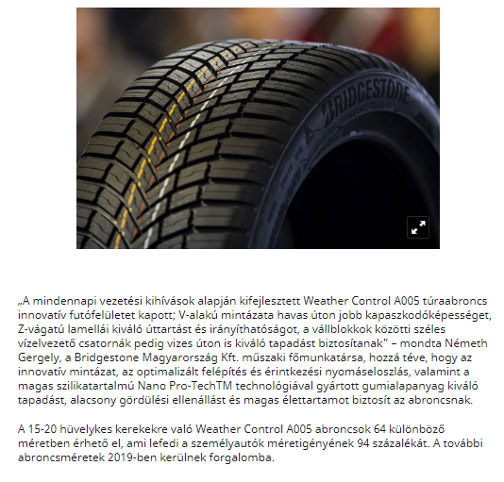

MEDIA: | Négyévszak.hu | MEDIA SPECIFICS
DATE: | 14.10.2018. | TYPE: | Online
PAGE: |  | Reach:
Ad value (€) |  | FREQUENCY: | -
HEADLINE: | Four Seasons
SUMMARY: | More than 15,000 consumers across Europe where involved in the development of the new Bridgestone Weather Control A005. Multiple research strategies were used to define the customer journey, evaluate expectations and identify the most common challenges of daily driving in a variety of situations and locations.

https://www.eletforma.hu/hirek/johet-eso-johet-ho/
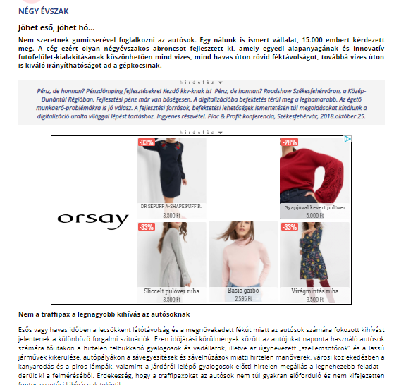
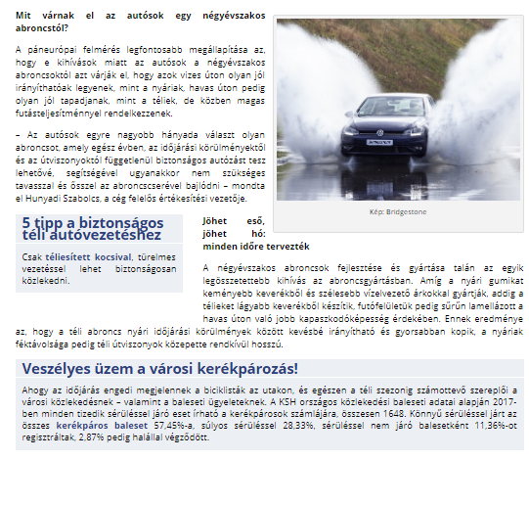

MEDIA: | Infotatabanya.hu | MEDIA SPECIFICS
DATE: | 14.10.2018. | TYPE: | Online
PAGE: |  | Reach: | 369 000
Ad value (€) | 3 145 | FREQUENCY: | -
HEADLINE: | Drivers don’t want to struggle with tire change
SUMMARY: | More than 15,000 consumers across Europe where involved in the development of the new Bridgestone Weather Control A005. Multiple research strategies were used to define the customer journey, evaluate expectations and identify the most common challenges of daily driving in a variety of situations and locations.

http://www.infotatabanya.hu/hirek/olvas/nem-akarnak-az-abroncscserevel-bajlodni-az-autosok-2018-10-16-084400

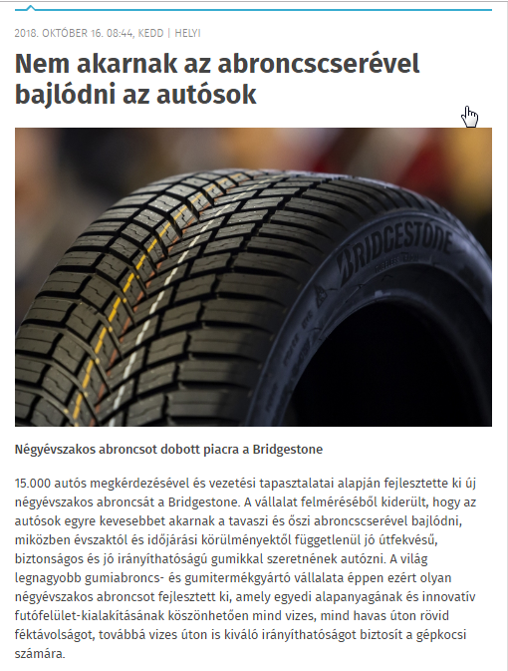

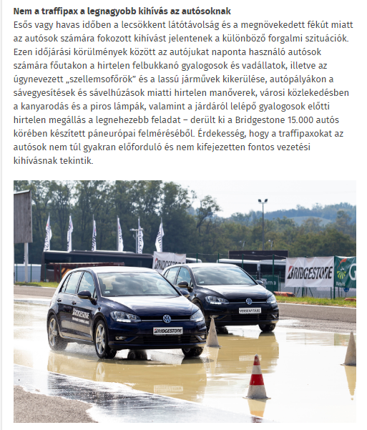
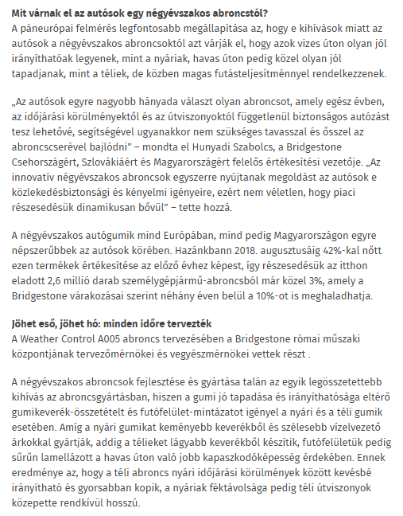
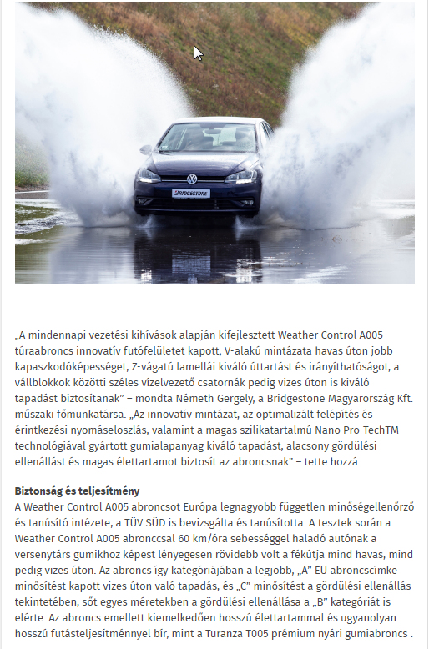
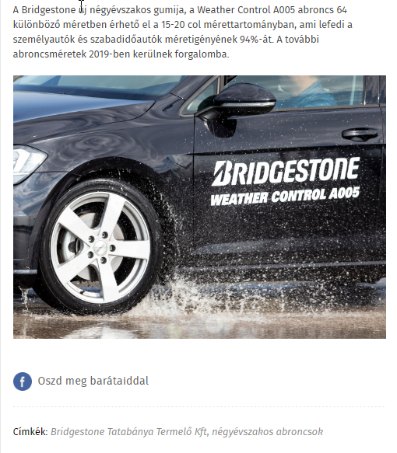

MEDIA: | Bellacafe.hu | MEDIA SPECIFICS
DATE: | 16.10.2018 | TYPE: | Online
PAGE: | - | REACH: | 4 400
AD VALUE (€) | 21 428 | FREQUENCY: | -
HEADLINE | Drivers don’t want to struggle with tire change
SUMMARY | More than 15,000 consumers across Europe where involved in the development of the new Bridgestone Weather Control A005. Multiple research strategies were used to define the customer journey, evaluate expectations and identify the most common challenges of daily driving in a variety of situations and locations.

https://www.bellacafe.hu/2018/10/16/nem-akarnak-az-abroncscserevel-bajlodni-az-autosok/

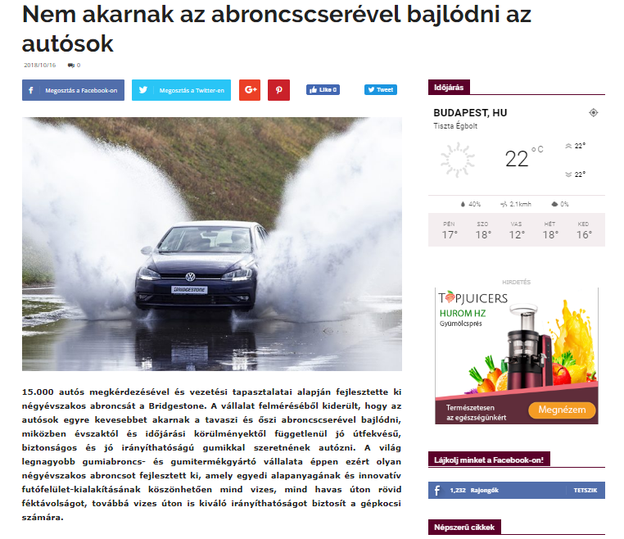
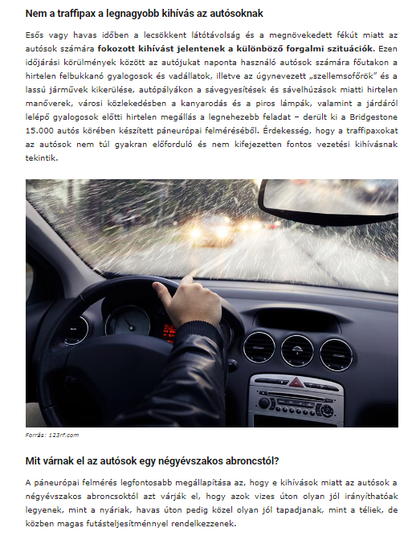
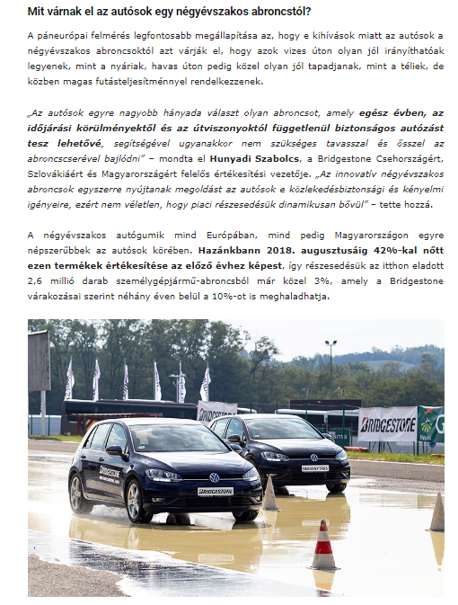
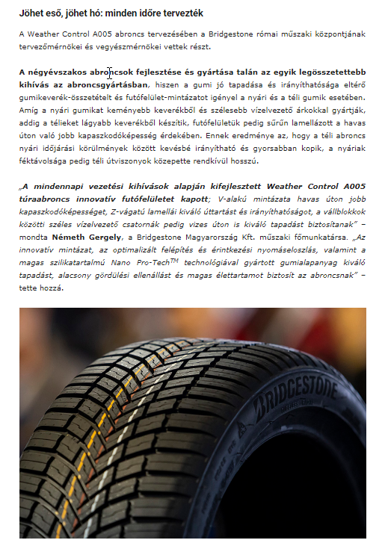
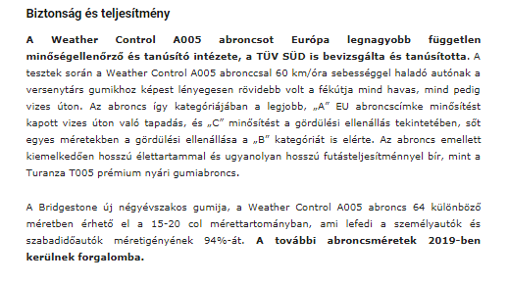

MEDIA: | Autoszektor.hu | MEDIA SPECIFICS
DATE: | 25.10.2018 | TYPE: | Online
PAGE: | - | REACH: | 9616
AD VALUE (€) | 690 | FREQUENCY: | -
HEADLINE | Fusion of four seasons
SUMMARY | More than 15,000 consumers across Europe where involved in the development of the new Bridgestone Weather Control A005. Multiple research strategies were used to define the customer journey, evaluate expectations and identify the most common challenges of daily driving in a variety of situations and locations.

http://www.autoszektor.hu/hu/content/gondolatjel-negy-evszak-egyesitese

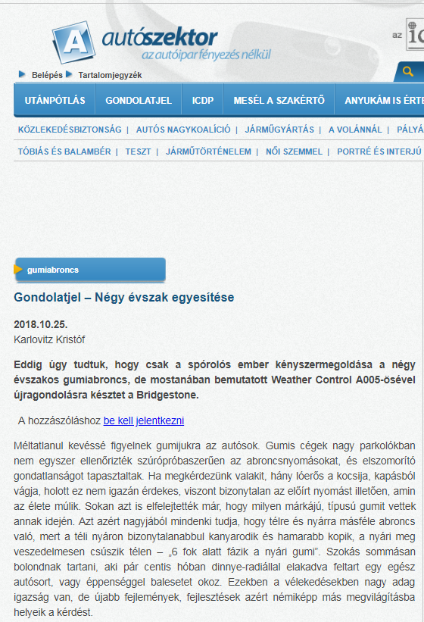

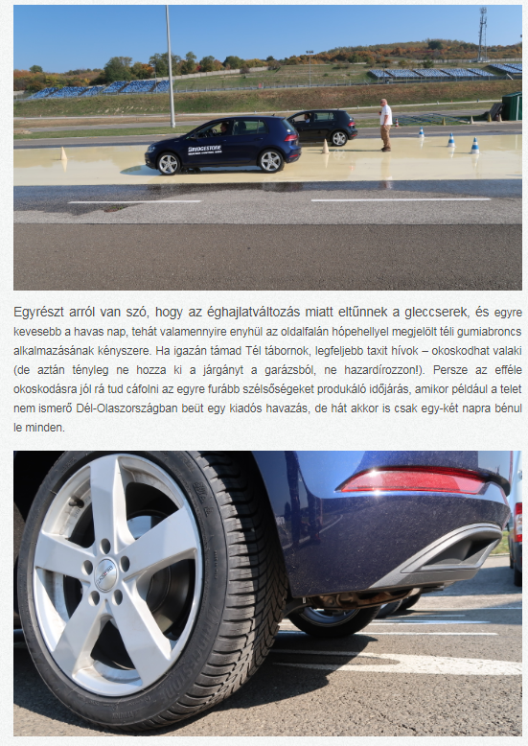

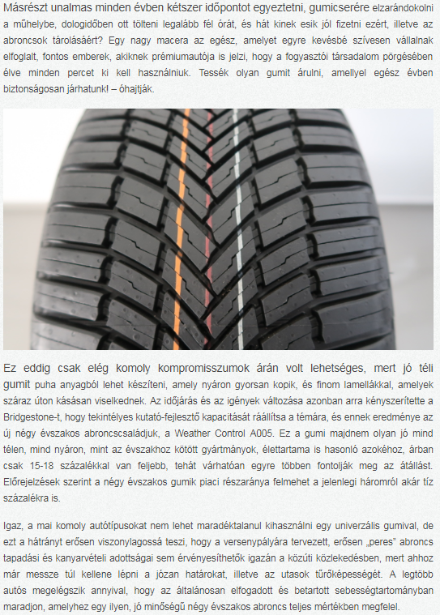

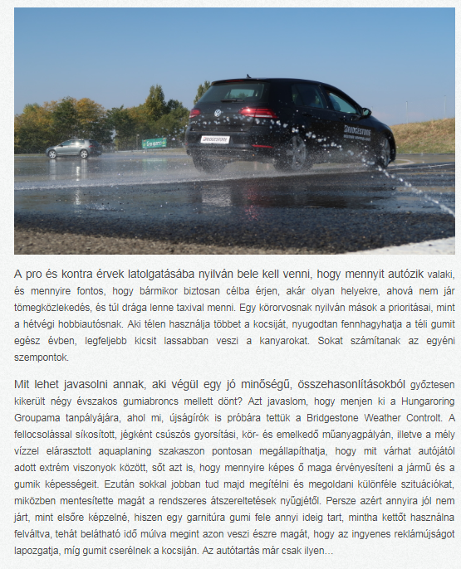

MEDIA: | Origo.hu | MEDIA SPECIFICS
DATE: | 24.10.2018. | TYPE: | Online
PAGE: |  | Reach: | 450 000
Ad value (€) | 3 500 | FREQUENCY: | -
HEADLINE: | Here is a new offer, if you don’t want to have troubles with your winter tyres
SUMMARY: | More than 15,000 consumers across Europe where involved in the development of the new Bridgestone Weather Control A005. Multiple research strategies were used to define the customer journey, evaluate expectations and identify the most common challenges of daily driving in a variety of situations and locations.

http://www.origo.hu/auto/20181022-mire-jo-a-negyevszakos-gumi.html

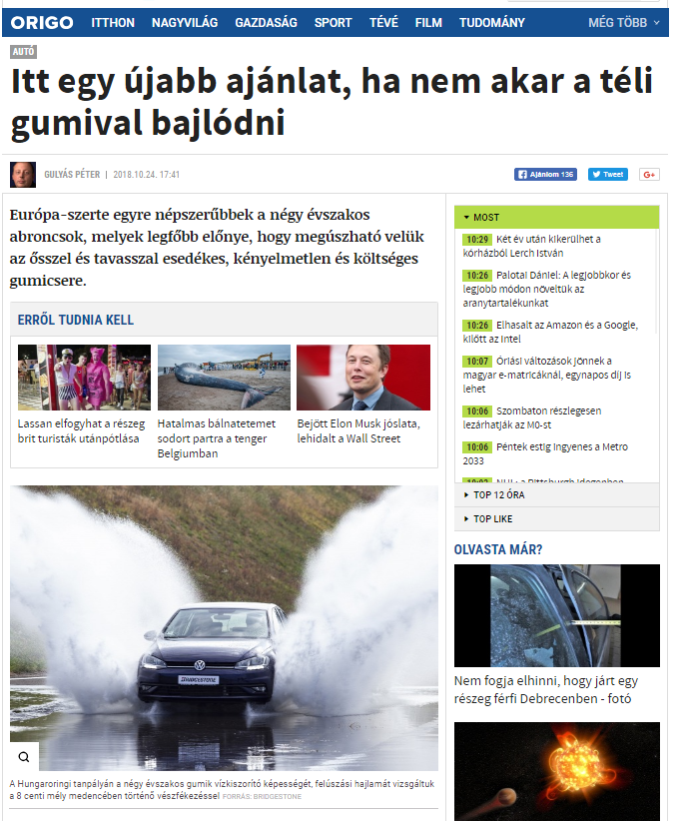

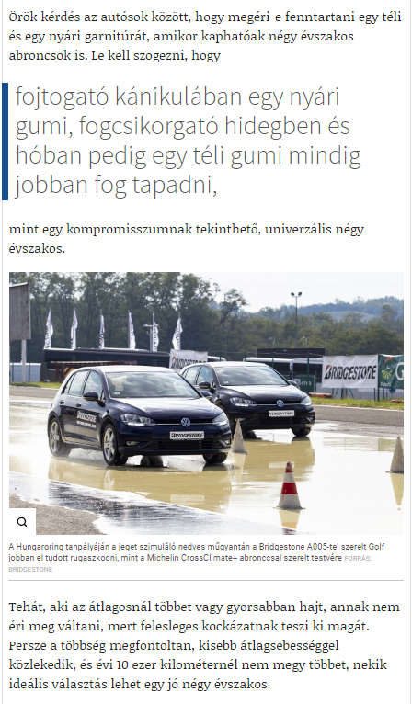

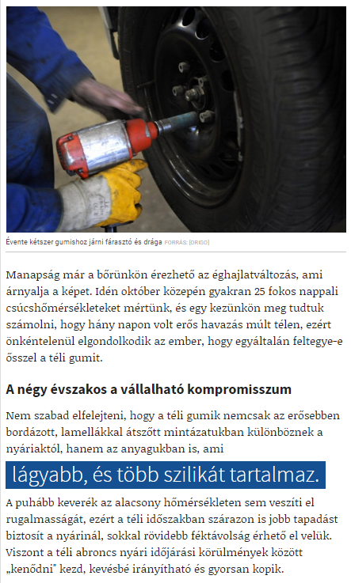

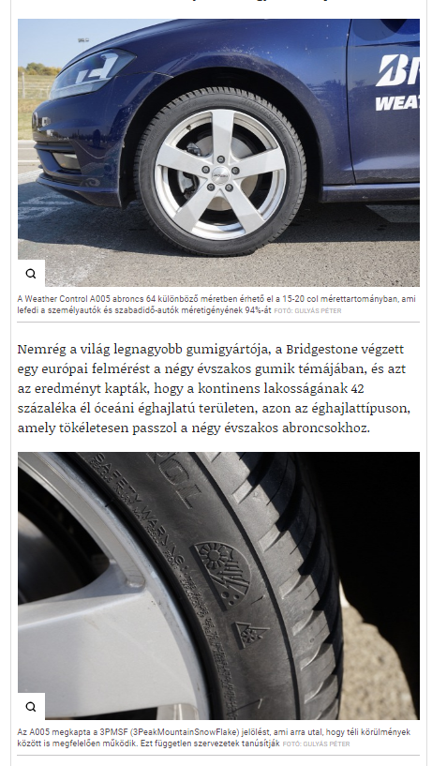

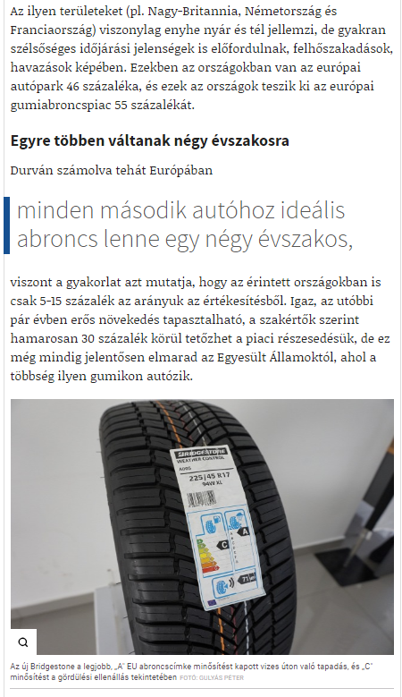

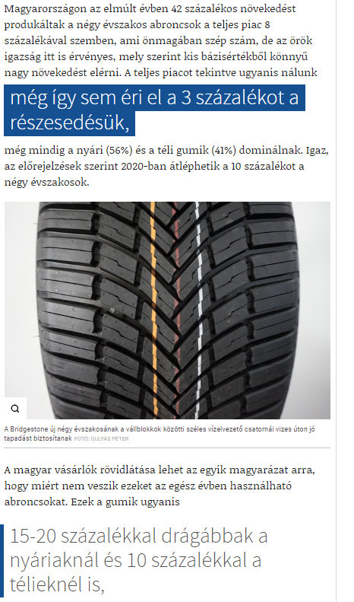

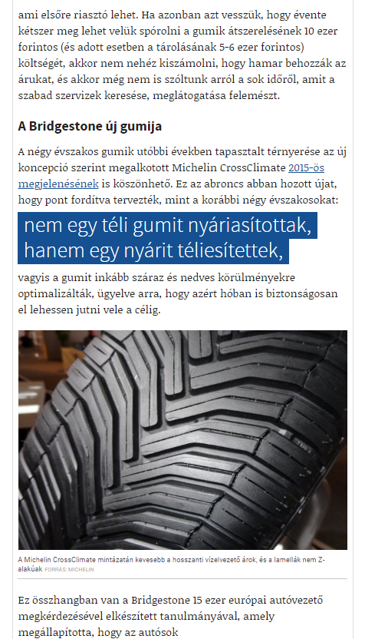

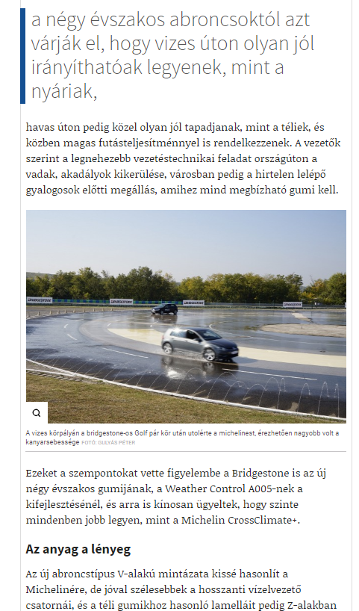

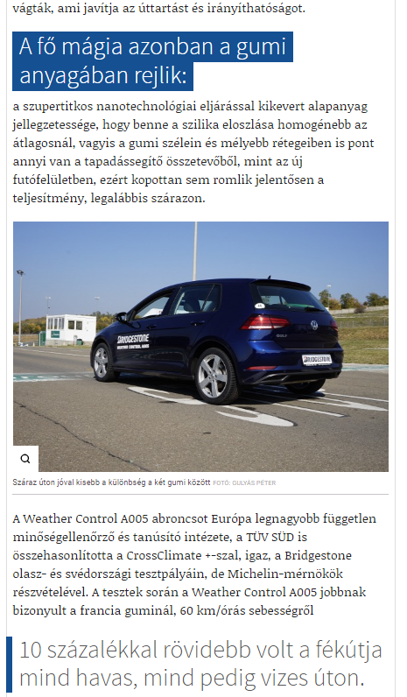

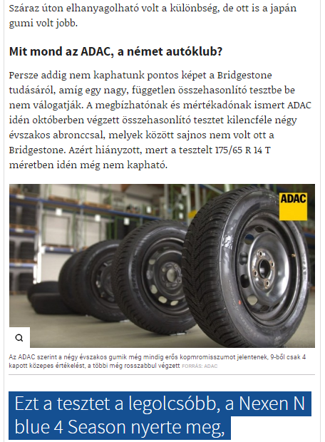

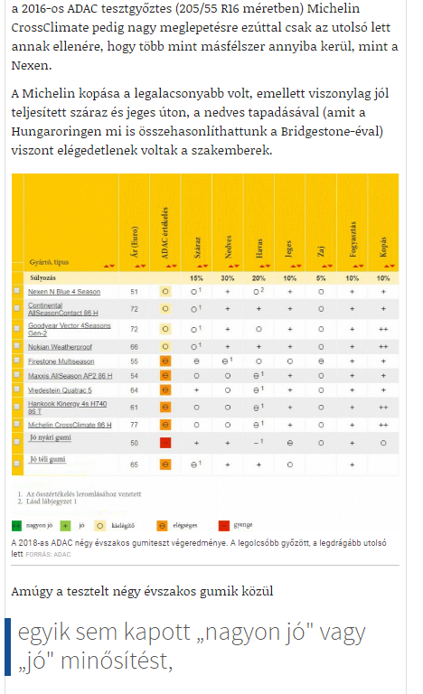

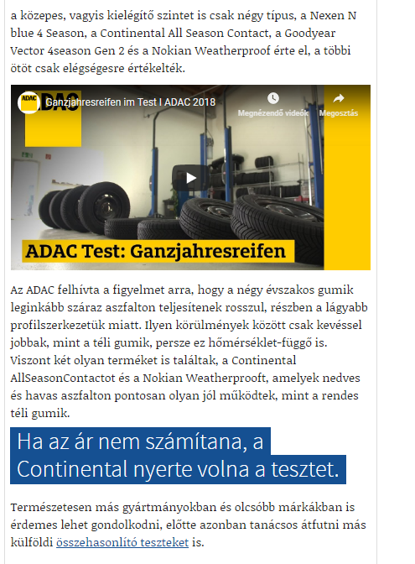

MEDIA: | Autonavigator.hu | MEDIA SPECIFICS
DATE: | 15.10.2018. | TYPE: | Online
PAGE: |  | Reach: | 11 333
Ad value (€) | N/A | FREQUENCY: | -
HEADLINE: | Only one set of tyre for the whole year? Here is a new promising offer
SUMMARY: | More than 15,000 consumers across Europe where involved in the development of the new Bridgestone Weather Control A005. Multiple research strategies were used to define the customer journey, evaluate expectations and identify the most common challenges of daily driving in a variety of situations and locations.

https://www.autonavigator.hu/cikkek/egyetlen-gumi-egesz-evre-itt-egy-ujabb-igeretes-ajanlat/

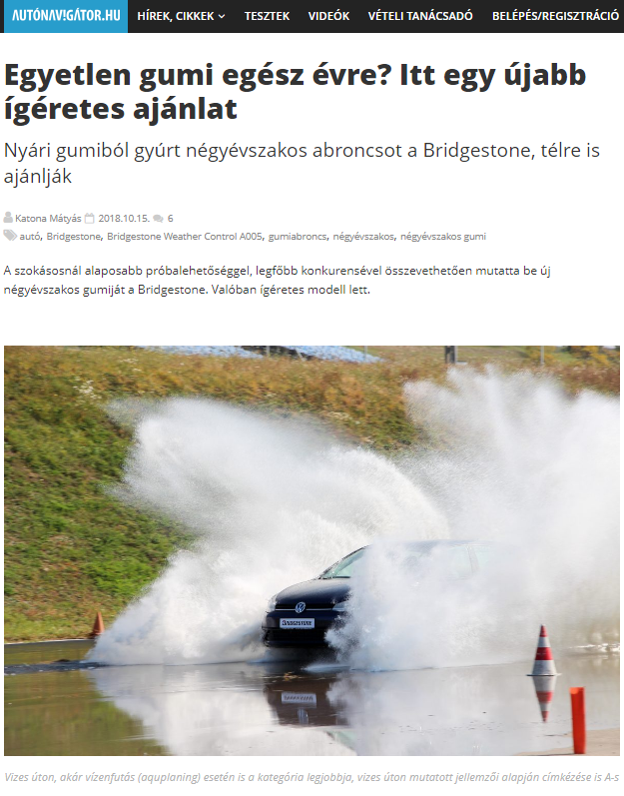

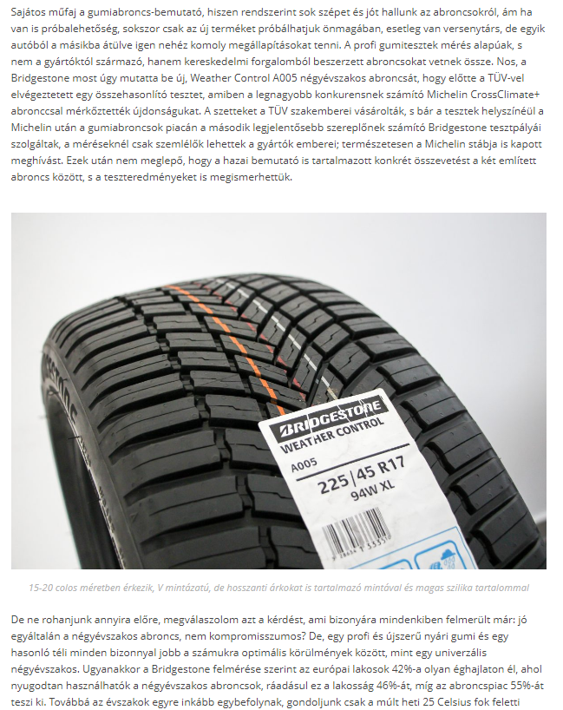

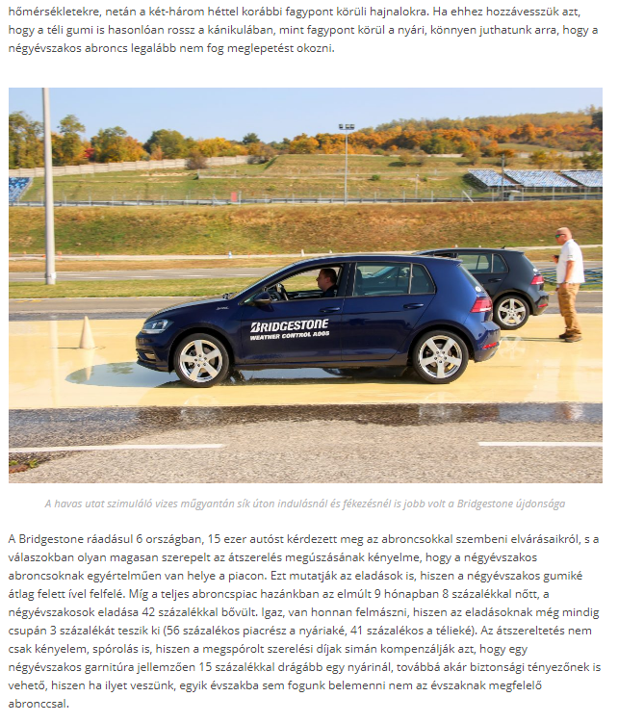

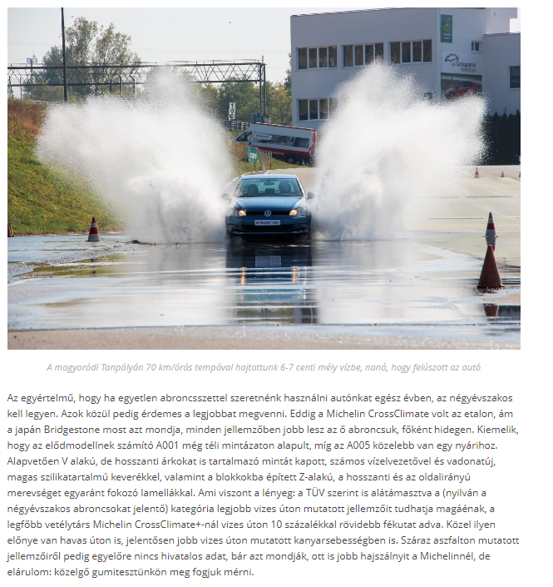

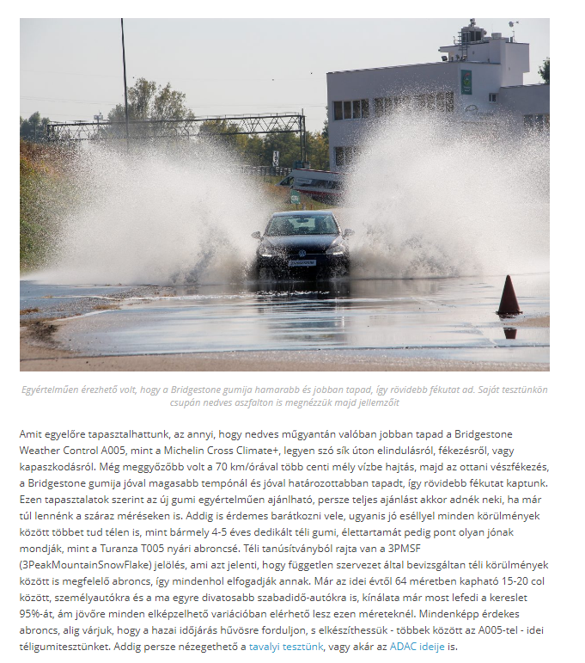

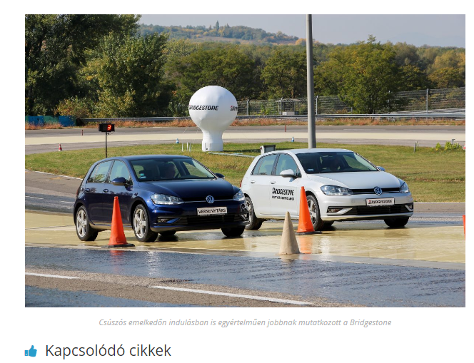

MEDIA: | Autonavigator.hu | MEDIA SPECIFICS
DATE: | 15.10.2018. | TYPE: | Online
PAGE: |  | Reach: | N/A
Ad value (€) | N/A | FREQUENCY: | -
HEADLINE: | Predictabilty and comfort
SUMMARY: | More than 15,000 consumers across Europe where involved in the development of the new Bridgestone Weather Control A005. Multiple research strategies were used to define the customer journey, evaluate expectations and identify the most common challenges of daily driving in a variety of situations and locations.

https://alkatreszek.hu/negyevszakos-gumi-bridgestone

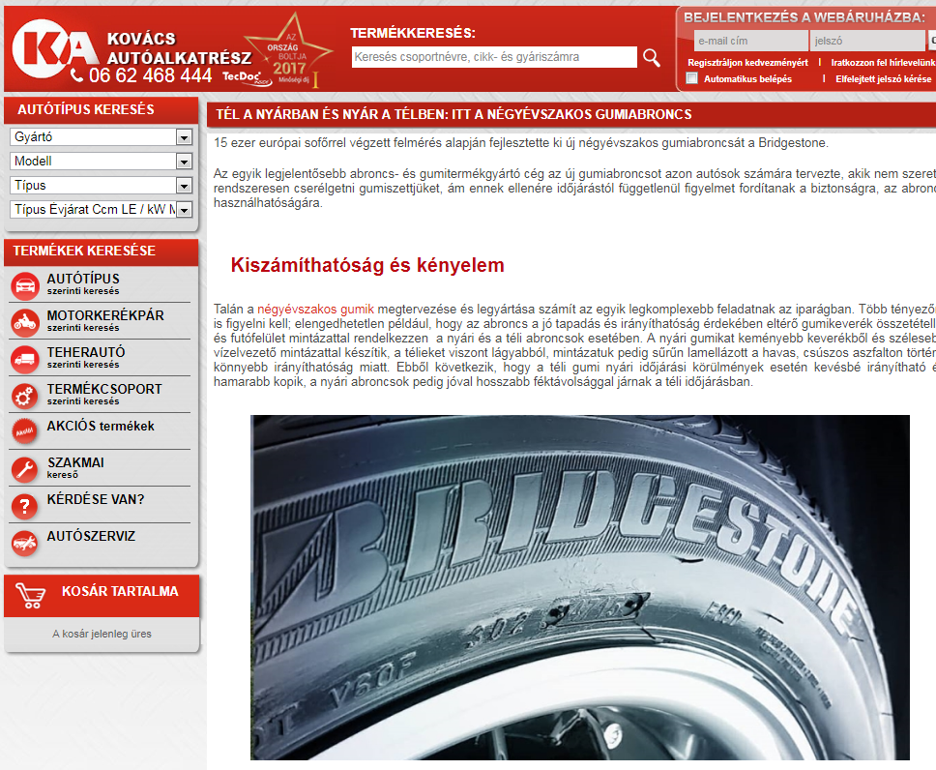

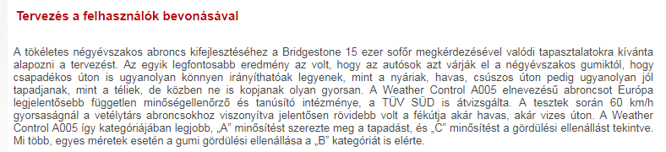

MEDIA: | Starthirek.hu | MEDIA SPECIFICS
DATE: | 25.10.2018. | TYPE: | Online
PAGE: |  | Reach: | N/A
Ad value (€) | N/A | FREQUENCY: | -
HEADLINE: | Fusion of four seasons
SUMMARY: | More than 15,000 consumers across Europe where involved in the development of the new Bridgestone Weather Control A005. Multiple research strategies were used to define the customer journey, evaluate expectations and identify the most common challenges of daily driving in a variety of situations and locations.

https://starthirek.hu/2018/10/25/gondolatjel-negy-evszak-egyesitese/

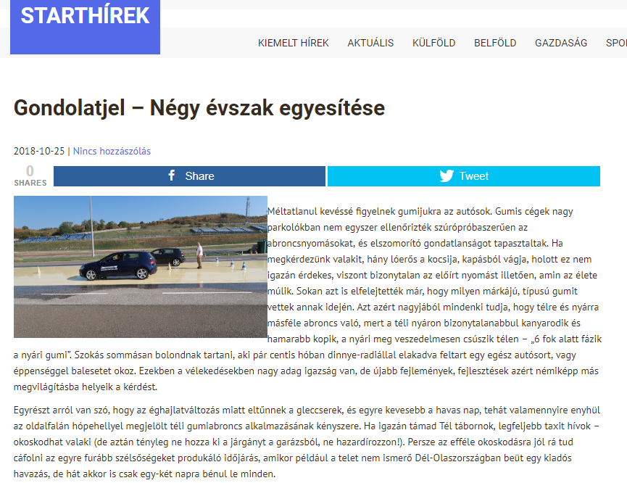

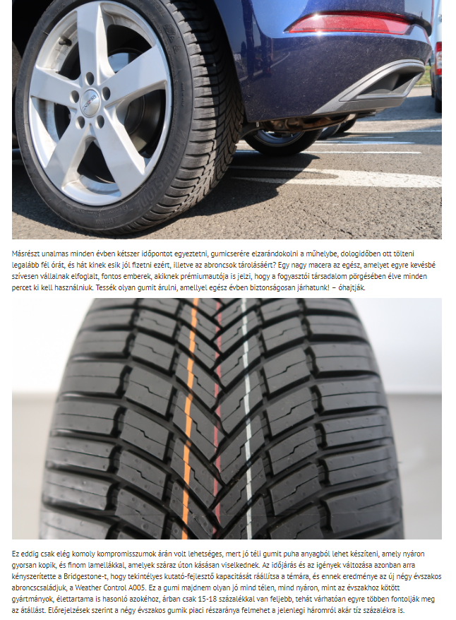

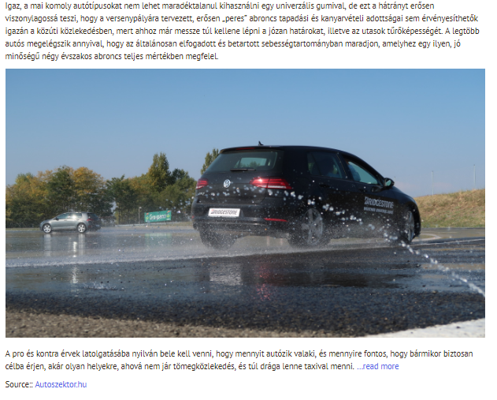

MEDIA: | Egyszermarlattamautot.hu | MEDIA SPECIFICS
DATE: | 10.10.2018. | TYPE: | Online
PAGE: |  | Reach: | N/A
Ad value (€) | N/A | FREQUENCY: | -
HEADLINE: | Drivers don’t want to struggle with tire change
SUMMARY: | More than 15,000 consumers across Europe where involved in the development of the new Bridgestone Weather Control A005. Multiple research strategies were used to define the customer journey, evaluate expectations and identify the most common challenges of daily driving in a variety of situations and locations.

http://egyszermarlattamautot.hu/2018/10/10/nem-akarnak-az-abroncscserevel-bajlodni-az-autosok﻿/

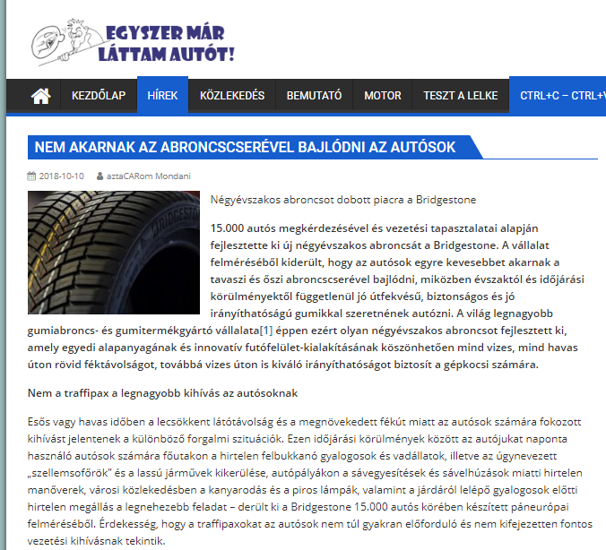

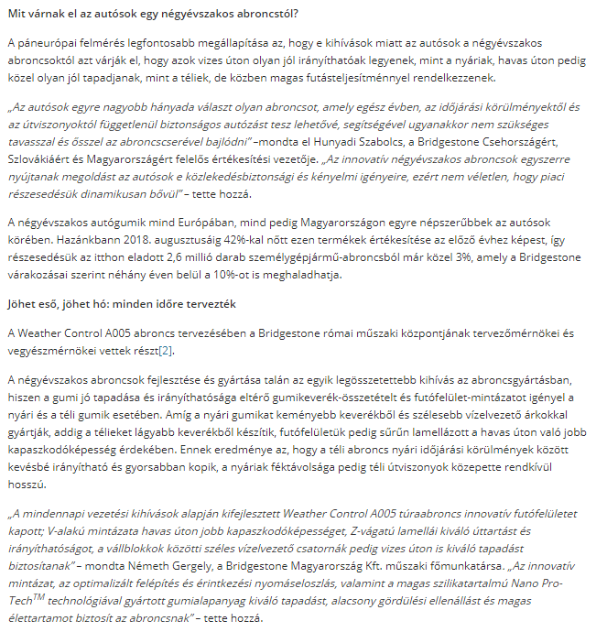

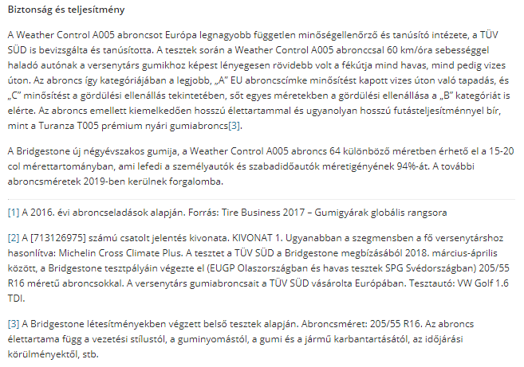

MEDIA: | Penzcentrum.hu | MEDIA SPECIFICS
DATE: | 13.10.2018. | TYPE: | Online
PAGE: |  | Reach: | 220 000
Ad value (€) | 230 | FREQUENCY: | -
HEADLINE: | There you go summer and winter tires: Hungarian drivers don’t want them
SUMMARY: | More than 15,000 consumers across Europe where involved in the development of the new Bridgestone Weather Control A005. Multiple research strategies were used to define the customer journey, evaluate expectations and identify the most common challenges of daily driving in a variety of situations and locations.

https://www.penzcentrum.hu/utazas/nesze-neked-teli-nyari-gumi-a-magyar-autosok-nem-kernek-belole.1070968.html

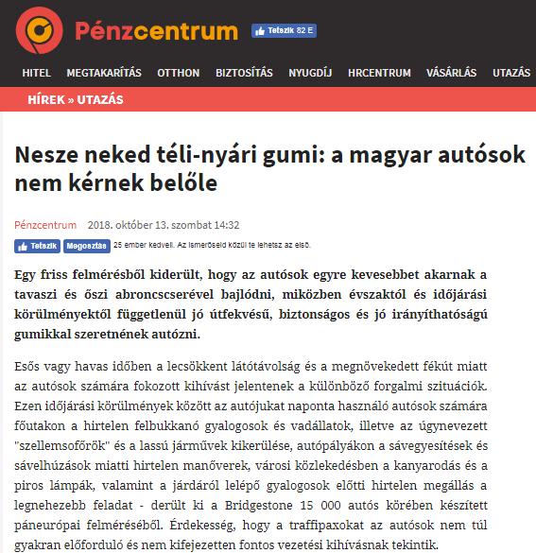

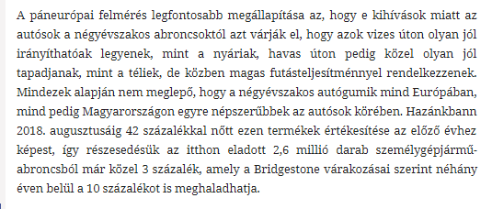

MEDIA: | Jazzy Rádió | MEDIA SPECIFICS
DATE: | 28.10.2018. | TYPE: | Electronic
PAGE: |  | Reach: | 32 000
Ad value (€) | 216 | FREQUENCY: | -
HEADLINE: | Interview with Gergely Németh
SUMMARY: | More than 15,000 consumers across Europe where involved in the development of the new Bridgestone Weather Control A005. Multiple research strategies were used to define the customer journey, evaluate expectations and identify the most common challenges of daily driving in a variety of situations and locations.

http://premiercom.hu/download/Bridgestone/Jazzy_Radio_Interview_with_Gergely_Nemeth_2018_10_28.wav

MEDIA: | Trend FM | MEDIA SPECIFICS
DATE: | 26.10.2018. | TYPE: | Electronic
PAGE: |  | Reach: | 213 000
Ad value (€) | 2 226 | FREQUENCY: | 3 alkalommal
HEADLINE: | Interview with Szabolcs Hunyadi
SUMMARY: | More than 15,000 consumers across Europe where involved in the development of the new Bridgestone Weather Control A005. Multiple research strategies were used to define the customer journey, evaluate expectations and identify the most common challenges of daily driving in a variety of situations and locations.

http://premiercom.hu/download/Bridgestone/Trend_FM_Interview_With_Szabolcs_Hunyadi_26_10_2018.wav

MEDIA: | Gumipiacmagazin.hu | MEDIA SPECIFICS
DATE: | 26.10.2018. | TYPE: | Online
PAGE: |  | Reach: | 100
Ad value (€) | 2 | FREQUENCY: | -
HEADLINE: | Bridgestone Weather Control A005 – all season tire
SUMMARY: | More than 15,000 consumers across Europe where involved in the development of the new Bridgestone Weather Control A005. Multiple research strategies were used to define the customer journey, evaluate expectations and identify the most common challenges of daily driving in a variety of situations and locations.

https://gumipiacmagazin.hu/2018/10/09/bridgestone-a005-negyevszakos-gumiabroncs/

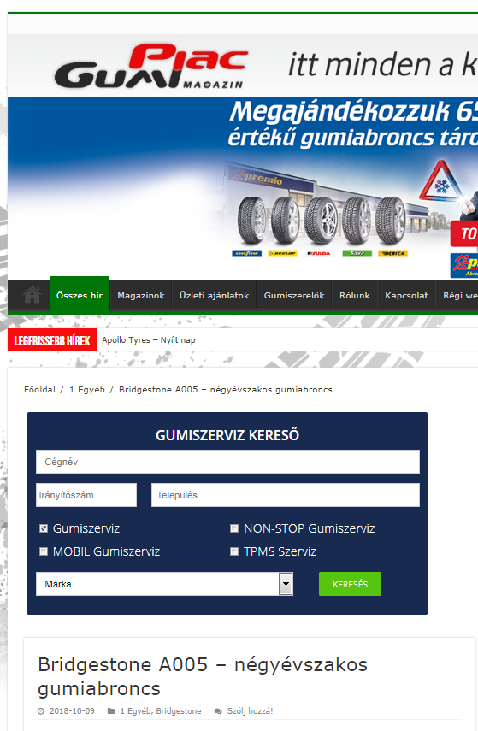

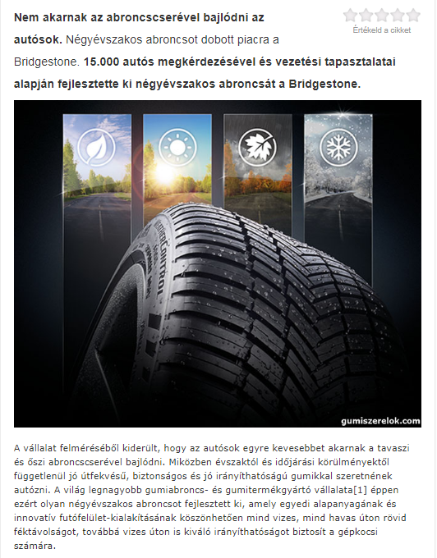

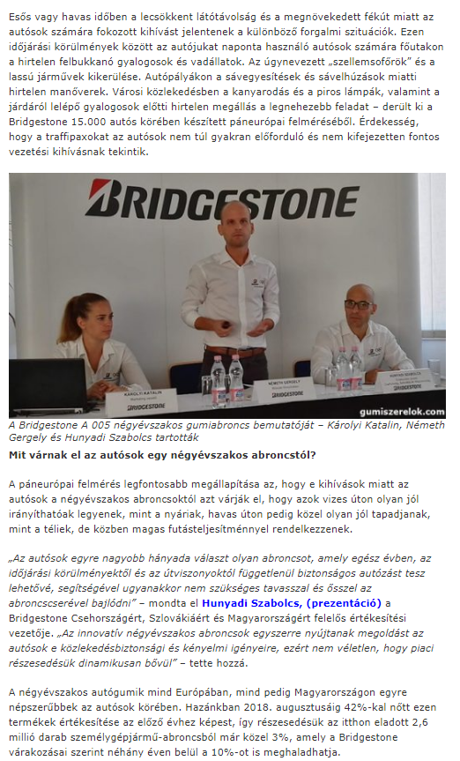

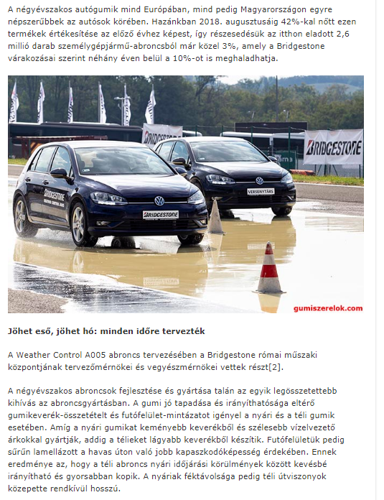

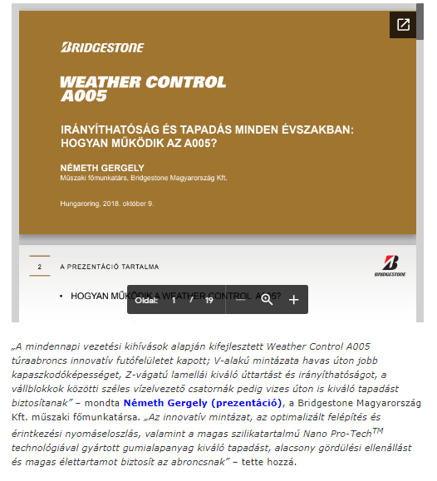

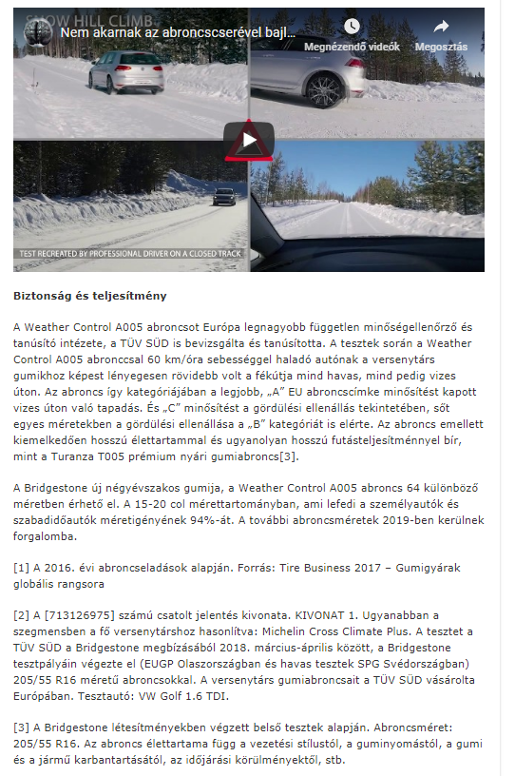

MEDIA: | M1 Ma délelőtt | MEDIA SPECIFICS
DATE: | 09.11.2018. | TYPE: | Electronic
PAGE: |  | Reach: | 240 000
Ad value (€) | 1 000 | FREQUENCY: | -
HEADLINE: | Interview with Gergely Németh
SUMMARY: | More than 15,000 consumers across Europe where involved in the development of the new Bridgestone Weather Control A005. Multiple research strategies were used to define the customer journey, evaluate expectations and identify the most common challenges of daily driving in a variety of situations and locations.

https://www.mediaklikk.hu/video/ma-delelott-2018-11-09-i-adas-2/

