PRESS CLIPPING Hungary
FOOTBALL FOR FRIENDSHIP

04. April 2017

Media name: | Nemzeti Sport
Media type & URL: | Online
Media logo:
Header: | Hungarian mid-defender will play in the international team of “FOOTBALL FOR FRIENDSHIP”
Date: | 06/04/2017
Newsbreak: | Project launch
Short summary | The Fifth season of the international children social programme „FOOTBALL FOR FRIENDSHIP” has been launched. The programme was announced by Gazprom Company, the official partner of the FIFA and the 2018 FIFA World Cup™. The number of the participating countries of the programme increased from 32 to 64 this year. In the frame of the programme - which is supported by the Hungarian Football Federation Grassroots Program - 8 international football teams were united from the countries. They will enter the field in July in St Petersburg, and then watch together the final of the FIFA Confederation Cup. A 12-year-old Hungarian sports reporter accompanies them in St Petersburg. For this position a young football fun will be selected by a tender.
Link: | http://premiercom.hu/download/private/Gazprom/NSPrint_0406.pdf

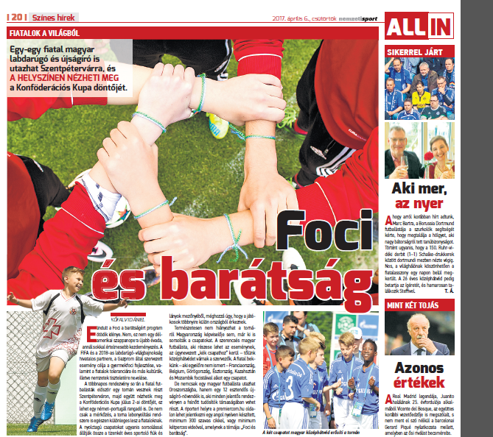

Media name: | MTI
Media type & URL: | Newswire
Media logo: | 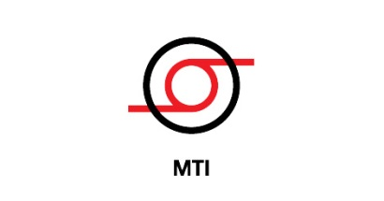
Header: | Hungarian mid-defender will play in the international team of “FOOTBALL FOR FRIENDSHIP”
Date: | 04/04/2017
Newsbreak: | Project launch
Short summary | The Fifth season of the international children social programme „FOOTBALL FOR FRIENDSHIP” has been launched. The programme was announced by Gazprom Company, the official partner of the FIFA and the 2018 FIFA World Cup™. The number of the participating countries of the programme increased from 32 to 64 this year. In the frame of the programme - which is supported by the Hungarian Football Federation Grassroots Program - 8 international football teams were united from the countries. They will enter the field in July in St Petersburg, and then watch together the final of the FIFA Confederation Cup. A 12-year-old Hungarian sports reporter accompanies them in St Petersburg. For this position a young football fun will be selected by a tender.
Link:

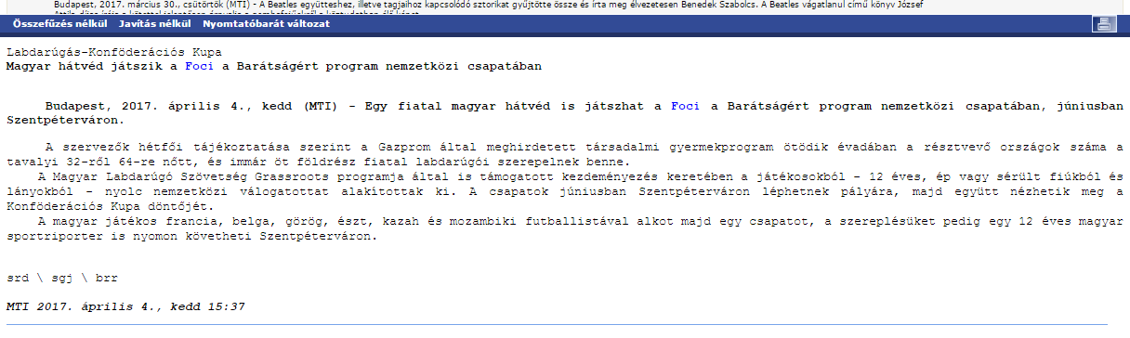

Media name: | nemzetisport.hu
Media type & URL: | Online
Media logo:
Header: | Hungarian mid-defender will play in the international team of “FOOTBALL FOR FRIENDSHIP”
Date: | 05/04/2017
Newsbreak: | Project launch
Short summary | The Fifth season of the international children social programme „FOOTBALL FOR FRIENDSHIP” has been launched. The programme was announced by Gazprom Company, the official partner of the FIFA and the 2018 FIFA World Cup™. The number of the participating countries of the programme increased from 32 to 64 this year. In the frame of the programme - which is supported by the Hungarian Football Federation Grassroots Program - 8 international football teams were united from the countries. They will enter the field in July in St Petersburg, and then watch together the final of the FIFA Confederation Cup. A 12-year-old Hungarian sports reporter accompanies them in St Petersburg. For this position a young football fun will be selected by a tender.
Link: | http://www.nemzetisport.hu/minden_mas_foci/foci-a-baratsagert-magyar-vedo-a-kulonleges-valogatottban-2561643

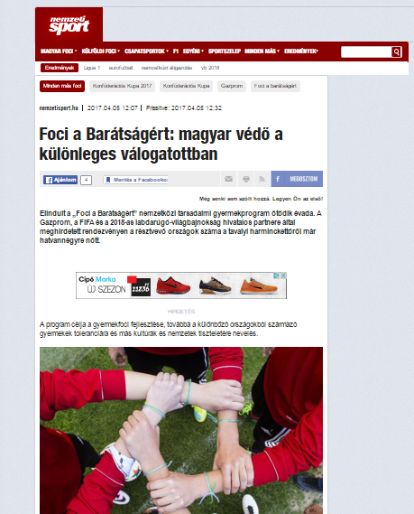

Media name: | Képes Sport
Media type & URL: | National Print
Media logo:
Header: | You also can become a journalist
Date: | 06/04/2017
Newsbreak: | Project launch
Short summary | The Fifth season of the international children social programme „FOOTBALL FOR FRIENDSHIP” has been launched. The programme was announced by Gazprom Company, the official partner of the FIFA and the 2018 FIFA World Cup™. The number of the participating countries of the programme increased from 32 to 64 this year. In the frame of the programme - which is supported by the Hungarian Football Federation Grassroots Program - 8 international football teams were united from the countries. They will enter the field in July in St Petersburg, and then watch together the final of the FIFA Confederation Cup. A 12-year-old Hungarian sports reporter accompanies them in St Petersburg. For this position a young football fun will be selected by a tender.
Link: | http://premiercom.hu/download/private/Gazprom/K%c3%a9pes%20Sport_KickOff_0406.pdf

User: gazprom
Password: f4f

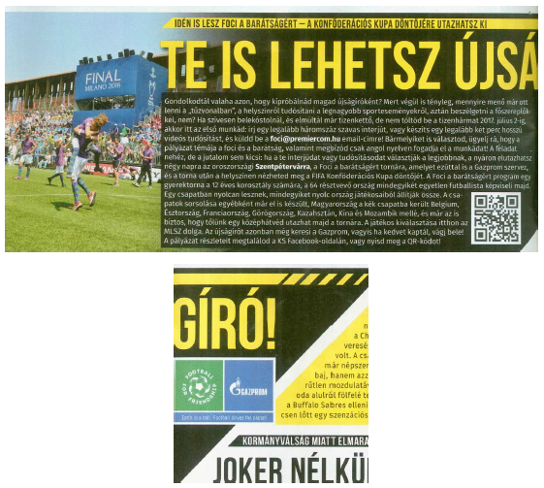
Media name: | 24.hu
Media type & URL: | Online
Media logo:
Header: | Hungarian mid-defender will play in the international team of “FOOTBALL FOR FRIENDSHIP”
Date: | 04/04/2017
Newsbreak: | Project launch
Short summary | The Fifth season of the international children social programme „FOOTBALL FOR FRIENDSHIP” has been launched. The programme was announced by Gazprom Company, the official partner of the FIFA and the 2018 FIFA World Cup™. The number of the participating countries of the programme increased from 32 to 64 this year. In the frame of the programme - which is supported by the Hungarian Football Federation Grassroots Program - 8 international football teams were united from the countries. They will enter the field in July in St Petersburg, and then watch together the final of the FIFA Confederation Cup. A 12-year-old Hungarian sports reporter accompanies them in St Petersburg. For this position a young football fun will be selected by a tender.
Link: | http://24.hu/sport/foci/2017/04/04/egy-fiatal-magyar-is-jatszhat-a-foci-a-baratsagert-program-nemzetkozi-csapataban/

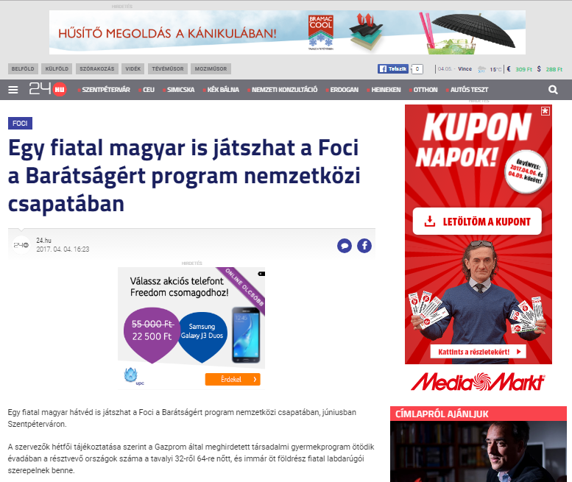

Media name: | m4sport.hu
Media type & URL: | Online
Media logo:
Header: | Hungarian mid-defender will play in the international team of “FOOTBALL FOR FRIENDSHIP”
Date: | 04/04/2017
Newsbreak: | Project launch
Short summary | The Fifth season of the international children social programme „FOOTBALL FOR FRIENDSHIP” has been launched. The programme was announced by Gazprom Company, the official partner of the FIFA and the 2018 FIFA World Cup™. The number of the participating countries of the programme increased from 32 to 64 this year. In the frame of the programme - which is supported by the Hungarian Football Federation Grassroots Program - 8 international football teams were united from the countries. They will enter the field in July in St Petersburg, and then watch together the final of the FIFA Confederation Cup. A 12-year-old Hungarian sports reporter accompanies them in St Petersburg. For this position a young football fun will be selected by a tender.
Link: | http://www.m4sport.hu/2017/04/04/magyar-hatved-is-bekerult-a-nemzetkozi-programba/

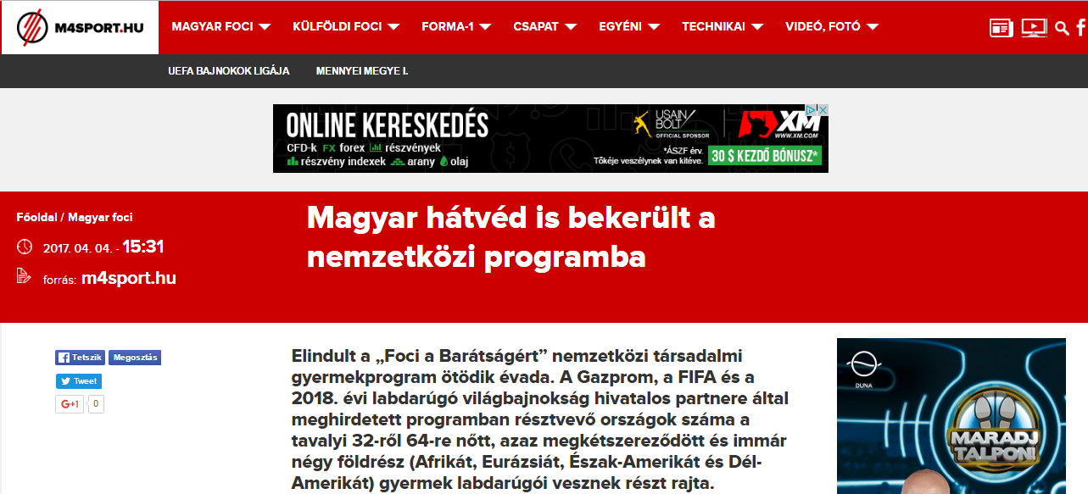

Media name: | mlsz.hu
Media type & URL: | Online
Media logo: | 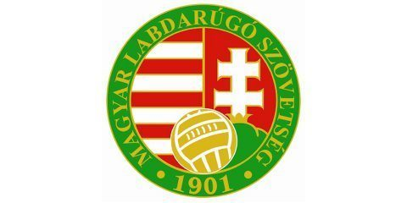
Header: | Hungarian mid-defender will play in the international team of “FOOTBALL FOR FRIENDSHIP”
Date: | 05/04/2017
Newsbreak: | Project launch
Short summary | The Fifth season of the international children social programme „FOOTBALL FOR FRIENDSHIP” has been launched. The programme was announced by Gazprom Company, the official partner of the FIFA and the 2018 FIFA World Cup™. The number of the participating countries of the programme increased from 32 to 64 this year. In the frame of the programme - which is supported by the Hungarian Football Federation Grassroots Program - 8 international football teams were united from the countries. They will enter the field in July in St Petersburg, and then watch together the final of the FIFA Confederation Cup. A 12-year-old Hungarian sports reporter accompanies them in St Petersburg. For this position a young football fun will be selected by a tender.
Link: | http://www.mlsz.hu/blog/2017/04/05/magyar-hatved-a-foci-a-baratsagert-nemzetkozi-csapataban/

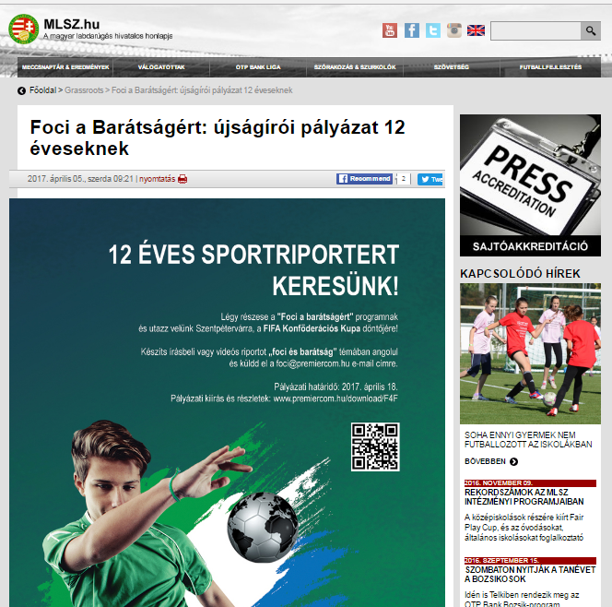

Media name: | magyarhirlap.hu
Media type & URL: | Online
Media logo: | 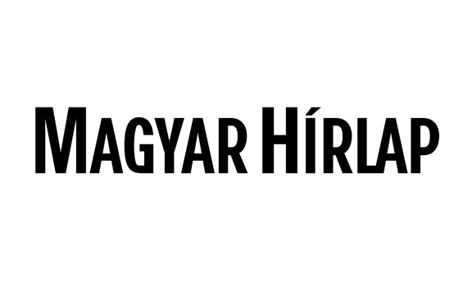
Header: | Hungarian mid-defender will play in the international team of “FOOTBALL FOR FRIENDSHIP”
Date: | 04/04/2017
Newsbreak: | Project launch
Short summary | The Fifth season of the international children social programme „FOOTBALL FOR FRIENDSHIP” has been launched. The programme was announced by Gazprom Company, the official partner of the FIFA and the 2018 FIFA World Cup™. The number of the participating countries of the programme increased from 32 to 64 this year. In the frame of the programme - which is supported by the Hungarian Football Federation Grassroots Program - 8 international football teams were united from the countries. They will enter the field in July in St Petersburg, and then watch together the final of the FIFA Confederation Cup. A 12-year-old Hungarian sports reporter accompanies them in St Petersburg. For this position a young football fun will be selected by a tender.
Link: | http://magyarhirlap.hu/cikk/84465/Magyar_hatved_jatszik_a_Foci_a_Baratsagert_program_nemzetkozi_csapataban

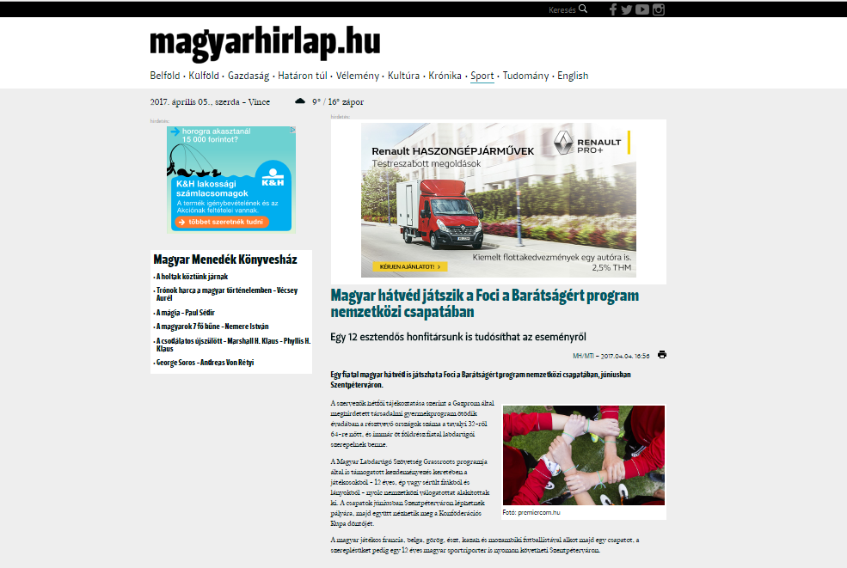

Media name: | nemzetisport.hu
Media type & URL: | Online
Media logo:
Header: | Hungarian mid-defender will play in the international team of “FOOTBALL FOR FRIENDSHIP”
Date: | 04/04/2017
Newsbreak: | Project launch
Short summary | The Fifth season of the international children social programme „FOOTBALL FOR FRIENDSHIP” has been launched. The programme was announced by Gazprom Company, the official partner of the FIFA and the 2018 FIFA World Cup™. The number of the participating countries of the programme increased from 32 to 64 this year. In the frame of the programme - which is supported by the Hungarian Football Federation Grassroots Program - 8 international football teams were united from the countries. They will enter the field in July in St Petersburg, and then watch together the final of the FIFA Confederation Cup. A 12-year-old Hungarian sports reporter accompanies them in St Petersburg. For this position a young football fun will be selected by a tender.
Link: | http://www.nemzetisport.hu/minden_mas_foci/foci-a-baratsagert-magyar-is-jatszik-a-nemzetkozi-csapatban-2561489

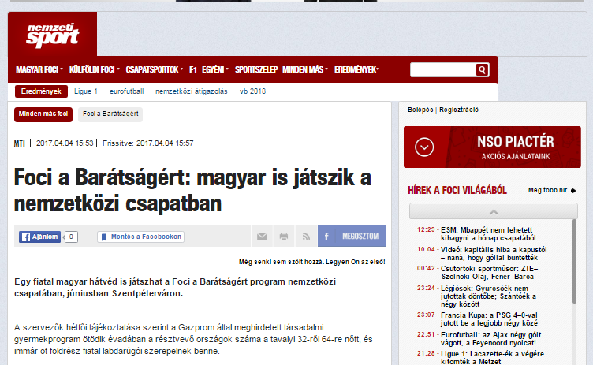

Media name: | sportfaktor.hu
Media type & URL: | Online
Media logo:
Header: | Hungarian mid-defender will play in the international team of “FOOTBALL FOR FRIENDSHIP”
Date: | 04/04/2017
Newsbreak: | Project launch
Short summary | The Fifth season of the international children social programme „FOOTBALL FOR FRIENDSHIP” has been launched. The programme was announced by Gazprom Company, the official partner of the FIFA and the 2018 FIFA World Cup™. The number of the participating countries of the programme increased from 32 to 64 this year. In the frame of the programme - which is supported by the Hungarian Football Federation Grassroots Program - 8 international football teams were united from the countries. They will enter the field in July in St Petersburg, and then watch together the final of the FIFA Confederation Cup. A 12-year-old Hungarian sports reporter accompanies them in St Petersburg. For this position a young football fun will be selected by a tender.
Link: | http://www.sportfaktor.hu/2017/04/04/magyar-hatved-jatszik-a-foci-a-baratsagert-program-nemzetkozi-csapataban/31162/

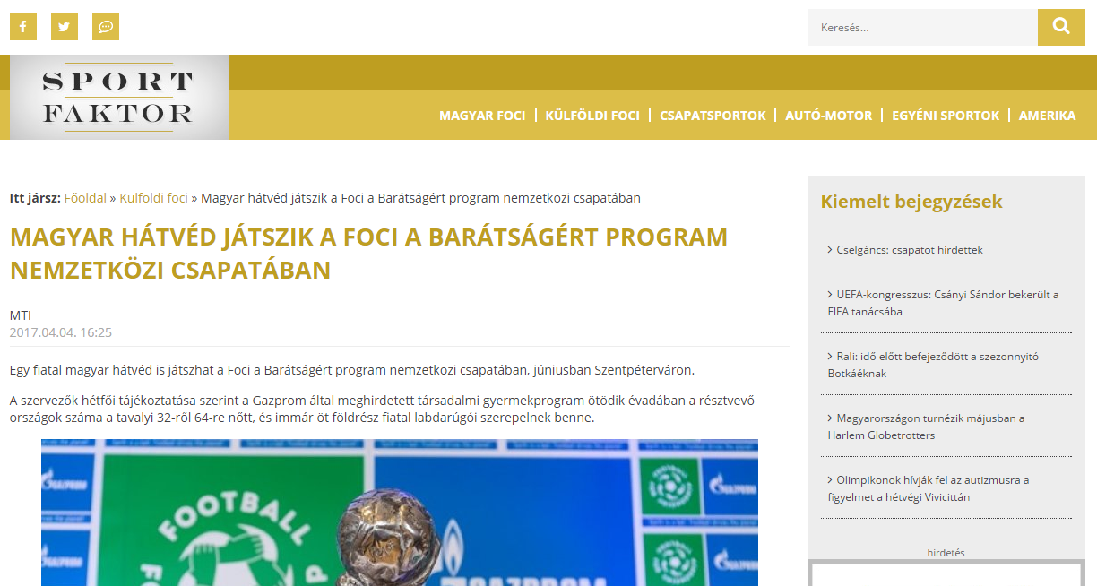

Media name: | webradio.hu
Media type & URL: | Online
Media logo:
Header: | Hungarian mid-defender will play in the international team of “FOOTBALL FOR FRIENDSHIP”
Date: | 04/04/2017
Newsbreak: | Project launch
Short summary | The Fifth season of the international children social programme „FOOTBALL FOR FRIENDSHIP” has been launched. The programme was announced by Gazprom Company, the official partner of the FIFA and the 2018 FIFA World Cup™. The number of the participating countries of the programme increased from 32 to 64 this year. In the frame of the programme - which is supported by the Hungarian Football Federation Grassroots Program - 8 international football teams were united from the countries. They will enter the field in July in St Petersburg, and then watch together the final of the FIFA Confederation Cup. A 12-year-old Hungarian sports reporter accompanies them in St Petersburg. For this position a young football fun will be selected by a tender.
Link: | http://webradio.hu/hirek/sport/magyar_hatved_jatszik_a_foci_a_baratsagert_program_nemzetkozi_csapataban

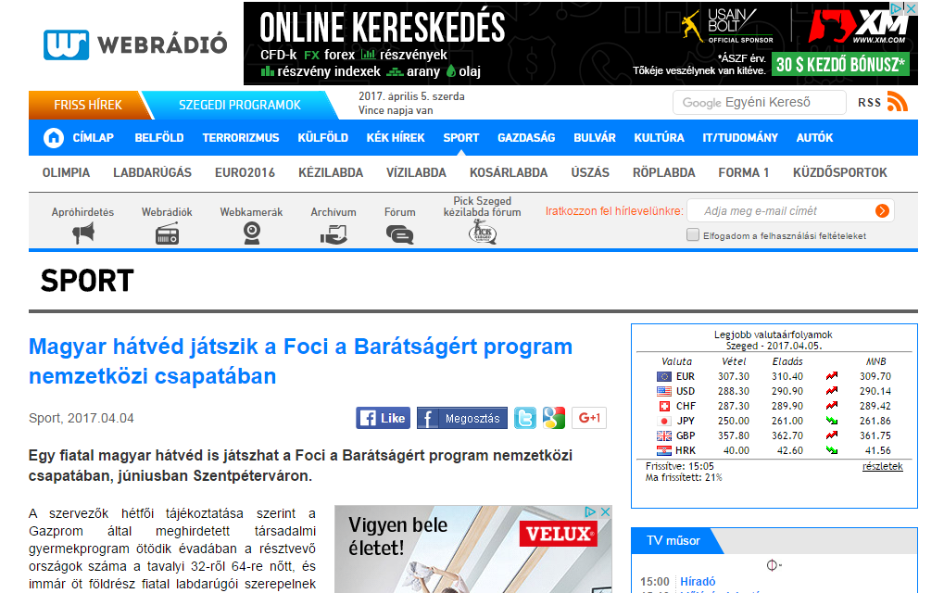

Media name: | mindenamisport.com
Media type & URL: | Online
Media logo:
Header: | Hungarian mid-defender will play in the international team of “FOOTBALL FOR FRIENDSHIP”
Date: | 04/04/2017
Newsbreak: | Project launch
Short summary | The Fifth season of the international children social programme „FOOTBALL FOR FRIENDSHIP” has been launched. The programme was announced by Gazprom Company, the official partner of the FIFA and the 2018 FIFA World Cup™. The number of the participating countries of the programme increased from 32 to 64 this year. In the frame of the programme - which is supported by the Hungarian Football Federation Grassroots Program - 8 international football teams were united from the countries. They will enter the field in July in St Petersburg, and then watch together the final of the FIFA Confederation Cup. A 12-year-old Hungarian sports reporter accompanies them in St Petersburg. For this position a young football fun will be selected by a tender.
Link: | http://www.mindenamisport.com/hirek/labdarugas-magyar-hatved-jatszik-a-foci-a-baratsagert-program-nemzetkozi-csapataban

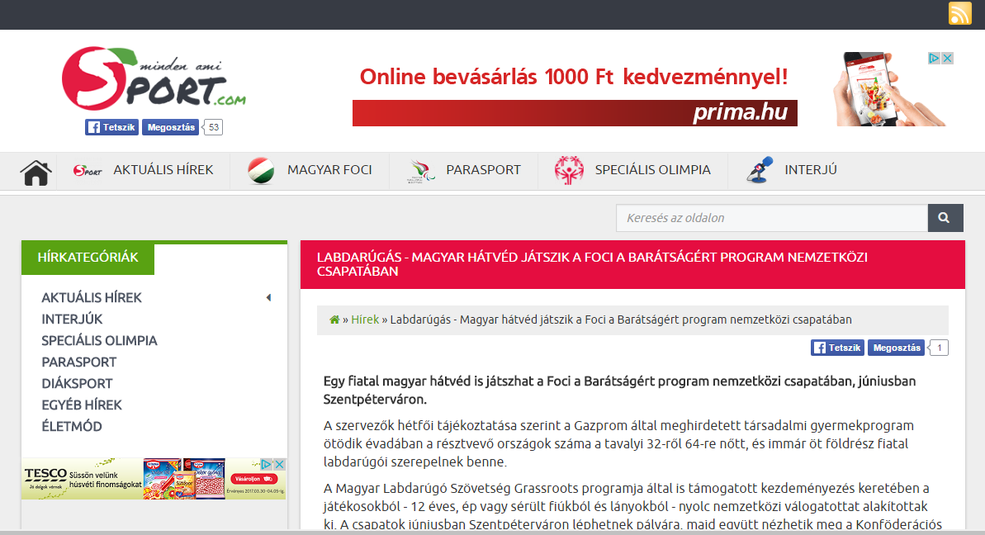

Media name: | panoramanet.hu
Media type & URL: | Online
Media logo:
Header: | Hungarian mid-defender will play in the international team of “FOOTBALL FOR FRIENDSHIP”
Date: | 04/04/2017
Newsbreak: | Project launch
Short summary | The Fifth season of the international children social programme „FOOTBALL FOR FRIENDSHIP” has been launched. The programme was announced by Gazprom Company, the official partner of the FIFA and the 2018 FIFA World Cup™. The number of the participating countries of the programme increased from 32 to 64 this year. In the frame of the programme - which is supported by the Hungarian Football Federation Grassroots Program - 8 international football teams were united from the countries. They will enter the field in July in St Petersburg, and then watch together the final of the FIFA Confederation Cup. A 12-year-old Hungarian sports reporter accompanies them in St Petersburg. For this position a young football fun will be selected by a tender.
Link: | http://panoramanet.hu/egy-fiatal-magyar-is-jatszhat-a-foci-a-baratsagert-program-nemzetkozi-csapataban/

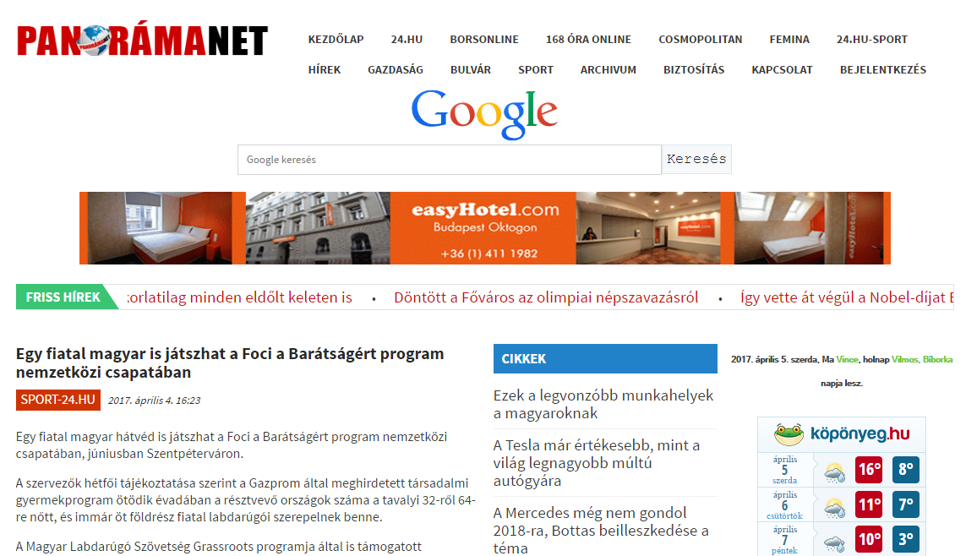

Media name: | haon.hu
Media type & URL: | Online
Media logo:
Header: | Hungarian mid-defender will play in the international team of “FOOTBALL FOR FRIENDSHIP”
Date: | 04/04/2017
Newsbreak: | Project launch
Short summary | The Fifth season of the international children social programme „FOOTBALL FOR FRIENDSHIP” has been launched. The programme was announced by Gazprom Company, the official partner of the FIFA and the 2018 FIFA World Cup™. The number of the participating countries of the programme increased from 32 to 64 this year. In the frame of the programme - which is supported by the Hungarian Football Federation Grassroots Program - 8 international football teams were united from the countries. They will enter the field in July in St Petersburg, and then watch together the final of the FIFA Confederation Cup. A 12-year-old Hungarian sports reporter accompanies them in St Petersburg. For this position a young football fun will be selected by a tender.
Link: | http://www.haon.hu/magyar-hatved-jatszik-a-foci-a-baratsagert-program-nemzetkozi-csapataban/3434147

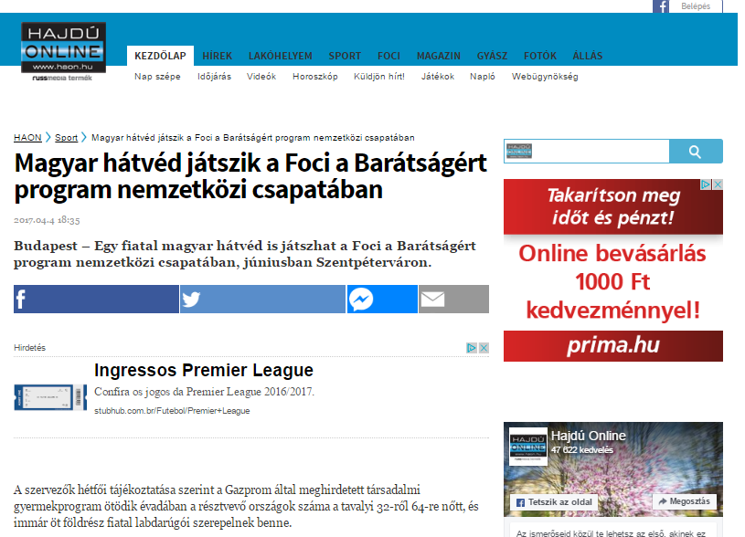

Media name: | sajomente.hu
Media type & URL: | Online
Media logo:
Header: | Hungarian mid-defender will play in the international team of “FOOTBALL FOR FRIENDSHIP”
Date: | 04/04/2017
Newsbreak: | Project launch
Short summary | The Fifth season of the international children social programme „FOOTBALL FOR FRIENDSHIP” has been launched. The programme was announced by Gazprom Company, the official partner of the FIFA and the 2018 FIFA World Cup™. The number of the participating countries of the programme increased from 32 to 64 this year. In the frame of the programme - which is supported by the Hungarian Football Federation Grassroots Program - 8 international football teams were united from the countries. They will enter the field in July in St Petersburg, and then watch together the final of the FIFA Confederation Cup. A 12-year-old Hungarian sports reporter accompanies them in St Petersburg. For this position a young football fun will be selected by a tender.
Link: | http://www.sajomente.hu/reszletek/hirek/50655

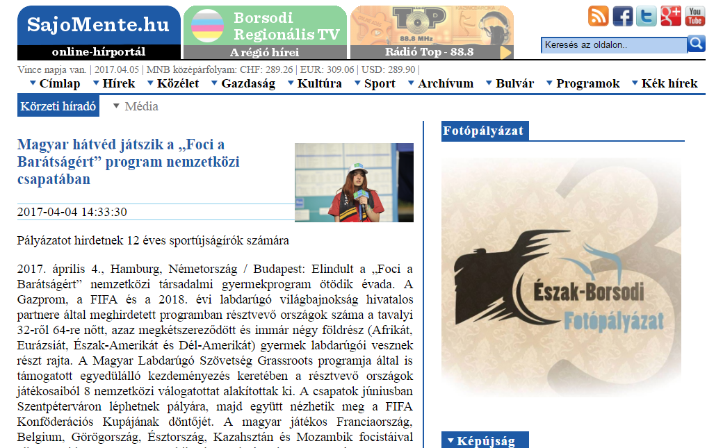

Media name: | alfoldiregiomagazin.hu
Media type & URL: | Online
Media logo:
Header: | Hungarian mid-defender will play in the international team of “FOOTBALL FOR FRIENDSHIP”
Date: | 04/04/2017
Newsbreak: | Project launch
Short summary | The Fifth season of the international children social programme „FOOTBALL FOR FRIENDSHIP” has been launched. The programme was announced by Gazprom Company, the official partner of the FIFA and the 2018 FIFA World Cup™. The number of the participating countries of the programme increased from 32 to 64 this year. In the frame of the programme - which is supported by the Hungarian Football Federation Grassroots Program - 8 international football teams were united from the countries. They will enter the field in July in St Petersburg, and then watch together the final of the FIFA Confederation Cup. A 12-year-old Hungarian sports reporter accompanies them in St Petersburg. For this position a young football fun will be selected by a tender.
Link: | http://alfoldiregiomagazin.hu/2017/04/magyar-hatved-jatszik-a-foci-a-baratsagert-program-nemzetkozi-csapataban/

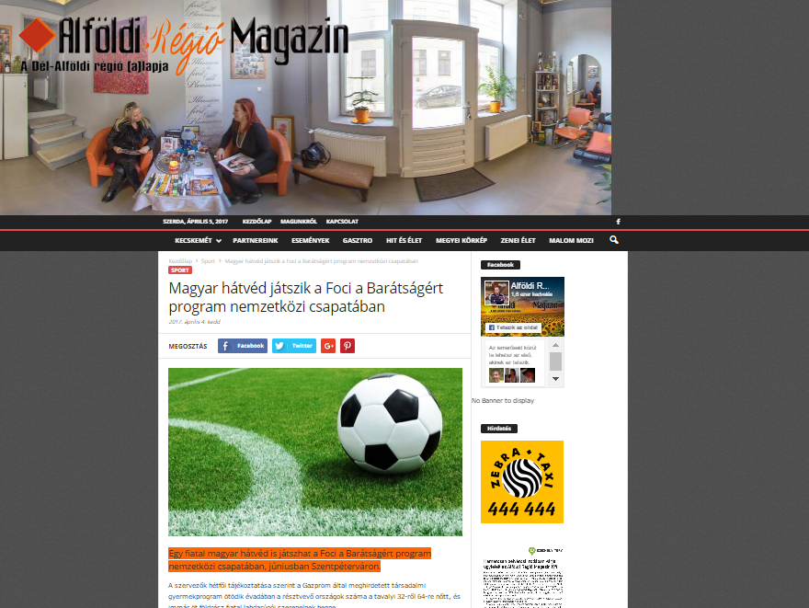

Media name: | hirek.ma
Media type & URL: | Online
Media logo:
Header: | Hungarian mid-defender will play in the international team of “FOOTBALL FOR FRIENDSHIP”
Date: | 04/04/2017
Newsbreak: | Project launch
Short summary | The Fifth season of the international children social programme „FOOTBALL FOR FRIENDSHIP” has been launched. The programme was announced by Gazprom Company, the official partner of the FIFA and the 2018 FIFA World Cup™. The number of the participating countries of the programme increased from 32 to 64 this year. In the frame of the programme - which is supported by the Hungarian Football Federation Grassroots Program - 8 international football teams were united from the countries. They will enter the field in July in St Petersburg, and then watch together the final of the FIFA Confederation Cup. A 12-year-old Hungarian sports reporter accompanies them in St Petersburg. For this position a young football fun will be selected by a tender.
Link: | http://hirek.ma/hirek/magyar-hatved-jatszik-a-foci-a-baratsagert-program-nemzetkozi-csapataban

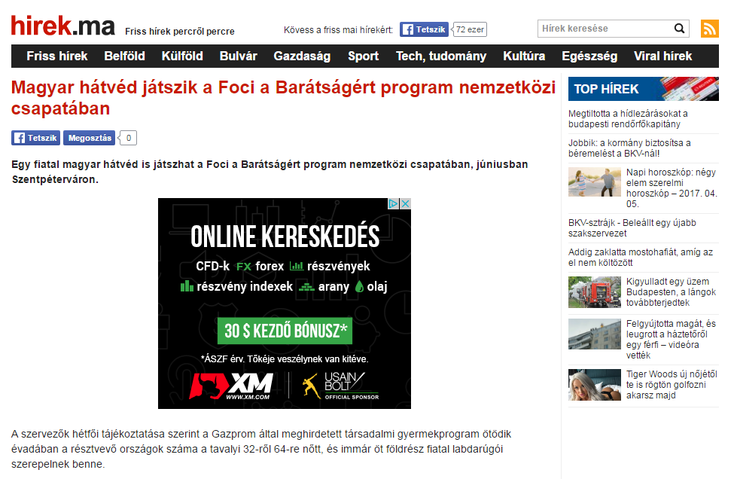

Media name: | mon.hu
Media type & URL: | Online
Media logo:
Header: | Hungarian mid-defender will play in the international team of “FOOTBALL FOR FRIENDSHIP”
Date: | 04/04/2017
Newsbreak: | Project launch
Short summary | The Fifth season of the international children social programme „FOOTBALL FOR FRIENDSHIP” has been launched. The programme was announced by Gazprom Company, the official partner of the FIFA and the 2018 FIFA World Cup™. The number of the participating countries of the programme increased from 32 to 64 this year. In the frame of the programme - which is supported by the Hungarian Football Federation Grassroots Program - 8 international football teams were united from the countries. They will enter the field in July in St Petersburg, and then watch together the final of the FIFA Confederation Cup. A 12-year-old Hungarian sports reporter accompanies them in St Petersburg. For this position a young football fun will be selected by a tender.
Link: | http://www.mon.hu/magyar-hatved-jatszik-a-foci-a-baratsagert-program-nemzetkozi-csapataban/3434147

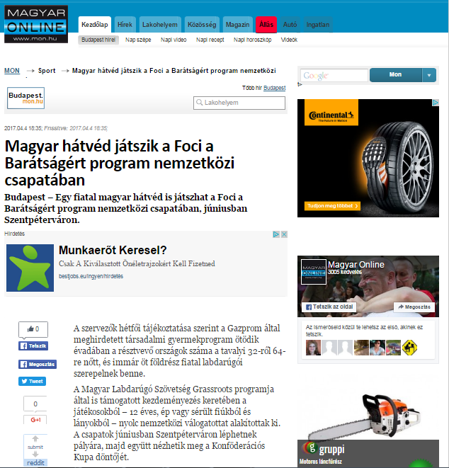

Media name: | velemenyezd.hu
Media type & URL: | Online
Media logo:
Header: | Hungarian mid-defender will play in the international team of “FOOTBALL FOR FRIENDSHIP”
Date: | 04/04/2017
Newsbreak: | Project launch
Short summary | The Fifth season of the international children social programme „FOOTBALL FOR FRIENDSHIP” has been launched. The programme was announced by Gazprom Company, the official partner of the FIFA and the 2018 FIFA World Cup™. The number of the participating countries of the programme increased from 32 to 64 this year. In the frame of the programme - which is supported by the Hungarian Football Federation Grassroots Program - 8 international football teams were united from the countries. They will enter the field in July in St Petersburg, and then watch together the final of the FIFA Confederation Cup. A 12-year-old Hungarian sports reporter accompanies them in St Petersburg. For this position a young football fun will be selected by a tender.
Link: | http://velemenyezd.hu/velemenyezd.tvn?cid=OS7m&hir=Magyar%20h%E1tv%E9d%20j%E1tszik%20a%20Foci%20a%20Bar%E1ts%E1g%E9rt%20program%20nemzetk%F6zi%20csapat%E1ban

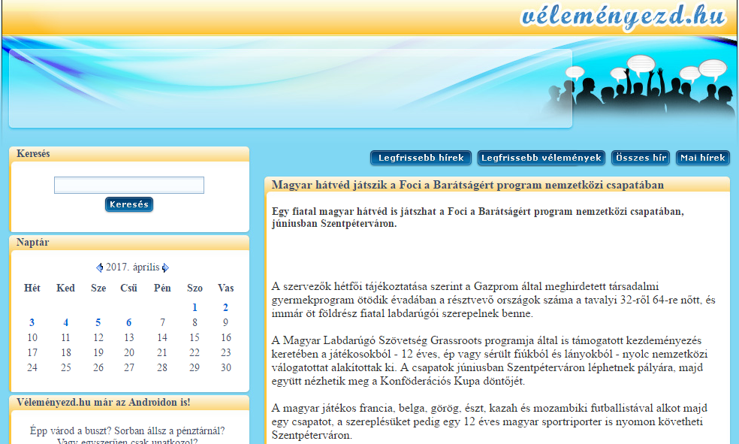

Media name: | eloben.hu
Media type & URL: | Online
Media logo:
Header: | Hungarian mid-defender will play in the international team of “FOOTBALL FOR FRIENDSHIP”
Date: | 04/04/2017
Newsbreak: | Project launch
Short summary | The Fifth season of the international children social programme „FOOTBALL FOR FRIENDSHIP” has been launched. The programme was announced by Gazprom Company, the official partner of the FIFA and the 2018 FIFA World Cup™. The number of the participating countries of the programme increased from 32 to 64 this year. In the frame of the programme - which is supported by the Hungarian Football Federation Grassroots Program - 8 international football teams were united from the countries. They will enter the field in July in St Petersburg, and then watch together the final of the FIFA Confederation Cup. A 12-year-old Hungarian sports reporter accompanies them in St Petersburg. For this position a young football fun will be selected by a tender.
Link: | http://eloben.hu/sport/2017-04-04/magyar-hatved-jatszik-a-foci-a-baratsagert-program-nemzetkozi-csapataban

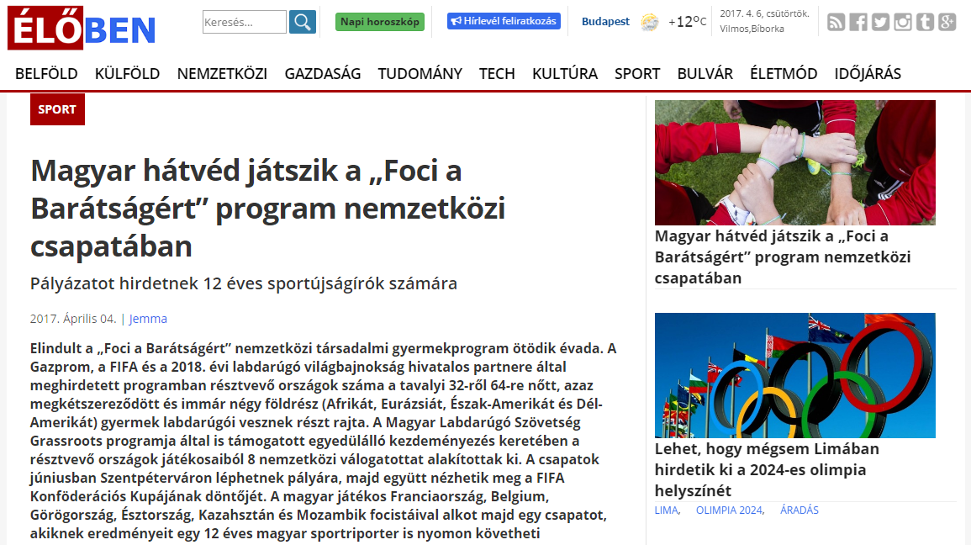

Media name: | szon.hu
Media type & URL: | Online
Media logo:
Header: | Hungarian mid-defender will play in the international team of “FOOTBALL FOR FRIENDSHIP”
Date: | 04/04/2017
Newsbreak: | Project launch
Short summary | The Fifth season of the international children social programme „FOOTBALL FOR FRIENDSHIP” has been launched. The programme was announced by Gazprom Company, the official partner of the FIFA and the 2018 FIFA World Cup™. The number of the participating countries of the programme increased from 32 to 64 this year. In the frame of the programme - which is supported by the Hungarian Football Federation Grassroots Program - 8 international football teams were united from the countries. They will enter the field in July in St Petersburg, and then watch together the final of the FIFA Confederation Cup. A 12-year-old Hungarian sports reporter accompanies them in St Petersburg. For this position a young football fun will be selected by a tender.
Link: | http://www.szon.hu/magyar-hatved-jatszik-a-foci-a-baratsagert-program-nemzetkozi-csapataban/3434147

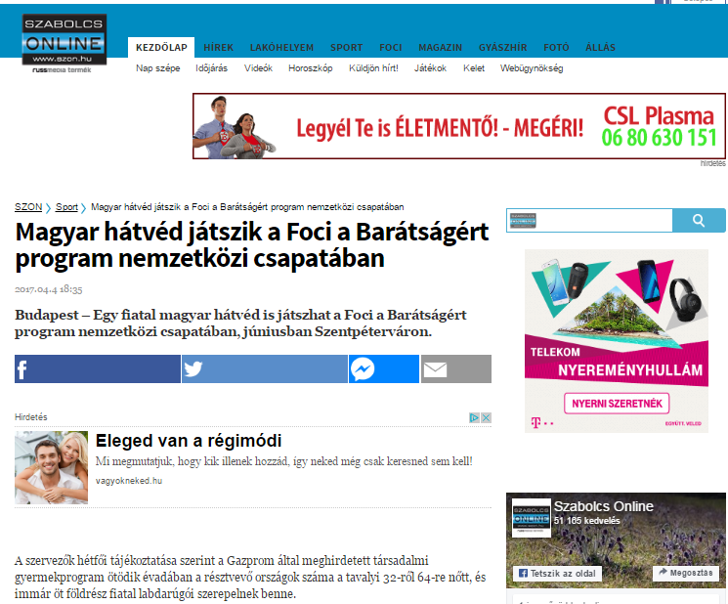

Media name: | boon.hu
Media type & URL: | Online
Media logo:
Header: | Hungarian mid-defender will play in the international team of “FOOTBALL FOR FRIENDSHIP”
Date: | 04/04/2017
Newsbreak: | Project launch
Short summary | The Fifth season of the international children social programme „FOOTBALL FOR FRIENDSHIP” has been launched. The programme was announced by Gazprom Company, the official partner of the FIFA and the 2018 FIFA World Cup™. The number of the participating countries of the programme increased from 32 to 64 this year. In the frame of the programme - which is supported by the Hungarian Football Federation Grassroots Program - 8 international football teams were united from the countries. They will enter the field in July in St Petersburg, and then watch together the final of the FIFA Confederation Cup. A 12-year-old Hungarian sports reporter accompanies them in St Petersburg. For this position a young football fun will be selected by a tender.
Link: | http://www.boon.hu/magyar-hatved-jatszik-a-foci-a-baratsagert-program-nemzetkozi-csapataban/3434147

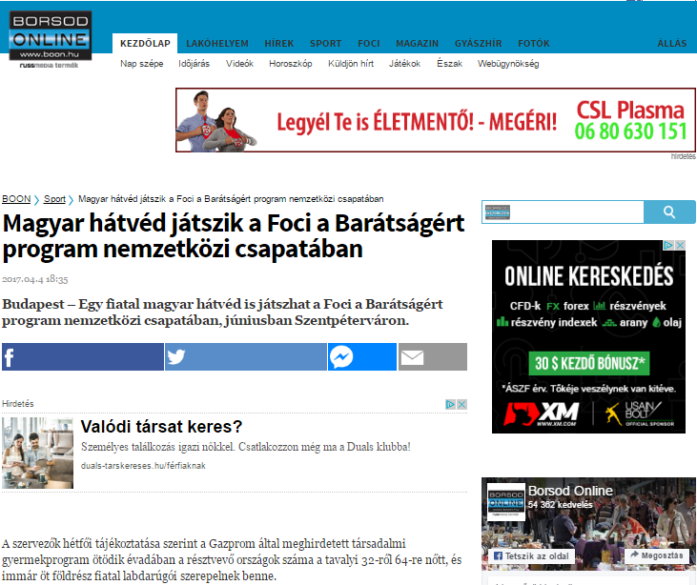

Media name: | erdon.ro
Media type & URL: | Online
Media logo:
Header: | Hungarian mid-defender will play in the international team of “FOOTBALL FOR FRIENDSHIP”
Date: | 04/04/2017
Newsbreak: | Project launch
Short summary | The Fifth season of the international children social programme „FOOTBALL FOR FRIENDSHIP” has been launched. The programme was announced by Gazprom Company, the official partner of the FIFA and the 2018 FIFA World Cup™. The number of the participating countries of the programme increased from 32 to 64 this year. In the frame of the programme - which is supported by the Hungarian Football Federation Grassroots Program - 8 international football teams were united from the countries. They will enter the field in July in St Petersburg, and then watch together the final of the FIFA Confederation Cup. A 12-year-old Hungarian sports reporter accompanies them in St Petersburg. For this position a young football fun will be selected by a tender.
Link: | http://www.erdon.ro/magyar-hatved-jatszik-a-foci-a-baratsagert-program-nemzetkozi-csapataban/3434147

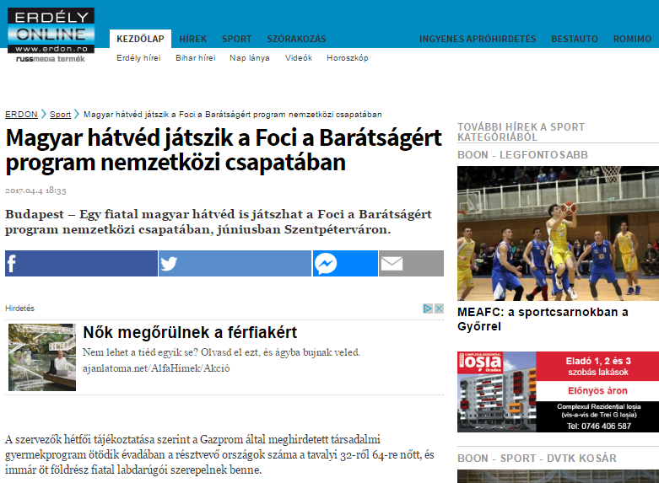

Media name: | miferfiak.hu
Media type & URL: | Online
Media logo: | 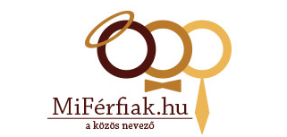
Header: | A tender was announced for 12-year-old sport reporters
Date: | 04/04/2017
Newsbreak: | Project launch
Short summary | The Fifth season of the international children social programme „FOOTBALL FOR FRIENDSHIP” has been launched. The programme was announced by Gazprom Company, the official partner of the FIFA and the 2018 FIFA World Cup™. The number of the participating countries of the programme increased from 32 to 64 this year. In the frame of the programme - which is supported by the Hungarian Football Federation Grassroots Program - 8 international football teams were united from the countries. They will enter the field in July in St Petersburg, and then watch together the final of the FIFA Confederation Cup. A 12-year-old Hungarian sports reporter accompanies them in St Petersburg. For this position a young football fun will be selected by a tender.
Link: | http://www.erdon.ro/magyar-hatved-jatszik-a-foci-a-baratsagert-program-nemzetkozi-csapataban/3434147

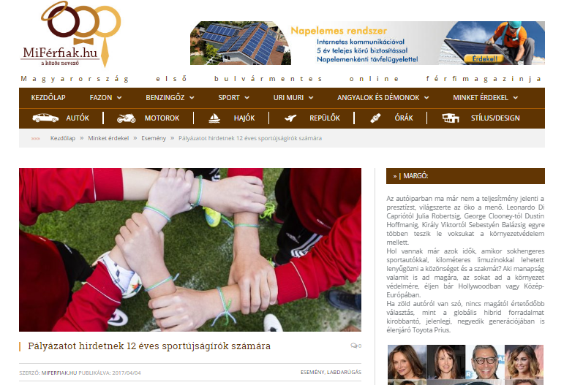

Media name: | utcaemberek.blogspot.hu
Media type & URL: | Online
Media logo:
Header: | Hungarian mid-defender will play in the international team of “FOOTBALL FOR FRIENDSHIP”
Date: | 04/04/2017
Newsbreak: | Project launch
Short summary | The Fifth season of the international children social programme „FOOTBALL FOR FRIENDSHIP” has been launched. The programme was announced by Gazprom Company, the official partner of the FIFA and the 2018 FIFA World Cup™. The number of the participating countries of the programme increased from 32 to 64 this year. In the frame of the programme - which is supported by the Hungarian Football Federation Grassroots Program - 8 international football teams were united from the countries. They will enter the field in July in St Petersburg, and then watch together the final of the FIFA Confederation Cup. A 12-year-old Hungarian sports reporter accompanies them in St Petersburg. For this position a young football fun will be selected by a tender.
Link: | http://utcaemberek.blogspot.hu/2017/04/magyar-hatved-jatszik-foci-baratsagert.html
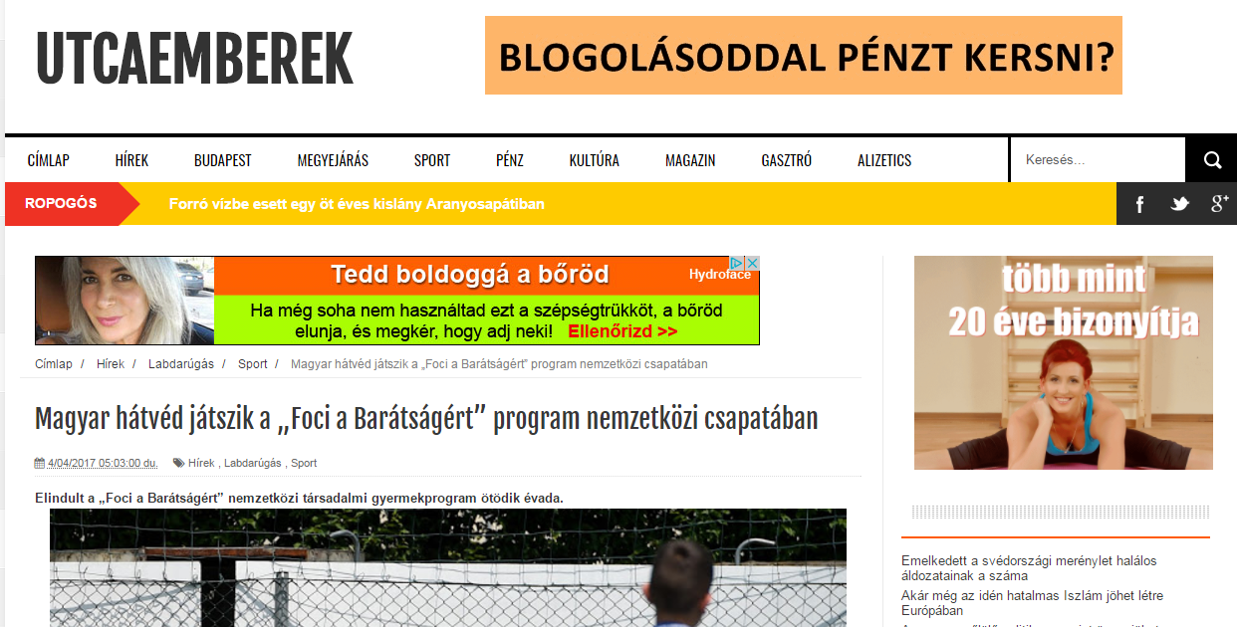

Media name: | sikerado.hu
Media type & URL: | Online
Media logo:
Header: | Hungarian mid-defender will play in the international team
Date: | 04/04/2017
Newsbreak: | Project launch
Short summary | The Fifth season of the international children social programme „FOOTBALL FOR FRIENDSHIP” has been launched. The programme was announced by Gazprom Company, the official partner of the FIFA and the 2018 FIFA World Cup™. The number of the participating countries of the programme increased from 32 to 64 this year. In the frame of the programme – which is supported by the Hungarian Football Federation Grassroots Program – 8 international football teams were united from the countries. They will enter the field in July in St Petersburg, and then watch together the final of the FIFA Confederation Cup. A 12-year-old Hungarian sports reporter accompanies them in St Petersburg. For this position a young football fun will be selected by a tender.
Link: | http://www.sikerado.hu/sport/2017/04/04/Magyar_hatved_a_nemzetkozi_csapatban

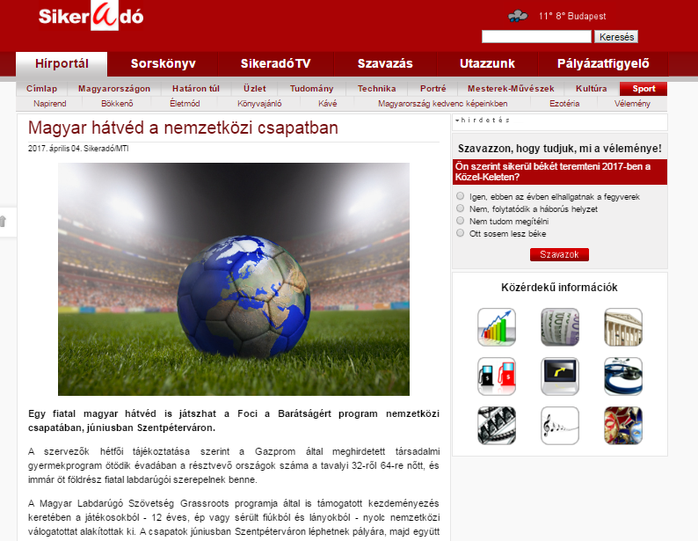
Media name: | sopronbaba.hu
Media type & URL: | Online
Media logo:
Header: | Hungarian mid-defender will play in the international team of “FOOTBALL FOR FRIENDSHIP”
Date: | 04/04/2017
Newsbreak: | Project launch
Short summary | The Fifth season of the international children social programme „FOOTBALL FOR FRIENDSHIP” has been launched. The programme was announced by Gazprom Company, the official partner of the FIFA and the 2018 FIFA World Cup™. The number of the participating countries of the programme increased from 32 to 64 this year. In the frame of the programme – which is supported by the Hungarian Football Federation Grassroots Program – 8 international football teams were united from the countries. They will enter the field in July in St Petersburg, and then watch together the final of the FIFA Confederation Cup. A 12-year-old Hungarian sports reporter accompanies them in St Petersburg. For this position a young football fun will be selected by a tender.
Link: | http://sopronbaba.hu/hirek/2145-sajtokozlemeny/

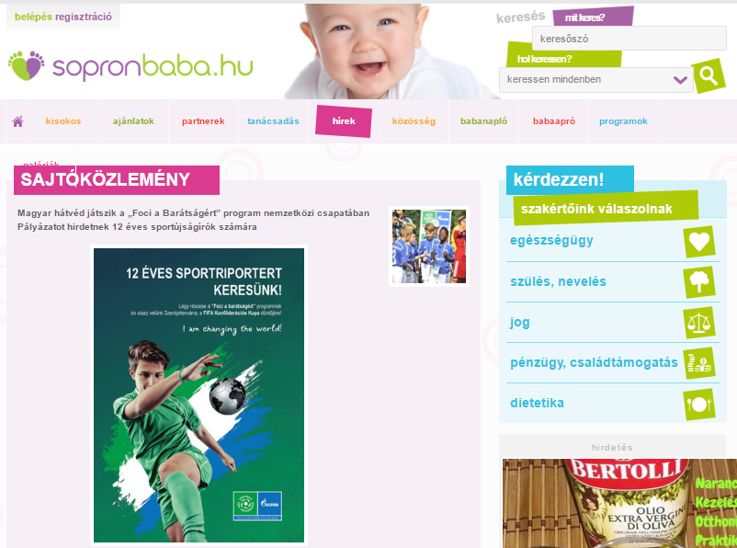

Media name: | arrabonababa.hu
Media type & URL: | Online
Media logo:
Header: | Hungarian mid-defender will play in the international team of “FOOTBALL FOR FRIENDSHIP”
Date: | 04/04/2017
Newsbreak: | Project launch
Short summary | The Fifth season of the international children social programme „FOOTBALL FOR FRIENDSHIP” has been launched. The programme was announced by Gazprom Company, the official partner of the FIFA and the 2018 FIFA World Cup™. The number of the participating countries of the programme increased from 32 to 64 this year. In the frame of the programme – which is supported by the Hungarian Football Federation Grassroots Program – 8 international football teams were united from the countries. They will enter the field in July in St Petersburg, and then watch together the final of the FIFA Confederation Cup. A 12-year-old Hungarian sports reporter accompanies them in St Petersburg. For this position a young football fun will be selected by a tender.
Link: | http://arrabonababa.hu/hirek/2145-sajtokozlemeny/

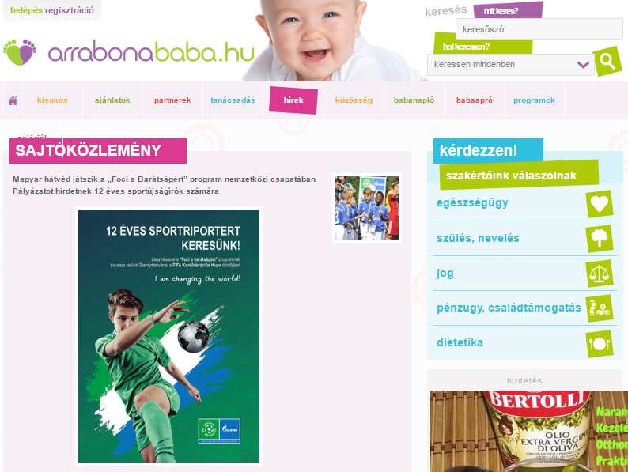

Media name: | savariababa.hu
Media type & URL: | Online
Media logo:
Header: | Hungarian mid-defender will play in the international team of “FOOTBALL FOR FRIENDSHIP”
Date: | 04/04/2017
Newsbreak: | Project launch
Short summary | The Fifth season of the international children social programme „FOOTBALL FOR FRIENDSHIP” has been launched. The programme was announced by Gazprom Company, the official partner of the FIFA and the 2018 FIFA World Cup™. The number of the participating countries of the programme increased from 32 to 64 this year. In the frame of the programme – which is supported by the Hungarian Football Federation Grassroots Program – 8 international football teams were united from the countries. They will enter the field in July in St Petersburg, and then watch together the final of the FIFA Confederation Cup. A 12-year-old Hungarian sports reporter accompanies them in St Petersburg. For this position a young football fun will be selected by a tender.
Link: | http://savariababa.hu/hirek/2145-sajtokozlemeny/

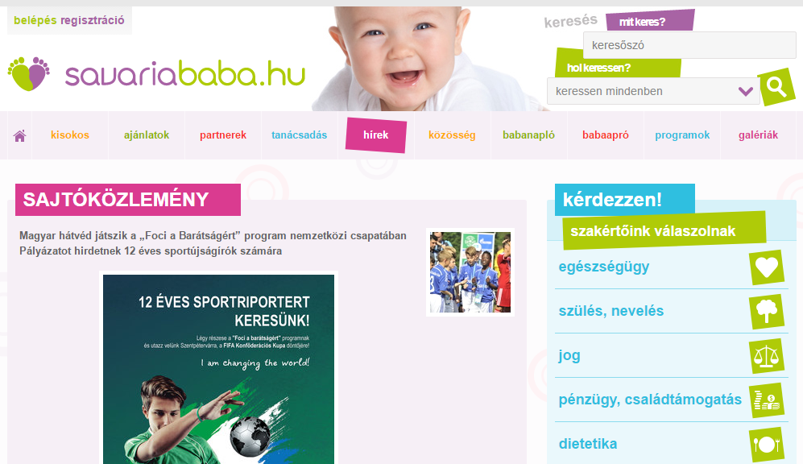

Media name: | albababa.hu
Media type & URL: | Online
Media logo:
Header: | Hungarian mid-defender will play in the international team of “FOOTBALL FOR FRIENDSHIP”
Date: | 04/04/2017
Newsbreak: | Project launch
Short summary | The Fifth season of the international children social programme „FOOTBALL FOR FRIENDSHIP” has been launched. The programme was announced by Gazprom Company, the official partner of the FIFA and the 2018 FIFA World Cup™. The number of the participating countries of the programme increased from 32 to 64 this year. In the frame of the programme – which is supported by the Hungarian Football Federation Grassroots Program – 8 international football teams were united from the countries. They will enter the field in July in St Petersburg, and then watch together the final of the FIFA Confederation Cup. A 12-year-old Hungarian sports reporter accompanies them in St Petersburg. For this position a young football fun will be selected by a tender.
Link: | http://albababa.hu/hirek/2145-sajtokozlemeny/

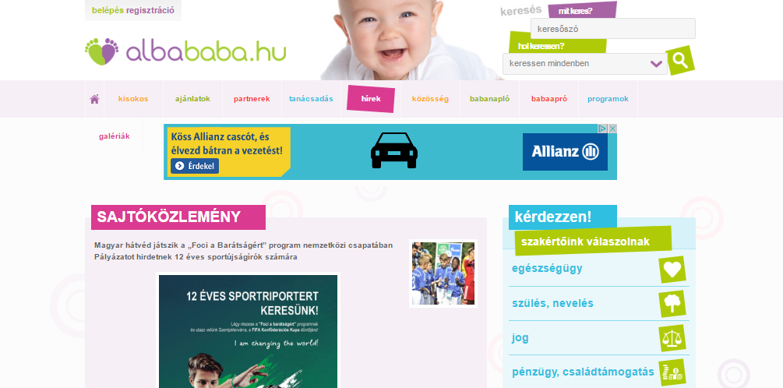

Media name: | zalababa.hu
Media type & URL: | Online
Media logo:
Header: | Hungarian mid-defender will play in the international team of “FOOTBALL FOR FRIENDSHIP”
Date: | 04/04/2017
Newsbreak: | Project launch
Short summary | The Fifth season of the international children social programme „FOOTBALL FOR FRIENDSHIP” has been launched. The programme was announced by Gazprom Company, the official partner of the FIFA and the 2018 FIFA World Cup™. The number of the participating countries of the programme increased from 32 to 64 this year. In the frame of the programme – which is supported by the Hungarian Football Federation Grassroots Program – 8 international football teams were united from the countries. They will enter the field in July in St Petersburg, and then watch together the final of the FIFA Confederation Cup. A 12-year-old Hungarian sports reporter accompanies them in St Petersburg. For this position a young football fun will be selected by a tender.
Link: | http://zalababa.hu/hirek/2145-sajtokozlemeny/

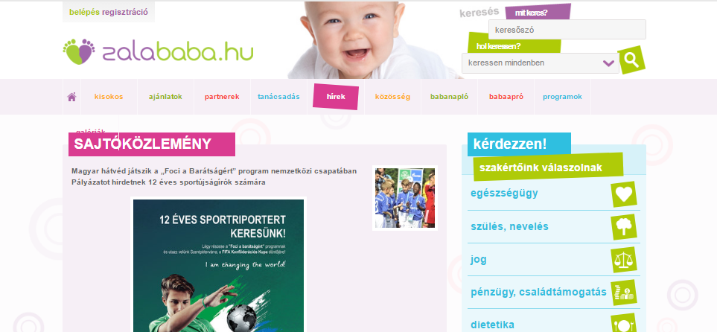
Media name: | tiz.hu
Media type & URL: | Online
Media logo:
Header: | Hungarian mid-defender will play in the international team of “FOOTBALL FOR FRIENDSHIP”
Date: | 04/04/2017
Newsbreak: | Project launch
Short summary | The Fifth season of the international children social programme „FOOTBALL FOR FRIENDSHIP” has been launched. The programme was announced by Gazprom Company, the official partner of the FIFA and the 2018 FIFA World Cup™. The number of the participating countries of the programme increased from 32 to 64 this year. In the frame of the programme – which is supported by the Hungarian Football Federation Grassroots Program – 8 international football teams were united from the countries. They will enter the field in July in St Petersburg, and then watch together the final of the FIFA Confederation Cup. A 12-year-old Hungarian sports reporter accompanies them in St Petersburg. For this position a young football fun will be selected by a tender.
Link: | http://tiz.hu/2017/04/04/egy-fiatal-magyar-is-jatszhat-a-foci-a-baratsagert-program-nemzetkozi-csapataban/

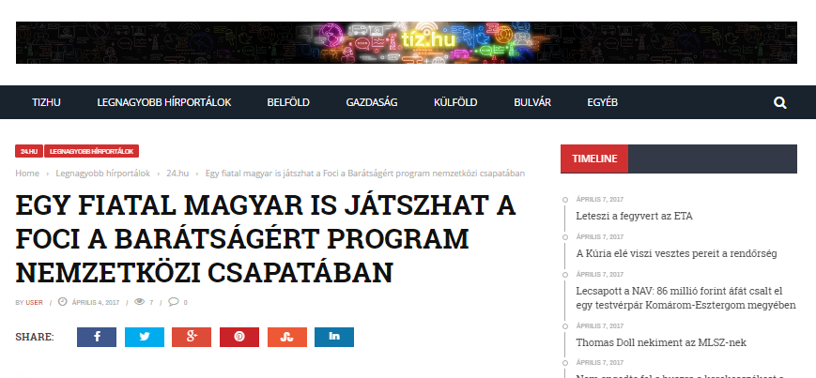
Media name: | Napló
Media type & URL: | Regional Print
Media logo:
Header: | Hungarian mid-defender will play in the international team of “FOOTBALL FOR FRIENDSHIP”
Date: | 05/04/2017
Newsbreak: | Project launch
Short summary | The Fifth season of the international children social programme „FOOTBALL FOR FRIENDSHIP” has been launched. The programme was announced by Gazprom Company, the official partner of the FIFA and the 2018 FIFA World Cup™. The number of the participating countries of the programme increased from 32 to 64 this year. In the frame of the programme – which is supported by the Hungarian Football Federation Grassroots Program – 8 international football teams were united from the countries. They will enter the field in July in St Petersburg, and then watch together the final of the FIFA Confederation Cup. A 12-year-old Hungarian sports reporter accompanies them in St Petersburg. For this position a young football fun will be selected by a tender.
Link: | http://premiercom.hu/download/private/Gazprom/F4F_0504_Napl%c3%b3_Kick%20Off.pdf

User: gazprom
Password: f4f

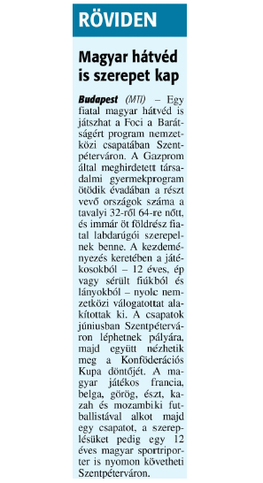

Media name: | xlsport.hu
Media type & URL: | Online
Media logo: | 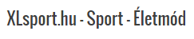
Header: | Hungarian mid-defender will play in the international team of “FOOTBALL FOR FRIENDSHIP”
Date: | 05/04/2017
Newsbreak: | Project launch
Short summary | The Fifth season of the international children social programme „FOOTBALL FOR FRIENDSHIP” has been launched. The programme was announced by Gazprom Company, the official partner of the FIFA and the 2018 FIFA World Cup™. The number of the participating countries of the programme increased from 32 to 64 this year. In the frame of the programme - which is supported by the Hungarian Football Federation Grassroots Program - 8 international football teams were united from the countries. They will enter the field in July in St Petersburg, and then watch together the final of the FIFA Confederation Cup. A 12-year-old Hungarian sports reporter accompanies them in St Petersburg. For this position a young football fun will be selected by a tender.
Link: | http://www.xlsport.hu/foci-a-baratsagert-ujsagiroi-palyazat-12-eveseknek/

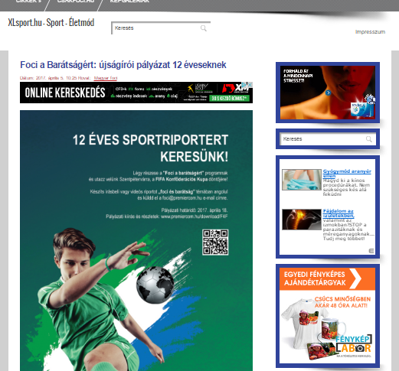

Media name: | utanpotlassport.hu
Media type & URL: | Online
Media logo:
Header: | “Football for friendship” reloaded
Date: | 05/04/2017
Newsbreak: | Project launch
Short summary | The Fifth season of the international children social programme „FOOTBALL FOR FRIENDSHIP” has been launched. The programme was announced by Gazprom Company, the official partner of the FIFA and the 2018 FIFA World Cup™. The number of the participating countries of the programme increased from 32 to 64 this year. In the frame of the programme - which is supported by the Hungarian Football Federation Grassroots Program - 8 international football teams were united from the countries. They will enter the field in July in St Petersburg, and then watch together the final of the FIFA Confederation Cup. A 12-year-old Hungarian sports reporter accompanies them in St Petersburg. For this position a young football fun will be selected by a tender.
Link: | http://www.utanpotlassport.hu/2017/04/05/foci-a-baratsagert-ujratoltve/

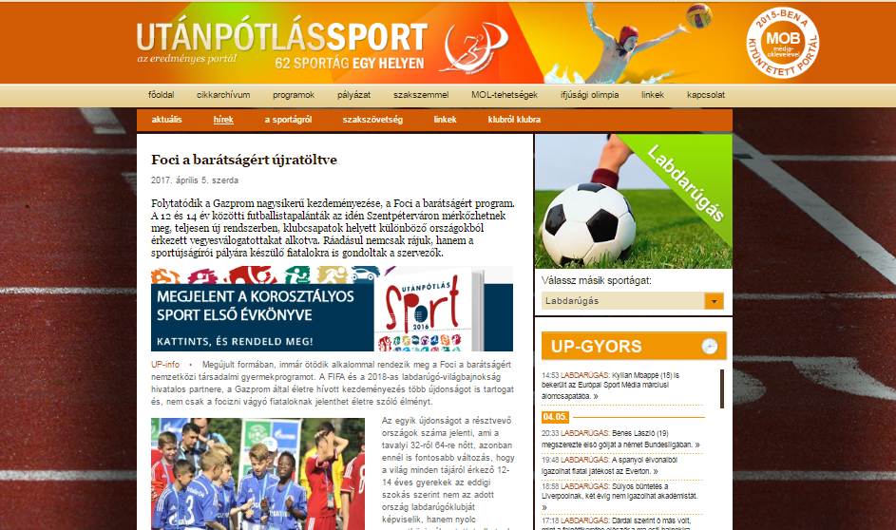

Media name: | nemzetisport.hu
Media type & URL: | Online
Media logo:
Header: | Football: Gazprom project for youth
Date: | 05/04/2017
Newsbreak: | Project launch
Short summary | The Fifth season of the international children social programme „FOOTBALL FOR FRIENDSHIP” has been launched. The programme was announced by Gazprom Company, the official partner of the FIFA and the 2018 FIFA World Cup™. The number of the participating countries of the programme increased from 32 to 64 this year. In the frame of the programme - which is supported by the Hungarian Football Federation Grassroots Program - 8 international football teams were united from the countries. They will enter the field in July in St Petersburg, and then watch together the final of the FIFA Confederation Cup. A 12-year-old Hungarian sports reporter accompanies them in St Petersburg. For this position a young football fun will be selected by a tender.
Link: | http://www.nemzetisport.hu/utanpotlassport/Labdarugas_Gazprom-program_az_utanpotlasert-2561683

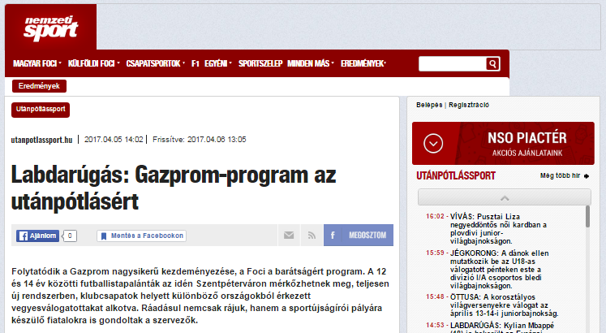

Media name: | xel..hu
Media type & URL: | Online
Media logo:
Header: | Hungarian mid-defender will play in the international team of “FOOTBALL FOR FRIENDSHIP”
Date: | 05/04/2017
Newsbreak: | Project launch
Short summary | The Fifth season of the international children social programme „FOOTBALL FOR FRIENDSHIP” has been launched. The programme was announced by Gazprom Company, the official partner of the FIFA and the 2018 FIFA World Cup™. The number of the participating countries of the programme increased from 32 to 64 this year. In the frame of the programme - which is supported by the Hungarian Football Federation Grassroots Program - 8 international football teams were united from the countries. They will enter the field in July in St Petersburg, and then watch together the final of the FIFA Confederation Cup. A 12-year-old Hungarian sports reporter accompanies them in St Petersburg. For this position a young football fun will be selected by a tender.
Link: | http://www.utanpotlassport.hu/2017/04/05/foci-a-baratsagert-ujratoltve/

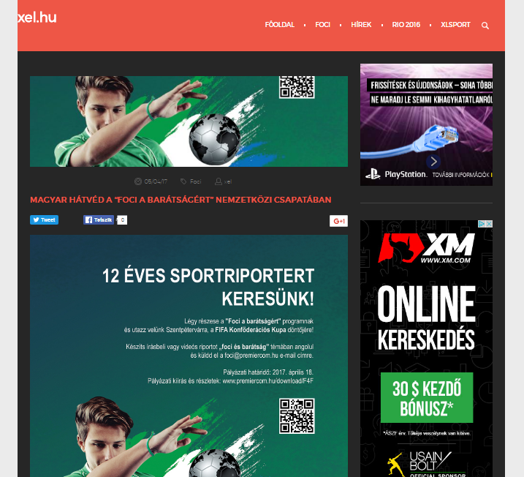

Media name: | kozepsuli..hu
Media type & URL: | Online
Media logo:
Header: | Hungarian mid-defender will play in the international team of “FOOTBALL FOR FRIENDSHIP”
Date: | 05/04/2017
Newsbreak: | Project launch
Short summary | The Fifth season of the international children social programme „FOOTBALL FOR FRIENDSHIP” has been launched. The programme was announced by Gazprom Company, the official partner of the FIFA and the 2018 FIFA World Cup™. The number of the participating countries of the programme increased from 32 to 64 this year. In the frame of the programme - which is supported by the Hungarian Football Federation Grassroots Program - 8 international football teams were united from the countries. They will enter the field in July in St Petersburg, and then watch together the final of the FIFA Confederation Cup. A 12-year-old Hungarian sports reporter accompanies them in St Petersburg. For this position a young football fun will be selected by a tender.
Link: | http://kozepsuli.hu/magyar-hatved-jatszik-foci-baratsagert-program-nemzetkozi-csapataban/

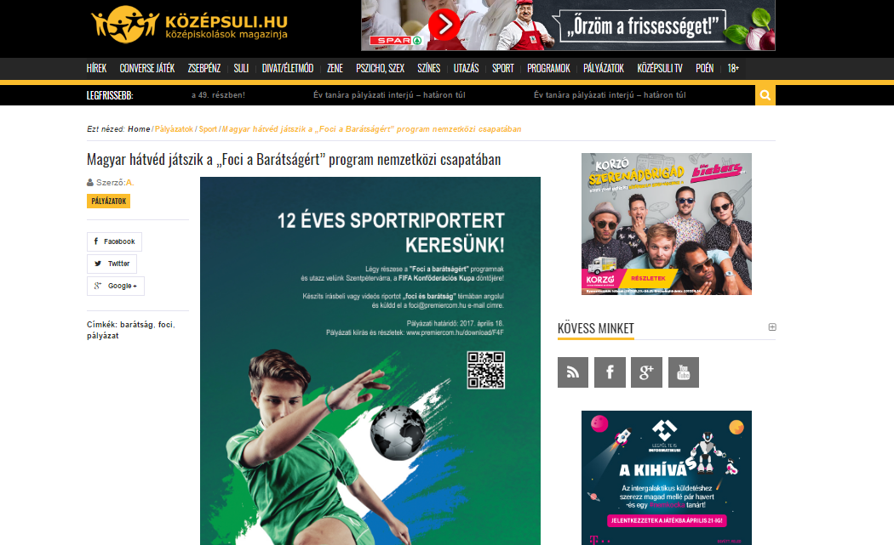

Media name: | ifipress.hu
Media type & URL: | Online
Media logo:
Header: | “The football for friendship” project look for a 12-year-old journalist
Date: | 05/04/2017
Newsbreak: | Project launch
Short summary | The Fifth season of the international children social programme „FOOTBALL FOR FRIENDSHIP” has been launched. The programme was announced by Gazprom Company, the official partner of the FIFA and the 2018 FIFA World Cup™. The number of the participating countries of the programme increased from 32 to 64 this year. In the frame of the programme - which is supported by the Hungarian Football Federation Grassroots Program - 8 international football teams were united from the countries. They will enter the field in July in St Petersburg, and then watch together the final of the FIFA Confederation Cup. A 12-year-old Hungarian sports reporter accompanies them in St Petersburg. For this position a young football fun will be selected by a tender.
Link: | http://ifipress.hu/12-eves-sportriportert-keres-a-foci-a-baratsagert-program/

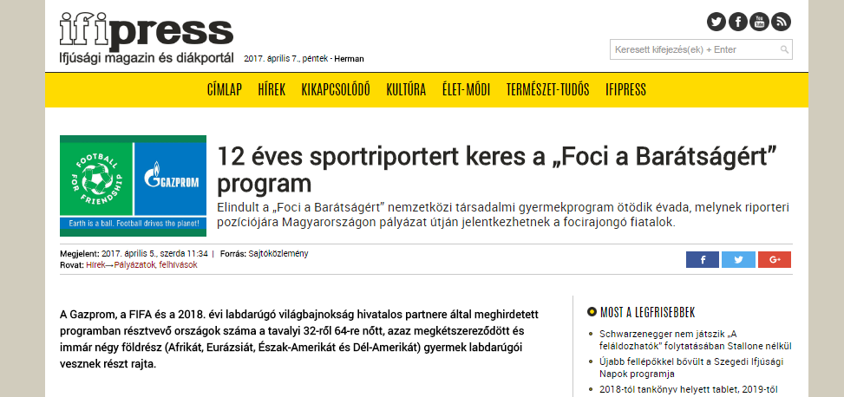

Media name: | palyazatmenedzser.hu
Media type & URL: | Online
Media logo:
Header: | “The football for friendship” project look for a 12-year-old journalist
Date: | 05/04/2017
Newsbreak: | Project launch
Short summary | The Fifth season of the international children social programme „FOOTBALL FOR FRIENDSHIP” has been launched. The programme was announced by Gazprom Company, the official partner of the FIFA and the 2018 FIFA World Cup™. The number of the participating countries of the programme increased from 32 to 64 this year. In the frame of the programme - which is supported by the Hungarian Football Federation Grassroots Program - 8 international football teams were united from the countries. They will enter the field in July in St Petersburg, and then watch together the final of the FIFA Confederation Cup. A 12-year-old Hungarian sports reporter accompanies them in St Petersburg. For this position a young football fun will be selected by a tender.
Link: | https://palyazatmenedzser.hu/2017/04/05/sportujsagiroi-palyazat-12-eves-focirajongoknak/

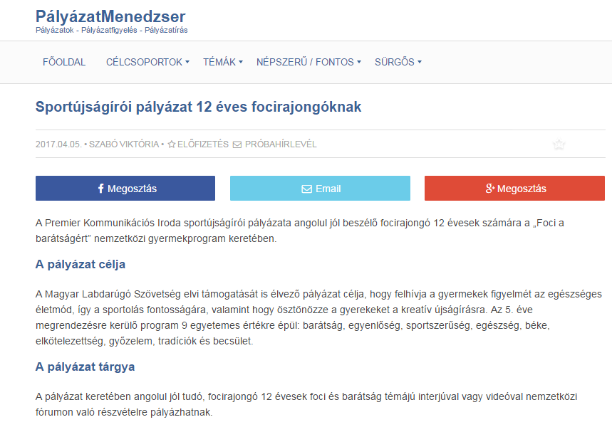
Media name: | ujnemzedek.hu
Media type & URL: | Online
Media logo:
Header: | “The football for friendship” project look for a 12-year-old journalist
Date: | 06/04/2017
Newsbreak: | Project launch
Short summary | The Fifth season of the international children social programme „FOOTBALL FOR FRIENDSHIP” has been launched. The programme was announced by Gazprom Company, the official partner of the FIFA and the 2018 FIFA World Cup™. The number of the participating countries of the programme increased from 32 to 64 this year. In the frame of the programme - which is supported by the Hungarian Football Federation Grassroots Program - 8 international football teams were united from the countries. They will enter the field in July in St Petersburg, and then watch together the final of the FIFA Confederation Cup. A 12-year-old Hungarian sports reporter accompanies them in St Petersburg. For this position a young football fun will be selected by a tender.
Link: | http://www.ujnemzedek.hu/hirek/12-eves-sportujsagirot-keresunk-palyazati-kiiras

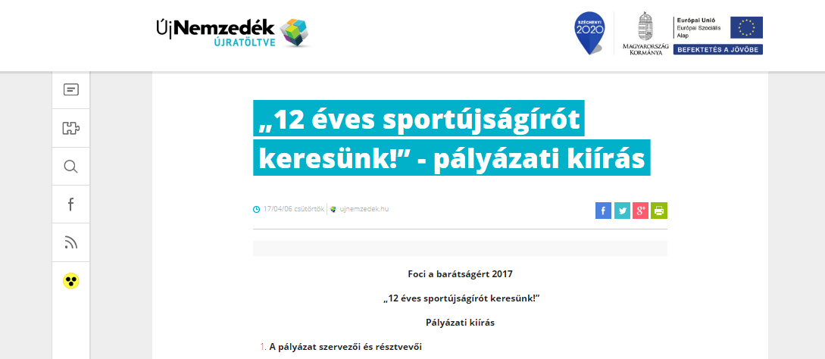

Media name: | focimagazin.hu
Media type & URL: | Online
Media logo:
Header: | “The football for friendship” project look for a 12-year-old journalist
Date: | 06/04/2017
Newsbreak: | Project launch
Short summary | The Fifth season of the international children social programme „FOOTBALL FOR FRIENDSHIP” has been launched. The programme was announced by Gazprom Company, the official partner of the FIFA and the 2018 FIFA World Cup™. The number of the participating countries of the programme increased from 32 to 64 this year. In the frame of the programme - which is supported by the Hungarian Football Federation Grassroots Program - 8 international football teams were united from the countries. They will enter the field in July in St Petersburg, and then watch together the final of the FIFA Confederation Cup. A 12-year-old Hungarian sports reporter accompanies them in St Petersburg. For this position a young football fun will be selected by a tender.
Link: | http://www.focimagazin.hu/2017/04/12-%C3%A9ves-sportriporter-kerestetik

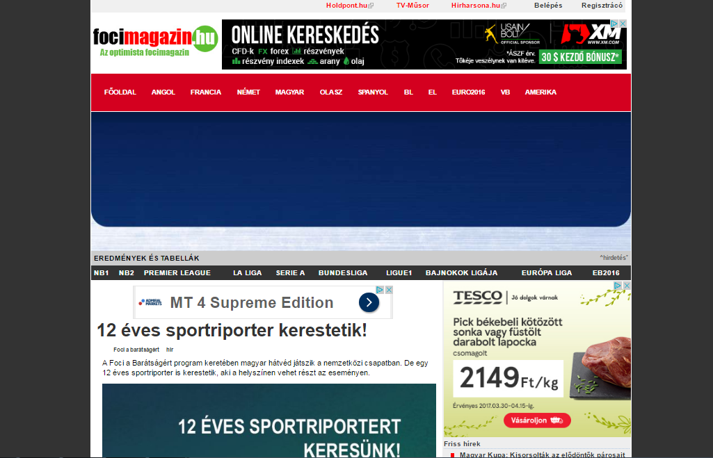

Media name: | csalad.hu
Media type & URL: | Online
Media logo:
Header: | “The football for friendship” project look for a 12-year-old journalist
Date: | 07/04/2017
Newsbreak: | Project launch
Short summary | The Fifth season of the international children social programme „FOOTBALL FOR FRIENDSHIP” has been launched. The programme was announced by Gazprom Company, the official partner of the FIFA and the 2018 FIFA World Cup™. The number of the participating countries of the programme increased from 32 to 64 this year. In the frame of the programme - which is supported by the Hungarian Football Federation Grassroots Program - 8 international football teams were united from the countries. They will enter the field in July in St Petersburg, and then watch together the final of the FIFA Confederation Cup. A 12-year-old Hungarian sports reporter accompanies them in St Petersburg. For this position a young football fun will be selected by a tender.
Link: | http://csalad.hu/2017/04/07/12-eves-sportriporter-kerestetik/?f=hk

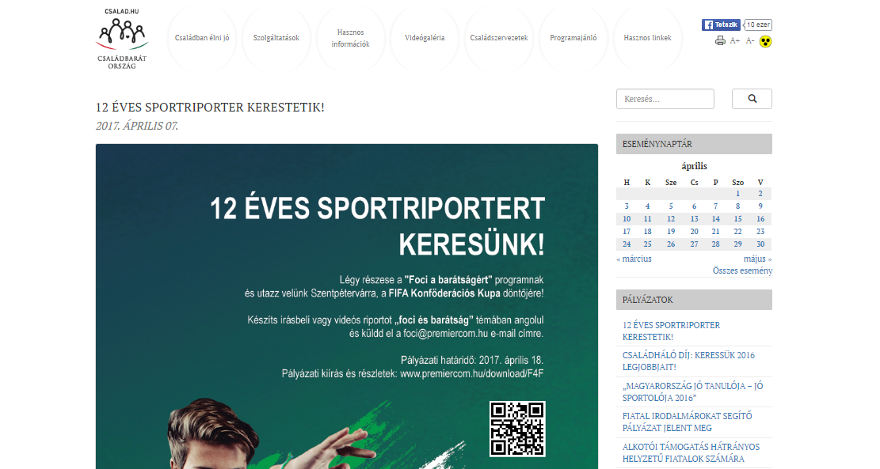

Media name: | portal.zsiraf.hu
Media type & URL: | Online
Media logo:
Header: | “The football for friendship” project look for a 12-year-old journalist
Date: | 09/04/2017
Newsbreak: | Project launch
Short summary | The Fifth season of the international children social programme „FOOTBALL FOR FRIENDSHIP” has been launched. The programme was announced by Gazprom Company, the official partner of the FIFA and the 2018 FIFA World Cup™. The number of the participating countries of the programme increased from 32 to 64 this year. In the frame of the programme - which is supported by the Hungarian Football Federation Grassroots Program - 8 international football teams were united from the countries. They will enter the field in July in St Petersburg, and then watch together the final of the FIFA Confederation Cup. A 12-year-old Hungarian sports reporter accompanies them in St Petersburg. For this position a young football fun will be selected by a tender.
Link: | http://portal.zsiraf.hu/index.php/sport/item/6725-junior-sportujsagiro-kerestetik

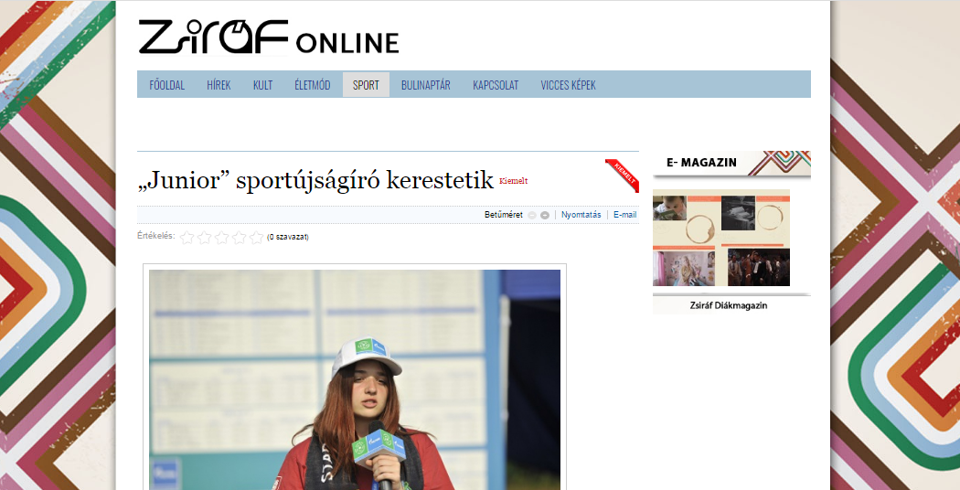

Media name: | vkla.hu
Media type & URL: | Online
Media logo: | 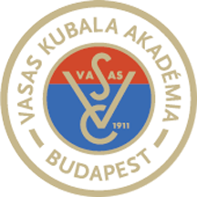
Header: | “The football for friendship” project look for a 12-year-old journalist
Date: | 09/04/2017
Newsbreak: | Project launch
Short summary | The Fifth season of the international children social programme „FOOTBALL FOR FRIENDSHIP” has been launched. The programme was announced by Gazprom Company, the official partner of the FIFA and the 2018 FIFA World Cup™. The number of the participating countries of the programme increased from 32 to 64 this year. In the frame of the programme - which is supported by the Hungarian Football Federation Grassroots Program - 8 international football teams were united from the countries. They will enter the field in July in St Petersburg, and then watch together the final of the FIFA Confederation Cup. A 12-year-old Hungarian sports reporter accompanies them in St Petersburg. For this position a young football fun will be selected by a tender.
Link: | http://www.vkla.hu/12-eves-sportriporter-kerestetik

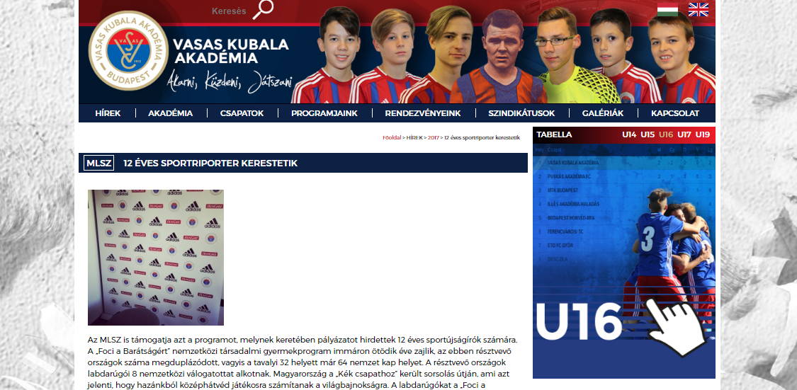

Media name: | sportmenu.net
Media type & URL: | Online
Media logo:
Header: | “The football for friendship” project look for a 12-year-old journalist
Date: | 10/04/2017
Newsbreak: | Project launch
Short summary | The Fifth season of the international children social programme „FOOTBALL FOR FRIENDSHIP” has been launched. The programme was announced by Gazprom Company, the official partner of the FIFA and the 2018 FIFA World Cup™. The number of the participating countries of the programme increased from 32 to 64 this year. In the frame of the programme - which is supported by the Hungarian Football Federation Grassroots Program - 8 international football teams were united from the countries. They will enter the field in July in St Petersburg, and then watch together the final of the FIFA Confederation Cup. A 12-year-old Hungarian sports reporter accompanies them in St Petersburg. For this position a young football fun will be selected by a tender.
Link: | http://sportmenu.net/magyar-hatved-is-jatszik-a-foci-a-baratsagert-programban-es-palyazatot-hirdetnek-12-eves-sportujsagirok-szamara/

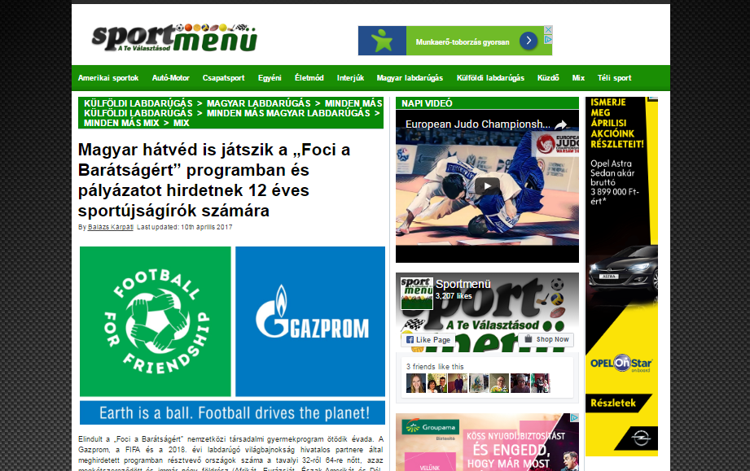

Media name: | fctiszaujvaros.hu
Media type & URL: | Online
Media logo:
Header: | “The football for friendship” project look for a 12-year-old journalist
Date: | 10/04/2017
Newsbreak: | Project launch
Short summary | The Fifth season of the international children social programme „FOOTBALL FOR FRIENDSHIP” has been launched. The programme was announced by Gazprom Company, the official partner of the FIFA and the 2018 FIFA World Cup™. The number of the participating countries of the programme increased from 32 to 64 this year. In the frame of the programme - which is supported by the Hungarian Football Federation Grassroots Program - 8 international football teams were united from the countries. They will enter the field in July in St Petersburg, and then watch together the final of the FIFA Confederation Cup. A 12-year-old Hungarian sports reporter accompanies them in St Petersburg. For this position a young football fun will be selected by a tender.
Link: | http://fctiszaujvaros.hu/479-12-eves-sportriporter-kerestetik

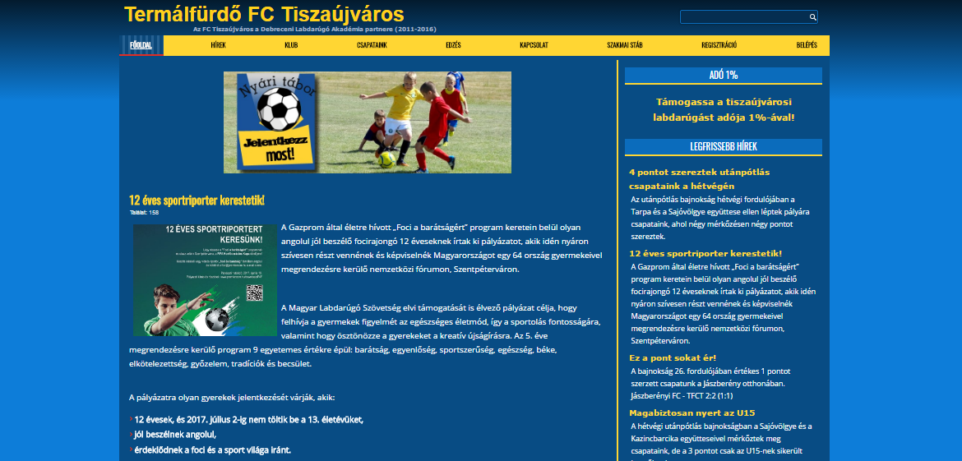

Media name: | pafi.hu
Media type & URL: | Online
Media logo:
Header: | “The football for friendship” project look for a 12-year-old journalist
Date: | 10/04/2017
Newsbreak: | Project launch
Short summary | The Fifth season of the international children social programme „FOOTBALL FOR FRIENDSHIP” has been launched. The programme was announced by Gazprom Company, the official partner of the FIFA and the 2018 FIFA World Cup™. The number of the participating countries of the programme increased from 32 to 64 this year. In the frame of the programme - which is supported by the Hungarian Football Federation Grassroots Program - 8 international football teams were united from the countries. They will enter the field in July in St Petersburg, and then watch together the final of the FIFA Confederation Cup. A 12-year-old Hungarian sports reporter accompanies them in St Petersburg. For this position a young football fun will be selected by a tender.
Link: | http://www.pafi.hu/_pafi/palyazat.nsf/ervdocidweburlap/361488518E3ED571C12580FA0066CAD6

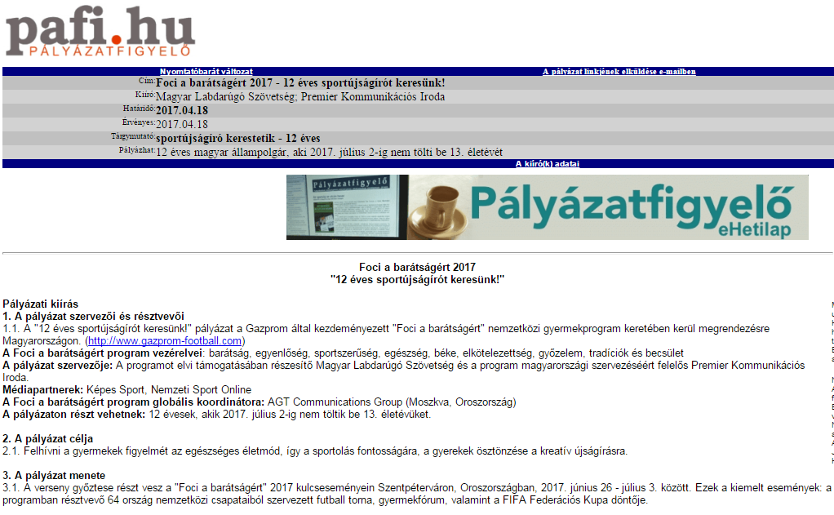

Media name: | Lánchíd Rádió
Media type & URL: | National electronic
Media logo:
Header: | “The football for friendship” project look for a 12-year-old journalist
Date: | 10/04/2017
Newsbreak: | Project launch
Short summary | The Fifth season of the international children social programme „FOOTBALL FOR FRIENDSHIP” has been launched. The programme was announced by Gazprom Company, the official partner of the FIFA and the 2018 FIFA World Cup™. The number of the participating countries of the programme increased from 32 to 64 this year. In the frame of the programme - which is supported by the Hungarian Football Federation Grassroots Program - 8 international football teams were united from the countries. They will enter the field in July in St Petersburg, and then watch together the final of the FIFA Confederation Cup. A 12-year-old Hungarian sports reporter accompanies them in St Petersburg. For this position a young football fun will be selected by a tender.
Link:

Media name: | bebikkicsikesnagyok.hu
Media type & URL: | Online
Media logo: | 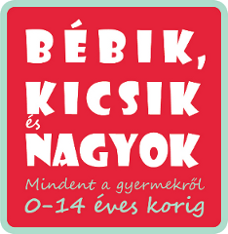
Header: | Football for friendship
Date: | 20/04/2017
Newsbreak: | Project launch
Short summary | The Fifth season of the international children social programme „FOOTBALL FOR FRIENDSHIP” has been launched. The programme was announced by Gazprom Company, the official partner of the FIFA and the 2018 FIFA World Cup™. The number of the participating countries of the programme increased from 32 to 64 this year. In the frame of the programme - which is supported by the Hungarian Football Federation Grassroots Program - 8 international football teams were united from the countries. They will enter the field in July in St Petersburg, and then watch together the final of the FIFA Confederation Cup. A 12-year-old Hungarian sports reporter accompanies them in St Petersburg. For this position a young football fun will be selected by a tender.
Link: | http://www.bebikkicsikesnagyok.hu/27008/foci-a-baratsagert/

