PRESS CLIPPING Hungary
FOOTBALL FOR FRIENDSHIP

25. April 2017

Media name: | Nemzeti Sport
Media type & URL: | National Press
Media logo:
Header: | Let's go to Russia!
Date: | 26/04/2017
Newsbreak: | FFDay
Short summary | The Fifth season of the international children social programme „FOOTBALL FOR FRIENDSHIP” has been launched. The programme was announced by Gazprom Company, the official partner of the FIFA and the 2018 FIFA World Cup™. The number of the participating countries of the programme increased from 32 to 64 this year. In the frame of the programme - which is supported by the Hungarian Football Federation Grassroots Program - 8 international football teams were united from the countries. They will enter the field in July in St Petersburg, and then watch together the final of the FIFA Confederation Cup. A 12-year-old Hungarian sports reporter accompanies them in St Petersburg. For this position a young football fun will be selected by a tender.
Link:

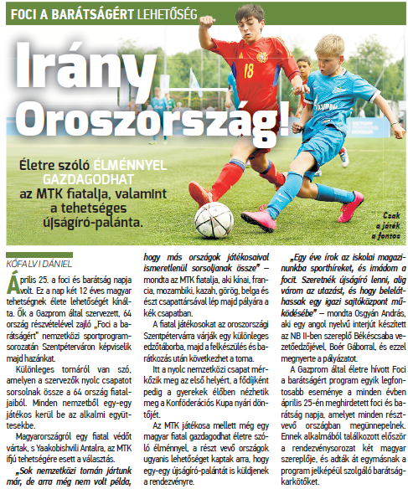
Media name: | nemzetisport.hu
Media type & URL: | Online
Media logo:
Header: | The young player of MTK and a boy from Békéscsaba will represent our country in Russia
Date: | 25/04/2017
Newsbreak: | FFDay
Short summary | The Fifth season of the international children social programme „FOOTBALL FOR FRIENDSHIP” has been launched. The programme was announced by Gazprom Company, the official partner of the FIFA and the 2018 FIFA World Cup™. The number of the participating countries of the programme increased from 32 to 64 this year. In the frame of the programme - which is supported by the Hungarian Football Federation Grassroots Program - 8 international football teams were united from the countries. They will enter the field in July in St Petersburg, and then watch together the final of the FIFA Confederation Cup. A 12-year-old Hungarian sports reporter accompanies them in St Petersburg. For this position a young football fun will be selected by a tender.
Link: | http://www.nemzetisport.hu/minden_mas_foci/foci-a-baratsagert-ok-kepviselik-magyarorszagot-szentpetervaron-2565441

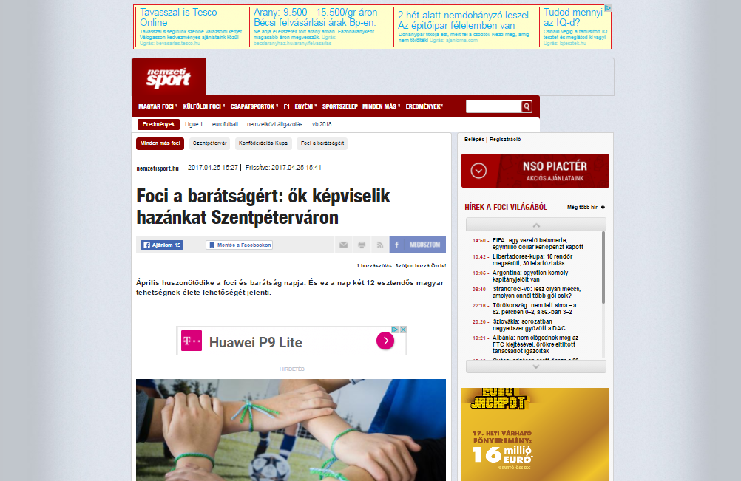

Media name: | Képes Sport
Media type & URL: | National Press
Media logo: | 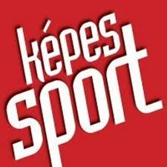
Header: | The Hungarian delegation is full
Date: | 26/04/2017
Newsbreak: | FFDay
Short summary | The Fifth season of the international children social programme „FOOTBALL FOR FRIENDSHIP” has been launched. The programme was announced by Gazprom Company, the official partner of the FIFA and the 2018 FIFA World Cup™. The number of the participating countries of the programme increased from 32 to 64 this year. In the frame of the programme - which is supported by the Hungarian Football Federation Grassroots Program - 8 international football teams were united from the countries. They will enter the field in July in St Petersburg, and then watch together the final of the FIFA Confederation Cup. A 12-year-old Hungarian sports reporter accompanies them in St Petersburg. For this position a young football fun will be selected by a tender.
Link:

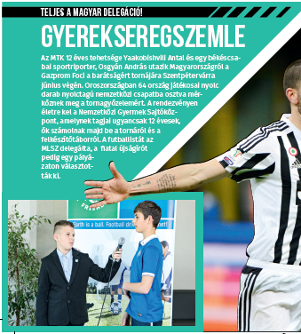

Media name: | focimagazin.hu
Media type & URL: | Online
Media logo:
Header: | The young player of MTK and a boy from Békéscsaba will represent our country in Russia
Date: | 25/04/2017
Newsbreak: | FFDay
Short summary | The Fifth season of the international children social programme „FOOTBALL FOR FRIENDSHIP” has been launched. The programme was announced by Gazprom Company, the official partner of the FIFA and the 2018 FIFA World Cup™. The number of the participating countries of the programme increased from 32 to 64 this year. In the frame of the programme - which is supported by the Hungarian Football Federation Grassroots Program - 8 international football teams were united from the countries. They will enter the field in July in St Petersburg, and then watch together the final of the FIFA Confederation Cup. A 12-year-old Hungarian sports reporter accompanies them in St Petersburg. For this position a young football fun will be selected by a tender.
Link: | http://www.m4sport.hu/2017/04/25/az-mtk-ifju-tehetsege-vesz-reszt-a-foci-a-baratsagert-programon/

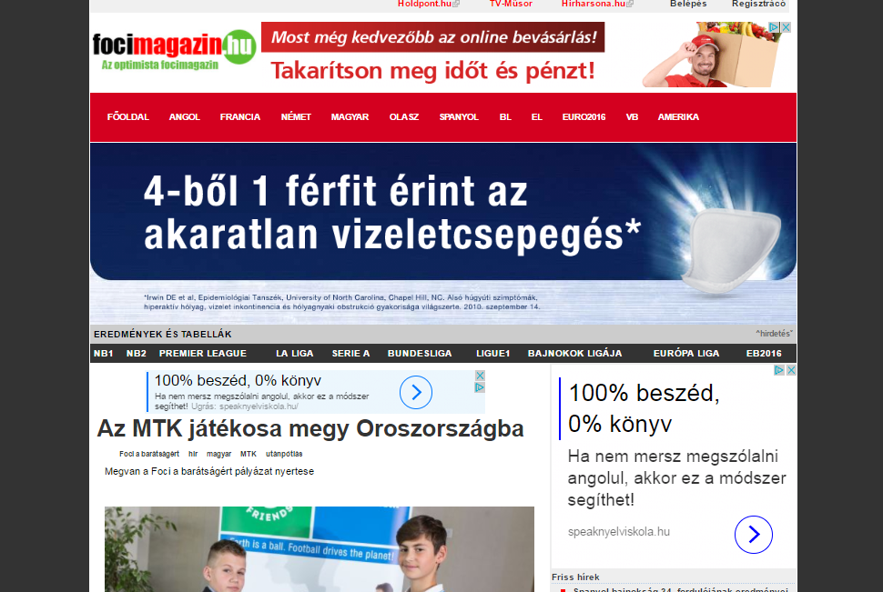

Media name: | ifipress.hu
Media type & URL: | Online
Media logo:
Header: | The young player of MTK and a boy from Békéscsaba will represent our country in Russia
Date: | 26/04/2017
Newsbreak: | Project launch
Short summary | The Fifth season of the international children social programme „FOOTBALL FOR FRIENDSHIP” has been launched. The programme was announced by Gazprom Company, the official partner of the FIFA and the 2018 FIFA World Cup™. The number of the participating countries of the programme increased from 32 to 64 this year. In the frame of the programme - which is supported by the Hungarian Football Federation Grassroots Program - 8 international football teams were united from the countries. They will enter the field in July in St Petersburg, and then watch together the final of the FIFA Confederation Cup. A 12-year-old Hungarian sports reporter accompanies them in St Petersburg. For this position a young football fun will be selected by a tender.
Link: | http://ifipress.hu/foci-a-baratsagert-2017/

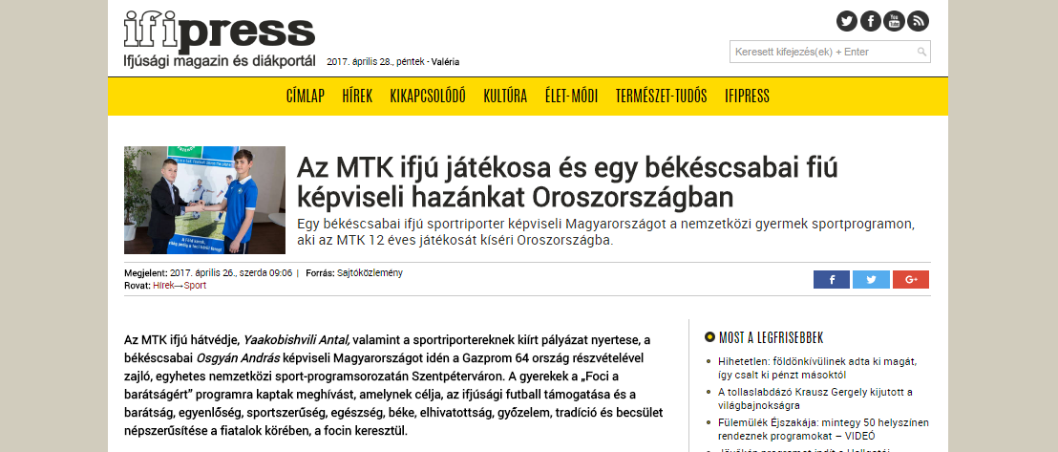

Media name: | sportmenu.hu
Media type & URL: | Online
Media logo:
Header: | The young player of MTK and a boy from Békéscsaba will represent our country in Russia
Date: | 26/04/2017
Newsbreak: | FFFDay
Short summary | The Fifth season of the international children social programme „FOOTBALL FOR FRIENDSHIP” has been launched. The programme was announced by Gazprom Company, the official partner of the FIFA and the 2018 FIFA World Cup™. The number of the participating countries of the programme increased from 32 to 64 this year. In the frame of the programme - which is supported by the Hungarian Football Federation Grassroots Program - 8 international football teams were united from the countries. They will enter the field in July in St Petersburg, and then watch together the final of the FIFA Confederation Cup. A 12-year-old Hungarian sports reporter accompanies them in St Petersburg. For this position a young football fun will be selected by a tender.
Link: | http://sportmenu.net/az-ifju-sportriporter-az-mtk-12-eves-jatekosat-kiseri-oroszorszagba/

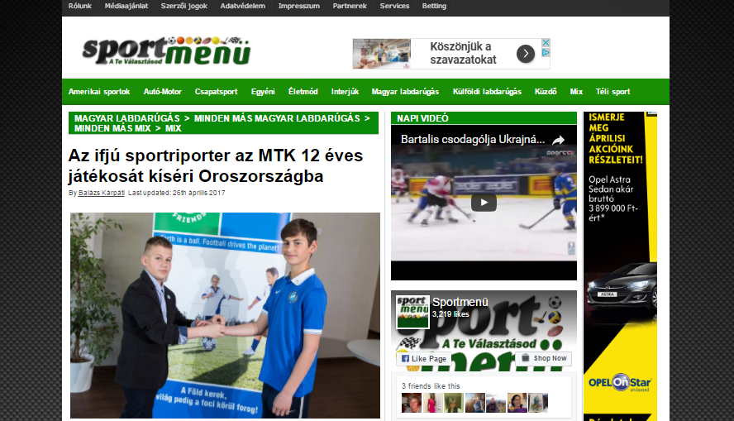

Media name: | utanpotlassport.hu
Media type & URL: | Online
Media logo:
Header: | The young player of MTK and a boy from Békéscsaba will represent our country in Russia
Date: | 26/04/2017
Newsbreak: | FFDay
Short summary | The Fifth season of the international children social programme „FOOTBALL FOR FRIENDSHIP” has been launched. The programme was announced by Gazprom Company, the official partner of the FIFA and the 2018 FIFA World Cup™. The number of the participating countries of the programme increased from 32 to 64 this year. In the frame of the programme - which is supported by the Hungarian Football Federation Grassroots Program - 8 international football teams were united from the countries. They will enter the field in July in St Petersburg, and then watch together the final of the FIFA Confederation Cup. A 12-year-old Hungarian sports reporter accompanies them in St Petersburg. For this position a young football fun will be selected by a tender.
Link: | http://www.utanpotlassport.hu/2017/04/26/irany-szentpetervar/

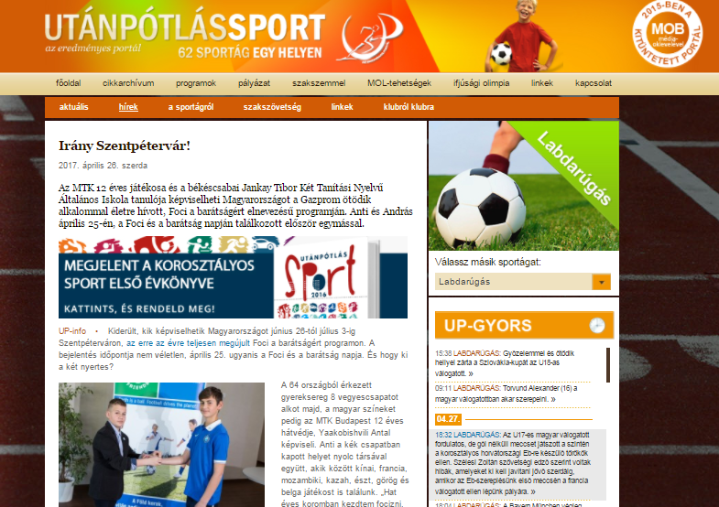

Media name: | beol.hu
Media type & URL: | Online
Media logo:
Header: | The young player of MTK and a boy from Békéscsaba will represent our country in Russia
Date: | 26/04/2017
Newsbreak: | FFDay
Short summary | The Fifth season of the international children social programme „FOOTBALL FOR FRIENDSHIP” has been launched. The programme was announced by Gazprom Company, the official partner of the FIFA and the 2018 FIFA World Cup™. The number of the participating countries of the programme increased from 32 to 64 this year. In the frame of the programme - which is supported by the Hungarian Football Federation Grassroots Program - 8 international football teams were united from the countries. They will enter the field in July in St Petersburg, and then watch together the final of the FIFA Confederation Cup. A 12-year-old Hungarian sports reporter accompanies them in St Petersburg. For this position a young football fun will be selected by a tender.
Link: | http://www.beol.hu/bekes/sport/egy-bekescsabai-fiu-kepviseli-hazankat-szentpetervaron-722180/#

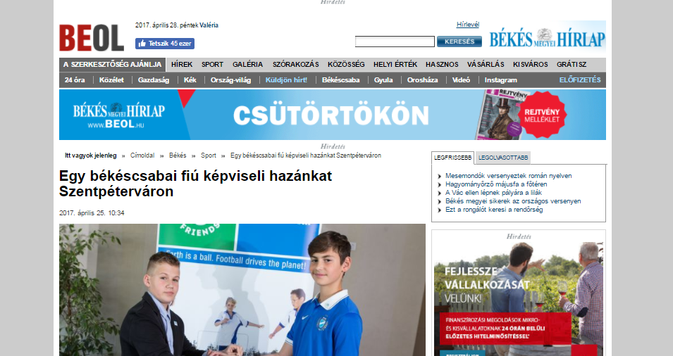

Media name: | m4sport.hu
Media type & URL: | Online
Media logo:
Header: | The young player of MTK and a boy from Békéscsaba will represent our country in Russia
Date: | 26/04/2017
Newsbreak: | FFDay
Short summary | The Fifth season of the international children social programme „FOOTBALL FOR FRIENDSHIP” has been launched. The programme was announced by Gazprom Company, the official partner of the FIFA and the 2018 FIFA World Cup™. The number of the participating countries of the programme increased from 32 to 64 this year. In the frame of the programme - which is supported by the Hungarian Football Federation Grassroots Program - 8 international football teams were united from the countries. They will enter the field in July in St Petersburg, and then watch together the final of the FIFA Confederation Cup. A 12-year-old Hungarian sports reporter accompanies them in St Petersburg. For this position a young football fun will be selected by a tender.
Link: | http://www.m4sport.hu/galeriak/foci-a-baratsagert/

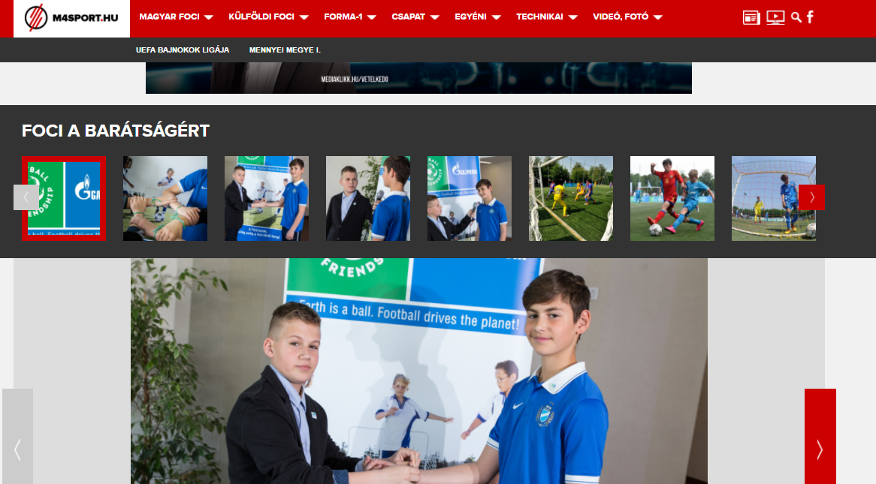

Media name: | m4sport.hu
Media type & URL: | Online
Media logo:
Header: | The young player of MTK and a boy from Békéscsaba will represent our country in Russia
Date: | 26/04/2017
Newsbreak: | FFDay
Short summary | The Fifth season of the international children social programme „FOOTBALL FOR FRIENDSHIP” has been launched. The programme was announced by Gazprom Company, the official partner of the FIFA and the 2018 FIFA World Cup™. The number of the participating countries of the programme increased from 32 to 64 this year. In the frame of the programme - which is supported by the Hungarian Football Federation Grassroots Program - 8 international football teams were united from the countries. They will enter the field in July in St Petersburg, and then watch together the final of the FIFA Confederation Cup. A 12-year-old Hungarian sports reporter accompanies them in St Petersburg. For this position a young football fun will be selected by a tender.
Link: | http://www.m4sport.hu/2017/04/25/az-mtk-ifju-tehetsege-vesz-reszt-a-foci-a-baratsagert-programon/

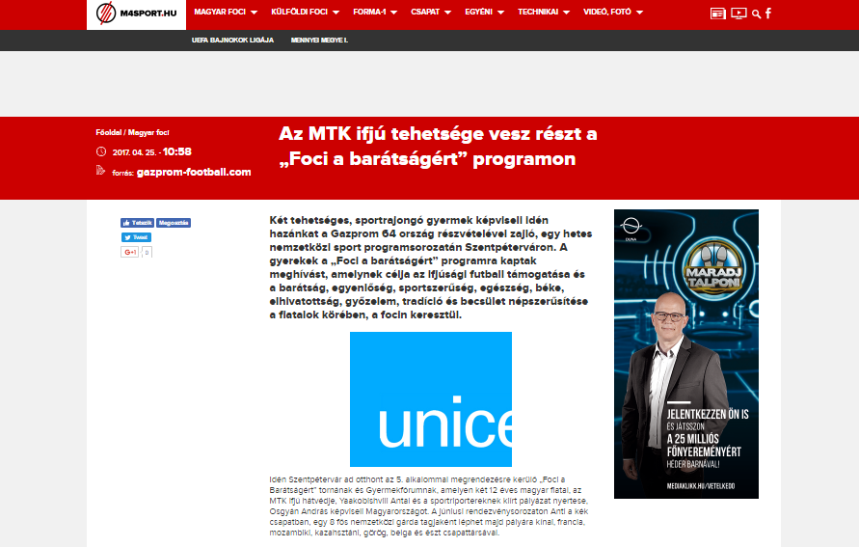

Media name: | mtk.hu
Media type & URL: | Online
Media logo:
Header: | The young player of MTK and a boy from Békéscsaba will represent our country in Russia
Date: | 01/05/2017
Newsbreak: | FFDay
Short summary | The Fifth season of the international children social programme „FOOTBALL FOR FRIENDSHIP” has been launched. The programme was announced by Gazprom Company, the official partner of the FIFA and the 2018 FIFA World Cup™. The number of the participating countries of the programme increased from 32 to 64 this year. In the frame of the programme - which is supported by the Hungarian Football Federation Grassroots Program - 8 international football teams were united from the countries. They will enter the field in July in St Petersburg, and then watch together the final of the FIFA Confederation Cup. A 12-year-old Hungarian sports reporter accompanies them in St Petersburg. For this position a young football fun will be selected by a tender.
Link: | http://mtk.hu/hirek/az-mtk-budapest-ifju-tehetsege-vesz-reszt-a-%E2%80%9Efoci-a-baratsagert%E2%80%9D-program-szentpetervari-rendezvenyen

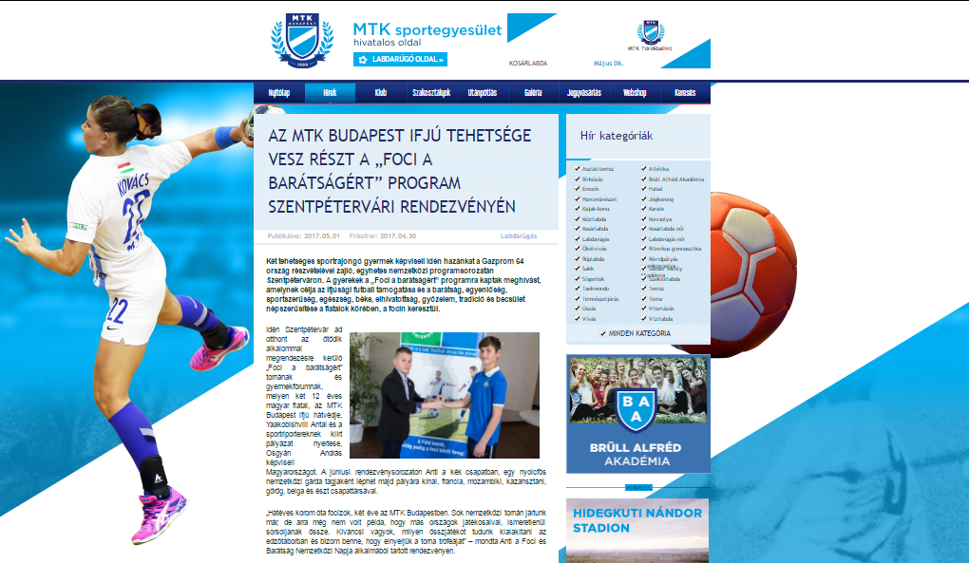

Media name: | xel.hu
Media type & URL: | Online
Media logo:
Header: | Hungarians in the programme of Football for Friendship
Date: | 02/05/2017
Newsbreak: | FFDay
Short summary | The Fifth season of the international children social programme „FOOTBALL FOR FRIENDSHIP” has been launched. The programme was announced by Gazprom Company, the official partner of the FIFA and the 2018 FIFA World Cup™. The number of the participating countries of the programme increased from 32 to 64 this year. In the frame of the programme - which is supported by the Hungarian Football Federation Grassroots Program - 8 international football teams were united from the countries. They will enter the field in July in St Petersburg, and then watch together the final of the FIFA Confederation Cup. A 12-year-old Hungarian sports reporter accompanies them in St Petersburg. For this position a young football fun will be selected by a tender.
Link: | http://www.xel.hu/magyarok-a-foci-a-baratsagert-nemzetkozi-programban/

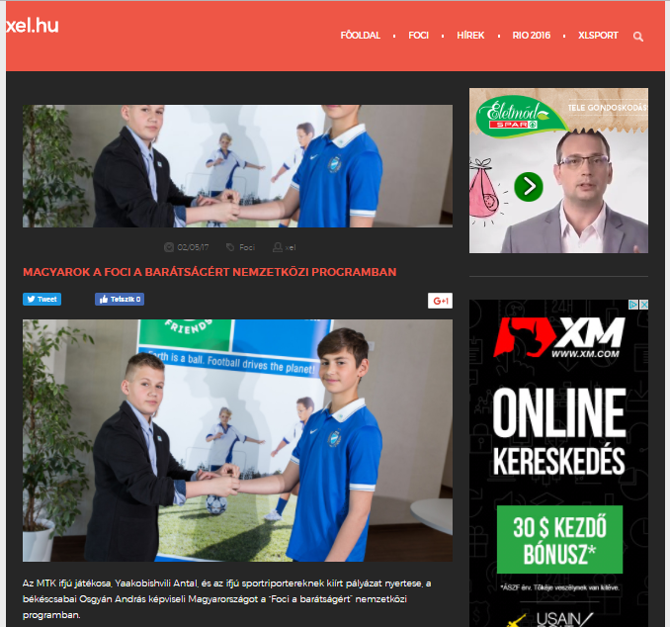

Media name: | xlsport.hu
Media type & URL: | Online
Media logo: | 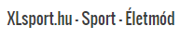
Header: | Hungarians in the programme of Football for Friendship
Date: | 03/05/2017
Newsbreak: | FFDay
Short summary | The Fifth season of the international children social programme „FOOTBALL FOR FRIENDSHIP” has been launched. The programme was announced by Gazprom Company, the official partner of the FIFA and the 2018 FIFA World Cup™. The number of the participating countries of the programme increased from 32 to 64 this year. In the frame of the programme - which is supported by the Hungarian Football Federation Grassroots Program - 8 international football teams were united from the countries. They will enter the field in July in St Petersburg, and then watch together the final of the FIFA Confederation Cup. A 12-year-old Hungarian sports reporter accompanies them in St Petersburg. For this position a young football fun will be selected by a tender.
Link: | http://www.xlsport.hu/magyarok-a-foci-a-baratsagert-nemzetkozi-programban/

