Danone Nations Cup
Local semi-final - Miskolc
April 22., 2017.
Prepared by: Communications
2017.04.28.
MÉDIA: | egriprogramok.hu | MEDIA SPECIFICS
DÁTE: | 23/04/2017 | TYPE: | online
PAGE: |  | REACH: | 4 000
AD VALUE (HUF) | 20 000 | FREQUENCY: | -
HEADLINE: | Eger Plútó football team won the local semi-final in Miskolc
SUMMARY: | The U12 football team of Eger Plútó has won the Miskolc Semi Final of the Danone Football Cup for Children, by defeating the BTC Team of Salgótarján. The tournament was organised by Danone and MLSZ Grassroots Program for youngsters. The objective of the cup is to raise awareness of the kids to sport and healthy nutrition. In April and May 2017, all together 96 football teams will compete in the "Danone Football Cup for Children” in order to enter to the Budapest final, the winner of which will represent Hungary at the International Finals, in New Jersey. Special element of the program was that participating children collected sport equipment for children living in state care and foster parents, who played in the cup the year before.

http://www.egriprogramok.hu/hu/kulturalis-hirek/4464-az-eger-pluto-csapata-nyerte-a-danone-focikupa-miskolci-elodoentojet.html
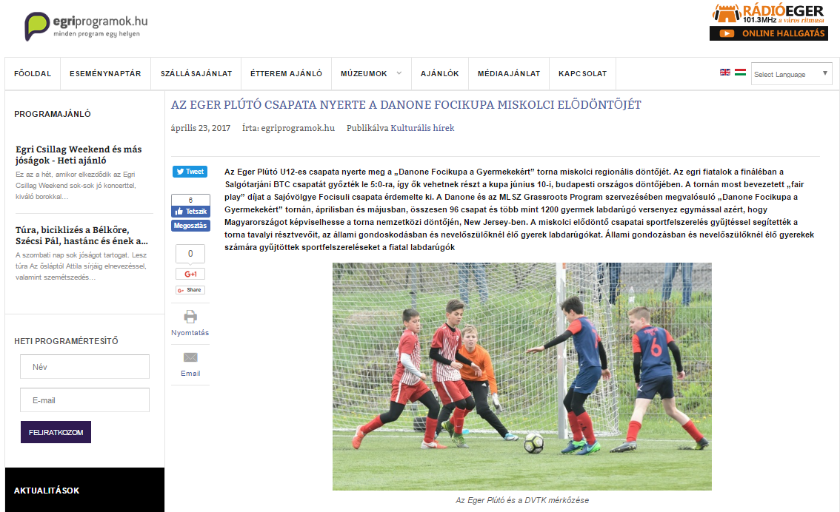

AZ EGER PLÚTÓ CSAPATA NYERTE A DANONE FOCIKUPA MISKOLCI ELŐDÖNTŐJÉT
Gólöröm, egészséges életmód és kiegyensúlyozott táplálkozás

A Danone Focikupa a Gyermekekért (Danone Nations Cup) a világ legnagyobb, immár 15 éves múltra visszatekintő, professzionális gyermek labdarúgó kupája, amelyen eddig mintegy 2,5 millió gyerek vett részt világszerte.

A Danone és a Magyar Labdarúgó Szövetség Grassroots Programja által közösen megrendezett U12-es torna célja, hogy a sporton és a labdarúgáson keresztül egészséges életmódra, valamint kiegyensúlyozott táplálkozásra nevelje a gyermekeket, ebben a Magyar Dietetikusok Országos Szövetsége, a torna szakmai partnere segíti a kezdeményezést.
A kupát az Emberi Erőforrások Minisztériuma és Miskolc Megyei Jogú Város Önkormányzata is támogatja, fővédnöke pedig Nyilasi Tibor, 70-szeres labdarúgó válogatott, tiszteletbeli nagykövete pedig Hevesi Tamás énekes és futballedző.

„A Danone Focikupa a Gyermekekért célja, hogy népszerűsítse a sportolást és az egészséges táplálkozást a gyerekek körében” – mondta Gyergyói-Szabó Anita, a Danone külső kommunikációs menedzsere. – „Vállalatunk a 19 éve tartó Tegyünk Együtt a Gyermekekért társadalmi programjában idén is különös figyelmet fordít az egészségi állapotuk vagy szociális helyzetük miatt hátrányt szenvedő gyerekekre is. Az idei Danone Focikupában egy valós nemzetközi megmérettetés lehetőségét nyújtjuk a résztvevőknek, miközben a sportszergyűjtéssel az állami gondozásban élő gyermekek sportolási körülményeit igyekszünk javítani” – tette hozzá.

Minden eddiginél több résztvevő
A Danone Focikupa a Gyermekekért torna idén jelentős mértékben kibővült. Míg tavaly mindössze 240 gyermek vett részt a programban, addig az idén 12 régióban, régiónként 8, összesen tehát 96 csapat képviseletében 1.200 gyermek vesz részt a tornában. A miskolci regionális elődöntőn a Diósgyőr VTK, a Sajóvölgye Focisuli, a Mezőkövesd-Zsóry FC, az Eger SE, a Salgótarjáni BTC, a Sátoraljaújhelyi TE, az Eger Plútó és az Encs VSC csapatai versenyeztek egymással a regionális elsőségért.

Sportszergyűjtéssel segítik a hátrányos helyzetű gyerek focistákat
Az idei torna különleges eleme azt volt, hogy az abban résztvevő csapatok sportszer- és sportfelszerelés gyűjtéssel segítették a torna tavalyi résztvevőit, az állami gondoskodásban és nevelőszülőknél élő gyerek labdarúgókat.

A miskolci regionális döntőn résztvevő csapatok által összegyűlt mezeket, futball cipőket, labdákat Földessy Judit a Borsod-Abaúj-Zemplén Megyei Gyermekvédelmi Központ és Területi Gyermekvédelmi Szakszolgálat Intézményvezetője és Dr. Dobosné Vörös Eleonóra a Fruska Gyermekotthon Vezetője vették át a Danone Magyarország Kft. képviselőjétől, Gyergyói-Szabó Anitától valamint a csapatoktól

Irány Amerika
A Danone Focikupa a Gyermekekért torna további regionális elődöntőit április és május folyamán, Debrecenben, Szegeden, Budapesten, Dunakeszin, Dabason, Felcsúton, Győrött, Békéscsabán, Pécsett és Szombathelyen tartják. Az országos döntő június 10-én, Budapesten kerül megrendezésre.
A döntő tétje nem más, mint az, hogy melyik csapat képviselheti Magyarországot Amerikában, New Jersey-ben, a 32 ország U12-es csapatának részvételével megtartott nemzetközi döntőben.
A miskolci regionális elődöntőt az UNIO-COOP Zrt. támogatta.
Facebookon! www.facebook.com/tegyunkegyuttagyermekekert

MÉDIA: | egerhirek.hu | MEDIA SPECIFICS
DÁTE: | 23.04.2017. | TYPE: | Online
PAGE: | - | REACH: | 50 000
AD VALUE (HUF) | 130 000 | FREQUENCY: | -
HEADLINE: | Eger Plútó football team won the local semi-final of Danone Football Cup in Miskolc
SUMMARY: | The U12 football team of Eger Plútó has won the Miskolc Semi Final of the Danone Football Cup for Children, by defeating the BTC Team of Salgótarján. The tournament was organised by Danone and MLSZ Grassroots Program for youngsters. The objective of the cup is to raise awareness of the kids to sport and healthy nutrition. In April and May 2017, all together 96 football teams will compete in the "Danone Football Cup for Children” in order to enter to the Budapest final, the winner of which will represent Hungary at the International Finals, in New Jersey. Special element of the program was that participating children collected sport equipment for children living in state care and foster parents, who played in the cup the year before.

http://www.egerhirek.hu/2017/04/23/az-eger-pluto-csapata-nyerte-a-danone-focikupa-miskolci-elodontojet/

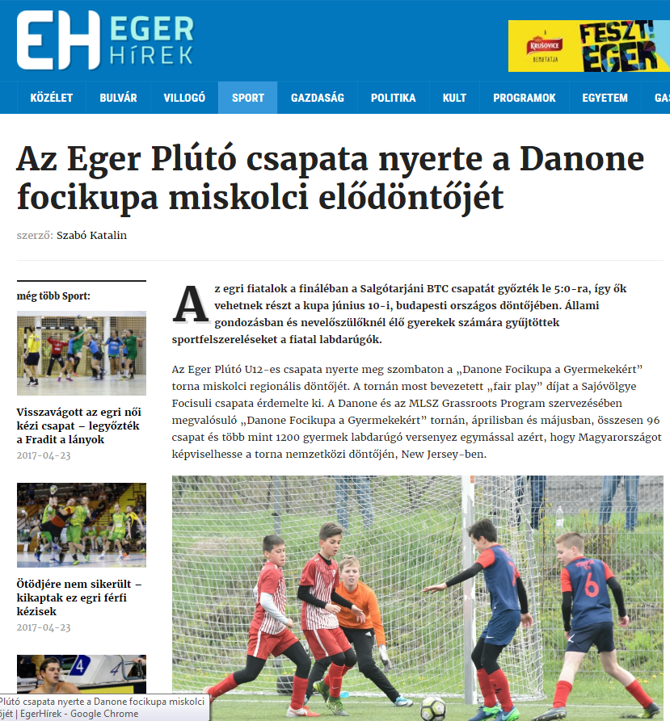

AZ EGER PLÚTÓ CSAPATA NYERTE A DANONE FOCIKUPA MISKOLCI ELŐDÖNTŐJÉT
Az egri fiatalok a fináléban a Salgótarjáni BTC csapatát győzték le 5:0-ra, így ők vehetnek részt a kupa június 10-i, budapesti országos döntőjében. Állami gondozásban és nevelőszülőknél élő gyerekek számára gyűjtöttek sportfelszereléseket a fiatal labdarúgók.
Az Eger Plútó U12-es csapata nyerte meg szombaton a „Danone Focikupa a Gyermekekért” torna miskolci regionális döntőjét. A tornán most bevezetett „fair play” díjat a Sajóvölgye Focisuli csapata érdemelte ki. A Danone és az MLSZ Grassroots Program szervezésében megvalósuló „Danone Focikupa a Gyermekekért” tornán, áprilisban és májusban, összesen 96 csapat és több mint 1200 gyermek labdarúgó versenyez egymással azért, hogy Magyarországot képviselhesse a torna nemzetközi döntőjén, New Jersey-ben.
Minden eddiginél több résztvevő.
Míg tavaly mindössze 240 gyermek vett részt a programban, addig az idén 12 régióban, régiónként 8, összesen tehát 96 csapat képviseletében 1.200 gyermek vesz részt a tornában. A miskolci regionális elődöntőn a Diósgyőr VTK, a Sajóvölgye Focisuli, a Mezőkövesd-Zsóry FC, az Eger SE, a Salgótarjáni BTC, a Sátoraljaújhelyi TE, az Eger Plútó és az Encs VSC csapatai versenyeztek egymással a regionális elsőségért.
Sportszergyűjtéssel segítik a hátrányos helyzetű gyerek focistákat.
Az idei torna különleges eleme azt volt, hogy az abban résztvevő csapatok sportszer- és sportfelszerelés gyűjtéssel segítették a torna tavalyi résztvevőit, az állami gondoskodásban és nevelőszülőknél élő gyerek labdarúgókat.
A Danone Focikupa a Gyermekekért torna további regionális elődöntőit április és május folyamán, Debrecenben, Szegeden, Budapesten, Dunakeszin, Dabason, Felcsúton, Győrött, Békéscsabán, Pécsett és Szombathelyen tartják. Az országos döntő június 10-én, Budapesten kerül megrendezésre. A döntő tétje nem más, mint az, hogy melyik csapat képviselheti Magyarországot Amerikában, New Jersey-ben, a 32 ország U12-es csapatának részvételével megtartott nemzetközi döntőben.
Gólöröm, egészséges életmód és kiegyensúlyozott táplálkozás.
A Danone Focikupa a Gyermekekért (Danone Nations Cup) a világ legnagyobb, immár 15 éves múltra visszatekintő, professzionális gyermek labdarúgó kupája, amelyen eddig mintegy 2,5 millió gyerek vett részt világszerte.
A Danone és a Magyar Labdarúgó Szövetség Grassroots Programja által közösen megrendezett U12-es torna célja, hogy a sporton és a labdarúgáson keresztül egészséges életmódra, valamint kiegyensúlyozott táplálkozásra nevelje a gyermekeket, ebben a Magyar Dietetikusok Országos Szövetsége, a torna szakmai partnere segíti a kezdeményezést.
A kupát az Emberi Erőforrások Minisztériuma és Miskolc Megyei Jogú Város Önkormányzata is támogatja, fővédnöke pedig Nyilasi Tibor, 70-szeres labdarúgó válogatott, tiszteletbeli nagykövete pedig Hevesi Tamás énekes és futballedző.

MÉDIA: | egerhirek.hu | MEDIA SPECIFICS
DÁTE: | 19.04.2017. | TYPE: | Online
PAGE: | - | REACH: | 50 000
AD VALUE (HUF) | 130 000 | FREQUENCY: | -
HEADLINE: | The young „Messis” from Eger may football their team until New Jersey
SUMMARY: | The U12 football team of Eger Plútó has won the Miskolc Semi Final of the Danone Football Cup for Children, by defeating the BTC Team of Salgótarján. The tournament was organised by Danone and MLSZ Grassroots Program for youngsters. The objective of the cup is to raise awareness of the kids to sport and healthy nutrition. In April and May 2017, all together 96 football teams will compete in the "Danone Football Cup for Children” in order to enter to the Budapest final, the winner of which will represent Hungary at the International Finals, in New Jersey. Special element of the program was that participating children collected sport equipment for children living in state care and foster parents, who played in the cup the year before.

http://www.egerhirek.hu/2017/04/19/az-egri-ifju-messik-new-jersey-ig-focizhatjak-el-csapatukat/

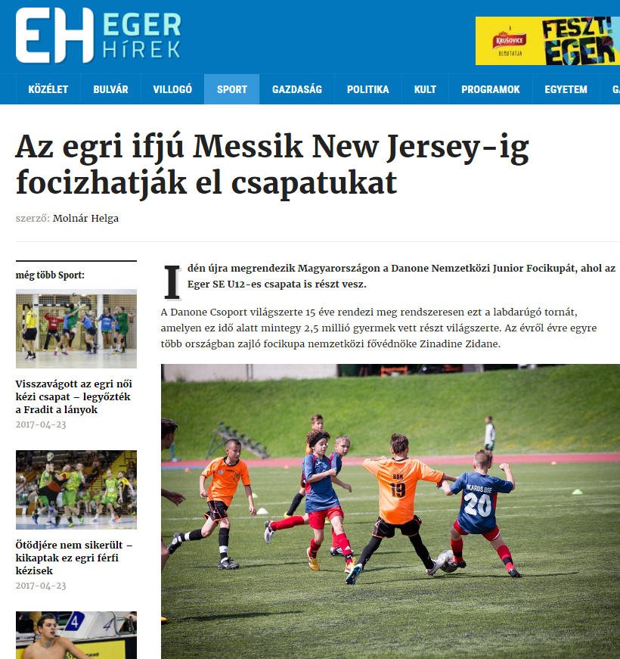

AZ EGRI IFJÚ MESSIK NEW JERSEY-IG FOCIZHATJÁK EL CSAPATUKAT
Idén újra megrendezik Magyarországon a Danone Nemzetközi Junior Focikupát, ahol az Eger SE U12-es csapata is részt vesz.
A Danone Csoport világszerte 15 éve rendezi meg rendszeresen ezt a labdarúgó tornát, amelyen ez idő alatt mintegy 2,5 millió gyermek vett részt világszerte. Az évről évre egyre több országban zajló focikupa nemzetközi fővédnöke Zinadine Zidane.
A mini manók New Jerseybe vágynak. Fotó: fourfourtwo.hu
Idén április 22-én Miskolcon kezdődik a 2017. évi „Danone Focikupa a Gyermekekért”, országos, U12-es gyermek labdarúgó torna. Az Danone és az MLSZ által rendezett kupa miskolci elődöntőjében a Diósgyőri VTK, a Sajóvölgye Focisuli, a Mezőkövesd-Zsóry FC, az Eger SE, a Salgótarjáni BTC, a Sátoraljaújhelyi TE, az Eger Plútó, valamint az Encs VSC csapatai küzdenek egymással azért, hogy Magyarországot képviselhessék New Jerseyben, ahol 32 ország vesz részt a nemzetközi döntőben. A torna különleges eleme, hogy a résztvevő labdarúgó akadémiák bevonásával a Danone és az MLSZ sportszer- és sportfelszerelés gyűjtést szervezett, amellyel a programban tavaly résztvevő, állami gondoskodásban és nevelőszülőknél élő gyerekeket segítik.
A Danone Nemzetközi Junior Focikupával célunk, hogy a magyar gyermekek számára is nemzetközi szintéren való megmérettetési lehetőséget biztosítsunk úgy, hogy mindeközben az egészséges életmódra és táplálkozásra ösztönözzük őket – írják a honlapjukon.

MÉDIA: | egrisztorik.hu | MEDIA SPECIFICS
DÁTE: | 24.04.2017. | TYPE: | Online
PAGE: | - | REACH: | 1 500
AD VALUE (HUF) | 5 600 | FREQUENCY: | -
HEADLINE: | Local semi-final of Danone Football Cup in Miskolc was won by Eger
SUMMARY: | The U12 football team of Eger Plútó has won the Miskolc Semi Final of the Danone Football Cup for Children, by defeating the BTC Team of Salgótarján. The tournament was organised by Danone and MLSZ Grassroots Program for youngsters. The objective of the cup is to raise awareness of the kids to sport and healthy nutrition. In April and May 2017, all together 96 football teams will compete in the "Danone Football Cup for Children” in order to enter to the Budapest final, the winner of which will represent Hungary at the International Finals, in New Jersey. Special element of the program was that participating children collected sport equipment for children living in state care and foster parents, who played in the cup the year before.

http://egrisztorik.hu/egriek-nyertek-danone-focikupa-miskolci-elodontojet/
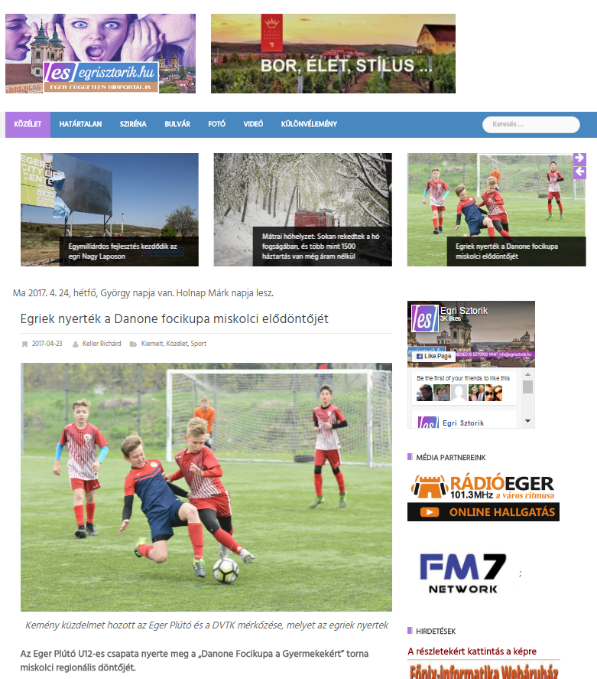

EGRIEK NYERTÉK A DANONE FOCIKUPA MISKOLCI ELŐDÖNTŐJÉT
Az Eger Plútó U12-es csapata nyerte meg a „Danone Focikupa a Gyermekekért” torna miskolci regionális döntőjét.
Az egri fiatalok a fináléban a Salgótarjáni BTC csapatát győzték le 5:0-ra, így ők vehetnek részt a kupa június 10-i, budapesti országos döntőjében.
A tornán most bevezetett „fair play” díjat a Sajóvölgye Focisuli csapata érdemelte ki. A Danone és az MLSZ Grassroots Program szervezésében megvalósuló „Danone Focikupa a Gyermekekért” tornán, áprilisban és májusban, összesen 96 csapat és több mint 1200 gyermek labdarúgó versenyez egymással azért, hogy Magyarországot képviselhesse a torna nemzetközi döntőjén, New Jersey-ben.
A miskolci elődöntő csapatai sportfelszerelés gyűjtéssel segítették a torna tavalyi résztvevőit, az állami gondoskodásban és nevelőszülőknél élő gyerek labdarúgókat.
Gyergyói-Szabó Anita, a Danone külső kommunikációs menedzsere átadja az összegyűjtött sportszereket Dr. Dobosné Vörös Eleonórának, a Fruska Gyermekotthon Vezetőjének
A kupát az Emberi Erőforrások Minisztériuma és Miskolc Megyei Jogú Város Önkormányzata is támogatja, fővédnöke pedig Nyilasi Tibor, 70-szeres labdarúgó válogatott, tiszteletbeli nagykövete pedig Hevesi Tamás énekes és futballedző.
„A Danone Focikupa a Gyermekekért célja, hogy népszerűsítse a sportolást és az egészséges táplálkozást a gyerekek körében” – mondta Gyergyói-Szabó Anita, a Danone külső kommunikációs menedzsere. – „Vállalatunk a 19 éve tartó Tegyünk Együtt a Gyermekekért társadalmi programjában idén is különös figyelmet fordít az egészségi állapotuk vagy szociális helyzetük miatt hátrányt szenvedő gyerekekre is. Az idei Danone Focikupában egy valós nemzetközi megmérettetés lehetőségét nyújtjuk a résztvevőknek, miközben a sportszergyűjtéssel az állami gondozásban élő gyermekek sportolási körülményeit igyekszünk javítani” – tette hozzá.
Hevesi Tamás, énekes, futballedző, Gyergyói-Szabó Anita, a Danone külső kommunikációs menedzsere és Rakaczki Zoltán, Miskolc Sportért Felelős Polgármesteri Biztosa a partvonalról figyelték az izgalmas mérkőzéseket
Gólöröm, egészséges életmód és kiegyensúlyozott táplálkozás
A Danone Focikupa a Gyermekekért (Danone Nations Cup) a világ legnagyobb, immár 15 éves múltra visszatekintő, professzionális gyermek labdarúgó kupája, amelyen eddig mintegy 2,5 millió gyerek vett részt világszerte.
A Danone és a Magyar Labdarúgó Szövetség Grassroots Programja által közösen megrendezett U12-es torna célja, hogy a sporton és a labdarúgáson keresztül egészséges életmódra, valamint kiegyensúlyozott táplálkozásra nevelje a gyermekeket, ebben a Magyar Dietetikusok Országos Szövetsége, a torna szakmai partnere segíti a kezdeményezést.
A Danone Magyarország Kft. a „Danone Focikupa a Gyermekekért” tornát az immáron 19 éve futó társadalmi célú támogató programja, a „Tegyünk Együtt a Gyermekekért” program részeként valósítja meg.
A TEGY program egy olyan keretprogram, amelynek égisze alatt szervezi meg a vállalat országos társadalmi célú támogató kezdeményezéseit. A TEGY program keretein belül a Danone 11 éven keresztül támogatta a daganatos beteg gyermekek rehabilitációját, 2013-2015 között pedig egy átfogó, az egészséges életmódra ösztönző programot hozott létre azzal a céllal, hogy a 11-12 éves gyermekek játékos módon sajátíthassák el az egészséges életmód alapelveit. A vállalat 2016 óta a szervezi meg a Danone Focikupa a Gyermekekért rendezvénysorozatot.
Ha a budapesti döntőt megnyerik az egriek, Magyarországot képviselhetik a torna nemzetközi döntőjén, New Jersey-ben
Minden eddiginél több résztvevő
A Danone Focikupa a Gyermekekért torna idén jelentős mértékben kibővült. Míg tavaly mindössze 240 gyermek vett részt a programban, addig az idén 12 régióban, régiónként 8, összesen tehát 96 csapat képviseletében 1.200 gyermek vesz részt a tornában. A miskolci regionális elődöntőn a Diósgyőr VTK, a Sajóvölgye Focisuli, a Mezőkövesd-Zsóry FC, az Eger SE, a Salgótarjáni BTC, a Sátoraljaújhelyi TE, az Eger Plútó és az Encs VSC csapatai versenyeztek egymással a regionális elsőségért.

MÉDIA: | eszak.hu | MEDIA SPECIFICS
DÁTE: | 24.04.2017. | TYPE: | Online
PAGE: | - | REACH: | 30 000
AD VALUE (HUF) | 25 000 | FREQUENCY: | -
HEADLINE: | This year the children’s football cup has started in Miskolc
SUMMARY: | The U12 football team of Eger Plútó has won the Miskolc Semi Final of the Danone Football Cup for Children, by defeating the BTC Team of Salgótarján. The tournament was organised by Danone and MLSZ Grassroots Program for youngsters. The objective of the cup is to raise awareness of the kids to sport and healthy nutrition. In April and May 2017, all together 96 football teams will compete in the "Danone Football Cup for Children” in order to enter to the Budapest final, the winner of which will represent Hungary at the International Finals, in New Jersey. Special element of the program was that participating children collected sport equipment for children living in state care and foster parents, who played in the cup the year before.

http://www.eszak.hu/fiataloknak/2017/04/23/miskolcon-indult-az-idei-gyermekfocikupa.eszak
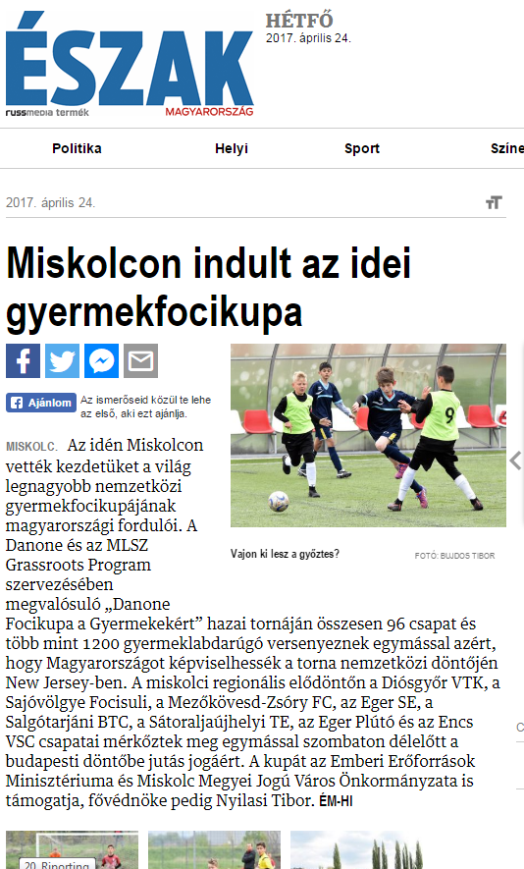

MISKOLCON INDULT AZ IDEI GYERMEKFOCIKUPA
Az idén Miskolcon vették kezdetüket a világ legnagyobb nemzetközi gyermek focikupájának magyarországi fordulói. A Danone és az MLSZ Grassroots Program szervezésében megvalósuló „Danone Focikupa a Gyermekekért” hazai tornáján összesen 96 csapat és több mint 1200 gyermeklabdarúgó versenyeznek egymással azért, hogy Magyarországot képviselhessék a torna nemzetközi döntőjén New Jersey-ben. A miskolci regionális elődöntőn a Diósgyőr VTK, a Sajóvölgye Focisuli, a Mezőkövesd-Zsóry FC, az Eger SE, a Salgótarjáni BTC, a Sátoraljaújhelyi TE, az Eger Plútó és az Encs VSC csapatai mérkőztek meg egymással szombaton délelőtt a budapesti döntőbe jutás jogáért. A kupát az Emberi Erőforrások Minisztériuma és Miskolc Megyei Jogú Város Önkormányzata is támogatja, fővédnöke pedig Nyilasi Tibor. ÉM-HI

MÉDIA: | Minap.hu | MEDIA SPECIFICS
DÁTE: | 22.04.2017. | TYPE: | Online
PAGE: | - | REACH: | 25.000
AD VALUE (HUF) | 100.000 | FREQUENCY: | -
HEADLINE: | Local semi-final in Miskolc was won by Eger football team
SUMMARY: | The U12 football team of Eger Plútó has won the Miskolc Semi Final of the Danone Football Cup for Children, by defeating the BTC Team of Salgótarján. The tournament was organised by Danone and MLSZ Grassroots Program for youngsters. The objective of the cup is to raise awareness of the kids to sport and healthy nutrition. In April and May 2017, all together 96 football teams will compete in the "Danone Football Cup for Children” in order to enter to the Budapest final, the winner of which will represent Hungary at the International Finals, in New Jersey. Special element of the program was that participating children collected sport equipment for children living in state care and foster parents, who played in the cup the year before.

http://minap.hu/cikkek/egri-focicsapat-nyerte-miskolci-elodontot
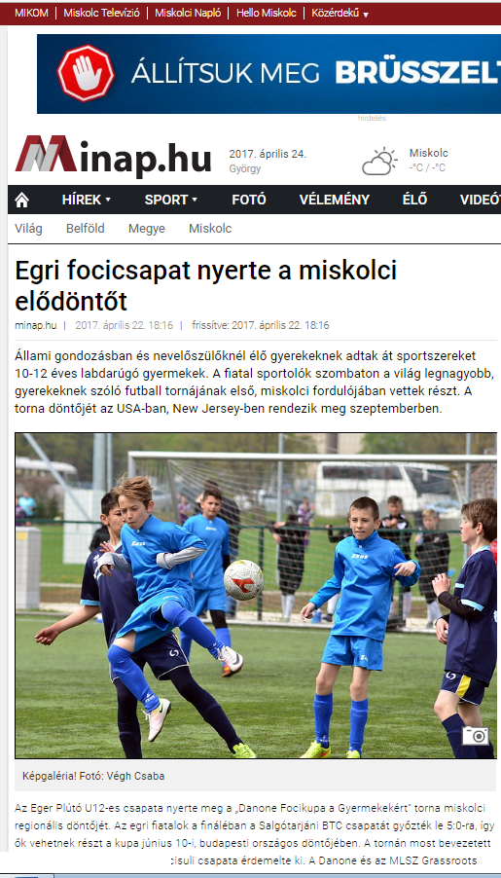
EGRI FOCICSAPAT NYERTE A MISKOLCI ELŐDÖNTŐT
Állami gondozásban és nevelőszülőknél élő gyerekeknek adtak át sportszereket 10-12 éves labdarúgó gyermekek. A fiatal sportolók szombaton a világ legnagyobb, gyerekeknek szóló futball tornájának első, miskolci fordulójában vettek részt. A torna döntőjét az USA-ban, New Jersey-ben rendezik meg szeptemberben.
Az Eger Plútó U12-es csapata nyerte meg a „Danone Focikupa a Gyermekekért” torna miskolci regionális döntőjét. Az egri fiatalok a fináléban a Salgótarjáni BTC csapatát győzték le 5:0-ra, így ők vehetnek részt a kupa június 10-i, budapesti országos döntőjében. A tornán most bevezetett „fair play” díjat a Sajóvölgye Focisuli csapata érdemelte ki. A Danone és az MLSZ Grassroots Program szervezésében megvalósuló tornán áprilisban és májusban összesen kilencvenhat csapat és így több mint ezerkétszáz gyermek versenyzett egymással azért, hogy Magyarországot képviselhesse a torna nemzetközi döntőjén, New Jersey-ben.
A miskolci elődöntő csapatai sportfelszerelések gyűjtésével segítették a torna tavalyi résztvevőit, az állami gondoskodásban és nevelőszülőknél élő gyerek labdarúgókat. A csapatok által összegyűlt mezeket, futball cipőket, labdákat Földessy Judit, a Borsod-Abaúj-Zemplén Megyei Gyermekvédelmi Központ és Területi Gyermekvédelmi Szakszolgálat intézményvezetője és Dobosné Vörös Eleonóra, a Fruska Gyermekotthon vezetője vették át.
A Danone Focikupa a Gyermekekért (Danone Nations Cup) a világ legnagyobb, immár 15 éves múltra visszatekintő, professzionális gyermek labdarúgó kupája, amelyen eddig mintegy 2,5 millió gyerek vett részt világszerte. A rendezvény célja, hogy a sporton és a labdarúgáson keresztül egészséges életmódra, valamint kiegyensúlyozott táplálkozásra nevelje a gyermekeket, ebben a Magyar Dietetikusok Országos Szövetsége, a torna szakmai partnere segíti a kezdeményezést. A kupát az Emberi Erőforrások Minisztériuma és Miskolc Megyei Jogú Város Önkormányzata is támogatta.
A torna idén jelentős mértékben kibővült. Míg tavaly mindössze kétszáznegyven gyermek vett részt a programban, addig az idén ezerkétszáz gyermek vett részt a tornában. A miskolci regionális elődöntőn a Diósgyőr VTK, a Sajóvölgye Focisuli, a Mezőkövesd-Zsóry FC, az Eger SE, a Salgótarjáni BTC, a Sátoraljaújhelyi TE, az Eger Plútó és az Encs VSC csapatai versenyeztek egymással a regionális elsőségért.

MÉDIA: | Minap.hu | MEDIA SPECIFICS
DÁTE: | 22.04.2017. | TYPE: | Online
PAGE: | - | REACH: | 25.000
AD VALUE (HUF) | 100.000 | FREQUENCY: | -
HEADLINE: | Local semi-final in Miskolc was won by Eger football team
SUMMARY: | The U12 football team of Eger Plútó has won the Miskolc Semi Final of the Danone Football Cup for Children, by defeating the BTC Team of Salgótarján. The tournament was organised by Danone and MLSZ Grassroots Program for youngsters. The objective of the cup is to raise awareness of the kids to sport and healthy nutrition. In April and May 2017, all together 96 football teams will compete in the "Danone Football Cup for Children” in order to enter to the Budapest final, the winner of which will represent Hungary at the International Finals, in New Jersey. Special element of the program was that participating children collected sport equipment for children living in state care and foster parents, who played in the cup the year before.

http://minap.hu/galeria/danone-focikupa-gyermekekert
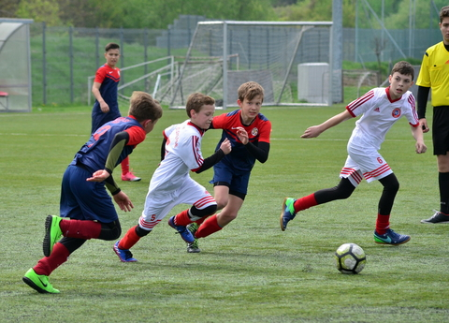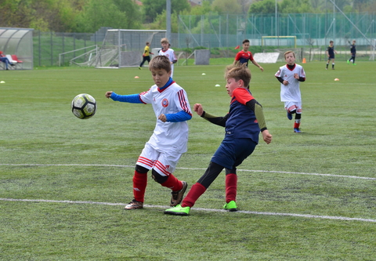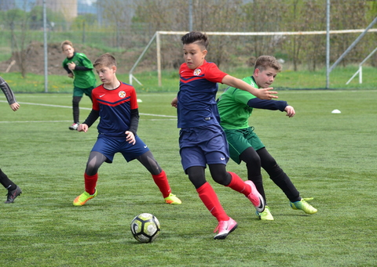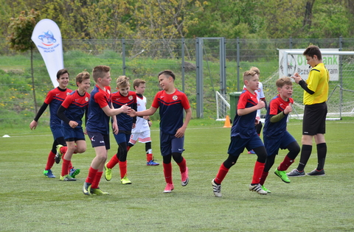

MÉDIA: | eszakhirnok.com | MEDIA SPECIFICS
DÁTE: | 19.04.2017. | TYPE: | Online
PAGE: | - | REACH: | 2 000
AD VALUE (HUF) | 17 143 | FREQUENCY: | -
HEADLINE: | More than 1000 children are playing football to represent Hungary int he USA
SUMMARY: | The U12 football team of Eger Plútó has won the Miskolc Semi Final of the Danone Football Cup for Children, by defeating the BTC Team of Salgótarján. The tournament was organised by Danone and MLSZ Grassroots Program for youngsters. The objective of the cup is to raise awareness of the kids to sport and healthy nutrition. In April and May 2017, all together 96 football teams will compete in the "Danone Football Cup for Children” in order to enter to the Budapest final, the winner of which will represent Hungary at the International Finals, in New Jersey. Special element of the program was that participating children collected sport equipment for children living in state care and foster parents, who played in the cup the year before.

https://www.eszakhirnok.com/miskolc/68062-miskolc-toebb-mint-1000-gyermek-focizik-azert-hogy-magyarorszagot-kepviselhesse-amerikaban.html#axzz4fA7Lo5ke
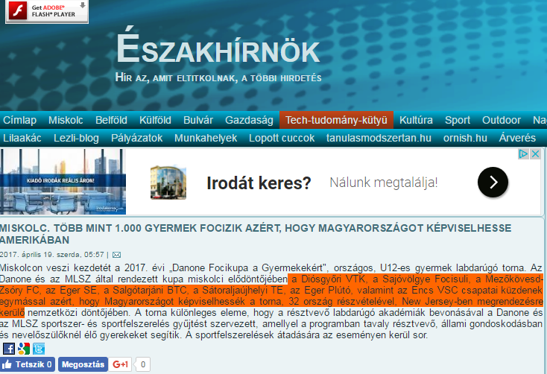

TÖBB MINT 1.000 GYERMEK FOCIZIK AZÉRT, HOGY MAGYARORSZÁGOT KÉPVISELHESSE AMERIKÁBAN
Miskolcon veszi kezdetét a 2017. évi „Danone Focikupa a Gyermekekért", országos, U12-es gyermek labdarúgó torna. Az Danone és az MLSZ által rendezett kupa miskolci elődöntőjében a Diósgyőri VTK, a Sajóvölgye Focisuli, a Mezőkövesd-Zsóry FC, az Eger SE, a Salgótarjáni BTC, a Sátoraljaújhelyi TE, az Eger Plútó, valamint az Encs VSC csapatai küzdenek egymással azért, hogy Magyarországot képviselhessék a torna, 32 ország részvételével, New Jersey-ben megrendezésre kerülő nemzetközi döntőjében. A torna különleges eleme, hogy a résztvevő labdarúgó akadémiák bevonásával a Danone és az MLSZ sportszer- és sportfelszerelés gyűjtést szervezett, amellyel a programban tavaly résztvevő, állami gondoskodásban és nevelőszülőknél élő gyerekeket segítik. A sportfelszerelések átadására az eseményen kerül sor.

MÉDIA: | miskolchirado.hu | MEDIA SPECIFICS
DÁTE: | 19.04.2017. | TYPE: | Online
PAGE: | - | REACH:
AD VALUE (HUF) | 75 000 | FREQUENCY: | 15 000
HEADLINE: | More than 1000 children are playing football to represent Hungary int he USA
SUMMARY: | The U12 football team of Eger Plútó has won the Miskolc Semi Final of the Danone Football Cup for Children, by defeating the BTC Team of Salgótarján. The tournament was organised by Danone and MLSZ Grassroots Program for youngsters. The objective of the cup is to raise awareness of the kids to sport and healthy nutrition. In April and May 2017, all together 96 football teams will compete in the "Danone Football Cup for Children” in order to enter to the Budapest final, the winner of which will represent Hungary at the International Finals, in New Jersey. Special element of the program was that participating children collected sport equipment for children living in state care and foster parents, who played in the cup the year before.

http://miskolchirado.hu/tobb-mint-ezer-gyermek-focizik-azert-hogy-magyarorszagot-kepviselhesse-amerikaban
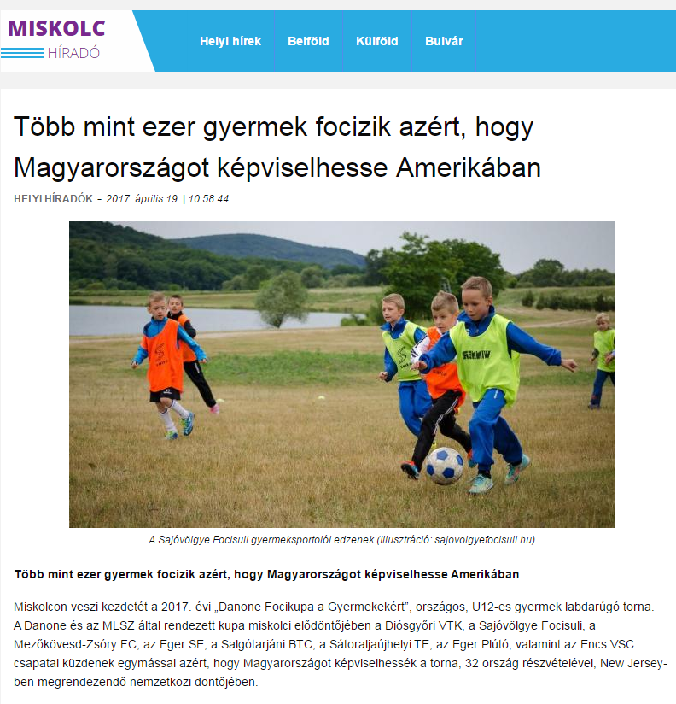

TÖBB MINT 1.000 GYERMEK FOCIZIK AZÉRT, HOGY MAGYARORSZÁGOT KÉPVISELHESSE AMERIKÁBAN
Miskolcon veszi kezdetét a 2017. évi „Danone Focikupa a Gyermekekért”, országos, U12-es gyermek labdarúgó torna. A Danone és az MLSZ által rendezett kupa miskolci elődöntőjében a Diósgyőri VTK, a Sajóvölgye Focisuli, a Mezőkövesd-Zsóry FC, az Eger SE, a Salgótarjáni BTC, a Sátoraljaújhelyi TE, az Eger Plútó, valamint az Encs VSC csapatai küzdenek egymással azért, hogy Magyarországot képviselhessék a torna, 32 ország részvételével, New Jersey-ben megrendezendő nemzetközi döntőjében.
A torna különleges eleme, hogy a résztvevő labdarúgó akadémiák bevonásával a Danone és az MLSZ sportszer- és sportfelszerelés gyűjtést szervezett, amellyel a programban tavaly résztvevő, állami gondoskodásban és nevelőszülőknél élő gyerekeket segítik. A sportfelszerelések átadására az eseményen kerül sor.

MÉDIA: | Facebook/Magyar Futball Akadémia | MEDIA SPECIFICS
DÁTE: | 20.04.2017. | TYPE: | Online
PAGE: | - | REACH:
AD VALUE (HUF) |  | FREQUENCY: | -
HEADLINE: | Together for the children
SUMMARY: | The U12 football team of Eger Plútó has won the Miskolc Semi Final of the Danone Football Cup for Children, by defeating the BTC Team of Salgótarján. The tournament was organised by Danone and MLSZ Grassroots Program for youngsters. The objective of the cup is to raise awareness of the kids to sport and healthy nutrition. In April and May 2017, all together 96 football teams will compete in the "Danone Football Cup for Children” in order to enter to the Budapest final, the winner of which will represent Hungary at the International Finals, in New Jersey. Special element of the program was that participating children collected sport equipment for children living in state care and foster parents, who played in the cup the year before.

https://www.facebook.com/honvedmfa/photos/a.207076962655691.59755.202005799829474/1630586400304733/?type=3&theater
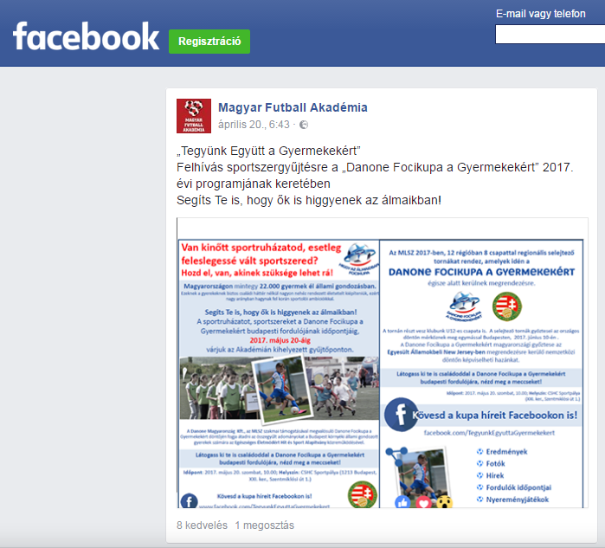

MÉDIA: | eto.hu | MEDIA SPECIFICS
DÁTE: | 18.04.2017. | TYPE: | Online
PAGE: | - | REACH: | N/A
AD VALUE (HUF) | N/A | FREQUENCY: | -
HEADLINE: | Danone Football Cup
SUMMARY: | The U12 football team of Eger Plútó has won the Miskolc Semi Final of the Danone Football Cup for Children, by defeating the BTC Team of Salgótarján. The tournament was organised by Danone and MLSZ Grassroots Program for youngsters. The objective of the cup is to raise awareness of the kids to sport and healthy nutrition. In April and May 2017, all together 96 football teams will compete in the "Danone Football Cup for Children” in order to enter to the Budapest final, the winner of which will represent Hungary at the International Finals, in New Jersey. Special element of the program was that participating children collected sport equipment for children living in state care and foster parents, who played in the cup the year before.

http://www.eto.hu/mobil/news.php?id=10827
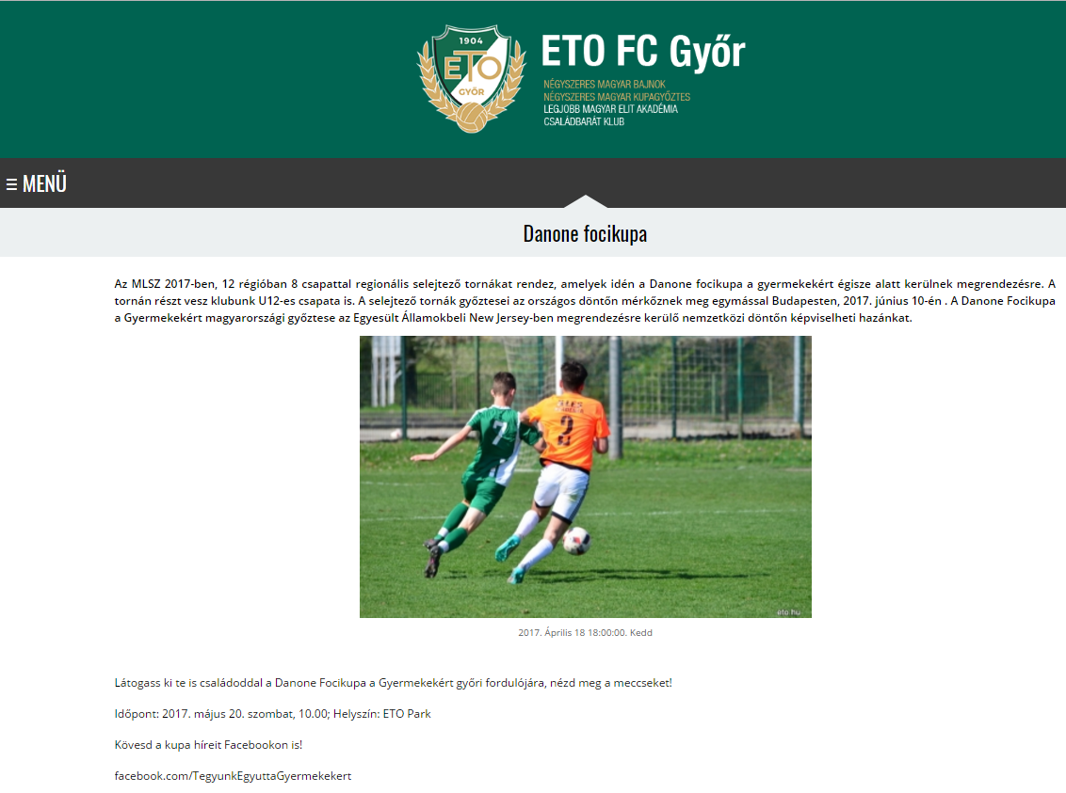

DANONE FOCIKUPA
Az MLSZ 2017-ben, 12 régióban 8 csapattal regionális selejtező tornákat rendez, amelyek idén a Danone focikupa a gyermekekért égisze alatt kerülnek megrendezésre. A tornán részt vesz klubunk U12-es csapata is. A selejtező tornák győztesei az országos döntőn mérkőznek meg egymással Budapesten, 2017. június 10-én . A Danone Focikupa a Gyermekekért magyarországi győztese az Egyesült Államokbeli New Jersey-ben megrendezésre kerülő nemzetközi döntőn képviselheti hazánkat.
Látogass ki te is családoddal a Danone Focikupa a Gyermekekért győri fordulójára, nézd meg a meccseket!
Időpont: 2017. május 20. szombat, 10.00; Helyszín: ETO Park
Kövesd a kupa híreit Facebookon is!
facebook.com/TegyunkEgyuttaGyermekekert

MÉDIA: | Facebook/Hevesi Tamás official site | MEDIA SPECIFICS
DÁTE: | 23.04.2017. | TYPE: | Online
PAGE: | - | REACH:
AD VALUE (HUF) |  | FREQUENCY: | -
HEADLINE: | Danone Football Cup
SUMMARY: | The U12 football team of Eger Plútó has won the Miskolc Semi Final of the Danone Football Cup for Children, by defeating the BTC Team of Salgótarján. The tournament was organised by Danone and MLSZ Grassroots Program for youngsters. The objective of the cup is to raise awareness of the kids to sport and healthy nutrition. In April and May 2017, all together 96 football teams will compete in the "Danone Football Cup for Children” in order to enter to the Budapest final, the winner of which will represent Hungary at the International Finals, in New Jersey. Special element of the program was that participating children collected sport equipment for children living in state care and foster parents, who played in the cup the year before.
https://www.facebook.com/hevesi.tamas.hivatalos.oldal/photos/a.402763779889156.1073741828.264703433695192/799203443578519/?type=3&theater
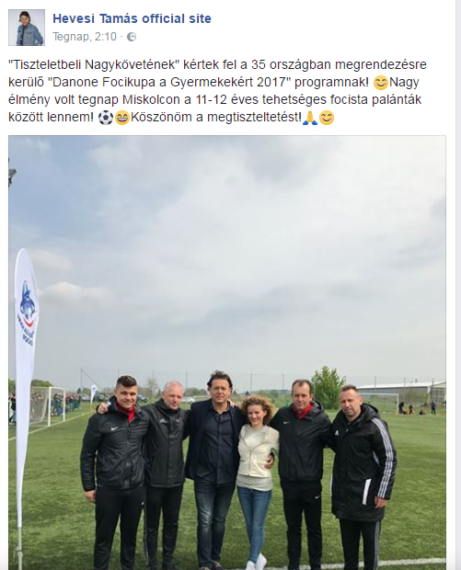

MÉDIA: | radiofocus.hu | MEDIA SPECIFICS
DÁTE: | 19.04.2017. | TYPE: | Online
PAGE: | - | REACH: | N/A
AD VALUE (HUF) | N/A | FREQUENCY: | -
HEADLINE: | The SBTC team is participating the children’s football cup
SUMMARY: | The U12 football team of Eger Plútó has won the Miskolc Semi Final of the Danone Football Cup for Children, by defeating the BTC Team of Salgótarján. The tournament was organised by Danone and MLSZ Grassroots Program for youngsters. The objective of the cup is to raise awareness of the kids to sport and healthy nutrition. In April and May 2017, all together 96 football teams will compete in the "Danone Football Cup for Children” in order to enter to the Budapest final, the winner of which will represent Hungary at the International Finals, in New Jersey. Special element of the program was that participating children collected sport equipment for children living in state care and foster parents, who played in the cup the year before.

http://radiofocus.hu/index.php?option=com_content&view=article&id=22983:gyermek-focitornan-szerepel-az-sbtc-u12-es-csapata&catid=13&Itemid=59
GYERMEK FOCITORNÁN SZEREPEL AZ SBTC U12-ES CSAPATA
Több mint ezer gyermek focizik azért, hogy Magyarországot képviselhesse az Amerikai Egyesült Államokban, köztük a Salgótarjáni BTC fiataljai is megméretik magukat. Miskolcon veszi kezdetét az idei "Danone Focikupa a Gyermekekért" országos, U12-es gyermek labdarúgótorna. A cég és a Magyar Labdarúgó Szövetség által életre hívott kupa hétvégi, miskolci elődöntőjében a Diósgyőri VTK, a Sajóvölgye Focisuli, a Mezőkövesd-Zsóry FC, az Eger SE, a Salgótarjáni BTC, a Sátoraljaújhelyi TE, az Eger Plútó, valamint az Encs VSC csapatai küzdenek egymással azért, hogy a későbbiekben Magyarországot képviselhessék a torna 32 ország részvételével, New Jersey-ben megrendezésre kerülő nemzetközi döntőjében. A mérkőzéseket a DVTK Akadémia sportpályáján rendezik majd.

MÉDIA: | Facebook/Ikarus BSE | MEDIA SPECIFICS
DÁTE: | 19.04.2017. | TYPE: | Online
PAGE: | - | REACH:
AD VALUE (HUF) |  | FREQUENCY: | -
HEADLINE: | Together for the children
SUMMARY: | The U12 football team of Eger Plútó has won the Miskolc Semi Final of the Danone Football Cup for Children, by defeating the BTC Team of Salgótarján. The tournament was organised by Danone and MLSZ Grassroots Program for youngsters. The objective of the cup is to raise awareness of the kids to sport and healthy nutrition. In April and May 2017, all together 96 football teams will compete in the "Danone Football Cup for Children” in order to enter to the Budapest final, the winner of which will represent Hungary at the International Finals, in New Jersey. Special element of the program was that participating children collected sport equipment for children living in state care and foster parents, who played in the cup the year before.

https://www.facebook.com/ikarusbse/posts/1370127543071530
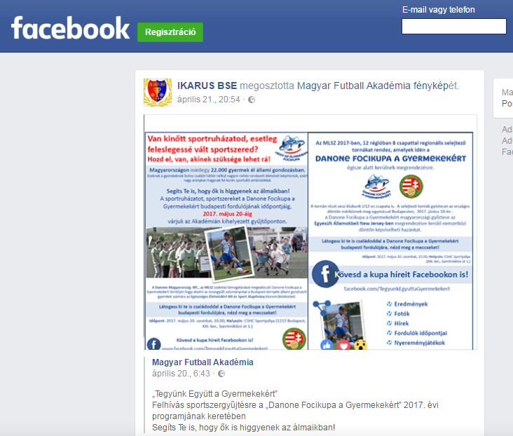

MÉDIA: | boon.hu | MEDIA SPECIFICS
DÁTE: | 24.04.2017. | TYPE: | Online
PAGE: | - | REACH: | 43 000
AD VALUE (HUF) | 215 000 | FREQUENCY: | -
HEADLINE: | This year the children’s football cup has started in Miskolc
SUMMARY: | The U12 football team of Eger Plútó has won the Miskolc Semi Final of the Danone Football Cup for Children, by defeating the BTC Team of Salgótarján. The tournament was organised by Danone and MLSZ Grassroots Program for youngsters. The objective of the cup is to raise awareness of the kids to sport and healthy nutrition. In April and May 2017, all together 96 football teams will compete in the "Danone Football Cup for Children” in order to enter to the Budapest final, the winner of which will represent Hungary at the International Finals, in New Jersey. Special element of the program was that participating children collected sport equipment for children living in state care and foster parents, who played in the cup the year before.

http://www.boon.hu/miskolcon-indult-az-idei-gyermekfocikupa/3456154
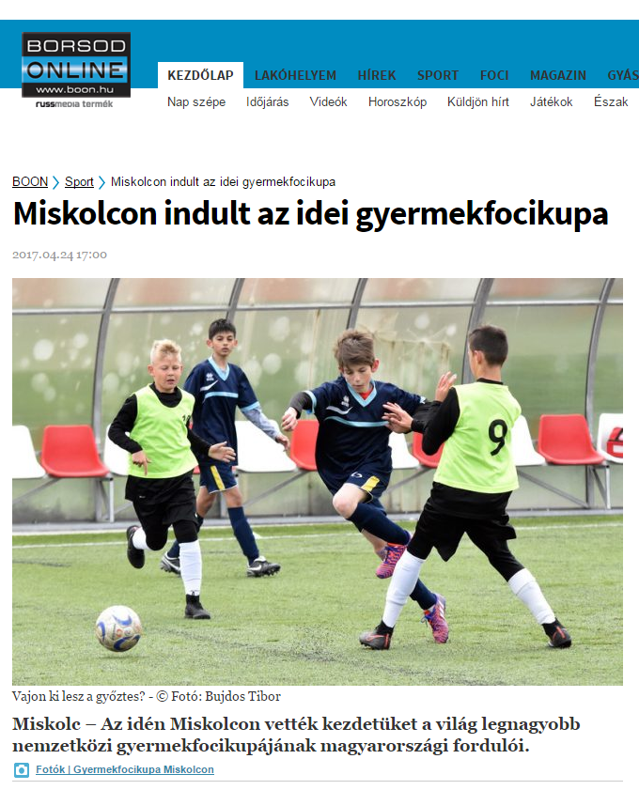

MISKOLCON INDULT AZ IDEI GYERMEKFOCIKUPA
Miskolc – Az idén Miskolcon vették kezdetüket a világ legnagyobb nemzetközi gyermekfocikupájának magyarországi fordulói.
A Danone és az MLSZ Grassroots Program szervezésében megvalósuló „Danone Focikupa a Gyermekekért” hazai tornáján összesen 96 csapat és több mint 1200 gyermeklabdarúgó versenyeznek egymással azért, hogy Magyarországot képviselhessék a torna nemzetközi döntőjén New Jersey-ben.
A miskolci regionális elődöntőn a Diósgyőr VTK, a Sajóvölgye Focisuli, a Mezőkövesd-Zsóry FC, az Eger SE, a Salgótarjáni BTC, a Sátoraljaújhelyi TE, az Eger Plútó és az Encs VSC csapatai mérkőztek meg egymással szombaton délelőtt a budapesti döntőbe jutás jogáért. A kupát az Emberi Erőforrások Minisztériuma és Miskolc Megyei Jogú Város Önkormányzata is támogatja, fővédnöke pedig Nyilasi Tibor.

MÉDIA: | jaszberenyifc.hu | MEDIA SPECIFICS
DÁTE: | 25.04.2017. | TYPE: | Online
PAGE: | - | REACH: | 6 000
AD VALUE (HUF) | 30 000 | FREQUENCY: | -
HEADLINE: | Little ones won, big ones lost
SUMMARY: | The U12 football team of Eger Plútó has won the Miskolc Semi Final of the Danone Football Cup for Children, by defeating the BTC Team of Salgótarján. The tournament was organised by Danone and MLSZ Grassroots Program for youngsters. The objective of the cup is to raise awareness of the kids to sport and healthy nutrition. In April and May 2017, all together 96 football teams will compete in the "Danone Football Cup for Children” in order to enter to the Budapest final, the winner of which will represent Hungary at the International Finals, in New Jersey. Special element of the program was that participating children collected sport equipment for children living in state care and foster parents, who played in the cup the year before.

http://jaszberenyifc.hu/a-kicsik-nyertek-a-nagyok-veszitettek/

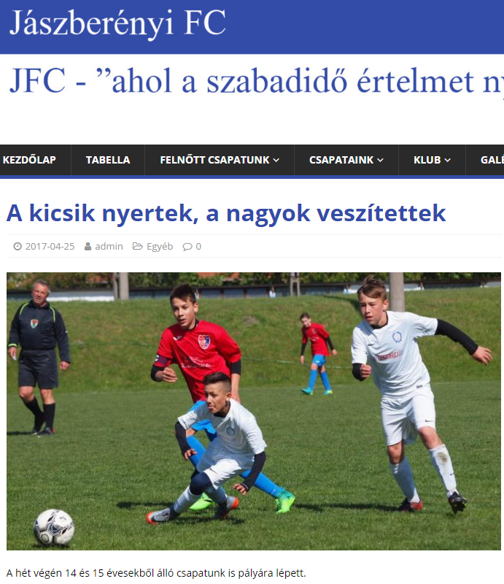

A KICSIK NYERTEK, A NAGYOK VESZÍTETTEK
A hét végén 14 és 15 évesekből álló csapatunk is pályára lépett.
U14
Jászberényi FC-Ikarus 4-1 (2-0)
Vezette: Markóth István
Jászberény: Jenei (Csáki) – Nagy-Varga, Gazsi, Szabó, Borbás – Kovács (Benedek), Palsó, Kurunczi, Muhari (Bagi) – Konkoly (Csizmadia) Varga (Tallósi). Edző: Arany László.
Gólszerzők: Muhari 3, Kurunczi 1, illetve Ódor
Arany László: – Csapatom nagyon lelkesen és jól játszott, így megérdemelten nyerte meg a mérkőzést. U15
U15
Jászberényi FC-Ikarus 3-5 (3-0)
Vezette: Gulácsi
Jászberény: Kövér (Csáki) – Petró, Kálmán, Szepes, Vas – Kökény, Forgács, Bedő, Rékasi – Molnár, Tamás. Edző: Arany László.
Gólszerzők: Molnár 2, Tamás 1, illetve Puskás 3, Szabó 2
Jók: Kálmán, Molnár, Tamás
Arany László: – Két ellentétes félidő jellemezte a mérkőzést, az elsőben mi, a másodikban ellenfelünk játszott fölényben. Tanulnunk kell a hibáinkból.

MÉDIA: | redioeger.hu | MEDIA SPECIFICS
DÁTE: | 23/04/2017 and 24/04/2017 | TYPE: | Online
PAGE: | - | REACH: | 1 800
AD VALUE (HUF) | 10 000 | FREQUENCY: | -
HEADLINE: | Plútó has won
SUMMARY: | The U12 football team of Eger Plútó has won the Miskolc Semi Final of the Danone Football Cup for Children, by defeating the BTC Team of Salgótarján. The tournament was organised by Danone and MLSZ Grassroots Program for youngsters. The objective of the cup is to raise awareness of the kids to sport and healthy nutrition. In April and May 2017, all together 96 football teams will compete in the "Danone Football Cup for Children” in order to enter to the Budapest final, the winner of which will represent Hungary at the International Finals, in New Jersey. Special element of the program was that participating children collected sport equipment for children living in state care and foster parents, who played in the cup the year before.

http://www.radioeger.hu/hir.php?htip=sport&hirid=9281

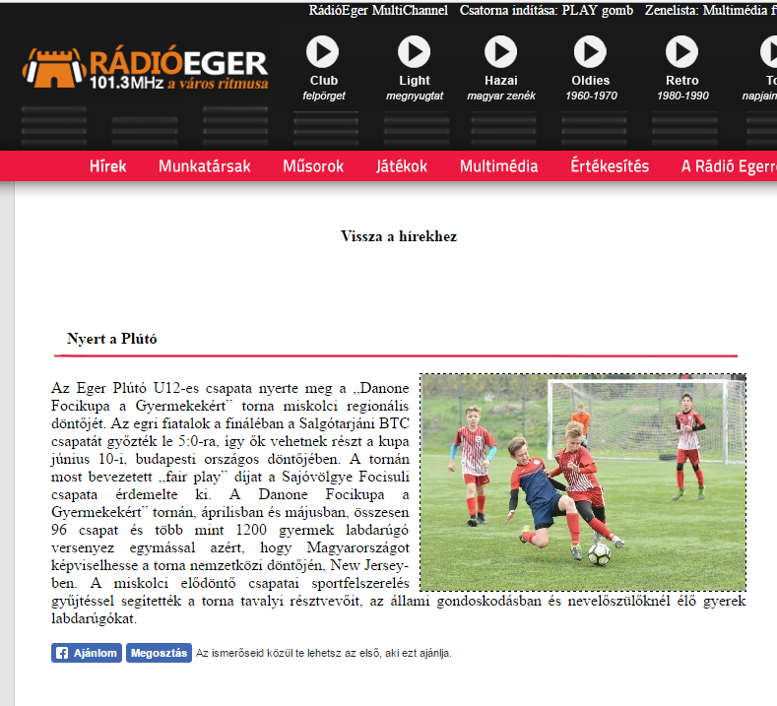
MÉDIA: | Rádió Eger | MEDIA SPECIFICS
DÁTE: | 23.04.2017. (broadcasted 3 times) and 24/04/2017 (broadcasted once) | TYPE: | Radio
PAGE: | - | REACH: | 819 422
AD VALUE (HUF) | 150 000 | FREQUENCY: | -
HEADLINE: | Plútó has won
SUMMARY: | The U12 football team of Eger Plútó has won the Miskolc Semi Final of the Danone Football Cup for Children, by defeating the BTC Team of Salgótarján. The tournament was organised by Danone and MLSZ Grassroots Program for youngsters. The objective of the cup is to raise awareness of the kids to sport and healthy nutrition. In April and May 2017, all together 96 football teams will compete in the "Danone Football Cup for Children” in order to enter to the Budapest final, the winner of which will represent Hungary at the International Finals, in New Jersey. Special element of the program was that participating children collected sport equipment for children living in state care and foster parents, who played in the cup the year before.

MÉDIA: | Észak-Magyarország | MEDIA SPECIFICS
DÁTE: | 24.04.2017. | TYPE: | Print
PAGE: | - | REACH: | 94.000
AD VALUE (HUF) | 162.000 | FREQUENCY: | -
HEADLINE: | This year the children’s football cup has started in Miskolc
SUMMARY: | The U12 football team of Eger Plútó has won the Miskolc Semi Final of the Danone Football Cup for Children, by defeating the BTC Team of Salgótarján. The tournament was organised by Danone and MLSZ Grassroots Program for youngsters. The objective of the cup is to raise awareness of the kids to sport and healthy nutrition. In April and May 2017, all together 96 football teams will compete in the "Danone Football Cup for Children” in order to enter to the Budapest final, the winner of which will represent Hungary at the International Finals, in New Jersey. Special element of the program was that participating children collected sport equipment for children living in state care and foster parents, who played in the cup the year before.

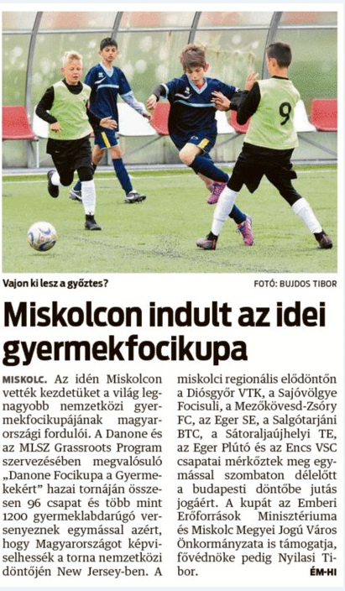

MISKOLCON INDULT AZ IDEI GYERMEKFOCIKUPA
Az idén Miskolcon vették kezdetüket a világ legnagyobb nemzetközi gyermekfocikupájának magyarországi fordulói. A Danone és az MLSZ Grassroots Program szervezésében megvalósuló "Danone Focikupa a Gyermekekért" hazai tornáján összesen 96 csapat és több mint 1200 gyermeklabdarúgó versenyeznek egymással azért, hogy Magyarországot képviselhessék a torna nemzetközi döntőjén New Jersey-ben. A miskolci regionális elődöntőn a Diósgyőr VTK, a Sajóvölgye Focisuli, a Mezőkövesd-Zsóry FC, az Eger SE, a Salgótarjáni BTC, a Sátoraljaújhelyi TE, az Eger Plútó és az Encs VSC csapatai mérkőztek meg egymással szombaton délelőtt a budapesti döntőbe jutás jogáért. A kupát az Emberi Erőforrások Minisztériuma és Miskolc Megyei Jogú Város Önkormányzata is támogatja, fővédnöke pedig Nyilasi Tibor.

MÉDIA: | royalmagazin.hu | MEDIA SPECIFICS
DÁTE: | 23.04.2017. | TYPE: | Online
PAGE: | - | REACH: | 25 000
AD VALUE (HUF) | 125 000 | FREQUENCY: | -
HEADLINE: | Eger Plútó football team won the local semi-final in Miskolc
SUMMARY: | The U12 football team of Eger Plútó has won the Miskolc Semi Final of the Danone Football Cup for Children, by defeating the BTC Team of Salgótarján. The tournament was organised by Danone and MLSZ Grassroots Program for youngsters. The objective of the cup is to raise awareness of the kids to sport and healthy nutrition. In April and May 2017, all together 96 football teams will compete in the "Danone Football Cup for Children” in order to enter to the Budapest final, the winner of which will represent Hungary at the International Finals, in New Jersey. Special element of the program was that participating children collected sport equipment for children living in state care and foster parents, who played in the cup the year before.

http://royalmagazin.hu/hirek-borsod-abauj-zemplen-megye-b-a-z/sport-hirek-sportolok-formula1-forma1-foci-eb-dvtk-noi-kezilabda-magyar-vizilabda-valogatott-kosarlabda/41747-az-eger-pluto-csapata-nyerte-a-danone-focikupa-miskolci-elodontojet
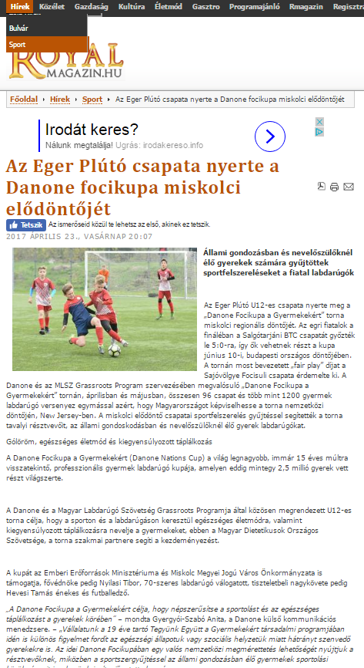

AZ EGER PLÚTÓ CSAPATA NYERTE A DANONE FOCIKUPA MISKOLCI ELŐDÖNTŐJÉT

Állami gondozásban és nevelőszülőknél élő gyerekek számára gyűjtöttek sportfelszereléseket a fiatal labdarúgók
Az Eger Plútó U12-es csapata nyerte meg a „Danone Focikupa a Gyermekekért” torna miskolci regionális döntőjét. Az egri fiatalok a fináléban a Salgótarjáni BTC csapatát győzték le 5:0-ra, így ők vehetnek részt a kupa június 10-i, budapesti országos döntőjében. A tornán most bevezetett „fair play” díjat a Sajóvölgye Focisuli csapata érdemelte ki. A Danone és az MLSZ Grassroots Program szervezésében megvalósuló „Danone Focikupa a Gyermekekért” tornán, áprilisban és májusban, összesen 96 csapat és több mint 1200 gyermek labdarúgó versenyez egymással azért, hogy Magyarországot képviselhesse a torna nemzetközi döntőjén, New Jersey-ben. A miskolci elődöntő csapatai sportfelszerelés gyűjtéssel segítették a torna tavalyi résztvevőit, az állami gondoskodásban és nevelőszülőknél élő gyerek labdarúgókat.
Gólöröm, egészséges életmód és kiegyensúlyozott táplálkozás
A Danone Focikupa a Gyermekekért (Danone Nations Cup) a világ legnagyobb, immár 15 éves múltra visszatekintő, professzionális gyermek labdarúgó kupája, amelyen eddig mintegy 2,5 millió gyerek vett részt világszerte.
A Danone és a Magyar Labdarúgó Szövetség Grassroots Programja által közösen megrendezett U12-es torna célja, hogy a sporton és a labdarúgáson keresztül egészséges életmódra, valamint kiegyensúlyozott táplálkozásra nevelje a gyermekeket, ebben a Magyar Dietetikusok Országos Szövetsége, a torna szakmai partnere segíti a kezdeményezést.
A kupát az Emberi Erőforrások Minisztériuma és Miskolc Megyei Jogú Város Önkormányzata is támogatja, fővédnöke pedig Nyilasi Tibor, 70-szeres labdarúgó válogatott, tiszteletbeli nagykövete pedig Hevesi Tamás énekes és futballedző.
„A Danone Focikupa a Gyermekekért célja, hogy népszerűsítse a sportolást és az egészséges táplálkozást a gyerekek körében” – mondta Gyergyói-Szabó Anita, a Danone külső kommunikációs menedzsere. – „Vállalatunk a 19 éve tartó Tegyünk Együtt a Gyermekekért társadalmi programjában idén is különös figyelmet fordít az egészségi állapotuk vagy szociális helyzetük miatt hátrányt szenvedő gyerekekre is. Az idei Danone Focikupában egy valós nemzetközi megmérettetés lehetőségét nyújtjuk a résztvevőknek, miközben a sportszergyűjtéssel az állami gondozásban élő gyermekek sportolási körülményeit igyekszünk javítani” – tette hozzá.
Minden eddiginél több résztvevő
A Danone Focikupa a Gyermekekért torna idén jelentős mértékben kibővült. Míg tavaly mindössze 240 gyermek vett részt a programban, addig az idén 12 régióban, régiónként 8, összesen tehát 96 csapat képviseletében 1.200 gyermek vesz részt a tornában. A miskolci regionális elődöntőn a Diósgyőr VTK, a Sajóvölgye Focisuli, a Mezőkövesd-Zsóry FC, az Eger SE, a Salgótarjáni BTC, a Sátoraljaújhelyi TE, az Eger Plútó és az Encs VSC csapatai versenyeztek egymással a regionális elsőségért.
Sportszergyűjtéssel segítik a hátrányos helyzetű gyerek focistákat
Az idei torna különleges eleme azt volt, hogy az abban résztvevő csapatok sportszer- és sportfelszerelés gyűjtéssel segítették a torna tavalyi résztvevőit, az állami gondoskodásban és nevelőszülőknél élő gyerek labdarúgókat.
A miskolci regionális döntőn résztvevő csapatok által összegyűlt mezeket, futball cipőket, labdákat Földessy Judit a Borsod-Abaúj-Zemplén Megyei Gyermekvédelmi Központ és Területi Gyermekvédelmi Szakszolgálat Intézményvezetője és Dr. Dobosné Vörös Eleonóra a Fruska Gyermekotthon Vezetője vették át a Danone Magyarország Kft. képviselőjétől, Gyergyói-Szabó Anitától valamint a csapatoktól
Irány Amerika
A Danone Focikupa a Gyermekekért torna további regionális elődöntőit április és május folyamán, Debrecenben, Szegeden, Budapesten, Dunakeszin, Dabason, Felcsúton, Győrött, Békéscsabán, Pécsett és Szombathelyen tartják. Az országos döntő június 10-én, Budapesten kerül megrendezésre.
A döntő tétje nem más, mint az, hogy melyik csapat képviselheti Magyarországot Amerikában, New Jersey-ben, a 32 ország U12-es csapatának részvételével megtartott nemzetközi döntőben.

MÉDIA: | szon.hu | MEDIA SPECIFICS
DÁTE: | 24.04.2017. | TYPE: | Online
PAGE: | - | REACH: | 44 000
AD VALUE (HUF) | 220 000 | FREQUENCY: | -
HEADLINE: | This year the children’s football cup has started in Miskolc
SUMMARY: | The U12 football team of Eger Plútó has won the Miskolc Semi Final of the Danone Football Cup for Children, by defeating the BTC Team of Salgótarján. The tournament was organised by Danone and MLSZ Grassroots Program for youngsters. The objective of the cup is to raise awareness of the kids to sport and healthy nutrition. In April and May 2017, all together 96 football teams will compete in the "Danone Football Cup for Children” in order to enter to the Budapest final, the winner of which will represent Hungary at the International Finals, in New Jersey. Special element of the program was that participating children collected sport equipment for children living in state care and foster parents, who played in the cup the year before.

http://www.szon.hu/miskolcon-indult-az-idei-gyermekfocikupa/3456154

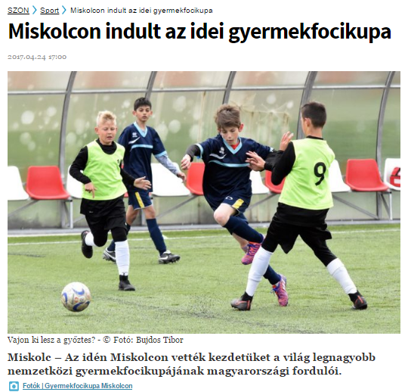

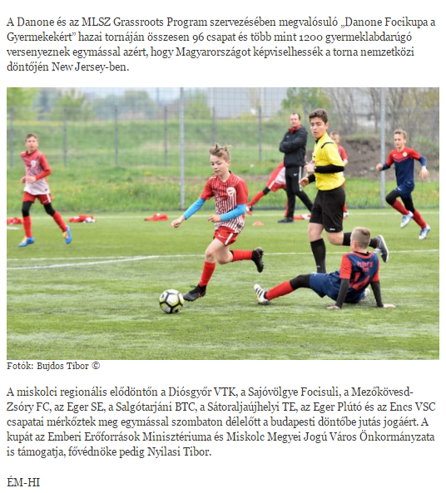

MÉDIA: | mon.hu | MEDIA SPECIFICS
DÁTE: | 24.04.2017. | TYPE: | Online
PAGE: | - | REACH: | 35 000
AD VALUE (HUF) | 175 000 | FREQUENCY: | -
HEADLINE: | This year the children’s football cup has started in Miskolc
SUMMARY: | The U12 football team of Eger Plútó has won the Miskolc Semi Final of the Danone Football Cup for Children, by defeating the BTC Team of Salgótarján. The tournament was organised by Danone and MLSZ Grassroots Program for youngsters. The objective of the cup is to raise awareness of the kids to sport and healthy nutrition. In April and May 2017, all together 96 football teams will compete in the "Danone Football Cup for Children” in order to enter to the Budapest final, the winner of which will represent Hungary at the International Finals, in New Jersey. Special element of the program was that participating children collected sport equipment for children living in state care and foster parents, who played in the cup the year before.

http://www.mon.hu/miskolcon-indult-az-idei-gyermekfocikupa/3456154

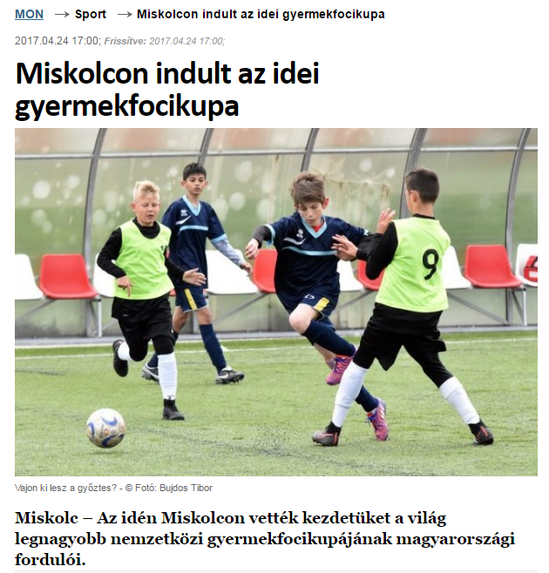

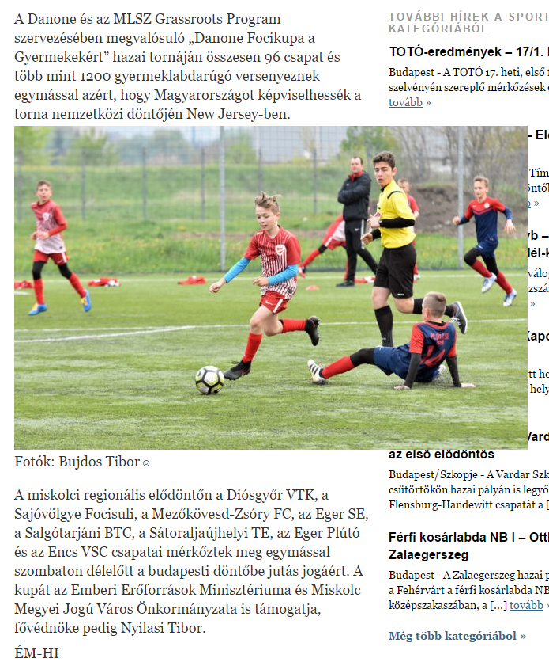

MÉDIA: | haon.hu | MEDIA SPECIFICS
DÁTE: | 24.04.2017. | TYPE: | Online
PAGE: | - | REACH: | 36 000
AD VALUE (HUF) | 180 000 | FREQUENCY: | -
HEADLINE: | This year the children’s football cup has started in Miskolc
SUMMARY: | The U12 football team of Eger Plútó has won the Miskolc Semi Final of the Danone Football Cup for Children, by defeating the BTC Team of Salgótarján. The tournament was organised by Danone and MLSZ Grassroots Program for youngsters. The objective of the cup is to raise awareness of the kids to sport and healthy nutrition. In April and May 2017, all together 96 football teams will compete in the "Danone Football Cup for Children” in order to enter to the Budapest final, the winner of which will represent Hungary at the International Finals, in New Jersey. Special element of the program was that participating children collected sport equipment for children living in state care and foster parents, who played in the cup the year before.

http://www.haon.hu/miskolcon-indult-az-idei-gyermekfocikupa/3456154

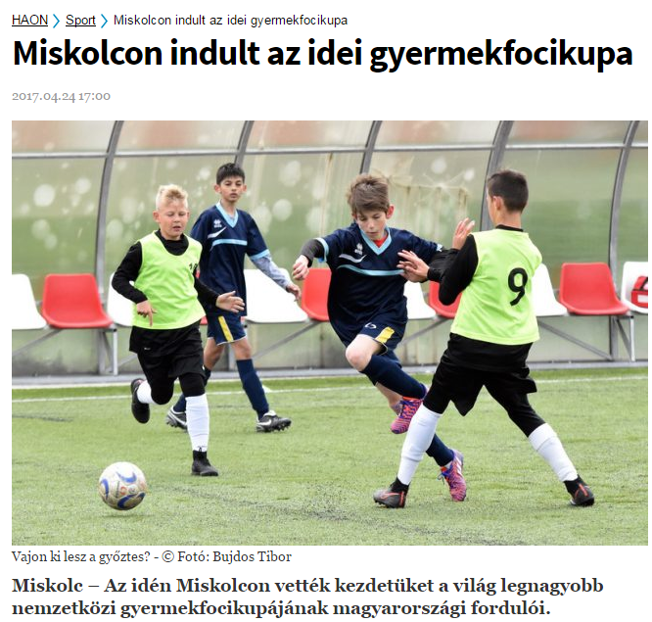

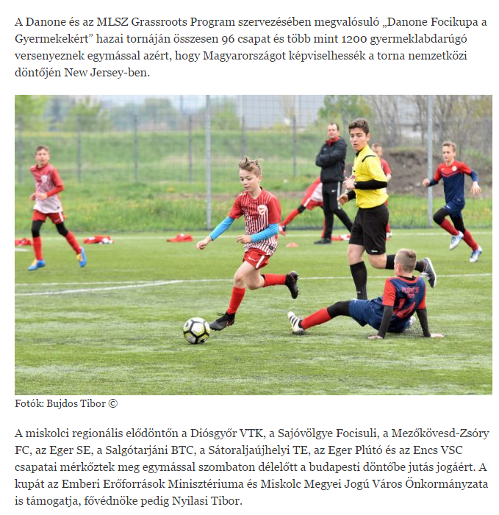

MÉDIA: | erdon.hu | MEDIA SPECIFICS
DÁTE: | 24.04.2017. | TYPE: | Online
PAGE: | - | REACH: | 30 000
AD VALUE (HUF) | 150 000 | FREQUENCY: | -
HEADLINE: | This year the children’s football cup has started in Miskolc
SUMMARY: | The U12 football team of Eger Plútó has won the Miskolc Semi Final of the Danone Football Cup for Children, by defeating the BTC Team of Salgótarján. The tournament was organised by Danone and MLSZ Grassroots Program for youngsters. The objective of the cup is to raise awareness of the kids to sport and healthy nutrition. In April and May 2017, all together 96 football teams will compete in the "Danone Football Cup for Children” in order to enter to the Budapest final, the winner of which will represent Hungary at the International Finals, in New Jersey. Special element of the program was that participating children collected sport equipment for children living in state care and foster parents, who played in the cup the year before.

http://www.erdon.ro/miskolcon-indult-az-idei-gyermekfocikupa/3456154

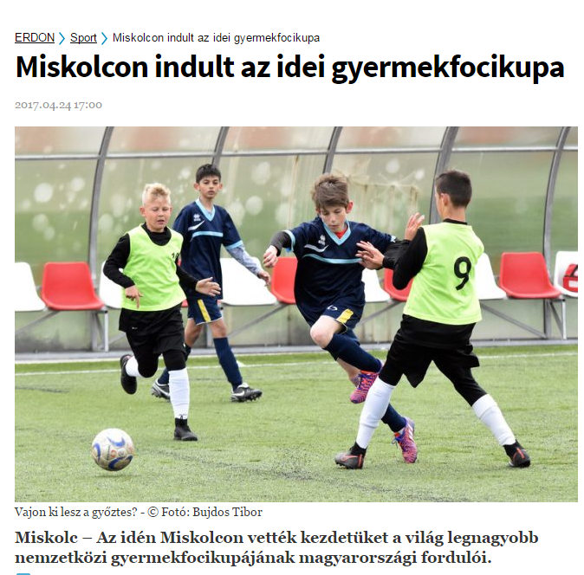

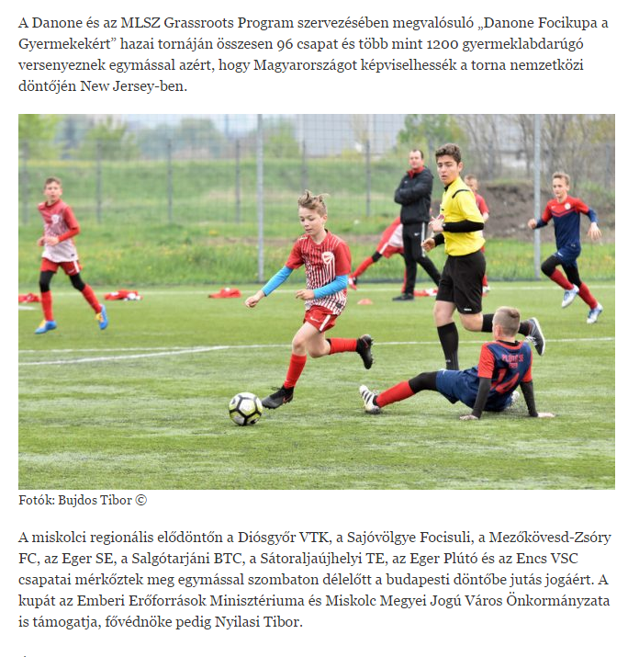

MÉDIA: | szuperinfo.hu | MEDIA SPECIFICS
DÁTE: | 24.04.2017. | TYPE: | Online
PAGE: | - | REACH: | 150 000
AD VALUE (HUF) | 450 000 | FREQUENCY: | -
HEADLINE: | This year the children’s football cup has started in Miskolc
SUMMARY: | The U12 football team of Eger Plútó has won the Miskolc Semi Final of the Danone Football Cup for Children, by defeating the BTC Team of Salgótarján. The tournament was organised by Danone and MLSZ Grassroots Program for youngsters. The objective of the cup is to raise awareness of the kids to sport and healthy nutrition. In April and May 2017, all together 96 football teams will compete in the "Danone Football Cup for Children” in order to enter to the Budapest final, the winner of which will represent Hungary at the International Finals, in New Jersey. Special element of the program was that participating children collected sport equipment for children living in state care and foster parents, who played in the cup the year before.

http://www.szuperinfo.hu/miskolcon-indult-az-idei-gyermekfocikupa/3456154

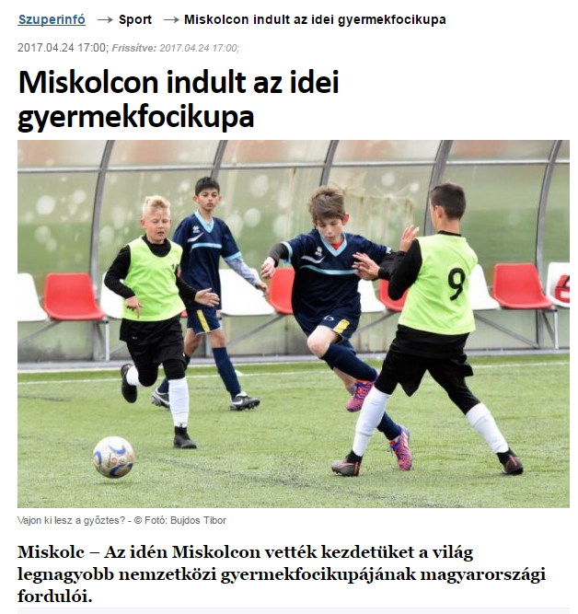

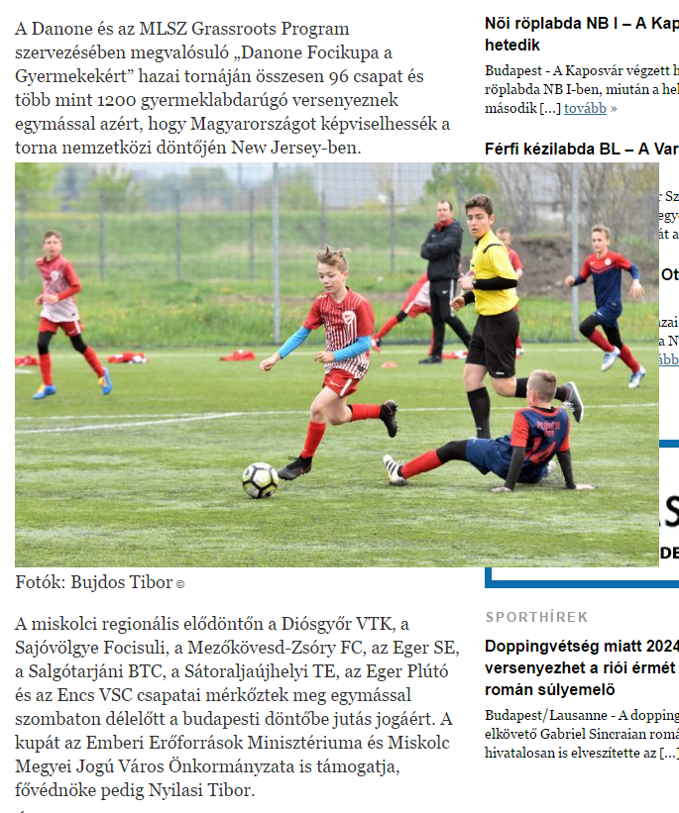

MÉDIA: | Rádió Focus (2x) | MEDIA SPECIFICS
DÁTE: | 21. and 22.04.2017. | TYPE: | Radio
PAGE: | - | REACH: | 130000
AD VALUE (HUF) | 120 000 | FREQUENCY: | -
HEADLINE: | The SBTC team is participating the children’s football cup
SUMMARY: | The U12 football team of Eger Plútó has won the Miskolc Semi Final of the Danone Football Cup for Children, by defeating the BTC Team of Salgótarján. The tournament was organised by Danone and MLSZ Grassroots Program for youngsters. The objective of the cup is to raise awareness of the kids to sport and healthy nutrition. In April and May 2017, all together 96 football teams will compete in the "Danone Football Cup for Children” in order to enter to the Budapest final, the winner of which will represent Hungary at the International Finals, in New Jersey. Special element of the program was that participating children collected sport equipment for children living in state care and foster parents, who played in the cup the year before.

Audio file is requested.

MÉDIA: | Szuperinfo Miskolc | MEDIA SPECIFICS
DÁTE: | 28. 04.2017. | TYPE: | Print
PAGE: | 11 | REACH: | 45.000
AD VALUE (HUF) | 378.000 | FREQUENCY: | weekly
HEADLINE: | Danone Football Cup for Children
SUMMARY: | The U12 football team of Eger Plútó has won the Miskolc Semi Final of the Danone Football Cup for Children, by defeating the BTC Team of Salgótarján. The tournament was organised by Danone and MLSZ Grassroots Program for youngsters. The objective of the cup is to raise awareness of the kids to sport and healthy nutrition. In April and May 2017, all together 96 football teams will compete in the "Danone Football Cup for Children” in order to enter to the Budapest final, the winner of which will represent Hungary at the International Finals, in New Jersey. Special element of the program was that participating children collected sport equipment for children living in state care and foster parents, who played in the cup the year before.

