MEDIA: | Hrglobe.hu | MEDIA SPECIFICS
DATE: | 2017.06.13. | TYPE: | Specialized online
PAGE: | - | Reach: | N/A
Ad value (EUR) | N/A | FREQUENCY: | -
HEADLINE: | Female hockey players are prepared for the world of job
SUMMARY: | For the first time in the history of Hungarian hockey, a career model is being introduced jointly by GE, the Hungarian Ice Hockey Federation, and the Canadian-Hungarian Hockey Club. The aim of the collaboration is to help the three-time national champion ladies on the national team who play in the Elite Women’s Hockey League (EWHL) to catch up with the European leading edge of the sport while beginning to build their subsequent career paths during their active athlete years. The program clearly also benefits GE since the values and skills the girls learn on the ice will be instrumental in further developing corporate culture and competitiveness. If it proves successful as devised in Hungary, this dual career model may become the example to follow for women’s hockey teams elsewhere in the world.

http://hrglobe.hu/munka/munka-vilagara-keszitik-fel-noi-hokisokat/

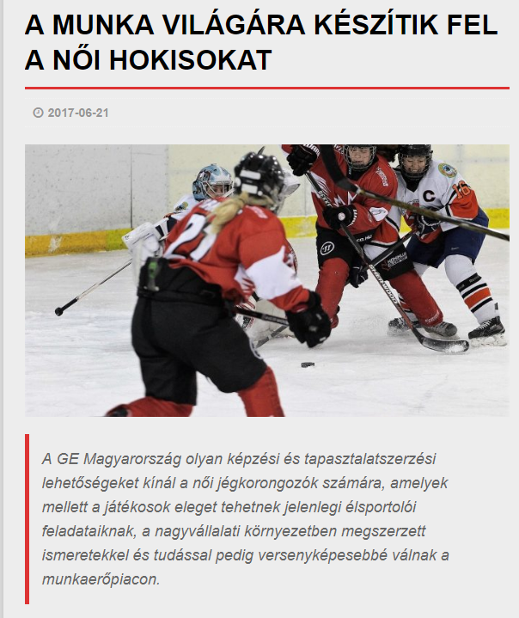

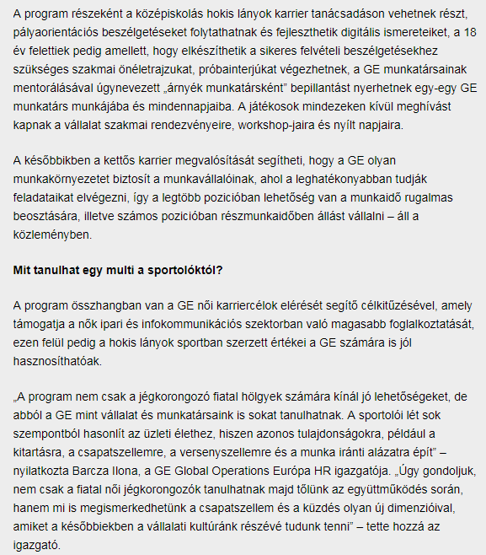
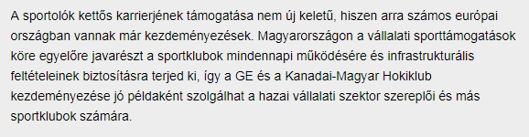

MEDIA: | Hrportal.hu | MEDIA SPECIFICS
DATE: | 2017.06.22. | TYPE: | Specialized online
PAGE: | - | Reach: | 25 000
Ad value (EUR) | 300 | FREQUENCY: | -
HEADLINE: | GE introduces a career model for female hockey players
SUMMARY: | For the first time in the history of Hungarian hockey, a career model is being introduced jointly by GE, the Hungarian Ice Hockey Federation, and the Canadian-Hungarian Hockey Club. The aim of the collaboration is to help the three-time national champion ladies on the national team who play in the Elite Women’s Hockey League (EWHL) to catch up with the European leading edge of the sport while beginning to build their subsequent career paths during their active athlete years. The program clearly also benefits GE since the values and skills the girls learn on the ice will be instrumental in further developing corporate culture and competitiveness. If it proves successful as devised in Hungary, this dual career model may become the example to follow for women’s hockey teams elsewhere in the world.

https://www.hrportal.hu/c/noi-hokisoknak-indit-karriermodellt-a-ge-20170622.html

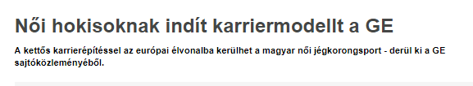
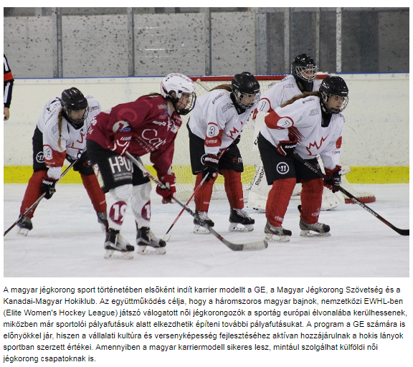

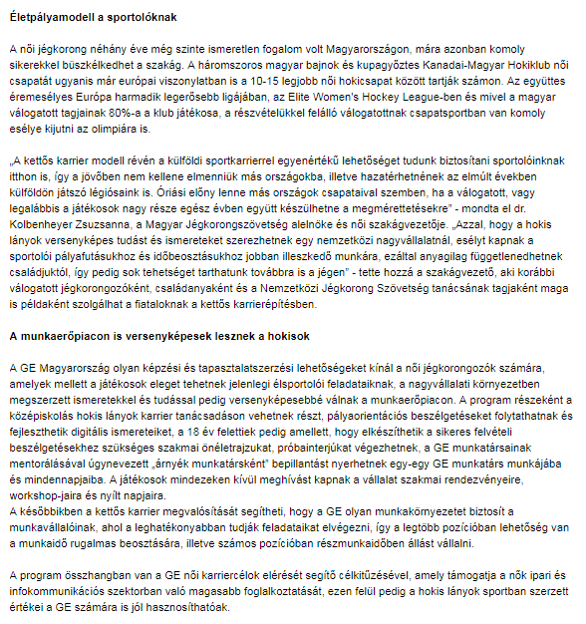
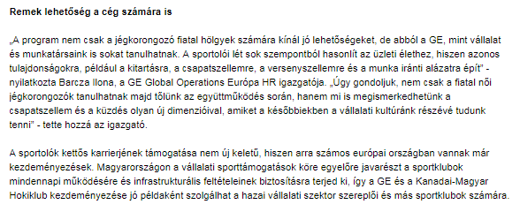

MEDIA: | Jegkorongblog.hu | MEDIA SPECIFICS
DATE: | 2017.06.21. | TYPE: | Specialized online
PAGE: | - | Reach: | N/A
Ad value (EUR) | N/A | FREQUENCY: | -
HEADLINE: | Career model for female ice hockey players
SUMMARY: | For the first time in the history of Hungarian hockey, a career model is being introduced jointly by GE, the Hungarian Ice Hockey Federation, and the Canadian-Hungarian Hockey Club. The aim of the collaboration is to help the three-time national champion ladies on the national team who play in the Elite Women’s Hockey League (EWHL) to catch up with the European leading edge of the sport while beginning to build their subsequent career paths during their active athlete years. The program clearly also benefits GE since the values and skills the girls learn on the ice will be instrumental in further developing corporate culture and competitiveness. If it proves successful as devised in Hungary, this dual career model may become the example to follow for women’s hockey teams elsewhere in the world.

http://www.jegkorongblog.hu/2017/06/21/eletpalyamodell-a-noi-jegkorongozoknak/

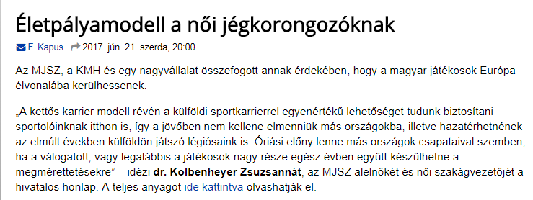

MEDIA: | Csalad.hu | MEDIA SPECIFICS
DATE: | 2017.06.22. | TYPE: | General online
PAGE: | - | Reach: | 13 000
Ad value (EUR) | 210 | FREQUENCY: | -
HEADLINE: | GE introduces a career model for female hockey players
SUMMARY: | For the first time in the history of Hungarian hockey, a career model is being introduced jointly by GE, the Hungarian Ice Hockey Federation, and the Canadian-Hungarian Hockey Club. The aim of the collaboration is to help the three-time national champion ladies on the national team who play in the Elite Women’s Hockey League (EWHL) to catch up with the European leading edge of the sport while beginning to build their subsequent career paths during their active athlete years. The program clearly also benefits GE since the values and skills the girls learn on the ice will be instrumental in further developing corporate culture and competitiveness. If it proves successful as devised in Hungary, this dual career model may become the example to follow for women’s hockey teams elsewhere in the world.

http://csalad.hu/2017/06/22/a-noi-hokisoknak-indit-karrier-modellt-a-ge-es-a-kanadai-magyar-hokiklub

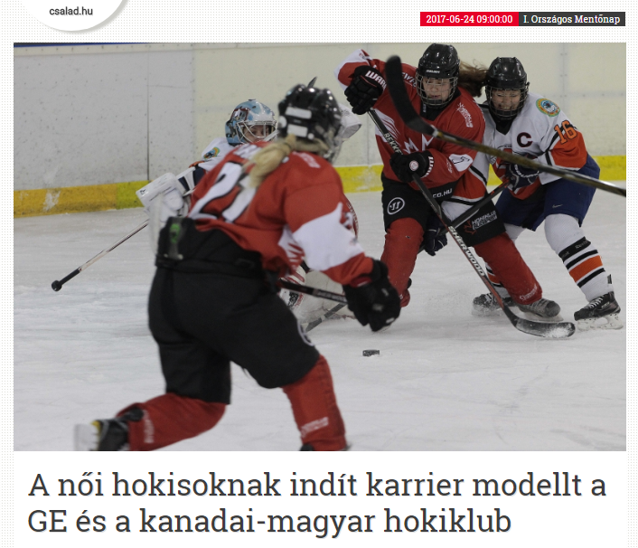

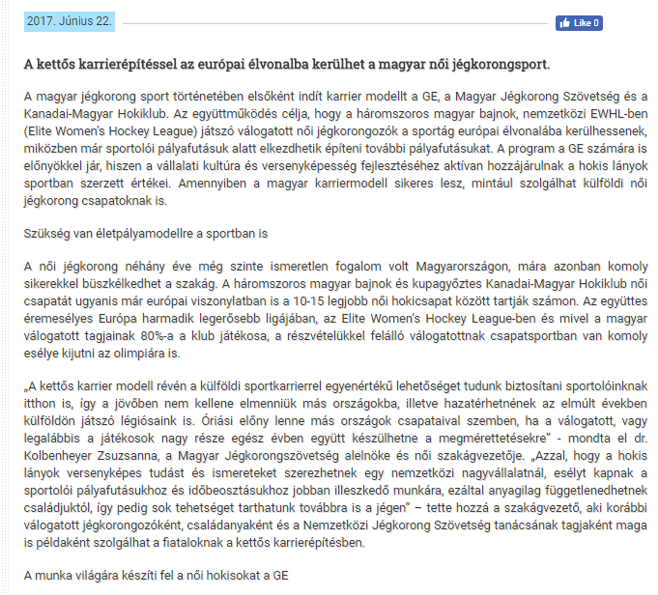

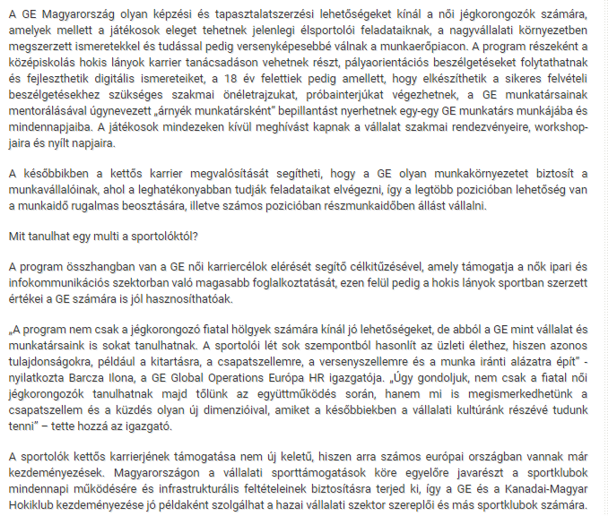

MEDIA: | Magnolia-magazin.hu | MEDIA SPECIFICS
DATE: | 2017.06.21. | TYPE: | General online
PAGE: | - | Reach: | N/A
Ad value (EUR) | N/A | FREQUENCY: | -
HEADLINE: | GE and Canadian-Hungarian Hockey Clubintroduces a career model for femalele hockey players
SUMMARY: | For the first time in the history of Hungarian hockey, a career model is being introduced jointly by GE, the Hungarian Ice Hockey Federation, and the Canadian-Hungarian Hockey Club. The aim of the collaboration is to help the three-time national champion ladies on the national team who play in the Elite Women’s Hockey League (EWHL) to catch up with the European leading edge of the sport while beginning to build their subsequent career paths during their active athlete years. The program clearly also benefits GE since the values and skills the girls learn on the ice will be instrumental in further developing corporate culture and competitiveness. If it proves successful as devised in Hungary, this dual career model may become the example to follow for women’s hockey teams elsewhere in the world.

http://www.magnolia-magazin.hu/erdekes/a-noi-hokisoknak-indit-karrier-modellt-a-ge-es-a-kanadai-magyar-hokiklub/

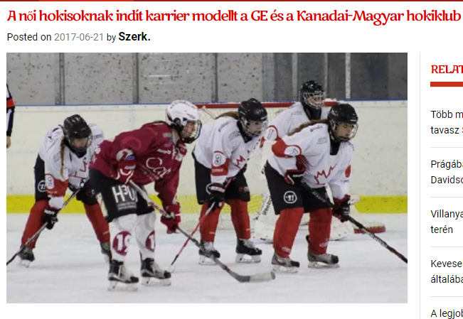

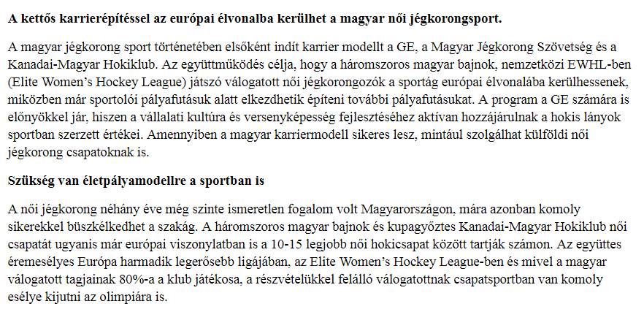

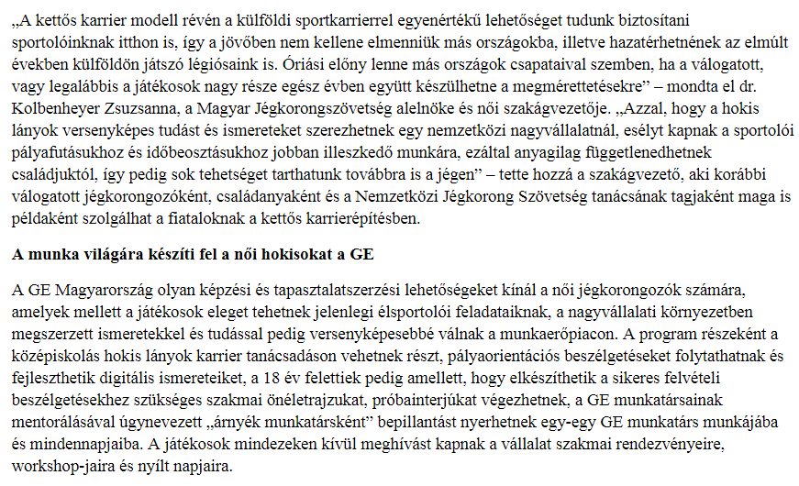
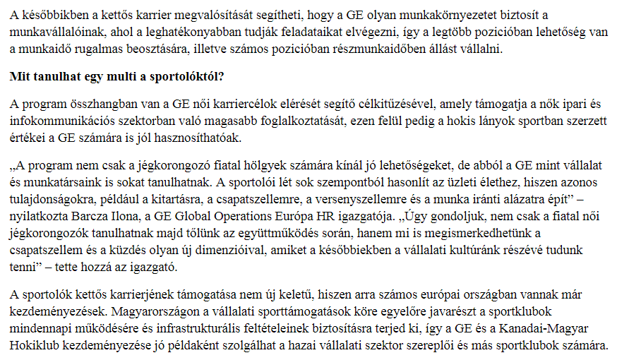

MEDIA: | Hir7.info | MEDIA SPECIFICS
DATE: | 2017.06.22. | TYPE: | General online
PAGE: | - | Reach: | 150 000
Ad value (EUR) | 700 | FREQUENCY: | -
HEADLINE: | Interview with Zsuzsanna Kolbenheyer
SUMMARY: | For the first time in the history of Hungarian hockey, a career model is being introduced jointly by GE, the Hungarian Ice Hockey Federation, and the Canadian-Hungarian Hockey Club. The aim of the collaboration is to help the three-time national champion ladies on the national team who play in the Elite Women’s Hockey League (EWHL) to catch up with the European leading edge of the sport while beginning to build their subsequent career paths during their active athlete years. The program clearly also benefits GE since the values and skills the girls learn on the ice will be instrumental in further developing corporate culture and competitiveness. If it proves successful as devised in Hungary, this dual career model may become the example to follow for women’s hockey teams elsewhere in the world.

http://hir7.info/2017/06/22/delelott-fiatal-noi-jegkorongozok-kolbenheyer-zsuzsanna/

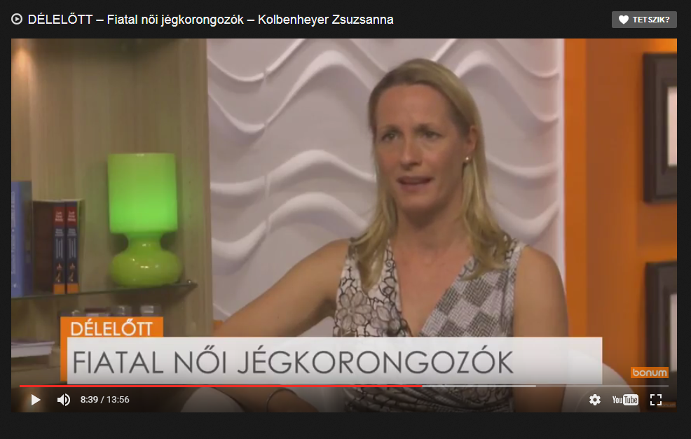

MEDIA: | Bonumtv.hu | MEDIA SPECIFICS
DATE: | 2017.06.22. | TYPE: | General online
PAGE: | - | Reach: | N/A
Ad value (EUR) | N/A | FREQUENCY: | -
HEADLINE: | Interview with Zsuzsanna Kolbenheyer
SUMMARY: | For the first time in the history of Hungarian hockey, a career model is being introduced jointly by GE, the Hungarian Ice Hockey Federation, and the Canadian-Hungarian Hockey Club. The aim of the collaboration is to help the three-time national champion ladies on the national team who play in the Elite Women’s Hockey League (EWHL) to catch up with the European leading edge of the sport while beginning to build their subsequent career paths during their active athlete years. The program clearly also benefits GE since the values and skills the girls learn on the ice will be instrumental in further developing corporate culture and competitiveness. If it proves successful as devised in Hungary, this dual career model may become the example to follow for women’s hockey teams elsewhere in the world.

http://bonumtv.hu/fiatal-noi-jegkorongozok-kolbenheyer-zsuzsanna/

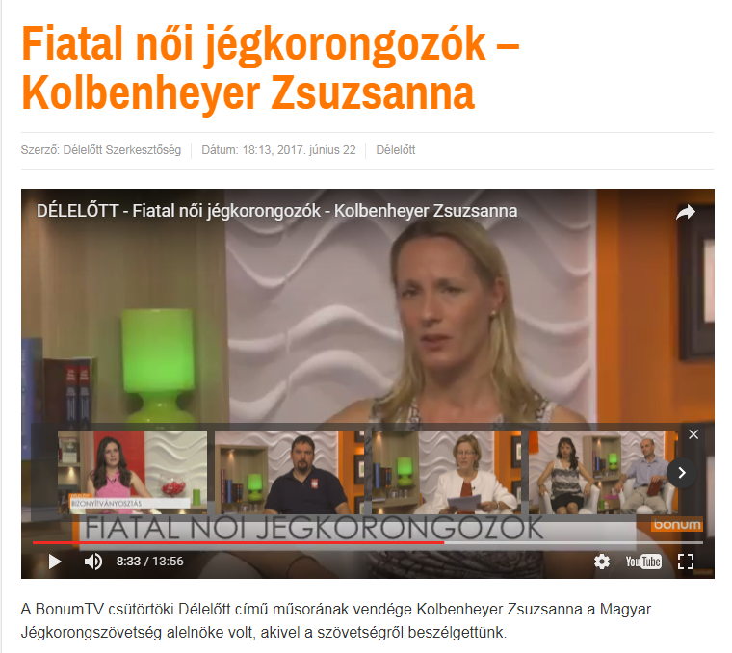

MEDIA: | Vkn.hu | MEDIA SPECIFICS
DATE: | 2017.06.21. | TYPE: | General online
PAGE: | - | Reach: | N/A
Ad value (EUR) | N/A | FREQUENCY: | -
HEADLINE: | Career model introdudec for female hockey players
SUMMARY: | For the first time in the history of Hungarian hockey, a career model is being introduced jointly by GE, the Hungarian Ice Hockey Federation, and the Canadian-Hungarian Hockey Club. The aim of the collaboration is to help the three-time national champion ladies on the national team who play in the Elite Women’s Hockey League (EWHL) to catch up with the European leading edge of the sport while beginning to build their subsequent career paths during their active athlete years. The program clearly also benefits GE since the values and skills the girls learn on the ice will be instrumental in further developing corporate culture and competitiveness. If it proves successful as devised in Hungary, this dual career model may become the example to follow for women’s hockey teams elsewhere in the world.

http://vkn.hu/gazdasag-politika-nok-fizetes-munka/noi-hokisoknak-inditanak-karrier-modellt/

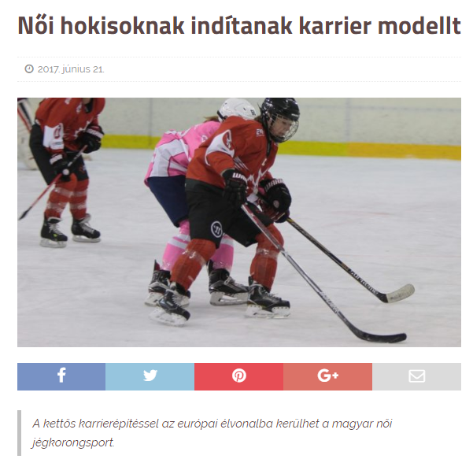

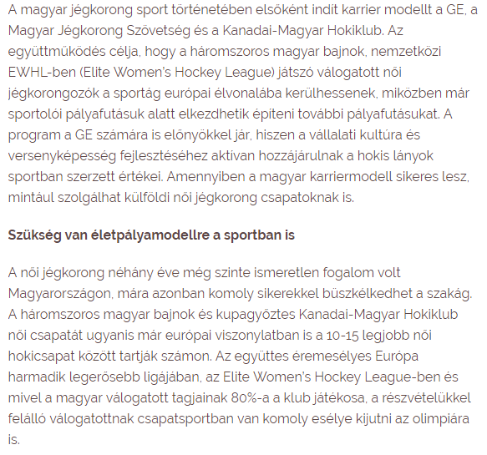
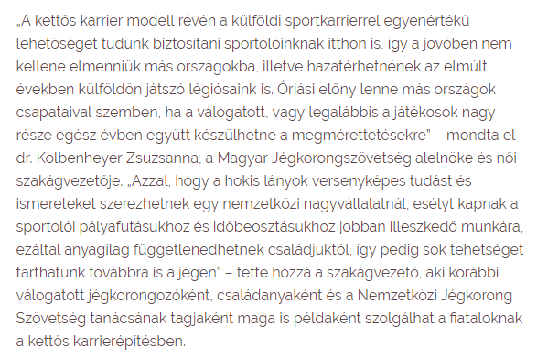

MEDIA: | Csillagpont Rádió | MEDIA SPECIFICS
DATE: | 2017.06.21. | TYPE: | Regional electronic
PAGE: | - | Reach: | 50 000
Ad value (EUR) | 250 | FREQUENCY: | -
HEADLINE: | Interview with Zsuzsanna Kolbenheyer
SUMMARY: | For the first time in the history of Hungarian hockey, a career model is being introduced jointly by GE, the Hungarian Ice Hockey Federation, and the Canadian-Hungarian Hockey Club. The aim of the collaboration is to help the three-time national champion ladies on the national team who play in the Elite Women’s Hockey League (EWHL) to catch up with the European leading edge of the sport while beginning to build their subsequent career paths during their active athlete years. The program clearly also benefits GE since the values and skills the girls learn on the ice will be instrumental in further developing corporate culture and competitiveness. If it proves successful as devised in Hungary, this dual career model may become the example to follow for women’s hockey teams elsewhere in the world.

Audio is requested.

MEDIA: | MTV1 | MEDIA SPECIFICS
DATE: | 2017.06.23. | TYPE: | National electronic
PAGE: | - | Reach: | 450 000
Ad value (EUR) | 2 418 | FREQUENCY: | -
HEADLINE: | Interview with Ilona Barcza and Zsuzsanna Kolbenheyer
SUMMARY: | For the first time in the history of Hungarian hockey, a career model is being introduced jointly by GE, the Hungarian Ice Hockey Federation, and the Canadian-Hungarian Hockey Club. The aim of the collaboration is to help the three-time national champion ladies on the national team who play in the Elite Women’s Hockey League (EWHL) to catch up with the European leading edge of the sport while beginning to build their subsequent career paths during their active athlete years. The program clearly also benefits GE since the values and skills the girls learn on the ice will be instrumental in further developing corporate culture and competitiveness. If it proves successful as devised in Hungary, this dual career model may become the example to follow for women’s hockey teams elsewhere in the world.

http://www.mediaklikk.hu/video/ma-este-2017-06-23-i-adas/

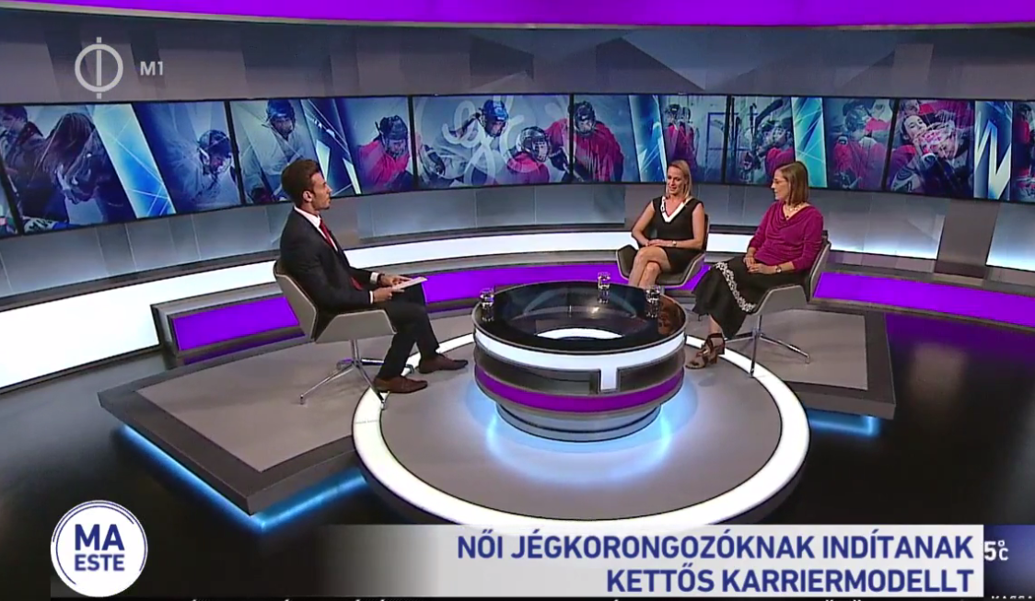

MEDIA: | News4business.hu | MEDIA SPECIFICS
DATE: | 2017.06.23. | TYPE: | Specialized online
PAGE: | - | Reach: | 15 000
Ad value (EUR) | 200 | FREQUENCY: | -
HEADLINE: | GE introduces a career model for female hockey players
SUMMARY: | For the first time in the history of Hungarian hockey, a career model is being introduced jointly by GE, the Hungarian Ice Hockey Federation, and the Canadian-Hungarian Hockey Club. The aim of the collaboration is to help the three-time national champion ladies on the national team who play in the Elite Women’s Hockey League (EWHL) to catch up with the European leading edge of the sport while beginning to build their subsequent career paths during their active athlete years. The program clearly also benefits GE since the values and skills the girls learn on the ice will be instrumental in further developing corporate culture and competitiveness. If it proves successful as devised in Hungary, this dual career model may become the example to follow for women’s hockey teams elsewhere in the world.

http://www.news4business.hu/kozlemenyek/press_release.php?id=33290

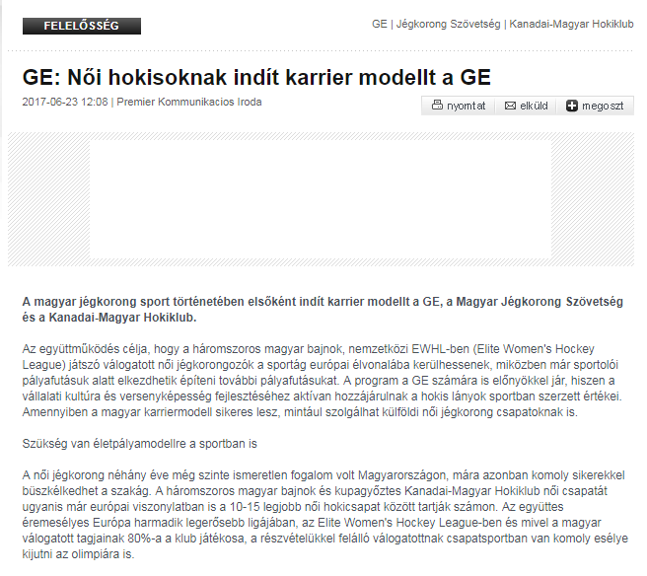

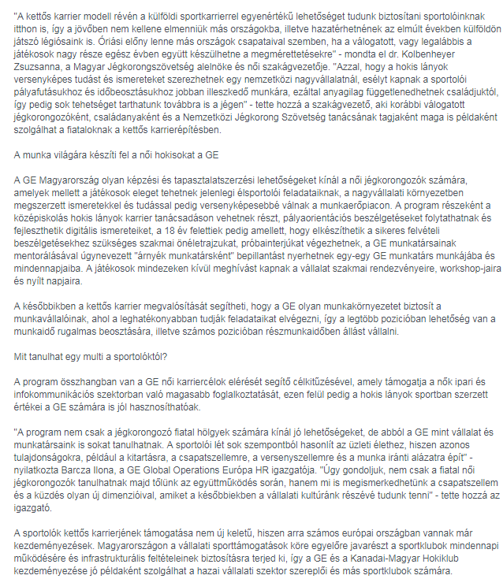

MEDIA: | Marketinginfo.hu | MEDIA SPECIFICS
DATE: | 2017.06.22. | TYPE: | General online
PAGE: | - | Reach: | 3 500
Ad value (EUR) | 50 | FREQUENCY: | -
HEADLINE: | GE introduces a career model for female hockey players
SUMMARY: | For the first time in the history of Hungarian hockey, a career model is being introduced jointly by GE, the Hungarian Ice Hockey Federation, and the Canadian-Hungarian Hockey Club. The aim of the collaboration is to help the three-time national champion ladies on the national team who play in the Elite Women’s Hockey League (EWHL) to catch up with the European leading edge of the sport while beginning to build their subsequent career paths during their active athlete years. The program clearly also benefits GE since the values and skills the girls learn on the ice will be instrumental in further developing corporate culture and competitiveness. If it proves successful as devised in Hungary, this dual career model may become the example to follow for women’s hockey teams elsewhere in the world.

http://www.marketinginfo.hu/hirek/article.php?id=46584

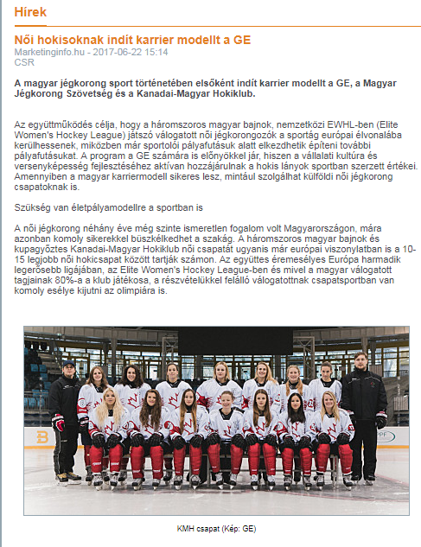

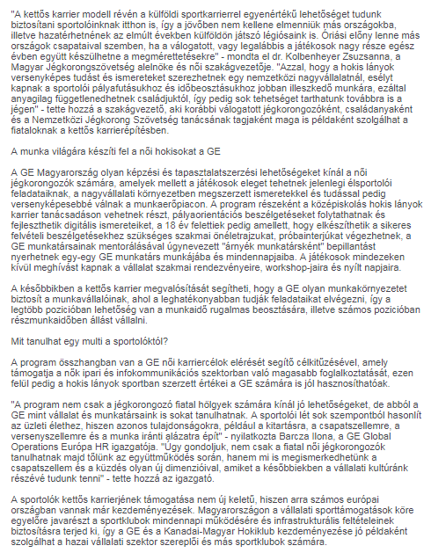

MEDIA: | Bevezetem.eu | MEDIA SPECIFICS
DATE: | 2017.06.25. | TYPE: | General online
PAGE: | - | Reach: | 2 000
Ad value (EUR) | 40 | FREQUENCY: | -
HEADLINE: | Hngarian female ice hockey sport can get to the forefront with double career model
SUMMARY: | For the first time in the history of Hungarian hockey, a career model is being introduced jointly by GE, the Hungarian Ice Hockey Federation, and the Canadian-Hungarian Hockey Club. The aim of the collaboration is to help the three-time national champion ladies on the national team who play in the Elite Women’s Hockey League (EWHL) to catch up with the European leading edge of the sport while beginning to build their subsequent career paths during their active athlete years. The program clearly also benefits GE since the values and skills the girls learn on the ice will be instrumental in further developing corporate culture and competitiveness. If it proves successful as devised in Hungary, this dual career model may become the example to follow for women’s hockey teams elsewhere in the world.

http://bevezetem.eu/2017/06/25/a-kettos-karrierepitessel-az-europai-elvonalba-kerulhet-a-magyar-noi-jegkorongsport

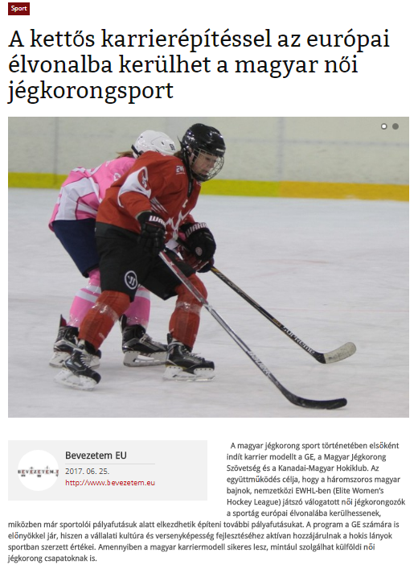

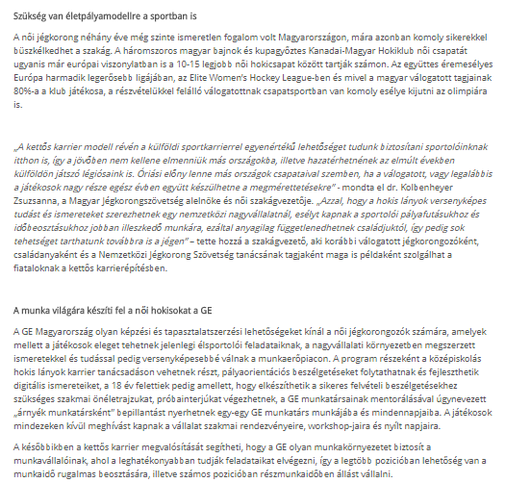
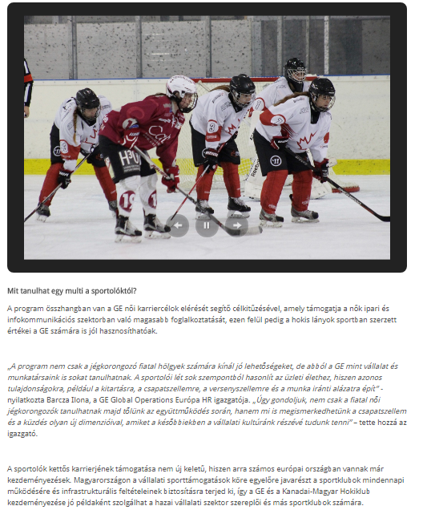

MEDIA: | Sportexpert.hu | MEDIA SPECIFICS
DATE: | 2017.06.23. | TYPE: | Specialized online
PAGE: | - | Reach: | N/A
Ad value (EUR) | N/A | FREQUENCY: | -
HEADLINE: | Career model for female ice hockey players
SUMMARY: | For the first time in the history of Hungarian hockey, a career model is being introduced jointly by GE, the Hungarian Ice Hockey Federation, and the Canadian-Hungarian Hockey Club. The aim of the collaboration is to help the three-time national champion ladies on the national team who play in the Elite Women’s Hockey League (EWHL) to catch up with the European leading edge of the sport while beginning to build their subsequent career paths during their active athlete years. The program clearly also benefits GE since the values and skills the girls learn on the ice will be instrumental in further developing corporate culture and competitiveness. If it proves successful as devised in Hungary, this dual career model may become the example to follow for women’s hockey teams elsewhere in the world.

http://sportexpert.hu/karrier-modell-noi-hokisok-reszere/

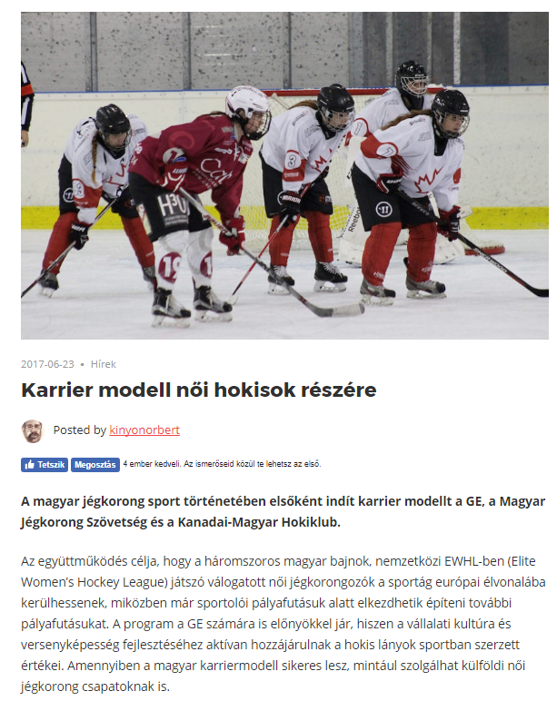

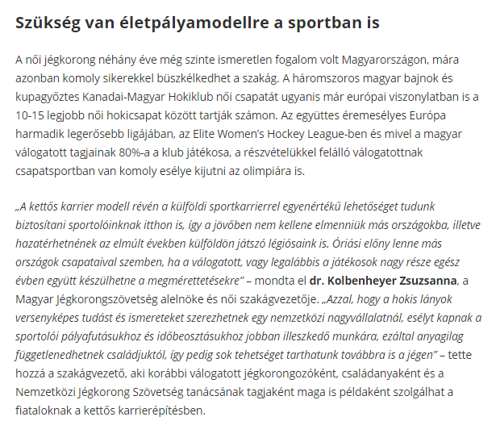
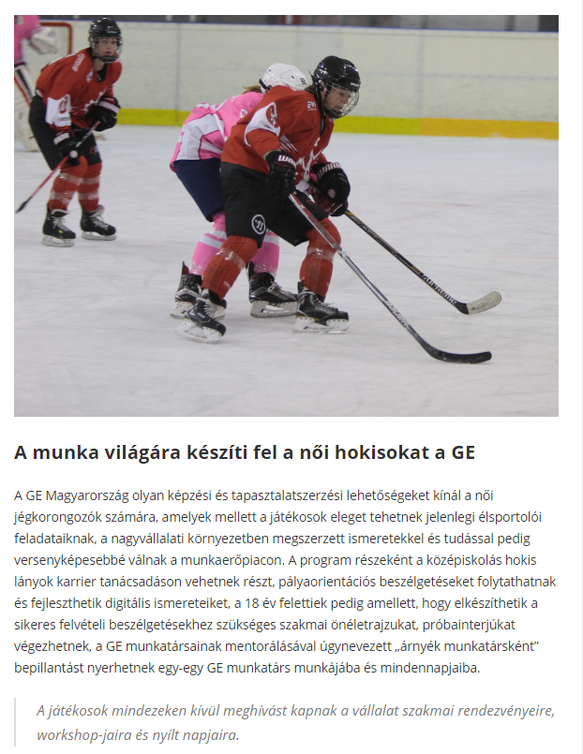
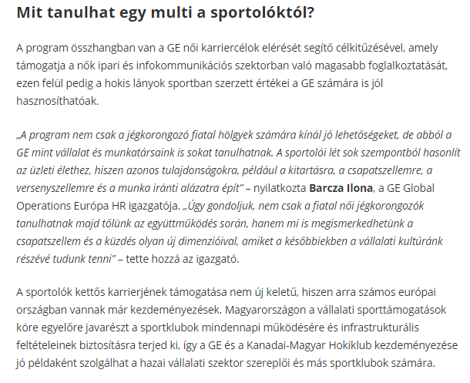

MEDIA: | Mmonline.hu | MEDIA SPECIFICS
DATE: | 2017.06.27. | TYPE: | General online
PAGE: | - | Reach: | 930
Ad value (EUR) | 120 | FREQUENCY: | -
HEADLINE: | GE in a special program
SUMMARY: | For the first time in the history of Hungarian hockey, a career model is being introduced jointly by GE, the Hungarian Ice Hockey Federation, and the Canadian-Hungarian Hockey Club. The aim of the collaboration is to help the three-time national champion ladies on the national team who play in the Elite Women’s Hockey League (EWHL) to catch up with the European leading edge of the sport while beginning to build their subsequent career paths during their active athlete years. The program clearly also benefits GE since the values and skills the girls learn on the ice will be instrumental in further developing corporate culture and competitiveness. If it proves successful as devised in Hungary, this dual career model may become the example to follow for women’s hockey teams elsewhere in the world.

http://www.mmonline.hu/cikk/kulonleges_programban_a_ge

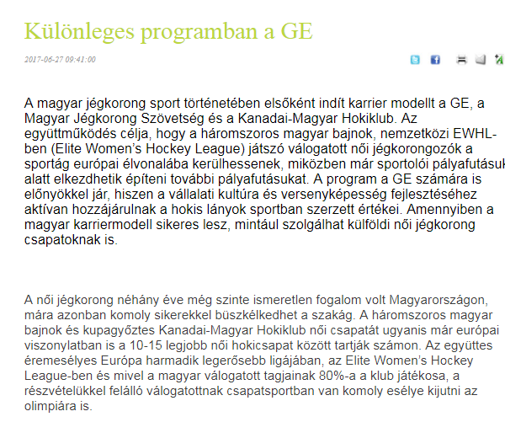

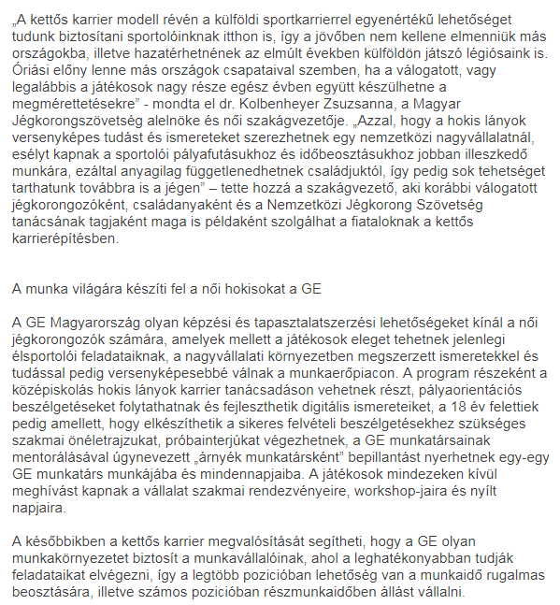
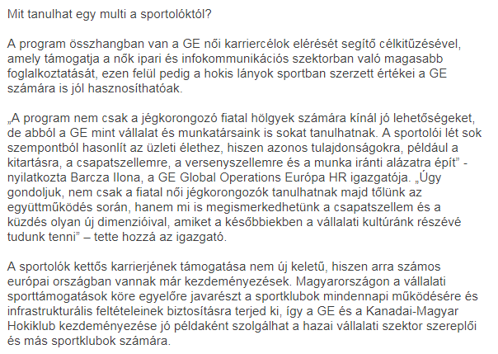

MEDIA: | Mediapiac.com | MEDIA SPECIFICS
DATE: | 2017.06.27. | TYPE: | General online
PAGE: | - | Reach: | 850
Ad value (EUR) | 100 | FREQUENCY: | -
HEADLINE: | Female hockey players are prepared for the world of job
SUMMARY: | For the first time in the history of Hungarian hockey, a career model is being introduced jointly by GE, the Hungarian Ice Hockey Federation, and the Canadian-Hungarian Hockey Club. The aim of the collaboration is to help the three-time national champion ladies on the national team who play in the Elite Women’s Hockey League (EWHL) to catch up with the European leading edge of the sport while beginning to build their subsequent career paths during their active athlete years. The program clearly also benefits GE since the values and skills the girls learn on the ice will be instrumental in further developing corporate culture and competitiveness. If it proves successful as devised in Hungary, this dual career model may become the example to follow for women’s hockey teams elsewhere in the world.

http://www.mediapiac.com/marketing/A-munka-vilagara-kesziti-fel-a-noi-hokisokat-a-GE/23528/

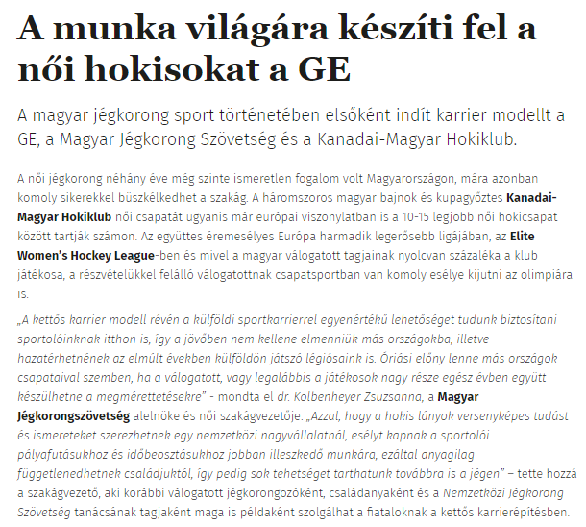

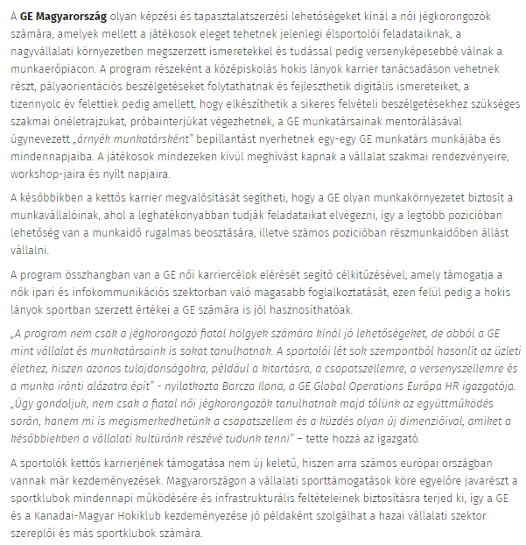

MEDIA: | Hirek.prim.hu | MEDIA SPECIFICS
DATE: | 2017.06.27. | TYPE: | General online
PAGE: | - | Reach: | 3 500
Ad value (EUR) | 290 | FREQUENCY: | -
HEADLINE: | Female hockey players are prepared for the world of job
SUMMARY: | For the first time in the history of Hungarian hockey, a career model is being introduced jointly by GE, the Hungarian Ice Hockey Federation, and the Canadian-Hungarian Hockey Club. The aim of the collaboration is to help the three-time national champion ladies on the national team who play in the Elite Women’s Hockey League (EWHL) to catch up with the European leading edge of the sport while beginning to build their subsequent career paths during their active athlete years. The program clearly also benefits GE since the values and skills the girls learn on the ice will be instrumental in further developing corporate culture and competitiveness. If it proves successful as devised in Hungary, this dual career model may become the example to follow for women’s hockey teams elsewhere in the world.

http://hirek.prim.hu/cikk/2017/06/27/a_munka_vilagara_kesziti_fel_a_noi_hokisokat_a_ge

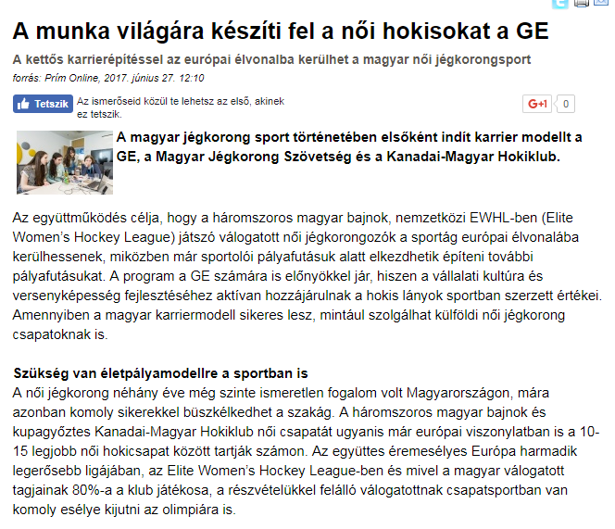

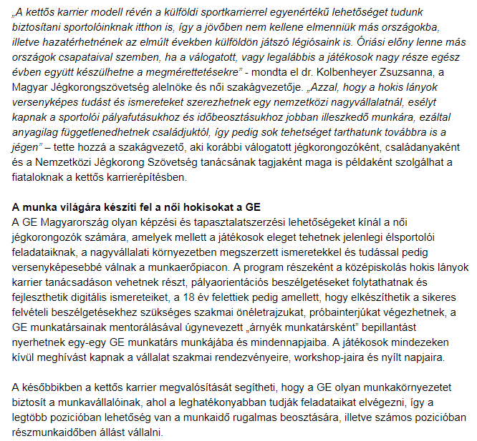
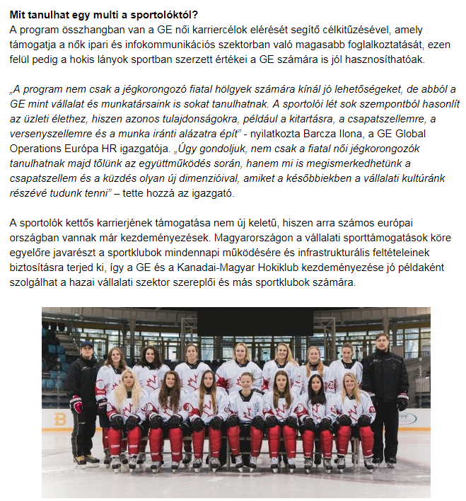

MEDIA: | Kreativ.hu | MEDIA SPECIFICS
DATE: | 2017.06.27. | TYPE: | General online
PAGE: | - | Reach: | 3 276
Ad value (EUR) | 1 870 | FREQUENCY: | -
HEADLINE: | GE Hungary supports the career of female ice hockey players after sport
SUMMARY: | For the first time in the history of Hungarian hockey, a career model is being introduced jointly by GE, the Hungarian Ice Hockey Federation, and the Canadian-Hungarian Hockey Club. The aim of the collaboration is to help the three-time national champion ladies on the national team who play in the Elite Women’s Hockey League (EWHL) to catch up with the European leading edge of the sport while beginning to build their subsequent career paths during their active athlete years. The program clearly also benefits GE since the values and skills the girls learn on the ice will be instrumental in further developing corporate culture and competitiveness. If it proves successful as devised in Hungary, this dual career model may become the example to follow for women’s hockey teams elsewhere in the world.

http://kreativ.hu/cikk/noi_hokisok_sport_utani_palyafutasat_segiti_a_ge_magyarorszag

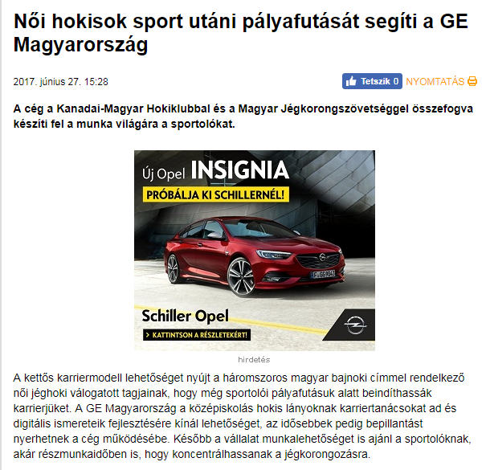

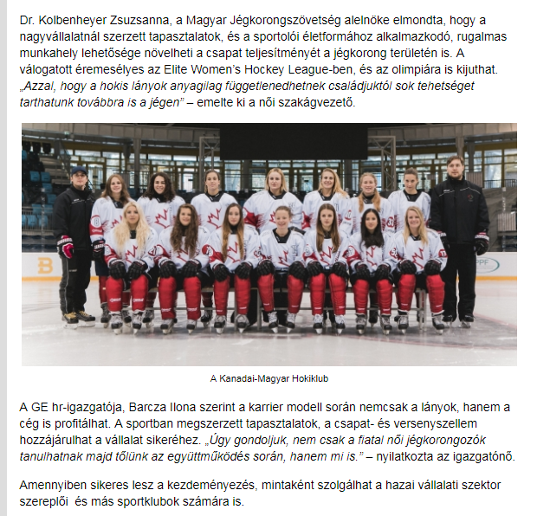

MEDIA: | M4sport.hu | MEDIA SPECIFICS
DATE: | 2017.06.27. | TYPE: | Specialized online
PAGE: | - | Reach: | 12 000
Ad value (EUR) | 200 | FREQUENCY: | -
HEADLINE: | Career model is introduced for female hockey players
SUMMARY: | For the first time in the history of Hungarian hockey, a career model is being introduced jointly by GE, the Hungarian Ice Hockey Federation, and the Canadian-Hungarian Hockey Club. The aim of the collaboration is to help the three-time national champion ladies on the national team who play in the Elite Women’s Hockey League (EWHL) to catch up with the European leading edge of the sport while beginning to build their subsequent career paths during their active athlete years. The program clearly also benefits GE since the values and skills the girls learn on the ice will be instrumental in further developing corporate culture and competitiveness. If it proves successful as devised in Hungary, this dual career model may become the example to follow for women’s hockey teams elsewhere in the world.

http://www.m4sport.hu/2017/06/27/karriermodell-indul-a-noi-hokisoknak/

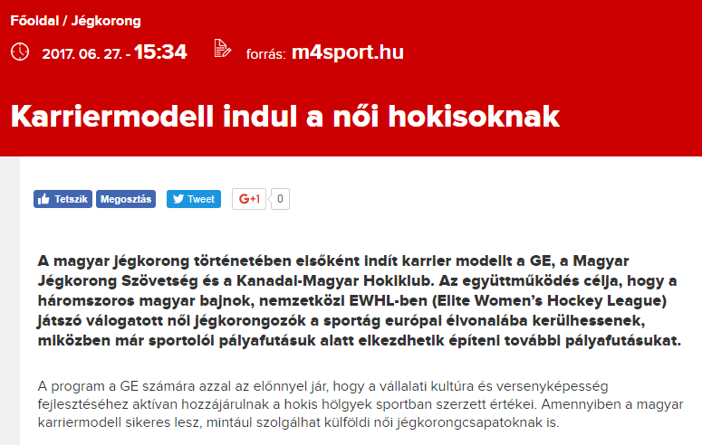

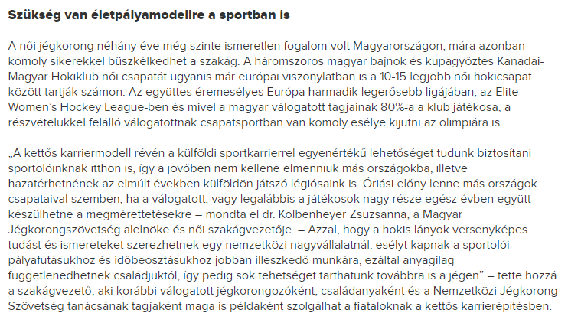

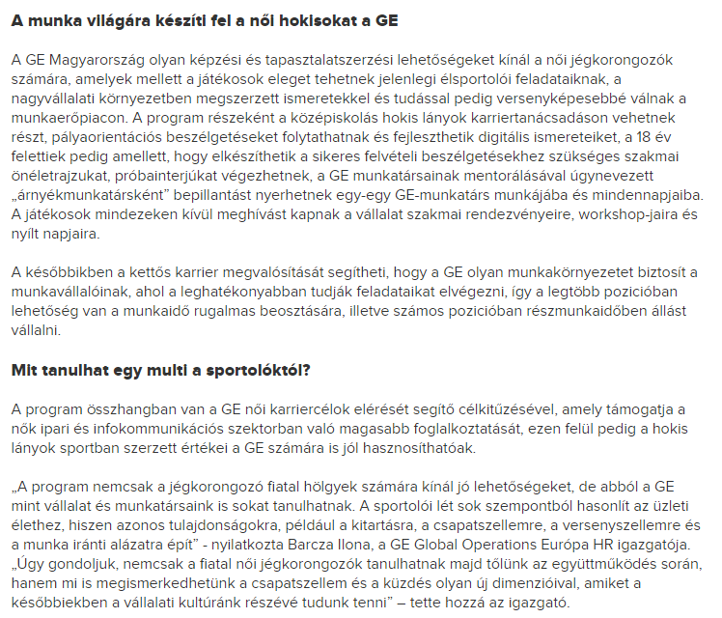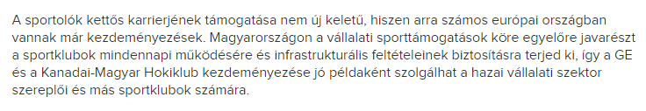

MEDIA: | Szakszervezetek.hu | MEDIA SPECIFICS
DATE: | 2017.06.27. | TYPE: | General online
PAGE: | - | Reach: | N/A
Ad value (EUR) | N/A | FREQUENCY: | -
HEADLINE: | GE prepares female hockey players for the world of job
SUMMARY: | For the first time in the history of Hungarian hockey, a career model is being introduced jointly by GE, the Hungarian Ice Hockey Federation, and the Canadian-Hungarian Hockey Club. The aim of the collaboration is to help the three-time national champion ladies on the national team who play in the Elite Women’s Hockey League (EWHL) to catch up with the European leading edge of the sport while beginning to build their subsequent career paths during their active athlete years. The program clearly also benefits GE since the values and skills the girls learn on the ice will be instrumental in further developing corporate culture and competitiveness. If it proves successful as devised in Hungary, this dual career model may become the example to follow for women’s hockey teams elsewhere in the world.

https://szakszervezetek.hu/hirek/10691-a-munka-vilagara-kesziti-fel-a-noi-hokisokat-a-ge

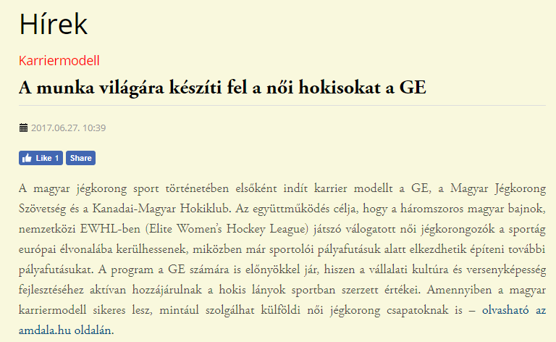

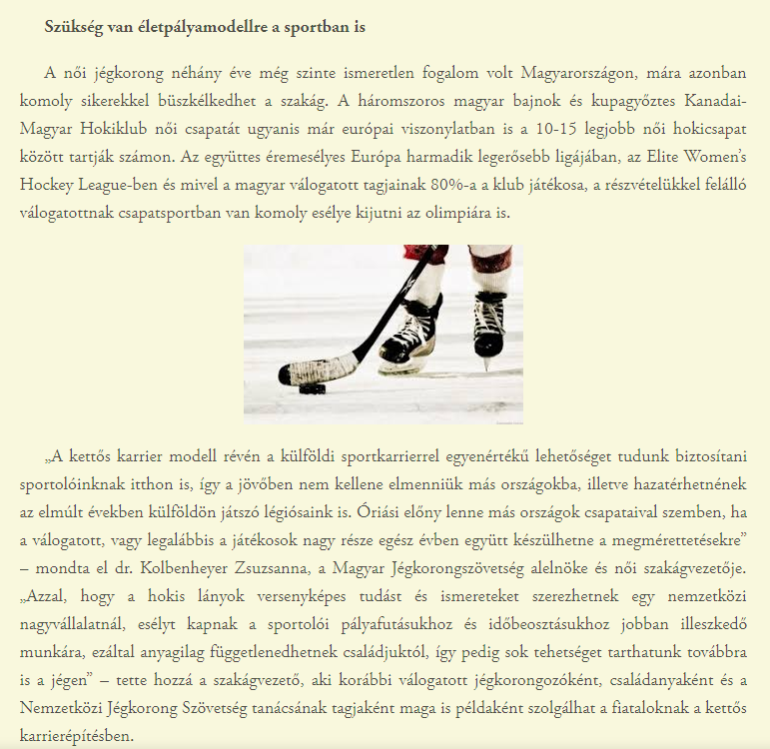
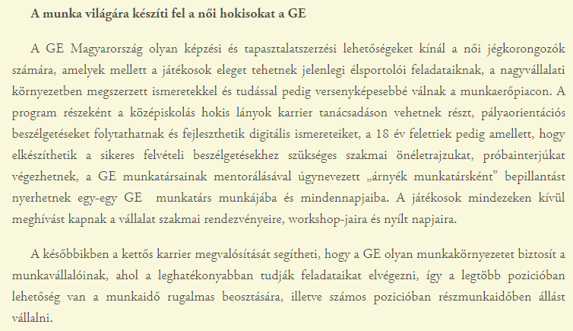
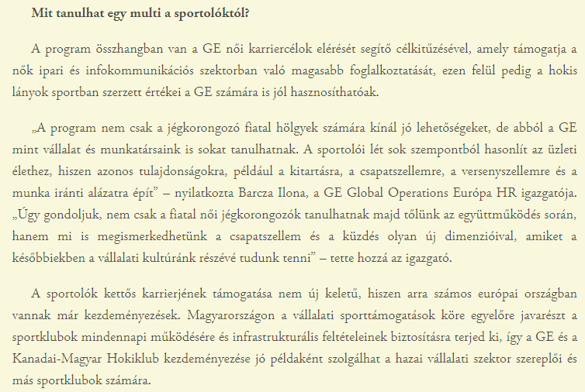

MEDIA: | Amdala.hu | MEDIA SPECIFICS
DATE: | 2017.06.27. | TYPE: | General online
PAGE: | - | Reach: | N/A
Ad value (EUR) | N/A | FREQUENCY: | -
HEADLINE: | GE prepares female hockey players for the world of job
SUMMARY: | For the first time in the history of Hungarian hockey, a career model is being introduced jointly by GE, the Hungarian Ice Hockey Federation, and the Canadian-Hungarian Hockey Club. The aim of the collaboration is to help the three-time national champion ladies on the national team who play in the Elite Women’s Hockey League (EWHL) to catch up with the European leading edge of the sport while beginning to build their subsequent career paths during their active athlete years. The program clearly also benefits GE since the values and skills the girls learn on the ice will be instrumental in further developing corporate culture and competitiveness. If it proves successful as devised in Hungary, this dual career model may become the example to follow for women’s hockey teams elsewhere in the world.

http://www.amdala.hu/a-munka-vilagara-kesziti-fel-a-noi-hokisokat-a-ge/

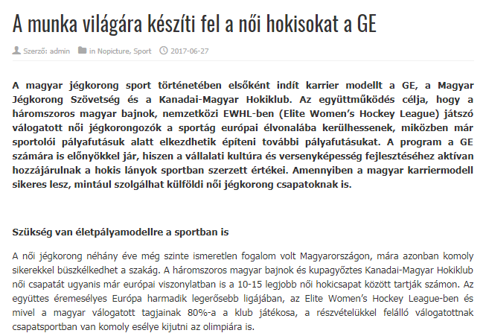

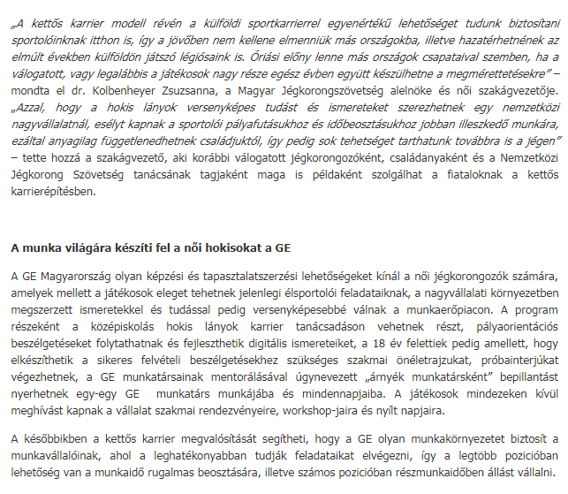
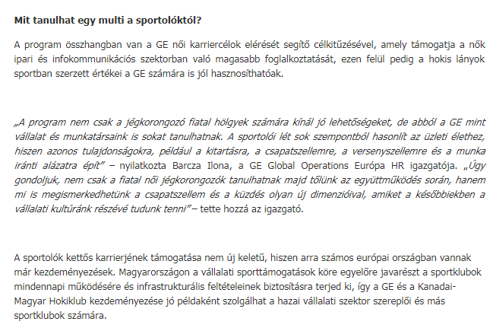

MEDIA: | Hirposta.hu | MEDIA SPECIFICS
DATE: | 2017.06.27. | TYPE: | General online
PAGE: | - | Reach: | N/A
Ad value (EUR) | N/A | FREQUENCY: | -
HEADLINE: | GE prepares female hockey players for the world of job
SUMMARY: | For the first time in the history of Hungarian hockey, a career model is being introduced jointly by GE, the Hungarian Ice Hockey Federation, and the Canadian-Hungarian Hockey Club. The aim of the collaboration is to help the three-time national champion ladies on the national team who play in the Elite Women’s Hockey League (EWHL) to catch up with the European leading edge of the sport while beginning to build their subsequent career paths during their active athlete years. The program clearly also benefits GE since the values and skills the girls learn on the ice will be instrumental in further developing corporate culture and competitiveness. If it proves successful as devised in Hungary, this dual career model may become the example to follow for women’s hockey teams elsewhere in the world.

http://hirposta.hu/cikk/5096899/A_munka_vilagara_kesziti_fel_a_noi_hokisokat_a_GE/

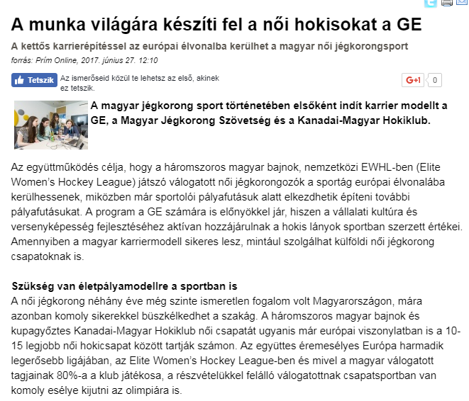

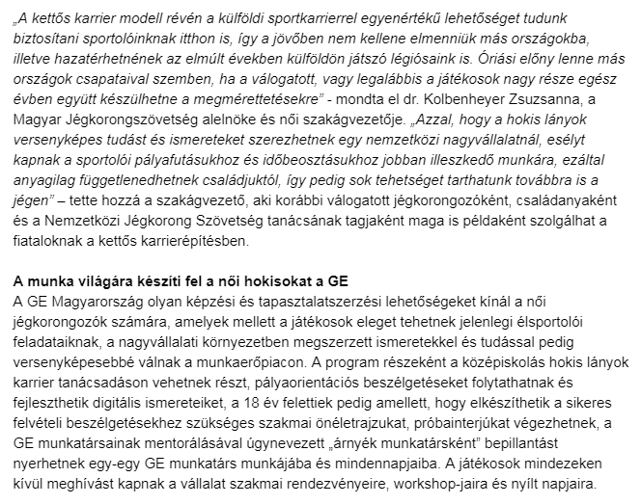
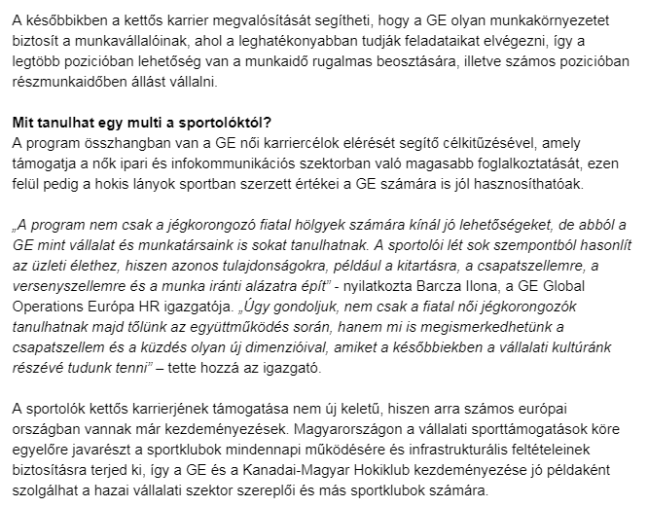
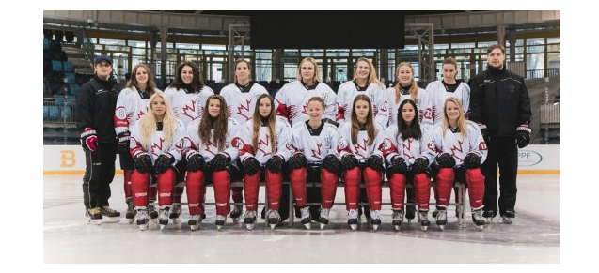
MEDIA: | Kreativ.hu newsletter | MEDIA SPECIFICS
DATE: | 2017.06.27. | TYPE: | General online
PAGE: | - | Reach: | 10 000
Ad value (EUR) | 150 | FREQUENCY: | -
HEADLINE: | GE Hungary supports the career of female ice hockey players after sport
SUMMARY: | For the first time in the history of Hungarian hockey, a career model is being introduced jointly by GE, the Hungarian Ice Hockey Federation, and the Canadian-Hungarian Hockey Club. The aim of the collaboration is to help the three-time national champion ladies on the national team who play in the Elite Women’s Hockey League (EWHL) to catch up with the European leading edge of the sport while beginning to build their subsequent career paths during their active athlete years. The program clearly also benefits GE since the values and skills the girls learn on the ice will be instrumental in further developing corporate culture and competitiveness. If it proves successful as devised in Hungary, this dual career model may become the example to follow for women’s hockey teams elsewhere in the world.

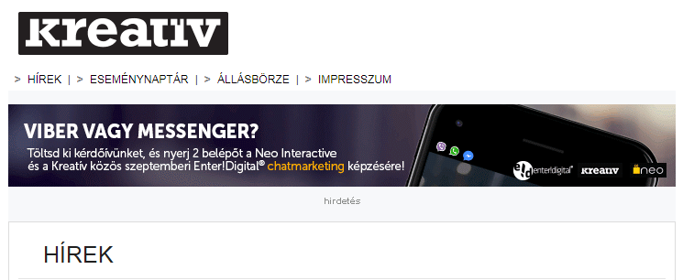

MEDIA: | Lánchíd Rádió | MEDIA SPECIFICS
DATE: | 2017.06.28. | TYPE: | National electronic
PAGE: | - | Reach: | 120 000
Ad value (EUR) | 500 | FREQUENCY: | -
HEADLINE: | Career model for female ice hockey players
SUMMARY: | For the first time in the history of Hungarian hockey, a career model is being introduced jointly by GE, the Hungarian Ice Hockey Federation, and the Canadian-Hungarian Hockey Club. The aim of the collaboration is to help the three-time national champion ladies on the national team who play in the Elite Women’s Hockey League (EWHL) to catch up with the European leading edge of the sport while beginning to build their subsequent career paths during their active athlete years. The program clearly also benefits GE since the values and skills the girls learn on the ice will be instrumental in further developing corporate culture and competitiveness. If it proves successful as devised in Hungary, this dual career model may become the example to follow for women’s hockey teams elsewhere in the world.

http://www.premiercom.hu/download/private/GE/Lanchid--20170628--0911.mp3

Username: generalelectric
Password: 4312

MEDIA: | Socialbranding.hu | MEDIA SPECIFICS
DATE: | 2017.06.28. | TYPE: | General online
PAGE: | - | Reach: | 5 500
Ad value (EUR) | 80 | FREQUENCY: | -
HEADLINE: | Hngarian female ice hockey sport can get to the forefront
SUMMARY: | For the first time in the history of Hungarian hockey, a career model is being introduced jointly by GE, the Hungarian Ice Hockey Federation, and the Canadian-Hungarian Hockey Club. The aim of the collaboration is to help the three-time national champion ladies on the national team who play in the Elite Women’s Hockey League (EWHL) to catch up with the European leading edge of the sport while beginning to build their subsequent career paths during their active athlete years. The program clearly also benefits GE since the values and skills the girls learn on the ice will be instrumental in further developing corporate culture and competitiveness. If it proves successful as devised in Hungary, this dual career model may become the example to follow for women’s hockey teams elsewhere in the world.

http://socialbranding.hu/csr/socialbranding/2017/06/28/elvonalba-kerulhet-a-magyar-noi-jegkorongsport/

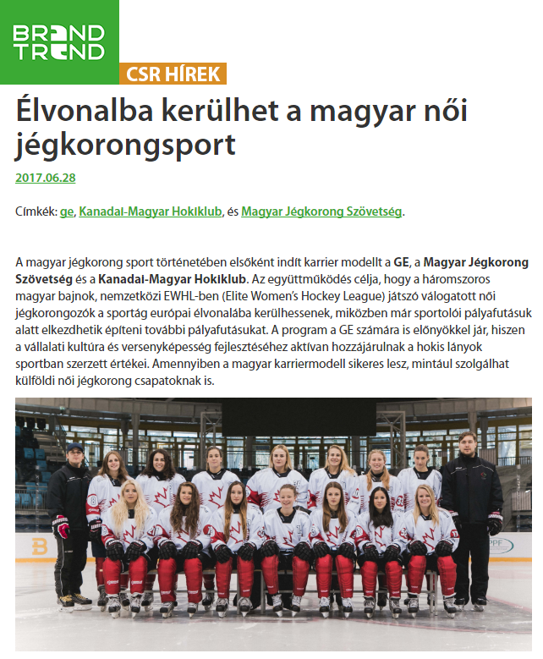

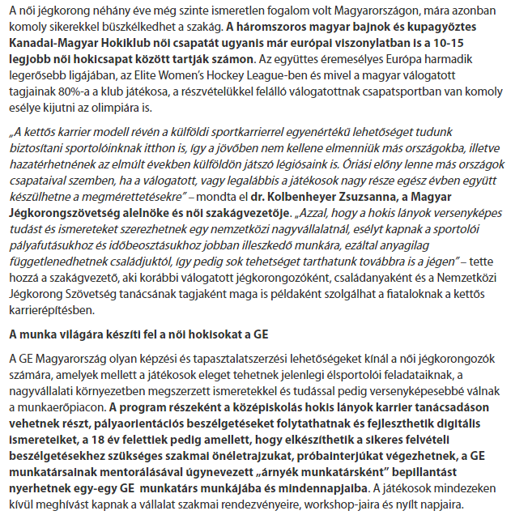
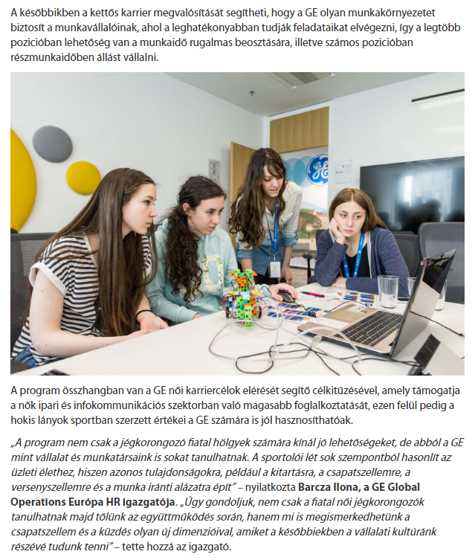

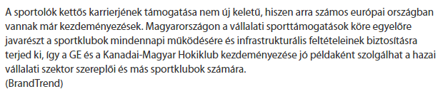

MEDIA: | Brandtrend.hu | MEDIA SPECIFICS
DATE: | 2017.06.28. | TYPE: | General online
PAGE: | - | Reach: | 9 677
Ad value (EUR) | 160 | FREQUENCY: | -
HEADLINE: | Hungarian female ice hockey sport can get to the forefront
SUMMARY: | For the first time in the history of Hungarian hockey, a career model is being introduced jointly by GE, the Hungarian Ice Hockey Federation, and the Canadian-Hungarian Hockey Club. The aim of the collaboration is to help the three-time national champion ladies on the national team who play in the Elite Women’s Hockey League (EWHL) to catch up with the European leading edge of the sport while beginning to build their subsequent career paths during their active athlete years. The program clearly also benefits GE since the values and skills the girls learn on the ice will be instrumental in further developing corporate culture and competitiveness. If it proves successful as devised in Hungary, this dual career model may become the example to follow for women’s hockey teams elsewhere in the world.

http://brandtrend.hu/socialbranding/2017/06/28/elvonalba-kerulhet-a-magyar-noi-jegkorongsport

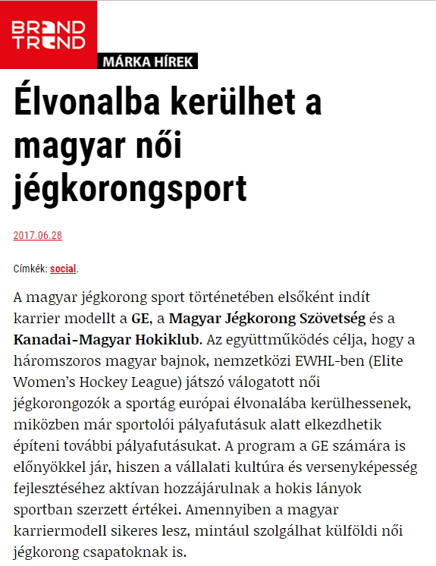

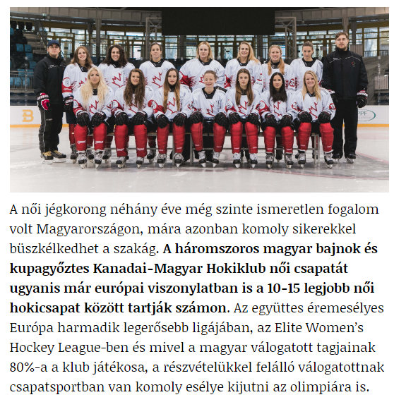
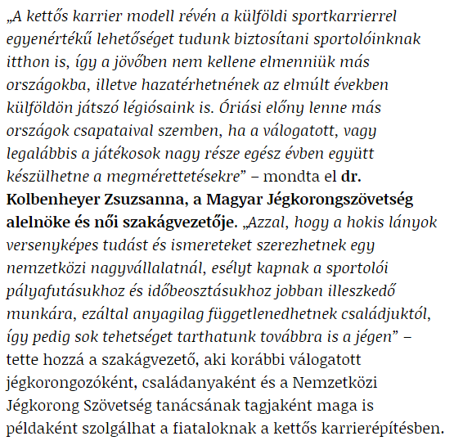

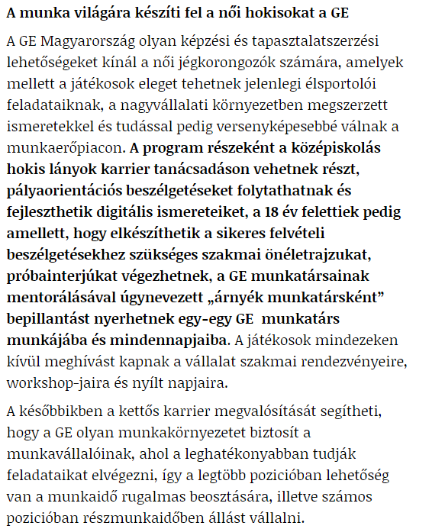

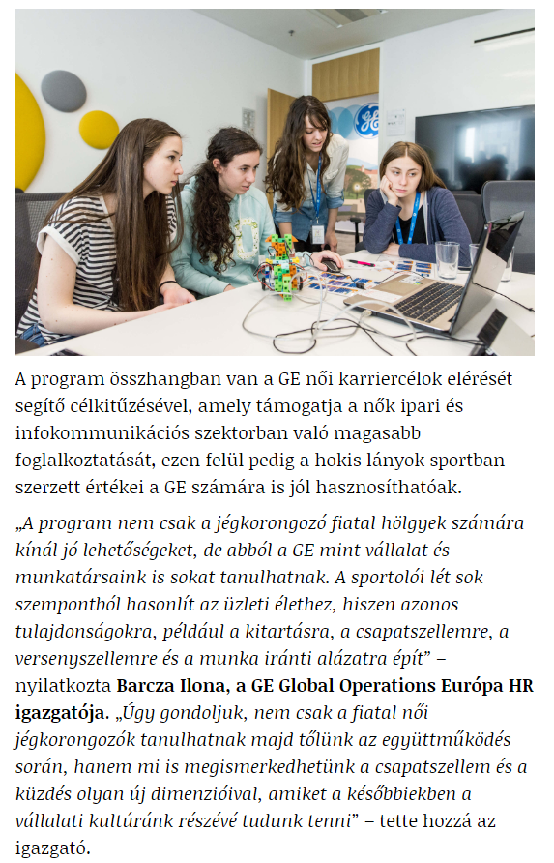
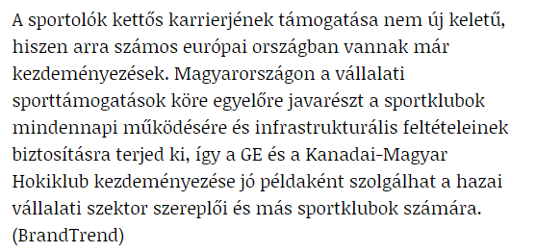

MEDIA: | Karcfm.hu | MEDIA SPECIFICS
DATE: | 2017.06.29. | TYPE: | General online
PAGE: | - | Reach: | 4 500
Ad value (EUR) | 80 | FREQUENCY: | -
HEADLINE: | Teaser for the interview with Ilona Barcza
SUMMARY: | For the first time in the history of Hungarian hockey, a career model is being introduced jointly by GE, the Hungarian Ice Hockey Federation, and the Canadian-Hungarian Hockey Club. The aim of the collaboration is to help the three-time national champion ladies on the national team who play in the Elite Women’s Hockey League (EWHL) to catch up with the European leading edge of the sport while beginning to build their subsequent career paths during their active athlete years. The program clearly also benefits GE since the values and skills the girls learn on the ice will be instrumental in further developing corporate culture and competitiveness. If it proves successful as devised in Hungary, this dual career model may become the example to follow for women’s hockey teams elsewhere in the world.

http://karcfm.hu/2017/06/spajz-csutortok-0900-2/

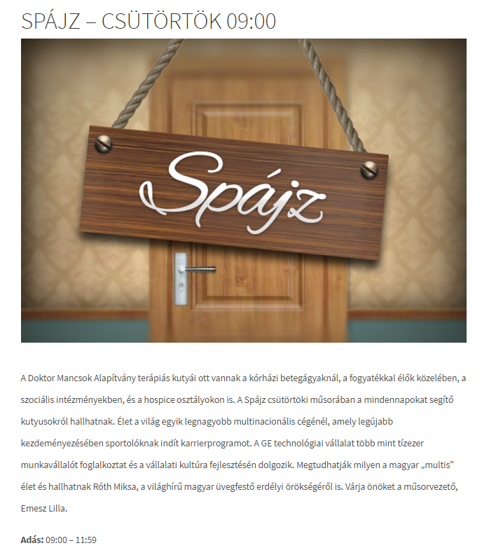

MEDIA: | Karc FM | MEDIA SPECIFICS
DATE: | 2017.06.29. | TYPE: | Regional electronic
PAGE: | - | Reach: | 85 000
Ad value (EUR) | 811 | FREQUENCY: | -
HEADLINE: | Interview with Ilona Barcza and Zsuzsanna Kolbenheyer
SUMMARY: | For the first time in the history of Hungarian hockey, a career model is being introduced jointly by GE, the Hungarian Ice Hockey Federation, and the Canadian-Hungarian Hockey Club. The aim of the collaboration is to help the three-time national champion ladies on the national team who play in the Elite Women’s Hockey League (EWHL) to catch up with the European leading edge of the sport while beginning to build their subsequent career paths during their active athlete years. The program clearly also benefits GE since the values and skills the girls learn on the ice will be instrumental in further developing corporate culture and competitiveness. If it proves successful as devised in Hungary, this dual career model may become the example to follow for women’s hockey teams elsewhere in the world.

http://karcfm.hu/archiv/spajz-2017-06-29-0900-1159/

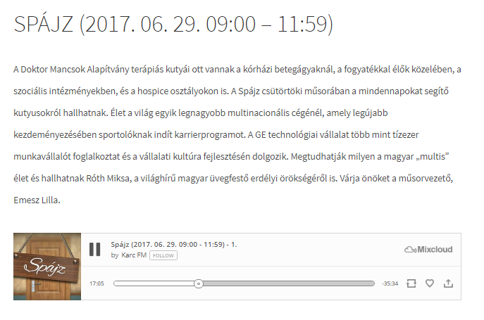

MEDIA: | Eletforma.hu | MEDIA SPECIFICS
DATE: | 2017.07.01.. | TYPE: | General online
PAGE: | - | Reach: | 8 718
Ad value (EUR) | 140 | FREQUENCY: | -
HEADLINE: | Hockey takes women into the director's seat!
SUMMARY: | For the first time in the history of Hungarian hockey, a career model is being introduced jointly by GE, the Hungarian Ice Hockey Federation, and the Canadian-Hungarian Hockey Club. The aim of the collaboration is to help the three-time national champion ladies on the national team who play in the Elite Women’s Hockey League (EWHL) to catch up with the European leading edge of the sport while beginning to build their subsequent career paths during their active athlete years. The program clearly also benefits GE since the values and skills the girls learn on the ice will be instrumental in further developing corporate culture and competitiveness. If it proves successful as devised in Hungary, this dual career model may become the example to follow for women’s hockey teams elsewhere in the world.

http://www.eletforma.hu/test-es-lelek/hoki-repiti-a-noket-az-igazgatoi-szekbe/

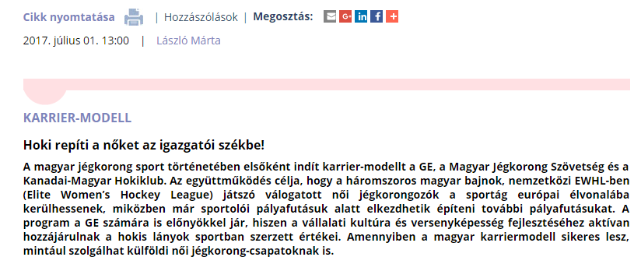
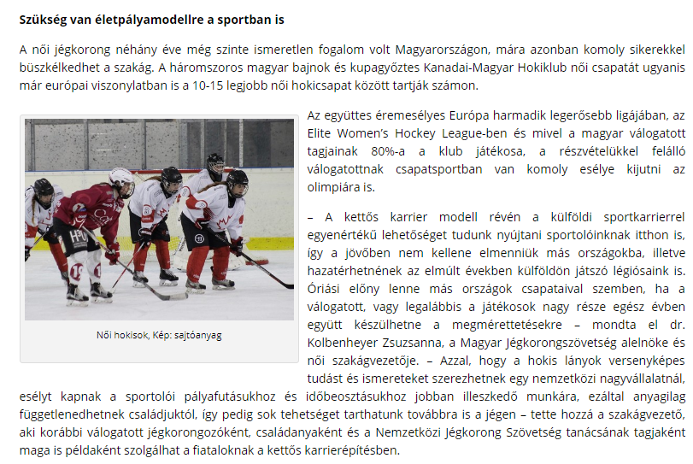

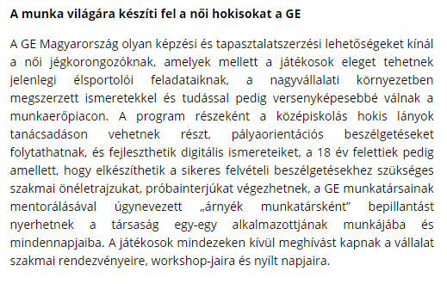

MEDIA: | Kossuth Rádió | MEDIA SPECIFICS
DATE: | 2017.07.04. | TYPE: | General online
PAGE: | - | Reach: | 1 651 134
Ad value (EUR) | 644 | FREQUENCY: | -
HEADLINE: | Interview with Ilona Barcza
SUMMARY: | For the first time in the history of Hungarian hockey, a career model is being introduced jointly by GE, the Hungarian Ice Hockey Federation, and the Canadian-Hungarian Hockey Club. The aim of the collaboration is to help the three-time national champion ladies on the national team who play in the Elite Women’s Hockey League (EWHL) to catch up with the European leading edge of the sport while beginning to build their subsequent career paths during their active athlete years. The program clearly also benefits GE since the values and skills the girls learn on the ice will be instrumental in further developing corporate culture and competitiveness. If it proves successful as devised in Hungary, this dual career model may become the example to follow for women’s hockey teams elsewhere in the world.

Kossuth Rádió

Audio file is requested.

MEDIA: | Origo.hu - Sport | MEDIA SPECIFICS
DATE: | 2017.07.11. | TYPE: | Specialized online
PAGE: | - | Reach: | 544 000
Ad value (EUR) | 31 | FREQUENCY: | -
HEADLINE: | Young hockey player girls have got a great possibility
SUMMARY: | For the first time in the history of Hungarian hockey, a career model is being introduced jointly by GE, the Hungarian Ice Hockey Federation, and the Canadian-Hungarian Hockey Club. The aim of the collaboration is to help the three-time national champion ladies on the national team who play in the Elite Women’s Hockey League (EWHL) to catch up with the European leading edge of the sport while beginning to build their subsequent career paths during their active athlete years. The program clearly also benefits GE since the values and skills the girls learn on the ice will be instrumental in further developing corporate culture and competitiveness. If it proves successful as devised in Hungary, this dual career model may become the example to follow for women’s hockey teams elsewhere in the world.

http://www.origo.hu/sport/csapat/20170711-ge-magyar-kanadai-egyuttmukodes.html

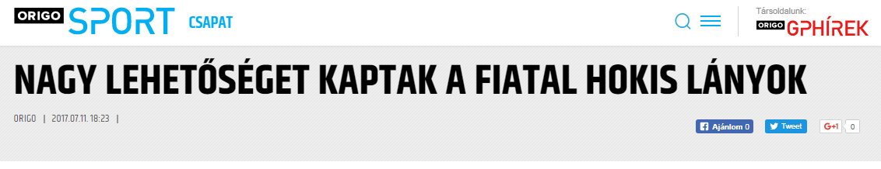
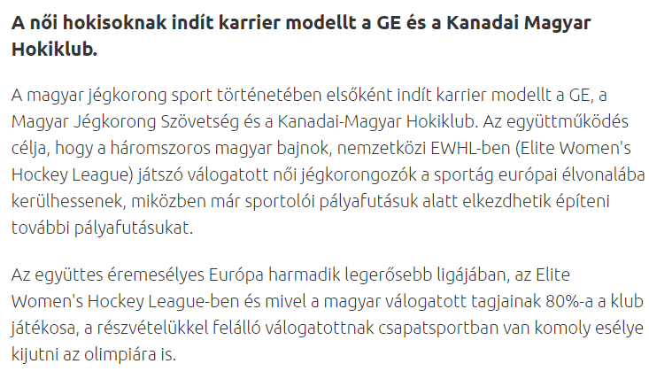

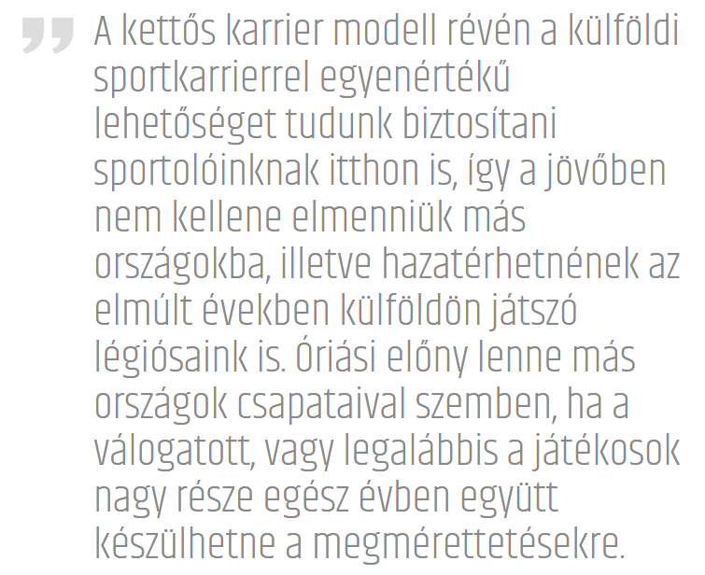
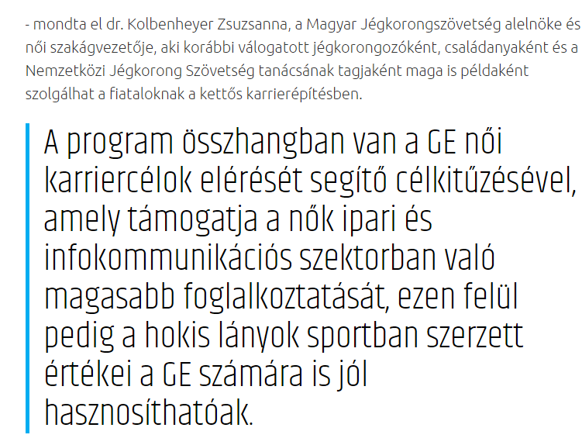
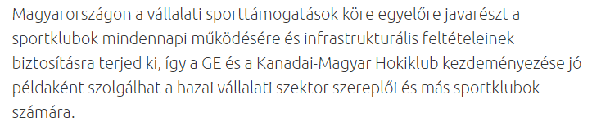

MEDIA: | monster.hu | MEDIA SPECIFICS
DATE: | 2017.07.13. | TYPE: | Specialized online
PAGE: | - | Reach: | N/A
Ad value (EUR) | N/A | FREQUENCY: | -
HEADLINE: | GE: They help for the female hockey players with interviews and cv writing
SUMMARY: | For the first time in the history of Hungarian hockey, a career model is being introduced jointly by GE, the Hungarian Ice Hockey Federation, and the Canadian-Hungarian Hockey Club. The aim of the collaboration is to help the three-time national champion ladies on the national team who play in the Elite Women’s Hockey League (EWHL) to catch up with the European leading edge of the sport while beginning to build their subsequent career paths during their active athlete years. The program clearly also benefits GE since the values and skills the girls learn on the ice will be instrumental in further developing corporate culture and competitiveness. If it proves successful as devised in Hungary, this dual career model may become the example to follow for women’s hockey teams elsewhere in the world.

https://www.monster.hu/karrier-tanacsok/cikk/GE-oneletrajz-irassal-es-probainterjukkal-is-segitik-a-jegkorongozokat?re=swoop

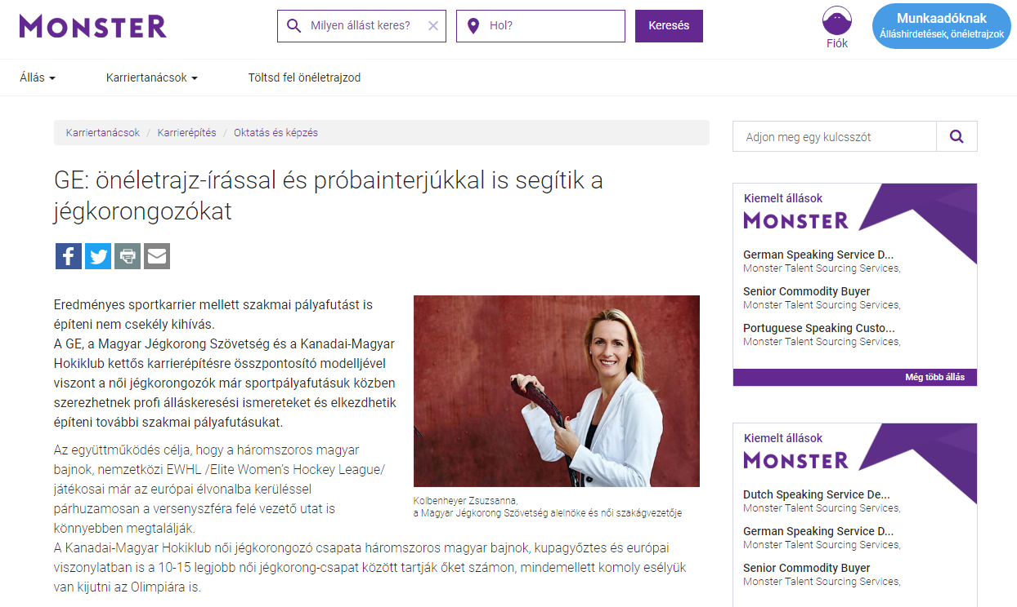
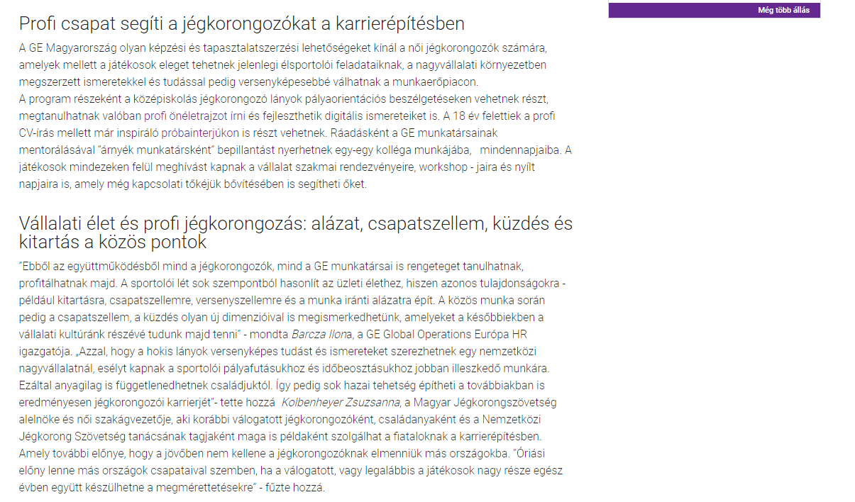

MEDIA: | sportime.hu | MEDIA SPECIFICS
DATE: | 2017.07.13. | TYPE: | Specialized online
PAGE: | - | Reach: | N/A
Ad value (EUR) | 97 | FREQUENCY: | -
HEADLINE: | Career model for ladies
SUMMARY: | For the first time in the history of Hungarian hockey, a career model is being introduced jointly by GE, the Hungarian Ice Hockey Federation, and the Canadian-Hungarian Hockey Club. The aim of the collaboration is to help the three-time national champion ladies on the national team who play in the Elite Women’s Hockey League (EWHL) to catch up with the European leading edge of the sport while beginning to build their subsequent career paths during their active athlete years. The program clearly also benefits GE since the values and skills the girls learn on the ice will be instrumental in further developing corporate culture and competitiveness. If it proves successful as devised in Hungary, this dual career model may become the example to follow for women’s hockey teams elsewhere in the world.

http://sportime.hu/jegkorong/karriermodell-holgyeknek-7950

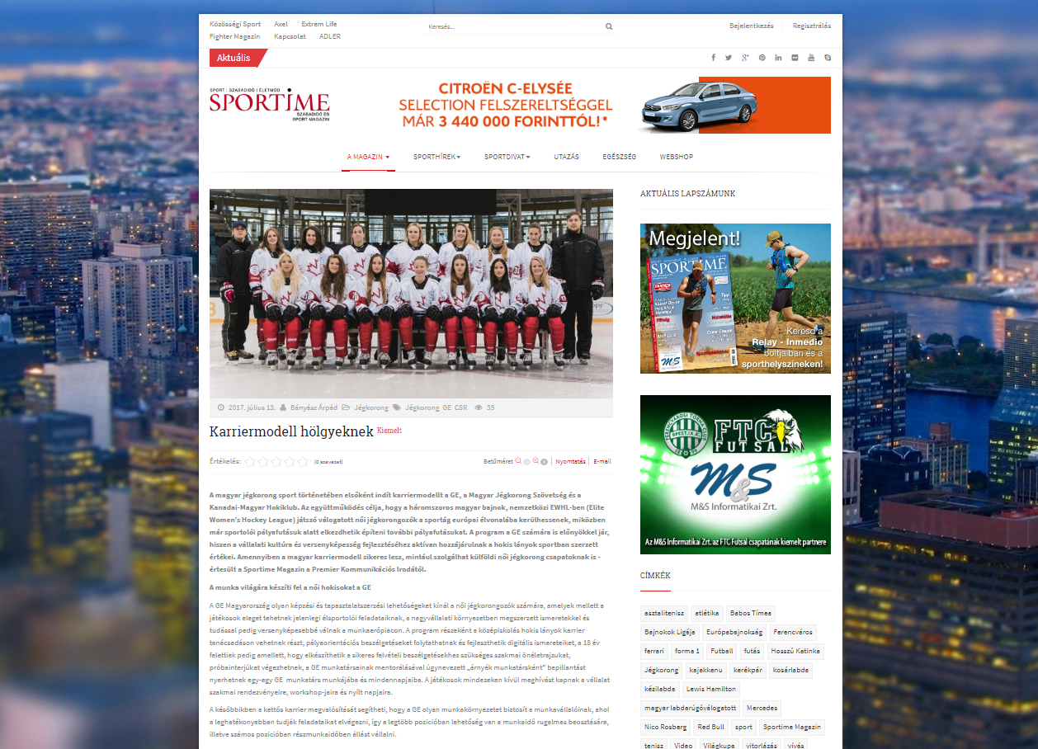
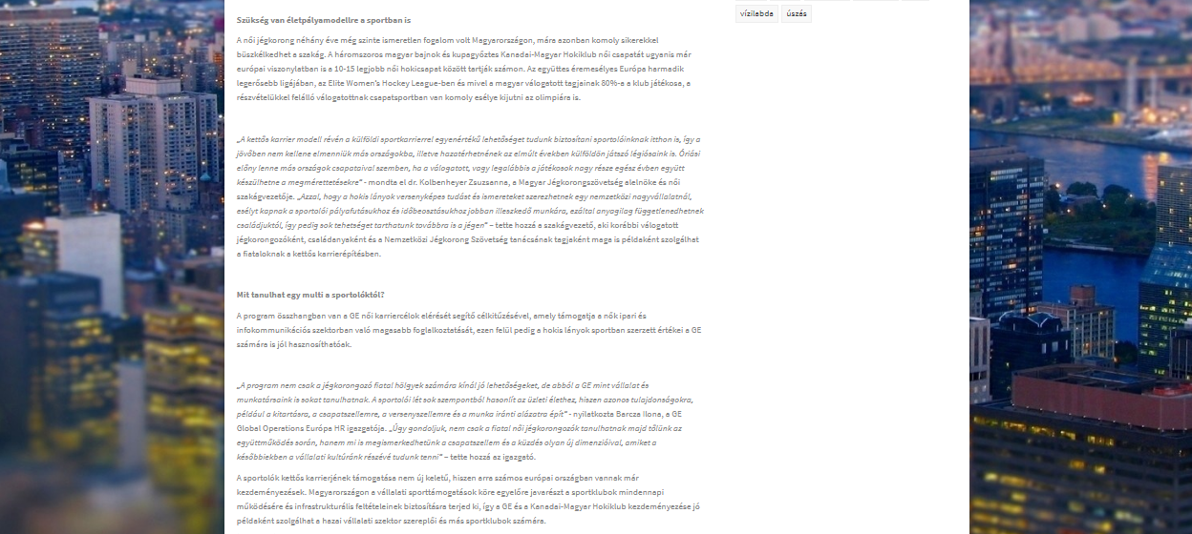

MEDIA: | Katolikus Rádió | MEDIA SPECIFICS
DATE: | 2017.07.17. | TYPE: | National Electronic
PAGE: | - | Reach: | 103 000
Ad value (EUR) | 564 | FREQUENCY: | -
HEADLINE: | Hungarian female ice hockey sport can get to the forefront
SUMMARY: | For the first time in the history of Hungarian hockey, a career model is being introduced jointly by GE, the Hungarian Ice Hockey Federation, and the Canadian-Hungarian Hockey Club. The aim of the collaboration is to help the three-time national champion ladies on the national team who play in the Elite Women’s Hockey League (EWHL) to catch up with the European leading edge of the sport while beginning to build their subsequent career paths during their active athlete years. The program clearly also benefits GE since the values and skills the girls learn on the ice will be instrumental in further developing corporate culture and competitiveness. If it proves successful as devised in Hungary, this dual career model may become the example to follow for women’s hockey teams elsewhere in the world.

http://www.katolikusradio.hu/musoraink/adas/1/433900

