Danone football cup for cHILDREN
Szeged Press release
April 25 2019.
Prepared by: Premier Hungary Communications
2019.04.25.
MÉDIA: | Szeged.hu | MEDIA SPECIFICS
DÁTE: | 23.04.2019. | TYPE: | Online
PAGE: | - | REACH: | 100 000
AD VALUE (HUF) | 300 000 | FREQUENCY: | -
HEADLINE: | Hírös ÉP’s team wins Danone Football cup semifinal in Szeged
SUMMARY: | In recent years, the proportion of overweight and obesity amongst Hungarian children has halted, but still every third child aged around 10 has some overweight. In this age however, the intake of calcium, which is responsible for the growth of bones is critically low, and the vegetable and fruit consumption is also far below the ideal amount in a quarter of all children– reveal a study made by Danone and the National Association of Hungarian Dieticians. This is why Danone launches the Danone Nations Cup for Children, the largest football cup for children aged 10-12, recognised by FIFA.

https://szeged.hu/hirek/28262/a-hiros-ep-csapata-nyerte-a-danone-focikupa-szegedi-elodontojet
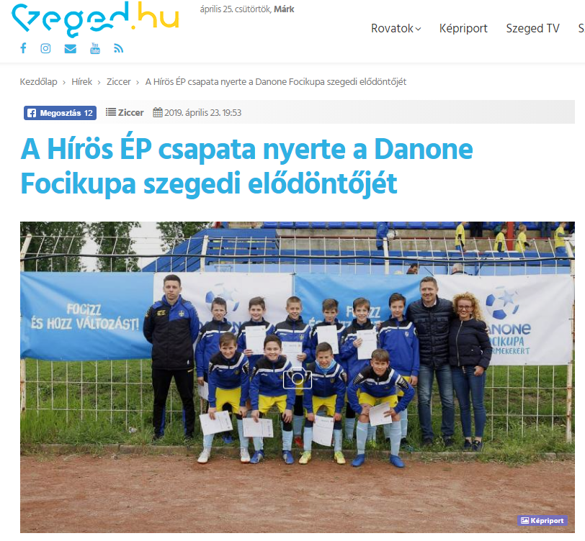

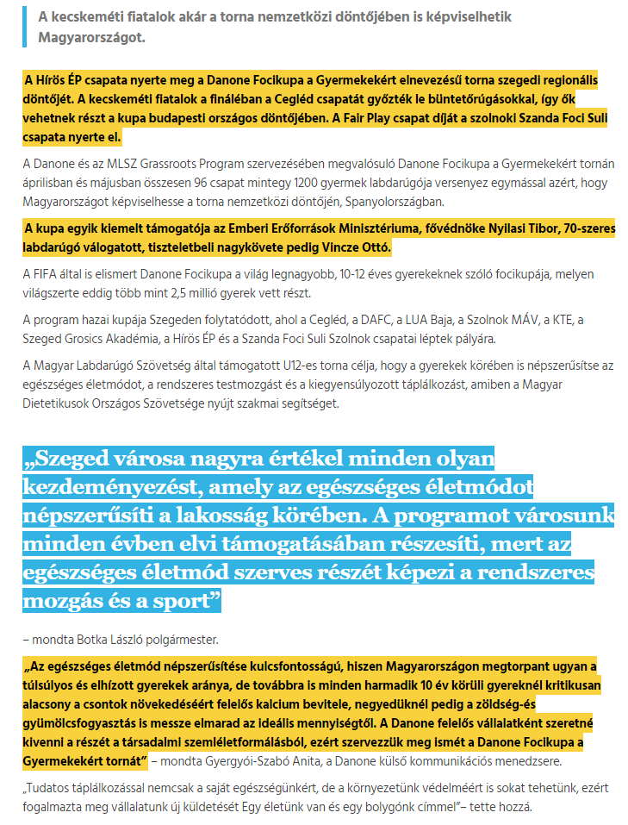

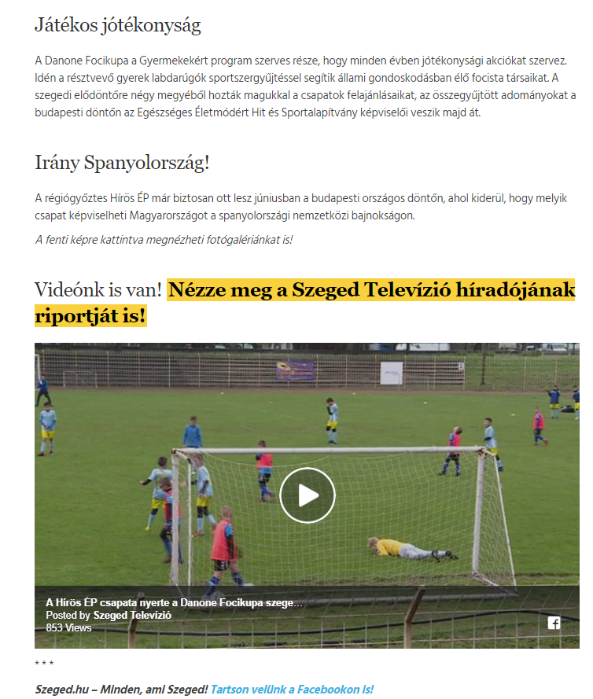

MÉDIA: | Delmagyar.hu | MEDIA SPECIFICS
DÁTE: | 23.04.2019. | TYPE: | Online
PAGE: | - | REACH: | 55 000
AD VALUE (HUF) | 419 | FREQUENCY: | -
HEADLINE: | Hírös ÉP’s team wins Danone Football cup semifinal in Szeged
SUMMARY: | In recent years, the proportion of overweight and obesity amongst Hungarian children has halted, but still every third child aged around 10 has some overweight. In this age however, the intake of calcium, which is responsible for the growth of bones is critically low, and the vegetable and fruit consumption is also far below the ideal amount in a quarter of all children– reveal a study made by Danone and the National Association of Hungarian Dieticians. This is why Danone launches the Danone Nations Cup for Children, the largest football cup for children aged 10-12, recognised by FIFA.

https://www.delmagyar.hu/sport/barcelonaert_fociznak_szegeden_8_csapat_kuzd_a_danone-kupa_selejtezojeben/2594816/
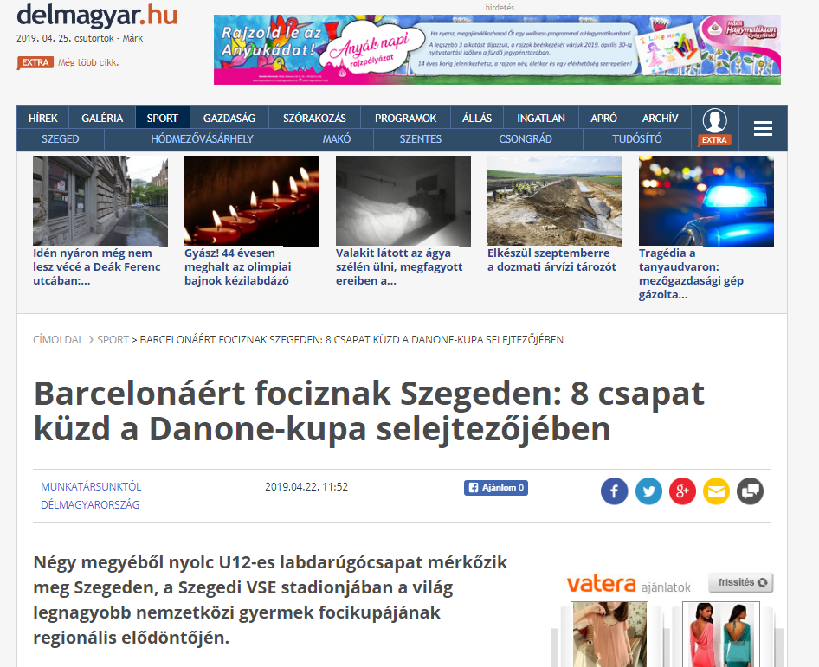

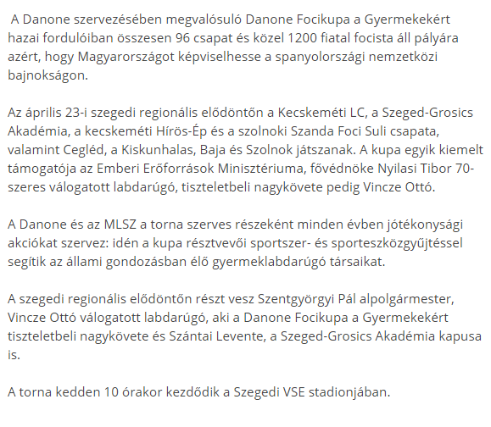

MÉDIA: | Kecskemetilapok.hu | MEDIA SPECIFICS
DÁTE: | 22.04.2019. | TYPE: | Online
PAGE: | - | REACH: | 500
AD VALUE (HUF) | 95 | FREQUENCY: | -
HEADLINE: | More than 1000 children playing football aiming to represent our nation in Spain
SUMMARY: | In recent years, the proportion of overweight and obesity amongst Hungarian children has halted, but still every third child aged around 10 has some overweight. In this age however, the intake of calcium, which is responsible for the growth of bones is critically low, and the vegetable and fruit consumption is also far below the ideal amount in a quarter of all children– reveal a study made by Danone and the National Association of Hungarian Dieticians. This is why Danone launches the Danone Nations Cup for Children, the largest football cup for children aged 10-12, recognised by FIFA.

https://kecskemetilapok.hu/labdarugas/tobb-mint-1000-gyerek-focizik-azert-hogy-hazankat-kepviselhesse-spanyolorszagban
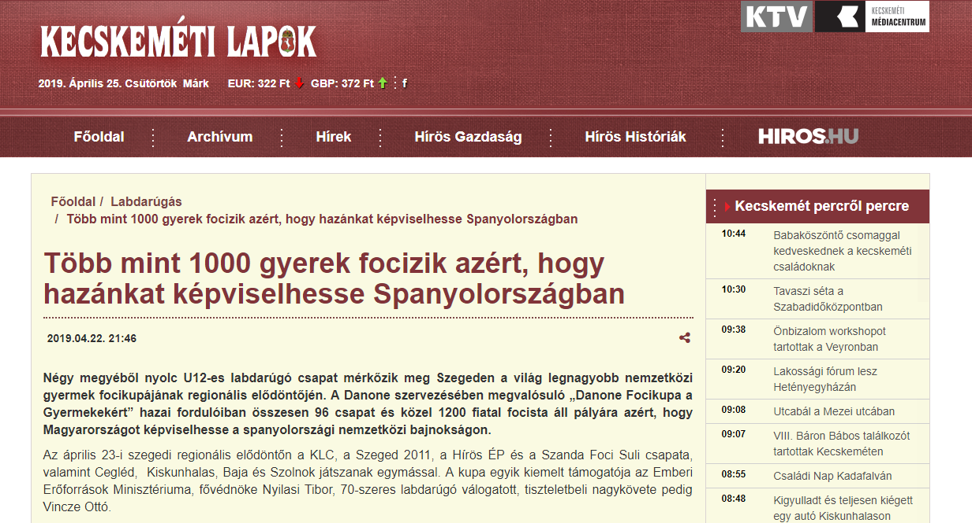

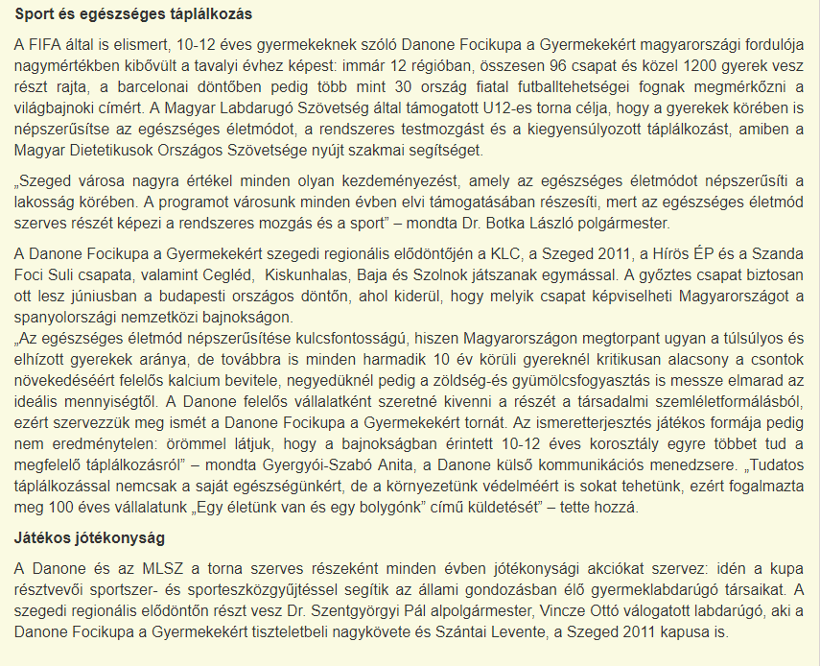

MÉDIA: | Baon.hu | MEDIA SPECIFICS
DÁTE: | 22.04.2019. | TYPE: | Online
PAGE: | - | REACH: | 41 500
AD VALUE (HUF) | 180 000 | FREQUENCY: | -
HEADLINE: | Hírös-Ép’s youngsters won the regional cup
SUMMARY: | In recent years, the proportion of overweight and obesity amongst Hungarian children has halted, but still every third child aged around 10 has some overweight. In this age however, the intake of calcium, which is responsible for the growth of bones is critically low, and the vegetable and fruit consumption is also far below the ideal amount in a quarter of all children– reveal a study made by Danone and the National Association of Hungarian Dieticians. This is why Danone launches the Danone Nations Cup for Children, the largest football cup for children aged 10-12, recognised by FIFA.

https://www.baon.hu/sport/helyi-sport/a-hiros-ep-fiataljai-nyertek-a-regionalis-tornat-1873144/
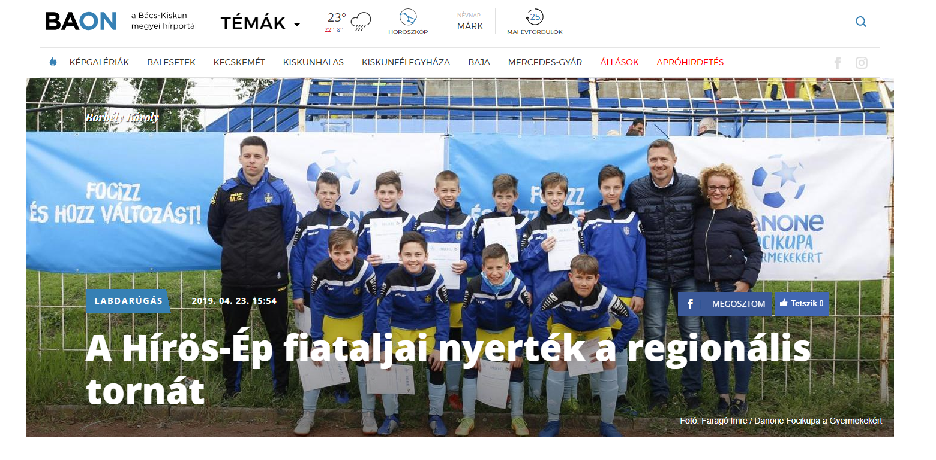

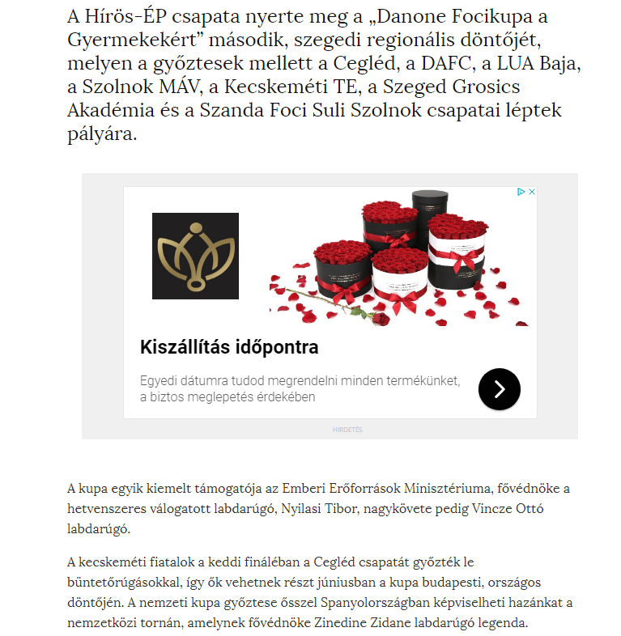

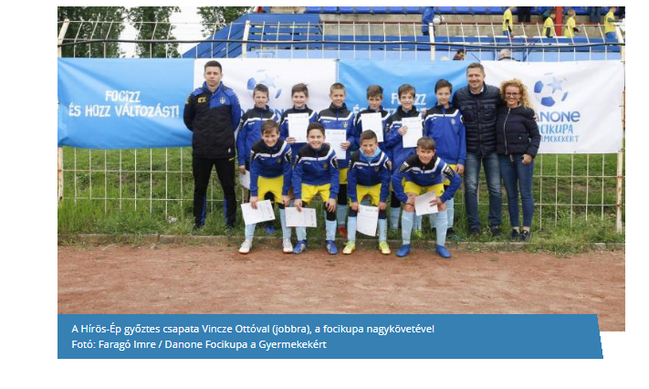

MÉDIA: | Delmagyar.hu | MEDIA SPECIFICS
DÁTE: | 23.04.2019. | TYPE: | Online
PAGE: | - | REACH: | 55 000
AD VALUE (HUF) | 419 | FREQUENCY: | -
HEADLINE: | Kecskemét’s joy at Danone Football Cup in Szeged – Szeged GA finished 3rd
SUMMARY: | In recent years, the proportion of overweight and obesity amongst Hungarian children has halted, but still every third child aged around 10 has some overweight. In this age however, the intake of calcium, which is responsible for the growth of bones is critically low, and the vegetable and fruit consumption is also far below the ideal amount in a quarter of all children– reveal a study made by Danone and the National Association of Hungarian Dieticians. This is why Danone launches the Danone Nations Cup for Children, the largest football cup for children aged 10-12, recognised by FIFA.

https://www.delmagyar.hu/sport/kecskemeti_orom_a_szegedi_danone_focikupan_-_a_szeged-ga_3_lett/2595048/
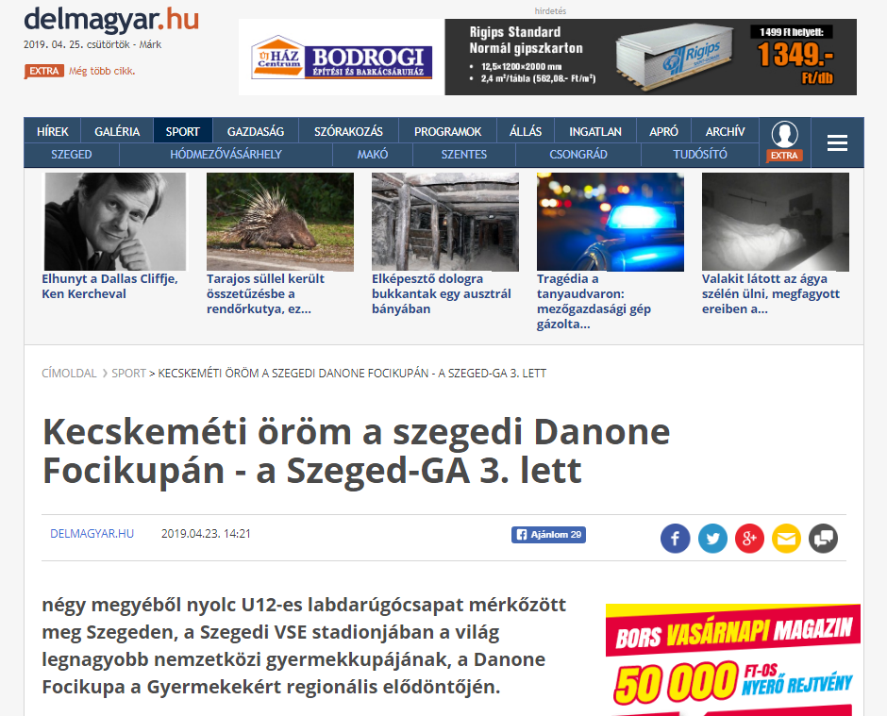

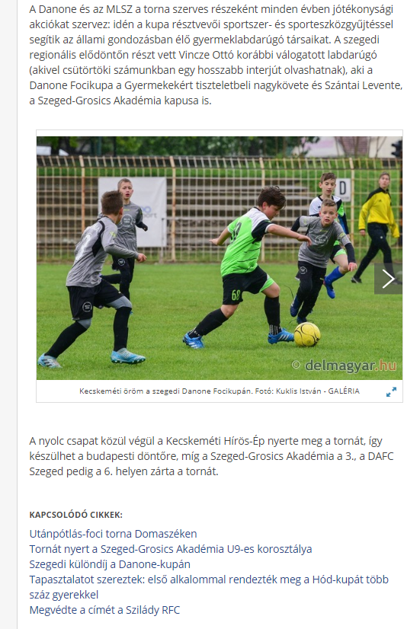

MÉDIA: | Keol.hu | MEDIA SPECIFICS
DÁTE: | 23.04.2019. | TYPE: | Online
PAGE: | - | REACH: | 40 000
AD VALUE (HUF) | 150 000 | FREQUENCY: | -
HEADLINE: | Hírös-Ép wins Danone Football Cup
SUMMARY: | In recent years, the proportion of overweight and obesity amongst Hungarian children has halted, but still every third child aged around 10 has some overweight. In this age however, the intake of calcium, which is responsible for the growth of bones is critically low, and the vegetable and fruit consumption is also far below the ideal amount in a quarter of all children– reveal a study made by Danone and the National Association of Hungarian Dieticians. This is why Danone launches the Danone Nations Cup for Children, the largest football cup for children aged 10-12, recognised by FIFA.

https://keol.hu/kecskemet-bacs/a-hiros-ep-csapata-nyerte-meg-a-danone-focikupat
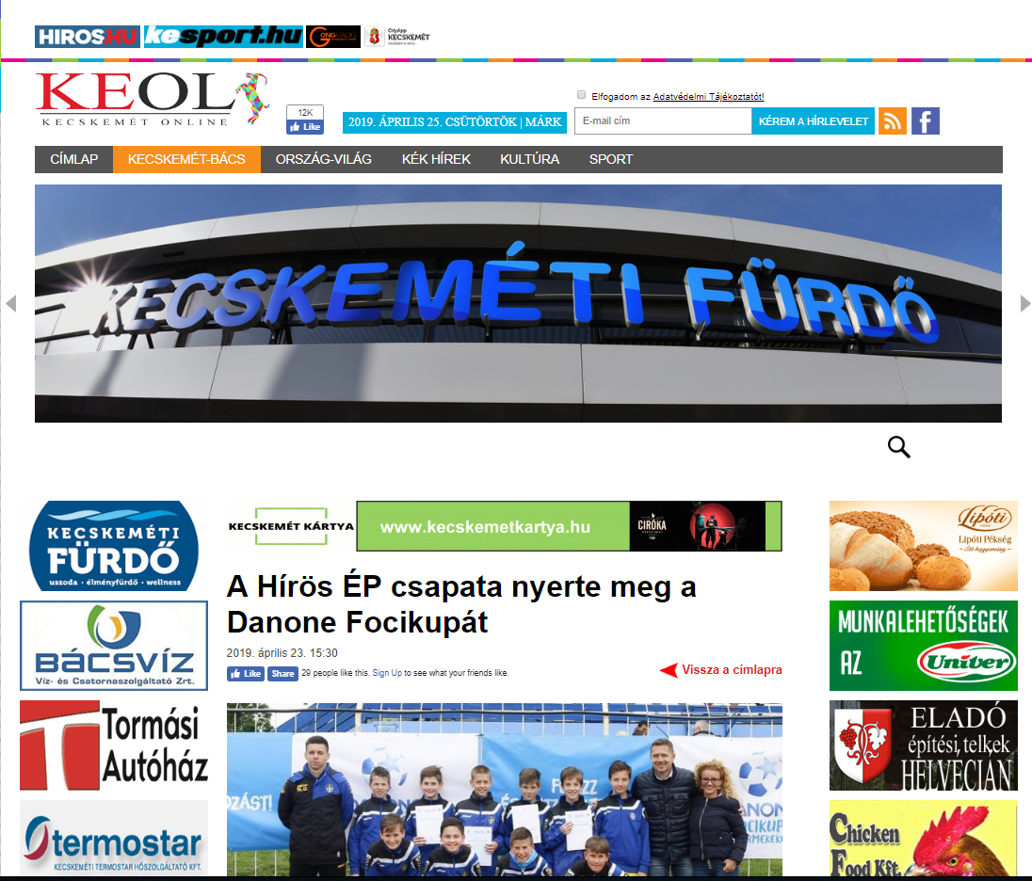

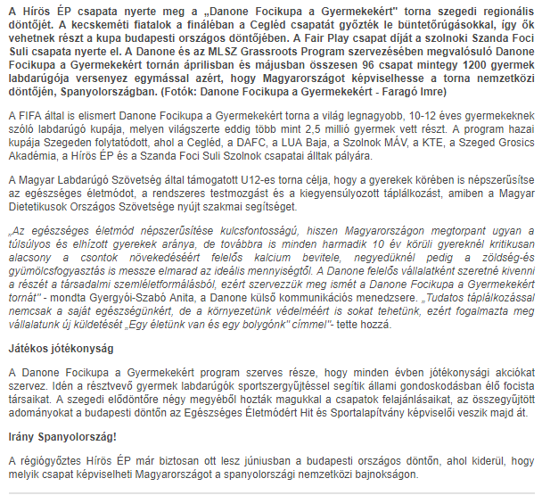

MÉDIA: | Kesport.hu | MEDIA SPECIFICS
DÁTE: | 23.04.2019. | TYPE: | Online
PAGE: | - | REACH: | 500
AD VALUE (HUF) | 30 495 | FREQUENCY: | -
HEADLINE: | Danone Football Cup for Children
SUMMARY: | In recent years, the proportion of overweight and obesity amongst Hungarian children has halted, but still every third child aged around 10 has some overweight. In this age however, the intake of calcium, which is responsible for the growth of bones is critically low, and the vegetable and fruit consumption is also far below the ideal amount in a quarter of all children– reveal a study made by Danone and the National Association of Hungarian Dieticians. This is why Danone launches the Danone Nations Cup for Children, the largest football cup for children aged 10-12, recognised by FIFA.

http://kesport.hu/2019/04/18/danone-focikupa-a-gyermekekert/
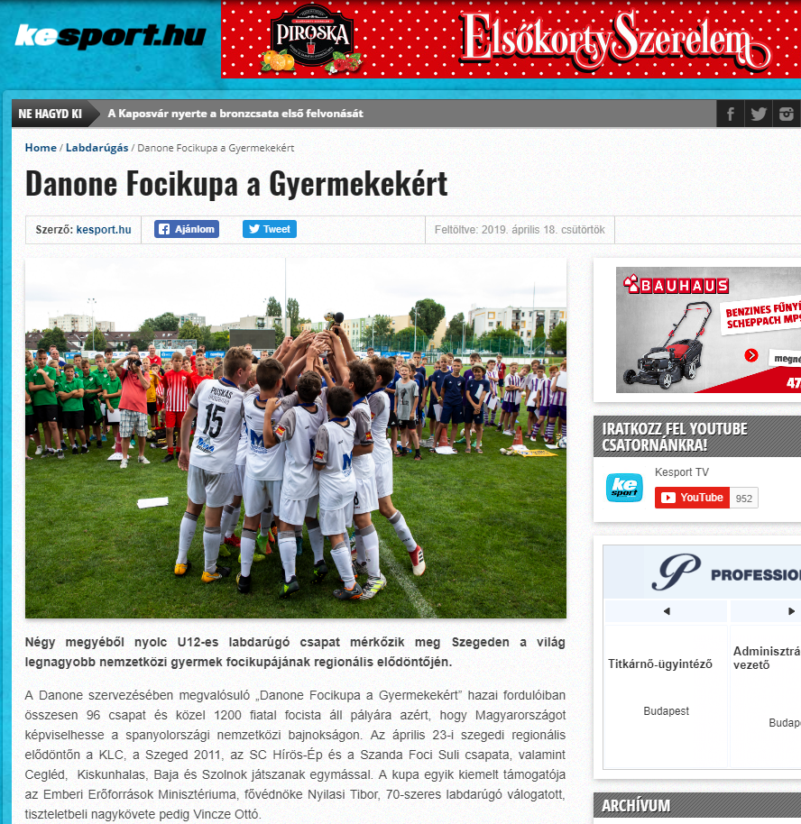
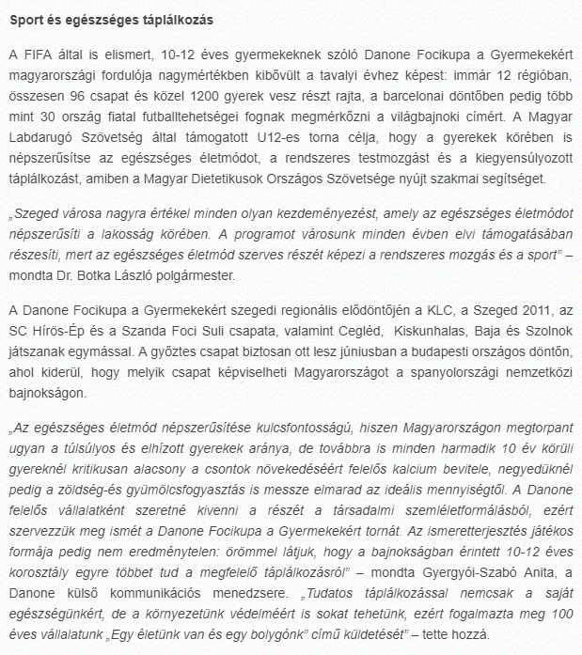

MÉDIA: | Infohodmezovasarhely.hu | MEDIA SPECIFICS
DÁTE: | 23.04.2019. | TYPE: | Online
PAGE: | - | REACH: | 500
AD VALUE (HUF) | 30 495 | FREQUENCY: | -
HEADLINE: | Danone Football Cup for Children regional semifinal
SUMMARY: | In recent years, the proportion of overweight and obesity amongst Hungarian children has halted, but still every third child aged around 10 has some overweight. In this age however, the intake of calcium, which is responsible for the growth of bones is critically low, and the vegetable and fruit consumption is also far below the ideal amount in a quarter of all children– reveal a study made by Danone and the National Association of Hungarian Dieticians. This is why Danone launches the Danone Nations Cup for Children, the largest football cup for children aged 10-12, recognised by FIFA.

http://www.infohodmezovasarhely.hu/hirek/olvas/permalink:danone-focikupa-a-gyermekekert-regionalis-elodonto-2019-04-23-134053
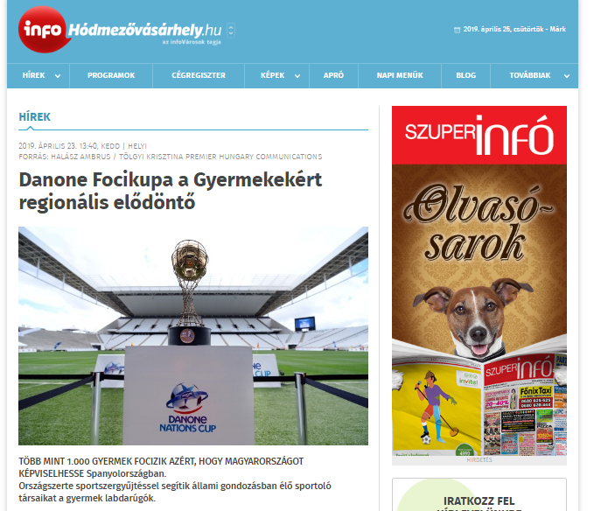
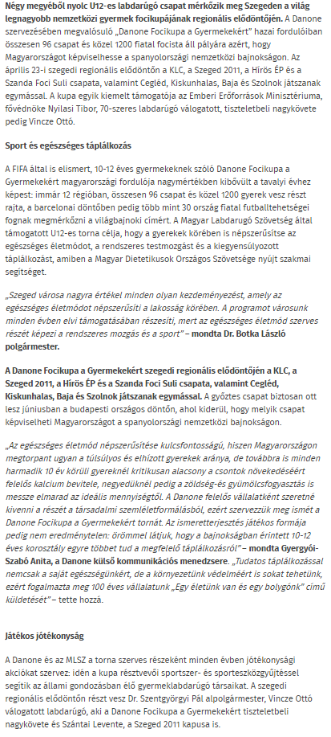
MÉDIA: | Hiros.hu | MEDIA SPECIFICS
DÁTE: | 23.04.2019. | TYPE: | Online
PAGE: | - | REACH: | 500
AD VALUE (HUF) | 30 495 | FREQUENCY: | -
HEADLINE: | Hírös ÉP’s team wins Danone Football cup semifinal in Szeged
SUMMARY: | In recent years, the proportion of overweight and obesity amongst Hungarian children has halted, but still every third child aged around 10 has some overweight. In this age however, the intake of calcium, which is responsible for the growth of bones is critically low, and the vegetable and fruit consumption is also far below the ideal amount in a quarter of all children– reveal a study made by Danone and the National Association of Hungarian Dieticians. This is why Danone launches the Danone Nations Cup for Children, the largest football cup for children aged 10-12, recognised by FIFA.

https://hiros.hu/sport/labdarugas/a-hiros-ep-nyerte-a-danone-focikupa-szegedi-elodontojet
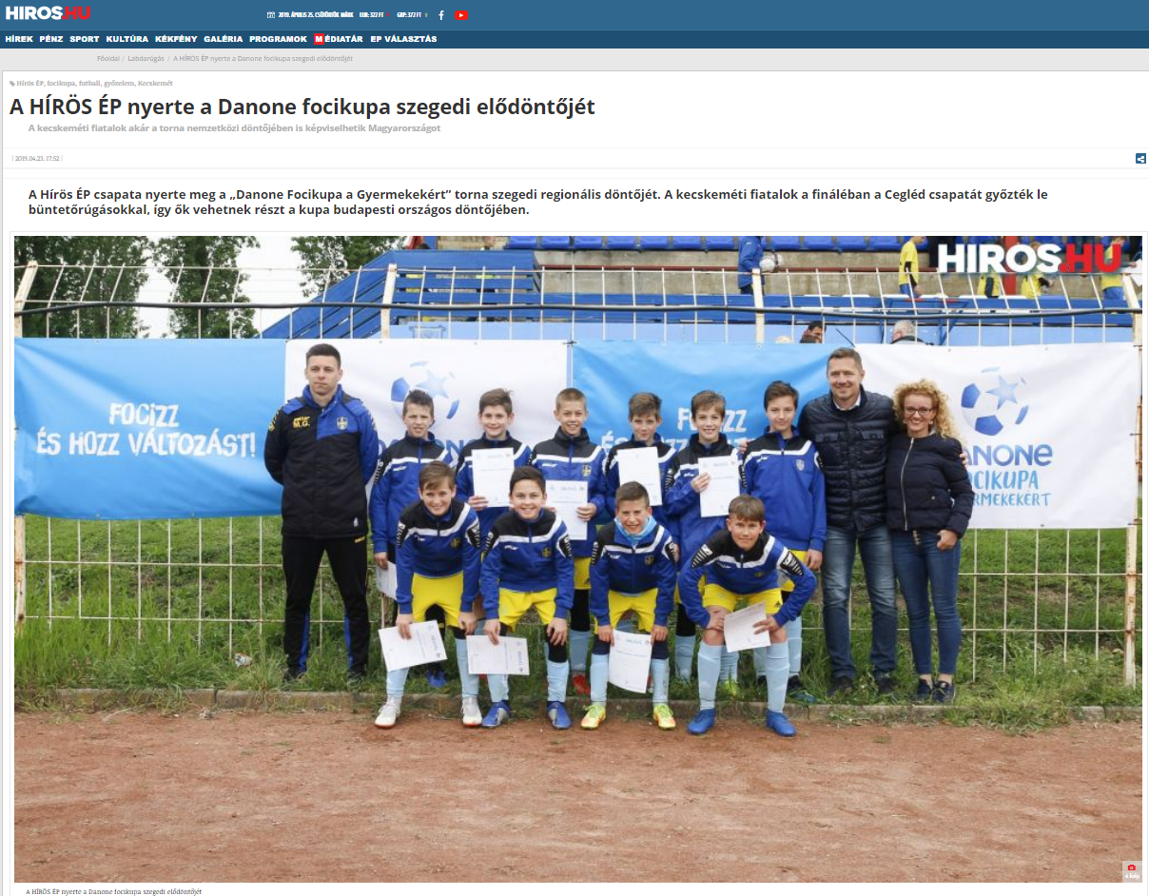

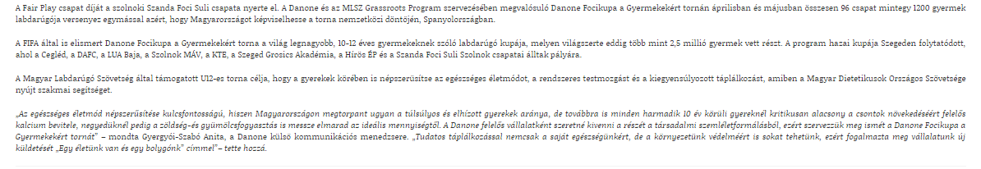

MÉDIA: | allevents.hu | MEDIA SPECIFICS
DÁTE: | 23.04.2019. | TYPE: | Online
PAGE: | - | REACH: | 500
AD VALUE (HUF) | 31 137 | FREQUENCY: | -
HEADLINE: | Regional semifinal - Szeged
SUMMARY: | In recent years, the proportion of overweight and obesity amongst Hungarian children has halted, but still every third child aged around 10 has some overweight. In this age however, the intake of calcium, which is responsible for the growth of bones is critically low, and the vegetable and fruit consumption is also far below the ideal amount in a quarter of all children– reveal a study made by Danone and the National Association of Hungarian Dieticians. This is why Danone launches the Danone Nations Cup for Children, the largest football cup for children aged 10-12, recognised by FIFA.

https://allevents.in/szeged/region%C3%A1lis-el%C5%91d%C3%B6nt%C5%91-szeged/200017117496250
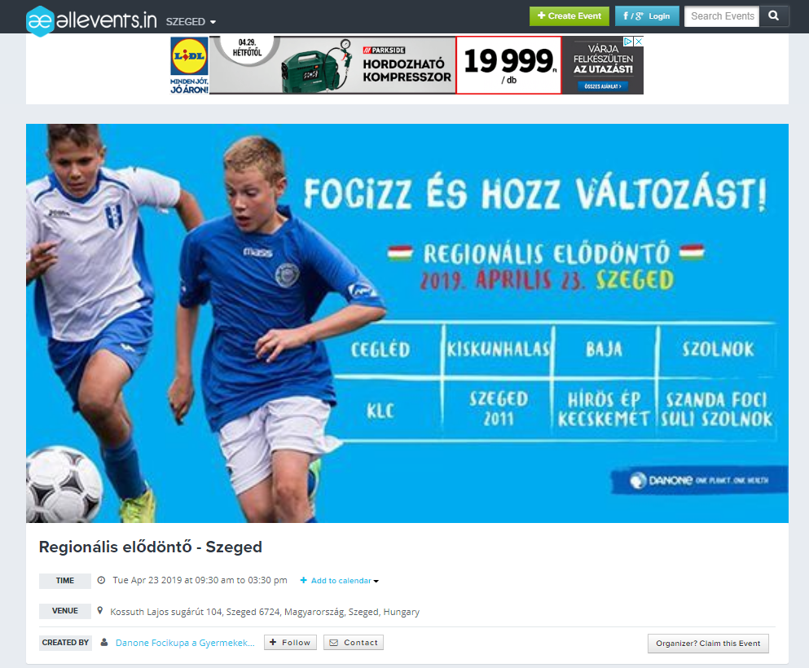

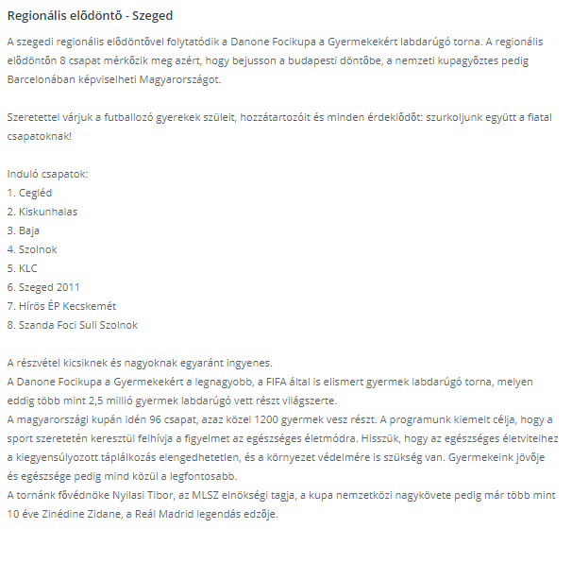

MÉDIA: | Bacsmegye.hu | MEDIA SPECIFICS
DÁTE: | 23.04.2019. | TYPE: | Online
PAGE: | - | REACH: | 500
AD VALUE (HUF) | 31 137 | FREQUENCY: | -
HEADLINE: | Hírös ÉP’s team wins Danone Football cup semifinal in Szeged
SUMMARY: | In recent years, the proportion of overweight and obesity amongst Hungarian children has halted, but still every third child aged around 10 has some overweight. In this age however, the intake of calcium, which is responsible for the growth of bones is critically low, and the vegetable and fruit consumption is also far below the ideal amount in a quarter of all children– reveal a study made by Danone and the National Association of Hungarian Dieticians. This is why Danone launches the Danone Nations Cup for Children, the largest football cup for children aged 10-12, recognised by FIFA.

https://bacsmegye.hu/kecskemet/2019/04/a-kecskemeti-hiros-ep-csapata-nyerte-a-danone-focikupa-szegedi-regionalis-dontojet
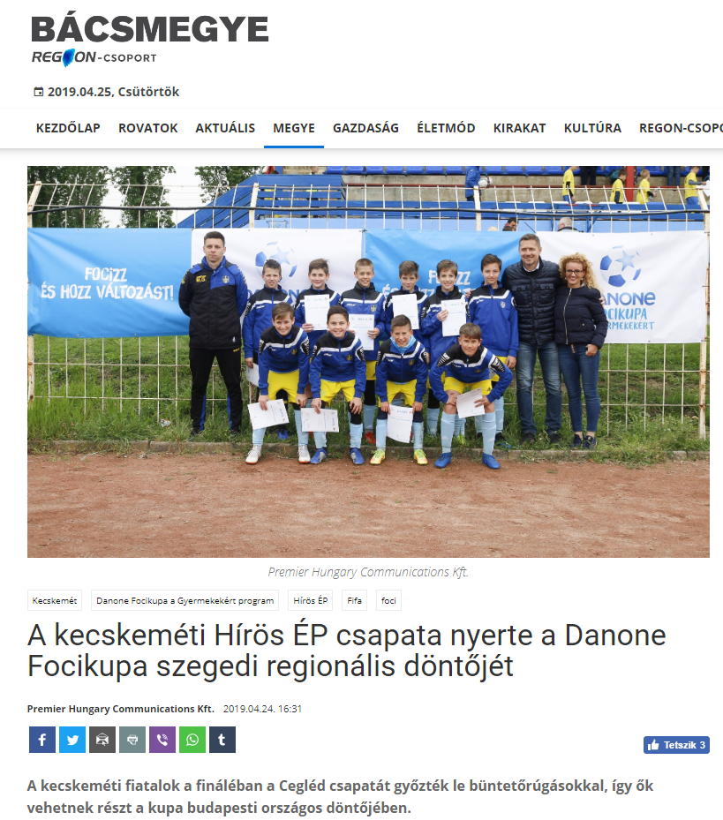

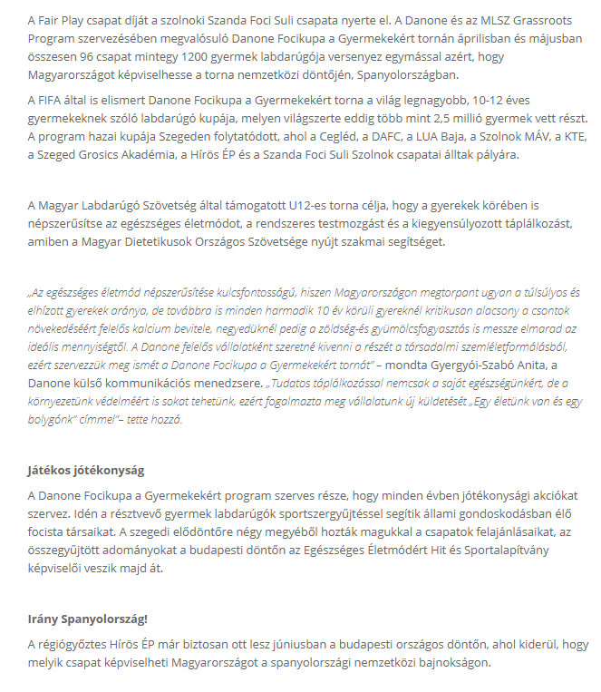

MÉDIA: | Délmagyarország | MEDIA SPECIFICS
DÁTE: | 20.04.2019. | TYPE: | Print
PAGE: | 20 | REACH: | 101 412
AD VALUE (HUF) | 180 000 | FREQUENCY: | -
HEADLINE: | Playing football in Szeged aiming to go to Barcelona
SUMMARY: | In recent years, the proportion of overweight and obesity amongst Hungarian children has halted, but still every third child aged around 10 has some overweight. In this age however, the intake of calcium, which is responsible for the growth of bones is critically low, and the vegetable and fruit consumption is also far below the ideal amount in a quarter of all children– reveal a study made by Danone and the National Association of Hungarian Dieticians. This is why Danone launches the Danone Nations Cup for Children, the largest football cup for children aged 10-12, recognised by FIFA.
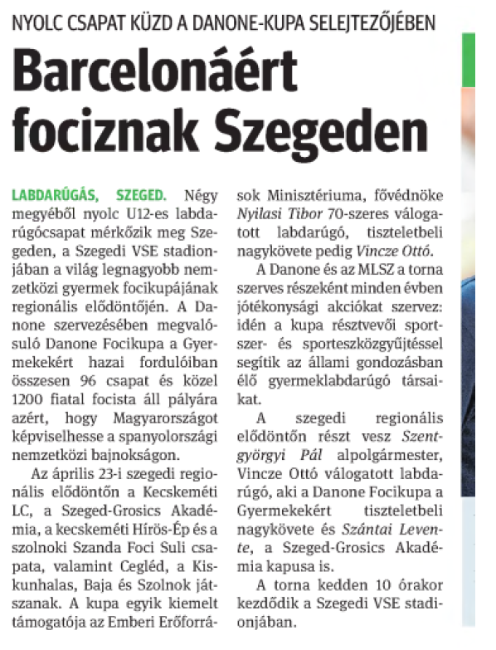
MÉDIA: | Délmagyarország | MEDIA SPECIFICS
DÁTE: | 24.04.2019. | TYPE: | Print
PAGE: | 14 | REACH: | 101 412
AD VALUE (HUF) | 180 000 | FREQUENCY: | -
HEADLINE: | Playing football in Szeged aiming to go to Barcelona
SUMMARY: | In recent years, the proportion of overweight and obesity amongst Hungarian children has halted, but still every third child aged around 10 has some overweight. In this age however, the intake of calcium, which is responsible for the growth of bones is critically low, and the vegetable and fruit consumption is also far below the ideal amount in a quarter of all children– reveal a study made by Danone and the National Association of Hungarian Dieticians. This is why Danone launches the Danone Nations Cup for Children, the largest football cup for children aged 10-12, recognised by FIFA.

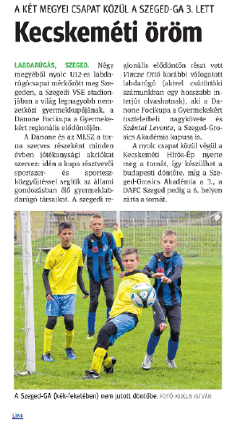

MÉDIA: | Vkla.hu | MEDIA SPECIFICS
DÁTE: | 20.04.2019. | TYPE: | Online
PAGE: | - | REACH: | 500
AD VALUE (HUF) | 30 495 | FREQUENCY: | -
HEADLINE: | Vasas Kubala’s U12 team also gets in fight at Danone Football Cup
SUMMARY: | In recent years, the proportion of overweight and obesity amongst Hungarian children has halted, but still every third child aged around 10 has some overweight. In this age however, the intake of calcium, which is responsible for the growth of bones is critically low, and the vegetable and fruit consumption is also far below the ideal amount in a quarter of all children– reveal a study made by Danone and the National Association of Hungarian Dieticians. This is why Danone launches the Danone Nations Cup for Children, the largest football cup for children aged 10-12, recognised by FIFA.

http://www.vkla.hu/a-2019-es-danone-focikupan-a-vasas-kubala-akademia-u12-es-korosztalya-is-harcba-szall
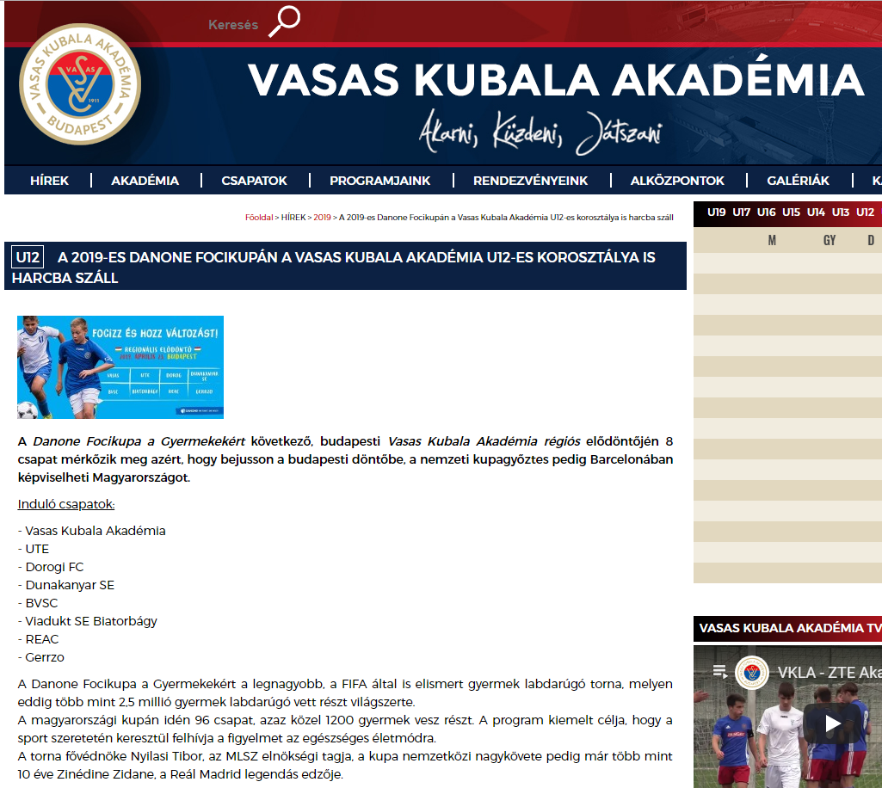
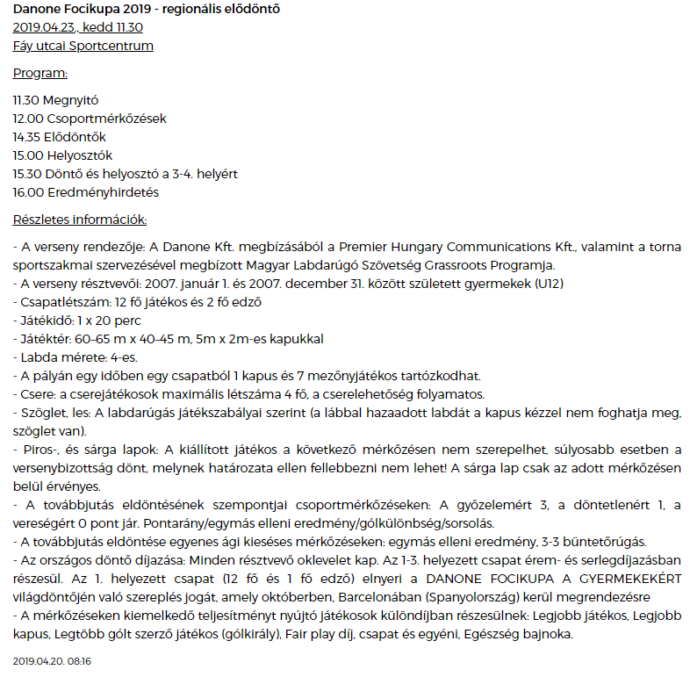

MÉDIA: | Schirosep.hu | MEDIA SPECIFICS
DÁTE: | 23.04.2019. | TYPE: | Online
PAGE: | - | REACH: | 500
AD VALUE (HUF) | 31 137 | FREQUENCY: | -
HEADLINE: | We won the semifinal of Danone Football Cup
SUMMARY: | In recent years, the proportion of overweight and obesity amongst Hungarian children has halted, but still every third child aged around 10 has some overweight. In this age however, the intake of calcium, which is responsible for the growth of bones is critically low, and the vegetable and fruit consumption is also far below the ideal amount in a quarter of all children– reveal a study made by Danone and the National Association of Hungarian Dieticians. This is why Danone launches the Danone Nations Cup for Children, the largest football cup for children aged 10-12, recognised by FIFA.

https://schirosep.hu/hirek/utanpotlas-kecskemet/irany-a-donto
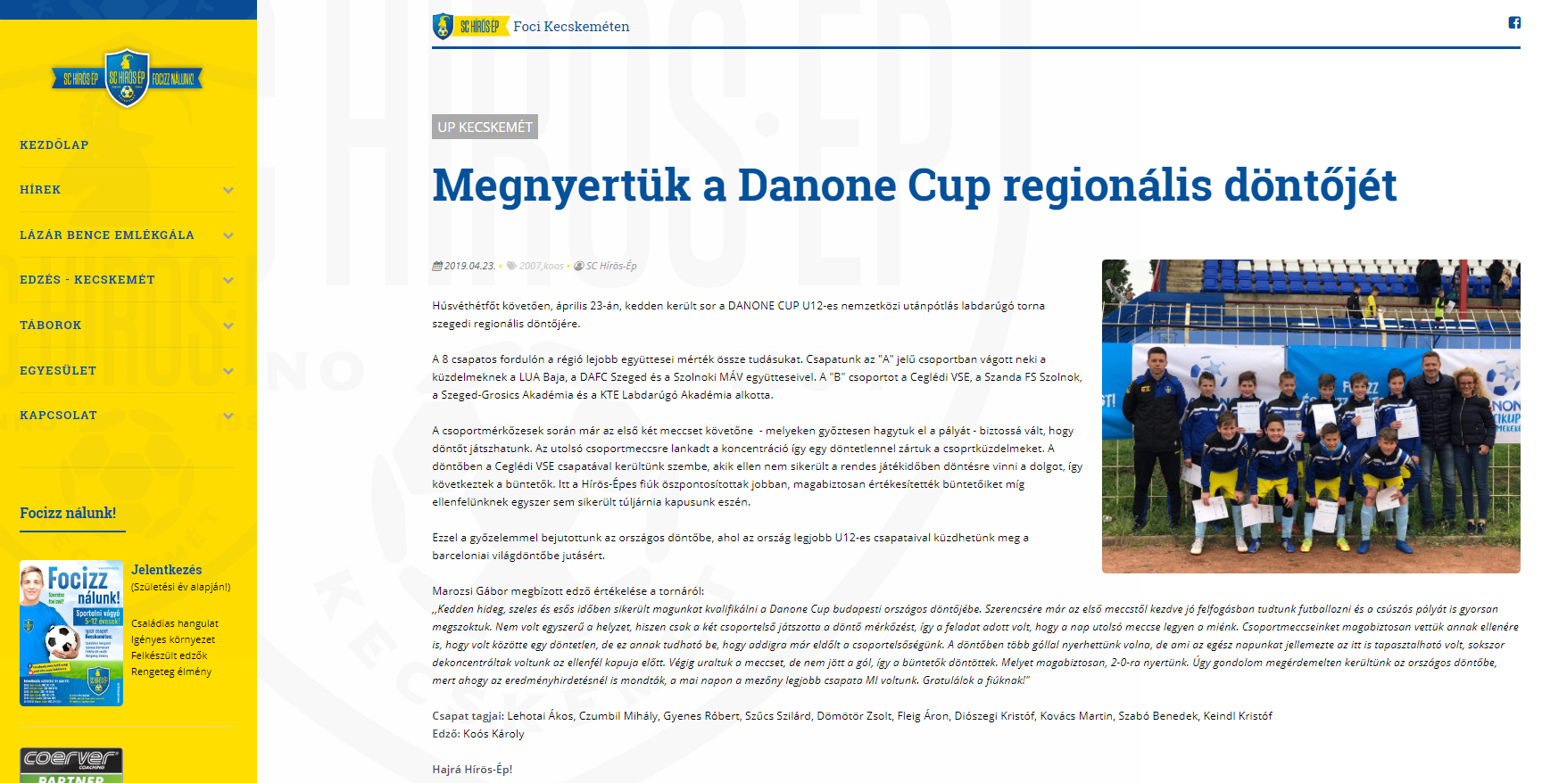

MÉDIA: | Kteakademia.hu | MEDIA SPECIFICS
DÁTE: | 20.04.2019. | TYPE: | Online
PAGE: | - | REACH: | 500
AD VALUE (HUF) | 31 137 | FREQUENCY: | -
HEADLINE: | Danone Cup happens with charity donation
SUMMARY: | In recent years, the proportion of overweight and obesity amongst Hungarian children has halted, but still every third child aged around 10 has some overweight. In this age however, the intake of calcium, which is responsible for the growth of bones is critically low, and the vegetable and fruit consumption is also far below the ideal amount in a quarter of all children– reveal a study made by Danone and the National Association of Hungarian Dieticians. This is why Danone launches the Danone Nations Cup for Children, the largest football cup for children aged 10-12, recognised by FIFA.

https://kteakademia.hu/hirek/hireink/jotekonysagi-gyujtessel-zajlik-iden-a-danone-kupa
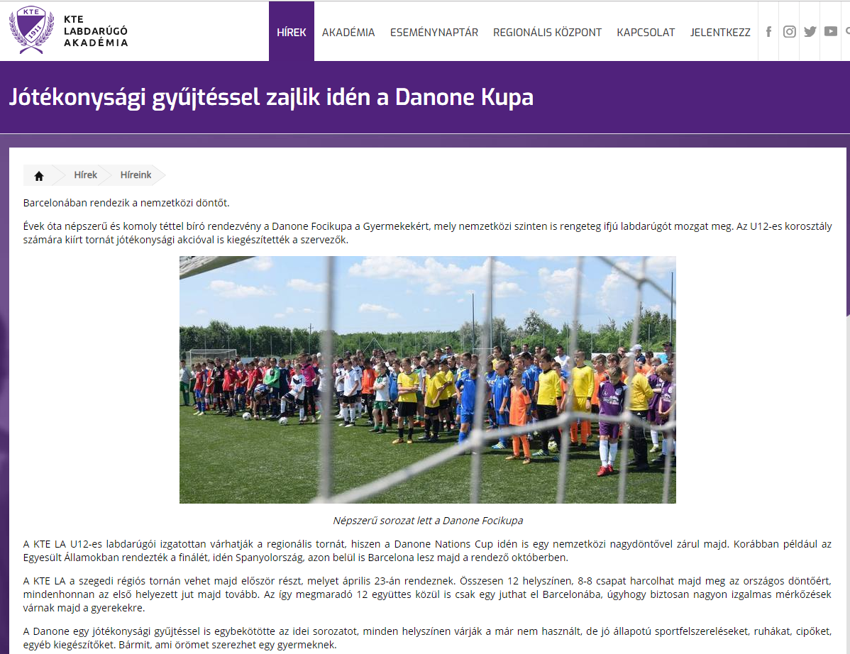

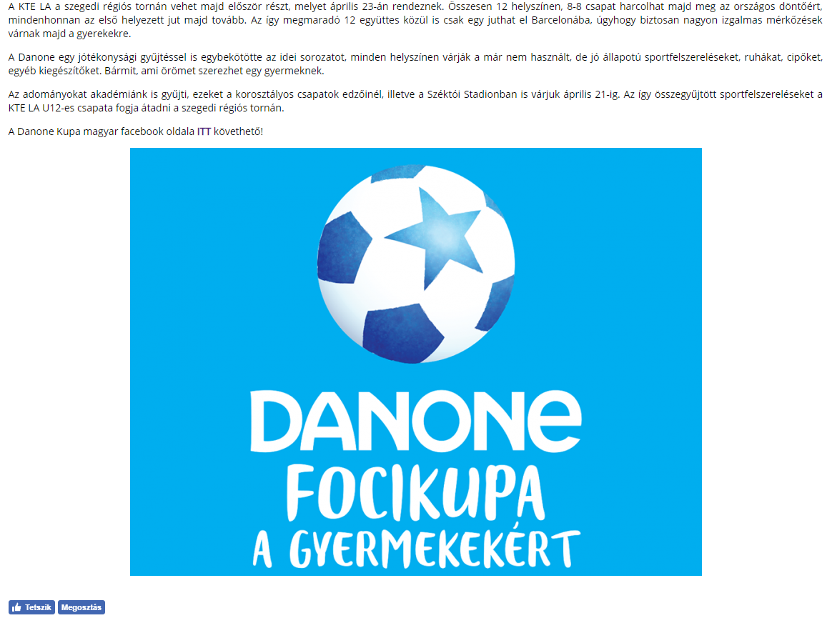

MÉDIA: | Delmagyar.hu | MEDIA SPECIFICS
DÁTE: | 25.04.2019. | TYPE: | Online
PAGE: | - | REACH: | 55 000
AD VALUE (HUF) | 419 | FREQUENCY: | -
HEADLINE: | Interview with Ottó Vincze
SUMMARY: | In recent years, the proportion of overweight and obesity amongst Hungarian children has halted, but still every third child aged around 10 has some overweight. In this age however, the intake of calcium, which is responsible for the growth of bones is critically low, and the vegetable and fruit consumption is also far below the ideal amount in a quarter of all children– reveal a study made by Danone and the National Association of Hungarian Dieticians. This is why Danone launches the Danone Nations Cup for Children, the largest football cup for children aged 10-12, recognised by FIFA.

https://www.delmagyar.hu/sport/ikarusszal_skandinaviaban_-_vincze_ottonak_tobb_szegeddel_kapcsolatos_elmenye_maradt_meg/2595228/?utm_source=hirkereso&utm_medium=feed&utm_campaign=hirkereso
