Danone football cup for cHILDREN
Regional Press releases
April 10 2019.
Prepared by: Premier Hungary Communications
2019.04.11.
MÉDIA: | duol.hu | MEDIA SPECIFICS
DÁTE: | 10.04.2019. | TYPE: | Online
PAGE: | - | REACH: | 100 000
AD VALUE (HUF) | 300 000 | FREQUENCY: | -
HEADLINE: | Danone Nations Cup: The national finals will be at stake
SUMMARY: | In recent years, the proportion of overweight and obesity amongst Hungarian children has halted, but still every third child aged around 10 has some overweight. In this age however, the intake of calcium, which is responsible for the growth of bones is critically low, and the vegetable and fruit consumption is also far below the ideal amount in a quarter of all children– reveal a study made by Danone and the National Association of Hungarian Dieticians. This is why Danone launches the Danone Nations Cup for Children, the largest football cup for children aged 10-12, recognised by FIFA.

https://www.duol.hu/sport/helyi-sport/az-orszagos-dontobe-jutas-lesz-a-tet-2762419/

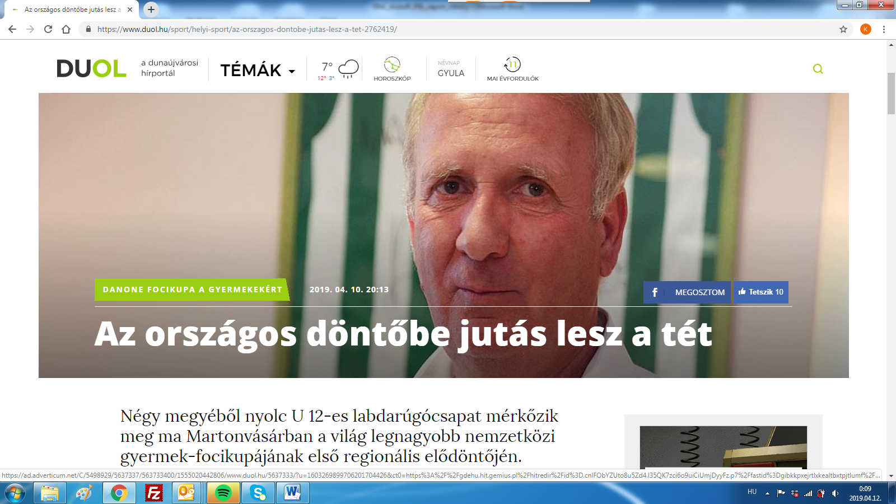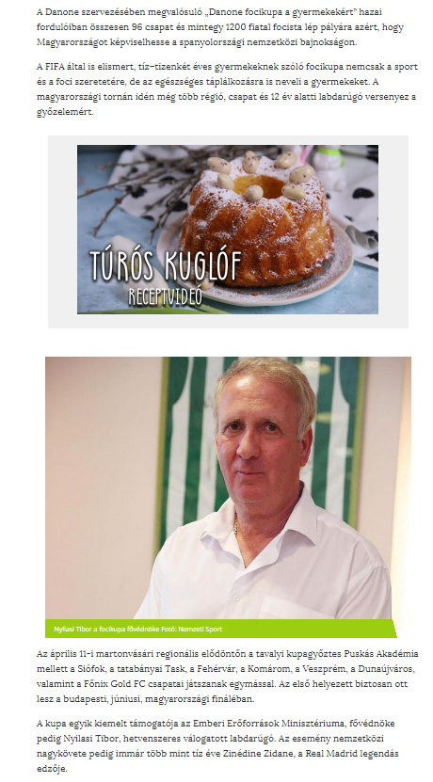

MEDIA: | pfla.hu | MEDIA SPECIFICS
DÁTE: | 12.04.2019. | TYPE: | online
PAGE: | - | REACH: | 7000
AD VALUE (HUF) | 15 000 | FREQUENCY: | -
HEADLINE: | Successful semi-final
SUMMARY: | In recent years, the proportion of overweight and obesity amongst Hungarian children has halted, but still every third child aged around 10 has some overweight. In this age however, the intake of calcium, which is responsible for the growth of bones is critically low, and the vegetable and fruit consumption is also far below the ideal amount in a quarter of all children– reveal a study made by Danone and the National Association of Hungarian Dieticians. This is why Danone launches the Danone Nations Cup for Children, the largest football cup for children aged 10-12, recognised by FIFA.

https://www.pfla.hu/?q=news/9274
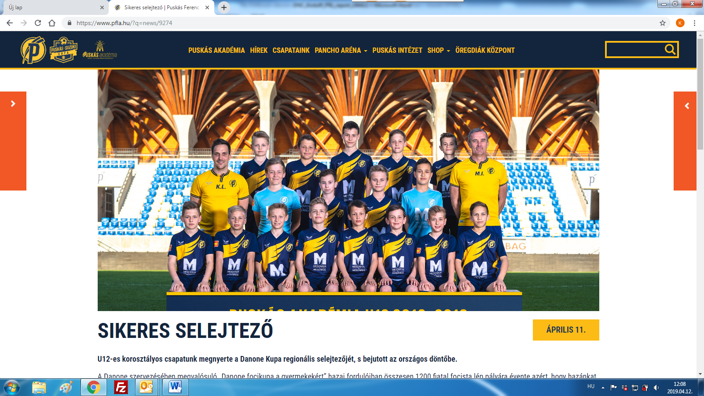

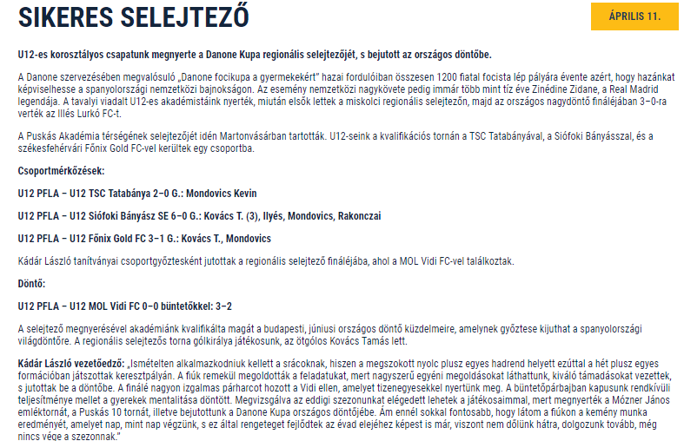

MEDIA: | feol.hu | MEDIA SPECIFICS
DÁTE: | 12.04.2019. | TYPE: | online
PAGE: | - | REACH: | 200 000
AD VALUE (HUF) | 500 000 | FREQUENCY: | -
HEADLINE: | Hispania is the aim for the youngsters of Felcsút
SUMMARY: | In recent years, the proportion of overweight and obesity amongst Hungarian children has halted, but still every third child aged around 10 has some overweight. In this age however, the intake of calcium, which is responsible for the growth of bones is critically low, and the vegetable and fruit consumption is also far below the ideal amount in a quarter of all children– reveal a study made by Danone and the National Association of Hungarian Dieticians. This is why Danone launches the Danone Nations Cup for Children, the largest football cup for children aged 10-12, recognised by FIFA.

https://www.feol.hu/sport/helyi-sport/hispania-a-felcsuti-fiatalok-celja-2970028/

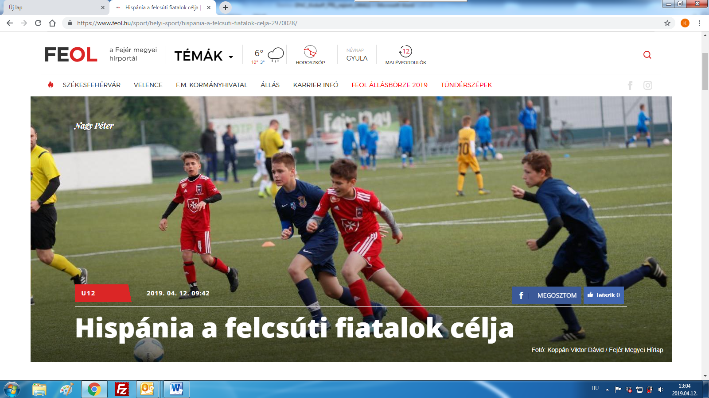

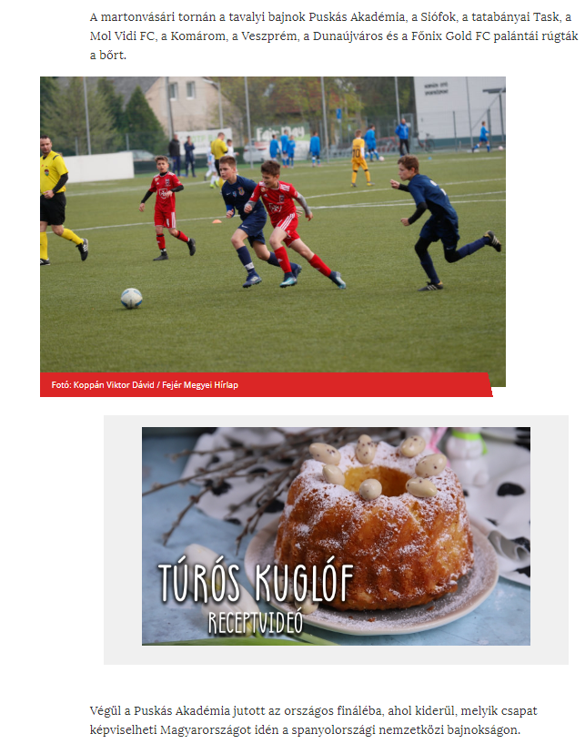

MEDIA: | Dunaújvárosi Hírlap | MEDIA SPECIFICS
DÁTE: | 11.04.2019. | TYPE: | Print
PAGE: | 16 | REACH: | 16 800
AD VALUE (HUF) | 159 | FREQUENCY: | -
HEADLINE: | Going to the national final is at stake
SUMMARY: | In recent years, the proportion of overweight and obesity amongst Hungarian children has halted, but still every third child aged around 10 has some overweight. In this age however, the intake of calcium, which is responsible for the growth of bones is critically low, and the vegetable and fruit consumption is also far below the ideal amount in a quarter of all children– reveal a study made by Danone and the National Association of Hungarian Dieticians. This is why Danone launches the Danone Nations Cup for Children, the largest football cup for children aged 10-12, recognised by FIFA.

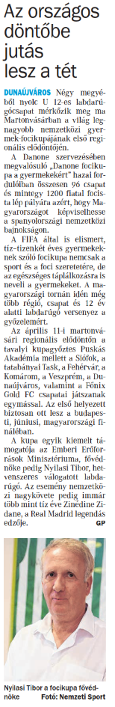
MEDIA: | Dunaújvárosi Hírlap | MEDIA SPECIFICS
DÁTE: | 12.04.2019. | TYPE: | Print
PAGE: | 11 | REACH: | 16 800
AD VALUE (HUF) | 159 | FREQUENCY: | -
HEADLINE: | DPASE team finished sixth
SUMMARY: | In recent years, the proportion of overweight and obesity amongst Hungarian children has halted, but still every third child aged around 10 has some overweight. In this age however, the intake of calcium, which is responsible for the growth of bones is critically low, and the vegetable and fruit consumption is also far below the ideal amount in a quarter of all children– reveal a study made by Danone and the National Association of Hungarian Dieticians. This is why Danone launches the Danone Nations Cup for Children, the largest football cup for children aged 10-12, recognised by FIFA.

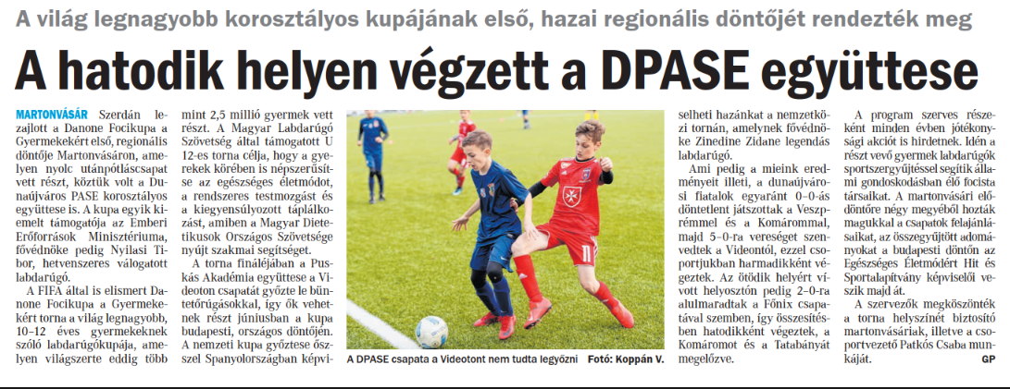

MEDIA: | Duol.hu | MEDIA SPECIFICS
DÁTE: | 11.04.2019. | TYPE: | Online
PAGE: | - | REACH: | 100 000
AD VALUE (HUF) | 300 000 | FREQUENCY: | -
HEADLINE: | Going to the national final is at stake
SUMMARY: | In recent years, the proportion of overweight and obesity amongst Hungarian children has halted, but still every third child aged around 10 has some overweight. In this age however, the intake of calcium, which is responsible for the growth of bones is critically low, and the vegetable and fruit consumption is also far below the ideal amount in a quarter of all children– reveal a study made by Danone and the National Association of Hungarian Dieticians. This is why Danone launches the Danone Nations Cup for Children, the largest football cup for children aged 10-12, recognised by FIFA.

https://www.duol.hu/sport/helyi-sport/a-hatodik-helyen-vegzett-a-dpase-egyuttese-2765116/
