Danone football cup for cHILDREN
Kick-of Press release
April 10 2019.
Prepared by: Premier Hungary Communications
2019.04.11.
MÉDIA: | pharmaonline.hu | MEDIA SPECIFICS
DÁTE: | 10.04.2019. | TYPE: | Online
PAGE: | - | REACH: | 42.000
AD VALUE (HUF) | 198.000 | FREQUENCY: | -
HEADLINE: | Calcium intake of school children is critically low
SUMMARY: | In recent years, the proportion of overweight and obesity amongst Hungarian children has halted, but still every third child aged around 10 has some overweight. In this age however, the intake of calcium, which is responsible for the growth of bones is critically low, and the vegetable and fruit consumption is also far below the ideal amount in a quarter of all children– reveal a study made by Danone and the National Association of Hungarian Dieticians. This is why Danone launches the Danone Nations Cup for Children, the largest football cup for children aged 10-12, recognised by FIFA.

http://pharmaonline.hu/gyogyszereszi_gondozas/cikk/kritikusan_alacsony_a_kisiskolasok_kalciumbevitele

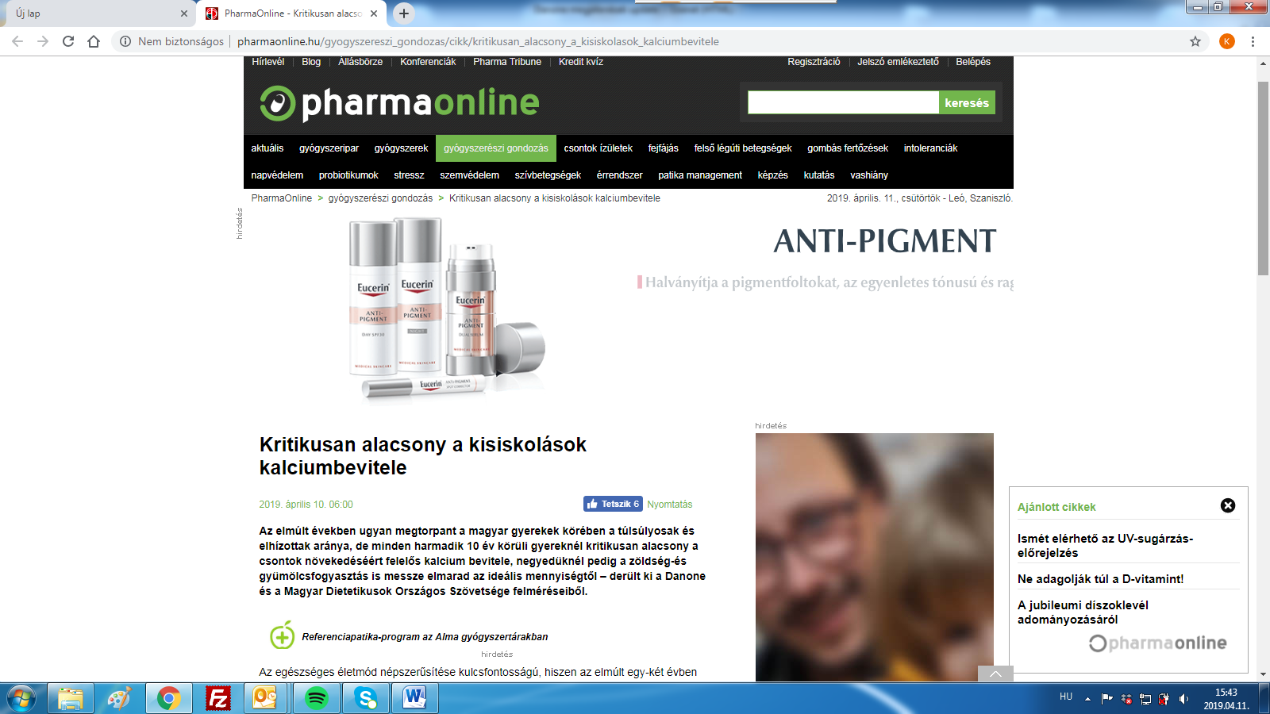

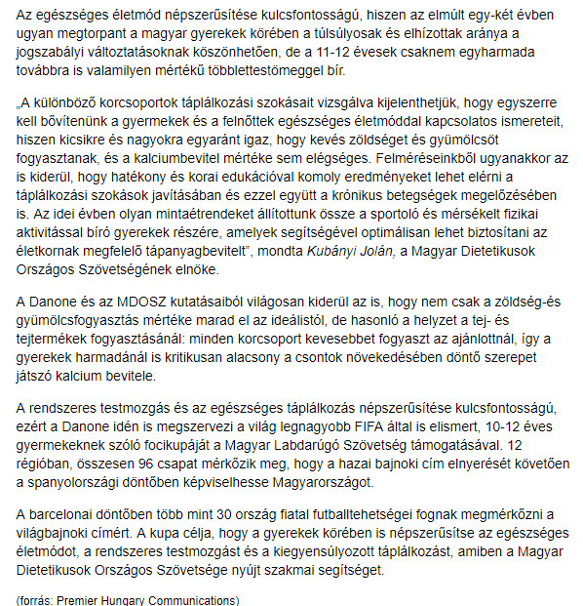

MÉDIA: | napidoktor.hu | MEDIA SPECIFICS
DÁTE: | 10.04.2019. | TYPE: | Online
PAGE: | - | REACH: | 109 000
AD VALUE (HUF) | 600.000 | FREQUENCY: | -
HEADLINE: | Calcium intake of every third school child is critically low
SUMMARY: | In recent years, the proportion of overweight and obesity amongst Hungarian children has halted, but still every third child aged around 10 has some overweight. In this age however, the intake of calcium, which is responsible for the growth of bones is critically low, and the vegetable and fruit consumption is also far below the ideal amount in a quarter of all children– reveal a study made by Danone and the National Association of Hungarian Dieticians. This is why Danone launches the Danone Nations Cup for Children, the largest football cup for children aged 10-12, recognised by FIFA.

https://napidoktor.hu/iskolataska/kritikusan-alacsony-a-kisiskolasok-kalciumbevitele/

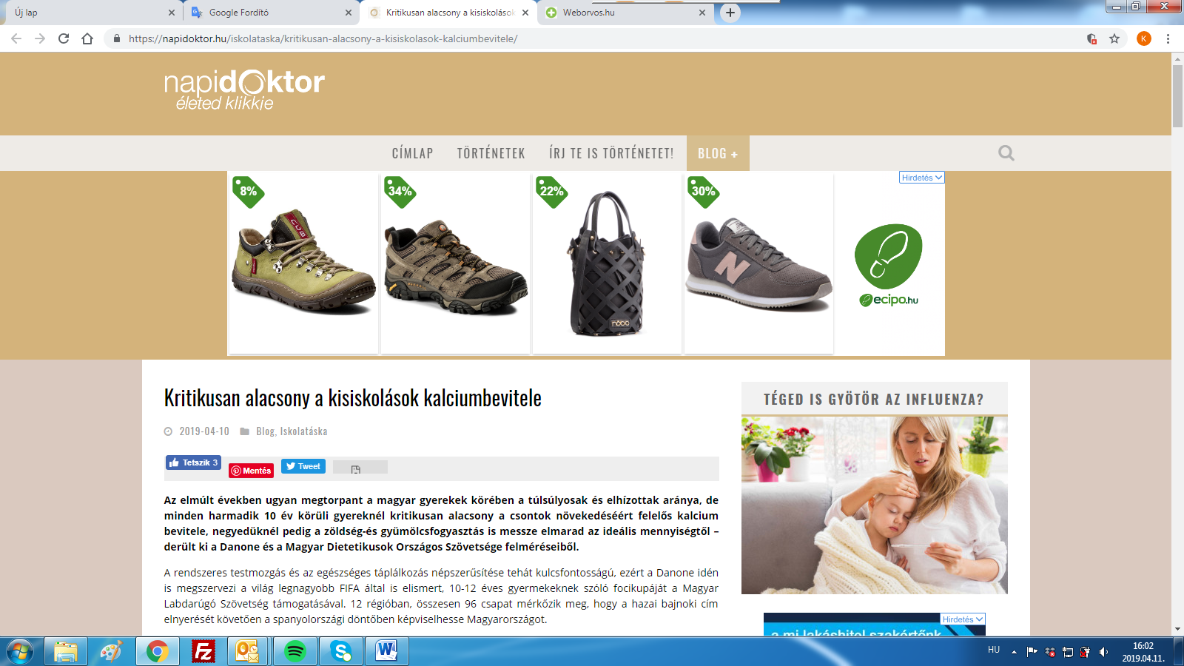

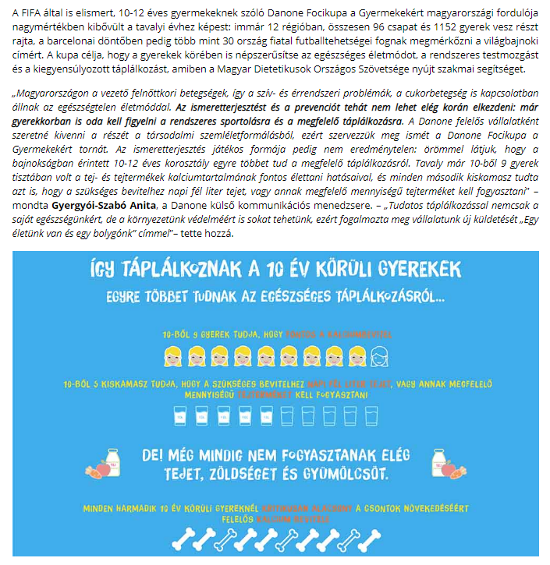

MÉDIA: | weborvos.hu | MEDIA SPECIFICS
DÁTE: | 10.04.2019. | TYPE: | online
PAGE: | - | REACH: | 570.000
AD VALUE (HUF) | 350 000 | FREQUENCY: | -
HEADLINE: | Calcium intake of school children is critically low
SUMMARY: | In recent years, the proportion of overweight and obesity amongst Hungarian children has halted, but still every third child aged around 10 has some overweight. In this age however, the intake of calcium, which is responsible for the growth of bones is critically low, and the vegetable and fruit consumption is also far below the ideal amount in a quarter of all children– reveal a study made by Danone and the National Association of Hungarian Dieticians. This is why Danone launches the Danone Nations Cup for Children, the largest football cup for children aged 10-12, recognised by FIFA.

https://weborvos.hu/hirek/kritikusan-alacsony-a-kisiskolasok-kalciumbevitele-251576

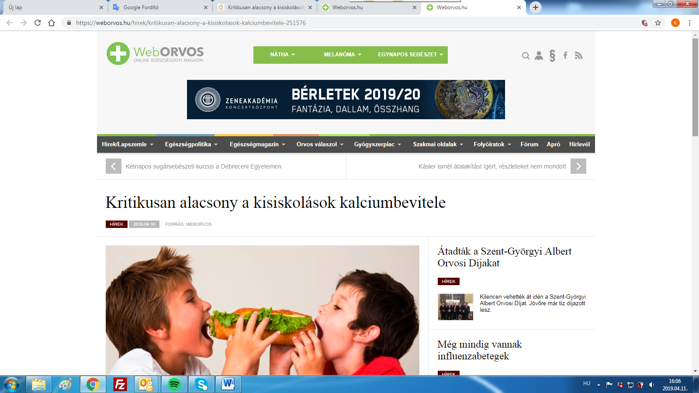

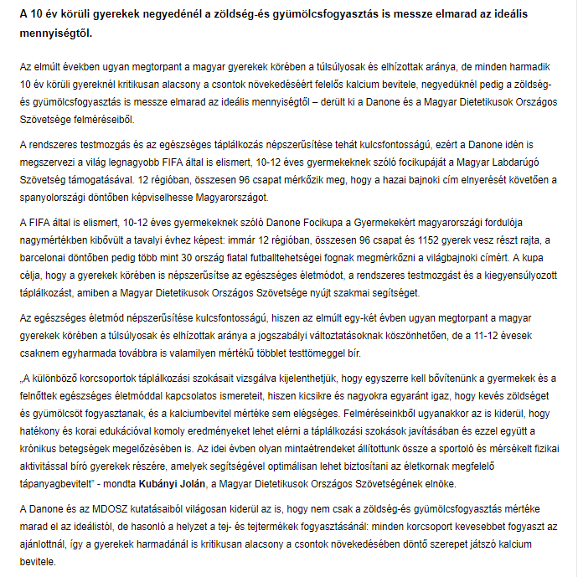

MÉDIA: | bulvarmagazin.hu | MEDIA SPECIFICS
DÁTE: | 09.04. 2019. | TYPE: | Online
PAGE: | - | REACH: | 37 500
AD VALUE (HUF) | 40 000 | FREQUENCY: | -
HEADLINE: | Calcium intake of school children is critically low (study + infographics)
SUMMARY: | In recent years, the proportion of overweight and obesity amongst Hungarian children has halted, but still every third child aged around 10 has some overweight. In this age however, the intake of calcium, which is responsible for the growth of bones is critically low, and the vegetable and fruit consumption is also far below the ideal amount in a quarter of all children– reveal a study made by Danone and the National Association of Hungarian Dieticians. This is why Danone launches the Danone Nations Cup for Children, the largest football cup for children aged 10-12, recognised by FIFA.

https://bulvarmagazin.hu/eletmod/kritikusan-alacsony-a-kisiskolasok-kalciumbevitele-felmeres-infografika/

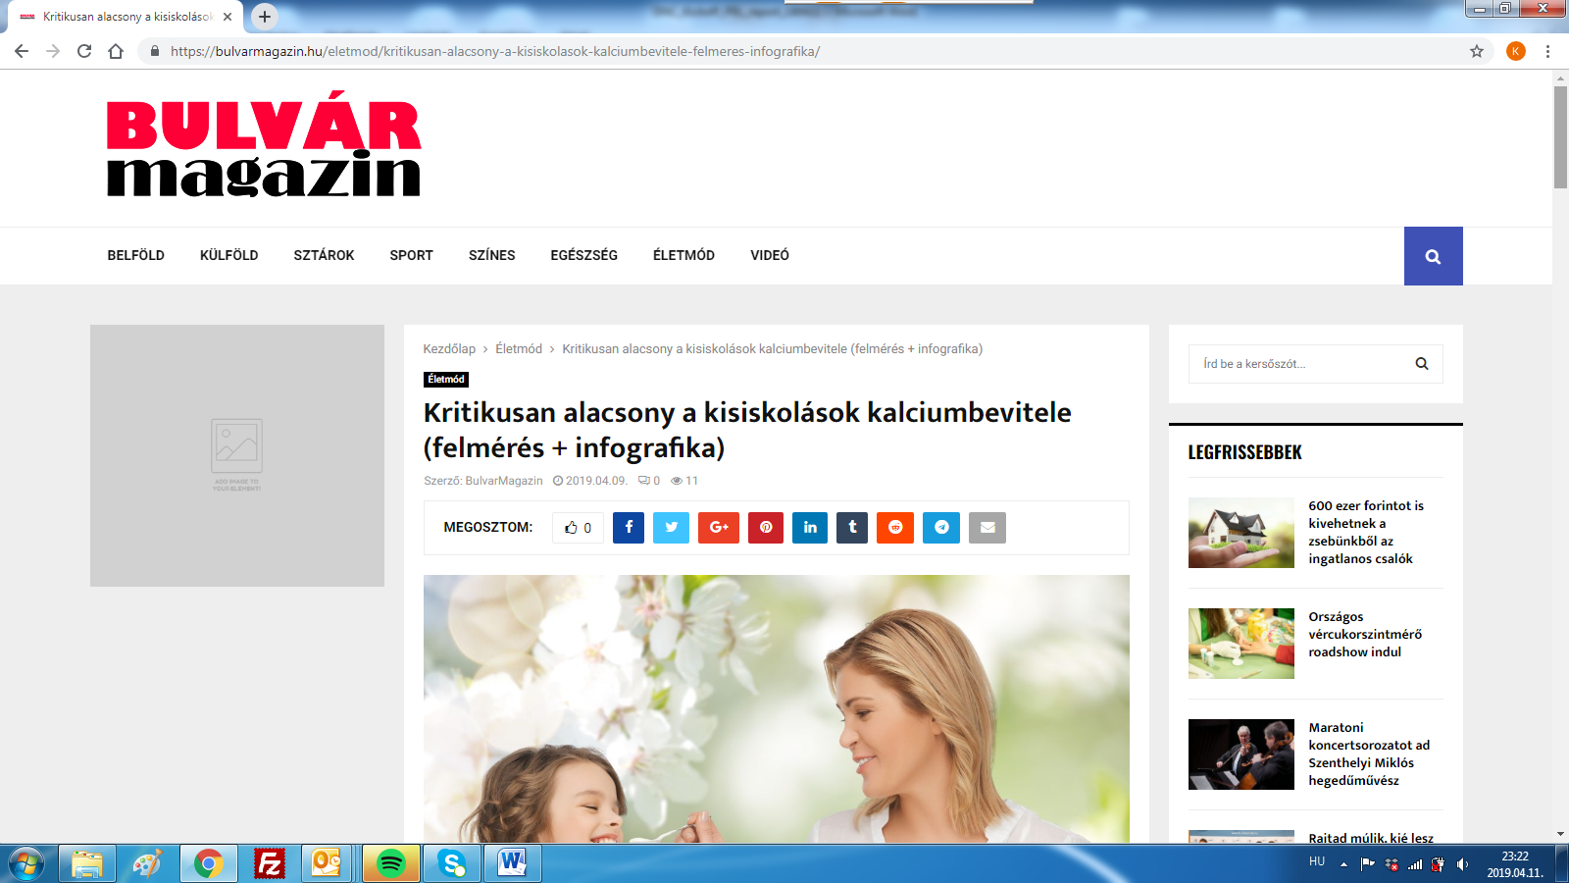

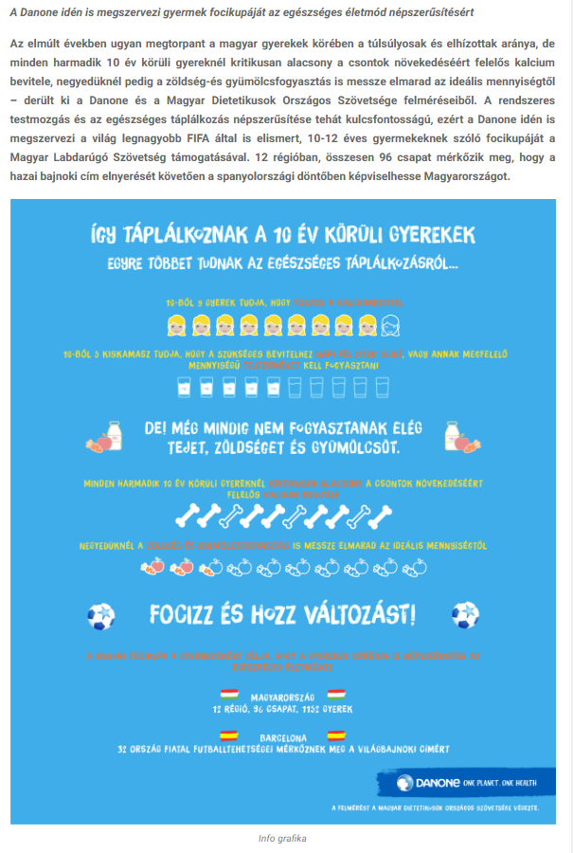
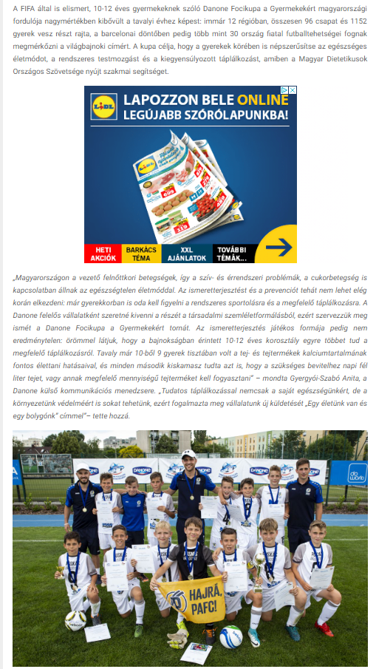

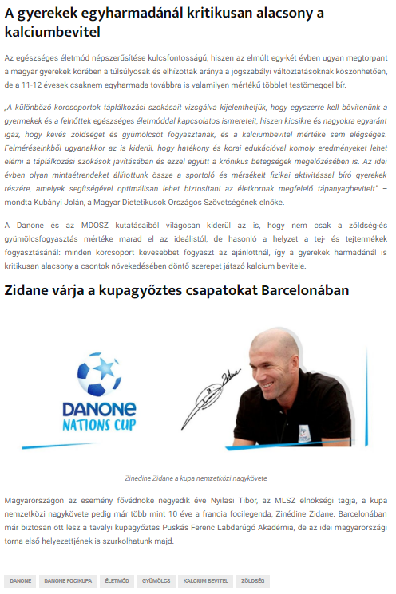
MÉDIA: | jnsz.hu | MEDIA SPECIFICS
DÁTE: | 10.04.2019. | TYPE: | Online
PAGE: | - | REACH: | 42 100
AD VALUE (HUF) | 85 000 | FREQUENCY: | -
HEADLINE: | Calcium intake of school children is critically low
SUMMARY: | In recent years, the proportion of overweight and obesity amongst Hungarian children has halted, but still every third child aged around 10 has some overweight. In this age however, the intake of calcium, which is responsible for the growth of bones is critically low, and the vegetable and fruit consumption is also far below the ideal amount in a quarter of all children– reveal a study made by Danone and the National Association of Hungarian Dieticians. This is why Danone launches the Danone Nations Cup for Children, the largest football cup for children aged 10-12, recognised by FIFA.

https://jnsz.hu/aktualis/2019/04/kritikusan-alacsony-a-kisiskolasok-kalciumbevitele

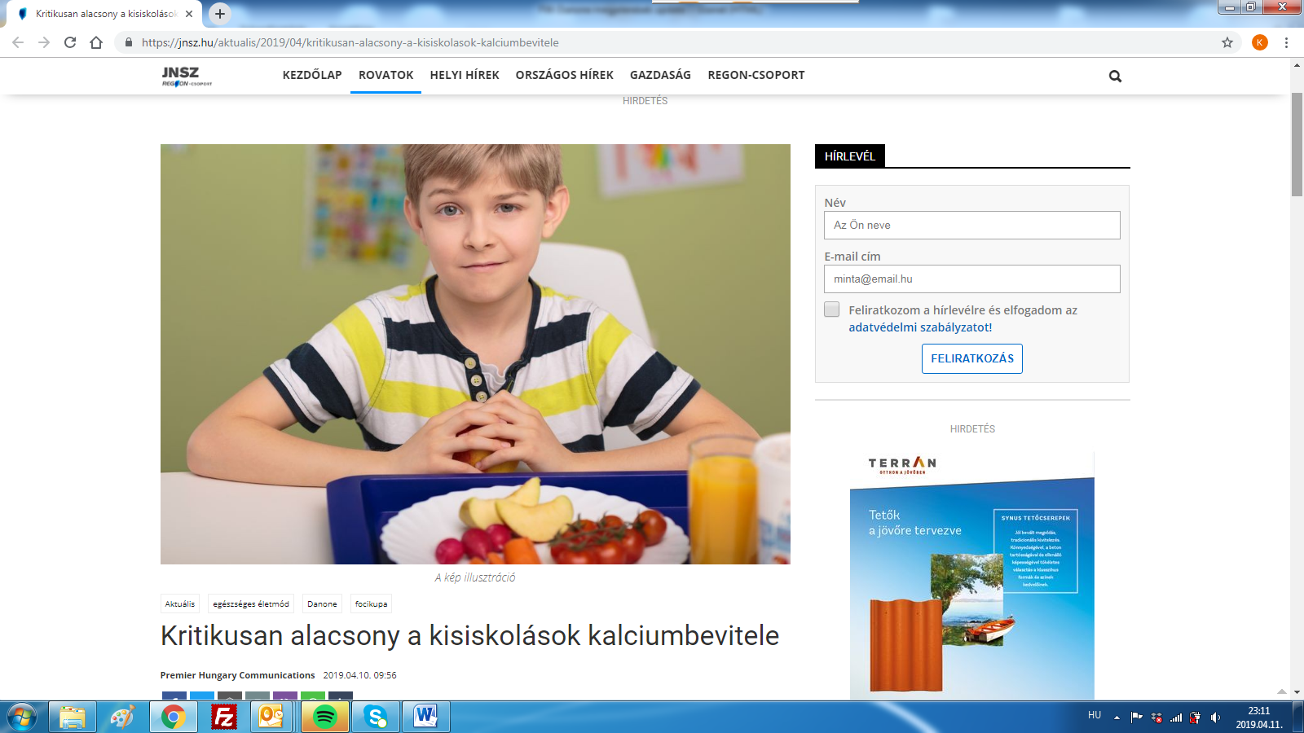

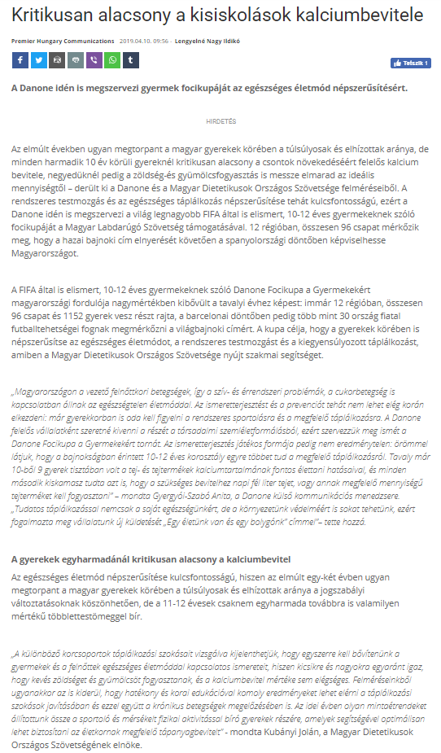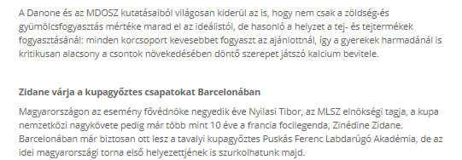

MÉDIA: | miklostv.hu | MEDIA SPECIFICS
DÁTE: | 09.04. 2019. | TYPE: | Online
PAGE: | - | REACH: | 33 700
AD VALUE (HUF) | 50 000 | FREQUENCY: | -
HEADLINE: | Calcium intake of school children is critically low and they don’t eat enough fruits and vegetables either
SUMMARY: | In recent years, the proportion of overweight and obesity amongst Hungarian children has halted, but still every third child aged around 10 has some overweight. In this age however, the intake of calcium, which is responsible for the growth of bones is critically low, and the vegetable and fruit consumption is also far below the ideal amount in a quarter of all children– reveal a study made by Danone and the National Association of Hungarian Dieticians. This is why Danone launches the Danone Nations Cup for Children, the largest football cup for children aged 10-12, recognised by FIFA.

http://miklostv.hu/index.php/112-varoson-tul/1795-kritikusan-alacsony-a-kisiskolasok-kalciumbevitele-es-nem-esznek-eleg-zoldseget-gyumolcsot-sem
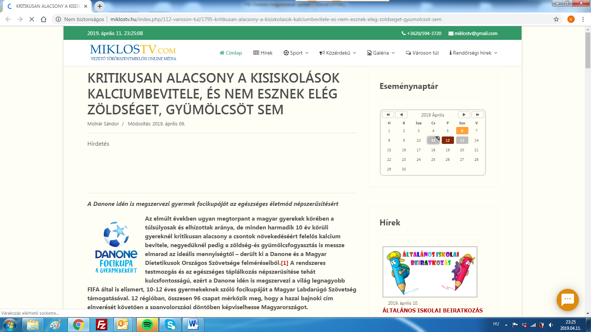

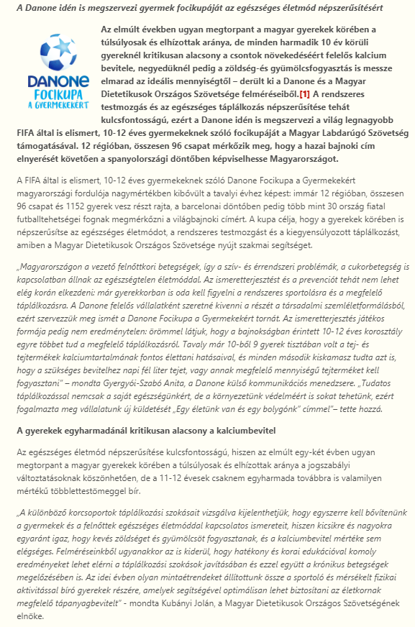
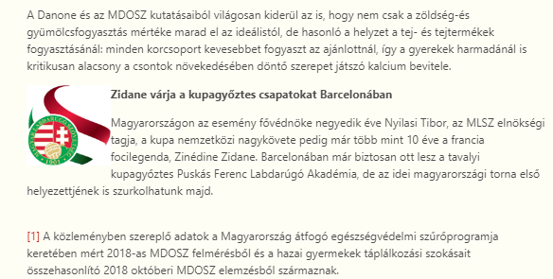

MÉDIA: | keleten.hu | MEDIA SPECIFICS
DÁTE: | 09.04.2019. | TYPE: | Online
PAGE: | - | REACH: | 26 000
AD VALUE (HUF) | 85 000 | FREQUENCY: | -
HEADLINE: | Calcium intake of school children is critically low and they don’t eat enough fruits and vegetables either
SUMMARY: | In recent years, the proportion of overweight and obesity amongst Hungarian children has halted, but still every third child aged around 10 has some overweight. In this age however, the intake of calcium, which is responsible for the growth of bones is critically low, and the vegetable and fruit consumption is also far below the ideal amount in a quarter of all children– reveal a study made by Danone and the National Association of Hungarian Dieticians. This is why Danone launches the Danone Nations Cup for Children, the largest football cup for children aged 10-12, recognised by FIFA.

http://www.keleten.hu/kultura/5614/kritikusan-alacsony-a-kisiskolasok-kalciumbevitele-es-nem-esznek-eleg-zoldseget-gyumolcsot-sem/
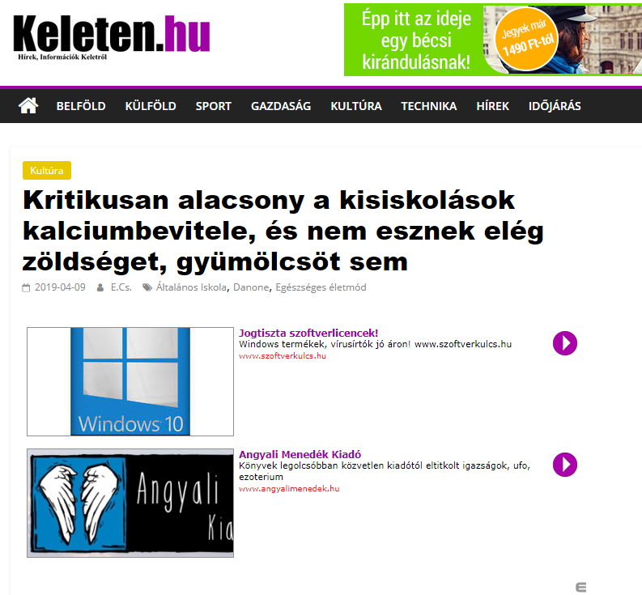
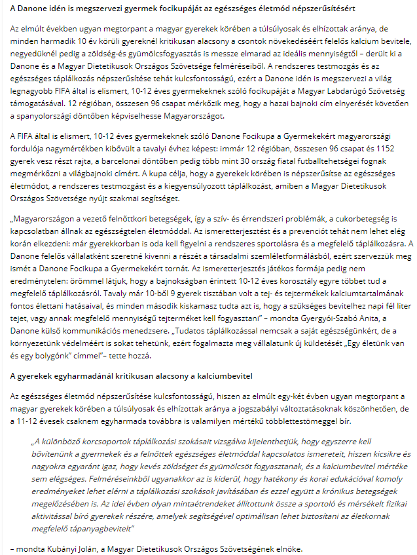

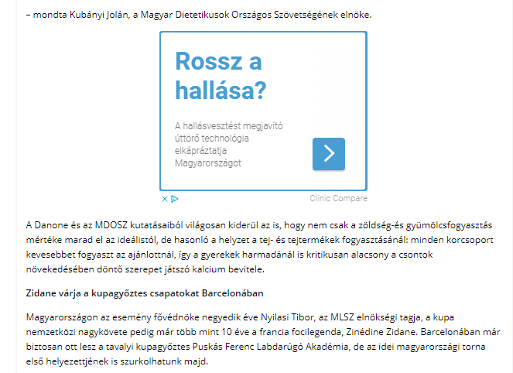

MÉDIA: | royalmagazin.hu | MEDIA SPECIFICS
DÁTE: | 09.04.2019. | TYPE: | Online
PAGE: | - | REACH: | 38 500
AD VALUE (HUF) | 45 000 | FREQUENCY: | -
HEADLINE: | Calcium intake of school children is critically low and they don’t eat enough fruits and vegetables either
SUMMARY: | In recent years, the proportion of overweight and obesity amongst Hungarian children has halted, but still every third child aged around 10 has some overweight. In this age however, the intake of calcium, which is responsible for the growth of bones is critically low, and the vegetable and fruit consumption is also far below the ideal amount in a quarter of all children– reveal a study made by Danone and the National Association of Hungarian Dieticians. This is why Danone launches the Danone Nations Cup for Children, the largest football cup for children aged 10-12, recognised by FIFA.

http://www.royalmagazin.hu/hirek/hirek/49161-kritikusan-alacsony-a-kisiskolasok-kalciumbevitele-es-nem-esznek-eleg-zoldseget-gyumolcsot-sem

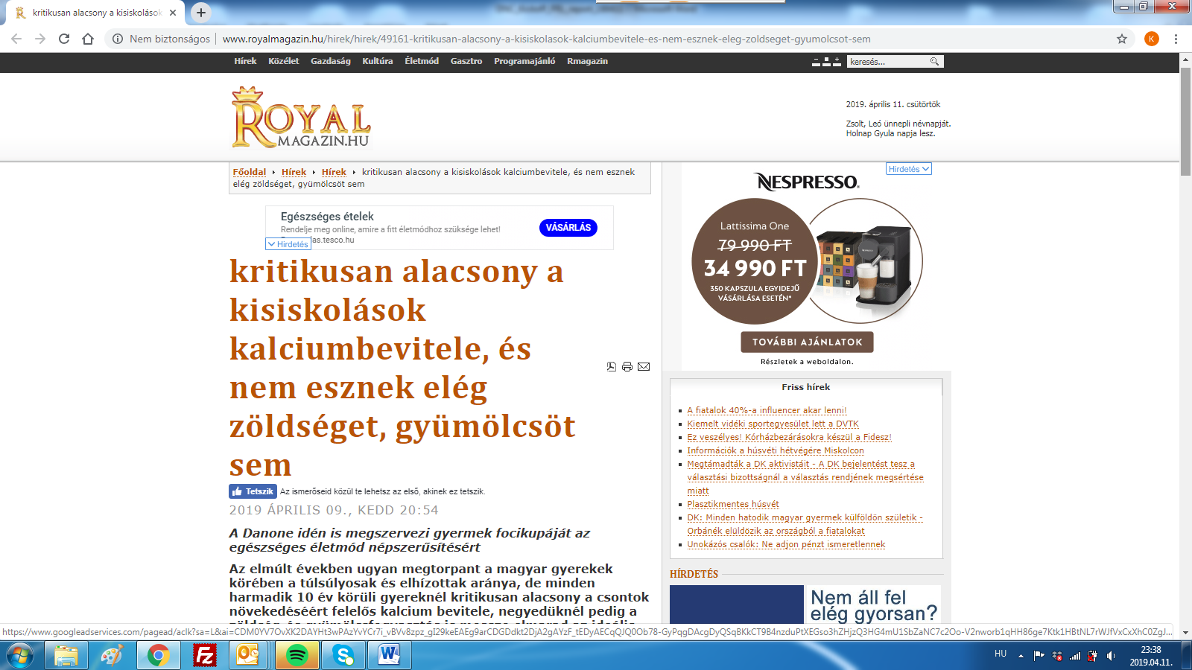

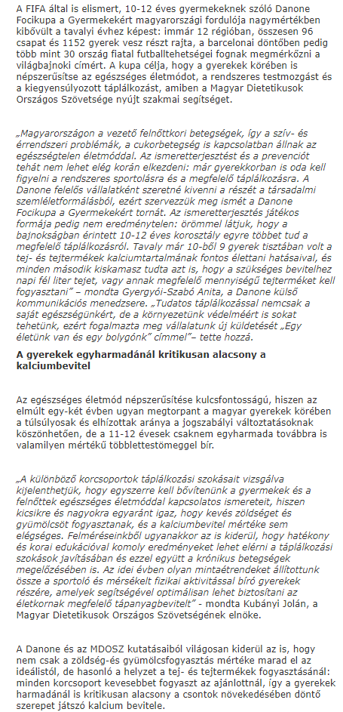

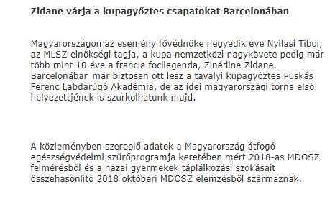

MÉDIA: | infovarosok.hu | MEDIA SPECIFICS
DÁTE: | 10.04.2019. | TYPE: | Online
PAGE: | - | REACH: | 369 000
AD VALUE (HUF) | 1 025 000 | FREQUENCY: | 41 times
HEADLINE: | Calcium intake of school children is critically low and they don’t eat enough fruits and vegetables either
SUMMARY: | In recent years, the proportion of overweight and obesity amongst Hungarian children has halted, but still every third child aged around 10 has some overweight. In this age however, the intake of calcium, which is responsible for the growth of bones is critically low, and the vegetable and fruit consumption is also far below the ideal amount in a quarter of all children– reveal a study made by Danone and the National Association of Hungarian Dieticians. This is why Danone launches the Danone Nations Cup for Children, the largest football cup for children aged 10-12, recognised by FIFA.

http://www.infohodmezovasarhely.hu/hirek/olvas/kritikusan-alacsony-a-kisiskolasok-kalciumbevitele-es-nem-esznek-eleg-zoldseget-gyumolcsot-sem-2019-04-10-101424
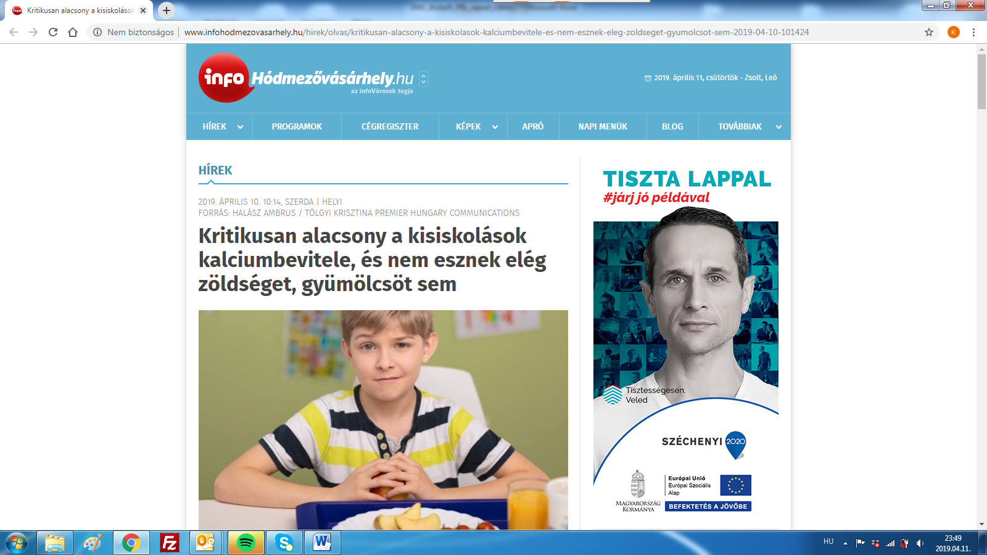

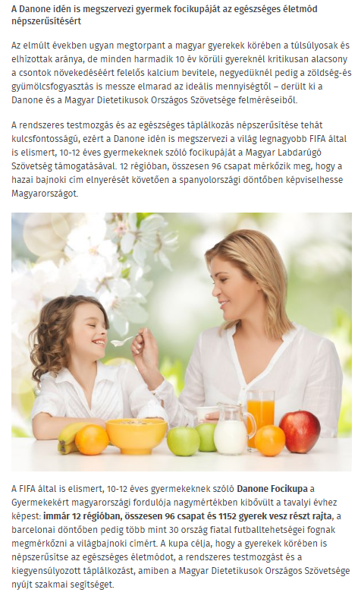

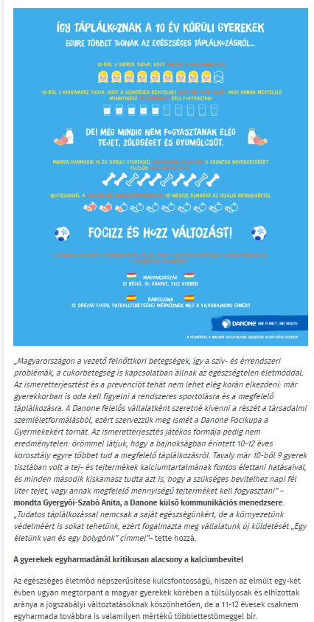
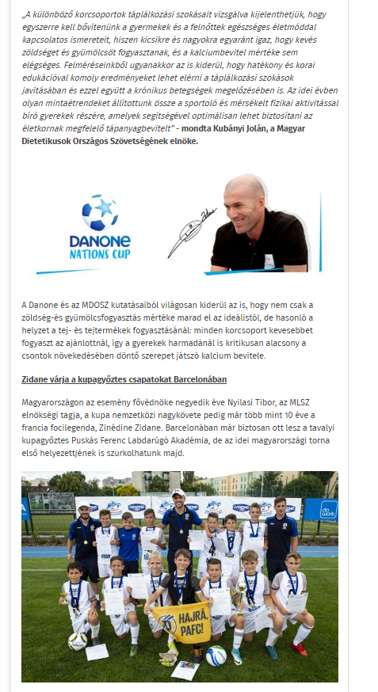

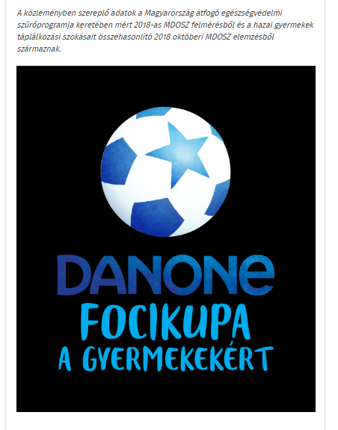

MÉDIA: | propeller.hu | MEDIA SPECIFICS
DÁTE: | 10.04.2019. | TYPE: | Online
PAGE: | - | REACH: | 28.000
AD VALUE (HUF) | 45 000 | FREQUENCY: | -
HEADLINE: | Calcium intake of school children is critically low
SUMMARY: | In recent years, the proportion of overweight and obesity amongst Hungarian children has halted, but still every third child aged around 10 has some overweight. In this age however, the intake of calcium, which is responsible for the growth of bones is critically low, and the vegetable and fruit consumption is also far below the ideal amount in a quarter of all children– reveal a study made by Danone and the National Association of Hungarian Dieticians. This is why Danone launches the Danone Nations Cup for Children, the largest football cup for children aged 10-12, recognised by FIFA.

http://propeller.hu/szorakozas/3411324-kritikusan-alacsony-kisiskolasok-kalciumbevitele
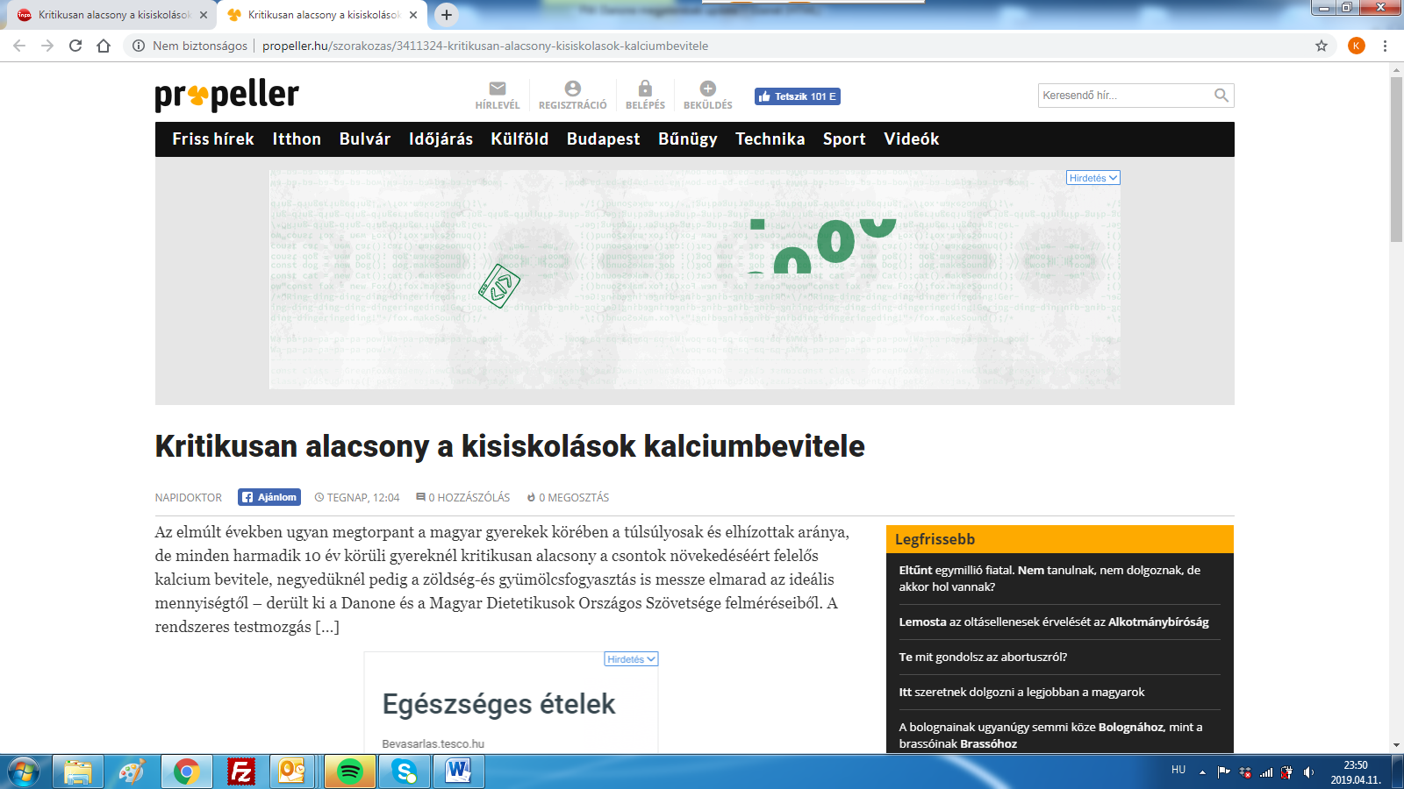

MÉDIA: | storeinsider.hu | MEDIA SPECIFICS
DÁTE: | 10.04.2019. | TYPE: | Online
PAGE: | - | REACH: | 49 000
AD VALUE (HUF) | 210 000 | FREQUENCY: | -
HEADLINE: | Danone Nations Cup will be organised this year again
SUMMARY: | In recent years, the proportion of overweight and obesity amongst Hungarian children has halted, but still every third child aged around 10 has some overweight. In this age however, the intake of calcium, which is responsible for the growth of bones is critically low, and the vegetable and fruit consumption is also far below the ideal amount in a quarter of all children– reveal a study made by Danone and the National Association of Hungarian Dieticians. This is why Danone launches the Danone Nations Cup for Children, the largest football cup for children aged 10-12, recognised by FIFA.

http://storeinsider.hu/gazdasag/cikk/iden_is_lesz_danone_focikupa_a_gyermekekert
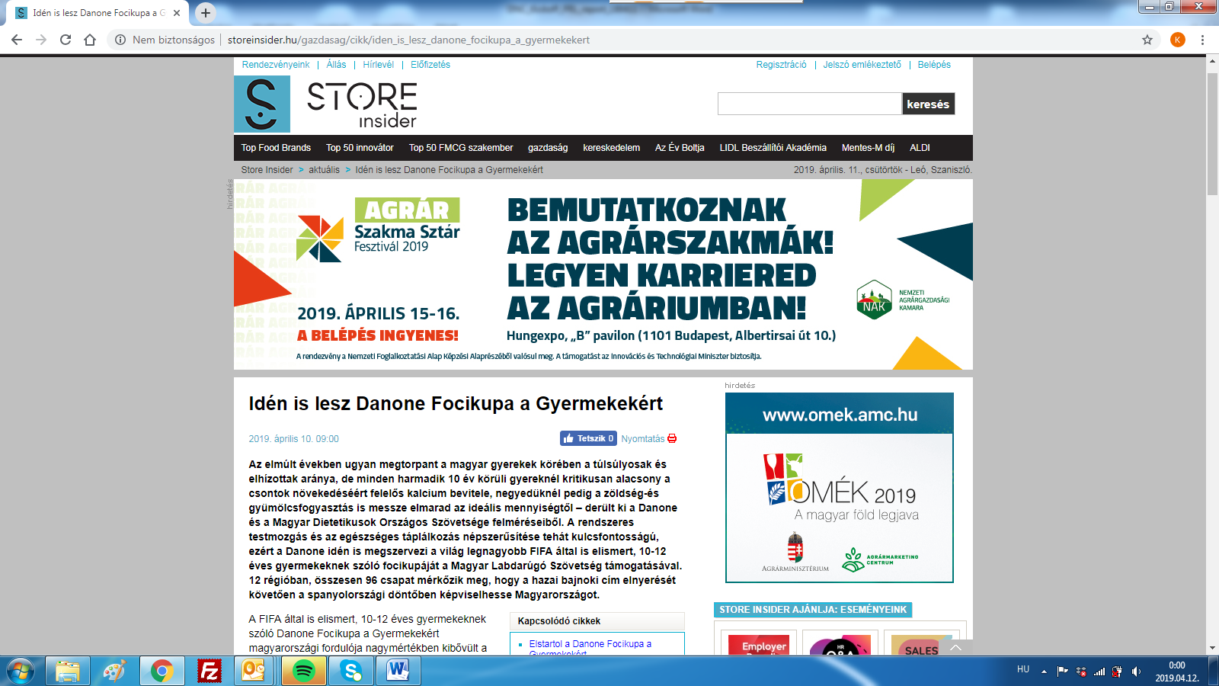

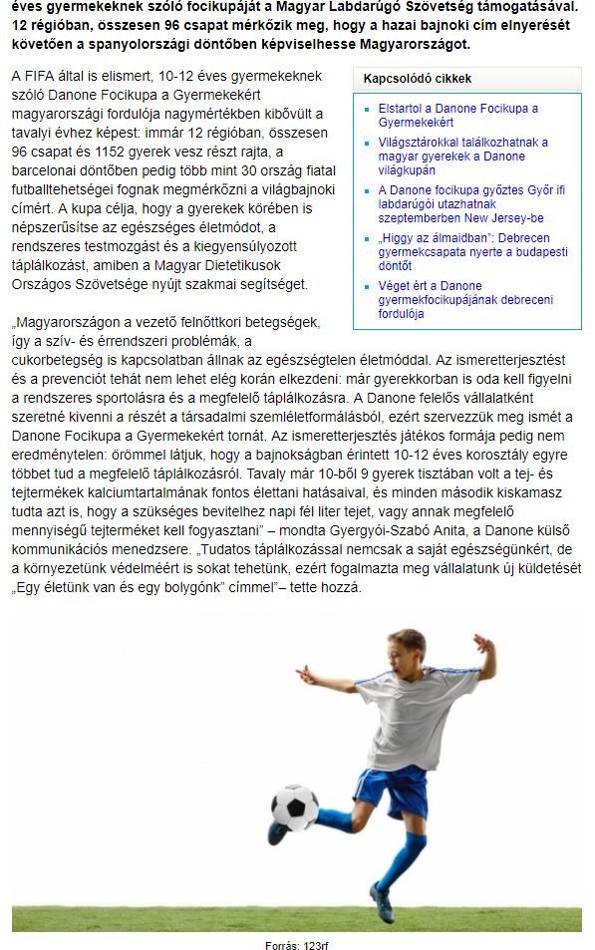
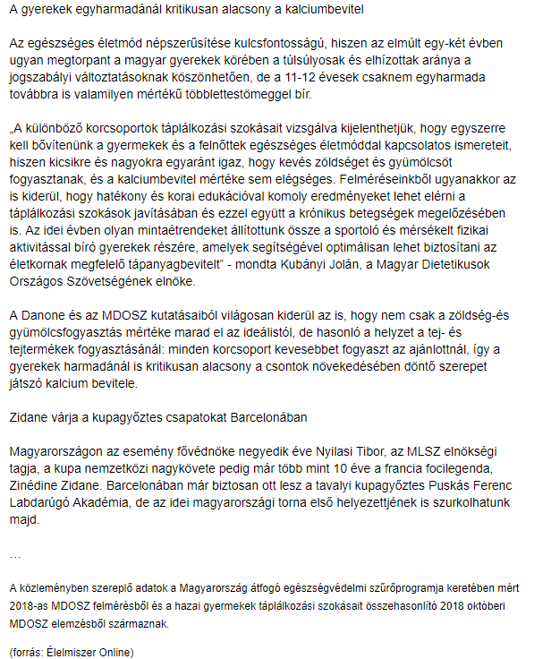

MÉDIA: | duol.hu | MEDIA SPECIFICS
DÁTE: | 10.04.2019. | TYPE: | Online
PAGE: | - | REACH: | 100 000
AD VALUE (HUF) | 300 000 | FREQUENCY: | -
HEADLINE: | Danone Nations Cup: The national finals will be at stake
SUMMARY: | In recent years, the proportion of overweight and obesity amongst Hungarian children has halted, but still every third child aged around 10 has some overweight. In this age however, the intake of calcium, which is responsible for the growth of bones is critically low, and the vegetable and fruit consumption is also far below the ideal amount in a quarter of all children– reveal a study made by Danone and the National Association of Hungarian Dieticians. This is why Danone launches the Danone Nations Cup for Children, the largest football cup for children aged 10-12, recognised by FIFA.

https://www.duol.hu/sport/helyi-sport/az-orszagos-dontobe-jutas-lesz-a-tet-2762419/

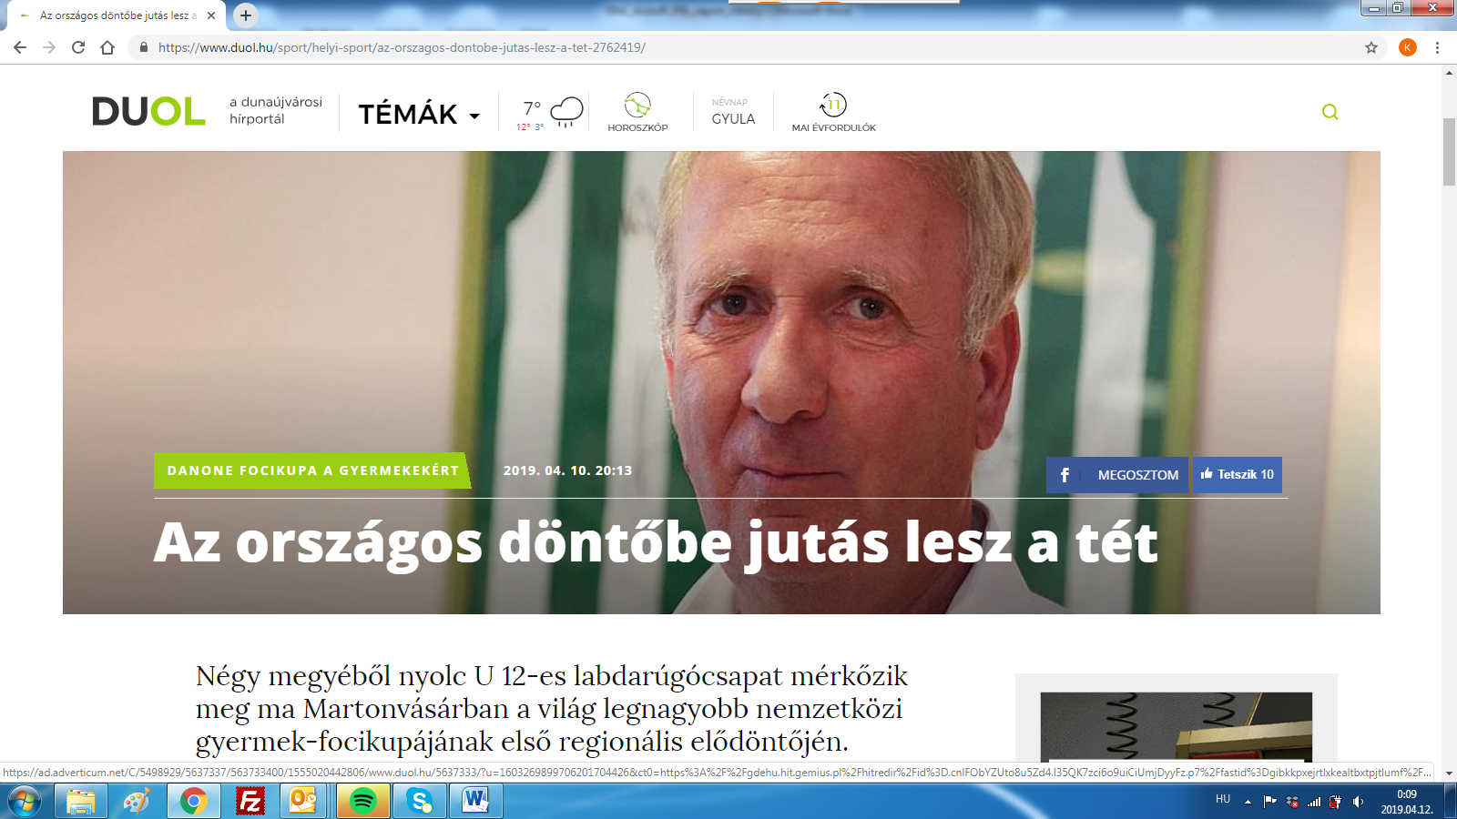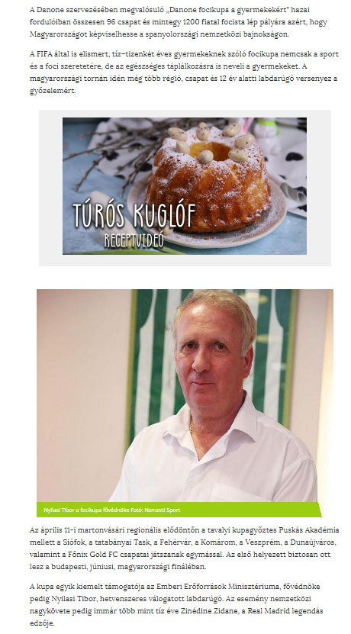

MÉDIA: | Trend FM – Egészségkód | MEDIA SPECIFICS
DÁTE: | 11.04.2019. | TYPE: | radio
PAGE: | www.trendfm.hu | REACH: | 71 000
AD VALUE (HUF) | 240 000 | FREQUENCY: | 3
HEADLINE: | interview with Jolán Kubányi, president of the National Association of Hungarian Dieticians
SUMMARY: | In recent years, the proportion of overweight and obesity amongst Hungarian children has halted, but still every third child aged around 10 has some overweight. In this age however, the intake of calcium, which is responsible for the growth of bones is critically low, and the vegetable and fruit consumption is also far below the ideal amount in a quarter of all children– reveal a study made by Danone and the National Association of Hungarian Dieticians. This is why Danone launches the Danone Nations Cup for Children, the largest football cup for children aged 10-12, recognised by FIFA.

https://trendfm.hu/musor?musor=7844

MEDIA: | Inforádió | MEDIA SPECIFICS
DÁTE: | 10.04.2019. | TYPE: | radio
PAGE: | - | REACH: | 79 000
AD VALUE (HUF) | 264 000 | FREQUENCY: | 4
HEADLINE: | interview with Jolán Kubányi, president of the National Association of Hungarian Dieticians
SUMMARY: | In recent years, the proportion of overweight and obesity amongst Hungarian children has halted, but still every third child aged around 10 has some overweight. In this age however, the intake of calcium, which is responsible for the growth of bones is critically low, and the vegetable and fruit consumption is also far below the ideal amount in a quarter of all children– reveal a study made by Danone and the National Association of Hungarian Dieticians. This is why Danone launches the Danone Nations Cup for Children, the largest football cup for children aged 10-12, recognised by FIFA.

Hanganyag bekérve

MEDIA: | blikk.hu/Életmód | MEDIA SPECIFICS
DÁTE: | 12.04.2019. | TYPE: | online
PAGE: | - | REACH: | 570 000
AD VALUE (HUF) | 500 000 | FREQUENCY: | -
HEADLINE: | Unfortunately calcium intake of school children is critically low
SUMMARY: | In recent years, the proportion of overweight and obesity amongst Hungarian children has halted, but still every third child aged around 10 has some overweight. In this age however, the intake of calcium, which is responsible for the growth of bones is critically low, and the vegetable and fruit consumption is also far below the ideal amount in a quarter of all children– reveal a study made by Danone and the National Association of Hungarian Dieticians. This is why Danone launches the Danone Nations Cup for Children, the largest football cup for children aged 10-12, recognised by FIFA.

http://www.blikk.hu/eletmod/tippek/keves-zoldseget-es-gyumolcsot-esznek-a-gyerekek/0e38zeq

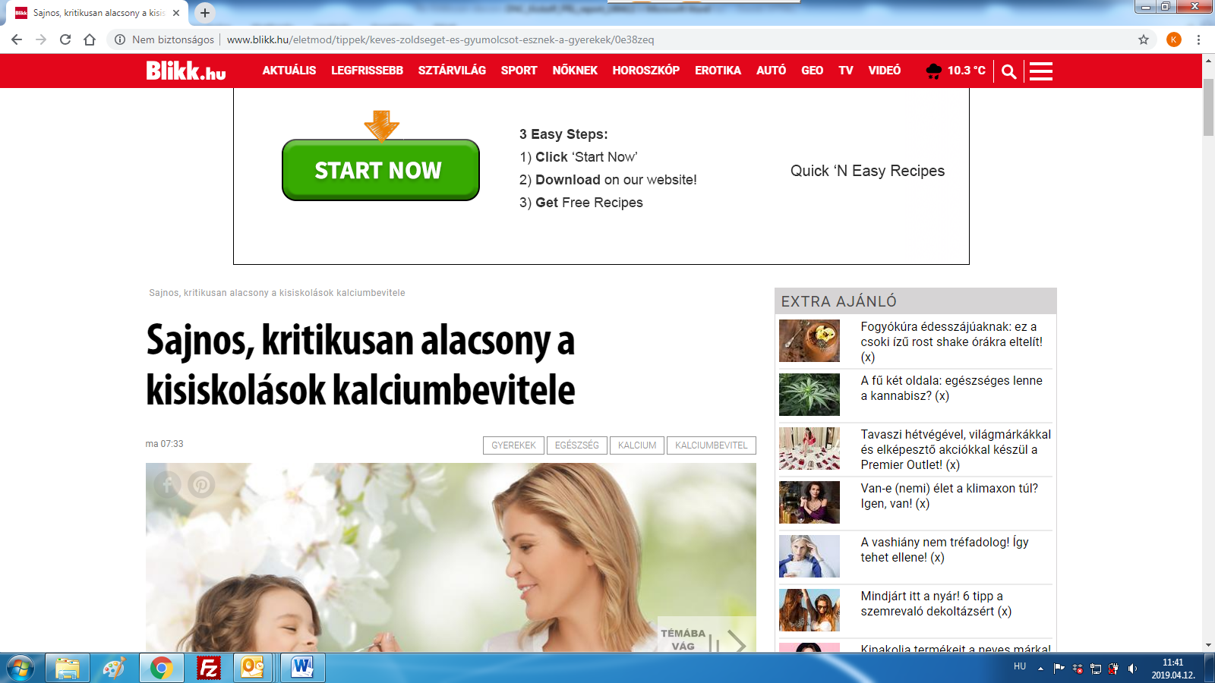

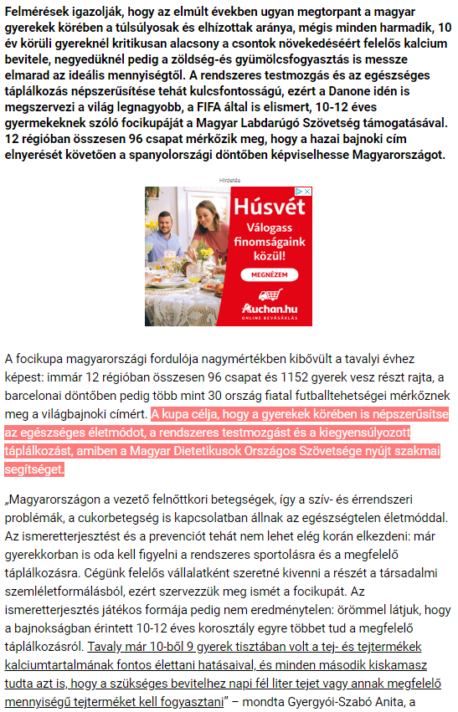
MEDIA: | blikk.hu/Egészség | MEDIA SPECIFICS
DÁTE: | 12.04.2019. | TYPE: | online
PAGE: | - | REACH: | 570 000
AD VALUE (HUF) | 500 000 | FREQUENCY: | -
HEADLINE: | Unfortunately calcium intake of school children is critically low
SUMMARY: | In recent years, the proportion of overweight and obesity amongst Hungarian children has halted, but still every third child aged around 10 has some overweight. In this age however, the intake of calcium, which is responsible for the growth of bones is critically low, and the vegetable and fruit consumption is also far below the ideal amount in a quarter of all children– reveal a study made by Danone and the National Association of Hungarian Dieticians. This is why Danone launches the Danone Nations Cup for Children, the largest football cup for children aged 10-12, recognised by FIFA.

http://www.blikk.hu/eletmod/egeszseg/keves-zoldseget-es-gyumolcsot-esznek-a-gyerekek/gv7n95p
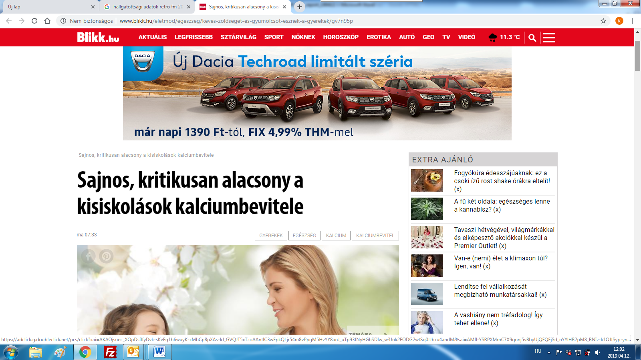

MEDIA: | pfla.hu | MEDIA SPECIFICS
DÁTE: | 12.04.2019. | TYPE: | online
PAGE: | - | REACH: | 7000
AD VALUE (HUF) | 15 000 | FREQUENCY: | -
HEADLINE: | Successful semi-final
SUMMARY: | In recent years, the proportion of overweight and obesity amongst Hungarian children has halted, but still every third child aged around 10 has some overweight. In this age however, the intake of calcium, which is responsible for the growth of bones is critically low, and the vegetable and fruit consumption is also far below the ideal amount in a quarter of all children– reveal a study made by Danone and the National Association of Hungarian Dieticians. This is why Danone launches the Danone Nations Cup for Children, the largest football cup for children aged 10-12, recognised by FIFA.

https://www.pfla.hu/?q=news/9274
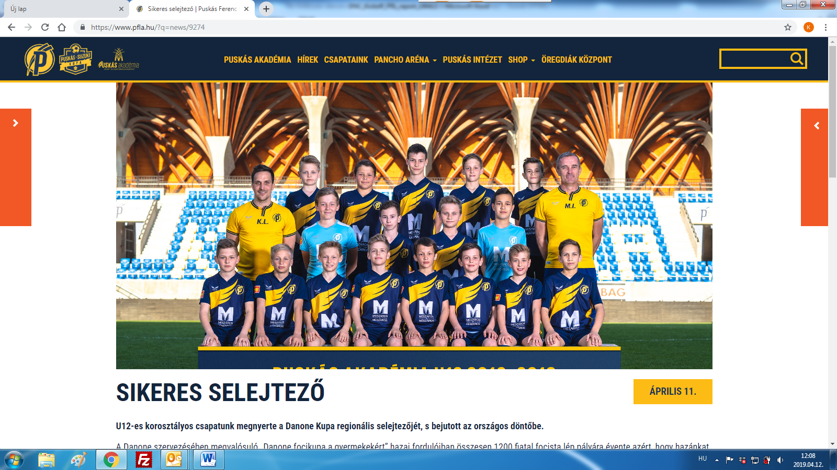

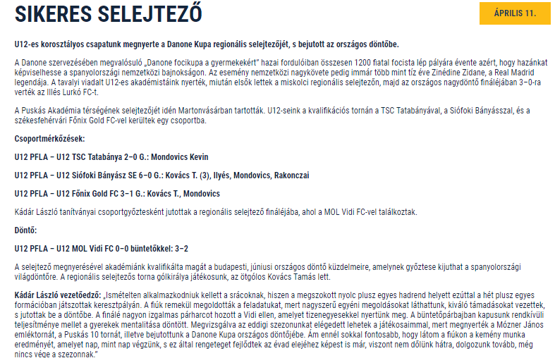

MEDIA: | feol.hu | MEDIA SPECIFICS
DÁTE: | 12.04.2019. | TYPE: | online
PAGE: | - | REACH: | 200 000
AD VALUE (HUF) | 500 000 | FREQUENCY: | -
HEADLINE: | Hispania is the aim for the youngsters of Felcsút
SUMMARY: | In recent years, the proportion of overweight and obesity amongst Hungarian children has halted, but still every third child aged around 10 has some overweight. In this age however, the intake of calcium, which is responsible for the growth of bones is critically low, and the vegetable and fruit consumption is also far below the ideal amount in a quarter of all children– reveal a study made by Danone and the National Association of Hungarian Dieticians. This is why Danone launches the Danone Nations Cup for Children, the largest football cup for children aged 10-12, recognised by FIFA.

https://www.feol.hu/sport/helyi-sport/hispania-a-felcsuti-fiatalok-celja-2970028/

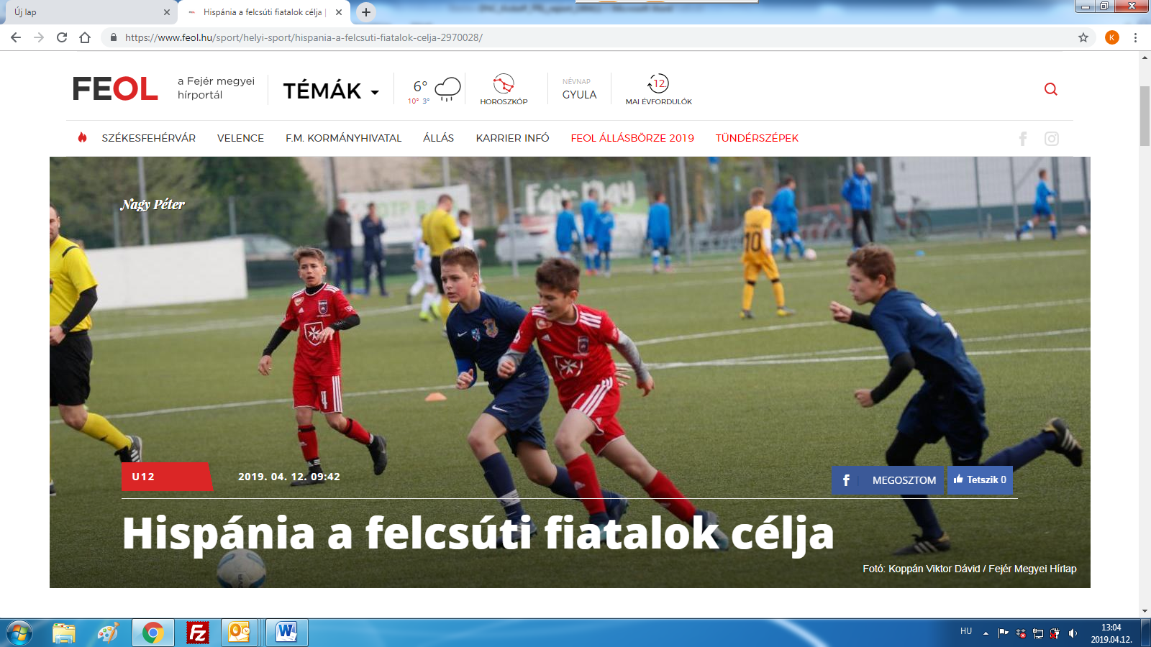

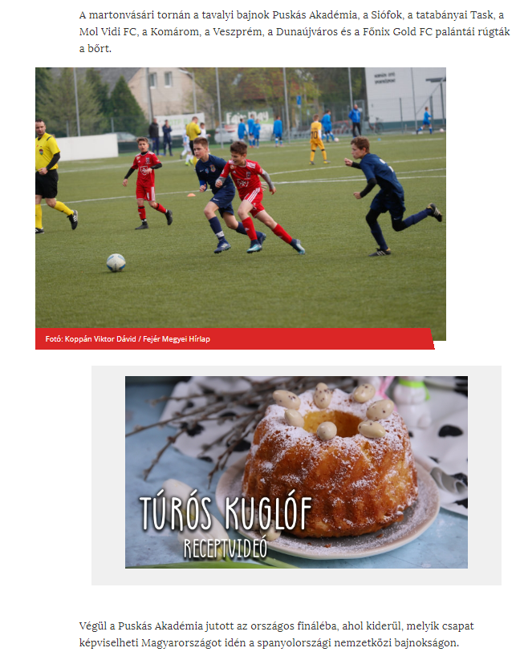

MEDIA: | hellovidek.hu | MEDIA SPECIFICS
DÁTE: | 14.04.2019. | TYPE: | online
PAGE: | - | REACH: | 71 428
AD VALUE (HUF) | 230 | FREQUENCY: | -
HEADLINE: | Danone promotes healthy lifestyle with football
SUMMARY: | In recent years, the proportion of overweight and obesity amongst Hungarian children has halted, but still every third child aged around 10 has some overweight. In this age however, the intake of calcium, which is responsible for the growth of bones is critically low, and the vegetable and fruit consumption is also far below the ideal amount in a quarter of all children– reveal a study made by Danone and the National Association of Hungarian Dieticians. This is why Danone launches the Danone Nations Cup for Children, the largest football cup for children aged 10-12, recognised by FIFA.

https://www.hellovidek.hu/szorakozas/2019/04/14/focival-nepszerusiti-az-egeszseges-eletmodot-a-danone
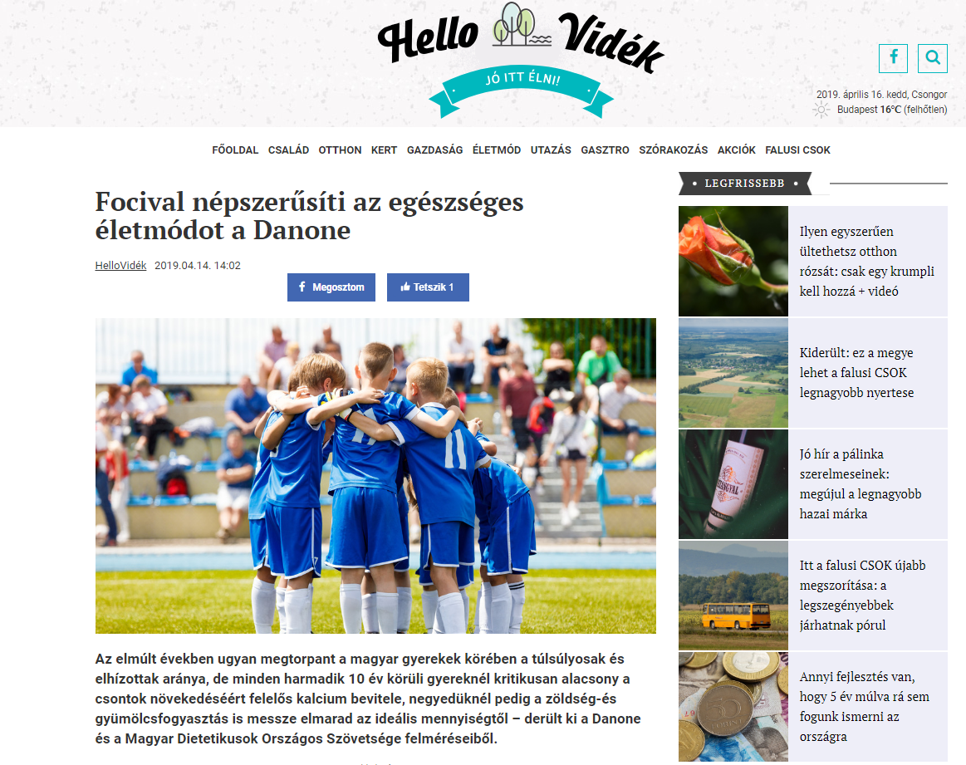

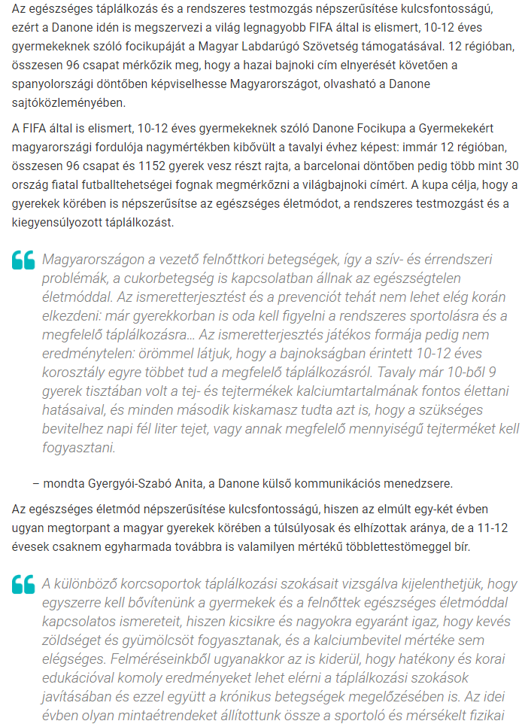
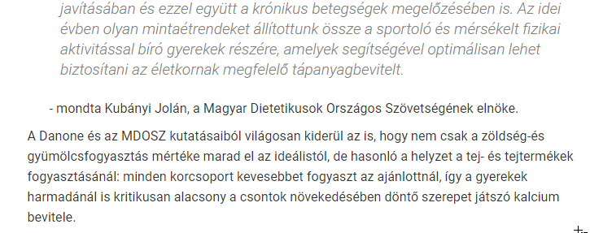

MEDIA: | delina.hu | MEDIA SPECIFICS
DÁTE: | 13.04.2019. | TYPE: | online
PAGE: | - | REACH: | 500
AD VALUE (HUF) | 94 | FREQUENCY: | -
HEADLINE: | Teenagers calcium intake is critically low
SUMMARY: | In recent years, the proportion of overweight and obesity amongst Hungarian children has halted, but still every third child aged around 10 has some overweight. In this age however, the intake of calcium, which is responsible for the growth of bones is critically low, and the vegetable and fruit consumption is also far below the ideal amount in a quarter of all children– reveal a study made by Danone and the National Association of Hungarian Dieticians. This is why Danone launches the Danone Nations Cup for Children, the largest football cup for children aged 10-12, recognised by FIFA.

http://delina.hu/egeszseg/2019/04/13/kritikusan-alacsony-a-kisiskolasok-kalciumbevitele
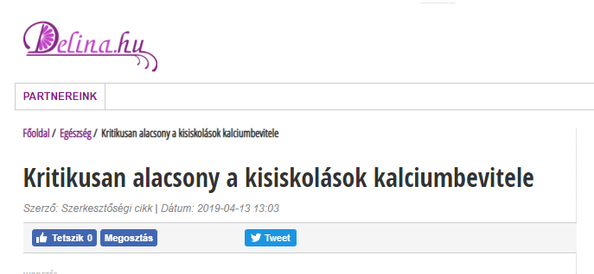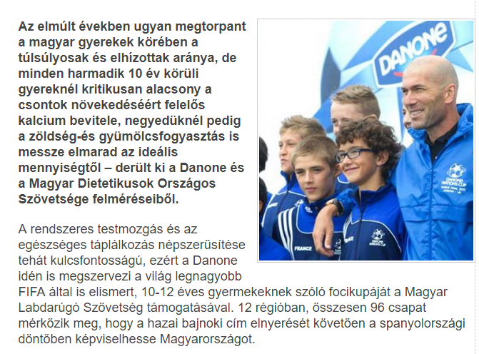

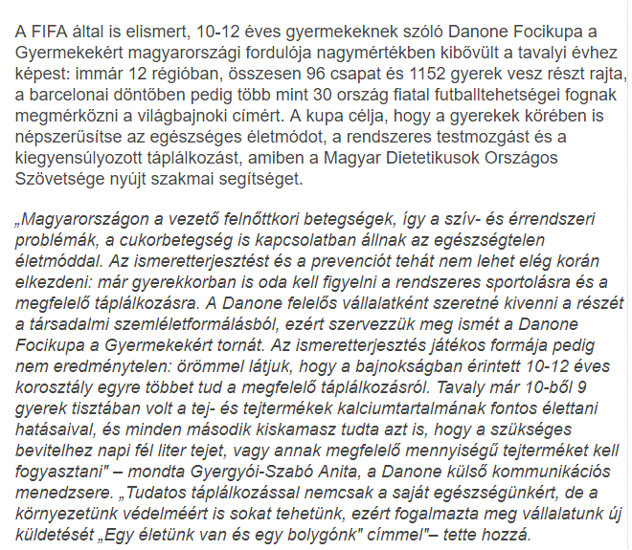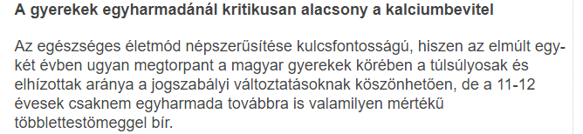

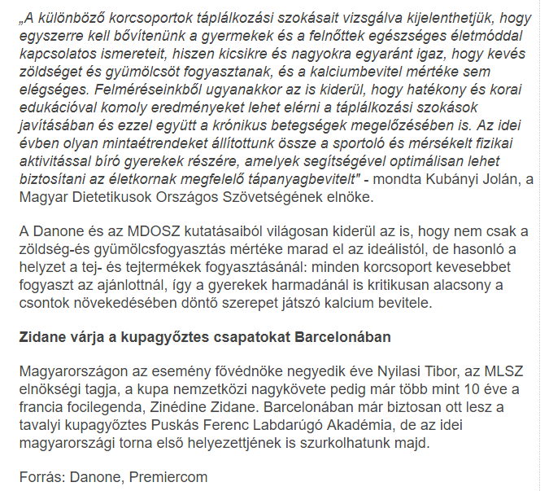

MEDIA: | mcsipos.hu | MEDIA SPECIFICS
DÁTE: | 16.04.2019. | TYPE: | online
PAGE: | - | REACH: | 500
AD VALUE (HUF) | 94 | FREQUENCY: | -
HEADLINE: | Topic of the day: teenagers’ calcium intake is critically low
SUMMARY: | In recent years, the proportion of overweight and obesity amongst Hungarian children has halted, but still every third child aged around 10 has some overweight. In this age however, the intake of calcium, which is responsible for the growth of bones is critically low, and the vegetable and fruit consumption is also far below the ideal amount in a quarter of all children– reveal a study made by Danone and the National Association of Hungarian Dieticians. This is why Danone launches the Danone Nations Cup for Children, the largest football cup for children aged 10-12, recognised by FIFA.

http://mcsipos.hu/2019/04/16/a-nap-temaja-kritikusan-alacsony-a-kisiskolasok-kalciumbevitele/
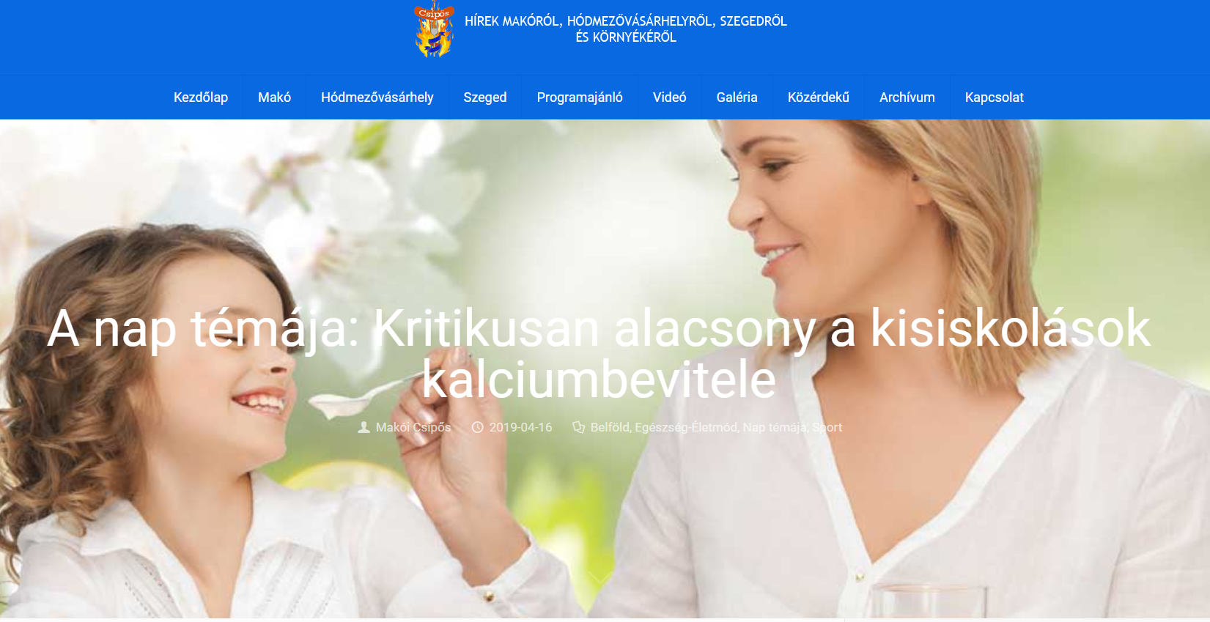

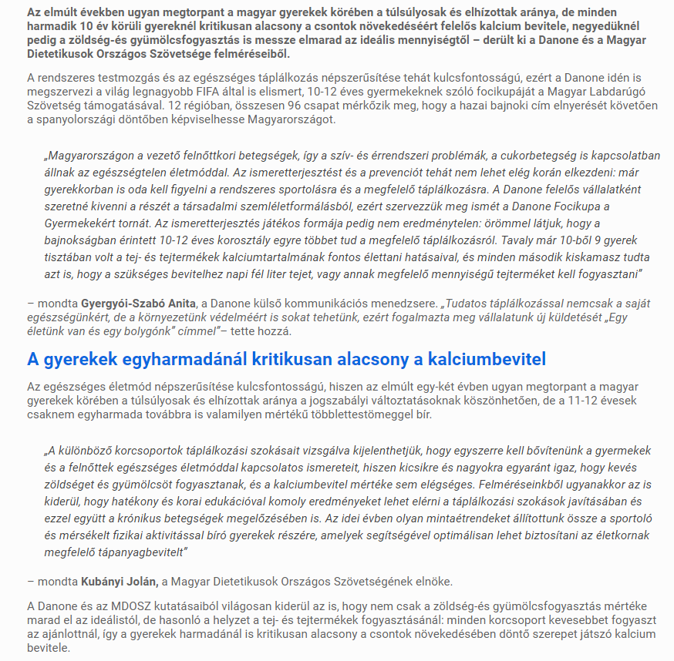

MEDIA: | eduline.hu | MEDIA SPECIFICS
DÁTE: | 15.04.2019. | TYPE: | online
PAGE: | - | REACH: | 505
AD VALUE (HUF) | 97 | FREQUENCY: | -
HEADLINE: | Do you know how much fruit and vegetable is necessary to eat for a student?
SUMMARY: | In recent years, the proportion of overweight and obesity amongst Hungarian children has halted, but still every third child aged around 10 has some overweight. In this age however, the intake of calcium, which is responsible for the growth of bones is critically low, and the vegetable and fruit consumption is also far below the ideal amount in a quarter of all children– reveal a study made by Danone and the National Association of Hungarian Dieticians. This is why Danone launches the Danone Nations Cup for Children, the largest football cup for children aged 10-12, recognised by FIFA.

https://eduline.hu/campus_life/20190415_nem_emelkedett_az_elhizott_gyerekek_aranya
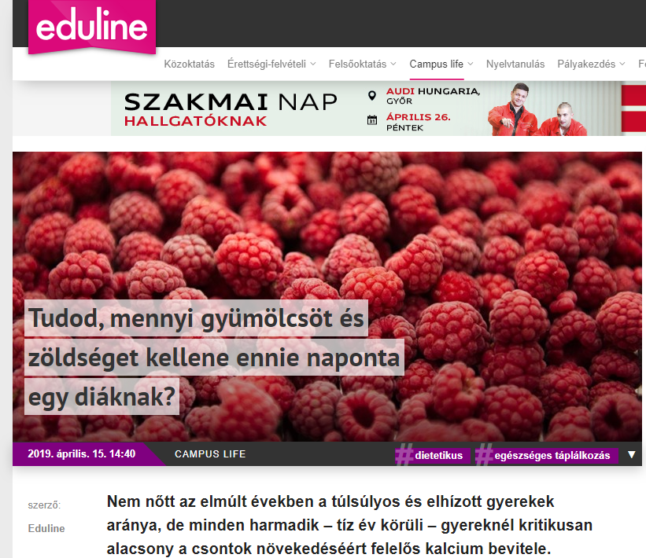

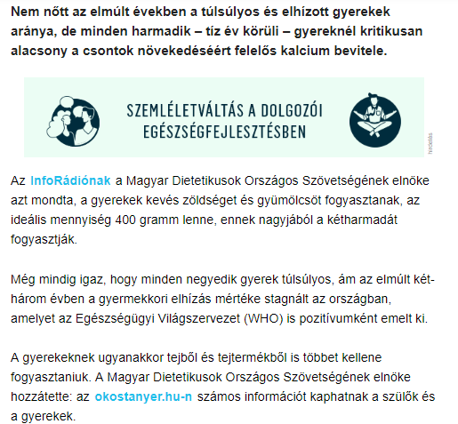

MEDIA: | infostart.hu | MEDIA SPECIFICS
DÁTE: | 15.04.2019. | TYPE: | online
PAGE: | - | REACH: | 507
AD VALUE (HUF) | 95 | FREQUENCY: | -
HEADLINE: | Kids not eating enough fruits and vegetables – significant consequences may be
SUMMARY: | In recent years, the proportion of overweight and obesity amongst Hungarian children has halted, but still every third child aged around 10 has some overweight. In this age however, the intake of calcium, which is responsible for the growth of bones is critically low, and the vegetable and fruit consumption is also far below the ideal amount in a quarter of all children– reveal a study made by Danone and the National Association of Hungarian Dieticians. This is why Danone launches the Danone Nations Cup for Children, the largest football cup for children aged 10-12, recognised by FIFA.

https://infostart.hu/belfold/2019/04/15/keves-gyumolcsot-es-zoldseget-esznek-a-gyerekek-sulyos-kovetkezmenyei-lehetnek
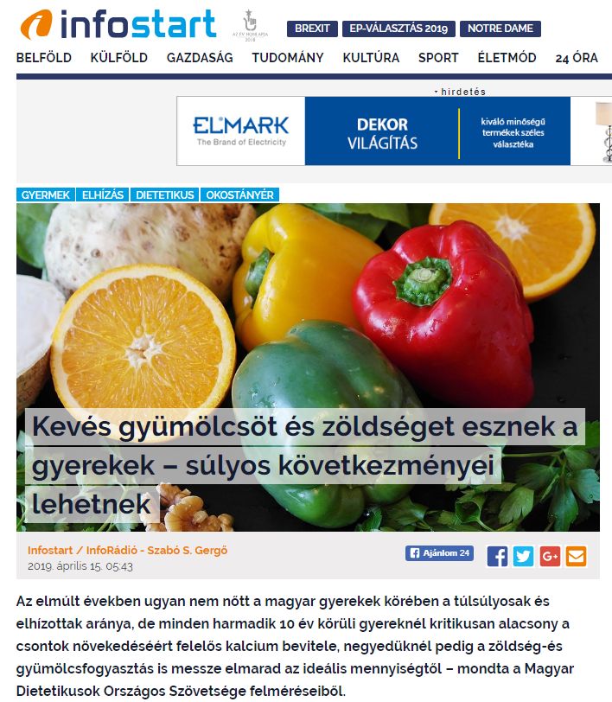
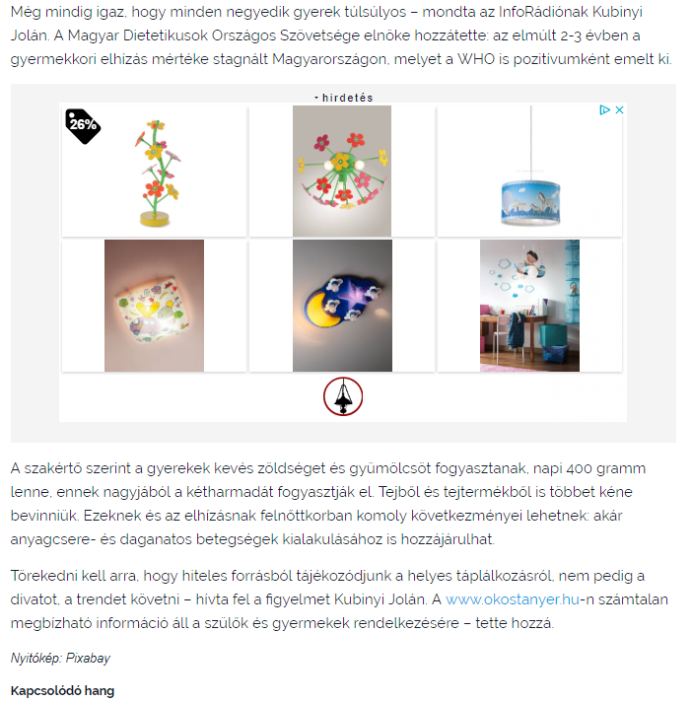

MEDIA: | ridikul.hu | MEDIA SPECIFICS
DÁTE: | 11.04.2019. | TYPE: | online
PAGE: | - | REACH: | 505
AD VALUE (HUF) | 95 | FREQUENCY: | -
HEADLINE: | We should be more cautious about calcium intake
SUMMARY: | In recent years, the proportion of overweight and obesity amongst Hungarian children has halted, but still every third child aged around 10 has some overweight. In this age however, the intake of calcium, which is responsible for the growth of bones is critically low, and the vegetable and fruit consumption is also far below the ideal amount in a quarter of all children– reveal a study made by Danone and the National Association of Hungarian Dieticians. This is why Danone launches the Danone Nations Cup for Children, the largest football cup for children aged 10-12, recognised by FIFA.

https://www.ridikul.hu/cikk/2019/04/11/jobban-oda-kellene-figyelnunk-a-kalciumbevitelre/
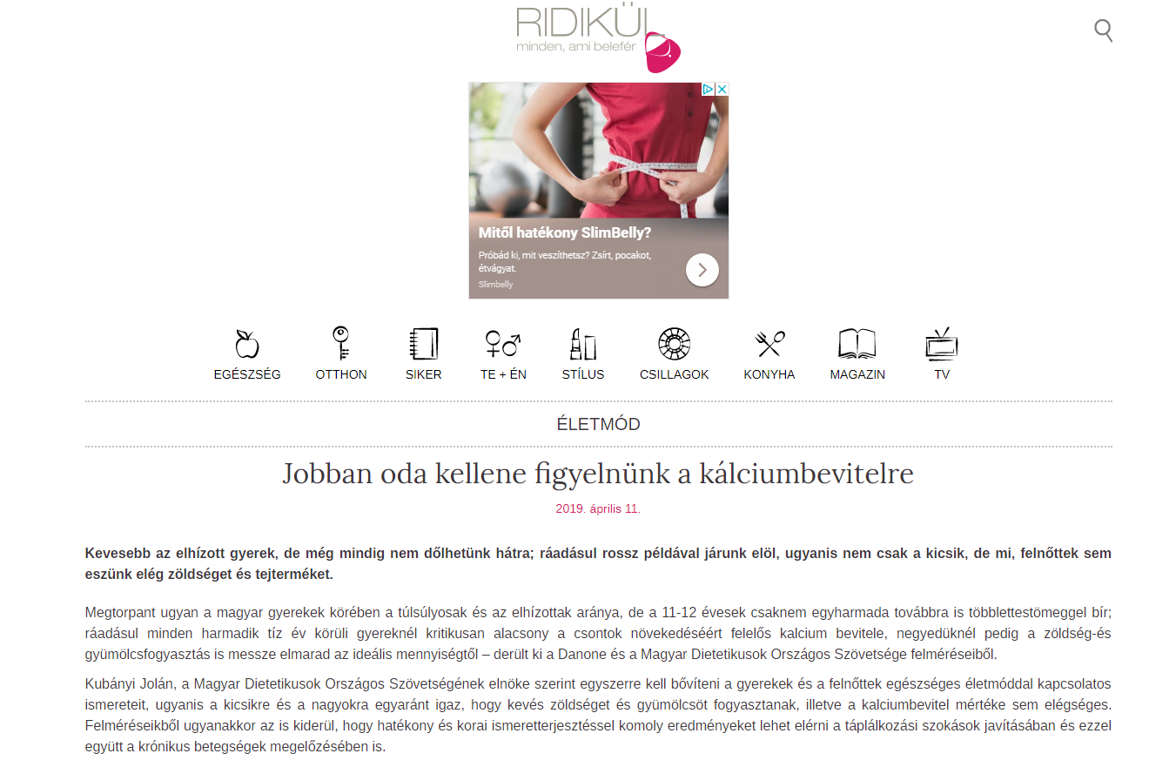

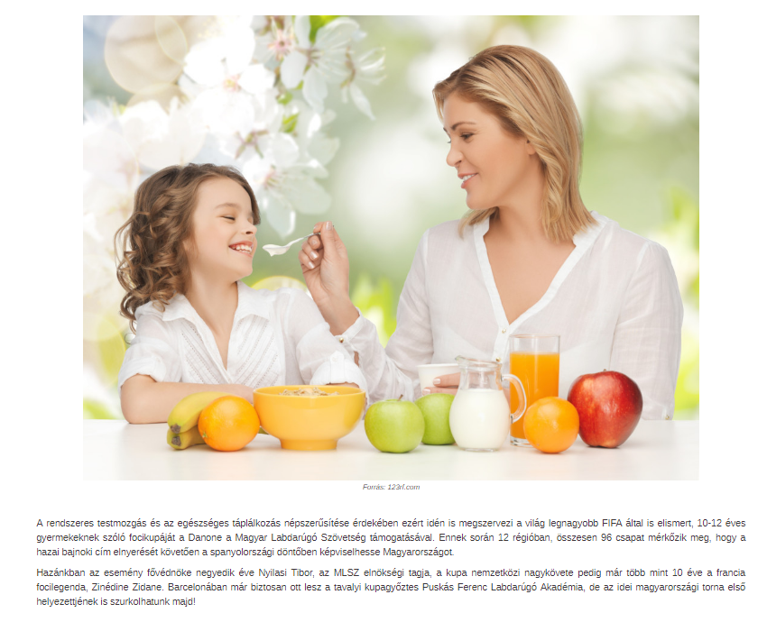

MEDIA: | bestfmnyiregyhaza.hu | MEDIA SPECIFICS
DÁTE: | 15.04.2019. | TYPE: | online
PAGE: | - | REACH: | 505
AD VALUE (HUF) | 95 | FREQUENCY: | -
HEADLINE: | Kids not eating enough fruits and vegetables
SUMMARY: | In recent years, the proportion of overweight and obesity amongst Hungarian children has halted, but still every third child aged around 10 has some overweight. In this age however, the intake of calcium, which is responsible for the growth of bones is critically low, and the vegetable and fruit consumption is also far below the ideal amount in a quarter of all children– reveal a study made by Danone and the National Association of Hungarian Dieticians. This is why Danone launches the Danone Nations Cup for Children, the largest football cup for children aged 10-12, recognised by FIFA.

https://bestfmnyiregyhaza.hu/hir/keves-gyumolcsot-es-zoldseget-esznek-a-gyerekek/530
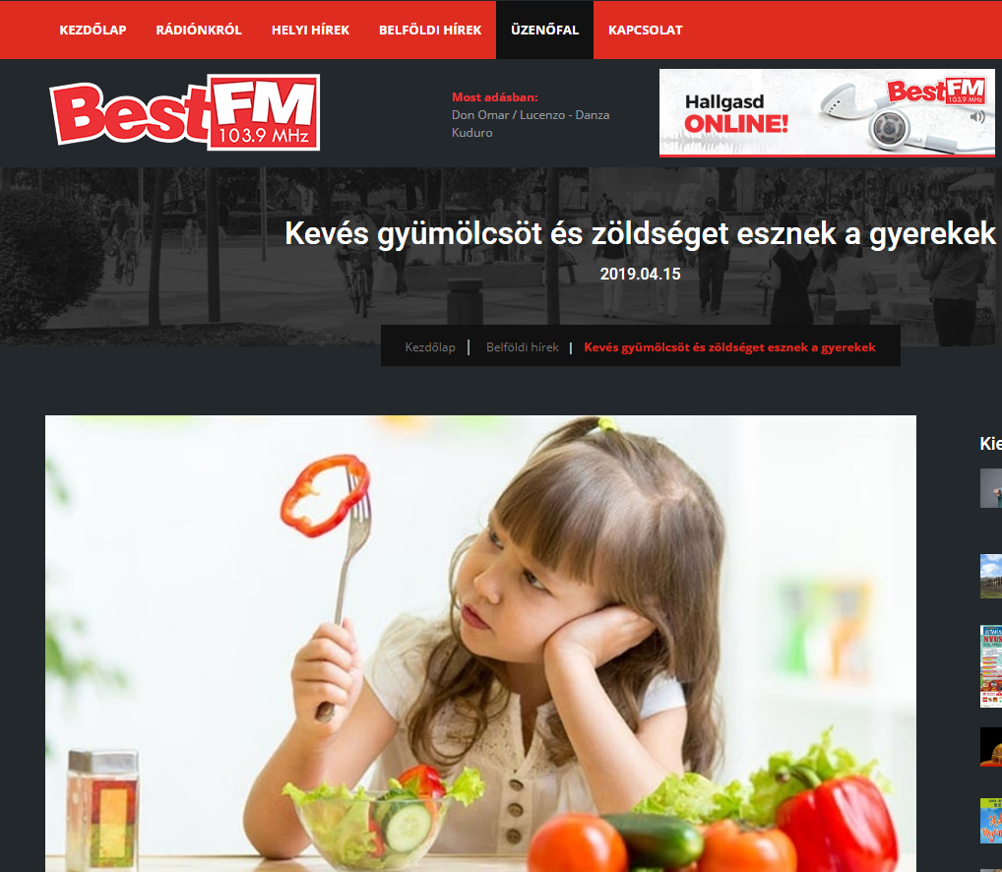
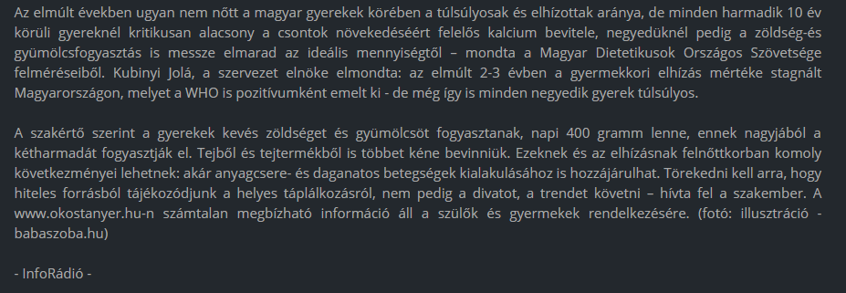

MEDIA: | marketingpirula.hu | MEDIA SPECIFICS
DÁTE: | 10.04.2019. | TYPE: | online
PAGE: | - | REACH: | 500
AD VALUE (HUF) | 95 | FREQUENCY: | -
HEADLINE: | More calcium to students!
SUMMARY: | In recent years, the proportion of overweight and obesity amongst Hungarian children has halted, but still every third child aged around 10 has some overweight. In this age however, the intake of calcium, which is responsible for the growth of bones is critically low, and the vegetable and fruit consumption is also far below the ideal amount in a quarter of all children– reveal a study made by Danone and the National Association of Hungarian Dieticians. This is why Danone launches the Danone Nations Cup for Children, the largest football cup for children aged 10-12, recognised by FIFA.

http://www.marketingpirula.hu/hirek/tobb-kalciumot-az-iskolasoknak/
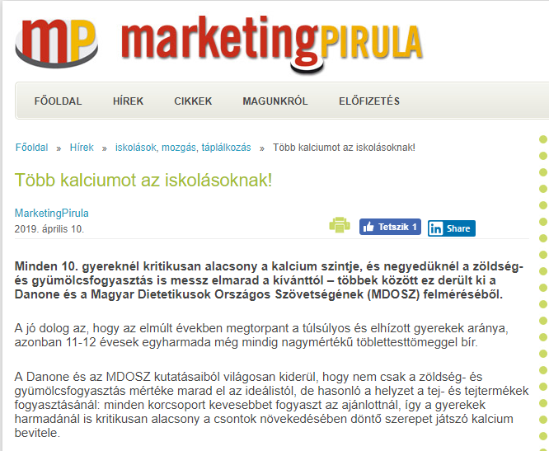

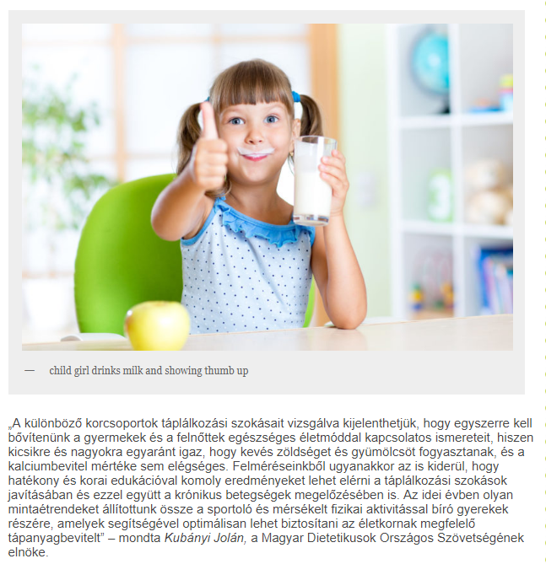

MEDIA: | Vaci-naplo.hu | MEDIA SPECIFICS
DÁTE: | 15.04.2019. | TYPE: | online
PAGE: | - | REACH: | 500
AD VALUE (HUF) | 95 | FREQUENCY: | -
HEADLINE: | More calcium to students!
SUMMARY: | In recent years, the proportion of overweight and obesity amongst Hungarian children has halted, but still every third child aged around 10 has some overweight. In this age however, the intake of calcium, which is responsible for the growth of bones is critically low, and the vegetable and fruit consumption is also far below the ideal amount in a quarter of all children– reveal a study made by Danone and the National Association of Hungarian Dieticians. This is why Danone launches the Danone Nations Cup for Children, the largest football cup for children aged 10-12, recognised by FIFA.

https://www.vaci-naplo.hu/2019/04/keves-gyumolcsot-es-zoldseget-esznek-a-gyerekek/
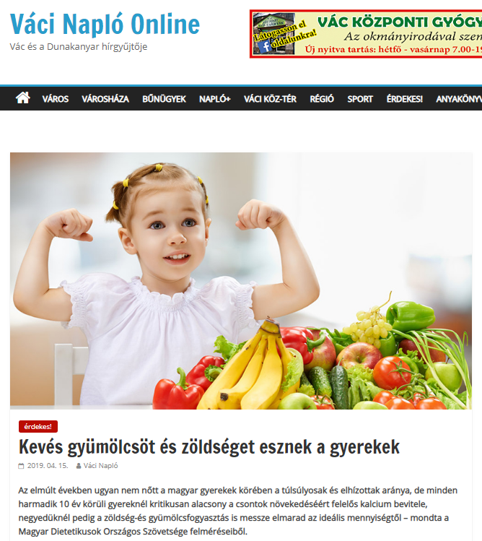
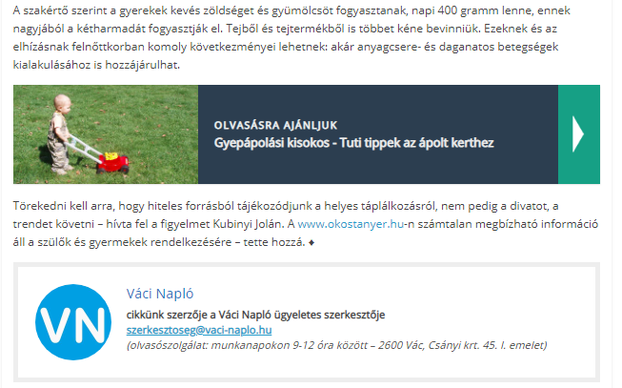

MEDIA: | Civilhetes.net | MEDIA SPECIFICS
DÁTE: | 09.04.2019. | TYPE: | online
PAGE: | - | REACH: | 501
AD VALUE (HUF) | 95 | FREQUENCY: | -
HEADLINE: | Students’ calcium-intake is critically low, not eating enough fruits and vegetables
SUMMARY: | In recent years, the proportion of overweight and obesity amongst Hungarian children has halted, but still every third child aged around 10 has some overweight. In this age however, the intake of calcium, which is responsible for the growth of bones is critically low, and the vegetable and fruit consumption is also far below the ideal amount in a quarter of all children– reveal a study made by Danone and the National Association of Hungarian Dieticians. This is why Danone launches the Danone Nations Cup for Children, the largest football cup for children aged 10-12, recognised by FIFA.

https://civilhetes.net/kritikusan-alacsony-a-kisiskolasok-kalciumbevitele-es-nem-esznek-eleg-zoldseget-gyumolcsot-sem
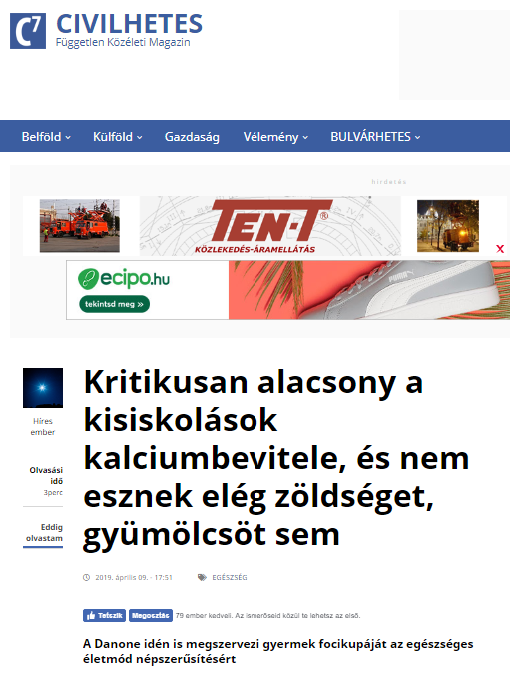

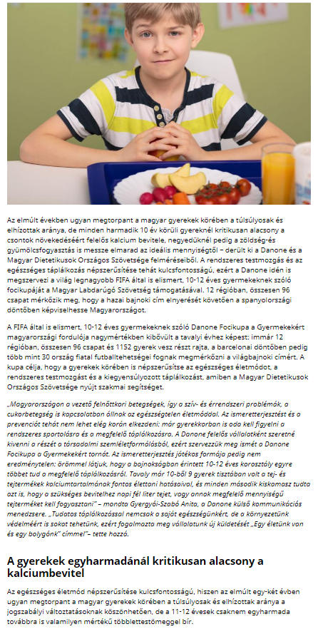
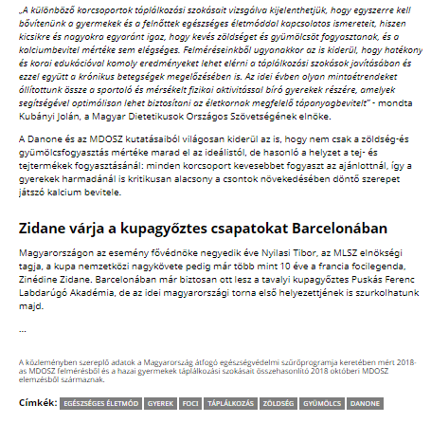

MEDIA: | Kossuth Rádió | MEDIA SPECIFICS
DÁTE: | 15.04.2019. | TYPE: | Electronic
PAGE: | - | REACH: | 1 206 000
AD VALUE (HUF) | 5 000 | FREQUENCY: | -
HEADLINE: | Interview with Jolán Kubányi, president of MDOSZ
SUMMARY: | In recent years, the proportion of overweight and obesity amongst Hungarian children has halted, but still every third child aged around 10 has some overweight. In this age however, the intake of calcium, which is responsible for the growth of bones is critically low, and the vegetable and fruit consumption is also far below the ideal amount in a quarter of all children– reveal a study made by Danone and the National Association of Hungarian Dieticians. This is why Danone launches the Danone Nations Cup for Children, the largest football cup for children aged 10-12, recognised by FIFA.

http://premiercom.hu/download/Danone/Kossuth%20R-di%c3%b3%20-%20interj%c3%ba%20Kub%c3%a1nyi%20Jol%c3%a1nnal.wav

MEDIA: | Dunaújvárosi Hírlap | MEDIA SPECIFICS
DÁTE: | 11.04.2019. | TYPE: | Print
PAGE: | 16 | REACH: | 16 800
AD VALUE (HUF) | 159 | FREQUENCY: | -
HEADLINE: | Going to the national final is at stake
SUMMARY: | In recent years, the proportion of overweight and obesity amongst Hungarian children has halted, but still every third child aged around 10 has some overweight. In this age however, the intake of calcium, which is responsible for the growth of bones is critically low, and the vegetable and fruit consumption is also far below the ideal amount in a quarter of all children– reveal a study made by Danone and the National Association of Hungarian Dieticians. This is why Danone launches the Danone Nations Cup for Children, the largest football cup for children aged 10-12, recognised by FIFA.

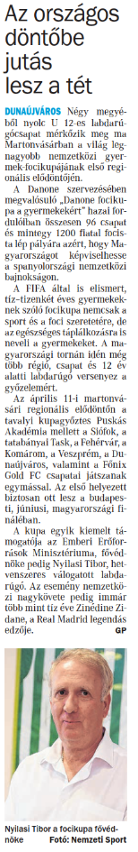
MEDIA: | Dunaújvárosi Hírlap | MEDIA SPECIFICS
DÁTE: | 12.04.2019. | TYPE: | Print
PAGE: | 11 | REACH: | 16 800
AD VALUE (HUF) | 159 | FREQUENCY: | -
HEADLINE: | DPASE team finished sixth
SUMMARY: | In recent years, the proportion of overweight and obesity amongst Hungarian children has halted, but still every third child aged around 10 has some overweight. In this age however, the intake of calcium, which is responsible for the growth of bones is critically low, and the vegetable and fruit consumption is also far below the ideal amount in a quarter of all children– reveal a study made by Danone and the National Association of Hungarian Dieticians. This is why Danone launches the Danone Nations Cup for Children, the largest football cup for children aged 10-12, recognised by FIFA.

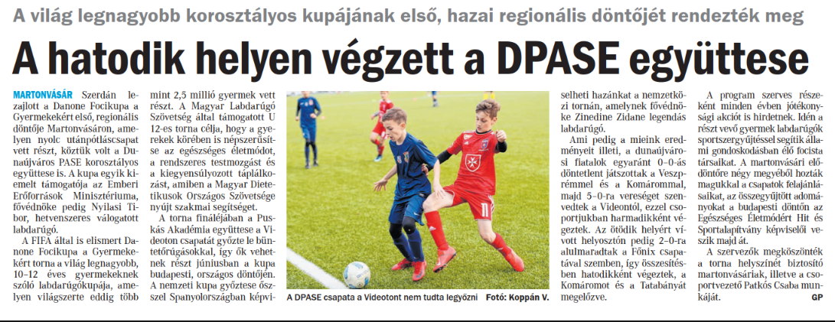

MEDIA: | Duol.hu | MEDIA SPECIFICS
DÁTE: | 11.04.2019. | TYPE: | Online
PAGE: | - | REACH: | 100 000
AD VALUE (HUF) | 300 000 | FREQUENCY: | -
HEADLINE: | Going to the national final is at stake
SUMMARY: | In recent years, the proportion of overweight and obesity amongst Hungarian children has halted, but still every third child aged around 10 has some overweight. In this age however, the intake of calcium, which is responsible for the growth of bones is critically low, and the vegetable and fruit consumption is also far below the ideal amount in a quarter of all children– reveal a study made by Danone and the National Association of Hungarian Dieticians. This is why Danone launches the Danone Nations Cup for Children, the largest football cup for children aged 10-12, recognised by FIFA.

https://www.duol.hu/sport/helyi-sport/a-hatodik-helyen-vegzett-a-dpase-egyuttese-2765116/
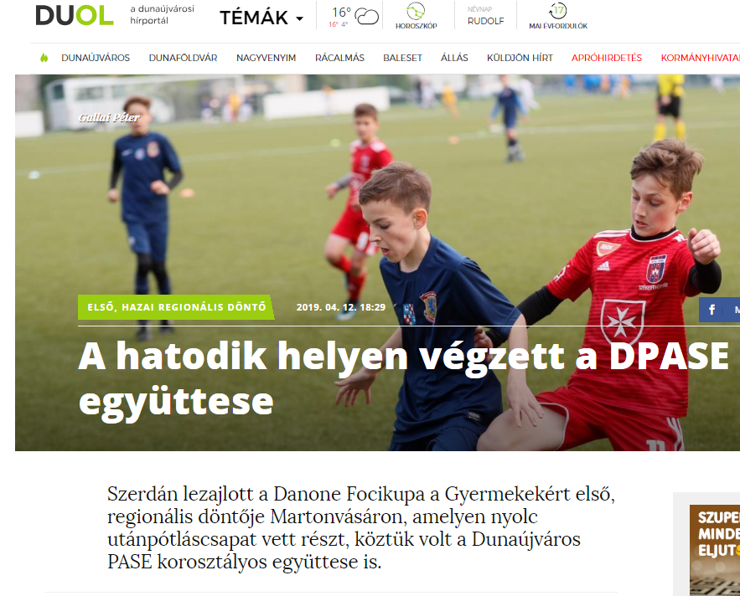

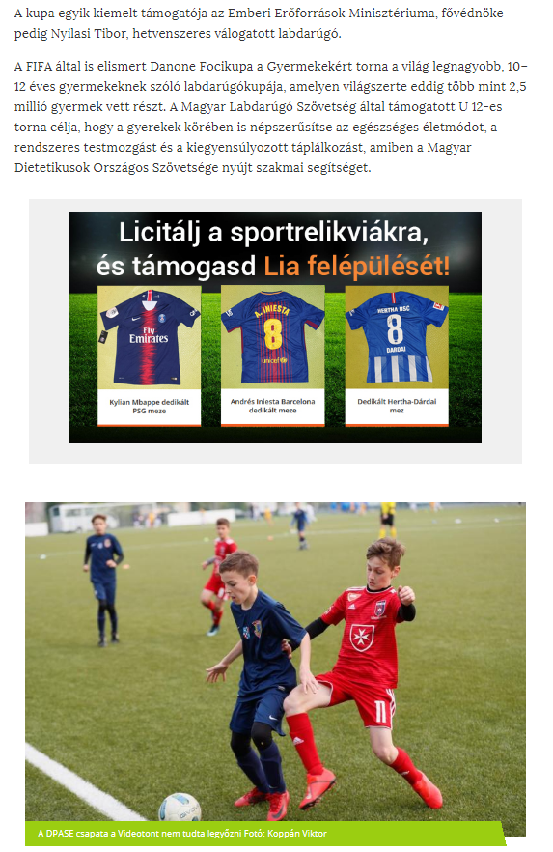
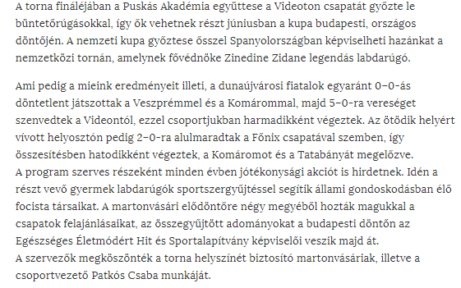

MEDIA: | M1 Ma reggel | MEDIA SPECIFICS
DÁTE: | 23.04.2019. 5’10” | TYPE: | Electronic
PAGE: | - | REACH: | 141 752
AD VALUE (HUF) | 300 000 | FREQUENCY: | -
HEADLINE: | Interview with Zsuzsanna Szűcs
SUMMARY: | In recent years, the proportion of overweight and obesity amongst Hungarian children has halted, but still every third child aged around 10 has some overweight. In this age however, the intake of calcium, which is responsible for the growth of bones is critically low, and the vegetable and fruit consumption is also far below the ideal amount in a quarter of all children– reveal a study made by Danone and the National Association of Hungarian Dieticians. This is why Danone launches the Danone Nations Cup for Children, the largest football cup for children aged 10-12, recognised by FIFA.

https://www.mediaklikk.hu/video/ma-delelott-2019-04-23-i-adas-3/
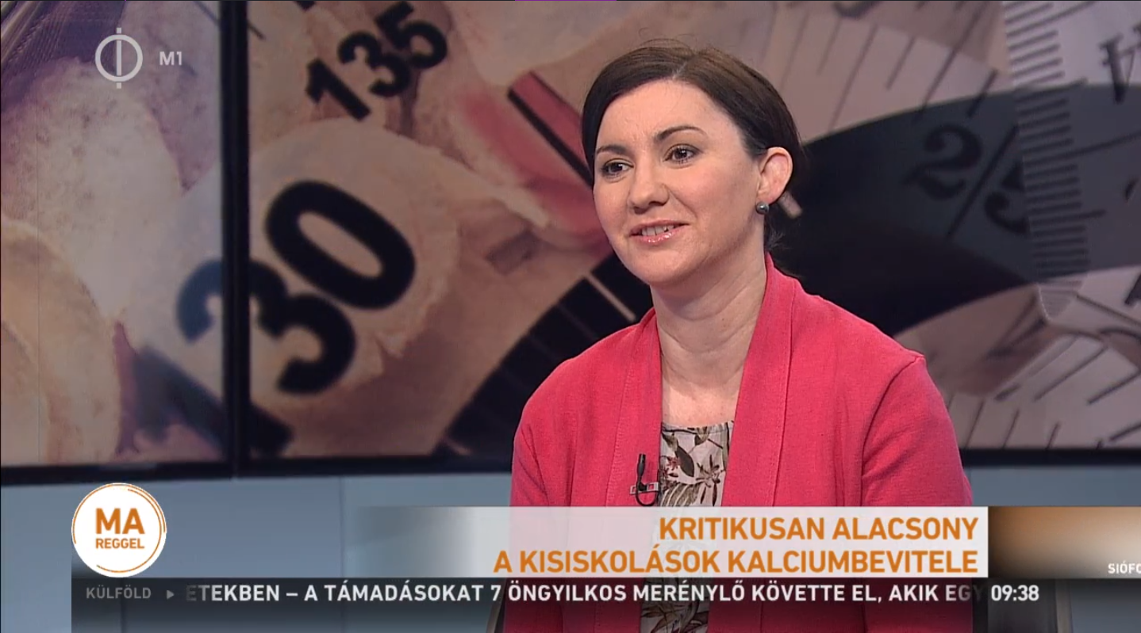

MEDIA: | Termékmix.hu | MEDIA SPECIFICS
DÁTE: | 10.04.2019. | TYPE: | Online
PAGE: | - | REACH: | 238
AD VALUE (HUF) | 41 | FREQUENCY: | -
HEADLINE: | Danone this year also organizes football cup for children in order to promote healthy lifestyle
SUMMARY: | In recent years, the proportion of overweight and obesity amongst Hungarian children has halted, but still every third child aged around 10 has some overweight. In this age however, the intake of calcium, which is responsible for the growth of bones is critically low, and the vegetable and fruit consumption is also far below the ideal amount in a quarter of all children– reveal a study made by Danone and the National Association of Hungarian Dieticians. This is why Danone launches the Danone Nations Cup for Children, the largest football cup for children aged 10-12, recognised by FIFA.

http://termekmix.hu/ipar/hirek/2706-a-danone-iden-is-megszervezi-gyermek-focikupajat-az-egeszseges-eletmod-nepszerusitesert
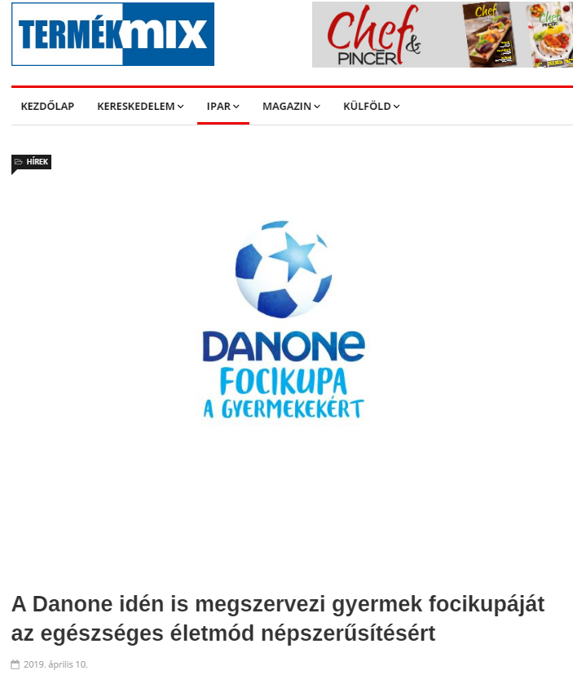
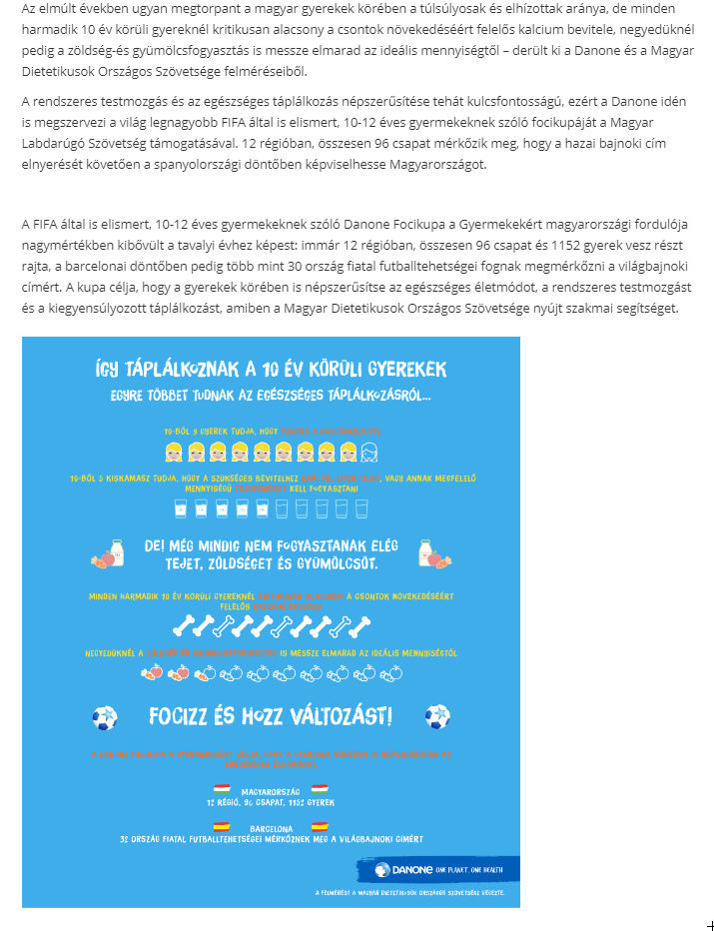

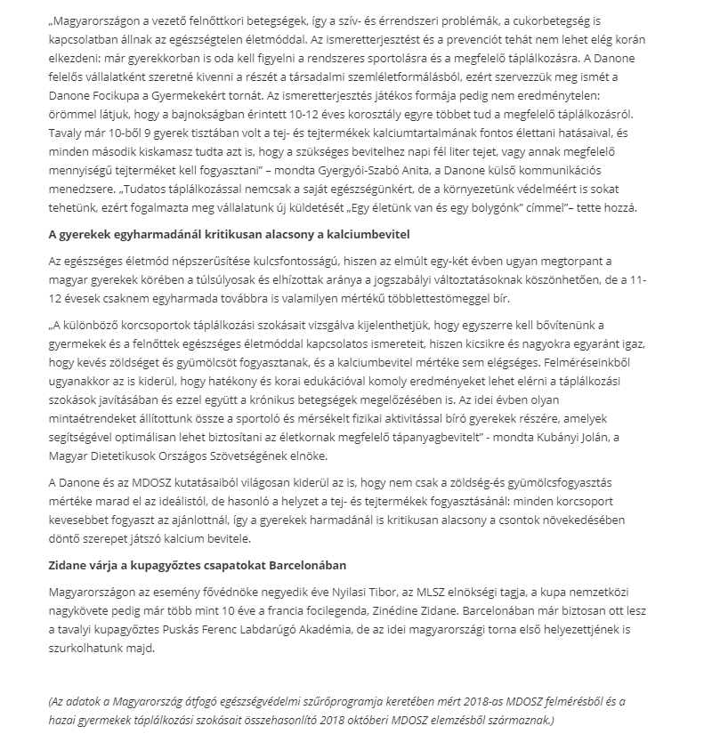

MEDIA: | Hirzilla.hu | MEDIA SPECIFICS
DÁTE: | 12.04.2019. | TYPE: | Online
PAGE: | - | REACH: | 500
AD VALUE (HUF) | 94 | FREQUENCY: | -
HEADLINE: | Unfortunately, students’ calcium intake is critically low
SUMMARY: | In recent years, the proportion of overweight and obesity amongst Hungarian children has halted, but still every third child aged around 10 has some overweight. In this age however, the intake of calcium, which is responsible for the growth of bones is critically low, and the vegetable and fruit consumption is also far below the ideal amount in a quarter of all children– reveal a study made by Danone and the National Association of Hungarian Dieticians. This is why Danone launches the Danone Nations Cup for Children, the largest football cup for children aged 10-12, recognised by FIFA.

http://hirzilla.hu/hirek/online-hirek/blikk/2019/04/12/sajnos-kritikusan-alacsony-a-kisiskolasok-kalciumbevitele/?feed_id=36624&_unique_id=5cb031b43c252
