MEDIA: | Civilhetes.net | MEDIA SPECIFICS
DATE: | 12.09.2018 | TYPE: | Online
PAGE: |  | REACH: | n/a
AD VALUE (€) | n/a | FREQUENCY: | 2 alkalommal
HEADLINE | With kilometers for children smiles
SUMMARY | Laugh and joy heals, therefore Bridgestone donates 1,5 million HUF to Red Nose Clown Doctors Foundation after the 10.000 kilometers collected by colleagues of Bridgestone by walking, running and cycling more than 10,000 kilometers. The Foundation’s clown doctors will use the donation to bring the children treated in the Szent Borbála Hospital in Tatabánya with chronical illnesses and traumas smile, joy and laugh.

https://civilhetes.net/kilometerekkel-a-gyermekmosolyokert

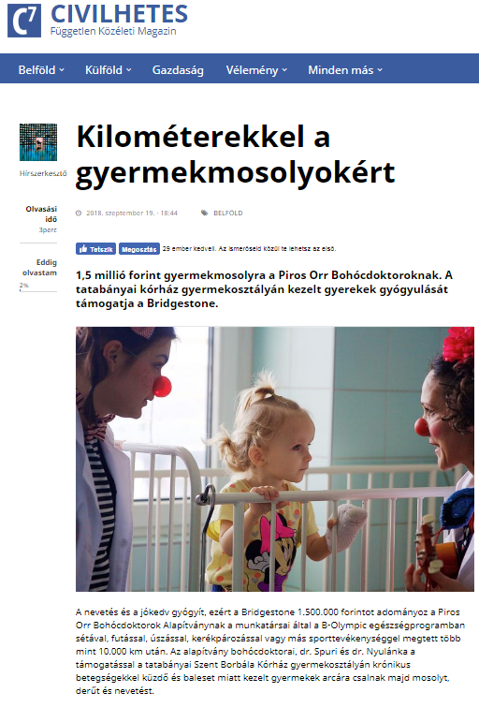

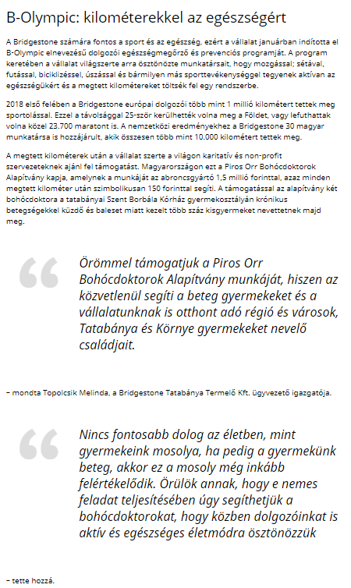

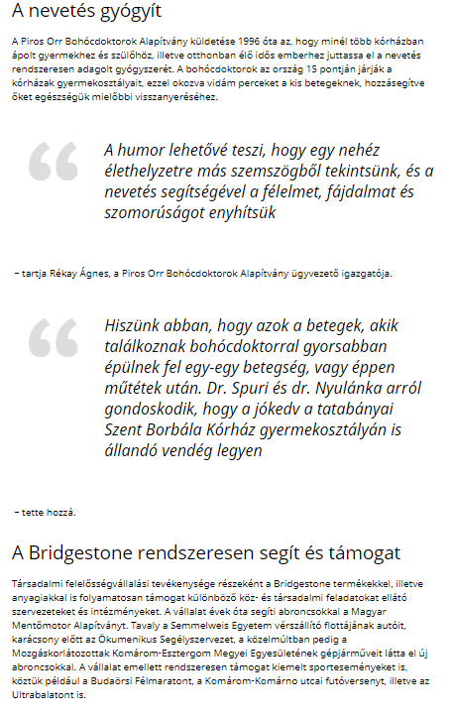

MEDIA: | Weborvos.hu | MEDIA SPECIFICS
DATE: | 19.09.2018 | TYPE: | Online
PAGE: |  | REACH: | 3 192
AD VALUE (€) | 138 | FREQUENCY: | -
HEADLINE | 1,5 million HUF for Red Nose Clown Doctors
SUMMARY | Laugh and joy heals, therefore Bridgestone donates 1,5 million HUF to Red Nose Clown Doctors Foundation after the 10.000 kilometers collected by colleagues of Bridgestone by walking, running and cycling more than 10,000 kilometers. The Foundation’s clown doctors will use the donation to bring the children treated in the Szent Borbála Hospital in Tatabánya with chronical illnesses and traumas smile, joy and laugh.

https://weborvos.hu/hirek/15-millio-forint-a-piros-orr-bohocdoktoroknak-248051

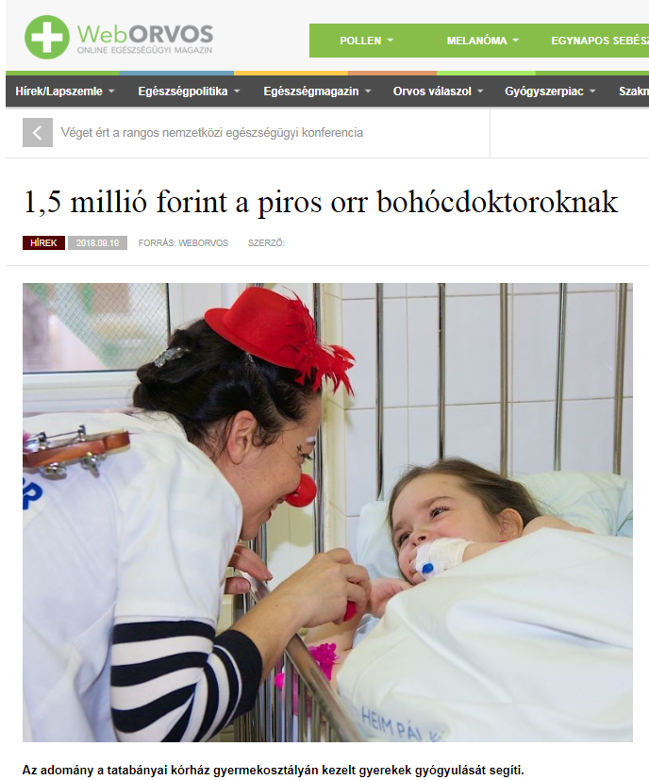

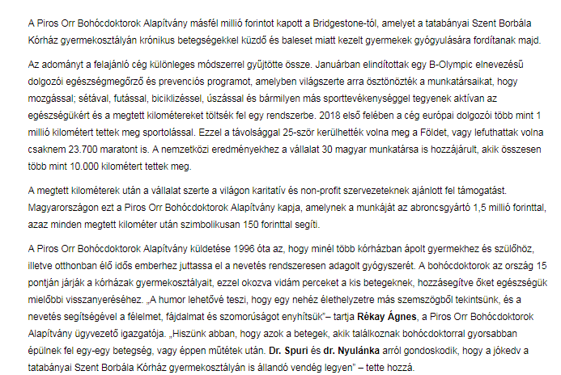

MEDIA: | Mixonline.hu | MEDIA SPECIFICS
DATE: | 20.09.2018 | TYPE: | Online
PAGE: |  | REACH: | 148 212
AD VALUE (€) | 64 | FREQUENCY: | -
HEADLINE | 1,5 million HUF for Red Nose Clown Doctors
SUMMARY | Laugh and joy heals, therefore Bridgestone donates 1,5 million HUF to Red Nose Clown Doctors Foundation after the 10.000 kilometers collected by colleagues of Bridgestone by walking, running and cycling more than 10,000 kilometers. The Foundation’s clown doctors will use the donation to bring the children treated in the Szent Borbála Hospital in Tatabánya with chronical illnesses and traumas smile, joy and laugh.

http://www.mixonline.hu/Cikk.aspx?id=155038

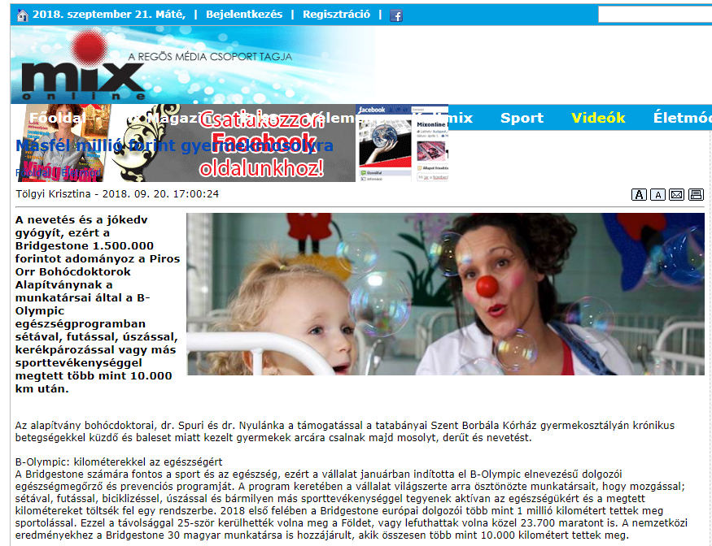

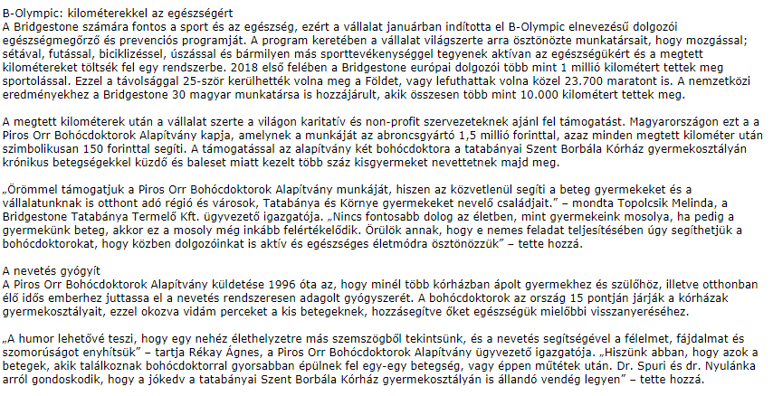

MEDIA: | Hrportal.hu | MEDIA SPECIFICS
DATE: | 20.09.2018 | TYPE: | Online
PAGE: |  | REACH: | 25 000
AD VALUE (€) | 46 | FREQUENCY: | -
HEADLINE | Bridgestone donates 1,5 million HUF for Red Nose Clown Doctors
SUMMARY | Laugh and joy heals, therefore Bridgestone donates 1,5 million HUF to Red Nose Clown Doctors Foundation after the 10.000 kilometers collected by colleagues of Bridgestone by walking, running and cycling more than 10,000 kilometers. The Foundation’s clown doctors will use the donation to bring the children treated in the Szent Borbála Hospital in Tatabánya with chronical illnesses and traumas smile, joy and laugh.

https://www.hrportal.hu/hr/a-bridgestone-masfel-millio-forintot-adomanyoz-a-bohocdoktoroknak-20180920.html

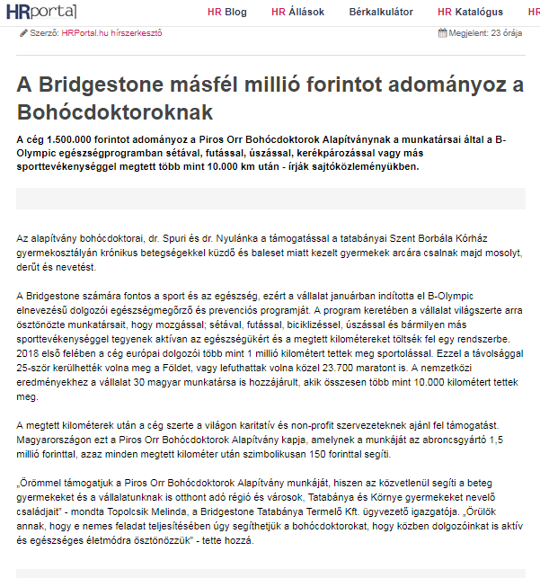

MEDIA: | Autoszektor.hu | MEDIA SPECIFICS
DATE: | 20.09.2018 | TYPE: | Online
PAGE: |  | REACH: | 4 808
AD VALUE (€) | 345 | FREQUENCY: | -
HEADLINE | Bridgestone supports hospitalized children’s healing
SUMMARY | Laugh and joy heals, therefore Bridgestone donates 1,5 million HUF to Red Nose Clown Doctors Foundation after the 10.000 kilometers collected by colleagues of Bridgestone by walking, running and cycling more than 10,000 kilometers. The Foundation’s clown doctors will use the donation to bring the children treated in the Szent Borbála Hospital in Tatabánya with chronical illnesses and traumas smile, joy and laugh.

http://www.autoszektor.hu/hu/content/beteg-gyerekek-gyogyulasat-tamogatja-bridgestone

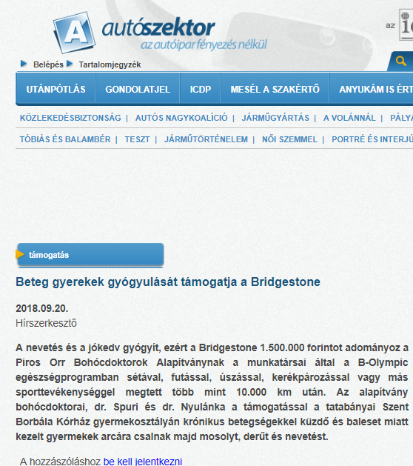
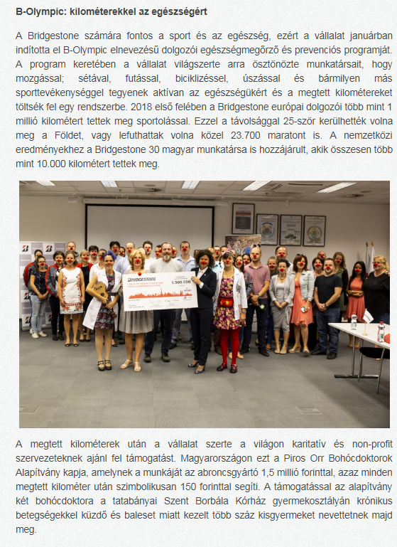

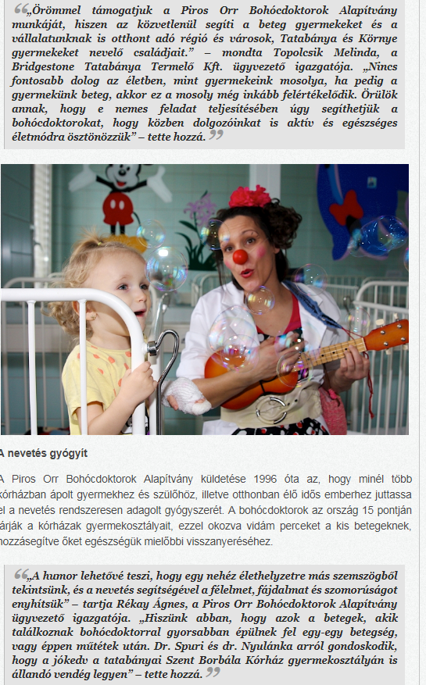

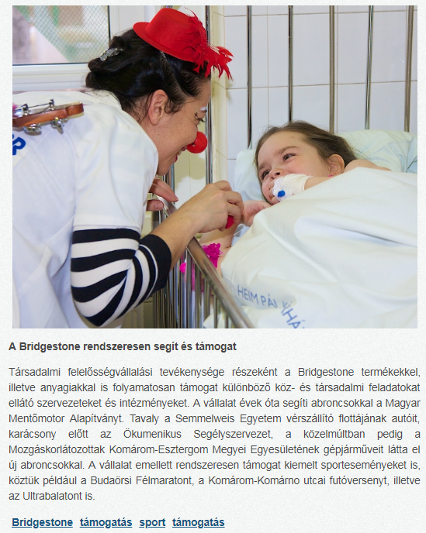

MEDIA: | infotatabanya.hu | MEDIA SPECIFICS
DATE: | 21.09.2018 | TYPE: | Online
PAGE: |  | REACH: | 9 000
AD VALUE (€) | 81 | FREQUENCY: | -
HEADLINE | Bridgestone supports hospitalized children’s healing
SUMMARY | Laugh and joy heals, therefore Bridgestone donates 1,5 million HUF to Red Nose Clown Doctors Foundation after the 10.000 kilometers collected by colleagues of Bridgestone by walking, running and cycling more than 10,000 kilometers. The Foundation’s clown doctors will use the donation to bring the children treated in the Szent Borbála Hospital in Tatabánya with chronical illnesses and traumas smile, joy and laugh.

http://www.infotatabanya.hu/hirek/olvas/permalink:15-millio-forint-gyermekmosolyra-a-piros-orr-bohocdoktoroknak-2018-09-21-093309

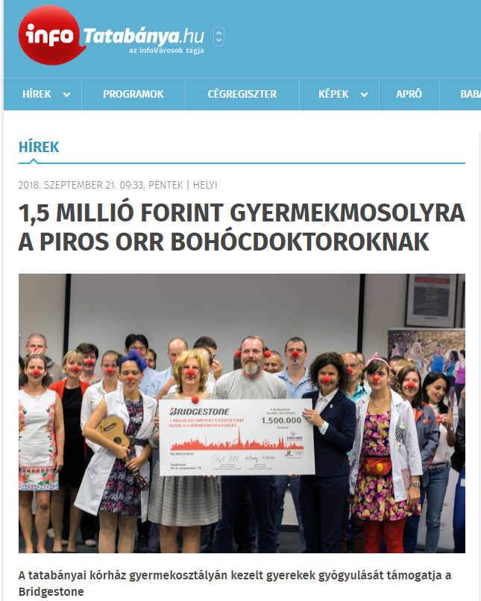
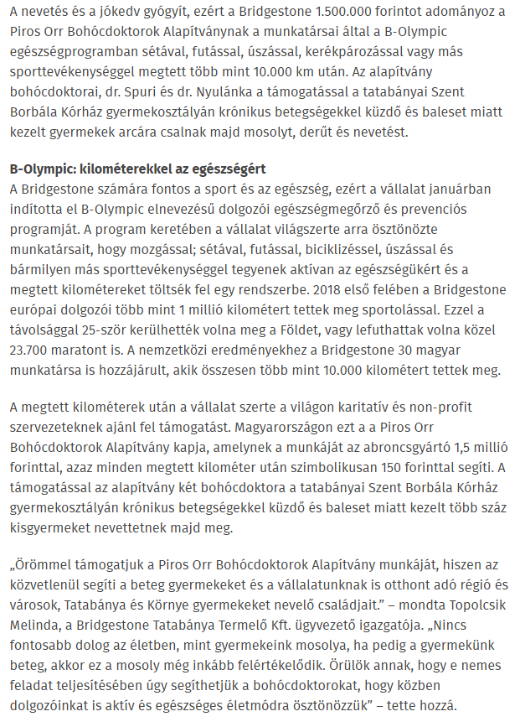

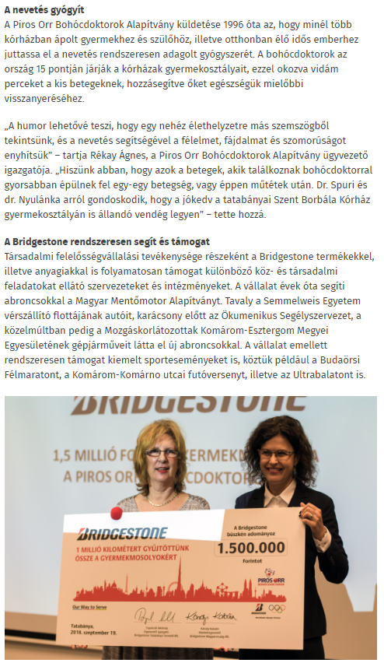

MEDIA: | 24 Óra | MEDIA SPECIFICS
DATE: | 20.09.2018 | TYPE: | Print
PAGE: | 1, 3 | REACH: | 40 200
AD VALUE (€) | 571 | FREQUENCY: | Daily
HEADLINE | Laugh heals, Bridgestone helps
SUMMARY | Laugh and joy heals, therefore Bridgestone donates 1,5 million HUF to Red Nose Clown Doctors Foundation after the 10.000 kilometers collected by colleagues of Bridgestone by walking, running and cycling more than 10,000 kilometers. The Foundation’s clown doctors will use the donation to bring the children treated in the Szent Borbála Hospital in Tatabánya with chronical illnesses and traumas smile, joy and laugh.

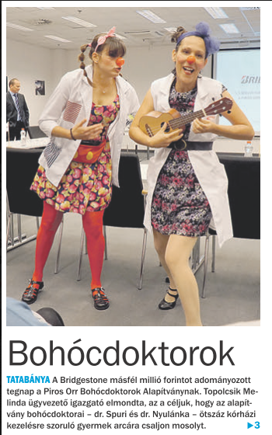

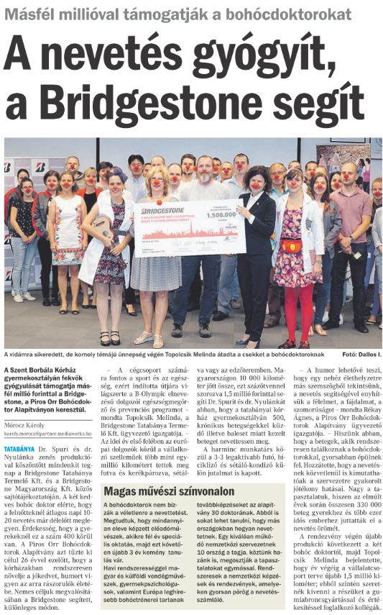

MEDIA: | M1 Ma délelőtt | MEDIA SPECIFICS
DATE: | 19.09.2018 | TYPE: | Electronic
PAGE: | 3’40- | REACH: | 141 752
AD VALUE (€) | 1 000 | FREQUENCY: | -
HEADLINE | Interview with Zsuzsa Magyar
SUMMARY | Laugh and joy heals, therefore Bridgestone donates 1,5 million HUF to Red Nose Clown Doctors Foundation after the 10.000 kilometers collected by colleagues of Bridgestone by walking, running and cycling more than 10,000 kilometers. The Foundation’s clown doctors will use the donation to bring the children treated in the Szent Borbála Hospital in Tatabánya with chronical illnesses and traumas smile, joy and laugh.

https://www.mediaklikk.hu/video/ma-delelott-2018-09-19-i-adas-5/

