MEDIA: | Origo.hu | MEDIA SPECIFICS
DATE: | 26.07.2018 | TYPE: | Online
PAGE: | - | REACH: | 544 000
AD VALUE (€) |  | FREQUENCY: | -
HEADLINE | Is tire more important for women or men? Here is the answer!
SUMMARY | While the ladies who are more cautious on the road are primarily concerned with tire pressure problems and injuries caused by pads and potholes, while men who drive more sporty typically go to the tire services because of tire damages due to their driving style – revealed by an analysis carried out among the heads of Bridgestone tire services. Because of the faster pace, for male drivers it is necessary to buy new tires more often than women, who are more caring for their car and tires. However, one thing is typical of both genders: in the case of a replacement, the quality and reliability of the tire is becoming increasingly important.

http://www.origo.hu/auto/20180726-a-nok-vagy-a-ferfiak-figyelnek-jobban-a-gumira-itt-a-valasz.html

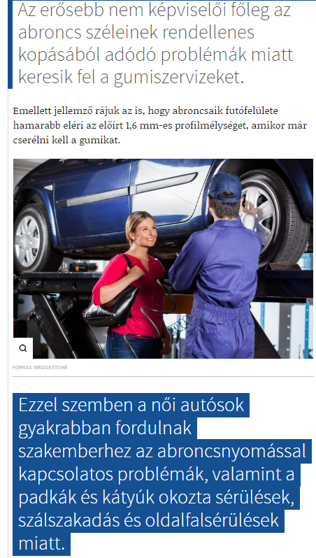

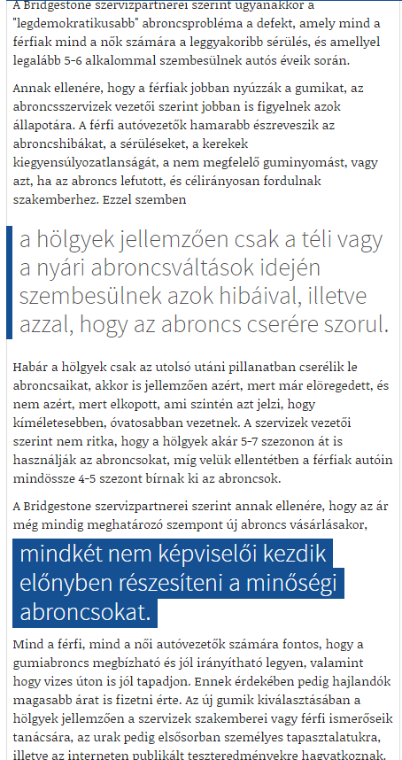

MEDIA: | Nlcafe.hu | MEDIA SPECIFICS
DATE: | 26.07.2018 | TYPE: | Online
PAGE: | - | REACH: | 345 000
AD VALUE (€) | 967 | FREQUENCY: | -
HEADLINE | Women vs men: who cares more about the tire?
SUMMARY | While the ladies who are more cautious on the road are primarily concerned with tire pressure problems and injuries caused by pads and potholes, while men who drive more sporty typically go to the tire services because of tire damages due to their driving style – revealed by an analysis carried out among the heads of Bridgestone tire services. Because of the faster pace, for male drivers it is necessary to buy new tires more often than women, who are more caring for their car and tires. However, one thing is typical of both genders: in the case of a replacement, the quality and reliability of the tire is becoming increasingly important.

https://www.nlcafe.hu/magyarorszagkul/20180726/no-ferfi-gumi-abroncs-autovezetes/

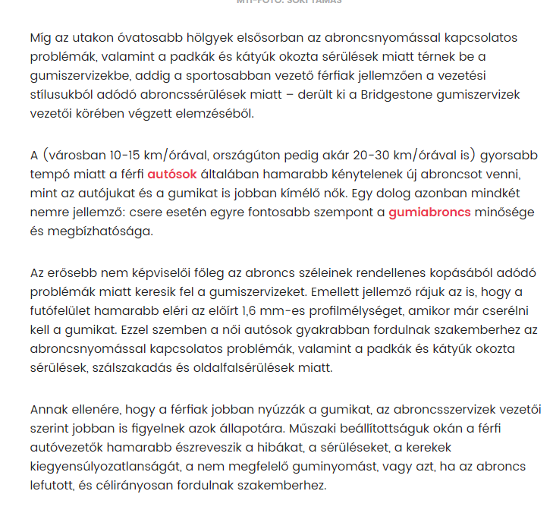

MEDIA: | Formula.hu | MEDIA SPECIFICS
DATE: | 26.07.2018 | TYPE: | Online
PAGE: | - | REACH: | 4 177
AD VALUE (€) | 54 | FREQUENCY: | -
HEADLINE | Women vs men: who cares more about the tire?
SUMMARY | While the ladies who are more cautious on the road are primarily concerned with tire pressure problems and injuries caused by pads and potholes, while men who drive more sporty typically go to the tire services because of tire damages due to their driving style – revealed by an analysis carried out among the heads of Bridgestone tire services. Because of the faster pace, for male drivers it is necessary to buy new tires more often than women, who are more caring for their car and tires. However, one thing is typical of both genders: in the case of a replacement, the quality and reliability of the tire is becoming increasingly important.

https://formula.hu/auto/2018/07/26/nok-vs-ferfiak-ki-figyel-jobban-a-gumira

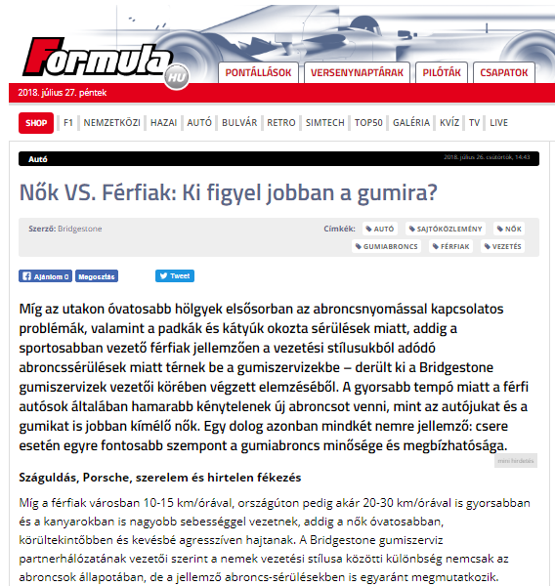

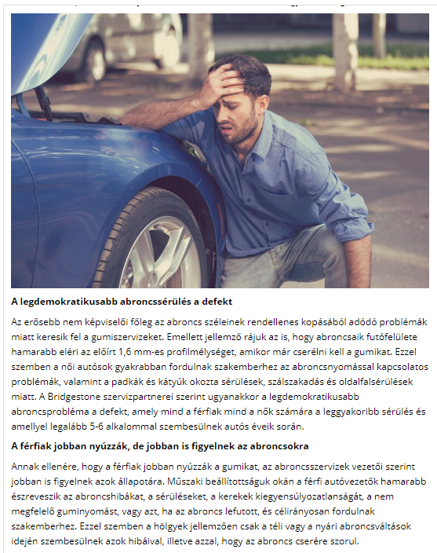

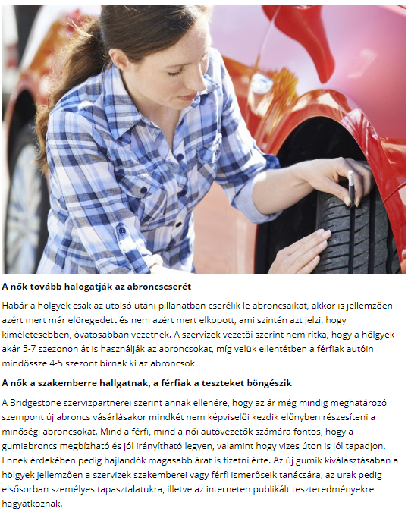

MEDIA: | Vezess.hu | MEDIA SPECIFICS
DATE: | 27.07.2018 | TYPE: | Online
PAGE: | - | REACH: | 4 177
AD VALUE (€) | 54 | FREQUENCY: | -
HEADLINE | Using tires: do women or men care more?
SUMMARY | While the ladies who are more cautious on the road are primarily concerned with tire pressure problems and injuries caused by pads and potholes, while men who drive more sporty typically go to the tire services because of tire damages due to their driving style – revealed by an analysis carried out among the heads of Bridgestone tire services. Because of the faster pace, for male drivers it is necessary to buy new tires more often than women, who are more caring for their car and tires. However, one thing is typical of both genders: in the case of a replacement, the quality and reliability of the tire is becoming increasingly important.

https://www.vezess.hu/vezetunk/2018/07/27/gumihasznalat-nok-vagy-ferfiak-figyelnek-jobban/

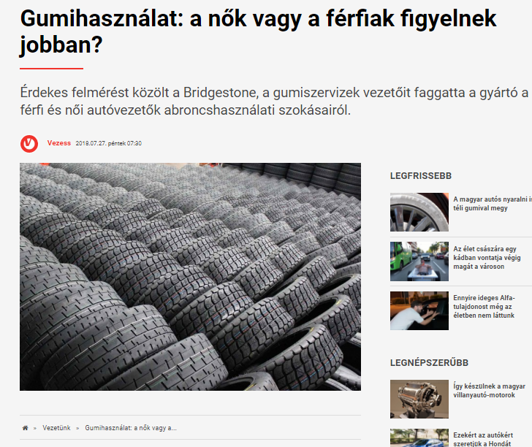

MEDIA: | Cilihetes.net | MEDIA SPECIFICS
DATE: | 26.07.2018 | TYPE: | Online
PAGE: | - | REACH: | N/A
AD VALUE (€) | N/A | FREQUENCY: | -
HEADLINE | Using tires: do women or men care more?
SUMMARY | While the ladies who are more cautious on the road are primarily concerned with tire pressure problems and injuries caused by pads and potholes, while men who drive more sporty typically go to the tire services because of tire damages due to their driving style – revealed by an analysis carried out among the heads of Bridgestone tire services. Because of the faster pace, for male drivers it is necessary to buy new tires more often than women, who are more caring for their car and tires. However, one thing is typical of both genders: in the case of a replacement, the quality and reliability of the tire is becoming increasingly important.

https://civilhetes.net/nok-vs-ferfiak-ki-figyel-jobban-a-gumira

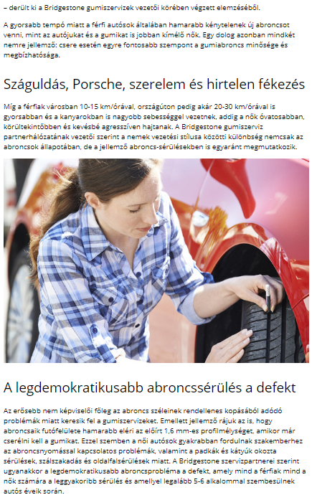

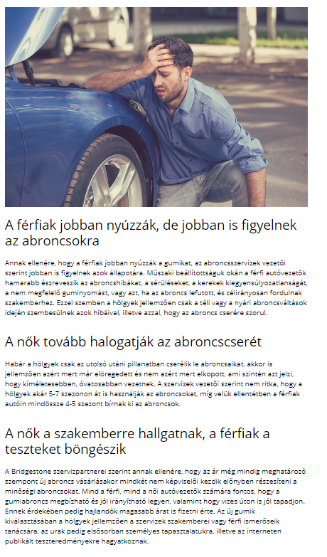

MEDIA: | Voilamode.blog.hu | MEDIA SPECIFICS
DATE: | 26.07.2018 | TYPE: | Online
PAGE: | - | REACH: | N/A
AD VALUE (€) | N/A | FREQUENCY: | -
HEADLINE | Women vs men: who cares more about the tire?
SUMMARY | While the ladies who are more cautious on the road are primarily concerned with tire pressure problems and injuries caused by pads and potholes, while men who drive more sporty typically go to the tire services because of tire damages due to their driving style – revealed by an analysis carried out among the heads of Bridgestone tire services. Because of the faster pace, for male drivers it is necessary to buy new tires more often than women, who are more caring for their car and tires. However, one thing is typical of both genders: in the case of a replacement, the quality and reliability of the tire is becoming increasingly important.

https://voilamode.blog.hu/2018/07/26/nok_vs_ferfiak_ki_figyel_jobban_a_gumira

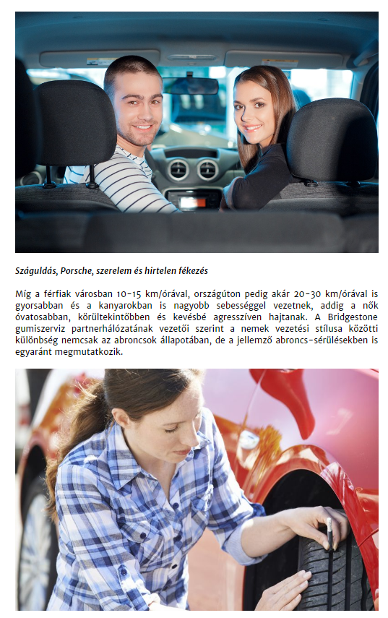

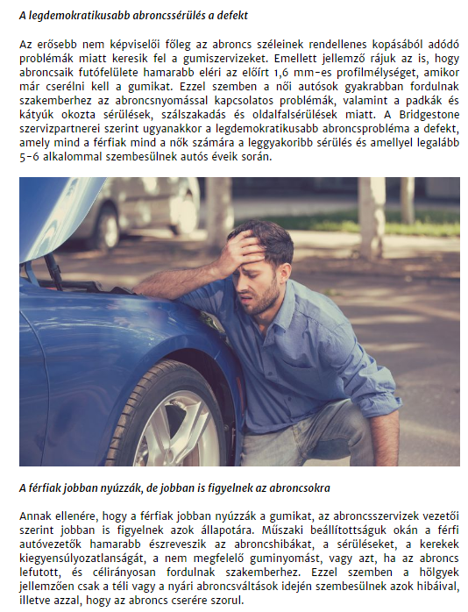

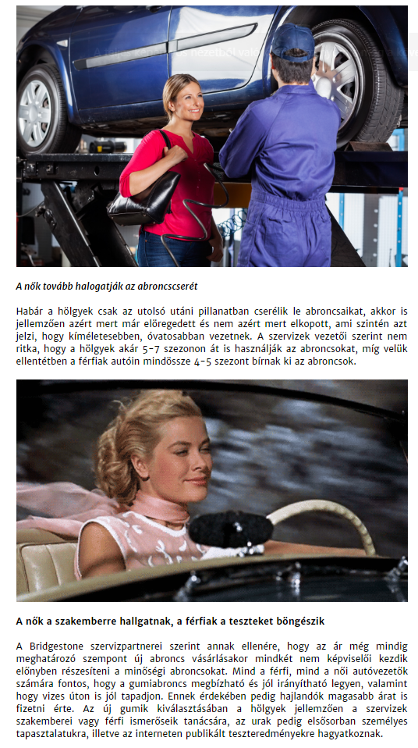

MEDIA: | Feherv arihirek.hu | MEDIA SPECIFICS
DATE: | 27.07.2018 | TYPE: | Online
PAGE: | - | REACH: | N/A
AD VALUE (€) | 8 | FREQUENCY: | -
HEADLINE | Women vs men: who cares more about the tire?
SUMMARY | While the ladies who are more cautious on the road are primarily concerned with tire pressure problems and injuries caused by pads and potholes, while men who drive more sporty typically go to the tire services because of tire damages due to their driving style – revealed by an analysis carried out among the heads of Bridgestone tire services. Because of the faster pace, for male drivers it is necessary to buy new tires more often than women, who are more caring for their car and tires. However, one thing is typical of both genders: in the case of a replacement, the quality and reliability of the tire is becoming increasingly important.

http://www.fehervarihirek.hu/index.php?option=com_content&task=view&id=22620&Itemid=1

MEDIA: | Profitline.hu | MEDIA SPECIFICS
DATE: | 29.07.2018 | TYPE: | Online
PAGE: | - | REACH: | 150 000
AD VALUE (€) | 967 | FREQUENCY: | -
HEADLINE | Women vs men: who cares more about the tire?
SUMMARY | While the ladies who are more cautious on the road are primarily concerned with tire pressure problems and injuries caused by pads and potholes, while men who drive more sporty typically go to the tire services because of tire damages due to their driving style – revealed by an analysis carried out among the heads of Bridgestone tire services. Because of the faster pace, for male drivers it is necessary to buy new tires more often than women, who are more caring for their car and tires. However, one thing is typical of both genders: in the case of a replacement, the quality and reliability of the tire is becoming increasingly important.

http://profitline.hu/Nok-VS.-Ferfiak:-Ki-figyel-jobban-a-gumira-381530

MEDIA: | Profitline.hu | MEDIA SPECIFICS
DATE: | 29.07.2018 | TYPE: | Online
PAGE: | - | REACH: | 150000
AD VALUE (€) | 100 | FREQUENCY: | -
HEADLINE | Our driving style leaves a mark on our tires
SUMMARY | While the ladies who are more cautious on the road are primarily concerned with tire pressure problems and injuries caused by pads and potholes, while men who drive more sporty typically go to the tire services because of tire damages due to their driving style – revealed by an analysis carried out among the heads of Bridgestone tire services. Because of the faster pace, for male drivers it is necessary to buy new tires more often than women, who are more caring for their car and tires. However, one thing is typical of both genders: in the case of a replacement, the quality and reliability of the tire is becoming increasingly important.

http://www.holvezessek.hu/hirek.html?azonosito=15608

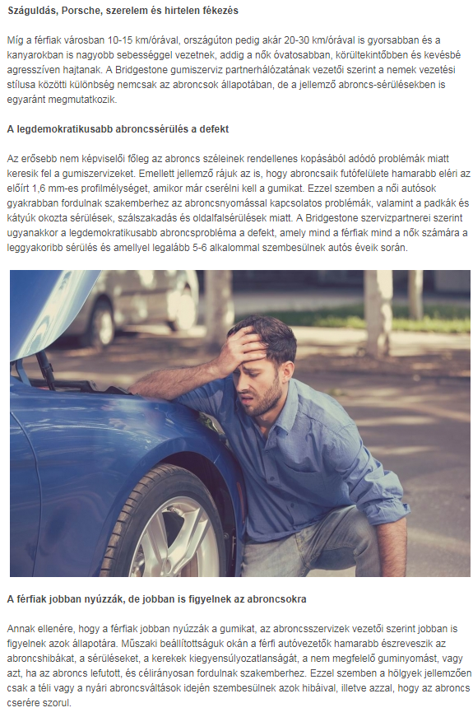

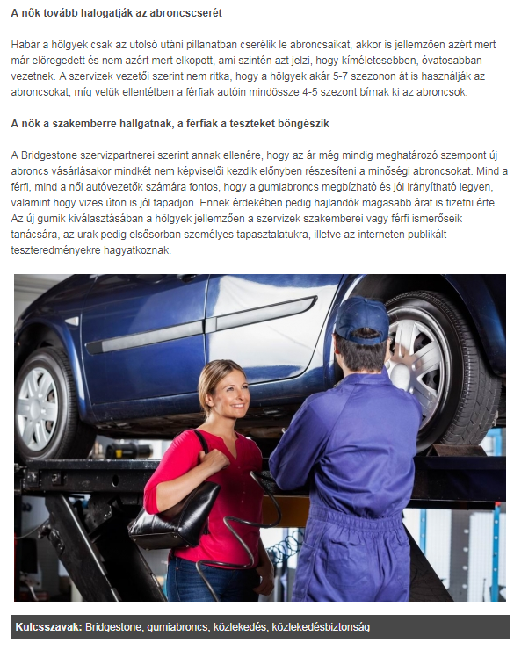

MEDIA: | Bellacafe.hu | MEDIA SPECIFICS
DATE: | 31.07.2018 | TYPE: | Online
PAGE: | - | REACH: | 4400
AD VALUE (€) | 10 | FREQUENCY: | -
HEADLINE | Women vs men: who cares more about the tire?
SUMMARY | While the ladies who are more cautious on the road are primarily concerned with tire pressure problems and injuries caused by pads and potholes, while men who drive more sporty typically go to the tire services because of tire damages due to their driving style – revealed by an analysis carried out among the heads of Bridgestone tire services. Because of the faster pace, for male drivers it is necessary to buy new tires more often than women, who are more caring for their car and tires. However, one thing is typical of both genders: in the case of a replacement, the quality and reliability of the tire is becoming increasingly important.

https://www.bellacafe.hu/2018/07/31/nok-vs-ferfiak-ki-figyel-jobban-a-gumiabroncsra/

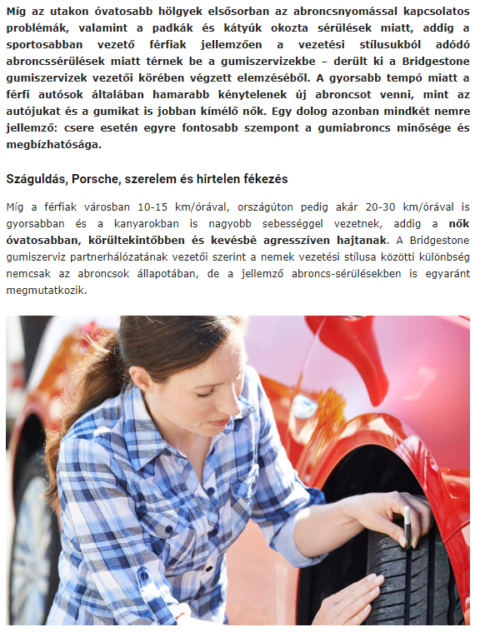

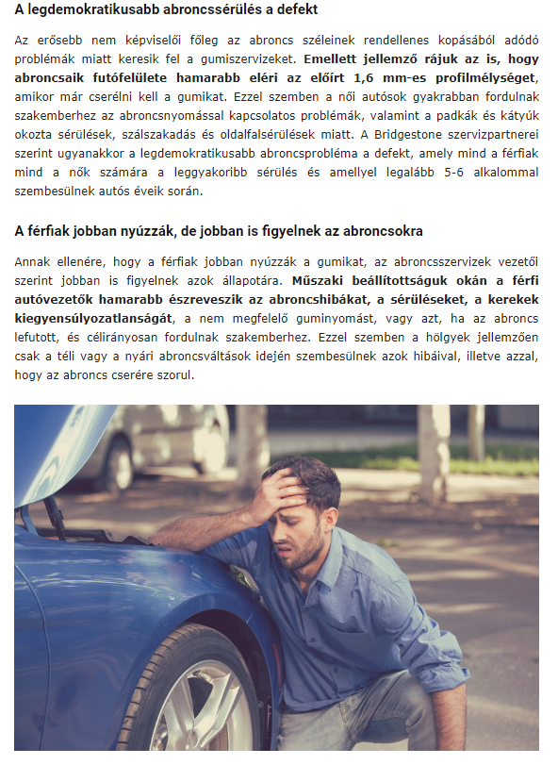

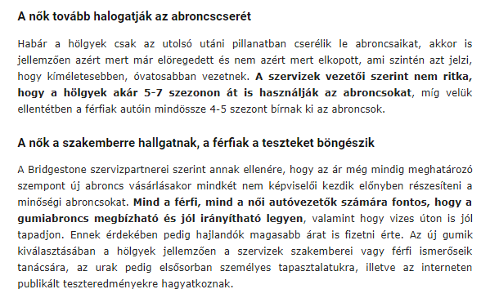

MEDIA: | Siofokinapilap.hu | MEDIA SPECIFICS
DATE: | 30.07.2018 | TYPE: | Online
PAGE: | - | REACH: | 28 333
AD VALUE (€) | 266 | FREQUENCY: | -
HEADLINE | Women vs men: who cares more about the tire?
SUMMARY | While the ladies who are more cautious on the road are primarily concerned with tire pressure problems and injuries caused by pads and potholes, while men who drive more sporty typically go to the tire services because of tire damages due to their driving style – revealed by an analysis carried out among the heads of Bridgestone tire services. Because of the faster pace, for male drivers it is necessary to buy new tires more often than women, who are more caring for their car and tires. However, one thing is typical of both genders: in the case of a replacement, the quality and reliability of the tire is becoming increasingly important.

http://www.siofokinapilap.hu/cikk/Nok_vagy_ferfiak__Ki_figyel_jobban_a_gumira_/215951/

MEDIA: | Szekesfehervarinapilap.hu | MEDIA SPECIFICS
DATE: | 30.07.2018 | TYPE: | Online
PAGE: | - | REACH: | 28 333
AD VALUE (€) | 266 | FREQUENCY: | -
HEADLINE | Women vs men: who cares more about the tire?
SUMMARY | While the ladies who are more cautious on the road are primarily concerned with tire pressure problems and injuries caused by pads and potholes, while men who drive more sporty typically go to the tire services because of tire damages due to their driving style – revealed by an analysis carried out among the heads of Bridgestone tire services. Because of the faster pace, for male drivers it is necessary to buy new tires more often than women, who are more caring for their car and tires. However, one thing is typical of both genders: in the case of a replacement, the quality and reliability of the tire is becoming increasingly important.

http://www.szekesfehervarinapilap.hu/cikk/Nok_vagy_ferfiak__Ki_figyel_jobban_a_gumira_/215951/

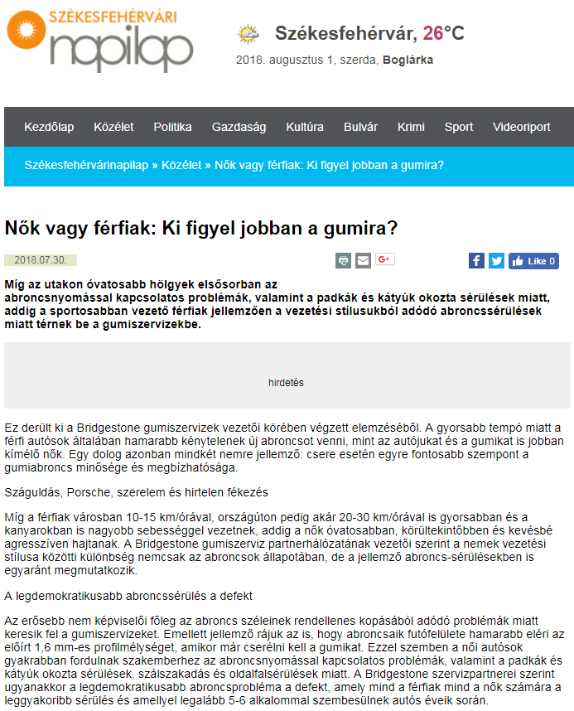

MEDIA: | Pecsinapilap.hu | MEDIA SPECIFICS
DATE: | 30.07.2018 | TYPE: | Online
PAGE: | - | REACH: | 28 333
AD VALUE (€) | 266 | FREQUENCY: | -
HEADLINE | Women vs men: who cares more about the tire?
SUMMARY | While the ladies who are more cautious on the road are primarily concerned with tire pressure problems and injuries caused by pads and potholes, while men who drive more sporty typically go to the tire services because of tire damages due to their driving style – revealed by an analysis carried out among the heads of Bridgestone tire services. Because of the faster pace, for male drivers it is necessary to buy new tires more often than women, who are more caring for their car and tires. However, one thing is typical of both genders: in the case of a replacement, the quality and reliability of the tire is becoming increasingly important.

http://www.pecsinapilap.hu/cikk/Nok_vagy_ferfiak__Ki_figyel_jobban_a_gumira_/215951/

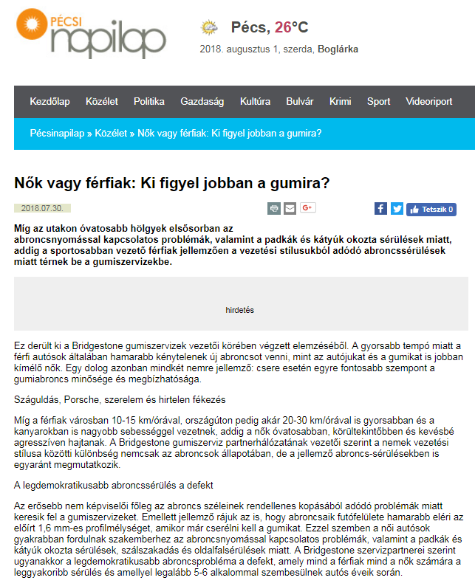

MEDIA: | Noizz.hu | MEDIA SPECIFICS
DATE: | 27.07.2018 | TYPE: | Online
PAGE: | - | REACH: | N/A
AD VALUE (€) | N/A | FREQUENCY: | -
HEADLINE | Women vs men: who cares more about the tire?
SUMMARY | While the ladies who are more cautious on the road are primarily concerned with tire pressure problems and injuries caused by pads and potholes, while men who drive more sporty typically go to the tire services because of tire damages due to their driving style – revealed by an analysis carried out among the heads of Bridgestone tire services. Because of the faster pace, for male drivers it is necessary to buy new tires more often than women, who are more caring for their car and tires. However, one thing is typical of both genders: in the case of a replacement, the quality and reliability of the tire is becoming increasingly important.

https://noizz.hu/auto/a-nok-vagy-a-ferfiak-figyelnek-jobban-a-kocsijukra/371hdcd

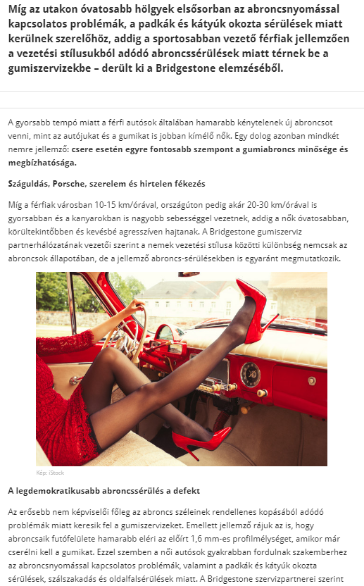

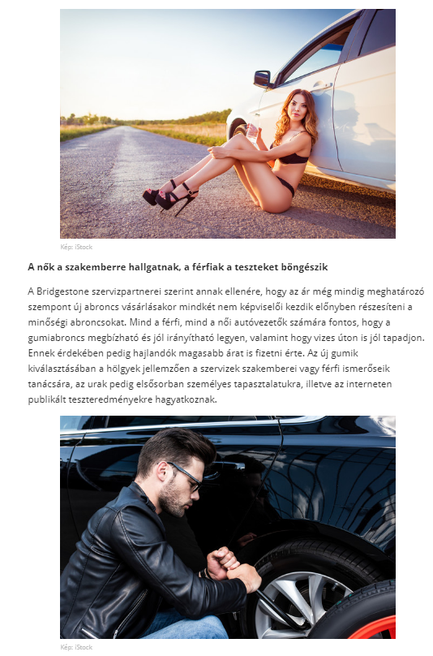

MEDIA: | Veszpremkukac.hu | MEDIA SPECIFICS
DATE: | 27.07.2018 | TYPE: | Online
PAGE: | - | REACH: | N/A
AD VALUE (€) | N/A | FREQUENCY: | -
HEADLINE | Women vs men: who cares more about the tire?
SUMMARY | While the ladies who are more cautious on the road are primarily concerned with tire pressure problems and injuries caused by pads and potholes, while men who drive more sporty typically go to the tire services because of tire damages due to their driving style – revealed by an analysis carried out among the heads of Bridgestone tire services. Because of the faster pace, for male drivers it is necessary to buy new tires more often than women, who are more caring for their car and tires. However, one thing is typical of both genders: in the case of a replacement, the quality and reliability of the tire is becoming increasingly important.

http://www.veszpremkukac.hu/nokferfiak-ki-figyel-jobban-a-gumira/

MEDIA: | Frisshirek.biz | MEDIA SPECIFICS
DATE: | 26.07.2018 | TYPE: | Online
PAGE: | - | REACH: | N/A
AD VALUE (€) | N/A | FREQUENCY: | -
HEADLINE | Women vs men: who cares more about the tire?
SUMMARY | While the ladies who are more cautious on the road are primarily concerned with tire pressure problems and injuries caused by pads and potholes, while men who drive more sporty typically go to the tire services because of tire damages due to their driving style – revealed by an analysis carried out among the heads of Bridgestone tire services. Because of the faster pace, for male drivers it is necessary to buy new tires more often than women, who are more caring for their car and tires. However, one thing is typical of both genders: in the case of a replacement, the quality and reliability of the tire is becoming increasingly important.

http://frisshirek.biz/noknek/nok-vs-ferfiak-ki-figyel-jobban-a-gumira

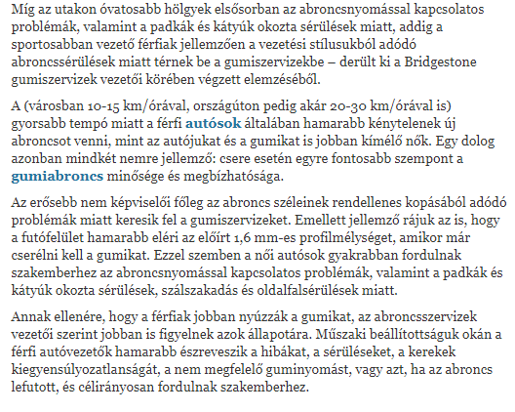

MEDIA: | Vörösmarty Rádió | MEDIA SPECIFICS
DATE: | 06.08.2018 | TYPE: | Electronic
PAGE: | - | REACH: | 79 000
AD VALUE (€) | 16 | FREQUENCY: | -
HEADLINE | Interview with Gergely Németh
SUMMARY | While the ladies who are more cautious on the road are primarily concerned with tire pressure problems and injuries caused by pads and potholes, while men who drive more sporty typically go to the tire services because of tire damages due to their driving style – revealed by an analysis carried out among the heads of Bridgestone tire services. Because of the faster pace, for male drivers it is necessary to buy new tires more often than women, who are more caring for their car and tires. However, one thing is typical of both genders: in the case of a replacement, the quality and reliability of the tire is becoming increasingly important.

http://premiercom.hu/download/Bridgestone/2018_08_06_Interview_with_Gergely_N%c3%a9meth_V%c3%b6r%c3%b6smarty_R%c3%a1di%c3%b3

MEDIA: | Blikk.hu –auto | MEDIA SPECIFICS
DATE: | 9.08.2018 | TYPE: | Online
PAGE: | - | REACH: | 400.000
AD VALUE (€) | 6.400 | FREQUENCY: | -
HEADLINE | Women vs men: who cares more about the tire?
SUMMARY | While the ladies who are more cautious on the road are primarily concerned with tire pressure problems and injuries caused by pads and potholes, while men who drive more sporty typically go to the tire services because of tire damages due to their driving style – revealed by an analysis carried out among the heads of Bridgestone tire services. Because of the faster pace, for male drivers it is necessary to buy new tires more often than women, who are more caring for their car and tires. However, one thing is typical of both genders: in the case of a replacement, the quality and reliability of the tire is becoming increasingly important.

http://www.blikk.hu/auto/garazs/a-nok-vagy-a-ferfiak-figyelnek-jobban-a-gumira/3t51b1d
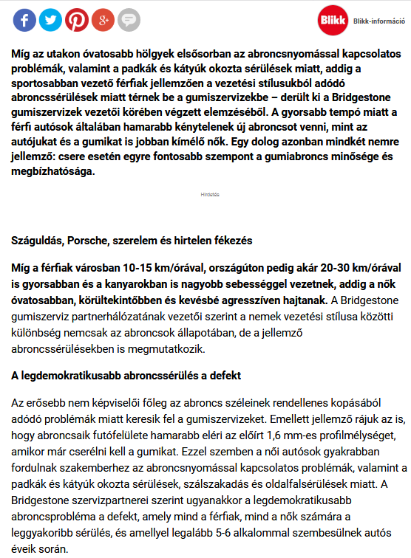

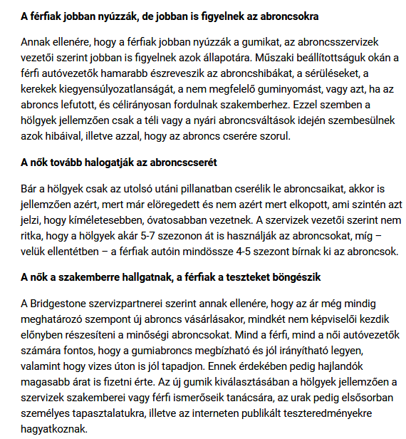

MEDIA: | Autoszektor.hu | MEDIA SPECIFICS
DATE: | 9.08.2018 | TYPE: | Online
PAGE: | - | REACH: | 4.808
AD VALUE (€) | 345 | FREQUENCY: | -
HEADLINE | Women vs men: who cares more about the tire?
SUMMARY | While the ladies who are more cautious on the road are primarily concerned with tire pressure problems and injuries caused by pads and potholes, while men who drive more sporty typically go to the tire services because of tire damages due to their driving style – revealed by an analysis carried out among the heads of Bridgestone tire services. Because of the faster pace, for male drivers it is necessary to buy new tires more often than women, who are more caring for their car and tires. However, one thing is typical of both genders: in the case of a replacement, the quality and reliability of the tire is becoming increasingly important.

http://www.autoszektor.hu/hu/content/nok-vs-ferfiak-ki-figyel-jobban-gumira

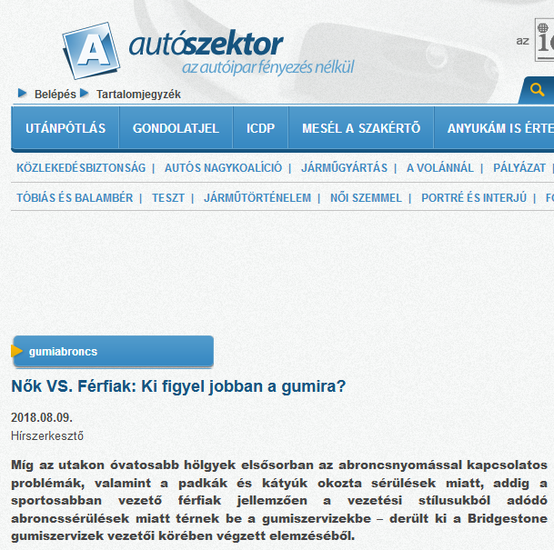

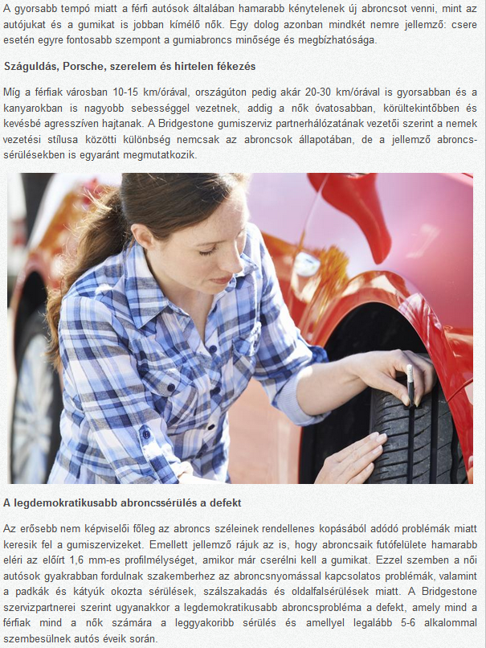

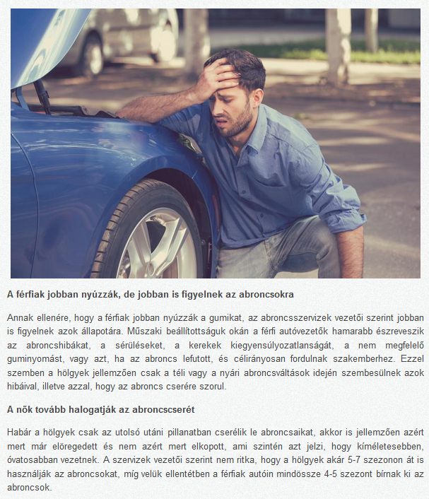

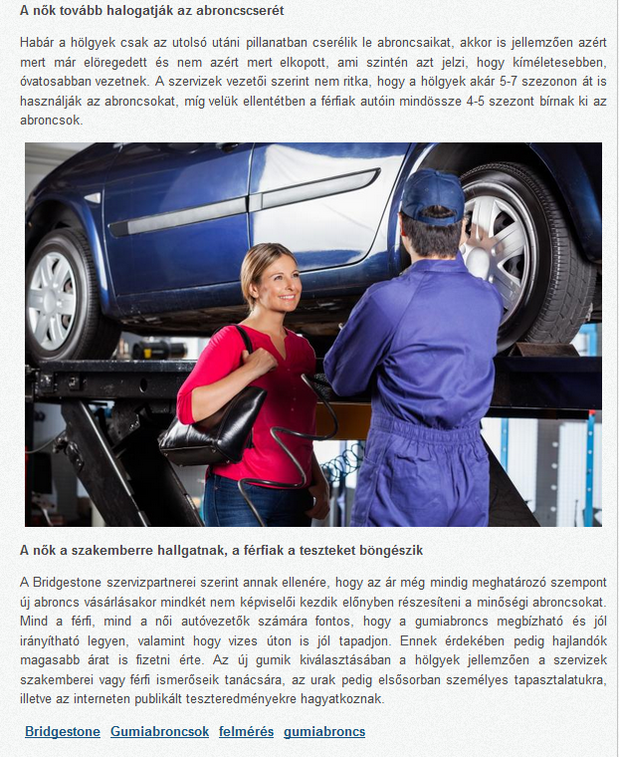

MEDIA: | Blikk.hu –lifestyle | MEDIA SPECIFICS
DATE: | 9.08.2018 | TYPE: | Online
PAGE: | - | REACH: | 400.000
AD VALUE (€) | 6.400 | FREQUENCY: | -
HEADLINE | Women vs men: who cares more about the tire?
SUMMARY | While the ladies who are more cautious on the road are primarily concerned with tire pressure problems and injuries caused by pads and potholes, while men who drive more sporty typically go to the tire services because of tire damages due to their driving style – revealed by an analysis carried out among the heads of Bridgestone tire services. Because of the faster pace, for male drivers it is necessary to buy new tires more often than women, who are more caring for their car and tires. However, one thing is typical of both genders: in the case of a replacement, the quality and reliability of the tire is becoming increasingly important.

http://www.blikk.hu/eletmod/tippek/a-nok-vagy-a-ferfiak-figyelnek-jobban-a-gumira/ef08m9n

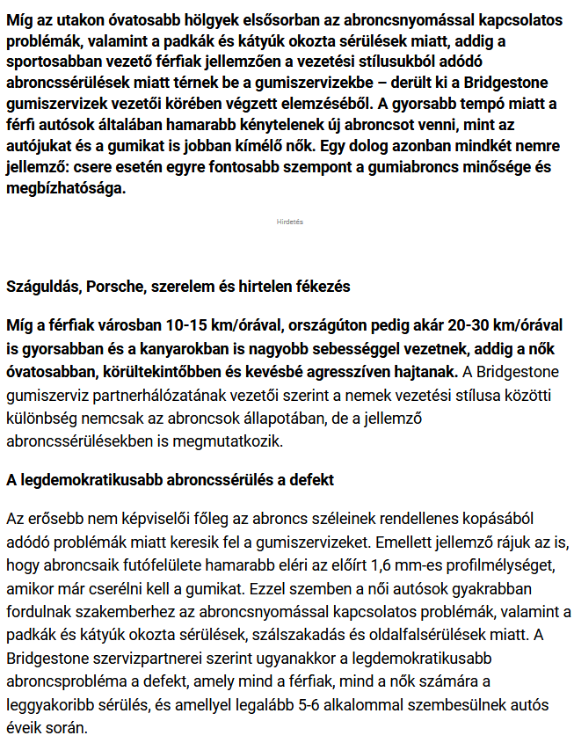

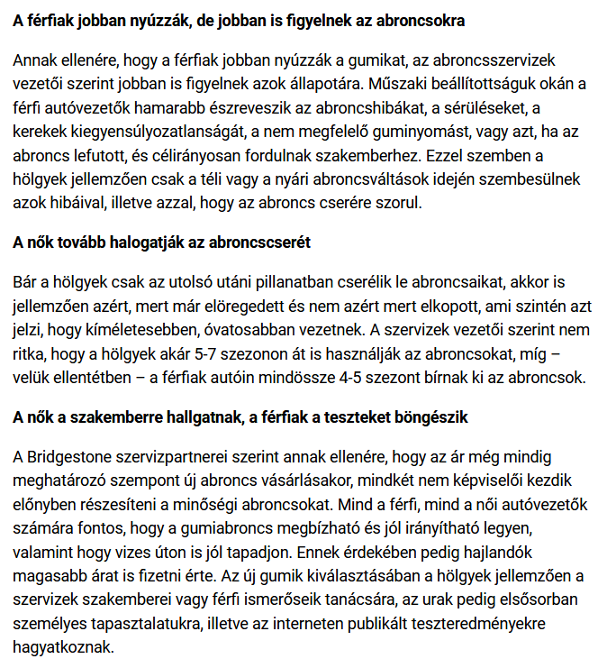
MEDIA: | Euroastra.blog.hu | MEDIA SPECIFICS
DATE: | 31.07.2018 | TYPE: | Online
PAGE: | - | REACH: | 2.399
AD VALUE (€) | 50 | FREQUENCY: | -
HEADLINE | Who cares more?
SUMMARY | While the ladies who are more cautious on the road are primarily concerned with tire pressure problems and injuries caused by pads and potholes, while men who drive more sporty typically go to the tire services because of tire damages due to their driving style – revealed by an analysis carried out among the heads of Bridgestone tire services. Because of the faster pace, for male drivers it is necessary to buy new tires more often than women, who are more caring for their car and tires. However, one thing is typical of both genders: in the case of a replacement, the quality and reliability of the tire is becoming increasingly important.

https://euroastra.blog.hu/2018/07/31/ki_figyel_jobban

MEDIA: | Starthirek.hu | MEDIA SPECIFICS
DATE: | 31.07.2018 | TYPE: | Online
PAGE: | - | REACH: | N/A
AD VALUE (€) | N/A | FREQUENCY: | -
HEADLINE | Women vs men: who cares more about the tire?
SUMMARY | While the ladies who are more cautious on the road are primarily concerned with tire pressure problems and injuries caused by pads and potholes, while men who drive more sporty typically go to the tire services because of tire damages due to their driving style – revealed by an analysis carried out among the heads of Bridgestone tire services. Because of the faster pace, for male drivers it is necessary to buy new tires more often than women, who are more caring for their car and tires. However, one thing is typical of both genders: in the case of a replacement, the quality and reliability of the tire is becoming increasingly important.

https://starthirek.hu/2018/08/09/nok-vs-ferfiak-ki-figyel-jobban-a-gumira/

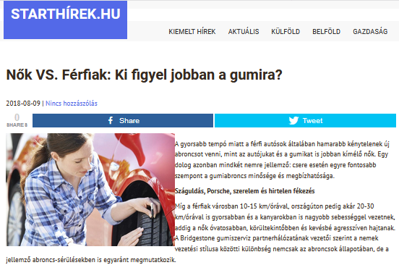

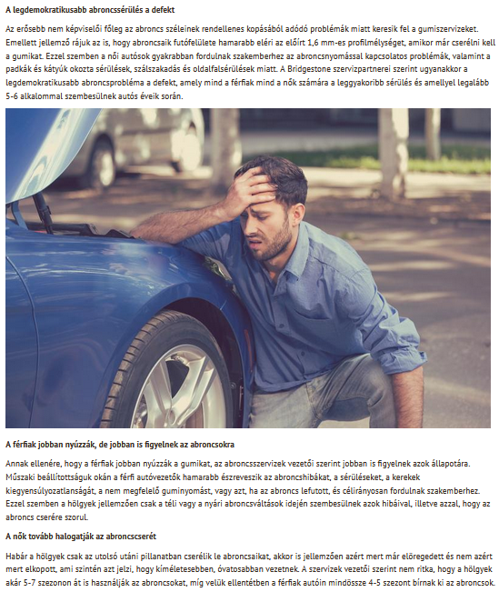

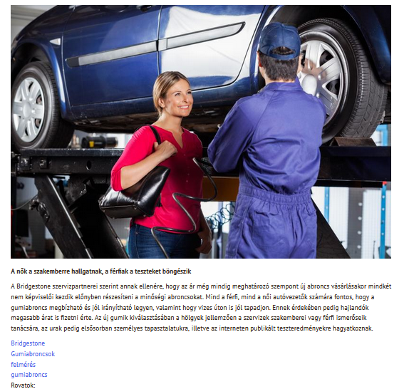

MEDIA: | Keleten.hu | MEDIA SPECIFICS
DATE: | 26.07.2018 | TYPE: | Online
PAGE: | - | REACH: | N/A
AD VALUE (€) | N/A | FREQUENCY: | -
HEADLINE | Women vs men: who cares more about the tire?
SUMMARY | While the ladies who are more cautious on the road are primarily concerned with tire pressure problems and injuries caused by pads and potholes, while men who drive more sporty typically go to the tire services because of tire damages due to their driving style – revealed by an analysis carried out among the heads of Bridgestone tire services. Because of the faster pace, for male drivers it is necessary to buy new tires more often than women, who are more caring for their car and tires. However, one thing is typical of both genders: in the case of a replacement, the quality and reliability of the tire is becoming increasingly important.

http://keleten.hu/index.php/technika/6181-ki-figyel-jobban-a-gumira

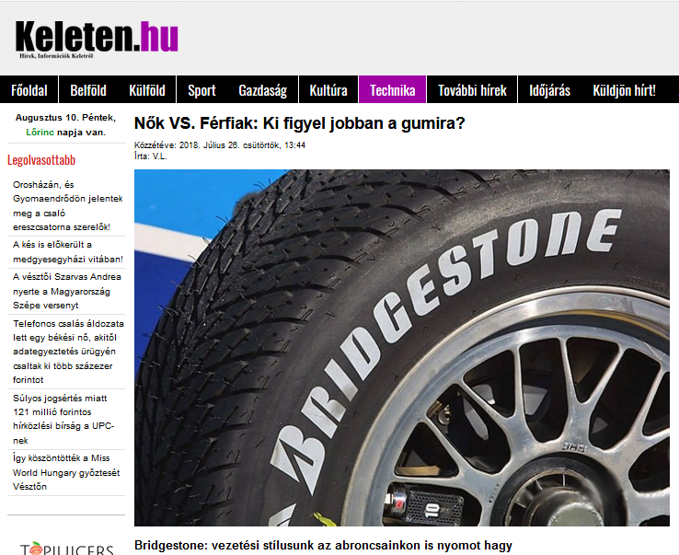

MEDIA: | VKN.hu | MEDIA SPECIFICS
DATE: | 26.07.2018 | TYPE: | Online
PAGE: | - | REACH: | N/A
AD VALUE (€) | N/A | FREQUENCY: | -
HEADLINE | Women vs men: who cares more about the tire?
SUMMARY | While the ladies who are more cautious on the road are primarily concerned with tire pressure problems and injuries caused by pads and potholes, while men who drive more sporty typically go to the tire services because of tire damages due to their driving style – revealed by an analysis carried out among the heads of Bridgestone tire services. Because of the faster pace, for male drivers it is necessary to buy new tires more often than women, who are more caring for their car and tires. However, one thing is typical of both genders: in the case of a replacement, the quality and reliability of the tire is becoming increasingly important.

https://vkn.hu/aktualis-meteorologia-csalad-szocialis/nok-vs-ferfiak-avagy-ki-figyel-jobban-a-gumira/

MEDIA: | Alapjarat.hu | MEDIA SPECIFICS
DATE: | 29.07.2018 | TYPE: | Online
PAGE: | - | REACH: | N/A
AD VALUE (€) | N/A | FREQUENCY: | -
HEADLINE | Using tires: do women or men care more?
SUMMARY | While the ladies who are more cautious on the road are primarily concerned with tire pressure problems and injuries caused by pads and potholes, while men who drive more sporty typically go to the tire services because of tire damages due to their driving style – revealed by an analysis carried out among the heads of Bridgestone tire services. Because of the faster pace, for male drivers it is necessary to buy new tires more often than women, who are more caring for their car and tires. However, one thing is typical of both genders: in the case of a replacement, the quality and reliability of the tire is becoming increasingly important.

https://www.alapjarat.hu/nagyvilag-bulvar/nagyvilag/a-nok-vagy-a-ferfiak-figyelnek-jobban-a-gumira/

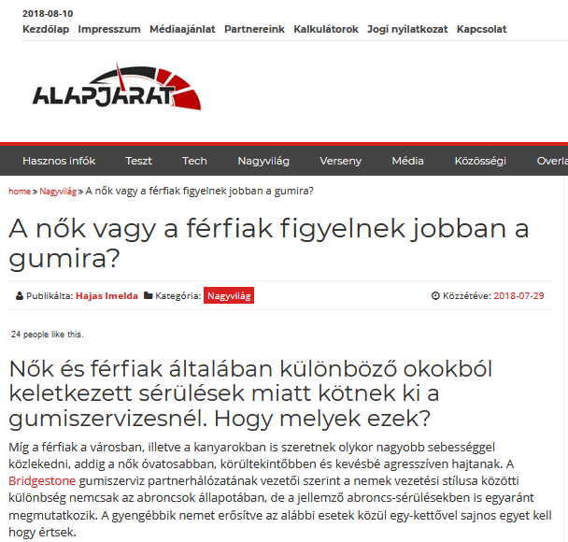
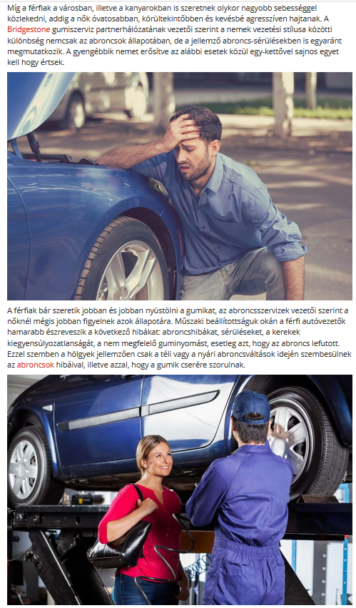

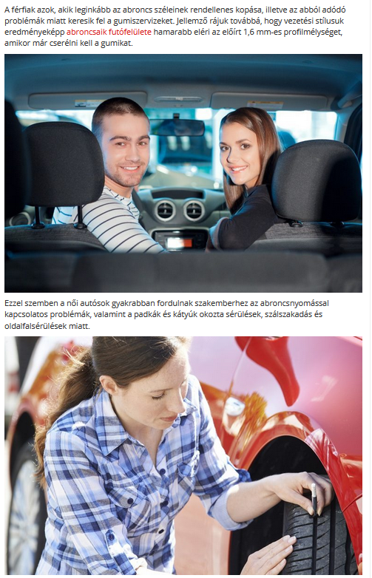

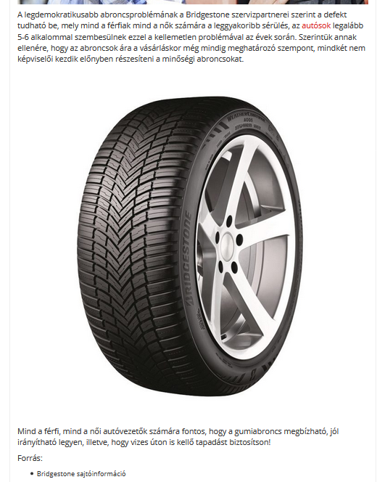

MEDIA: | Tesztalelkemindennek.hu | MEDIA SPECIFICS
DATE: | 29.07.2018 | TYPE: | Online
PAGE: | - | REACH: | N/A
AD VALUE (€) | N/A | FREQUENCY: | -
HEADLINE | Women are listening to the specialist, men are browsing tests
SUMMARY | While the ladies who are more cautious on the road are primarily concerned with tire pressure problems and injuries caused by pads and potholes, while men who drive more sporty typically go to the tire services because of tire damages due to their driving style – revealed by an analysis carried out among the heads of Bridgestone tire services. Because of the faster pace, for male drivers it is necessary to buy new tires more often than women, who are more caring for their car and tires. However, one thing is typical of both genders: in the case of a replacement, the quality and reliability of the tire is becoming increasingly important.

https://tesztalelkemindennek.hu/2018/07/29/a-nok-a-szakemberre-hallgatnak-a-ferfiak-a-teszteket-bongeszik/
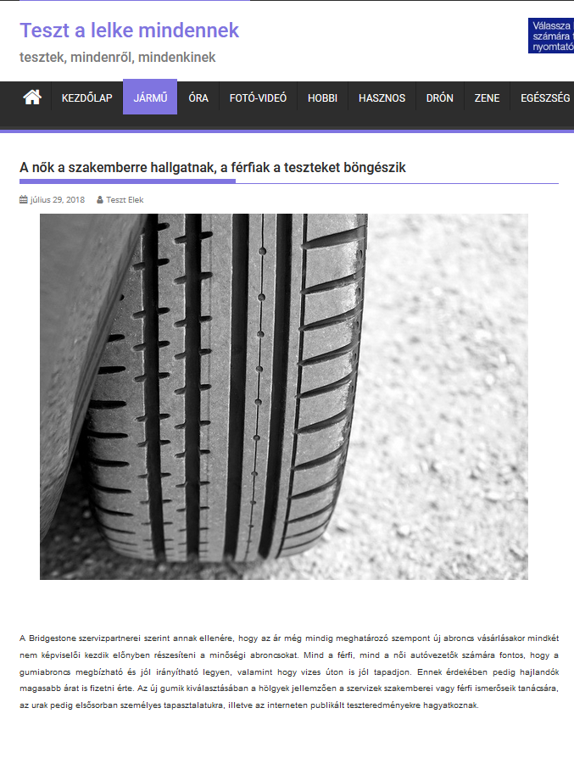
MEDIA: | Infomiskolc.hu x41 | MEDIA SPECIFICS
DATE: | 30.07.2018 | TYPE: | Online
PAGE: | - | REACH: | 369.000
AD VALUE (€) | 3.145 | FREQUENCY: | -
HEADLINE | Women are listening to the specialist, men are browsing tests
SUMMARY | While the ladies who are more cautious on the road are primarily concerned with tire pressure problems and injuries caused by pads and potholes, while men who drive more sporty typically go to the tire services because of tire damages due to their driving style – revealed by an analysis carried out among the heads of Bridgestone tire services. Because of the faster pace, for male drivers it is necessary to buy new tires more often than women, who are more caring for their car and tires. However, one thing is typical of both genders: in the case of a replacement, the quality and reliability of the tire is becoming increasingly important.

http://www.infomiskolc.hu/hirek/olvas/permalink:nok-vs-ferfiak-ki-figyel-jobban-a-gumira-2018-07-30-105433

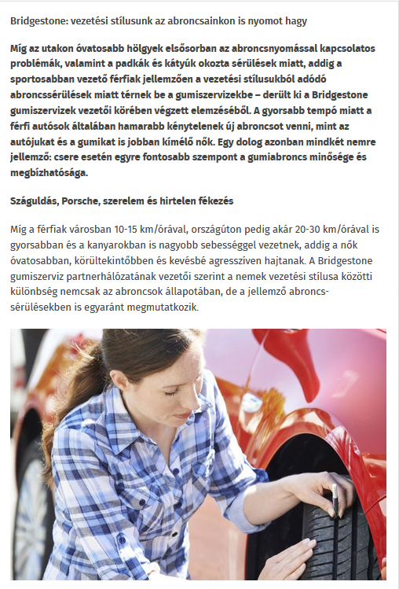

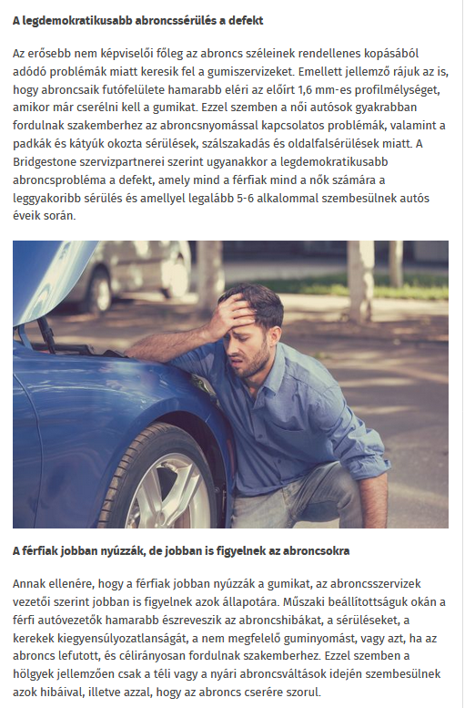

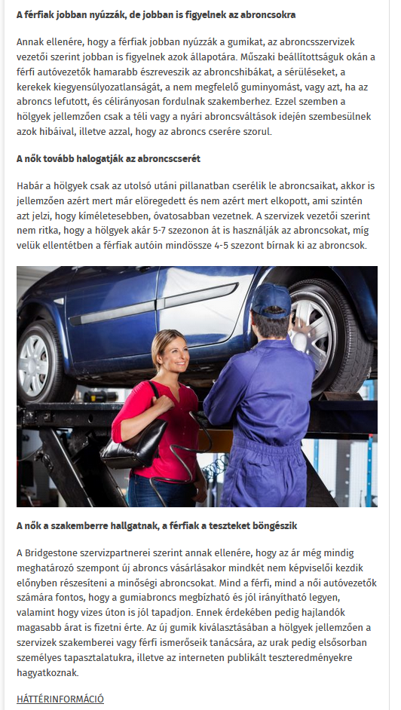

MEDIA: | Caranten.blog.hu | MEDIA SPECIFICS
DATE: | 30.07.2018 | TYPE: | Online
PAGE: | - | REACH: | N/A
AD VALUE (€) | N/A | FREQUENCY: | -
HEADLINE | Women vs men: who cares more about the tire?
SUMMARY | While the ladies who are more cautious on the road are primarily concerned with tire pressure problems and injuries caused by pads and potholes, while men who drive more sporty typically go to the tire services because of tire damages due to their driving style – revealed by an analysis carried out among the heads of Bridgestone tire services. Because of the faster pace, for male drivers it is necessary to buy new tires more often than women, who are more caring for their car and tires. However, one thing is typical of both genders: in the case of a replacement, the quality and reliability of the tire is becoming increasingly important.

https://caranten.blog.hu/2018/07/28/nok_vs_ferfiak_ki_figyel_jobban_a_gumira_575

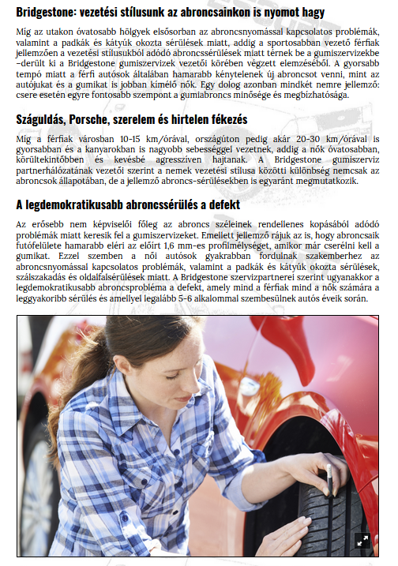

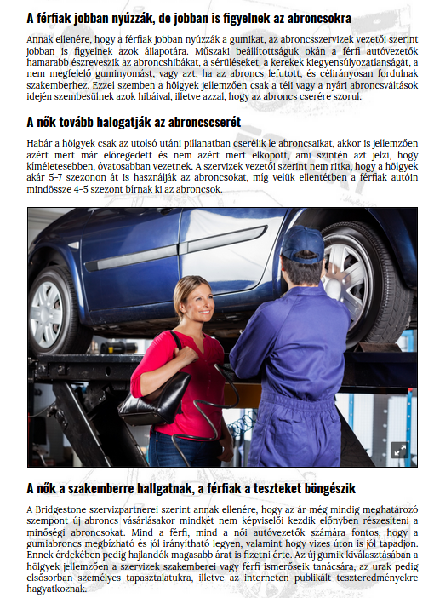

MEDIA: | Autoblog.hu | MEDIA SPECIFICS
DATE: | 10.08.2018 | TYPE: | Online
PAGE: | - | REACH: | 5 422
AD VALUE (€) | 32 | FREQUENCY: | -
HEADLINE | Women vs men: who cares more about the tire?
SUMMARY | While the ladies who are more cautious on the road are primarily concerned with tire pressure problems and injuries caused by pads and potholes, while men who drive more sporty typically go to the tire services because of tire damages due to their driving style – revealed by an analysis carried out among the heads of Bridgestone tire services. Because of the faster pace, for male drivers it is necessary to buy new tires more often than women, who are more caring for their car and tires. However, one thing is typical of both genders: in the case of a replacement, the quality and reliability of the tire is becoming increasingly important.

https://www.autoblog.hu/hirek/nok-vs-ferfiak-ki-figyel-jobban-a-gumira/

MEDIA: | Jogumi.blog.hu | MEDIA SPECIFICS
DATE: | 10.08.2018 | TYPE: | Online
PAGE: | - | REACH: | N/A
AD VALUE (€) | N/A | FREQUENCY: | -
HEADLINE | Women vs men: who cares more about the tire?
SUMMARY | While the ladies who are more cautious on the road are primarily concerned with tire pressure problems and injuries caused by pads and potholes, while men who drive more sporty typically go to the tire services because of tire damages due to their driving style – revealed by an analysis carried out among the heads of Bridgestone tire services. Because of the faster pace, for male drivers it is necessary to buy new tires more often than women, who are more caring for their car and tires. However, one thing is typical of both genders: in the case of a replacement, the quality and reliability of the tire is becoming increasingly important.

https://jogumi.blog.hu/2018/08/10/nok_es_ferfiak_ki_figyel_jobban_a_gumira

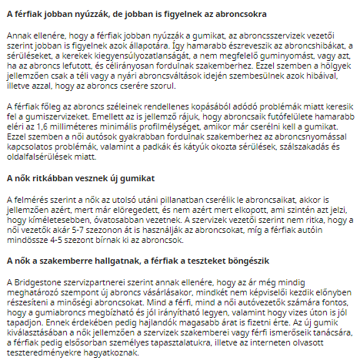

MEDIA: | Femina.hu | MEDIA SPECIFICS
DATE: | 10.08.2018 | TYPE: | Online
PAGE: | - | REACH: | 116 000
AD VALUE (€) | 1 209 | FREQUENCY: | -
HEADLINE | Women vs men: who cares more about the tire? Not only the driving style is different
SUMMARY | While the ladies who are more cautious on the road are primarily concerned with tire pressure problems and injuries caused by pads and potholes, while men who drive more sporty typically go to the tire services because of tire damages due to their driving style – revealed by an analysis carried out among the heads of Bridgestone tire services. Because of the faster pace, for male drivers it is necessary to buy new tires more often than women, who are more caring for their car and tires. However, one thing is typical of both genders: in the case of a replacement, the quality and reliability of the tire is becoming increasingly important.

https://femina.hu/terasz/gumiabroncs-allapota/

MEDIA: | Logisztika.hu | MEDIA SPECIFICS
DATE: | 10.08.2018 | TYPE: | Online
PAGE: | - | REACH: | N/A
AD VALUE (€) | N/A | FREQUENCY: | -
HEADLINE | Women vs men: who cares more about the tire?
SUMMARY | While the ladies who are more cautious on the road are primarily concerned with tire pressure problems and injuries caused by pads and potholes, while men who drive more sporty typically go to the tire services because of tire damages due to their driving style – revealed by an analysis carried out among the heads of Bridgestone tire services. Because of the faster pace, for male drivers it is necessary to buy new tires more often than women, who are more caring for their car and tires. However, one thing is typical of both genders: in the case of a replacement, the quality and reliability of the tire is becoming increasingly important.

http://logisztika.com/bridgestone-vezetesi-stilusunk-az-abroncsainkon-is-nyomot-hagy/

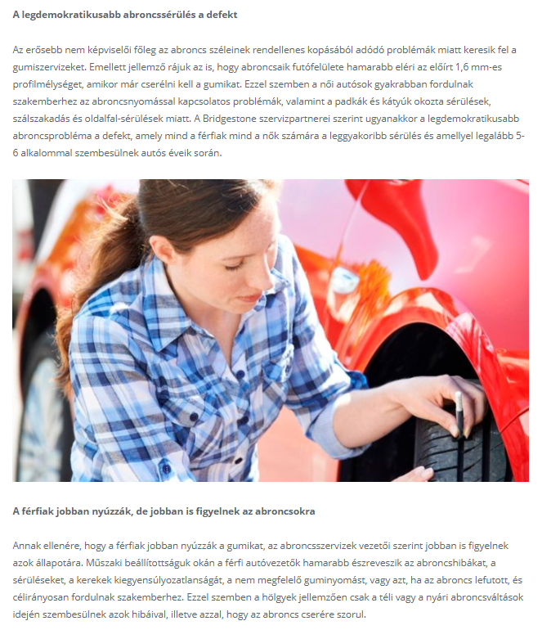

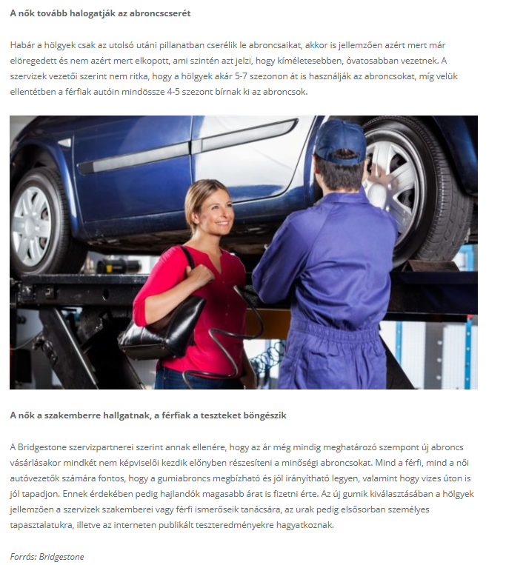

MEDIA: | Gazdasagportal.hu | MEDIA SPECIFICS
DATE: | 10.08.2018 | TYPE: | Online
PAGE: | - | REACH: | N/A
AD VALUE (€) | N/A | FREQUENCY: | -
HEADLINE | Women vs men: who cares more about the tire?
SUMMARY | While the ladies who are more cautious on the road are primarily concerned with tire pressure problems and injuries caused by pads and potholes, while men who drive more sporty typically go to the tire services because of tire damages due to their driving style – revealed by an analysis carried out among the heads of Bridgestone tire services. Because of the faster pace, for male drivers it is necessary to buy new tires more often than women, who are more caring for their car and tires. However, one thing is typical of both genders: in the case of a replacement, the quality and reliability of the tire is becoming increasingly important.

http://gazdasagportal.hu/index.php/nok-vs-ferfiak-ki-figyel-jobban-a-gumira/

MEDIA: | Maradokapenzemnel.blog.hu | MEDIA SPECIFICS
DATE: | 10.08.2018 | TYPE: | Online
PAGE: | - | REACH: | 4 333
AD VALUE (€) | 38 | FREQUENCY: | -
HEADLINE | Women vs men: who cares more about the tire?
SUMMARY | While the ladies who are more cautious on the road are primarily concerned with tire pressure problems and injuries caused by pads and potholes, while men who drive more sporty typically go to the tire services because of tire damages due to their driving style – revealed by an analysis carried out among the heads of Bridgestone tire services. Because of the faster pace, for male drivers it is necessary to buy new tires more often than women, who are more caring for their car and tires. However, one thing is typical of both genders: in the case of a replacement, the quality and reliability of the tire is becoming increasingly important.

https://maradokapenzemnel.blog.hu/2018/08/10/a_holgyek_vagy_az_urak_figyelnek_jobban_az_abroncsok_allapotara

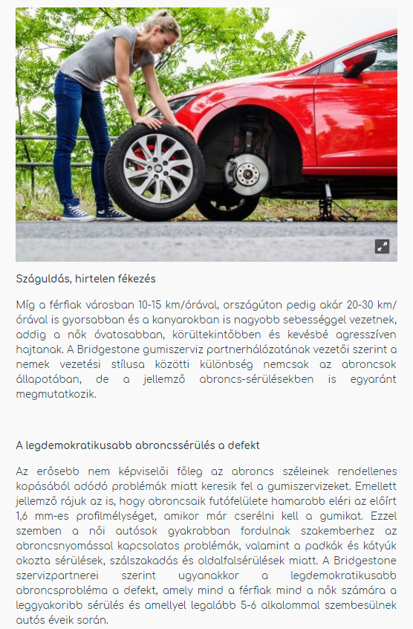

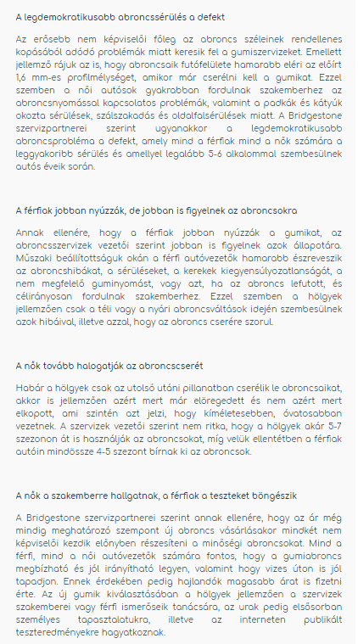

MEDIA: | Napi.hu főoldal | MEDIA SPECIFICS
DATE: | 10.08.2018 | TYPE: | Online
PAGE: | - | REACH: | 109 000
AD VALUE (€) | 1 935 | FREQUENCY: | -
HEADLINE | Women vs men: who cares more about the tire?
SUMMARY | While the ladies who are more cautious on the road are primarily concerned with tire pressure problems and injuries caused by pads and potholes, while men who drive more sporty typically go to the tire services because of tire damages due to their driving style – revealed by an analysis carried out among the heads of Bridgestone tire services. Because of the faster pace, for male drivers it is necessary to buy new tires more often than women, who are more caring for their car and tires. However, one thing is typical of both genders: in the case of a replacement, the quality and reliability of the tire is becoming increasingly important.

MEDIA: | Egyszermárlattamautot.hu | MEDIA SPECIFICS
DATE: | 17.08.2018 | TYPE: | Online
PAGE: | - | REACH: | n/a
AD VALUE (€) | N/a | FREQUENCY: | -
HEADLINE | Women vs men: who cares more about the tire?
SUMMARY | While the ladies who are more cautious on the road are primarily concerned with tire pressure problems and injuries caused by pads and potholes, while men who drive more sporty typically go to the tire services because of tire damages due to their driving style – revealed by an analysis carried out among the heads of Bridgestone tire services. Because of the faster pace, for male drivers it is necessary to buy new tires more often than women, who are more caring for their car and tires. However, one thing is typical of both genders: in the case of a replacement, the quality and reliability of the tire is becoming increasingly important.

http://egyszermarlattamautot.hu/2018/08/12/a-csajok-vagy-a-pasik-figyelnek-jobban-a-gumira/

