MEDIA: | origo.hu | MEDIA SPECIFICS
DATE: | 2018.03.26. | TYPE: | Online
PAGE: | - | Reach: | 544 000
Ad value (EUR) | 276 | FREQUENCY: | -
HEADLINE: | We could save a lot on electricity with beer cans
SUMMARY: | The full recycling of aluminium cans currently wasted could save the cost of the annual energy consumption 30,000-inhabitant city. Unfortunately, however, approximately 58% of the 1 billion aluminium cans put on the market in Hungary, i.e. 8,900 tonnes of aluminium, ends up as communal waste or in waste incinerators according to Returcom Nonprofit Ltd.’s most recent study. As a result, the valuable, endlessly recyclable aluminium disappears from the circulation of of raw materials.

http://www.origo.hu/gazdasag/20180326-uditos-soros-dobozok-rengeteg-sporolas-aram.html
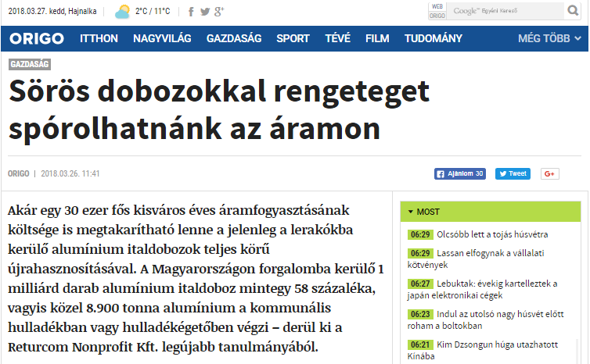

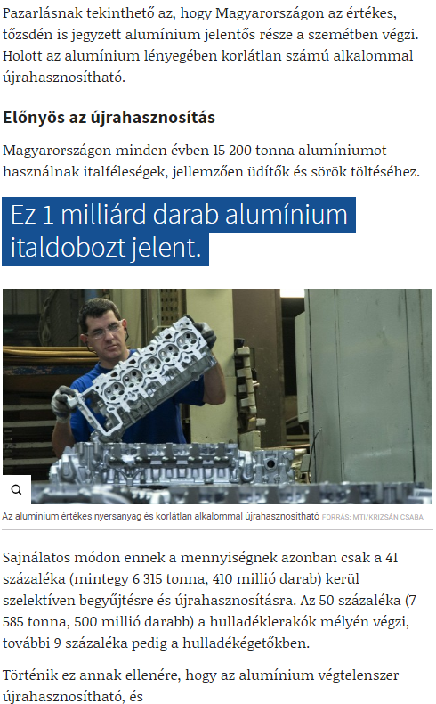

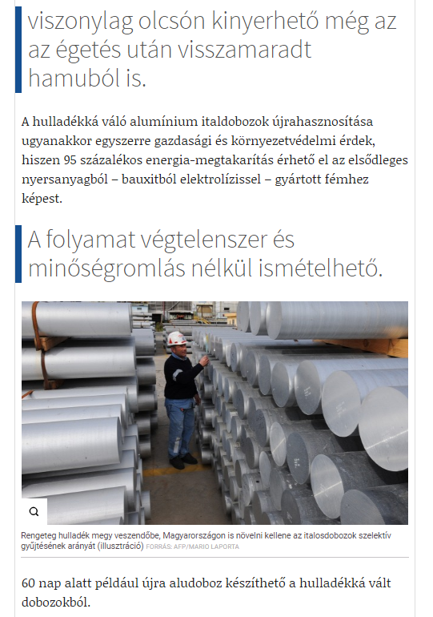

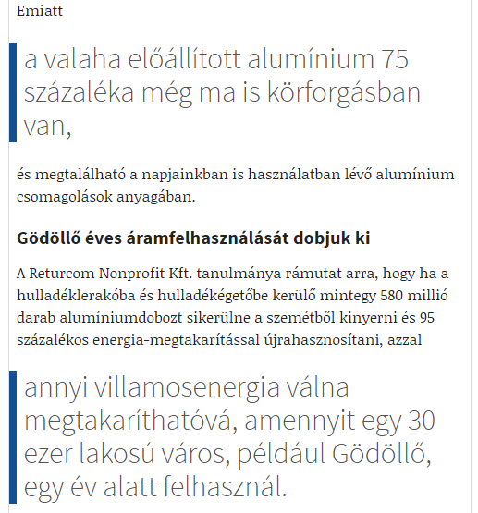

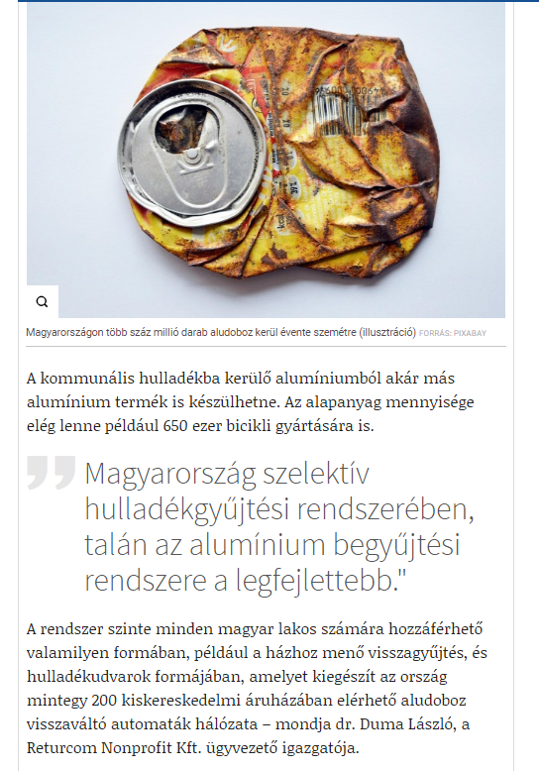

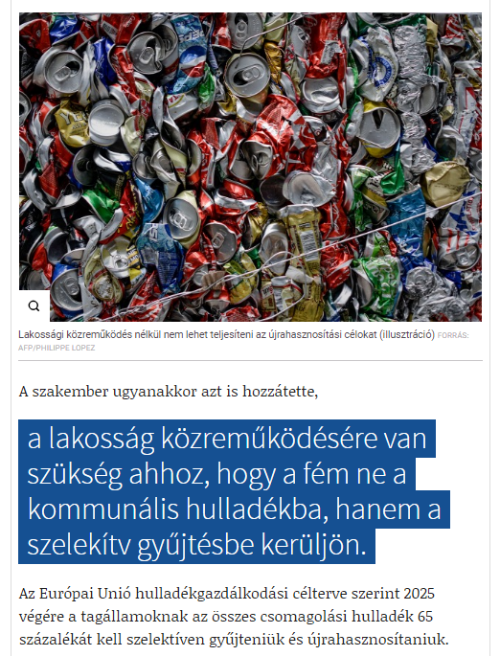

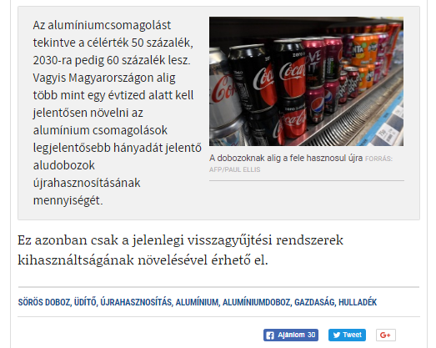

MEDIA: | elelmiszer.hu | MEDIA SPECIFICS
DATE: | 2018.03.26. | TYPE: | Online
PAGE: | - | Reach: | 2 500
Ad value (EUR) | 8 | FREQUENCY: | -
HEADLINE: | We discard irresponsibly aluminium cans
SUMMARY: | The full recycling of aluminium cans currently wasted could save the cost of the annual energy consumption 30,000-inhabitant city. Unfortunately, however, approximately 58% of the 1 billion aluminium cans put on the market in Hungary, i.e. 8,900 tonnes of aluminium, ends up as communal waste or in waste incinerators according to Returcom Nonprofit Ltd.’s most recent study. As a result, the valuable, endlessly recyclable aluminium disappears from the circulation of of raw materials.

http://elelmiszer.hu/cikk/felelotlenul_valunk_meg_az_aludobozoktol
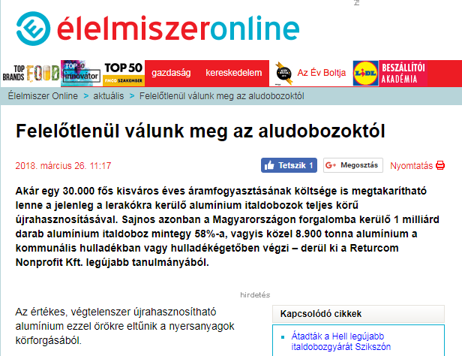

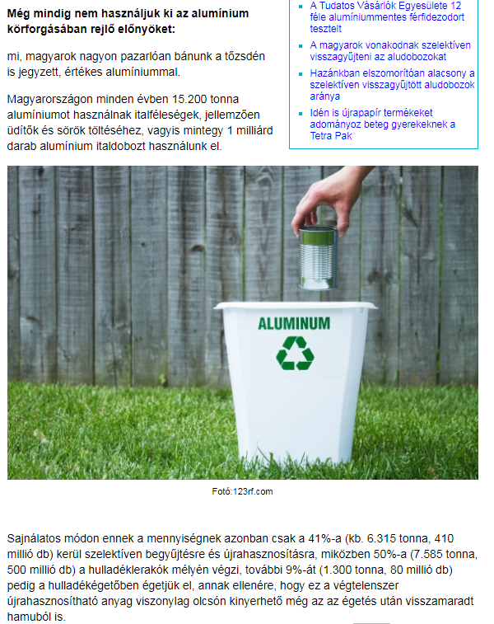

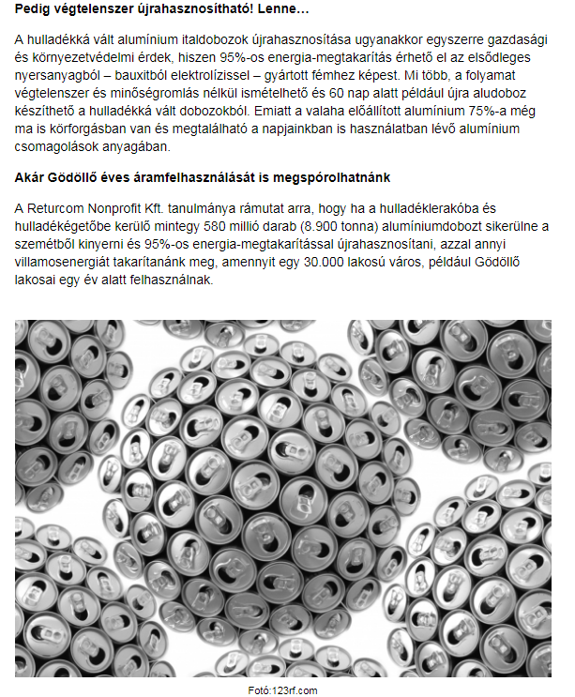

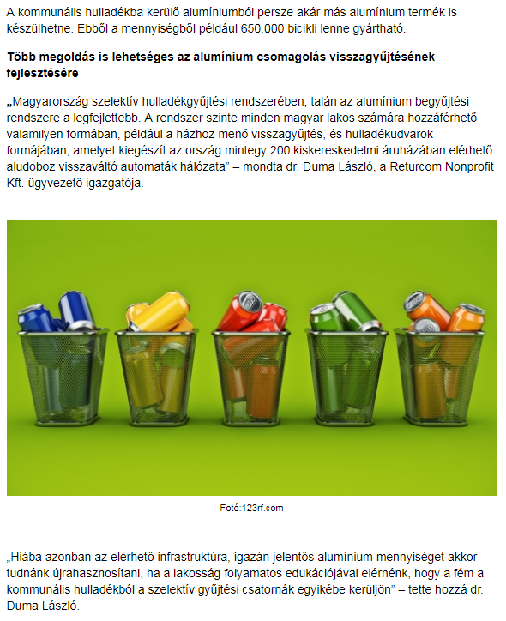

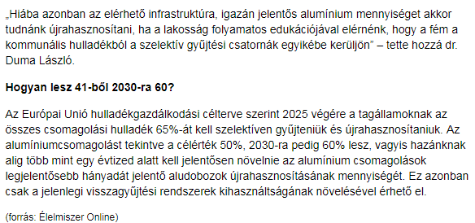

MEDIA: | sokszinuvidek.24.hu | MEDIA SPECIFICS
DATE: | 2018.03.26. | TYPE: | Online
PAGE: | - | Reach: | 445 000
Ad value (EUR) | 2386 | FREQUENCY: | -
HEADLINE: | 650.000 bicycles could be made of the wasted aluminium cans in a year
SUMMARY: | The full recycling of aluminium cans currently wasted could save the cost of the annual energy consumption 30,000-inhabitant city. Unfortunately, however, approximately 58% of the 1 billion aluminium cans put on the market in Hungary, i.e. 8,900 tonnes of aluminium, ends up as communal waste or in waste incinerators according to Returcom Nonprofit Ltd.’s most recent study. As a result, the valuable, endlessly recyclable aluminium disappears from the circulation of of raw materials.

https://sokszinuvidek.24.hu/eletmod/2018/03/26/evente-650-ezer-bicikli-keszulhetne-az-eldobalt-aludobozokbol/
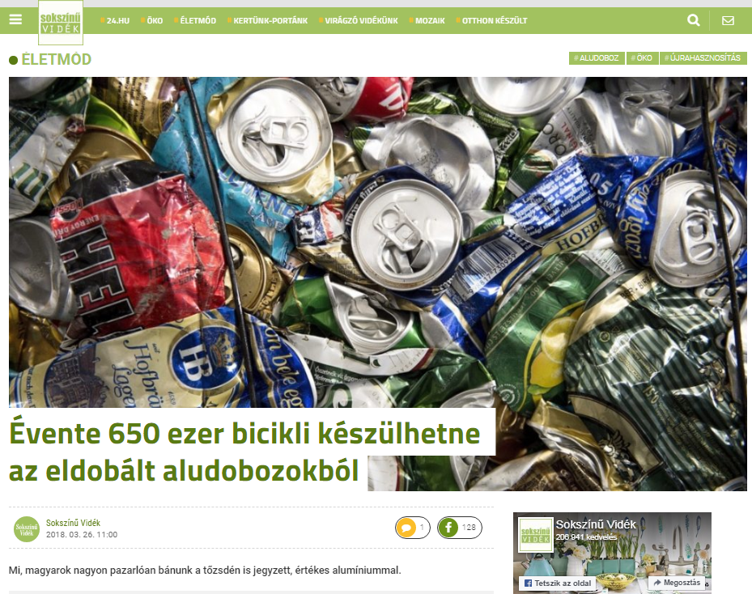

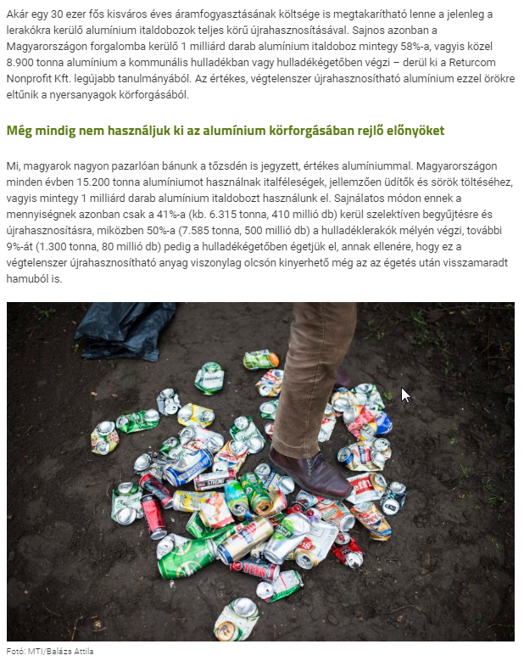

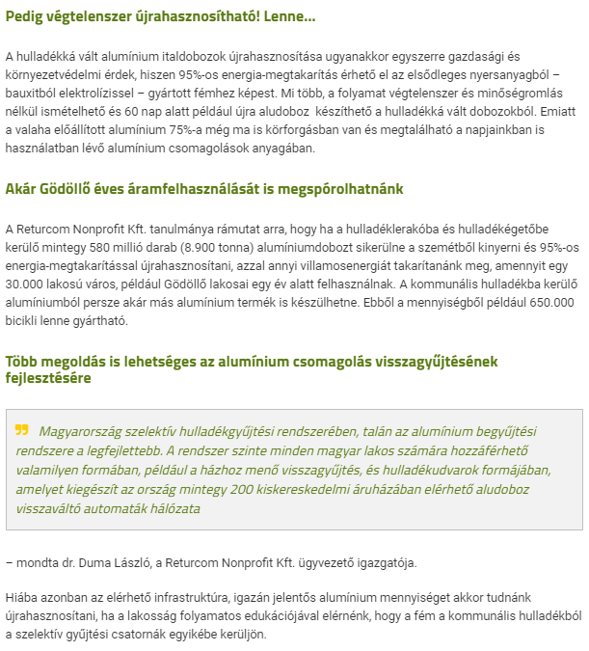

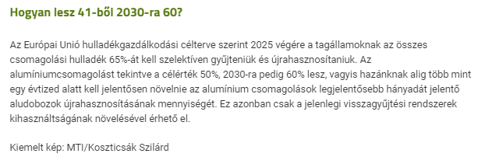

MEDIA: | mediapiac.com | MEDIA SPECIFICS
DATE: | 2018.03.26. | TYPE: | Online
PAGE: | - | Reach: | n/a
Ad value (EUR) | 166 | FREQUENCY: | -
HEADLINE: | Free electricity from aluminium cans?
SUMMARY: | The full recycling of aluminium cans currently wasted could save the cost of the annual energy consumption 30,000-inhabitant city. Unfortunately, however, approximately 58% of the 1 billion aluminium cans put on the market in Hungary, i.e. 8,900 tonnes of aluminium, ends up as communal waste or in waste incinerators according to Returcom Nonprofit Ltd.’s most recent study. As a result, the valuable, endlessly recyclable aluminium disappears from the circulation of of raw materials.

http://www.mediapiac.com/marketing/Ingyen-aram-aludobozbol/25514/
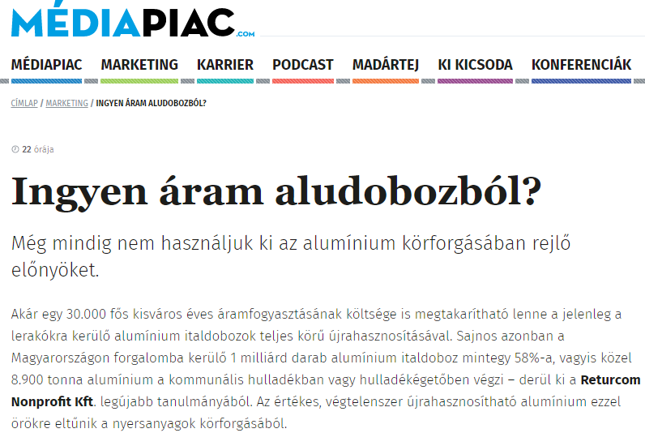

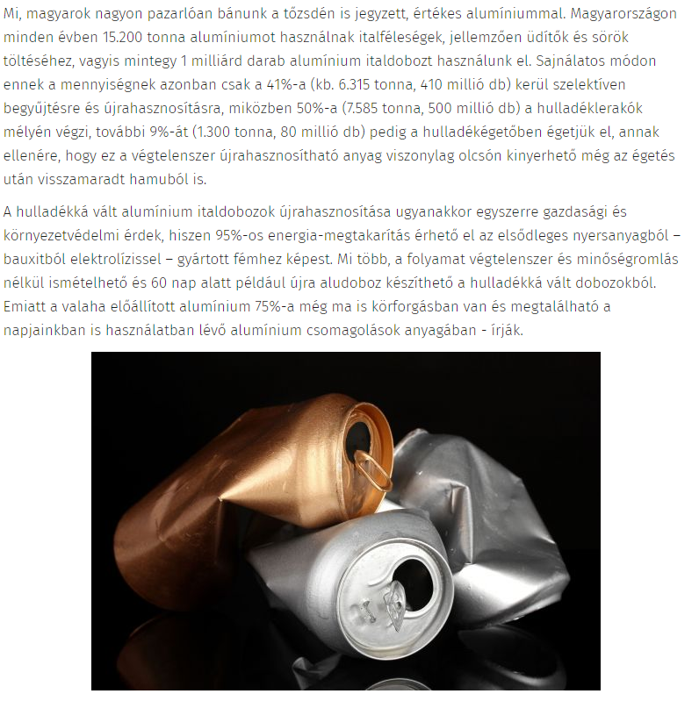

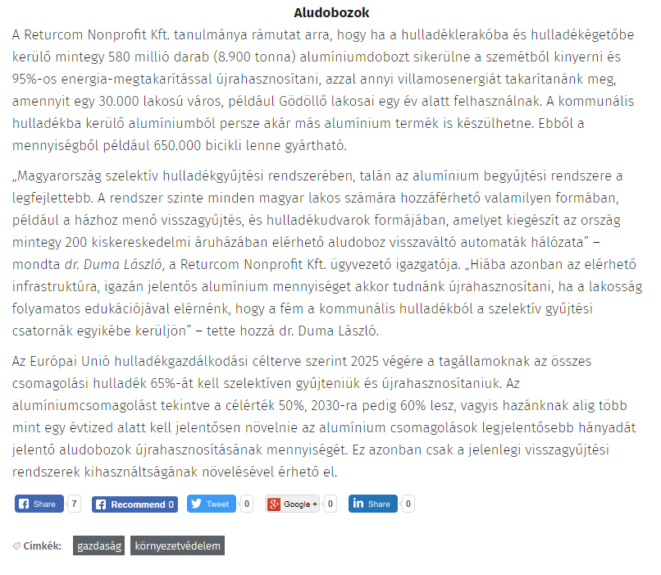

MEDIA: | origo.hu | MEDIA SPECIFICS
DATE: | 2018.03.26. | TYPE: | Online
PAGE: | - | Reach: | 544 000
Ad value (EUR) | 97 | FREQUENCY: | -
HEADLINE: | We could extract free electricity from aluminium cans
SUMMARY: | The full recycling of aluminium cans currently wasted could save the cost of the annual energy consumption 30,000-inhabitant city. Unfortunately, however, approximately 58% of the 1 billion aluminium cans put on the market in Hungary, i.e. 8,900 tonnes of aluminium, ends up as communal waste or in waste incinerators according to Returcom Nonprofit Ltd.’s most recent study. As a result, the valuable, endlessly recyclable aluminium disappears from the circulation of of raw materials.

http://www.origo.hu/techbazis/20180326-ingyen-elektromos-aram-aludobozokbol.html
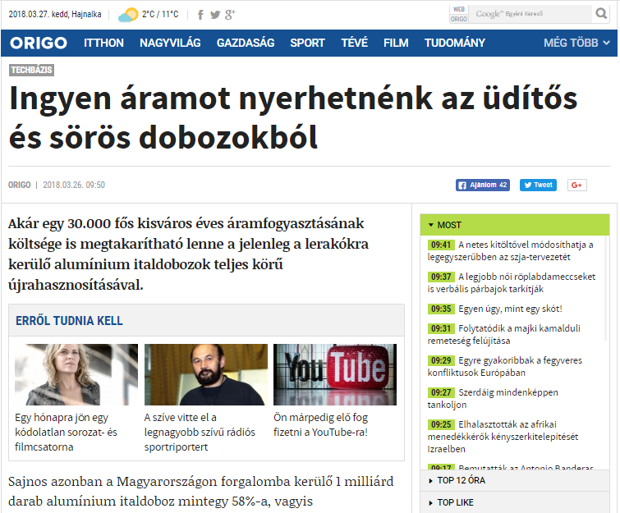

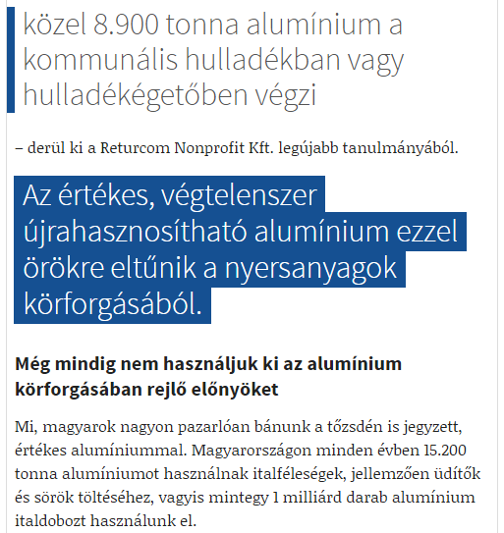

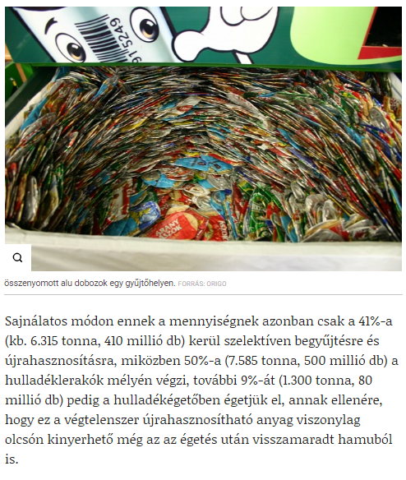

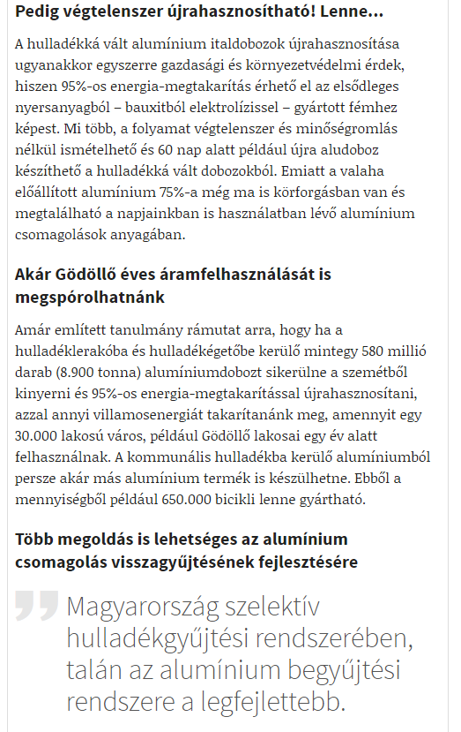

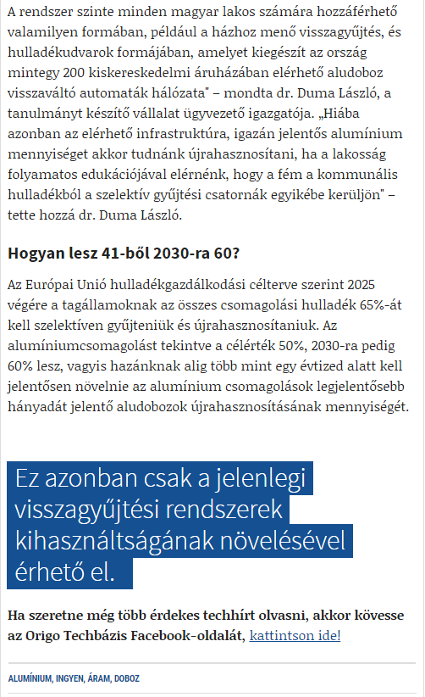

MEDIA: | mernokkocsma.hu | MEDIA SPECIFICS
DATE: | 2018.03.26. | TYPE: | Online
PAGE: | - | Reach: | 700
Ad value (EUR) | n/a | FREQUENCY: | -
HEADLINE: | Free electricity from aluminium cans?
SUMMARY: | The full recycling of aluminium cans currently wasted could save the cost of the annual energy consumption 30,000-inhabitant city. Unfortunately, however, approximately 58% of the 1 billion aluminium cans put on the market in Hungary, i.e. 8,900 tonnes of aluminium, ends up as communal waste or in waste incinerators according to Returcom Nonprofit Ltd.’s most recent study. As a result, the valuable, endlessly recyclable aluminium disappears from the circulation of of raw materials.

http://www.mernokkocsma.hu/hircsap/ingyen-aram-aludobozbol-20180326
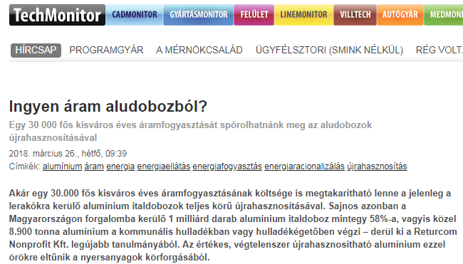

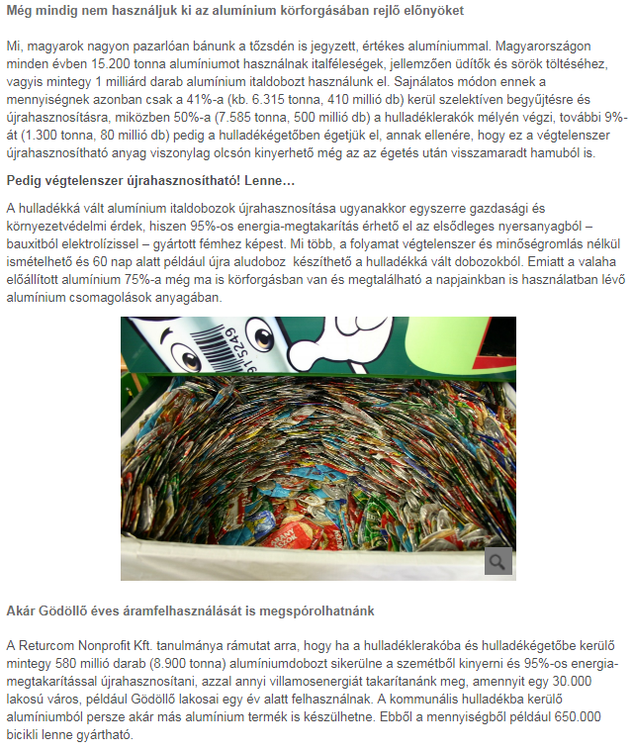

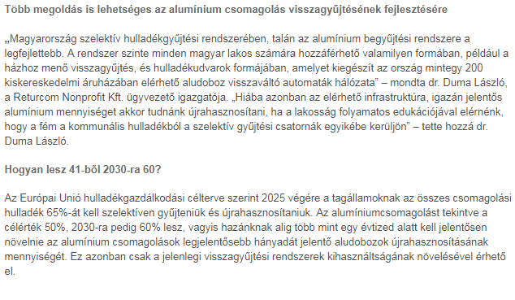

MEDIA: | techmonitor.hu | MEDIA SPECIFICS
DATE: | 2018.03.26. | TYPE: | Online
PAGE: | - | Reach: | 700
Ad value (EUR) | n/a | FREQUENCY: | -
HEADLINE: | Free electricity from aluminium cans?
SUMMARY: | The full recycling of aluminium cans currently wasted could save the cost of the annual energy consumption 30,000-inhabitant city. Unfortunately, however, approximately 58% of the 1 billion aluminium cans put on the market in Hungary, i.e. 8,900 tonnes of aluminium, ends up as communal waste or in waste incinerators according to Returcom Nonprofit Ltd.’s most recent study. As a result, the valuable, endlessly recyclable aluminium disappears from the circulation of of raw materials.

http://www.techmonitor.hu/tudastar/ingyen-aram-aludobozbol-20180326
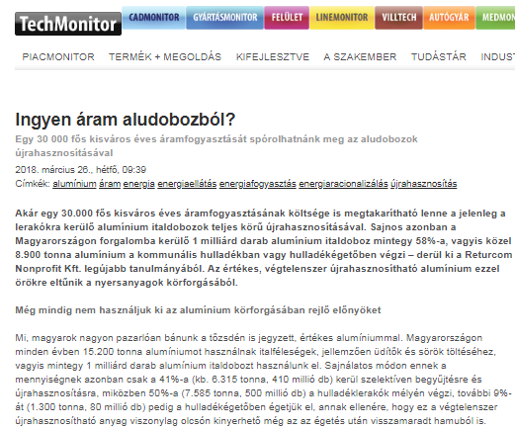

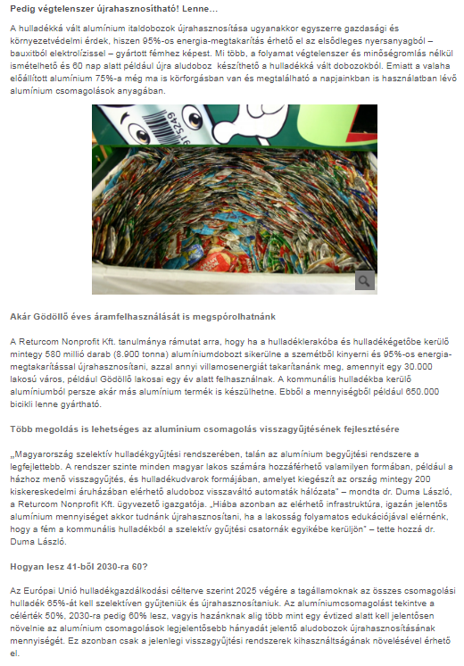

MEDIA: | villtech.hu | MEDIA SPECIFICS
DATE: | 2018.03.26. | TYPE: | Online
PAGE: | - | Reach: | 700
Ad value (EUR) | n/a | FREQUENCY: | -
HEADLINE: | Free electricity from aluminium cans?
SUMMARY: | The full recycling of aluminium cans currently wasted could save the cost of the annual energy consumption 30,000-inhabitant city. Unfortunately, however, approximately 58% of the 1 billion aluminium cans put on the market in Hungary, i.e. 8,900 tonnes of aluminium, ends up as communal waste or in waste incinerators according to Returcom Nonprofit Ltd.’s most recent study. As a result, the valuable, endlessly recyclable aluminium disappears from the circulation of of raw materials.

http://www.villtech.hu/energia/ingyen-aram-aludobozbol-20180326
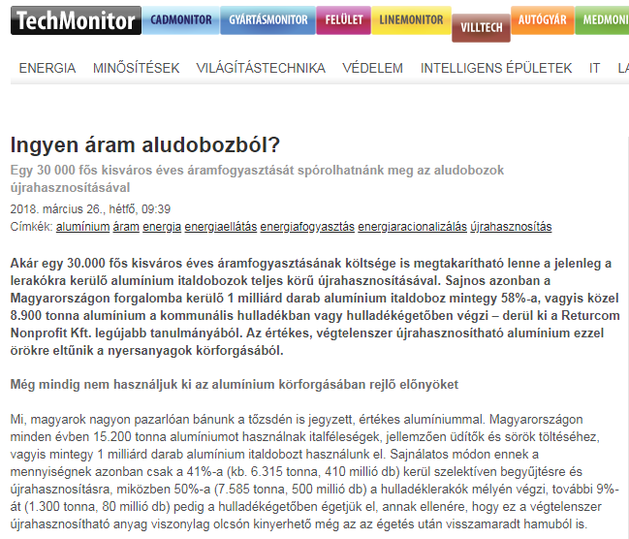
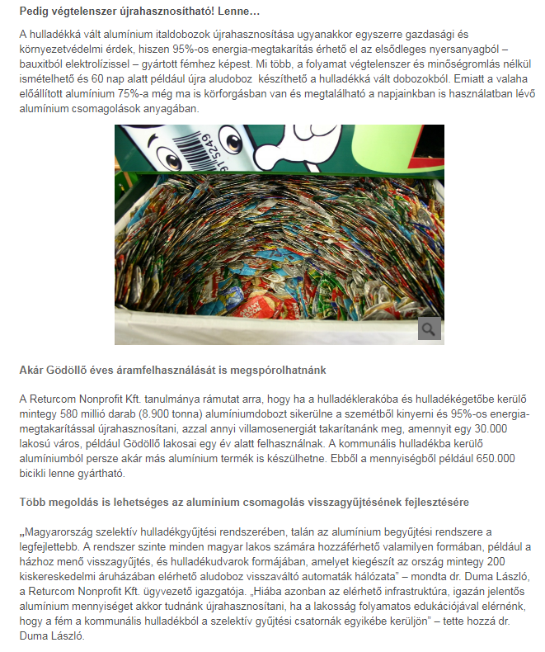

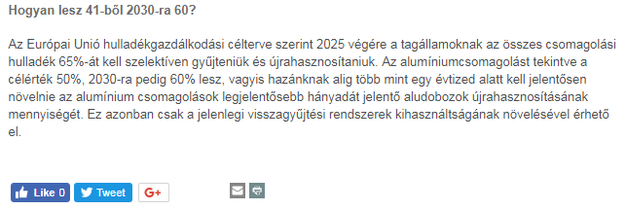

MEDIA: | eletszepitok.hu | MEDIA SPECIFICS
DATE: | 2018.03.27. | TYPE: | Online
PAGE: | - | Reach: | 77 000
Ad value (EUR) | 68 | FREQUENCY: | -
HEADLINE: | They produce 1 billion aluminium cans using 15 200 tons of aluminium in a year. Recycling it is economical and environmental interest. What can you do?
SUMMARY: | The full recycling of aluminium cans currently wasted could save the cost of the annual energy consumption 30,000-inhabitant city. Unfortunately, however, approximately 58% of the 1 billion aluminium cans put on the market in Hungary, i.e. 8,900 tonnes of aluminium, ends up as communal waste or in waste incinerators according to Returcom Nonprofit Ltd.’s most recent study. As a result, the valuable, endlessly recyclable aluminium disappears from the circulation of of raw materials.

https://eletszepitok.hu/aluminium-italdobozok-szelektiv-gyujtese-es-ujrahasznositasa/
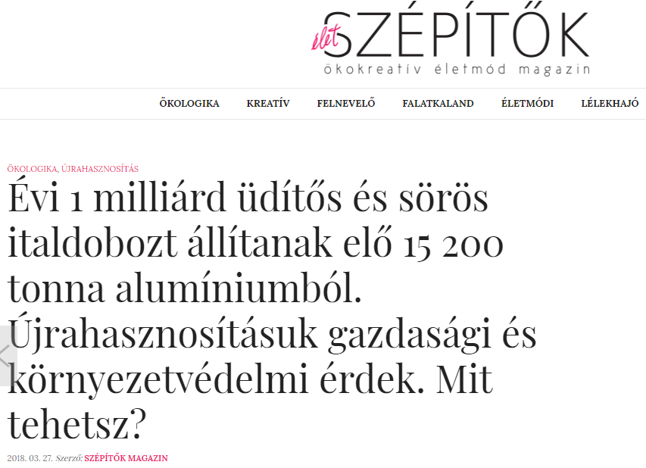

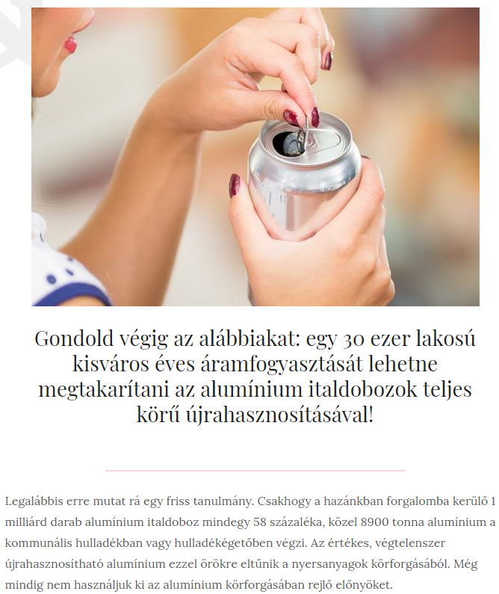

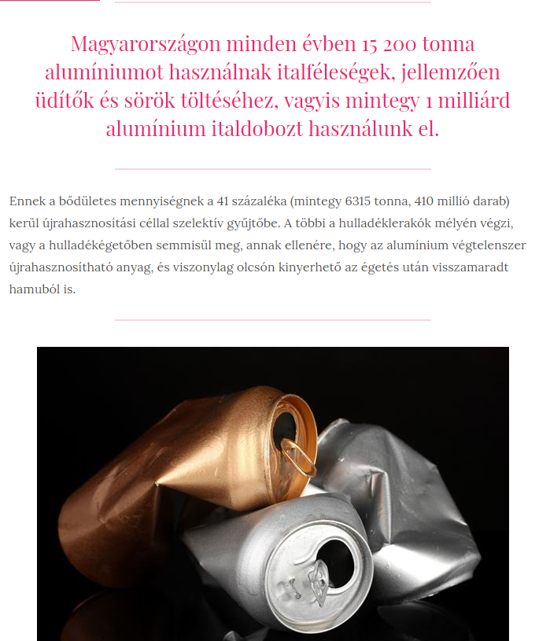

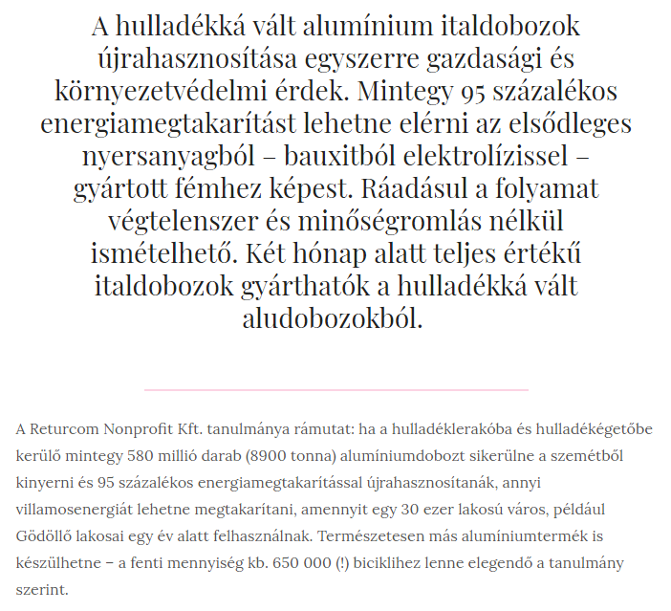
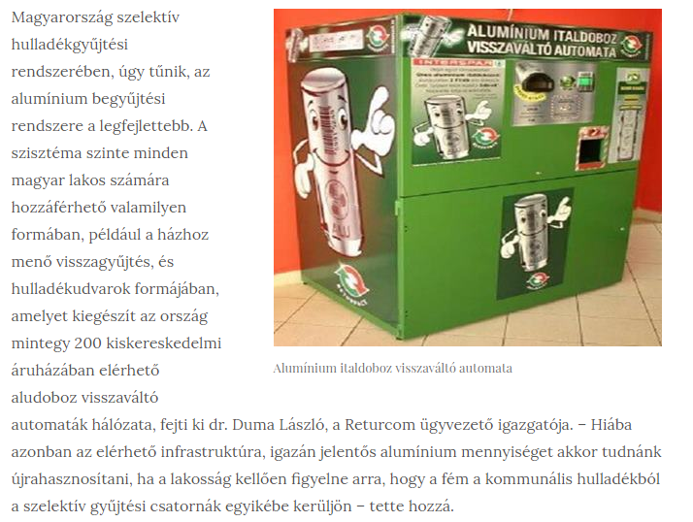

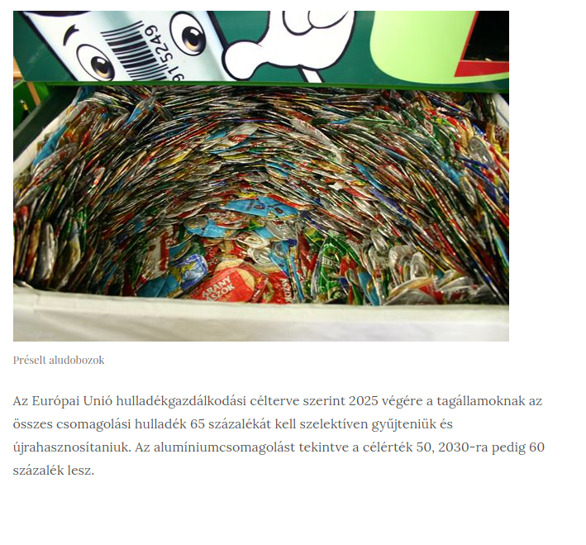

MEDIA: | profitline.hu | MEDIA SPECIFICS
DATE: | 2018.03.26. | TYPE: | Online
PAGE: | - | Reach: | 5 000
Ad value (EUR) | 967 | FREQUENCY: | -
HEADLINE: | Free electricity from aluminium cans?
SUMMARY: | The full recycling of aluminium cans currently wasted could save the cost of the annual energy consumption 30,000-inhabitant city. Unfortunately, however, approximately 58% of the 1 billion aluminium cans put on the market in Hungary, i.e. 8,900 tonnes of aluminium, ends up as communal waste or in waste incinerators according to Returcom Nonprofit Ltd.’s most recent study. As a result, the valuable, endlessly recyclable aluminium disappears from the circulation of of raw materials.

http://profitline.hu/Ingyen-aram-aludobozbol--376588
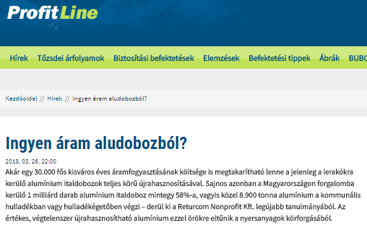

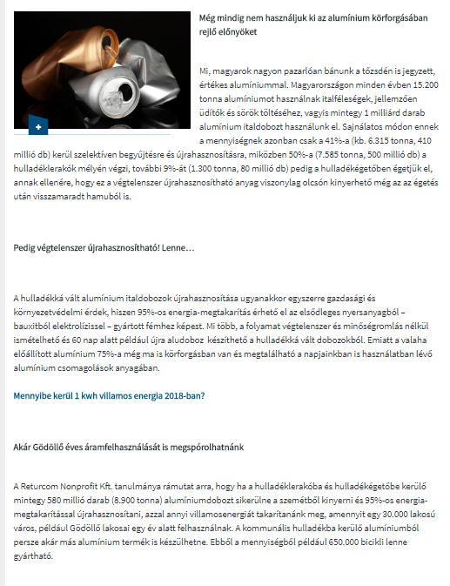

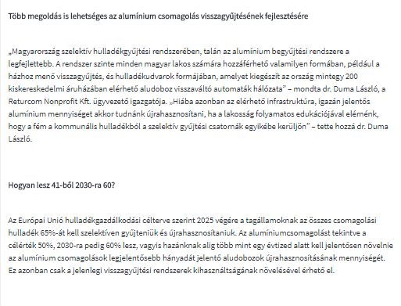

MEDIA: | packmarket.hu | MEDIA SPECIFICS
DATE: | 2018.03.26. | TYPE: | Online
PAGE: | - | Reach: | 500
Ad value (EUR) | 451 | FREQUENCY: | -
HEADLINE: | How can we make 60 from 41 until 2030?
SUMMARY: | The full recycling of aluminium cans currently wasted could save the cost of the annual energy consumption 30,000-inhabitant city. Unfortunately, however, approximately 58% of the 1 billion aluminium cans put on the market in Hungary, i.e. 8,900 tonnes of aluminium, ends up as communal waste or in waste incinerators according to Returcom Nonprofit Ltd.’s most recent study. As a result, the valuable, endlessly recyclable aluminium disappears from the circulation of of raw materials.

http://www.packmarket.hu/component/content/article/24-friss-hirek/630-hogyan-lesz-41-bl-2030-ra-60
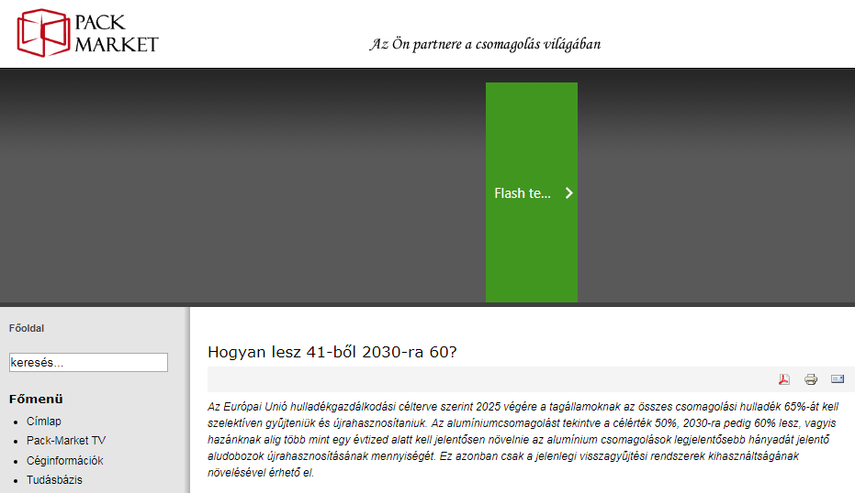

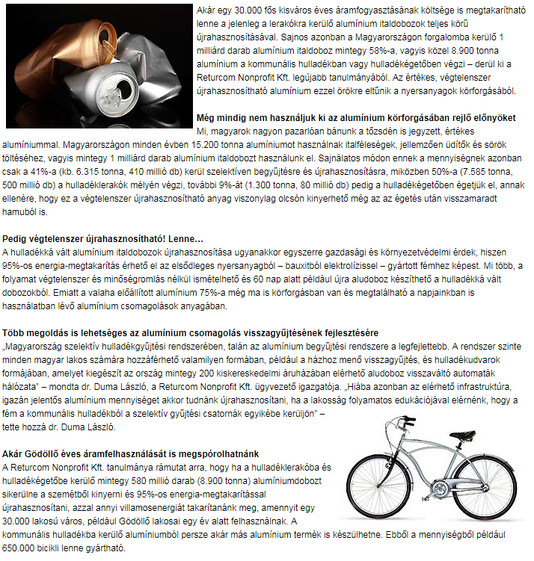

MEDIA: | civilhetes.net | MEDIA SPECIFICS
DATE: | 2018.03.26. | TYPE: | Online
PAGE: | - | Reach: | 500
Ad value (EUR) | 451 | FREQUENCY: | -
HEADLINE: | The full recycling of aluminium cans currently wasted could save the cost of the annual energy consumption 30,000-inhabitant city.
SUMMARY: | The full recycling of aluminium cans currently wasted could save the cost of the annual energy consumption 30,000-inhabitant city. Unfortunately, however, approximately 58% of the 1 billion aluminium cans put on the market in Hungary, i.e. 8,900 tonnes of aluminium, ends up as communal waste or in waste incinerators according to Returcom Nonprofit Ltd.’s most recent study. As a result, the valuable, endlessly recyclable aluminium disappears from the circulation of of raw materials.

https://civilhetes.net/egy-30000-fos-kisvaros-eves-aramfogyasztasat-sporolhatnank-meg-az-aludobozok-ujrahasznositasaval
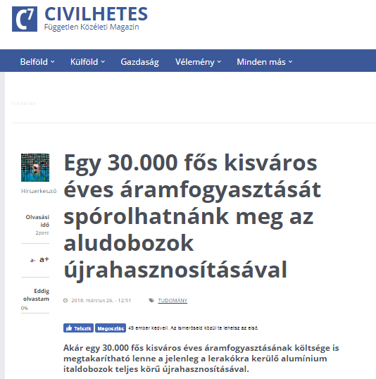
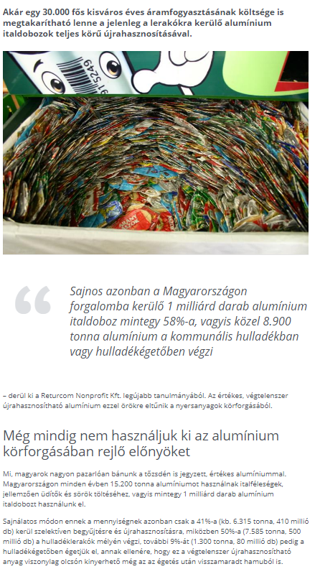

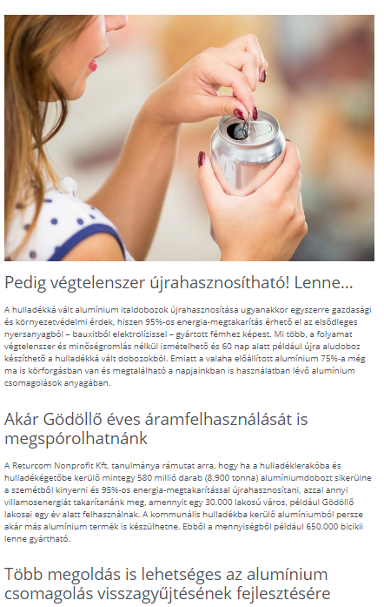

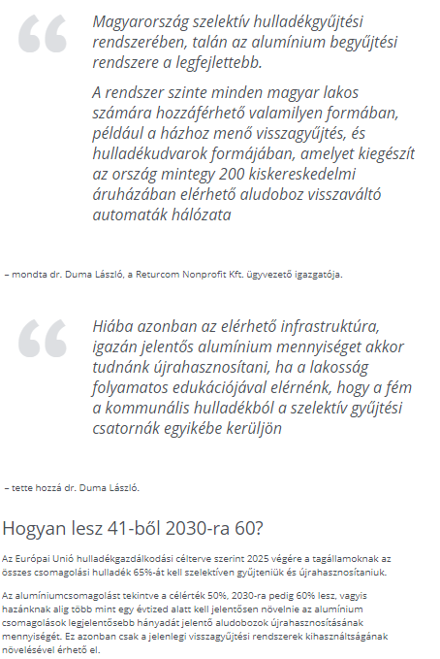

MEDIA: | profit7.hu | MEDIA SPECIFICS
DATE: | 2018.03.26. | TYPE: | Online
PAGE: | - | Reach: | n/a
Ad value (EUR) | n/a | FREQUENCY: | -
HEADLINE: | By recycling aluminium cans a lot of energy can be saved
SUMMARY: | The full recycling of aluminium cans currently wasted could save the cost of the annual energy consumption 30,000-inhabitant city. Unfortunately, however, approximately 58% of the 1 billion aluminium cans put on the market in Hungary, i.e. 8,900 tonnes of aluminium, ends up as communal waste or in waste incinerators according to Returcom Nonprofit Ltd.’s most recent study. As a result, the valuable, endlessly recyclable aluminium disappears from the circulation of of raw materials.

http://profit7.hu/hirek/aludobozok-ujrahasznositasabol-rengeteg-energia-takarithato-meg
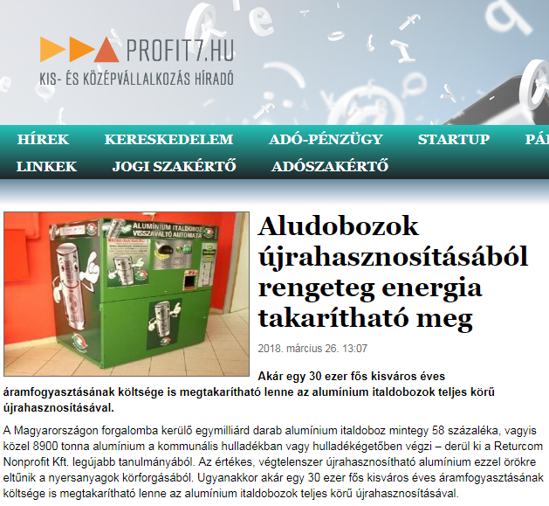

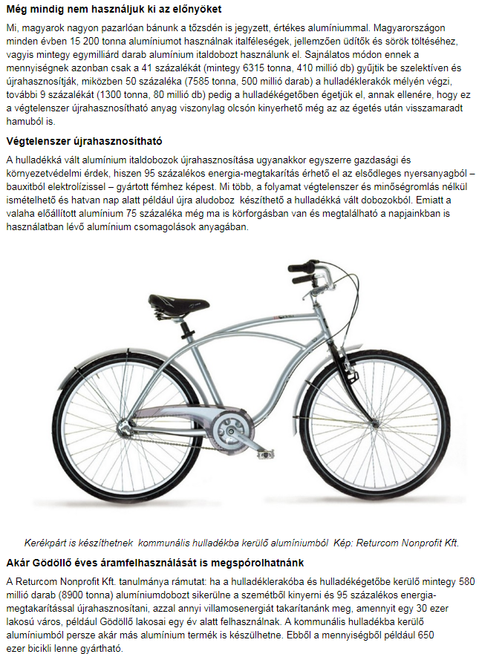

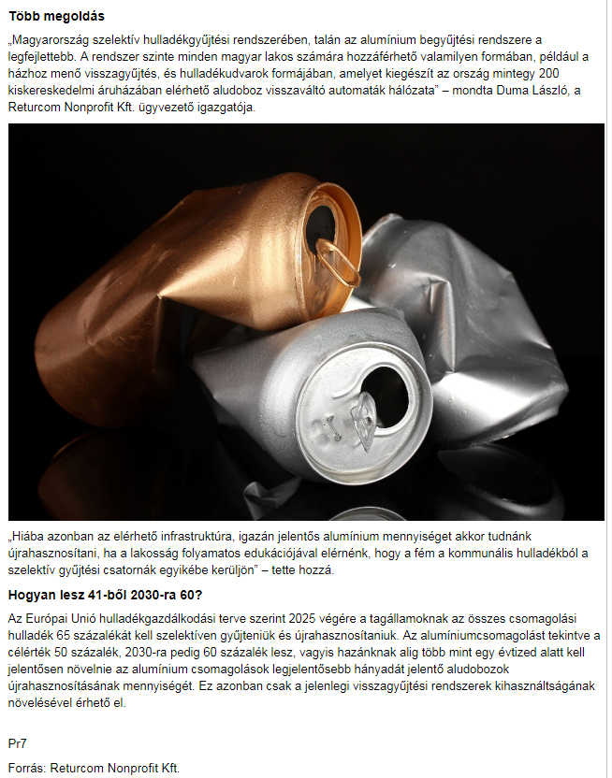

MEDIA: | bacsinfo.hu | MEDIA SPECIFICS
DATE: | 2018.03.26. | TYPE: | Online
PAGE: | - | Reach: | n/a
Ad value (EUR) | n/a | FREQUENCY: | -
HEADLINE: | By recycling aluminium cans a lot of energy can be saved
SUMMARY: | The full recycling of aluminium cans currently wasted could save the cost of the annual energy consumption 30,000-inhabitant city. Unfortunately, however, approximately 58% of the 1 billion aluminium cans put on the market in Hungary, i.e. 8,900 tonnes of aluminium, ends up as communal waste or in waste incinerators according to Returcom Nonprofit Ltd.’s most recent study. As a result, the valuable, endlessly recyclable aluminium disappears from the circulation of of raw materials.

http://bacsinfo.hu/index.php/2018/03/26/aludobozok-ujrahasznositasabol-rengeteg-energia-takarithato-meg/
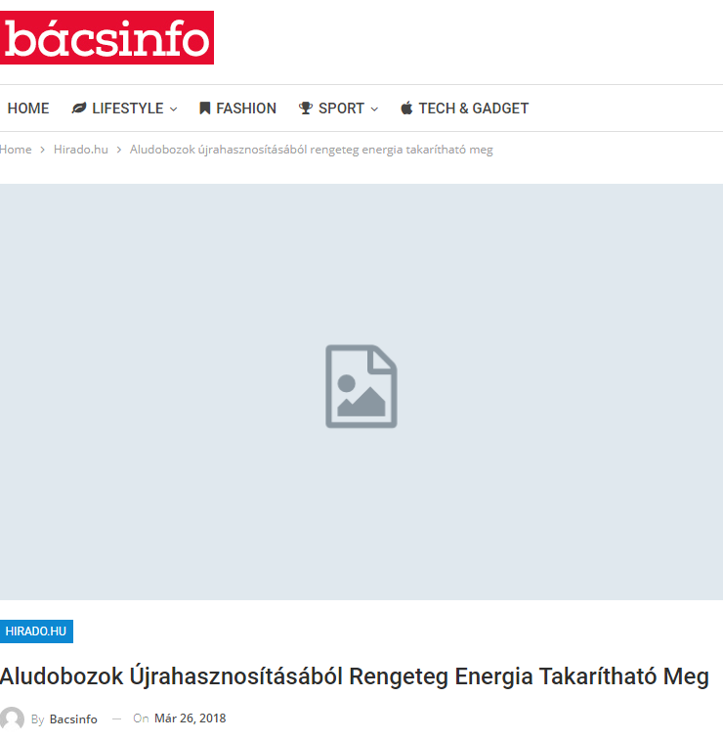
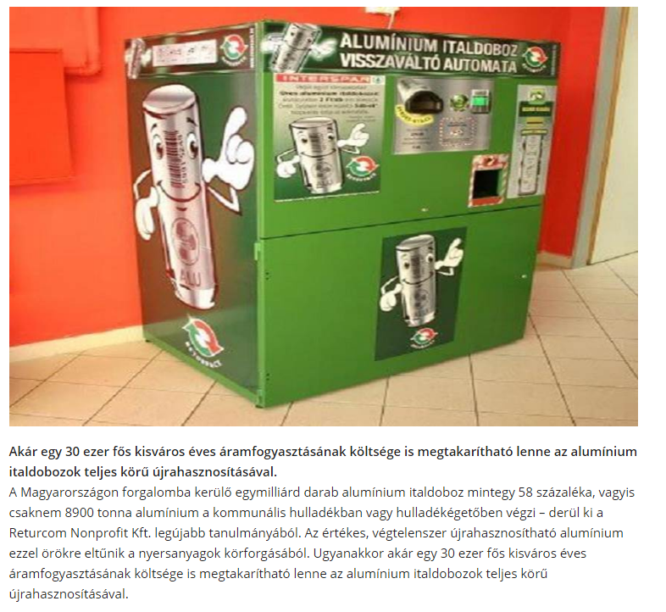

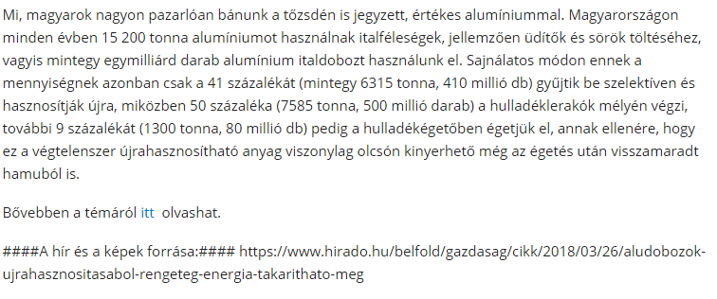

MEDIA: | utajovobe.eu | MEDIA SPECIFICS
DATE: | 2018.03.26. | TYPE: | Online
PAGE: | - | Reach: | 5 000
Ad value (EUR) | 16 | FREQUENCY: | -
HEADLINE: | By recycling aluminium could save the cost of the annual energy consumption of a city.
SUMMARY: | The full recycling of aluminium cans currently wasted could save the cost of the annual energy consumption 30,000-inhabitant city. Unfortunately, however, approximately 58% of the 1 billion aluminium cans put on the market in Hungary, i.e. 8,900 tonnes of aluminium, ends up as communal waste or in waste incinerators according to Returcom Nonprofit Ltd.’s most recent study. As a result, the valuable, endlessly recyclable aluminium disappears from the circulation of of raw materials.

http://utajovobe.eu/hirek/energetika/7557-az-aludobozok-ujrahasznositasaval-egy-kisvaros-eves-aramfogyasztasat-sporolhatnank-meg
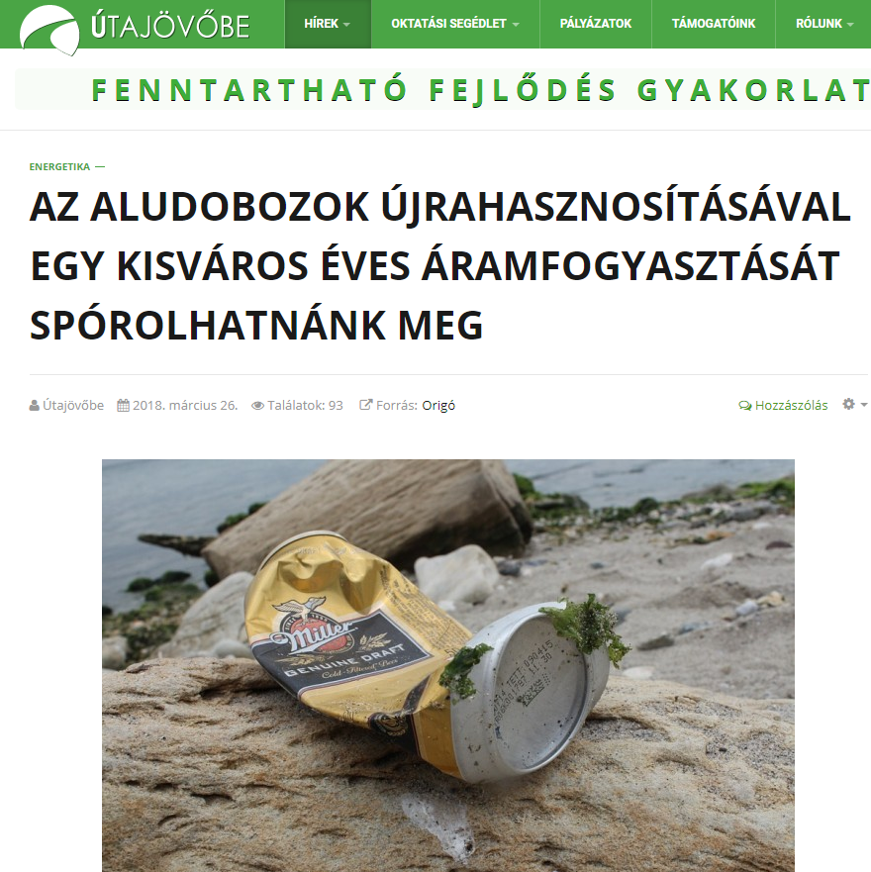

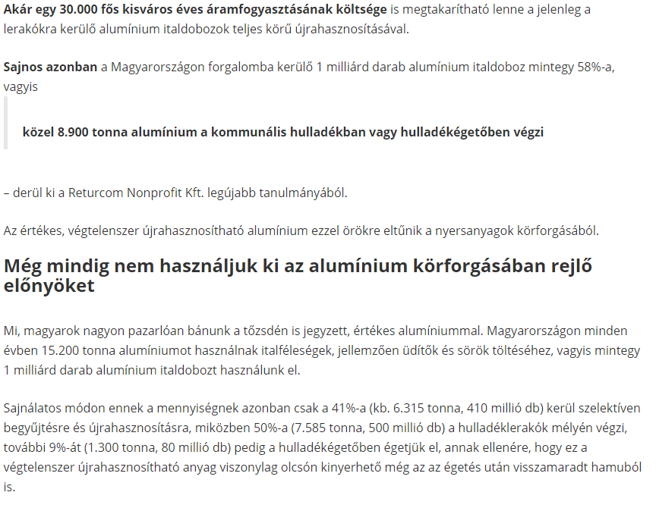

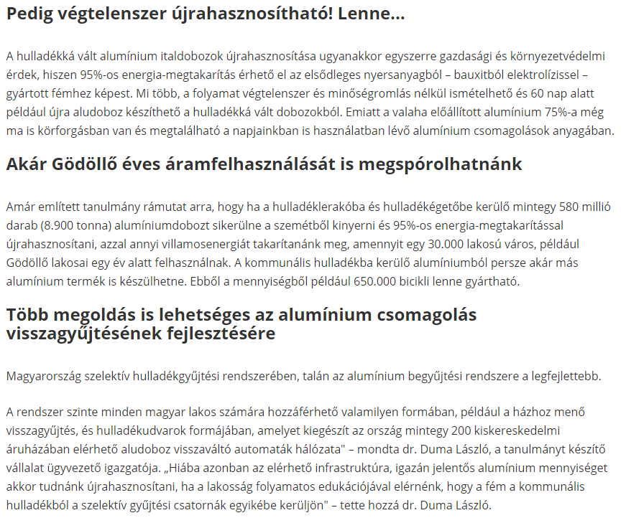

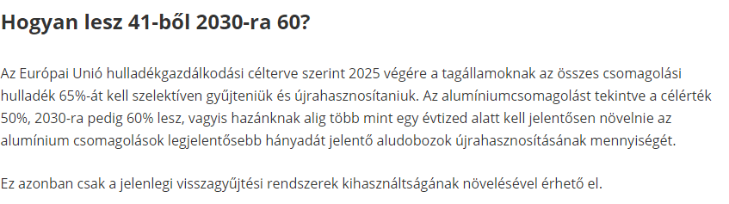

MEDIA: | forbes.hu | MEDIA SPECIFICS
DATE: | 2018.03.26. | TYPE: | Online
PAGE: | - | Reach: | 10 000
Ad value (EUR) | 685 | FREQUENCY: | -
HEADLINE: | We could save Gödöllő’s annual energy consumption with aluminium cans
SUMMARY: | The full recycling of aluminium cans currently wasted could save the cost of the annual energy consumption 30,000-inhabitant city. Unfortunately, however, approximately 58% of the 1 billion aluminium cans put on the market in Hungary, i.e. 8,900 tonnes of aluminium, ends up as communal waste or in waste incinerators according to Returcom Nonprofit Ltd.’s most recent study. As a result, the valuable, endlessly recyclable aluminium disappears from the circulation of of raw materials.

https://forbes.hu/legyel-jobb/godollo-eves-aramfogyasztasat-sporolhatnank-meg-aludobozokkal/
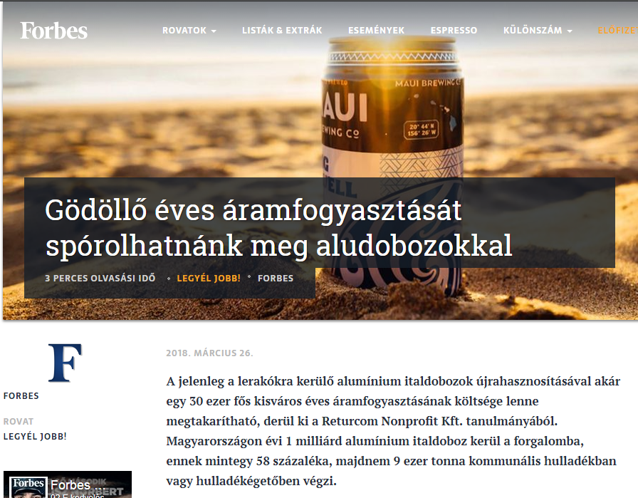

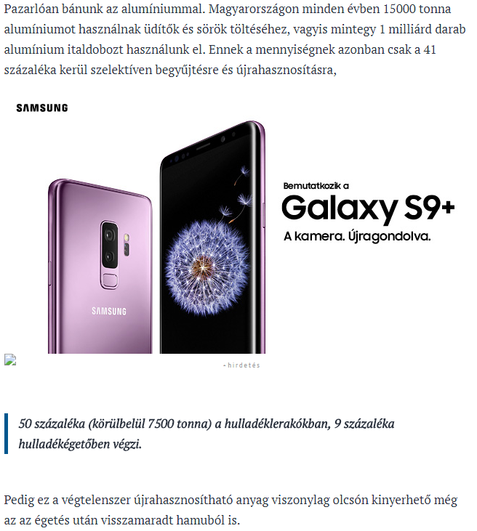

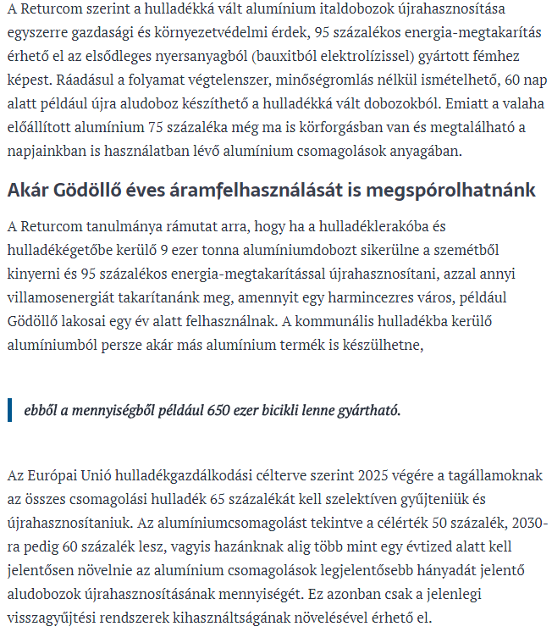

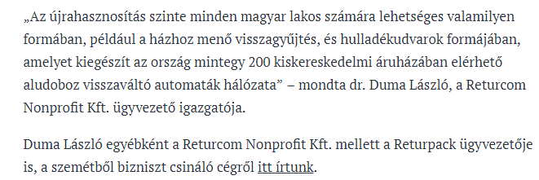

MEDIA: | ecolounge.hu | MEDIA SPECIFICS
DATE: | 2018.03.26. | TYPE: | Online
PAGE: | - | Reach: | n/a
Ad value (EUR) | 290 | FREQUENCY: | -
HEADLINE: | By recycling aluminium cans we could save the cost of the annual energy consumption of an 30,000-inhabitant city.
SUMMARY: | The full recycling of aluminium cans currently wasted could save the cost of the annual energy consumption 30,000-inhabitant city. Unfortunately, however, approximately 58% of the 1 billion aluminium cans put on the market in Hungary, i.e. 8,900 tonnes of aluminium, ends up as communal waste or in waste incinerators according to Returcom Nonprofit Ltd.’s most recent study. As a result, the valuable, endlessly recyclable aluminium disappears from the circulation of of raw materials.

http://ecolounge.hu/nagyvilag/30000-fos-kisvaros-aramfogyasztasat-sporolhatnank-meg-aludobozok-ujrahasznositasaval
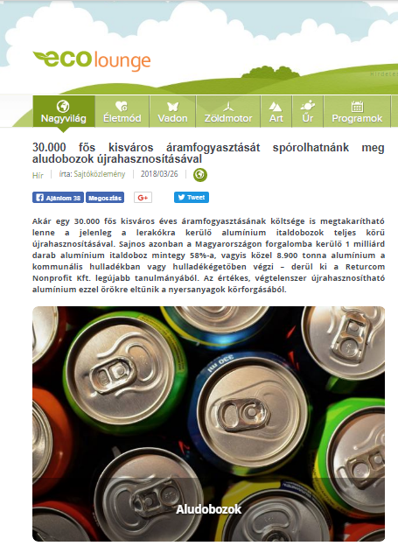
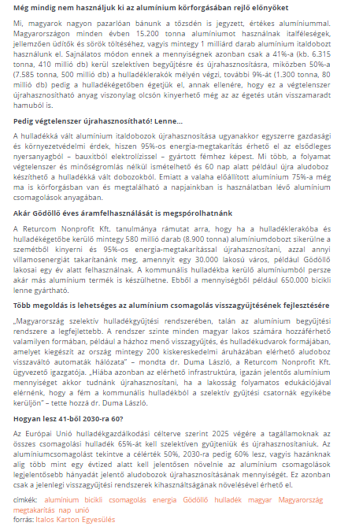

MEDIA: | hasznositsd.hu | MEDIA SPECIFICS
DATE: | 2018.03.26. | TYPE: | Online
PAGE: | - | Reach: | n/a
Ad value (EUR) | n/a | FREQUENCY: | -
HEADLINE: | By recycling aluminium cans we could save the cost of the annual energy consumption of an 30,000-inhabitant city.
SUMMARY: | The full recycling of aluminium cans currently wasted could save the cost of the annual energy consumption 30,000-inhabitant city. Unfortunately, however, approximately 58% of the 1 billion aluminium cans put on the market in Hungary, i.e. 8,900 tonnes of aluminium, ends up as communal waste or in waste incinerators according to Returcom Nonprofit Ltd.’s most recent study. As a result, the valuable, endlessly recyclable aluminium disappears from the circulation of of raw materials.

http://hasznositsd.hu/nagyvilag/30-000-fos-kisvaros-aramfogyasztasat-sporolhatnank-meg-aludobozok-ujrahasznositasaval
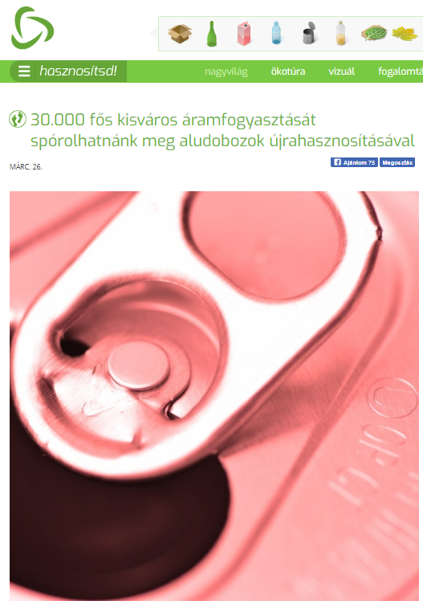
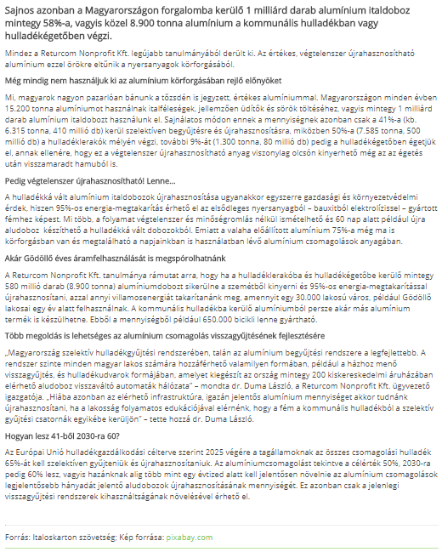

MEDIA: | hirado.hu | MEDIA SPECIFICS
DATE: | 2018.03.26. | TYPE: | Online
PAGE: | - | Reach: | 150 000
Ad value (EUR) | 1935 | FREQUENCY: | -
HEADLINE: | By recycling aluminium cans a lot of energy can be saved
SUMMARY: | The full recycling of aluminium cans currently wasted could save the cost of the annual energy consumption 30,000-inhabitant city. Unfortunately, however, approximately 58% of the 1 billion aluminium cans put on the market in Hungary, i.e. 8,900 tonnes of aluminium, ends up as communal waste or in waste incinerators according to Returcom Nonprofit Ltd.’s most recent study. As a result, the valuable, endlessly recyclable aluminium disappears from the circulation of of raw materials.

https://www.hirado.hu/belfold/gazdasag/cikk/2018/03/26/aludobozok-ujrahasznositasabol-rengeteg-energia-takarithato-meg/
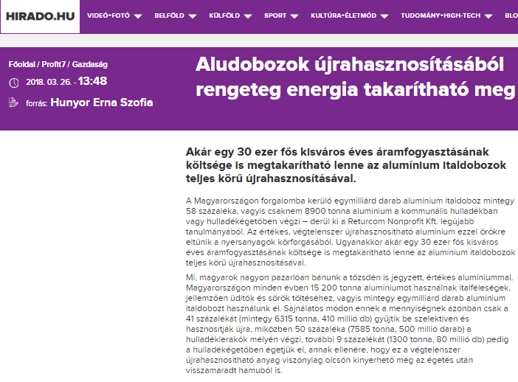

MEDIA: | otletmozaik.hu | MEDIA SPECIFICS
DATE: | 2018.03.27. | TYPE: | Online
PAGE: | - | Reach: | 1066
Ad value (EUR) | 14 | FREQUENCY: | -
HEADLINE: | Aluminium cans are valuable!
SUMMARY: | The full recycling of aluminium cans currently wasted could save the cost of the annual energy consumption 30,000-inhabitant city. Unfortunately, however, approximately 58% of the 1 billion aluminium cans put on the market in Hungary, i.e. 8,900 tonnes of aluminium, ends up as communal waste or in waste incinerators according to Returcom Nonprofit Ltd.’s most recent study. As a result, the valuable, endlessly recyclable aluminium disappears from the circulation of of raw materials.

http://otletmozaik.hu/blog/anyagujdonsagok/2102-a-kolas-es-sorosdoboz-ertekes
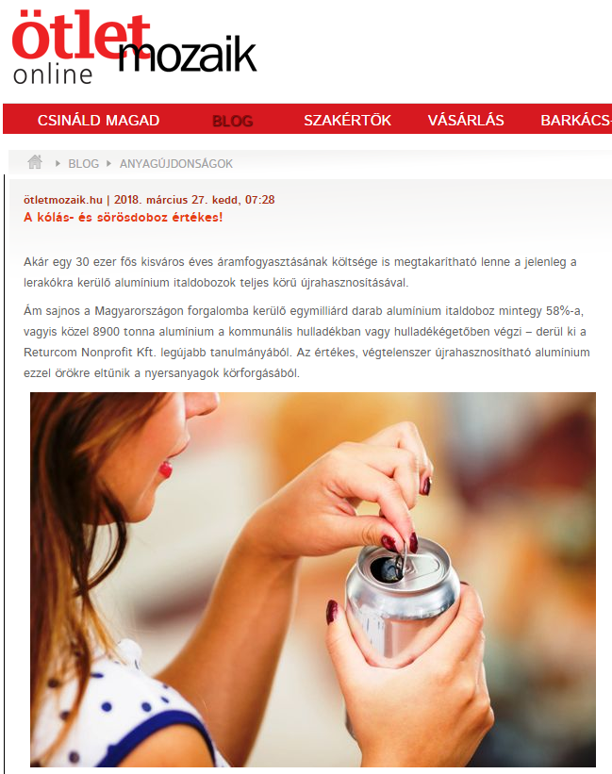

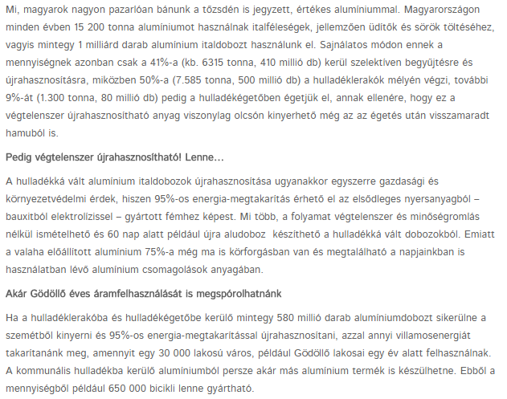

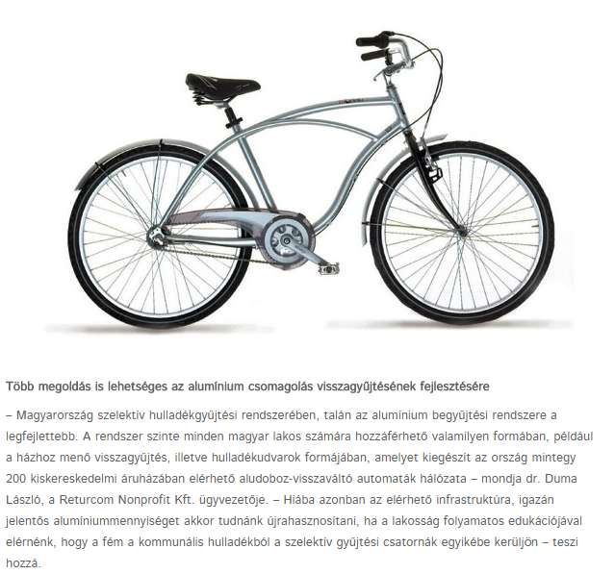

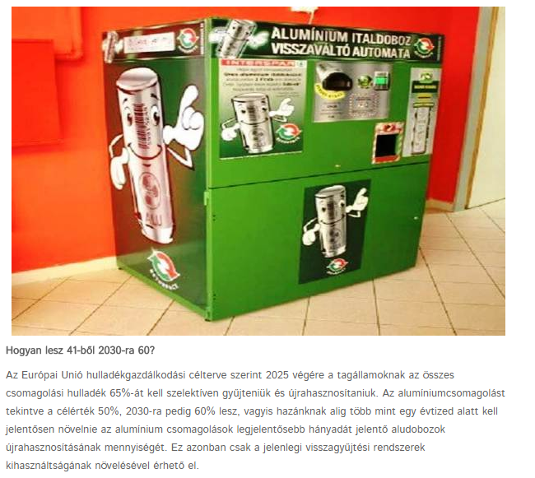

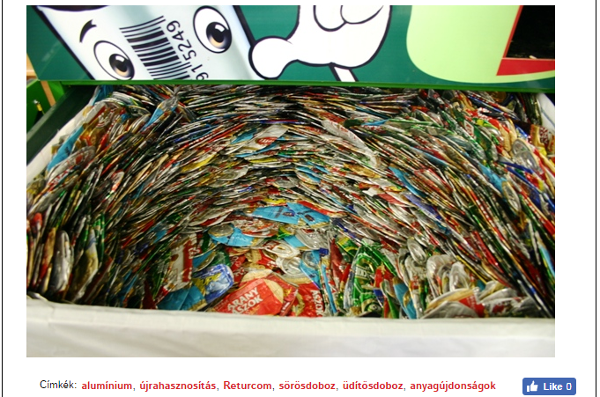

MEDIA: | sztradaradio.hu | MEDIA SPECIFICS
DATE: | 2018.03.26. | TYPE: | Online
PAGE: | - | Reach: | n/a
Ad value (EUR) | n/a | FREQUENCY: | -
HEADLINE: | By recycling aluminium cans we could save the cost of the annual energy consumption of an 30,000-inhabitant city.
SUMMARY: | The full recycling of aluminium cans currently wasted could save the cost of the annual energy consumption 30,000-inhabitant city. Unfortunately, however, approximately 58% of the 1 billion aluminium cans put on the market in Hungary, i.e. 8,900 tonnes of aluminium, ends up as communal waste or in waste incinerators according to Returcom Nonprofit Ltd.’s most recent study. As a result, the valuable, endlessly recyclable aluminium disappears from the circulation of of raw materials.

http://hirek.sztradaradio.hu/2018/03/26/egy-30-000-fos-kisvaros-eves-aramfogyasztasat-sporolhatnank-meg-az-aludobozok-ujrahasznositasaval/
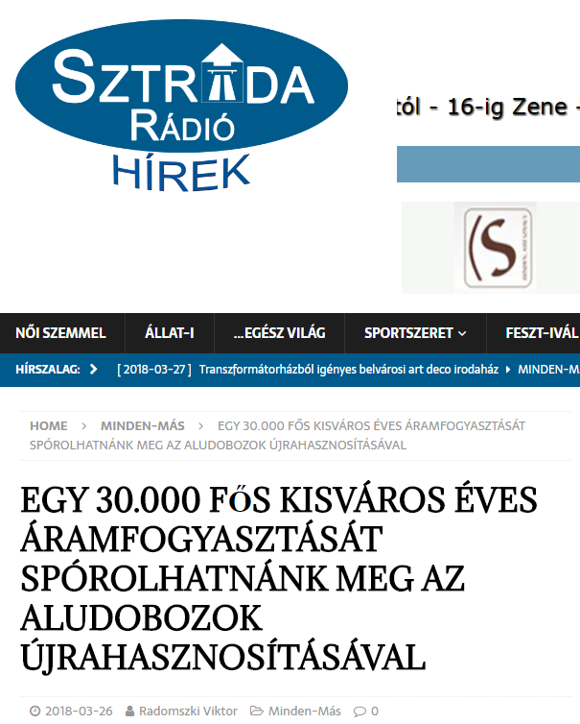
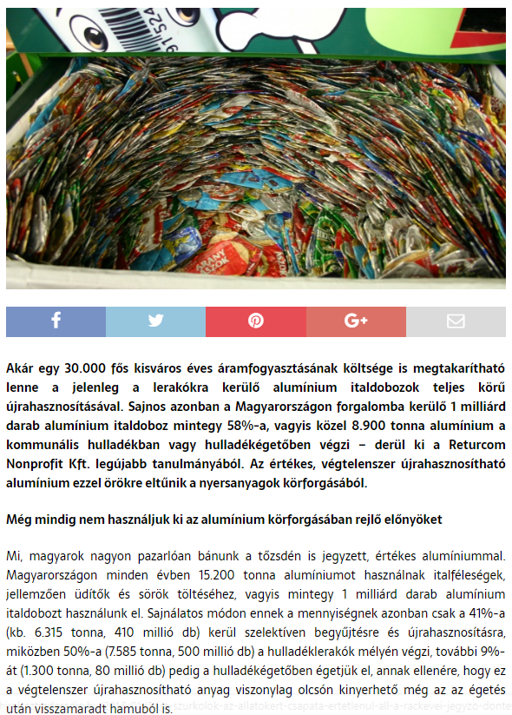

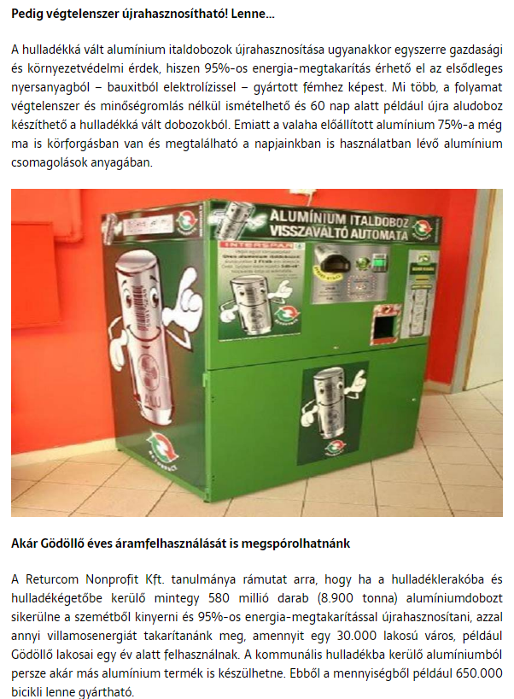

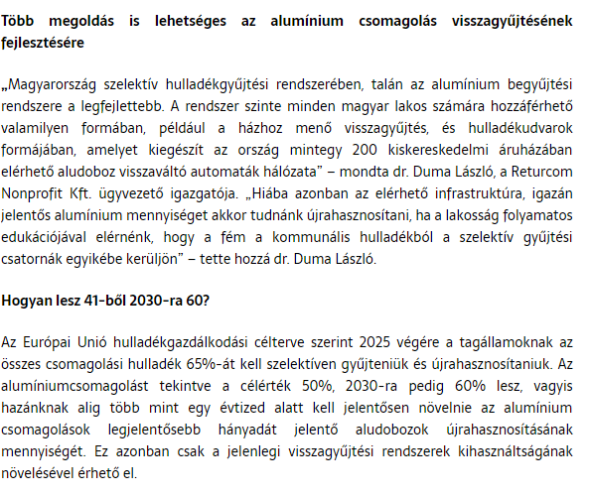

MEDIA: | borsod24.com | MEDIA SPECIFICS
DATE: | 2018.03.27. | TYPE: | Online
PAGE: | - | Reach: | n/a
Ad value (EUR) | n/a | FREQUENCY: | -
HEADLINE: | We could save a lot of free electricity with beer cans
SUMMARY: | The full recycling of aluminium cans currently wasted could save the cost of the annual energy consumption 30,000-inhabitant city. Unfortunately, however, approximately 58% of the 1 billion aluminium cans put on the market in Hungary, i.e. 8,900 tonnes of aluminium, ends up as communal waste or in waste incinerators according to Returcom Nonprofit Ltd.’s most recent study. As a result, the valuable, endlessly recyclable aluminium disappears from the circulation of of raw materials.

http://www.borsod24.com/magyarorszag/rengeteg-ingyen-aramot-nyerhetnenk-aludobozokbol/
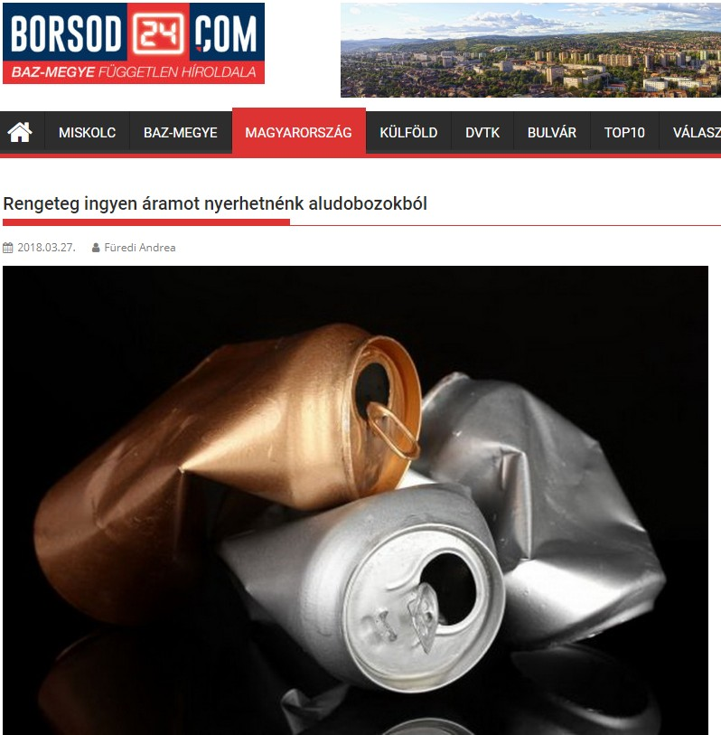
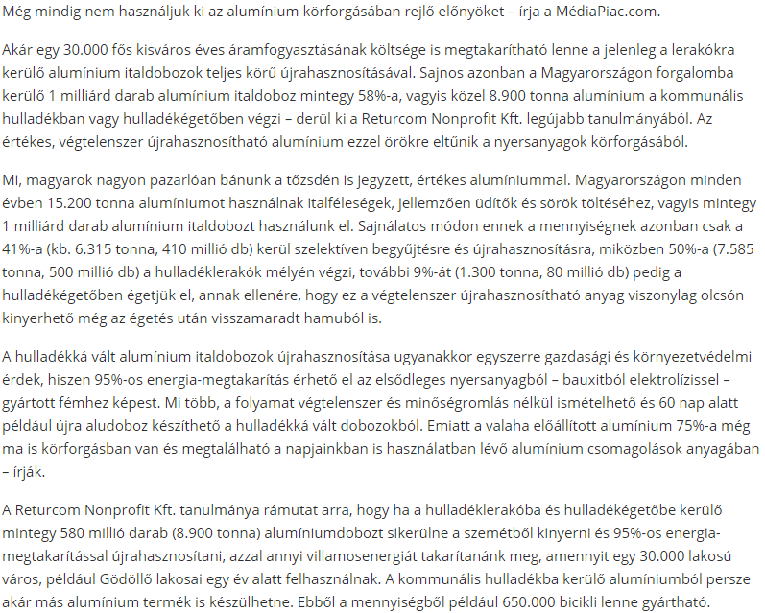

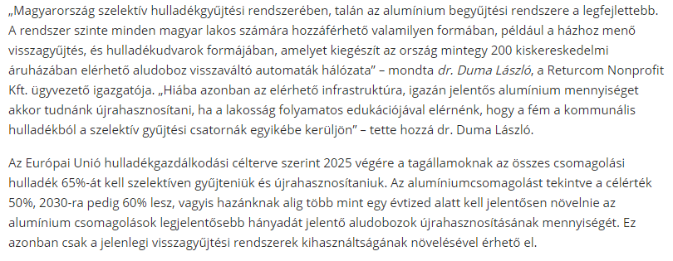

MEDIA: | markamonitor.hu | MEDIA SPECIFICS
DATE: | 2018.03.26. | TYPE: | Online
PAGE: | - | Reach: | n/a
Ad value (EUR) | n/a | FREQUENCY: | -
HEADLINE: | Free electricity from aluminium cans
SUMMARY: | The full recycling of aluminium cans currently wasted could save the cost of the annual energy consumption 30,000-inhabitant city. Unfortunately, however, approximately 58% of the 1 billion aluminium cans put on the market in Hungary, i.e. 8,900 tonnes of aluminium, ends up as communal waste or in waste incinerators according to Returcom Nonprofit Ltd.’s most recent study. As a result, the valuable, endlessly recyclable aluminium disappears from the circulation of of raw materials.

http://markamonitor.hu/markak/Aludobozbol-ingyenaram/2611/
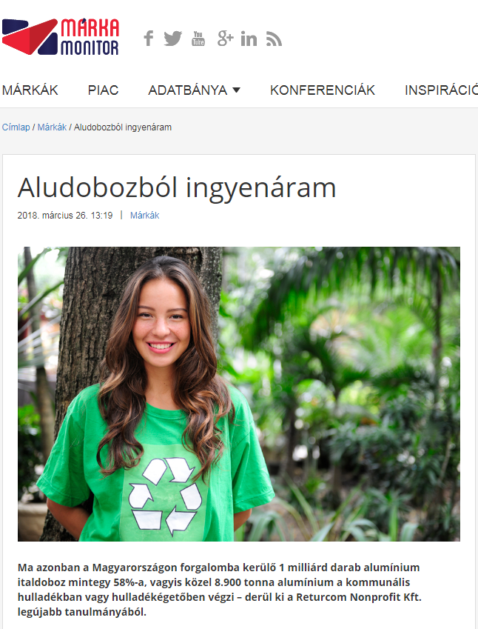

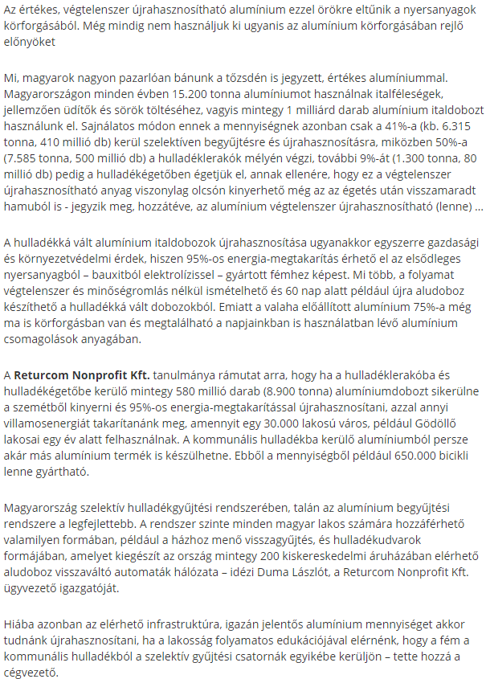

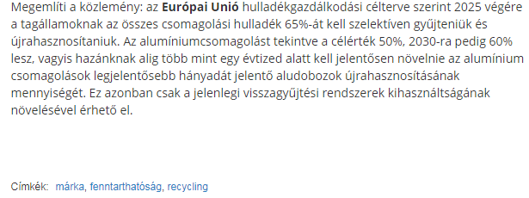

MEDIA: | ujnemzedek.hu | MEDIA SPECIFICS
DATE: | 2018.03.26. | TYPE: | Online
PAGE: | - | Reach: | n/a
Ad value (EUR) | n/a | FREQUENCY: | -
HEADLINE: | By recycling aluminium cans we could save the cost of the annual energy consumption of an 30,000-inhabitant city.
SUMMARY: | The full recycling of aluminium cans currently wasted could save the cost of the annual energy consumption 30,000-inhabitant city. Unfortunately, however, approximately 58% of the 1 billion aluminium cans put on the market in Hungary, i.e. 8,900 tonnes of aluminium, ends up as communal waste or in waste incinerators according to Returcom Nonprofit Ltd.’s most recent study. As a result, the valuable, endlessly recyclable aluminium disappears from the circulation of of raw materials.

http://www.ujnemzedek.hu/hirek/egy-30000-fos-kisvaros-eves-aramfogyasztasat-sporolhatnank-meg-az-aludobozok
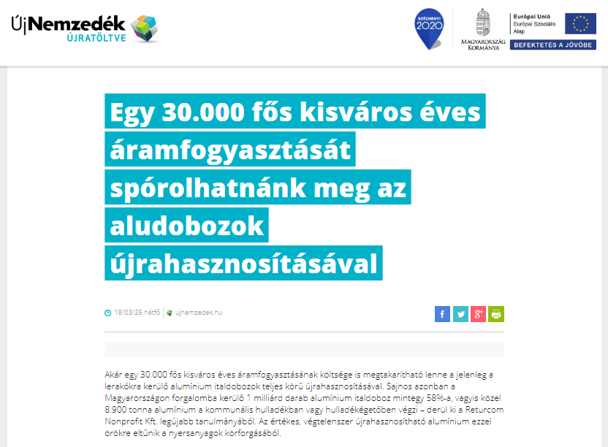

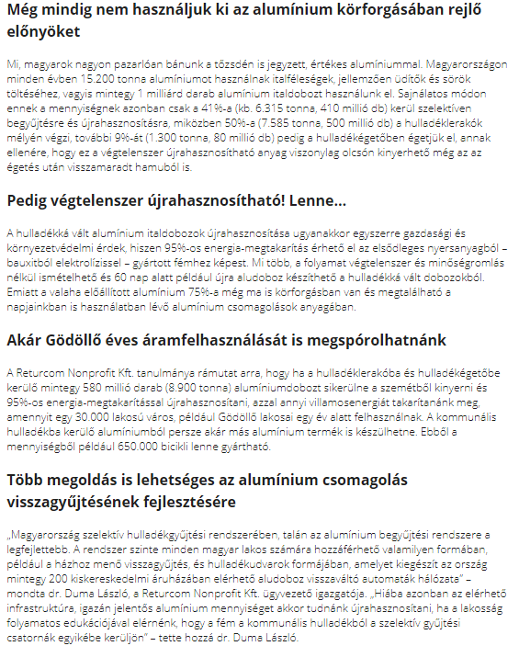

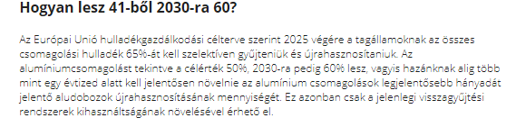

MEDIA: | biharlap.hu | MEDIA SPECIFICS
DATE: | 2018.03.26. | TYPE: | Online
PAGE: | - | Reach: | n/a
Ad value (EUR) | n/a | FREQUENCY: | -
HEADLINE: | We could save a lot on electricity with beer cans
SUMMARY: | The full recycling of aluminium cans currently wasted could save the cost of the annual energy consumption 30,000-inhabitant city. Unfortunately, however, approximately 58% of the 1 billion aluminium cans put on the market in Hungary, i.e. 8,900 tonnes of aluminium, ends up as communal waste or in waste incinerators according to Returcom Nonprofit Ltd.’s most recent study. As a result, the valuable, endlessly recyclable aluminium disappears from the circulation of of raw materials.

http://www.biharlap.hu/hir/29450/Soros-dobozokkal-rengeteget-sporolhatnank-az-aramon.html
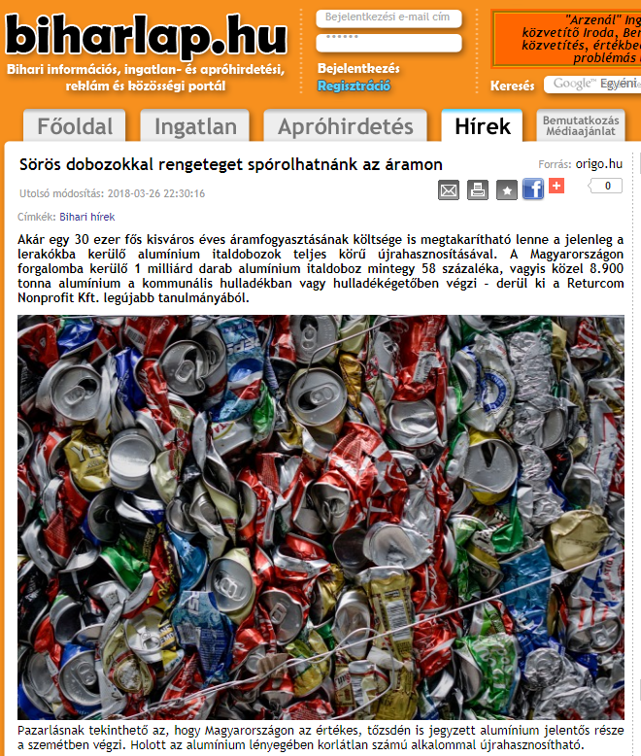

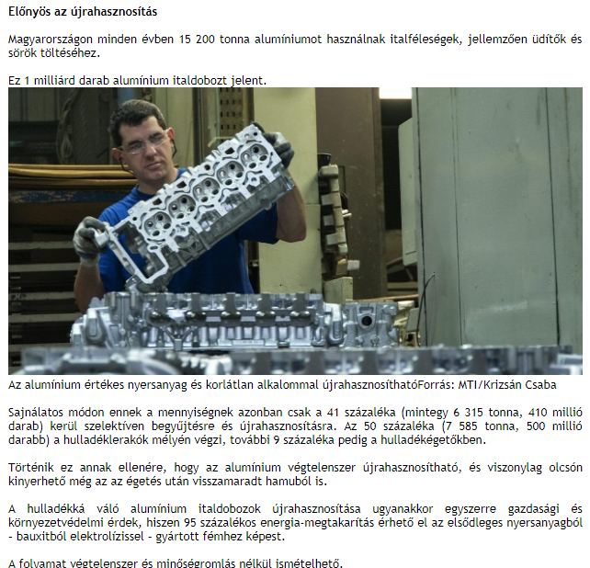

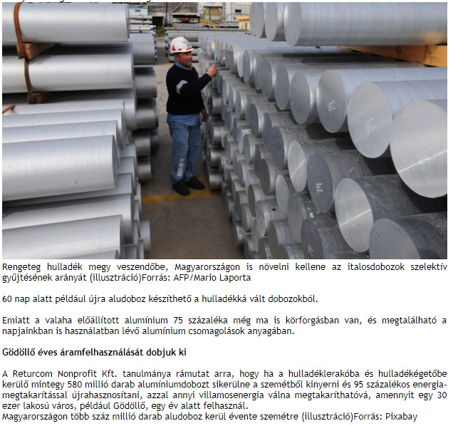

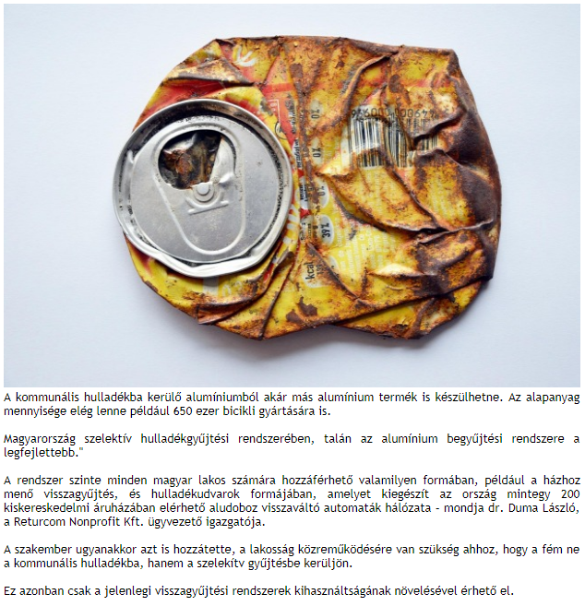

MEDIA: | Rádió 1 | MEDIA SPECIFICS
DATE: | 2018.03.27. 7:00, 8:30 | TYPE: | Electronic
PAGE: | - | Reach: | 1 321 000
Ad value (EUR) | n/a | FREQUENCY: | -
HEADLINE: | Recycling aluminium cans could save the cost of the electricity of a 30,000 citizen city
SUMMARY: | The full recycling of aluminium cans currently wasted could save the cost of the annual energy consumption 30,000-inhabitant city. Unfortunately, however, approximately 58% of the 1 billion aluminium cans put on the market in Hungary, i.e. 8,900 tonnes of aluminium, ends up as communal waste or in waste incinerators according to Returcom Nonprofit Ltd.’s most recent study. As a result, the valuable, endlessly recyclable aluminium disappears from the circulation of of raw materials.

http://www.premiercom.hu/download/BCME/Radio1_hirek_03_27.mp3

MEDIA: | Retro Rádió | MEDIA SPECIFICS
DATE: | 2018.03.27. 7:00, 8:30 | TYPE: | Electronic
PAGE: | - | Reach: | 74 125
Ad value (EUR) | 96 | FREQUENCY: | -
HEADLINE: | Recycling aluminium cans could save the cost of the electricity of a 30,000 citizen city
SUMMARY: | The full recycling of aluminium cans currently wasted could save the cost of the annual energy consumption 30,000-inhabitant city. Unfortunately, however, approximately 58% of the 1 billion aluminium cans put on the market in Hungary, i.e. 8,900 tonnes of aluminium, ends up as communal waste or in waste incinerators according to Returcom Nonprofit Ltd.’s most recent study. As a result, the valuable, endlessly recyclable aluminium disappears from the circulation of of raw materials.

http://www.premiercom.hu/download/BCME/Retro_Radio_03_27.mp3

MEDIA: | Lánchíd Rádió | MEDIA SPECIFICS
DATE: | 2018.03.28. 11:37 | TYPE: | Electronic
PAGE: | - | Reach: | 65 000
Ad value (EUR) | 796 | FREQUENCY: | -
HEADLINE: | Interview with László Duma
SUMMARY: | The full recycling of aluminium cans currently wasted could save the cost of the annual energy consumption 30,000-inhabitant city. Unfortunately, however, approximately 58% of the 1 billion aluminium cans put on the market in Hungary, i.e. 8,900 tonnes of aluminium, ends up as communal waste or in waste incinerators according to Returcom Nonprofit Ltd.’s most recent study. As a result, the valuable, endlessly recyclable aluminium disappears from the circulation of of raw materials.

http://www.premiercom.hu/download/BCME/Lanchid_03.27.mp4

